**Assignment 3 Report**

**Zihan Zhang**

**NUID: 001280965**

1. **Goal:**

Design a memory simulator with binary tree

1. **Design:**
2. **General design:**

The whole tree is a way to represent the construction of the memory. It is a hierarchy memory. The root of the tree represents the total number of the memory. Each level of the tree represents the different division degree of the whole memory. And in terms of request of small blocks, the tree will traverse the tree and find the block needed.

1. **Construction of the tree:**

Block: Differing from the blocks in last assignment, this block involves the links to the left subtree, right subtree as well as the parent node.

Initialization of the tree:

The initialization of the tree takes advantage of the recursion in which the granular operation of the single node will be applied recursively.

Operations:

Get block: If a request of a block of certain index, the system will traverse the whole tree to find the first block not in use. Then this block’s isUse mark will be set true. All the subtree of this block will also become unavailable.

Traversal: When a request The situations of traverse the left tree and the right tree are the different cases. In terms of the left tree, the system will search from the very left block on the bottom and then its parent and so on. Each time it has to check whether the right of each part is available because if the parent is unavailable some of the small part of it could be still available. The right tree, on the other hand, is searching from the root and then their subtrees during which it has to check whether the right of the node it’s traversing is available in case of overlooking some of the blocks available.

1. **Requests allocator:**

The request allocator is a multi-applications simulator. The function of it is to simulate the real process of the memory request. The key of it is a multi-threads manager.

Every random time(1-5s)It will start a new thread which will occupy the random size(0-topsize) of block in random time(0-5s).

This mechanism ensures the simulation of different threads competing to request memory resources.

1. **Result:**

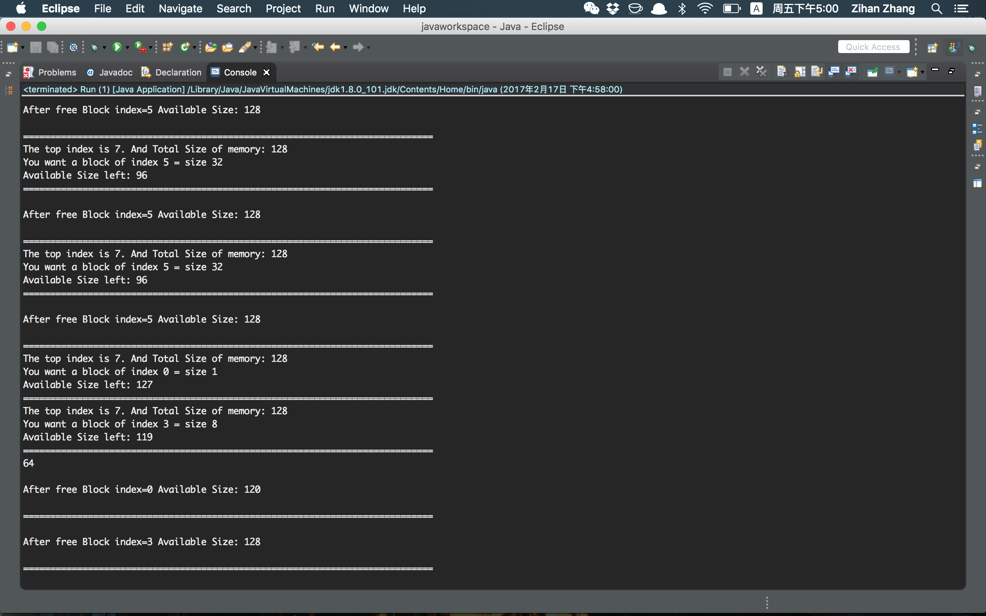

1. **Analytics:**

This is the graph illustrate the relation between number of requests and the time they spend. From the graph we can conclude that it’s a liner relationship which means the time complexity is O(n)

This is the number of the bad requests of different number of total requests allocated. From the graph we can conclude that the number of the bad requests is proportional to the number of total requests.