- The Week3Demo run showing Cash and Card payment outputs.
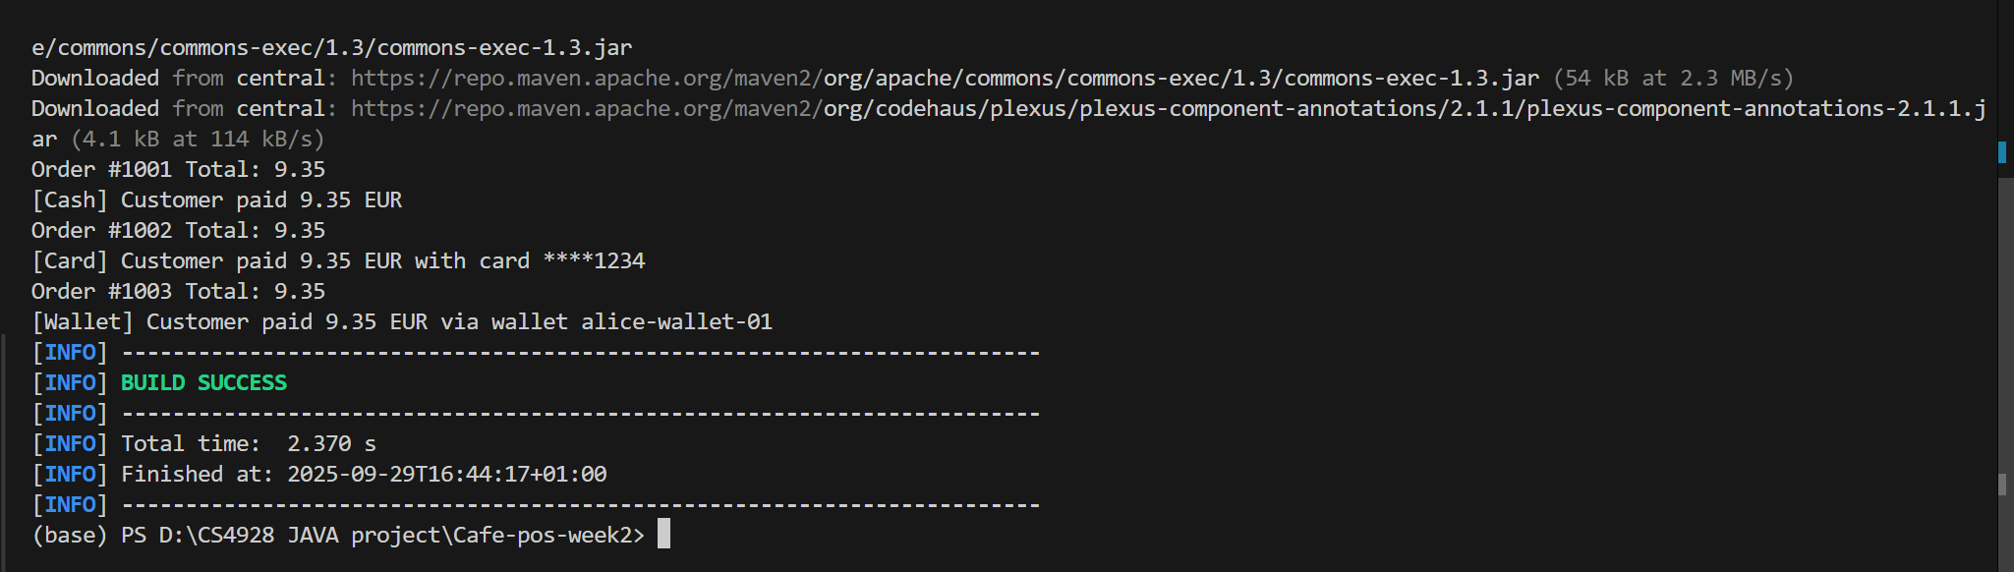
2.All JUnit test cases passing
