Bayesian Statistics and Bayesian Inference

Learning objectives

Explain what **“belief”** means to a Bayesian statistician

Define the terms **“prior”** and “**posterior”**

Specify **prior probabilities** and **distributions**

Use Bayes’ theorem to determine **posterior probabilities**

Describe the difference between **Bayesian and Frequentist statistics**

**Bayesian inference**

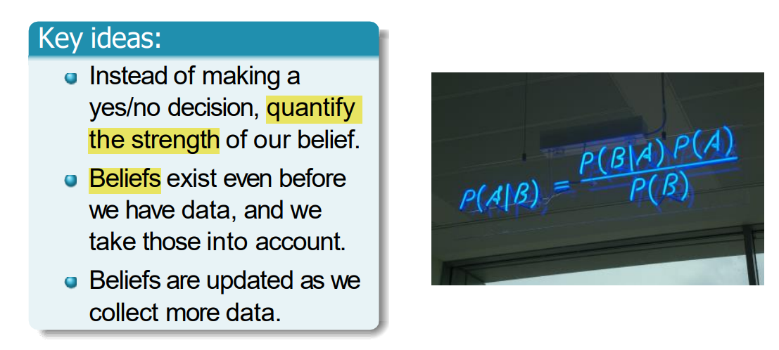

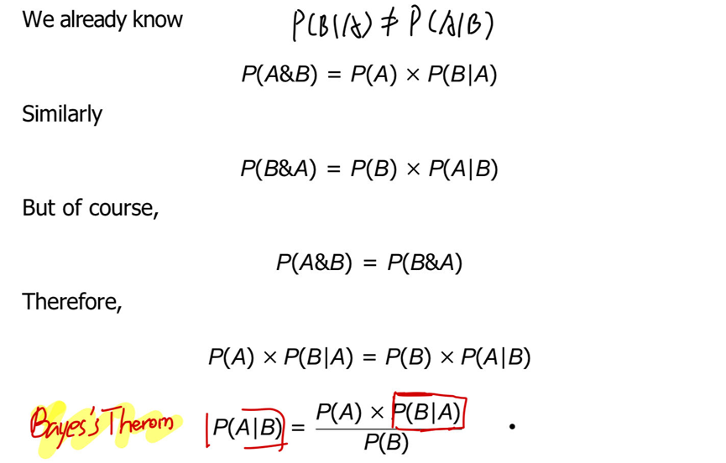

Belief 基于非本次研究

Prior The probability (or probability distribution) which describes our belief about the world before we collect any specific data.

P(H0|D): Posterior (what we want)

P(D|H0): Likelihood (connection strength between data and hypothesis)

