FixFirst diagnosis and verified repair for Python projects
NUS ISS Intelligent Reasoning Systems Practice Module | Group 24
HE ZIHANG | WEI YI | CHI YONGJUN
Report version 0.4 | 9 October 2026
DRAFT — INCOMPLETE — FOR TEAM DISCUSSION
A working draft for group discussion. Evidence, interpretation and wording require review by all three members. This report is incomplete and is not ready for submission.
Still pending: human study, independent installation and Windows acceptance, B12 phase two, B17, proposal attachment, individual reflections and final packaging.
Review agenda and proposed coverage checks: docs/report/TEAM-REVIEW.md.

Contents
1 Executive summary
2 Business case market research and literature review
3 System design and model
4 System development and implementation
5 Experiments
6 Findings and discussion
References and Appendices A to E

1 Executive summary
FixFirst helps a developer or coding agent understand why a Python project cannot run and decide what to fix first. It collects evidence from the project's own interpreter and checks, relates failures to dependency and API knowledge, proposes an action, and verifies the next run. Its web interface and command line serve people; its Model Context Protocol interface supplies the same diagnostic process to coding agents. FixFirst does not edit source code or install repair dependencies into the project environment. The user or agent performs the proposed changes.
The implementation combines production rules, domain and session knowledge graphs, an evidence based decision tree, and message grouping. The frozen v0.8 release candidate contains 132 rules and an 81 feature tree. The system focuses on dependencies, import paths, configuration and compatibility. A successful script execution establishes success for that entry and input; it does not establish business logic correctness.
The results show different benefits for different users and models. In the earlier twelve project evaluation of v0.7.0, four first steps were rated correct, one partial, six generic and one wrong. This exposed concrete gaps that informed subsequent development. In a separate experiment on 22 constructed tasks revealed after v0.8 was frozen, 660 paired agent runs were completed. On the 18 tasks within scope, MCP increased Gemma's strictly scored repair rate from 38.9% to 90.0%. Qwen3.6 and Qwen3.8 already solved most tasks; their clearest benefit was fewer turns, less time and fewer recorded tokens on tasks both groups could solve. These are results for the registered tasks and conditions, not a reliability estimate for arbitrary real projects.
A separate 132 run cloud comparison with DeepSeek V4.1 Flash was completed and independently recomputed. Both arms repaired all 54 scope runs, leaving no observed repair rate difference. Across the eighteen scope tasks, MCP to baseline ratios were 0.82 for turns, 0.71 for time and 0.72 for tokens. Savings were uneven across tasks, and code defect controls had additional overhead. Human usability results remain pending.

2 Business case market research and literature review

The problem
A repository may be available while its execution environment is no longer reproducible. An import failure can mean a missing distribution, a local path problem, a removed standard library name or a library version mismatch. Installing a package named after the import is therefore not always a useful first action. A passing dependency metadata check also does not establish that the application can execute.
Mukherjee, Almanza and Rubio Gonzalez examined 2,702 historical Python builds. Their PyDFix study identified 1,921 builds with dependency related reproducibility failures and obtained complete fixes for 859 of them [1]. This is evidence of a maintenance problem in that study's build datasets, rather than an estimate of the failure rate of all Python projects.
Our early thirteen project investigation similarly found that following installation instructions often did not produce a runnable test suite. Those projects became development material after their failures were inspected. The later A2 evaluation and sealed B7 tasks are distinguished from this pilot in Section 5.

Users and value
The initial users are students running an unfamiliar assignment, developers taking over a legacy Python repository, maintainers helping a new contributor, and researchers reproducing code. They need an executable next step supported by evidence. An agent needs that information in a compact form it can act on, together with a way to check whether the change actually worked.
For a person, the proposed value is a shorter route from traceback to a concrete action, with an explanation that can be checked. For an agent, the measured value can be a higher repair rate or fewer unsuccessful investigation steps. The agent experiment measures these outcomes separately; a reduction in turns is not assumed to imply a reduction in elapsed time.

Existing tools
Tool or approach | Main role | Relationship to FixFirst
pip check | Check compatibility of installed dependency metadata [4] | Supplies useful evidence; it does not run the project's program or tests
pipdeptree | Display installed package dependency relationships [5] | Helps inspect an environment; FixFirst connects those facts to observed failures
Dependabot | Propose configured dependency updates [6] | Useful for maintenance; FixFirst starts from the failure in the current environment
Renovate | Automate dependency update workflows [7] | Complementary to diagnosing and verifying a failed local run
tox | Execute checks in configured environments [8] | Reproduces checks; FixFirst explains collected evidence and prioritises actions
General coding agents | Inspect files, edit code and execute commands | FixFirst can provide diagnostic knowledge through MCP while the agent performs repairs

The distinction is a workflow comparison. We do not claim that existing tools are unable to diagnose errors, or that FixFirst replaces a general coding agent.

Relevant research
PyDFix analyses dependency related build failures and searches for version changes that restore reproducibility [1]. FixFirst shares the use of actual failure evidence and subsequent verification. Its interactive advice also includes local modules and project configuration, and its repair changes are performed by a person or agent.
DockerizeMe infers dependencies for Python code snippets using package knowledge and graph based inference [2]. Its study motivates the mapping from imported modules to distributions. FixFirst additionally checks whether the import refers to the standard library or a local project file before suggesting installation.
BugsInPy supplies real Python bugs with test suites for controlled testing and debugging research [3]. The paper reports 493 bugs in 17 projects; our repository's indexed snapshot has a different count, so these are not interchangeable denominators. It is useful for checking whether a diagnostic tool wrongly blames the environment for a code defect, but is not a balanced dataset of all five FixFirst cause classes.
These studies informed the design and evaluation sources. Their reported repair percentages are not directly comparable to our agent experiment because the tasks, interventions and success criteria differ.

Delivery and pricing
The submitted product is a free community implementation with local web, CLI and MCP interfaces. No paid account is required to use FixFirst's rules or classifier. A client that uses a commercial language model has its own provider charges; those are separate from FixFirst.
A possible later offer is paid maintenance and integration support, with team rule sharing or CI reporting. These are commercial hypotheses, not implemented subscriptions or validated willingness to pay. We have no customer survey from which to infer market size or revenue. The community edition and a working demonstration are the appropriate initial offer.

3 System design and model

The diagnostic loop
The user selects a project, its Python interpreter and a goal. FixFirst runs the relevant checks, groups related findings, derives evidence facts, queries domain knowledge, applies rules, orders actions and records the next verification. A later failure can become visible after an earlier collection error has been fixed. The plan is therefore recomputed after each check rather than treated as a complete list of repairs known in advance.
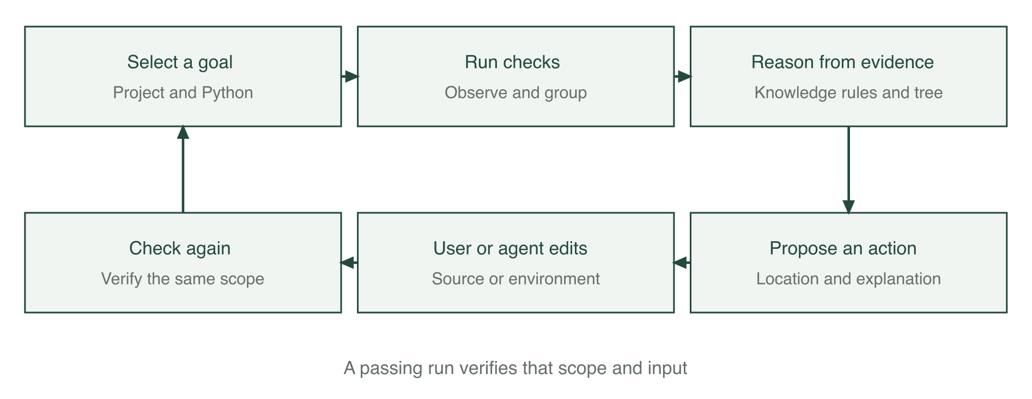
Figure 1. The developer or agent performs edits. FixFirst records checks, explanations and verification.

Evidence and root causes
The five cause classes are missing dependency, local module or import path, version incompatibility, missing configuration, and a defect in project code or tests. The last class is a diagnostic boundary: an assertion failure can require investigation of application logic that FixFirst does not attempt to repair.
Evidence includes the exception and its location, installed package metadata, static project declarations, import relationships, and the outcome of the selected program or tests. Where supported, runtime receiver identity distinguishes a real library object from a project class with the same name. Missing or over limit evidence causes the system to remain conservative.
Declarations are inspected statically; setup.py is not executed to discover requirements. A version pin, a lock file and a successful test run provide different kinds of evidence. A lock file records a chosen version, not proof that that version passes the project's tests.

Knowledge and rules
At frozen commit 5c224cf, the domain file contains 737 removal entries, 12 deprecation entries and 190 source records. The rule file contains 132 rules. These are entry counts, not counts of independent libraries, faults or semantically verified replacement programs. The receiver verification receipts and knowledge receipts describe what was executed; some replacement advice still lacks a dedicated semantic probe.
The production engine uses five phases: derive facts, diagnose, apply heuristics, consider a classifier fallback, and construct a plan. Rules retain their supporting facts and provenance. For example, a Python 3.12 import of collections.Mapping can be related to the removal documented for Python 3.10. The proposed source edit is to import Mapping from collections.abc. The issue is closed only after a relevant completed check succeeds.
The session graph connects goals, issues, facts, causes, rules, actions, checks and sources. It supports explanations of why a step was proposed and what remains unresolved. This graph is distinct from the domain knowledge that supplies API and distribution facts.

Decision tree and message grouping
The default tree is a Gini tree over 81 evidence features, with schema 8. It was trained on the fixed 215 case development dataset with maximum depth 6, minimum leaf size 2 and seed 42. Labels and parser categories are excluded from feature values. Its JSON identity is preserved by the frozen release. An older 44 feature model remains available for explicit compatibility use.
The tree supplies an unconfirmed likely cause when stronger evidence does not support a rule or heuristic. Its prediction and the product's final diagnosis are different outputs. A conservative evidence guard can suppress a confident model prediction, for example when receiver identity exceeds its bounded inspection limit.
Message grouping uses structural blocks, character n gram TF IDF, cosine similarity and complete link grouping with threshold 0.82. The committed collection and execution checks obtained the same pairwise scores as exact text grouping. They support correct operation on those controlled inputs, not a measured advantage for the similarity method.

Ordering and verification
Actions are ordered using preconditions, goal impact, evidence strength and cost. The first action is intended to be executable or to explain a constraint that needs review. Version suggestions must respect project declarations. If a declaration excludes the compatible range, an incompatible installation command is not presented as a repair.
Verification binds the goal, interpreter and execution scope. A completed passing test run is different from a cancelled, partial or collection only check. For a script, success applies to the saved entry, arguments and standard input. Editing tests or protected selection settings does not establish that the original problem was repaired.

Interfaces and course techniques
The web interface explains actions and exposes their evidence. The CLI supports repeatable checks and export. The MCP server exposes diagnose, check_again and explain over stdio. Its responses put an action before supporting explanation; the client agent retains responsibility for edits.
Course technique group | Implementation | Demonstrated role
Decision automation | Forward chaining production rules | Derive causes and actions under explicit conditions
Knowledge discovery and data mining | Gini tree and TF IDF grouping | Generalise from evidence and group similar messages
Cognitive techniques and knowledge representation | Domain and session knowledge graphs, explanations | Connect observations, knowledge, actions and sources
Resource optimisation contribution | Bounded release search | Explore compatible versions within a trial budget; no claim of A star or evolutionary optimisation

4 System development and implementation

Components and engineering process
The implementation separates execution and observation, static project inspection, domain loading, inference, action planning, verification, web presentation and MCP transport. This separation allows diagnosis to be replayed from saved observations without executing a project again.
Development proceeded through concrete failure analysis. Later improvements covered old test tools on new interpreters, Django settings, source only distributions, receiver attribution, constrained setuptools repair and local import roots. Product outputs were checked by independent acceptance scripts and registered positive and negative examples. Broad knowledge expansion alone did not address all observed failures; obtaining the right runtime evidence and presenting a usable action were also necessary.
The tree was expanded from 44 to 81 evidence features while preserving the original training records. Its integration report records a development comparison of 134 versus 186 correct predictions out of 215 when a scene was left out. That is a tree component comparison under those recorded conditions, not an increase in end to end repair rate on new projects.

Verification and operational limits
The application records process outcomes and uses timeouts. Diagnostic checks execute project code, as the project's tests or program would. Users should therefore check projects they trust. Source changes and dependency installations remain visible user or agent actions. Optional release search uses an isolated trial environment and its results apply only to the tested import and conditions.
Inspection is bounded. The additional import root index is disabled when the source file limit is reached, and receiver inspection has limits. A generic step in such a case is preferable to an unsupported install command, but can still cost a user or agent extra work. Interpreter changes, protected test changes and omitted pytest options are surfaced rather than silently treated as equivalent verification.
Windows specific adapters and commands are implemented. The evidence in this report includes macOS checks and recorded CI or regression artifacts; it does not substitute for final Windows real-device acceptance.

Frozen evaluation identity
The agent experiment uses tag b7-freeze-20261007 at commit 5c224cf, package version 0.8.0rc2. Product, runner, model and task identities were recorded before evaluation. The default model is the 81 feature tree. Earlier A2 and B3 results retain their own version and evidence identities and are not relabelled as results of this release.
AI assistants supported implementation, documentation and evidence checks. Human team members retain responsibility for the submitted system and claims. The assistance and review process is disclosed in Appendix E.

5 Experiments

Data roles and research questions
The experiments address different questions: whether the cause category is correct, whether a human judges the first step useful, and whether an agent actually repairs a project under a registered rule. Those measures are reported separately.
Material | Size | Use and evidence status
Fixed execution based training records | 215 | Train the default tree; development data
B3 ordinary and difficult cases | 220 and 30 | One shot category comparison on training related and development scenarios
A2 real projects | 12 | Earlier v0.7.0 first step assessment; labels before running
B7 public development pack | 12 | Calibrate the runner and product; excluded from formal evaluation
B7 sealed evaluation pack | 22 | Revealed after product freeze; 18 scope tasks plus four controls
BugsInPy and upstream defects | Recorded reproduction artifacts | Verification feasibility; full B12 phase two remains outstanding
User study fixtures | Example rows only | Validate analysis scripts; no participant outcome claims

Repeated runs of a task do not make it a new project. The sealed B7 pack consists of constructed programs using known failure mechanisms. It supplies an independent instance test after freezing, not a random sample of all real repositories.

Generated diagnosis and ablation results
The historical 44 feature evaluation reported hybrid accuracy of 0.930 when leaving out a failure scenario and 1.000 when leaving out a project template. The same materials influenced rules and knowledge, so these are internal development estimates. They are retained as historical results rather than recalculated or attributed to the frozen 81 feature model.
The ablation study reported 0.488 for rules without domain knowledge, 0.791 for rules with knowledge, and 0.828 after heuristics. The decision tree alone achieved 0.609 in the scenario split. This supports complementary component roles under that protocol. It does not establish that a particular component contributes the same amount on arbitrary project failures.

A2 real project advice
The recorded A2 result for v0.7.0 was four correct, one partial, six generic and one wrong first step out of twelve projects. The set includes one healthy project. Independent scoring agreed on 9 of 12 rows, or 75%, with Cohen's kappa 0.66; the original independent sheets were preserved when the three disagreements were reconciled.
The misses included old pytest or tooling failures, Django configuration, a platform specific date format, a source build requirement and an application logic defect. A cause category without a named usable next action was rated generic. This explains why 8 of 11 fault categories could match while only 4 of 12 first steps were rated correct. Cause recognition and useful advice are different outcomes.
These failures later informed v0.8 development. Replays or repairs on those same projects must consequently be reported as development comparisons. The A2 result is not replaced by the newer synthetic repair rate.

B3 one shot language model comparison
In the real project batch, each model answered twelve prompts without tools or an opportunity to execute its advice. There were 36 original requests and five technical missing answers, which remained in the complete denominator. Human reviewed first steps were compared with the earlier A2 product output.
Method | Correct causes out of 11 faults | Correct advice out of 12 requests | Technical missing answers
Qwen3.6 | 9 | 6 | 1
Qwen3.8 | 8 | 5 | 2
Gemma | 3 | 0 | 2
FixFirst v0.7.0 | 8 | 4 | 0

Advice rating agreement on available model answers was 29/31, with kappa 0.904. This was AI assisted drafting with human row review, not wholly unaided human assessment. Five missing answers were excluded from the agreement calculation, not treated as agreement. The model evidence was a bounded, redacted presentation of initial checks; the A2 product could also use its follow-up release search. The comparison is therefore not byte identical input or identical operation access.
The separate 750 request generated batch used 250 cases per model, deterministic decoding, no tools and no retries. Its ordinary and difficult category counts are below. The FixFirst comparison replays saved observations with the recorded older versions.
Method | Ordinary correct out of 220 | Difficult correct out of 30
FixFirst v0.7.0 | 220 | 30
Recorded v0.8 candidate ff92446 | 215 | 30
Qwen3.6 | 203 | 15
Gemma | 213 | 15
Qwen3.8 | 216 | 18

The candidate abstained on five old unittest alias observations without receiver attribution; these were counted as wrong rather than supplied with new evidence. The difficult product result includes heuristic suggestions, not thirty rule confirmed diagnoses. The generated and difficult materials are development related and do not show superiority on unseen real projects. This table measures category prediction, not repair success. Its older candidate is not the final 81 feature release.

B7 executed agent repair
The principal agent experiment compares the same local model with general file and command tools, either without FixFirst or with its MCP tools. The 22 task pack contains A dependency and version bounds, B removed APIs, C project configuration and layout, D combined faults, and E/F controls. The main analysis uses the 18 A to D tasks. Each model runs each arm five times, making 660 runs in total and 90 runs per arm in the scope analysis.
The product was frozen before the evaluation pack was revealed. Both arms share task descriptions, budget and H5 protection rules. Runs use at most 30 turns and 900 seconds, a 32,768 output token limit, up to three reminders, and the registered file tools. Paired arms share a seed identifier and alternate order. Prompt caching is enabled under a verified memory and SSD scheme, with a fresh cache at each run. MTP is disabled for all three models. Sampler settings differ by model and are held constant between that model's arms.
H5 protects test content, collection and result settings. Only pythonpath and DJANGO_SETTINGS_MODULE pytest configuration changes are allowed, with existing configuration carriers and collected nodes checked. A protected edit during the run is a strict failure even if the agent later restores it. The same restrictions are stated to both arms.
Model | Baseline repaired out of 90 | MCP repaired out of 90 | Increase in percentage points with 95% interval
Qwen3.6 | 79 or 87.8% | 89 or 98.9% | 11.1 [1.1, 22.2]
Gemma | 35 or 38.9% | 81 or 90.0% | 51.1 [35.6, 65.6]
Qwen3.8 | 84 or 93.3% | 86 or 95.6% | 2.2 [0.0, 6.7]

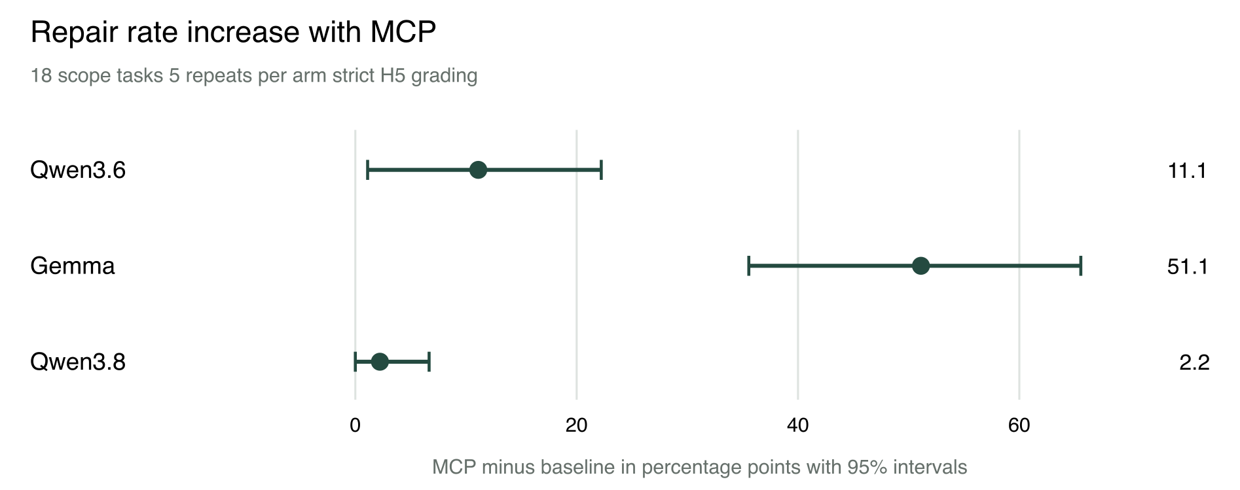
Figure 2. Paired task bootstrap intervals for MCP minus baseline. The unit represented by the interval is the task, not 90 independent projects.
Qwen3.6's rate difference depends on strict protection. Under the registered sensitivity reading that permits a run whose sole violation was another pytest option, the rates are 96.7% and 98.9%, a 2.2 point increase with an interval of -2.2 to 6.7. The final compliant state reading gives 94.4% versus 100.0%. Both are reported alongside the primary result, not substituted for it after observing the data.
Gemma's increase remains under the alternative readings. It improves on sixteen tasks and declines on one. Qwen3.8's ten unrepaired scope runs were all timeouts, eight concentrated in one task. Its repair rate difference does not establish a clear gain. Three Gemma MCP runs ended early after exhausting reminders; they were retained as failures, without retry or a changed reminder budget.
Efficiency is computed on tasks with at least three successful runs in each arm. Each task contributes the ratio of its successful run medians; the table takes a geometric mean across tasks. A value below one means fewer resources. Tokens include recorded input and output, including cached input, and are not a bill or a direct computation measure.
Model | Tasks | Turn ratio with 95% interval | Time ratio with 95% interval | Token ratio with 95% interval
Qwen3.6 | 15 | 0.54 [0.43, 0.69] | 0.46 [0.38, 0.56] | 0.36 [0.28, 0.46]
Gemma | 7 | 0.55 [0.34, 0.90] | 1.03 [0.72, 1.43] | 0.63 [0.37, 1.04]
Qwen3.8 | 17 | 0.82 [0.68, 0.98] | 0.73 [0.60, 0.89] | 0.74 [0.59, 0.91]

Gemma does not save elapsed time on the seven tasks both arms can solve. The separately registered all-task reading imputes a 900 second limit to unsuccessful runs; its much smaller Gemma time ratio mainly reflects failures in the baseline, not faster successful repair. For the two Qwen models, all three successful-task intervals are below one.
Controls are separate. Both Qwen models score 100% in both arms on E and F. Gemma scores 80% in both arms on E, and 100% versus 80% on F; the F decline comes from two early endings. No benefit outside the intended scope is claimed.
The batch ran once without infrastructure interruption, retry or loss. Independent recomputation matched the saved analysis, and archived responses were matched to service records. This supports the integrity of the recorded comparison. A separately registered cloud comparison follows.

DeepSeek cloud comparison
The registered cloud extension used DeepSeek V4.1 Flash through the deepseek-flash API alias on 9 October 2026. It retained the frozen product and runner, the same 22 task pack, H5 rules and task descriptions, and the 30 turn, 900 second and 32,768 output token limits. Each arm ran each task three times, making 132 runs. The two arms of each pair ran next to each other, with 33 baseline first and 33 MCP first pairs. This result is reported separately from the local models, which used five repetitions.
Both arms repaired 54 of 54 A to D scope runs and 12 of 12 control runs. All three scoring readings agree. The baseline reached the observed ceiling, so this task pack measured no repair rate gain; it does not establish that FixFirst cannot help a strong model on other tasks. All 132 runs finished normally, with no interruption, retry, loss, timeout or protected edit.
All eighteen scope tasks meet the registered efficiency requirement of at least two successful runs out of three in each arm. As in the local experiment, each task supplies the ratio of its successful run medians, and the table takes their geometric mean. The intervals are the registered paired task bootstrap intervals.
Measure | MCP to baseline ratio | 95% interval
Turns | 0.82 | 0.68 to 0.97
Time | 0.71 | 0.53 to 0.92
Recorded tokens | 0.72 | 0.50 to 0.99

The average reductions do not occur on every task. Time and tokens decrease on ten tasks and increase on eight; the task sign test for time has p = 0.81. Turns decrease on eight tasks, increase on four and remain equal on six. This supports an average magnitude improvement under the registered aggregation, not a claim that most tasks benefit.
A post hoc inspection by the independent reviewer identified five tasks with large savings: ea4, eb3, ec4, ec5 and ed2. Their time ratio is 0.28 and token ratio 0.23. The remaining thirteen tasks have ratios of 1.01 and 1.10 respectively. This partition was selected after inspecting results and is descriptive, not a preregistered outcome. In the F code defect controls, six runs per arm were all repaired, but total agent time and total recorded tokens with MCP were 1.84 and 1.77 times baseline. These control totals use a different aggregation from the scope table and illustrate possible overhead where FixFirst does not supply a useful environment repair.
The API conditions differ from the local service. A registered external adapter returns each reply unchanged and carries its reasoning content into later requests. Upstream requests specify thinking enabled, reasoning effort high, top_p 0.95 and max_tokens 32768; the runner's nominal medium effort maps to high, and temperature, top_k and seed are omitted upstream. Paired seed identifiers therefore identify neighbouring runs, not reproducible cloud sampling. The provider controls the model alias and prompt cache, which was not reset between runs. All 1,320 formal replies have one model name and one recorded system fingerprint. These are observations during this batch, not a frozen provider model.
Across all 22 tasks, baseline and MCP used 176,051 and 51,732 reasoning tokens. Cached input was approximately 93% and 91% respectively. FixFirst call time is included in the MCP arm. Peak price usage accounting totalled CNY 4.73 for the formal batch and CNY 5.05 including probes; arm totals were CNY 3.13 and CNY 1.60. These are conservative accounting values, not the actual off peak bill. Recorded token ratios include cached input and reasoning and must not be described as cost ratios. Elapsed time applies to this cloud service period and is not compared with local model speed.
Independent AI recomputation matched the registered analysis byte for byte. A separate record checker confirmed the 132 commands, 1,320 requests and replies, 14,321 archived files and settled ledger, with no record problems. Raw records and actual requests were retained. This extends the registered evidence with one cloud model and three repetitions per cell; constructed tasks and the small sample still limit generalisation to real repositories.

Grouping verification and remaining evaluations
The committed controlled grouping results have precision and recall 1.0 for both exact matching and TF IDF: 15 positive pairs in collection and five in execution, with no recorded false positive or false negative. The templates and error blocks restrict variation, so these results do not demonstrate a similarity grouping advantage.
B12 phase one records bug reproduction rather than a completed FixFirst before and after verification study. The full phase two analysis and B17 next-step ordering ablation remain separate tasks. Their intended questions are whether an issue stays open before the genuine repair and whether ranking changes the number of invalid actions; no outcome is inferred from the implemented feature alone.
The user study protocol records completion, elapsed time, cause explanations and SUS responses. The repository currently supplies demonstration fixtures for its analysis program. They are not participant data. We do not report a SUS score or a human time saving until the real sessions have been completed and reviewed. Final Windows installation and end to end acceptance likewise require a teammate's real machine.

6 Findings and discussion

Findings
Specific, executable advice matters more than merely choosing the right cause class. A2 exposed a gap between category recognition and useful first steps. Receiver attribution, constrained dependency ranges and persistent project configuration were therefore developed and verified as product mechanisms.
MCP's measured benefit depends on the agent. Gemma gains repair capability on the registered scope tasks. The two Qwen models already have high baseline repair rates; their clearer gain is efficiency. A faster or stronger baseline can leave little room for an additional tool to raise repair rate. This does not justify omitting the baseline or choosing tasks after seeing the formal result.
The tree is one part of a hybrid product. Its component prediction improves on development cases, but a rule can determine the first action regardless of the tree. Category accuracy alone is therefore insufficient to evaluate the user or agent experience.

Limitations
The formal pack comprises only eighteen scope tasks and four controls, with five repeats per arm for local models and three for the cloud extension. Tasks were constructed from selected failure mechanisms, and the developer and independent reviewer both used AI assistance. New task instances and preregistration reduce some bias but do not establish general real-world reliability.
Most primary tasks exercise mechanisms already represented in the rules or knowledge base. The B and D API removals were sampled from existing knowledge, while A and C instantiate existing mechanisms in new projects. E contains only two environment faults that the product does not cover; F contains two code defect controls. The sealed instances therefore test new instances of supported mechanisms, rather than broad coverage of previously unknown fault types. Coverage across unselected real repositories remains unmeasured. A separate coverage and fallback evaluation is proposed for team discussion; it has not been run.
H5 is stricter than ordinary software maintenance. It disallows some otherwise valid ways to persist configuration and penalises edits later reverted. Reporting the sensitivity readings is essential, especially for Qwen3.6. Efficiency is also conditioned on successful tasks and needs its denominators.
The one shot comparisons use a bounded representation of check evidence, whereas the product has structured records and knowledge. Older saved observations may lack newly required provenance. Technical missing answers, output parsing and shared local service behaviour affect those results. No cross-provider speed or price ranking is inferred from the experiments.
The cloud extension cannot freeze provider sampling, reasoning quantity, cache state or model updates. It supplies one additional model under its recorded service conditions, not a general result about strong agents. Cloud and local outcomes are kept separate.
Knowledge coverage is finite. Some supported library changes are inferred from heuristics, and not every replacement sentence has an execution probe. Bounded project inspection can miss unusual layouts or runtime objects. Source builds, interactive programs, long-running services and unsupported settings may require human review. Passing one run does not prove correctness over all inputs.
Human usability and final Windows acceptance remain evidence gaps. An 80% universal reliability claim would not follow from the recorded synthetic repair percentages.

Deviations from the proposal and next work
PyDFix was retained as motivation and an external source, while executed generated cases and real project records became the main diagnostic materials. BugsInPy was used first to establish reproduction feasibility. Baseline work expanded into distinct one shot diagnosis and MCP assisted repair comparisons. Direct program and unittest execution were added to support projects without pytest tests.
The next priorities are to complete the real user sessions and Windows checks, and close the outstanding verification and ordering studies. Product or model changes after the evaluation freeze must be evaluated as a new version with newly separated development and test evidence.

References
[1] S. Mukherjee, A. Almanza and C. Rubio Gonzalez. 2021. Fixing Dependency Errors for Python Build Reproducibility. ISSTA 2021, 439-451. DOI 10.1145/3460319.3464797. Author copy: https://web.cs.ucdavis.edu/~rubio/includes/issta21.pdf.
[2] E. Horton and C. Parnin. 2019. DockerizeMe Automatic Inference of Environment Dependencies for Python Code Snippets. arXiv:1905.11127. https://arxiv.org/abs/1905.11127.
[3] R. Widyasari et al. 2020. BugsInPy A Database of Existing Bugs in Python Programs to Enable Controlled Testing and Debugging Studies. ESEC/FSE 2020, 1556-1560. DOI 10.1145/3368089.3417943. Author preprint: https://arxiv.org/abs/2401.15481.
[4] pip documentation. pip check. https://pip.pypa.io/en/stable/cli/pip_check/. Accessed 9 October 2026.
[5] tox developers. pipdeptree. https://github.com/tox-dev/pipdeptree. Accessed 9 October 2026.
[6] GitHub documentation. Dependabot options reference. https://docs.github.com/en/code-security/reference/supply-chain-security/dependabot-options-reference. Accessed 9 October 2026.
[7] Renovate documentation. https://docs.renovatebot.com/. Accessed 9 October 2026.
[8] tox documentation. https://tox.wiki/en/stable/. Accessed 9 October 2026.
Project result identities, files and calculation sources are registered in docs/report/SOURCES.md and docs/report-assets/B11-results-v0.3-20261009.json. B3 result packages are identified by fixed commits in that register, including material awaiting publication merge.

Appendix A Project proposal
The original submitted proposal is to be included unchanged in the final submission. The discussion records how the implementation and evaluation developed beyond the proposal. The submission checklist requires the original attachment rather than regenerating it from this report.

Appendix B Mapping to MR RS and CGS
Function | Knowledge or technique | Module mapping
Evidence to causes and actions | Production rules, forward chaining and explanation | MR
Learned likely cause | Supervised Gini tree, validation and ablation | MR and RS
Action priority and release search | Decisions under goals, constraints and bounded trial budgets | RS
Domain and session relationships | Knowledge graphs and graph traversal | CGS
Repeated error grouping | Text features, similarity and clustering | CGS
Web and MCP interaction | Explanations and feedback after a check | CGS

This mapping follows the team's course alignment record. It does not label the bounded version search as A star or evolutionary computing.

Appendix C Installation and user guide
The following guide is also supplied at docs/USER_GUIDE.md. It includes the actual sample repair, direct program execution, CLI commands and MCP configuration. Its frozen product identity is the same as the B7 release. Independent installation checks remain part of the submission checklist.
This guide covers the frozen v0.8 product at b7-freeze-20261007 (commit 5c224cf, package version 0.8.0rc2). Use the browser or command line to diagnose your project, or connect the same checks to a coding agent through MCP. You make the changes; FixFirst checks their effect.

1 What you need
Use macOS, Linux or Windows 10/11 with Python 3.10 or later to install FixFirst. Python 3.12 is a convenient choice. Git is optional if you download the source ZIP instead. First installation needs internet access.
There are two Python environments: FixFirst's .venv runs the tool; your project's environment runs the code you want to check. Select the project's Python in the interface. The target can be a supported Python 3.9 to 3.14 environment, including venv or Conda. Do not install project dependencies into FixFirst's environment by mistake.
Checks run project code, just as its tests or program do. Use projects you trust. FixFirst's normal checks do not need a language model or API key.

2 Install and start
If you downloaded the source ZIP, extract it and open a terminal in that folder. Skip the git clone and cd FixFirst commands below.

macOS and Linux
Open a terminal and run:
git clone --branch b7-freeze-20261007 --depth 1 \
https://github.com/ZihangHe13123/FixFirst.git
cd FixFirst
bash scripts/setup.sh python3.12
.venv/bin/python -c \
"import importlib.metadata as m; print(m.version('fixfirst-local'))"
.venv/bin/fixfirst serve
If your Python has another command or location, replace python3.12 with it. The setup script creates the tool's environment and installs its dependencies. Keep the terminal open while using the browser. Press Ctrl+C in that terminal to stop the server.

Windows PowerShell
Open PowerShell and run:
git clone --branch b7-freeze-20261007 --depth 1 `
https://github.com/ZihangHe13123/FixFirst.git
cd FixFirst
powershell -ExecutionPolicy Bypass -File scripts\setup.ps1
.\.venv\Scripts\python.exe -c `
"import importlib.metadata as m; print(m.version('fixfirst-local'))"
.\.venv\Scripts\fixfirst.exe serve
The execution policy option applies to that setup process. It does not permanently change your machine's policy. After setup, start-fixfirst.bat is another way to start the application. On macOS, start-fixfirst.command is available.
The terminal prints the local browser address. Only this computer can reach the normal server. Open the printed address if the browser does not open automatically.
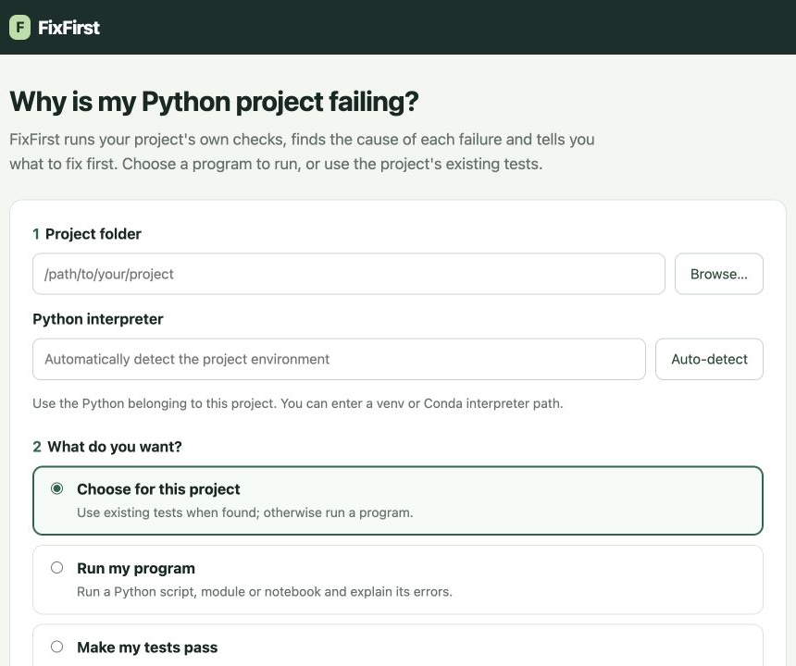
Guide figure 1. Choose a folder, the project's Python and the check you want to perform.

3 Try the supplied sample
On the start page choose Open a sample project. FixFirst creates a separate example with four faults and a FIXES.md file. Do not edit the original examples/playground template.
The first check finds two imports that stop test collection:
1. In pricing.py, change from collections import Mapping to from collections.abc import Mapping.
2. In reports.py, change from helper import double to from helpers import double.
3. Press Check again. The imports are verified, and two runtime failures become visible.
4. In stats.py, replace numpy.float(sum(values)) with float(sum(values)).
5. For this sample only, replace os.environ["SHOP_API_TOKEN"] in orders.py with os.environ.get("SHOP_API_TOKEN", "demo-token"). This is a dummy value for the example, not a real credential.
6. Press Check again. The goal should now show All tests pass, with the earlier issues under Fixed and verified.
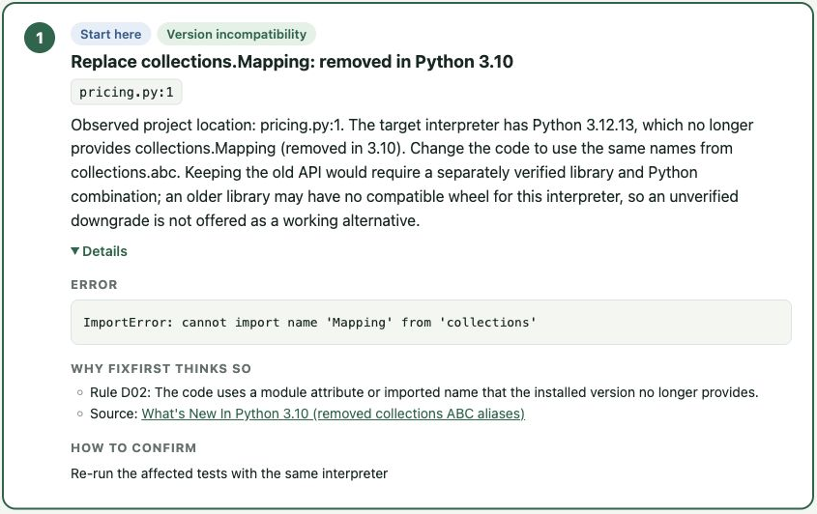
Guide figure 2. Details shows the observed error, supporting rule, documentation and confirmation check. The text instructions above give the edits without requiring you to read the screenshot.
FixFirst does not repair those files when you press a button. You edit them, and the next check verifies what happened. A later check may reveal a failure that an earlier collection error had hidden.
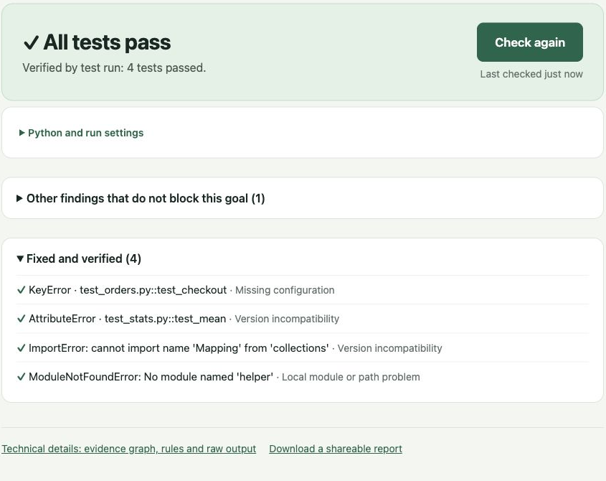
Guide figure 3. A completed passing check verifies the sample repair.

4 Check your own project
Enter your project folder, not a single source file. Select its Python executable, for example .venv/bin/python on macOS/Linux or .venv\Scripts\python.exe on Windows. Auto-detect can find common environments; check that the selected path is the one you normally use.
Choose for this project suggests a check from static file discovery. You can override it:
- Make my tests pass runs a pytest project.
- Run unittest tests uses standard-library unittest; pytest is not required.
- Run my program runs a script, module or optional notebook.
- Just get the tests to load checks collection without executing test bodies.
- Clean up code-check warnings uses Ruff for the code-check goal.
For a program, select the entry you normally run. Put each argument on a separate line and supply standard input when the program uses input(). A complete exit code 0 produces Program completed successfully. This verifies that entry and input, not all business logic or assignment answers.
Follow the first concrete step, then press Check again. Installation commands use the selected project interpreter. Review the command and the project's declarations before executing it. A conflicting version pin can require a source migration or declaration review instead of an installation command.
For an import path or Django setting, the product may propose a persistent project configuration. Use the file it names and preserve unrelated existing options. Some packaged projects also need installation to provide their own distribution metadata; setting PYTHONPATH alone is not always sufficient.
Notebook support is optional. In the FixFirst checkout, install the driver into the tool environment with:
.venv/bin/python -m pip install -e '.[notebooks]'
The selected notebook environment also needs ipykernel. Cells execute in a fresh kernel. Interactive input, GUI applications and indefinitely running services need another workflow.

5 Understand the result
What to do lists actions that affect the selected goal. When optional actions are present, the main list is labelled Must fix, with a separate Optional section. Optional items do not establish that the program is broken. A likely cause from a heuristic or tree is not a rule-confirmed diagnosis. Read Details to see the evidence, rule and source.
Technical details contains the session graph and raw check output. Find it, when offered, tries a bounded set of older releases in an isolated environment and needs internet access. A successful trial verifies its particular import; it does not prove every test will pass with that release.
Changing the entry, input or interpreter requires fresh verification. A partial, timed-out or cancelled check does not close an original issue. When FixFirst omits execution-changing pytest options, a passing recorded check does not replace your own normal test command; run that command as well.
Editing tests, conftest files or protected selection settings is not taken as repairing the original failure. If you intentionally change the project specification, the human interface can accept a new baseline. An MCP agent cannot use that operation.
If a step only asks you to inspect the project's code or tests, FixFirst does not yet have a supported environment repair for that failure. It is not a general business logic repair system.

6 Use the command line
The following commands run from the FixFirst checkout. Replace /path/to/project, the target Python path and SESSION_ID with your values. On Windows, use .\.venv\Scripts\fixfirst.exe and Windows paths; quote paths containing spaces.
.venv/bin/fixfirst init /path/to/project \
--python /path/to/project/.venv/bin/python --goal pass_tests
.venv/bin/fixfirst scan SESSION_ID
.venv/bin/fixfirst show SESSION_ID
.venv/bin/fixfirst report SESSION_ID --open
.venv/bin/fixfirst export SESSION_ID --output shared.html
For a project without tests:
.venv/bin/fixfirst init /path/to/project \
--python /path/to/project/.venv/bin/python \
--goal run_project --script main.py
.venv/bin/fixfirst scan SESSION_ID
--module package.main selects a module entry. Repeat --arg VALUE for arguments; use --arg=--flag for an argument beginning with a dash. --stdin-file answers.txt supplies saved input. --unittest-dir tests selects unittest discovery.
The default CLI store is .fixfirst/ in the working directory. Put --store /path/to/store before the subcommand to select another location. A default scan refreshes declarations and environment evidence as well as the goal's check. Use the product's normal Check again route after changes.

7 Connect a coding agent through MCP
Use a client that supports an MCP stdio server. For clients accepting an mcpServers JSON object, configure the absolute path to FixFirst's Python:
{
"mcpServers": {
"fixfirst": {
"command": "/absolute/path/to/FixFirst/.venv/bin/python",
"args": ["-m", "fixfirst", "mcp"]
}
}
}
On Windows, the command can be C:\\dev\\FixFirst\\.venv\\Scripts\\python.exe. Escape backslashes in JSON. Your client's configuration location and schema can differ; adapt the server command to its MCP settings. FixFirst itself needs no model provider credential.
Ask the agent to diagnose the project, act on the first supported step and check again. The tools are:
Tool | Use
diagnose | Run checks for a project and goal; return ordered steps and a session identifier
check_again | Repeat the saved checks after the agent changes files
explain | Read the evidence and rationale for a step without running checks

Example diagnose arguments for tests:
{
"project": "/absolute/path/to/project",
"python": "/absolute/path/to/project/.venv/bin/python",
"goal": "pass_tests"
}
For a script, use goal: "run_project" and add execution: {"kind":"script","entry":"main.py"}. Omit execution for pass_tests, collect_tests and check_style. If the tool says to remove an extra parameter, correct it and retry the same goal.
The agent performs source edits and dependency installations; MCP does not silently do those repairs. Use the returned session_id with check_again. Stop after a verified goal, or when the tool identifies a boundary that needs human investigation. Do not keep calling it as an algorithm repair engine.
MCP sessions normally live in ~/.fixfirst/sessions. To inspect them in the browser, start the web server with that store:
.venv/bin/fixfirst --store ~/.fixfirst/sessions serve

8 Troubleshooting
Python is not found. Install a supported Python and pass its executable to the setup script. For checks, select the project's interpreter rather than the tool's interpreter.
PowerShell blocks setup. Run the process-scoped -ExecutionPolicy Bypass command in Section 2. Do not permanently relax machine policy just to install this tool.
The browser does not open or a port is busy. Use the address printed in the terminal. To choose another port, run fixfirst serve --port 8765; --no-open starts without opening a browser.
Checks are slow. Test execution, package metadata, antivirus scans and optional release trials can take time. Keep the selected environment local where possible. A timeout is an incomplete check, not a successful repair.
The project has no pytest. A program or unittest goal does not require it. A pytest project needs pytest in its own environment, not merely in FixFirst's environment.
Find it cannot access the index. Check network access and the project's supported distribution. The normal local diagnosis remains available. A package with only a source distribution may need a compiler or an alternative installation workflow.
Paths contain spaces or Chinese characters. Enter the real folder and Python path, and quote command-line paths. Windows output commands are written for PowerShell.
Share a session. Use Download a shareable report or fixfirst export SESSION_ID --output shared.html. Inspect the exported copy before sharing it. Keep the local store for follow-up checks.

9 Uninstall and retain your work
Stop the running server and remove FixFirst's installation folder when you no longer need it. Your checked project's source is separate and should not be deleted. CLI/web session records may be in .fixfirst/ or your custom store; MCP sessions may be in ~/.fixfirst/sessions. Back up or export records you want to keep before removing those stores.
Product identity, screenshots and command verification for this guide are recorded in docs/report-assets/B14-verification-20261009.json. Final independent macOS and Windows installation checks remain in the submission checklist.

Appendix D Individual reports
HE ZIHANG, WEI YI and CHI YONGJUN each write their own reflection and peer evaluation according to the course submission instructions. This report does not generate or substitute those personal accounts.

Appendix E AI usage statement
Codex and Claude assisted with software implementation, documentation drafts, research checking, experiment preparation and evidence review. Local language models were evaluated as one shot respondents and coding agents; a separate cloud coding agent comparison was completed. Their outputs were retained as experimental data. AI assisted label or score drafts were reviewed by the human team, and the original independent and consensus records were kept where applicable.
The team reviews generated code and claims using source inspection, real execution, regression checks and independent acceptance. Independent AI recomputation is described as such; it is not represented as independent human replication. Real participants, human scoring decisions, final Windows operation, video narration and personal reflections remain the responsibility of the people concerned. No AI generated narration or participant result is supplied as a human contribution.

