Reflection on Spotify Track List Dashboard Feedback

1. Overview of the feedback
We collected 5 user responses to evaluate the usability and usefulness of our dashboard. Overall, the feedback was positive: most respondents found the dashboard visually clear, responsive, and helpful for exploring track patterns. Average ratings across the main Likert-scale questions were generally high, mostly ranging from 4.0 to 4.4 out of 5.
Users especially liked the overall visual design, responsiveness, and the Energy vs Valence scatter plot, which suggests that the dashboard already works well for general exploration. This means the core idea of the app is effective. At the same time, the feedback also revealed several recurring usability issues, mainly related to interaction clarity, access to track-level details, and layout efficiency.
The question list is shown in the Milestone3_Question_List.pdf.

2. List of received feedback
We received feedback from 8 users. Overall, the comments were mostly positive, but they also revealed several common issues. To present the feedback more clearly, we grouped it into major themes. Please see the below link for the feedback csv file.
DATA-551-Group-7/doc/milestone3/Spotify Track Insights Explorer User Feedback.csv at milestone3-test · andrewyang0620/DATA-551-Group-7
- Positive feedback
Several users said that the dashboard was visually clear and easy to use for general exploration. The Energy vs Valence scatter plot was mentioned multiple times as a favorite chart because it was interactive and helped users understand track patterns more easily. Users also gave positive comments about the responsiveness of the dashboard and its overall visual design.
Examples of positive feedback:
- Users liked the scatter plot because it was intuitive and visually informative.
- The dashboard was described as clean and responsive.
- Some users said the visualizations helped them understand the data more quickly.
- Confusion about interactions
A common issue was that some users were not fully sure how the interactions worked, especially the difference between filtering, selecting, and highlighting. Labels such as Total, Filtered, and Selected were not immediately clear to first-time users.
Examples of feedback in this theme:
- Users were unsure what “Selected” meant when no manual selection had been made.
- Some users found the interaction logic slightly confusing at first.
- The relationship between scatter plot interaction and dashboard updates was not always obvious.
- Difficulty accessing track-level details
Another recurring issue was that users wanted easier access to individual track information. While the dashboard worked well for broad exploration, it was less convenient when users wanted to inspect a specific song.
Examples of feedback in this theme:
- The track table felt too far down the page.
- Users expected more direct access to information for a clicked track.
- Some users wanted clearer track-level details after interaction.
- Layout and scrolling issues
A few users mentioned that the overall layout could be more compact. In particular, too much vertical scrolling made it less convenient to move between charts and detailed information.
Examples of feedback in this theme:
- Important content required too much scrolling.
- Users preferred more compact sections with internal scroll bars.
- The dashboard could be easier to navigate if key components were more visible.
- Suggested new features
Some users also suggested additional features that were not currently included in the dashboard. These were not the most urgent problems, but they still provided useful direction for future improvement.
Examples of suggested features:
- Better comparison between groups or tracks
- More detailed track profile information
- A clearer way to compare subsets of tracks

Overall summary of the received feedback
In summary, the received feedback shows that users generally liked the dashboard’s visual design, responsiveness, and exploratory value. However, the most common issues were interaction clarity, access to track-level details, and layout efficiency. These themes directly informed our revision priorities for the next milestone.

3. Key issues identified from user feedback
Although the overall feedback was positive, several issues came up more than once across the responses.
- Some users were not fully sure how the dashboard interactions worked, especially the difference between filtering, selecting, and highlighting. Labels such as “Total,” “Filtered,” and “Selected” were not immediately clear, and the connection between user actions and dashboard updates was sometimes hard to understand. This suggests that the interaction logic works but may not feel very intuitive for first-time users.


- Users also found it harder than expected to access individual track information. While the dashboard supports general exploration well, it was less convenient to move from high-level patterns to specific song details. In particular, the placement of the track table made track-level inspection feel less direct.

- A few users mentioned the layout and scrolling experience. Some important information required too much vertical scrolling, which made the dashboard feel less efficient. There is also too much blank space shown in the dashboard. This becomes more noticeable when users want to move back and forth between charts and detailed track information.

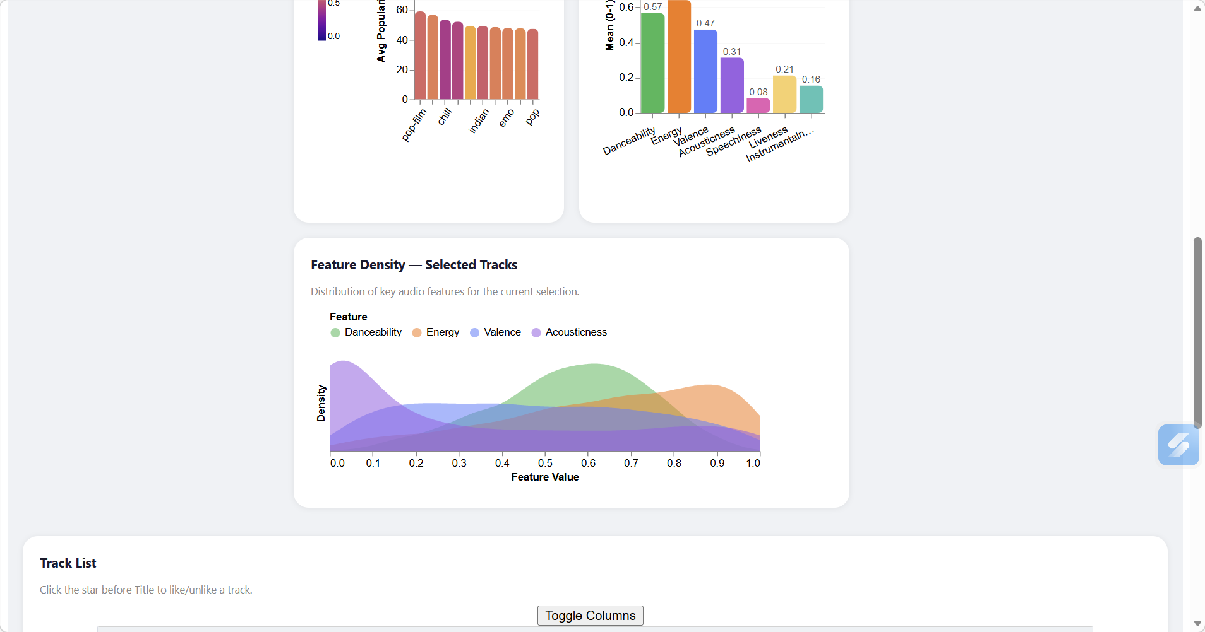

- Finally, some users suggested richer functionality, such as easier comparison across groups or more direct access to track-level context. These were not the most urgent issues, but they still point to useful directions for future improvement.

4. Revision priorities
Based on both the frequency of comments and their likely impact on usability, we would prioritize revisions in the following order.

Priority 1: Clarify interaction logic
Our first priority is to make the dashboard interactions easier to understand. We plan to improve the labels, add short guidance text, and make the difference between filtering, selecting, and highlighting more clear.
More specifically, we plan to hide the Selected tag when the user has not manually selected anything from the interactive scatter plot, so that it does not confuse first-time users. We will also add instructions and helper text so users can understand how and when to use selection.

Priority 2: Improve access to track-level details
Our second priority is to make individual track information easier to access. We plan to add a new card called Track Profile at the upper right of the dashboard. When a user clicks on a track, this card will show the basic information for that specific track.

Priority 3: Improve layout and reduce unnecessary scrolling
Our third priority is to make the dashboard more compact and easier to navigate. We plan to add scroll bars to the necessary sections so that the full dashboard does not become too long vertically. We also want to make the track list table at the bottom easier to notice and access.

Priority 4: Add richer comparison features
A final, lower-priority improvement would be to support stronger comparison between different tracks or subsets of tracks.
We plan to add a comparison feature for different tracks in the Track Profile card mentioned in Priority 2. We also want to add a tab-switch feature for the distribution plots, so that users can enter a comparison mode to compare groups of tracks. This was not the most common issue mentioned in the feedback, but it is still a useful direction because it would increase the analytical value of the app.

5. Conclusion
Overall, the feedback suggests that our dashboard is already useful for exploring general patterns, especially through its visual design, responsiveness, and scatter plot. However, it also shows that the next revision should focus more on usability than on adding new features. In particular, we need to make the interaction logic clearer, improve access to track-level details, and reduce unnecessary scrolling so the app feels more intuitive for first-time users.

