# INFSCI 2710 – Database Management – Fall 2018

## Homework#1 – A Simple Web Application

*Task 1 (20 points): Create a PHP script - selectStudent.php - in your web server. The script is designed to display all the record of ‘student’ table, total number of students and the average grade. That is, when you link to <http://localhost/selectStudent.php> in your browser, you will see the similar result of Figure 1.

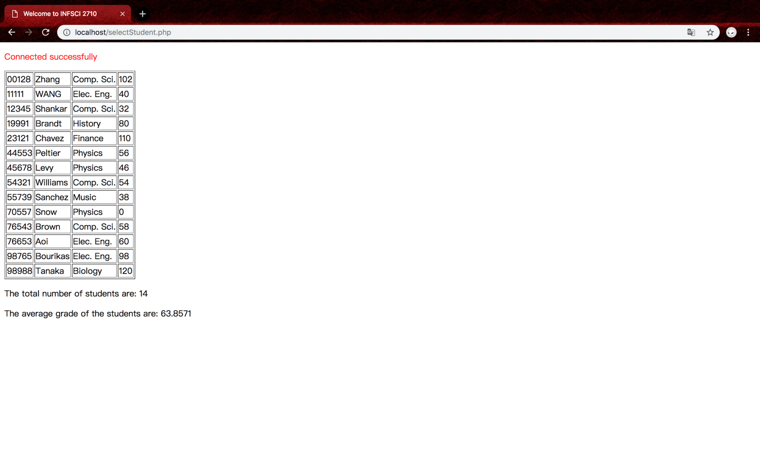

圖表 1selectStudent.php result

*Task 2 (20 points): Create 1) a PHP script ‘addStudent.php’; 2) an HTML file ‘addStudent.html’ (shown in Figure 2) - in your web server. The scripts are designed to insert a new record to ‘student’ table. That is, when you link to http://localhost/addStudent.html in your browser, you will see the similar result as below. The department field should be designed as a dropdown list to fulfill the requirement of the foreign key.

After you input all the fields and click submit. The new student profile will be inserted into the database. And you should let the user know if the work is done (with a link back to selectStudent.php) or unsuccessful (with a link back to addStudent.html) as shown in Figure 3.

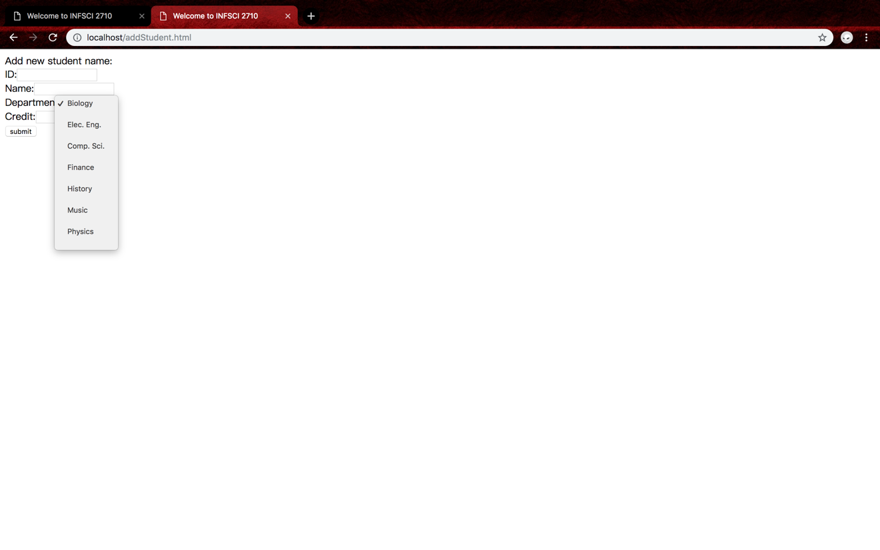

圖表 2addStudent.html effect

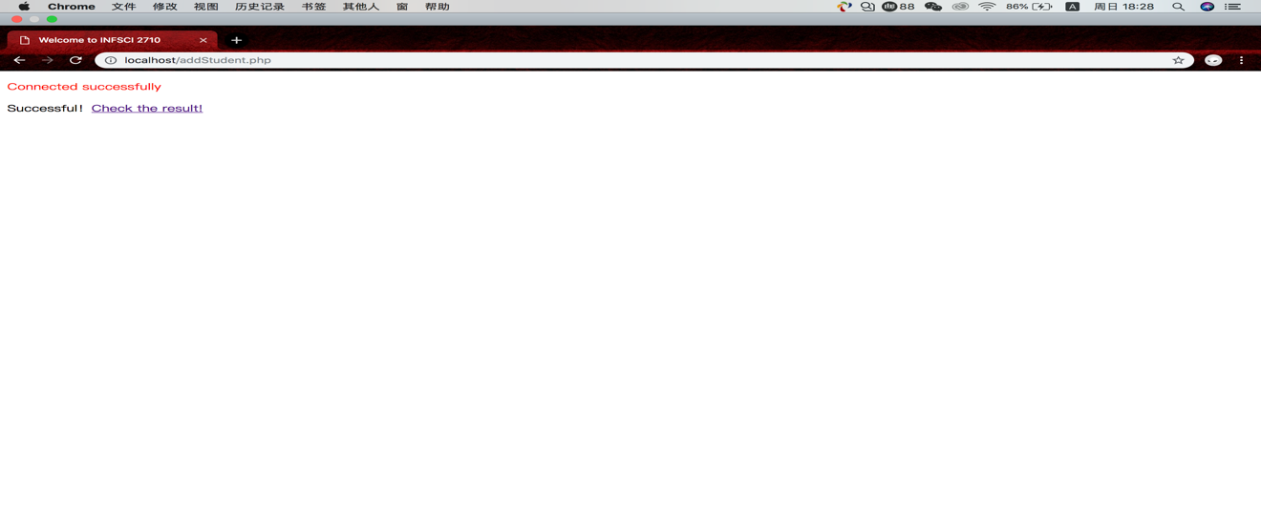

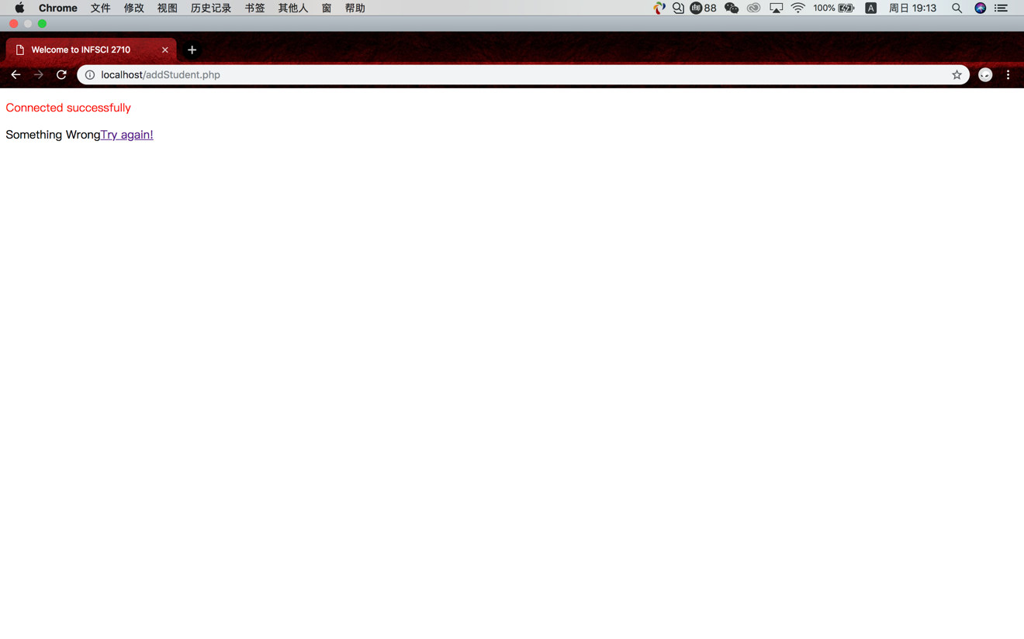

*Task 3 (20 points): 1) Create a PHP script ‘deleteStudent.php’; 2) Modify the script of ‘selectStudent.php’ with a new ‘Delete’ link in each row (shown in Figure 4) and a “Add New Student” link (point to addStudent.html) on the top. That is, when you click the link, the data row will be deleted.

After you click the Delete link. The student profile will be deleted from the database. And you should let the user know if the work done (with a link back to selectStudent.php) or unsuccessful (with a link back to selectStudent.php) as shown in Figure 5.

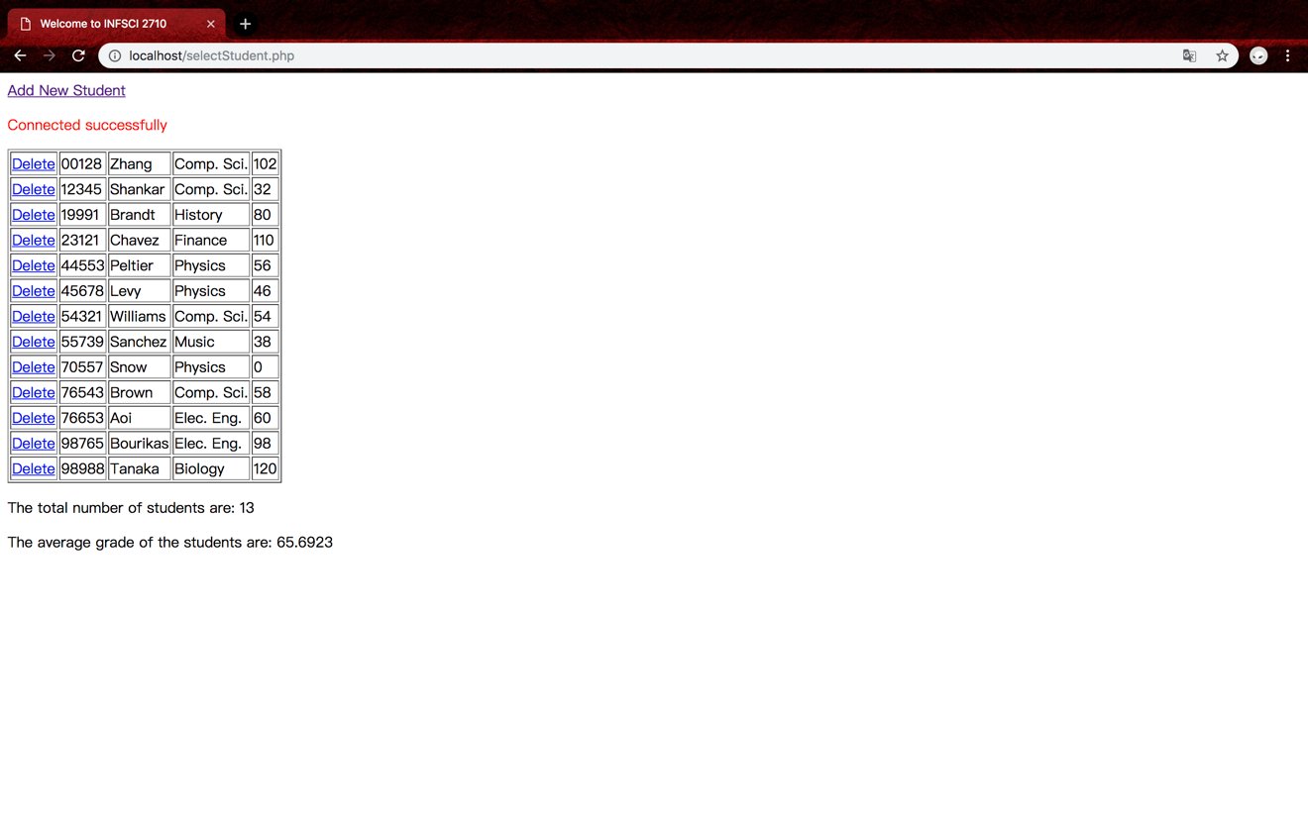



*Task 4 (35 points): 1) Create a PHP script ‘updateStudent.php’; 2) Create a PHP script ‘editStudent.php’; 3) update your PHP script ‘selectStudent.php’ with a new ‘Edit’ link in each row of data (shown in Figure 6).

You will be directed to a new page that you can update the student data when you click the Edit link (shown in Figure 7). (The ID is not editable.)

After you input all the fields and click submit. The new student profile will be updated to the database. And you should let the user know if the work done (with a link back to selectStudent.php) or unsuccessful (with a link back to selectStudent.php) as shown in Figure 8.

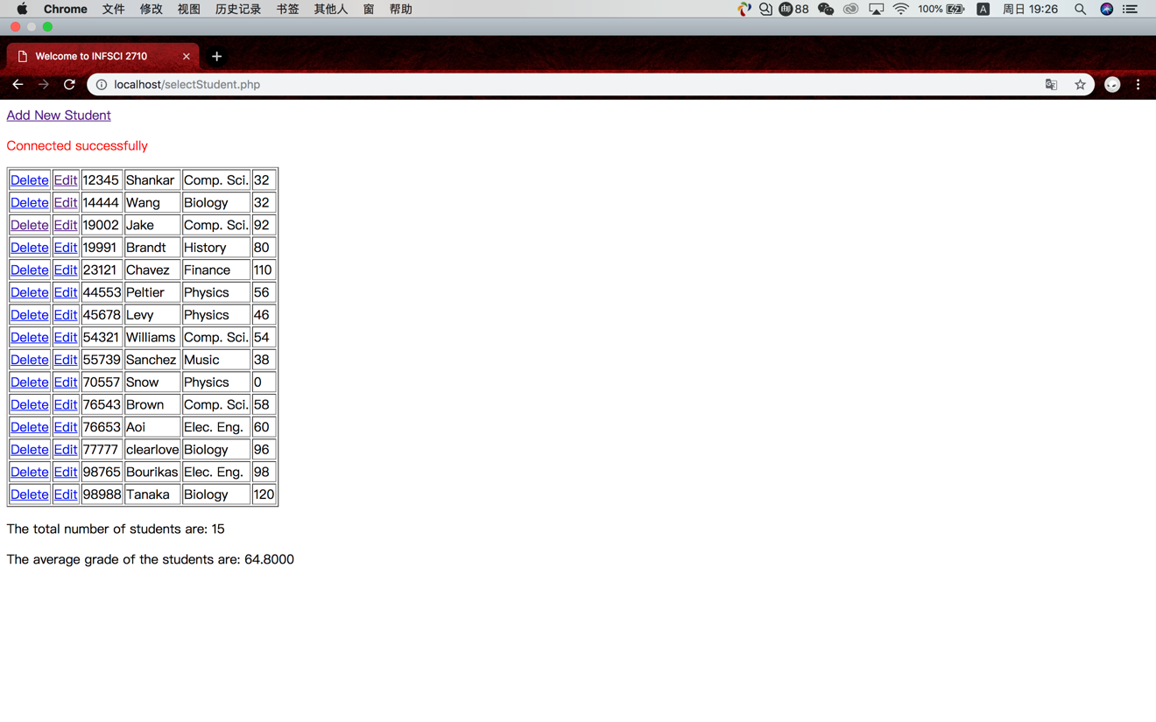

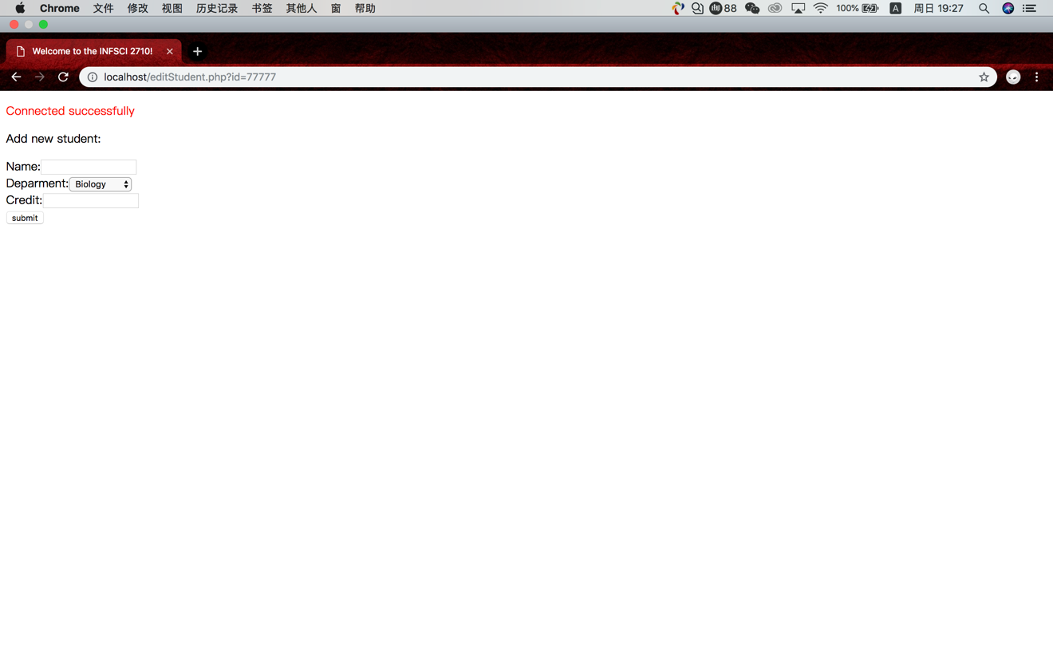

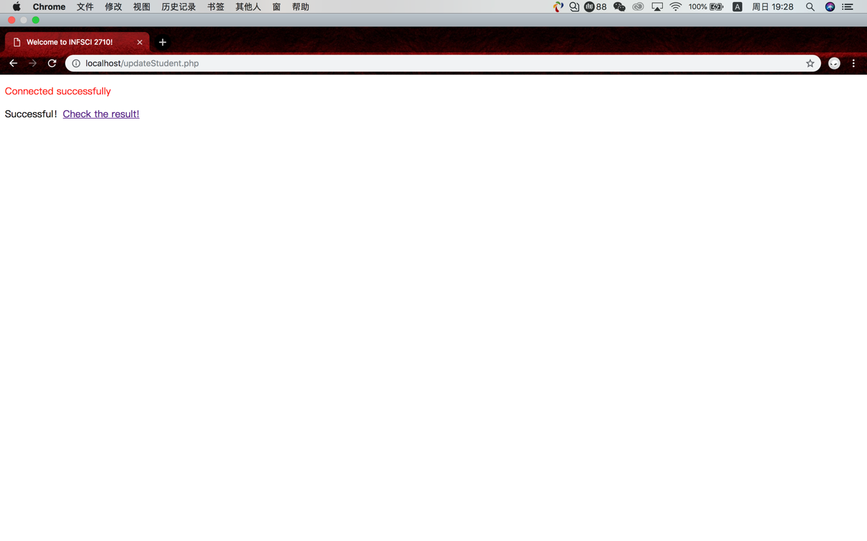

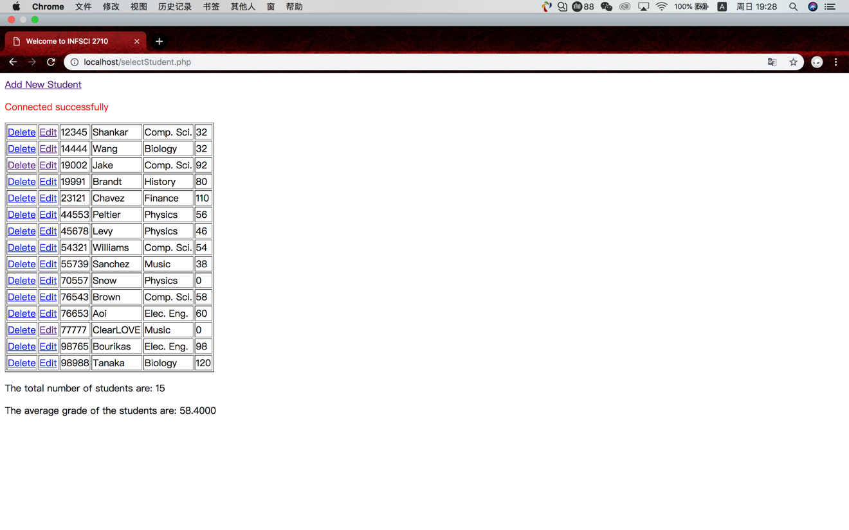

*Task 5 (5 Points): Please try to add two student profiles using the function of Task 2.

• Student#1 {name=Peter O’Donovan, department=Finance, grade=90}

• Student#2 {name=Peter Lee, department=Music, grade=Ten}.

Question 1: Is there any issue while you are adding the two profiles?

Question 2: How can you solve the issues you observed? Please discuss or show your solution (code) below.

A runnable code is preferred, but you will get credit by explaining your observation and prospect solutions.

Solution: Use some “if“ to judge the information we added whether we have inputted all unique information including ID, name, department and credit.