summa
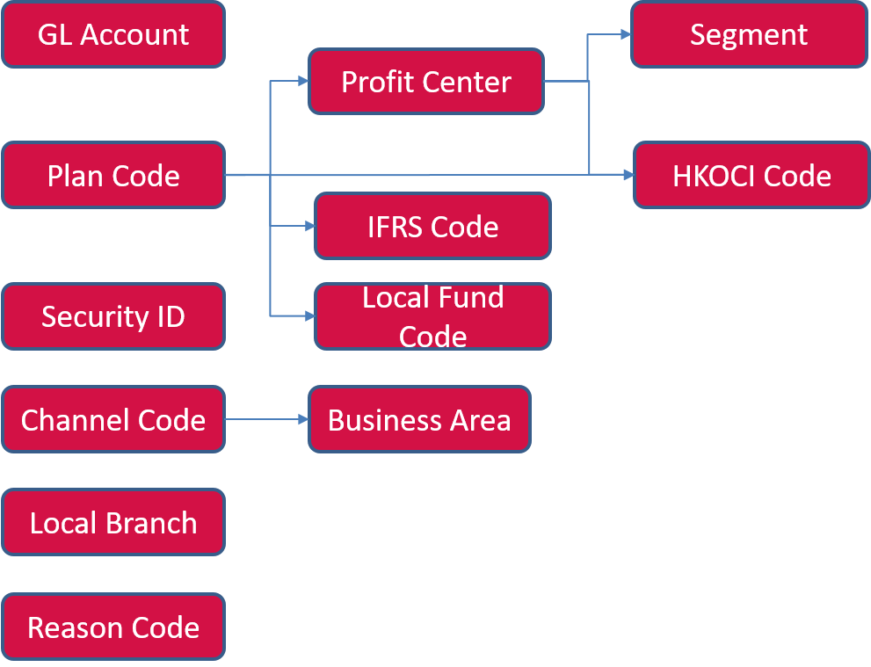
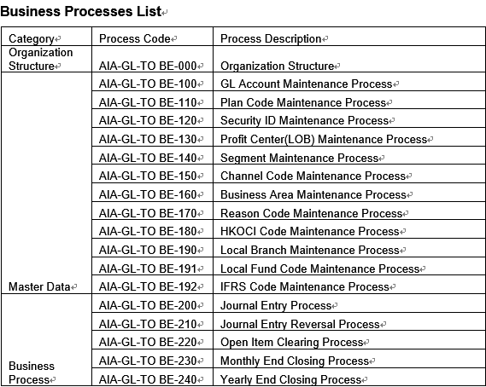

Organization Structure
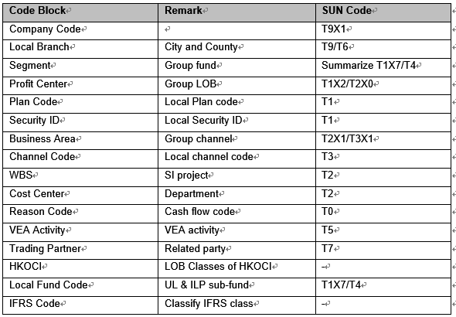
Tax code
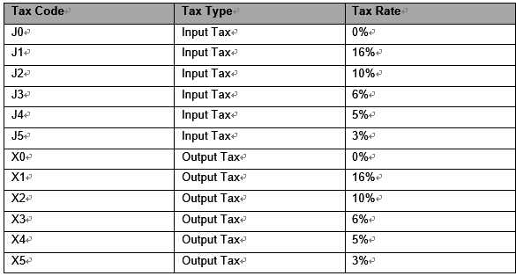
Reason code
Channel and business area
Posting key
Posting Key | Name | Credit/Debit | Account Type
01 | Invoice | Debit | Customer
11 | Credit Memo | Credit | Customer
21 | Credit Memo | Debit | Vendor
31 | Invoice | Credit | Vendor
40 | Debit Entry | Debit | GL Account
50 | Credit Entry | Credit | GL Account
70 | Debit Asset | Debit | Asset
75 | Credit Asset | Credit | Asset

For AIA China, following standard document types are used:
Document Type | Description | Purpose
CO | G/L Account Posting | Automatic generate when perform project settlement
AA | Asset Posting | Default document for fixed asset transaction
AF | Depreciation Postings | Asset periodic depreciation postings
KR | Vendor Invoice | Manual vendor invoice of AP sub-ledger
DR | Customer Invoice | Debit note
SA | GL Account Document | For manual posting journals by GL Team
SU | GL Clearing Document | GL clearing document
AB | GL Reversal Document | Reversal document for SA

Followings are newly created:
XA | PR Account Document | For manual posting GL journals by PR Team
XB | PR Clearing Document | PR clearing document
XC | PR Reversal Document | Reversal document for XA
XD | PA Account Document | For manual posting journals by PA Team
XE | PA Clearing Document | PA clearing document
XF | PA Reversal Document | Reversal document for XD
XG | BA Account Document | For manual posting journals by BA Team
XH | BA Clearing Document | BA clearing document
XI | BA Reversal Document | Reversal document for XG
XJ | Allocation | GL allocation
XK | Tax document | For manual tax document
XL | WII interface document | Document interfaced from WII
XM | FAM Non-ILP Manual | for manual document of FAM
XN | FAM Non-ILP Automatic | for automatic document of FAM
XO | FAM ILP Manual | For manual document of ILP
XP | FAM ILP Automatic | For automatic document of ILP
XQ | FAM ILP Adjustment | For ILP adjustment
XR | FAM Non-ILP Adjustment | For Non-ILP adjustment

The document types follow Group’s design and use.
YA | FX Revaluation | FX revaluation & translation
YB | FX Translation | FX revaluation & translation
YD | Ledger Specific Adj. | Manual G/L
Z1 | GL (Data Conv) | Data Conversion
Z2 | AP (Data Conv) | Data Conversion
Z3 | AR (Data Conv) | Data Conversion
Z4 | GL (Data Conv)-Excel | Data Conversion - From Excel
Z7 | ETL Reserve - Q rate | ETL Reserves - Q rate
Z8 | ETL Reserve Reversal - Q rate | ETL Reserves - Q rate
ZE | ETL Reserve | ETL Reserves
ZF | ETL Reserve Reversal | ETL Reserves
ZZ | Int. Payroll JV | Citi-Ray

