ESIP Lab Project

**Geoweaver: a web-based system for managing compound geospatial workflows of large-scale distributed deep networks**

November Progress Report

Prepared by

Ziheng Sun, Liping Di

Center for Spatial Information Science and Systems

George Mason University

20181126

Contents

Executive Summary 2

Project Actions 3

System Architecture 3

Geoweaver workflow designer 3

Geoweaver Back End 4

Geoweaver Workflow Runner and Monitor 4

Geoweaver Data Renderer 4

Geoweaver GitHub repository 4

Bootcamp 4

Evaluation 5

Next Steps 6

Executive Summary

This month Geoweaver team has carried out the project passing its half-way milestone as scheduled. Our progresses in October are listed in the following table:

|  |  |  |
| --- | --- | --- |
| **Milestones** | **Progress** | **Actions** |
| July 31: kick off, set up the development environment, develop web wrapper on top of open sourced deep learning/high performance computing library | 100% |  |
| Sep 30: develop workflow designer and data producer, complete bridge assembly between Geoweaver and data/function resources | 100% | * Geoweaver workflow interface has been developed * The bash-based processes has been supported thoroughly. |
| Nov 30: complete module integration, create and conduct LSTM experiment | 80% | * All the modules have been integrated. * The LSTM experiment is ready. |
| Jan 31: complete source code wrap-up, upload demonstration video, snapshot cloud instance, finish the GitHub final report and demonstrate it in ESIP winter 2019 | 80% | * Source code has been fully uploaded to Github. * The documents are completed. * Gif-format video documents are created and embedded into the github page. * A live instance is deployed onto a George Mason University server and published. |

Project Actions

System Architecture

The architecture design is put here to remind us to follow the original design and remember our goal during the development.

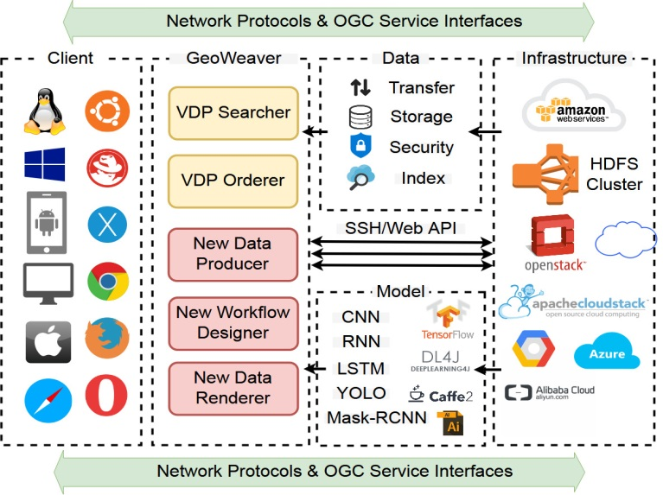

Figure 1. Architecutre design of Geweaver

Geoweaver workflow designer

The development of Geoweaver workflow designer has been finished.

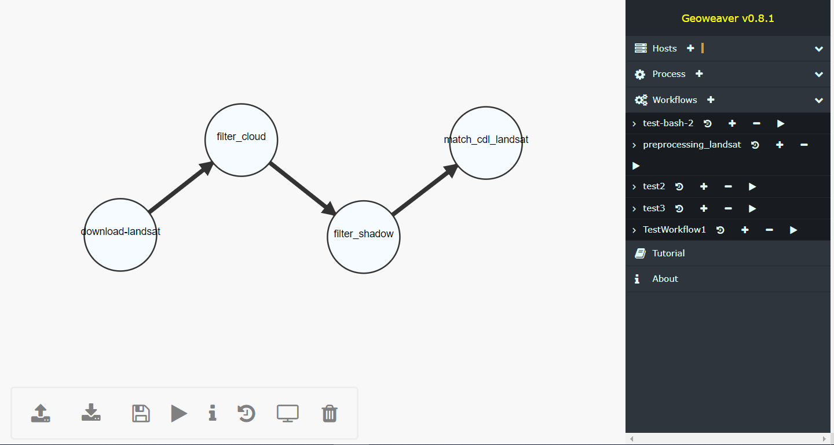

Figure 2. The workflow of our LSTM experiment in Geoweaver



Figure 3. Workspace toolbar menu (from left to right: upload workflow, download workflow, save workflow changes, execute workflow, show details of selected process, show provenance, display results, delete selected/all processes)

Geoweaver Back End

Completed.

Geoweaver Workflow Runner and Monitor

Runner and monitor are finally finished.

Demo can be found on Github (https://esipfed.github.io/Geoweaver/docs/runworkflow.gif).

Geoweaver Data Renderer

Rendering module will reuse the module from CyberConnector.

Geoweaver GitHub repository

The github repository has been updated with source code and documents (<https://github.com/ESIPFed/Geoweaver>).

Github page (<https://esipfed.github.io/Geoweaver/>) has been updated.

Gif video documents have been made and uploaded.

Bootcamp

Really enjoy the training camp and greatly inspired by the interaction with everyone. Reports have been sent few days ago.

Evaluation

Start to evaluate the system from two perspective: technical and user. The technical evaluation will include all the metrics measured automatically like response time, robustness, etc. The user evaluation will include invited users to try and give us feedbacks.

Next Steps

* Complete the workflow of LSTM crop maps.
* Create a cloud snapshot image or docker image of Geoweaver.
* Evaluate the performance of Geoweaver.
* Present Geoweaver in ESIP cluster telecons and winter conferences in Bethesda.