ESIP Lab Project

**Geoweaver: a web-based system for managing compound geospatial workflows of large-scale distributed deep networks**

December Progress Report

Prepared by

Ziheng Sun, Liping Di

Center for Spatial Information Science and Systems

George Mason University

20181218

Contents

Executive Summary 2

Project Actions 3

System Architecture 3

Geoweaver workflow designer 3

Tutorial and About 3

Geoweaver Workflow Runner and Monitor 3

Geoweaver Web Console 3

Geoweaver GitHub repository 4

AGU 4

Evaluation 5

Next Steps 6

Executive Summary

This month the development, deployment and testing of Geoweaver have been completed. Our progresses in December are listed in the following table:

|  |  |  |
| --- | --- | --- |
| **Milestones** | **Progress** | **Actions** |
| July 31: kick off, set up the development environment, develop web wrapper on top of open sourced deep learning/high performance computing library | 100% |  |
| Sep 30: develop workflow designer and data producer, complete bridge assembly between Geoweaver and data/function resources | 100% | * Geoweaver workflow interface has been developed * The bash-based processes has been supported thoroughly. |
| Nov 30: complete module integration, create and conduct LSTM experiment | 100% | * All the modules have been integrated. * The LSTM experiment is ready * Web SSH console is created. |
| Jan 31: complete source code wrap-up, upload demonstration video, snapshot cloud instance, finish the GitHub final report and demonstrate it in ESIP winter 2019 | 95% | * Source code has been fully uploaded to Github. * The documents are completed. * Gif-format video documents are created and embedded into the github page. * A live instance is deployed onto a George Mason University server and published. * Virtual machine snapshot is caught and published online. The link is attached in Github tutorial. |

Project Actions

System Architecture

The architecture design is put here to remind us to follow the original design and remember our goal during the development.

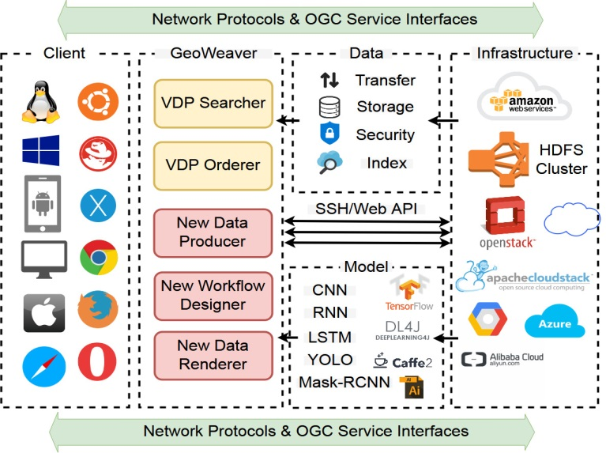

Figure 1. Architecutre design of Geweaver

Geoweaver workflow designer

The development of Geoweaver workflow designer has been finished.



Figure 2. Workspace toolbar menu (from left to right: upload workflow, download workflow, save workflow changes, execute workflow, show details of selected process, show provenance, display results, delete selected/all processes)

Tutorial and About

Information is written and embedded into the Github pages and Geoweaver dialogs.

Geoweaver Workflow Runner and Monitor

Runner and monitor are finally finished.

Geoweaver Web Console

The SSH console allows users to connect and do things via the familiar SSH console on the enrolled distributed hosts.

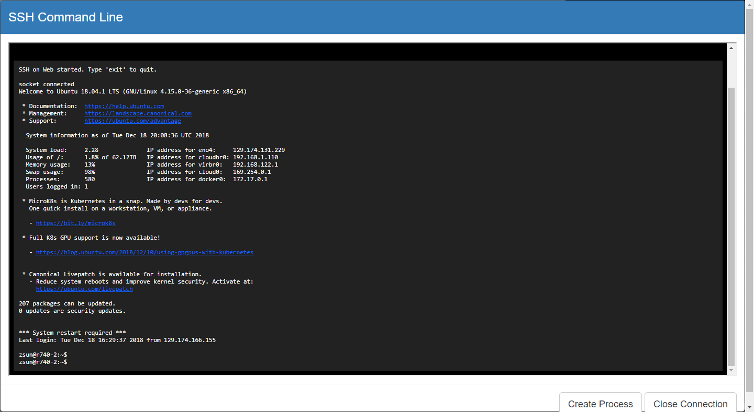

Figure 3. Open a SSH console to the enrolled host in Geoweaver

Geoweaver GitHub repository

The github repository has been updated with source code and documents (<https://github.com/ESIPFed/Geoweaver>).

Github page (<https://esipfed.github.io/Geoweaver/>) has been updated.

A new version for ESIP demo, 0.6.8, is released.

AGU

Meet many many people in AGU and talked with them on using deep learning in generating. agricultural maps. We are now more aware of what everyone in agricultural sector is doing and how they do it. In our view, Geoweaver is absolutely capable of playing a major role in assisting deep learning agricultural workflows in the near future.

Evaluation

System evaluation has been carried out and the result looks good. Since this system can be used basically anywhere, the general performance is verified on general hardware configuration. We cannot see anything stands in the way preventing scientists to use this software in real life researches.

We have received many favorable feedbacks in ESIP SGCI bootcamp in Boulder. We also have invited several collaborators in stakeholder field (e.g., USGS and University of Arkansas) to look at Geoweaver and give us some feedbacks. We will collect more feedbacks in ESIP winter meeting.

Next Steps

* Demonstrate the workflow of deep learning crop maps.
* Present Geoweaver in ESIP cluster telecons and winter conferences in Bethesda.