Game Design Document
The Darkness Below - Game Jam 2026
Jamie Jones and Joe Buckley | Final version, 13 November 2026
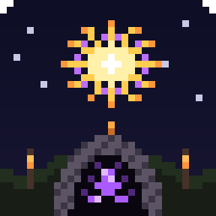
Item | Detail
Game | The Darkness Below - dark fantasy pixel art action adventure
Engine | Unity 6.5 (6000.5.2f1), 2D URP
Team | Jamie Jones and Joe Buckley
Repository | github.com/Ziiq234/GameJam (branch main)
Theme | Fireworks / gunpowder / sparkle
Deadline | Friday 13 November 2026
Play time | About 15-25 minutes for the main story, plus side quests

1. Summary
The Darkness Below is a top-down pixel art adventure. The village is getting ready for its firework festival but the enchanted rocket charges have been stolen. The player works through a questline for Cornelius, travels by boat between islands, buys a sword, clears two dungeons and beats the Mage in a boss fight. When all the charges are back the fireworks go off over the village and the game shows a victory screen.
This document replaces our first project plan. The first plan aimed for one village, one cave and 3 charges. We finished that loop early, so we kept going with the stretch goals and Joe's bigger story. The sections below describe the game as it is now.

2. Story
Story by Jamie Jones and Joe Buckley. The main quest steps in the order the player does them:
# | Step | What the player does
1 | Talk to Cornelius | Cornelius explains the charges have been stolen and asks for help.
2 | Deliver the message | Take a boat from the north shore to Halberd and give Theodor the message (+50 gold).
3 | Return to Cornelius | Cornelius says the forest is dangerous and the player needs a weapon.
4 | Buy a sword | Earn gold from bats on the forest road and buy the Iron Sword from the Blacksmith (75 gold).
5 | Forest dungeon | Enter the Dense Forest dungeon in the south-east, fight bats and rats and find the charges.
6 | Bring charges back | Return the charges to Cornelius (+100 gold).
7 | Collect taxes | Sail to Wizard Island, clear the Mage's bats, then beat the Mage in a boss fight. He drops his sword.
8 | Bring taxes back | Hand the taxes to Cornelius.
9 | Visit Theodor | Theodor rewards the player (shield and ring) and points them to the last charge.
10 | Wizard dungeon | Fight the evil wizards and the Head Wizard in the Wizard Island dungeon for the last charge.
11 | Final return | Give the last charge to Cornelius. Fireworks ending and victory screen.

Side quests
- Tom - kill the bats on the forest road, then tell him they are gone (gold reward).
- Rose - find her lost necklace on the north-east beach and bring it back (gold reward).
- Ella - deliver Theodor's letter to Ella in the start town (gold reward).

3. Characters
Character | Role
Player | The hero. Animated in 4 directions, 5 HP, can hold and swing a sword.
Cornelius | Main quest giver in the start village.
Theodor | Old friend of Cornelius who lives in Halberd. Gives rewards later in the story.
Blacksmith | Runs the shop. Sells the Iron Sword and health potions.
The Mage | Lives on Wizard Island. Boss fight after his bats are cleared.
Head Wizard and evil wizards | Enemies in the Wizard Island dungeon that shoot magic bolts.
Villagers (9) | Wander around the village and talk to the player. Tom, Rose and Ella give side quests.

4. World
The village map was made by Joe and merged with Jamie's scenes. The world is a group of islands joined by boats.
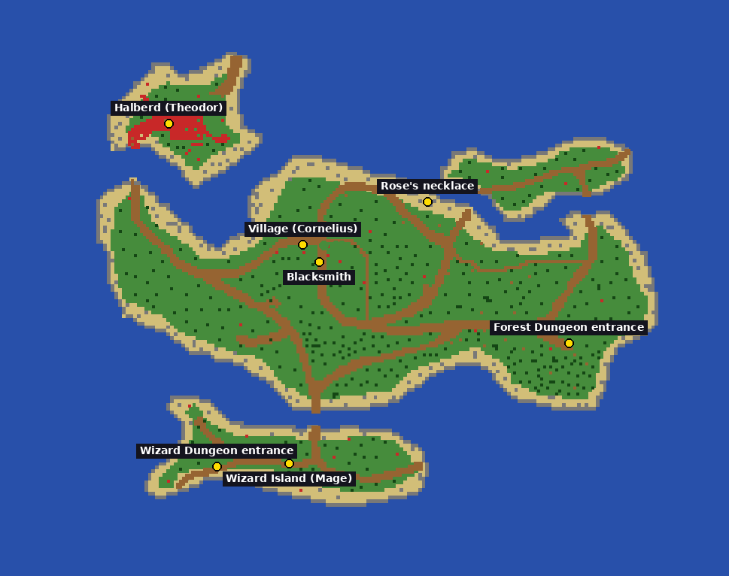
Figure 1 - the final map with the main quest locations
Scene | What is in it
MainMenu | Title, Play, Controls, Credits and Quit.
Village | All the islands, NPCs, the shop, docks and boats, road bats, Wizard Island and the Mage.
Dungeon | The Dense Forest dungeon (GameObject is called "Dungon"). Bats, rats and charges.
WizardDungeon | Purple tinted dungeon with evil wizards, the Head Wizard and the last charge.

5. Mechanics and controls
Key | Action
W A S D | Move
Space | Attack
E | Talk, use boats, next line of dialogue
Hold M | Show the whole map
1 / 2 | Buy items in the shop
Esc | Pause
- Combat: short melee attack. Damage and reach go up after buying the sword. Enemies get harder once the player has the sword.
- Health: the player has 5 HP. Health potions from the shop heal fully.
- Gold: dropped by enemies and given for quests. Spent in the Blacksmith's shop.
- Boats: press E at a dock to sail to the matching dock with a fade.
- Minimap: top right of the screen with name tags. Hold M to see the full map.
- Dev keys (for testing, left in the build): L teleports to the current quest target, K completes the current quest step.

6. Enemies
Enemy | Where | Behaviour
Bats | Forest road, Wizard Island, forest dungeon | Fly towards the player when close and do contact damage. Animated.
Rats | Forest dungeon | Fast ground enemy with low health.
Evil wizards | Wizard dungeon | Keep distance and shoot magic bolts.
The Mage (boss) | Wizard Island | Blinks around and shoots bolts. 15 HP. Drops his sword.

7. User interface and audio
All UI is drawn with OnGUI through a UIHelper script so it looks the same everywhere: the HUD, dialogue box, interaction prompts, shop, pause menu, minimap and the victory screen. See 03_Wireframes.docx.
Sound effects (sword swing, hits, pickups, fireworks) are made in code by SoundManager, so the game has no outside audio files.

8. Scripts
Folder | Scripts
Player | PlayerMovement, PlayerAttack, PlayerHealth, HeldSword
Enemies | EnemyController, EnemyDamage, EnemyHealth, EnemySpriteAnimator, MageBoss, MagicBolt, WizardShooter
Managers | GameManager, QuestManager, SoundManager, DevMenu
UI | DialogueBox, MiniMap, NameTag, UIHelper
NPCs | CharacterSpriteAnimator, NPCWander, QuestNPC, ShopKeeper, VillagerTalk
Items | CollectibleCharge, QuestItemPickup, SwordPickup
Utilities | SpriteMaker
World | BoatDock, CameraFollow, Decoration, FireworkController, SceneTransition, WaterCollision

9. Team and timeline
Person | Main jobs
Jamie Jones | Programming, putting the scenes together, testing, builds, GitHub.
Joe Buckley | Story and questline, village map, planning.

Date | Work done
6 Nov | Project plan, Unity project and GitHub repo set up.
10-11 Nov | Player movement and combat, first dungeon, charges, quest NPC.
13 Nov | Merged the two maps, animated player and bats, NPCs, full questline, shop and sword, Mage boss, second dungeon, fireworks ending, menus, sound, credits and build.

10. Stretch goals
Goal | Status
Fireworks ending with restart option | Done
Animated player and enemies | Done
Wandering NPCs | Done
Shop and sword | Done
Boss fight | Done
Second dungeon | Done
Side quests | Done
Menus (Controls, Credits) | Done
Sound effects | Done
Minimap | Done
Save game | Not done - future work

11. Known issues and future work
- There is no save system, so the game has to be finished in one go.
- The dev keys L and K are still in the build. They are useful for teachers testing the game but could be removed.
- The beach tile pack credit still needs the creator name added (see 06_Asset_Credits.txt).
- Future ideas: save game, more side quests, music, controller support.

