Group 7

Nathan Tannar

Jason Tsang

Philip LeBlanc

Josh Shercliffe

Kim Youjung

# Website

<https://github.com/nathantannar4/Safety-Beacon>

Assignment 1

CMPT 275



Figure : Safety Beacon Logo

Table of Contents

[Website 1](file:////Users/nathantannar/Documents/Active%20iOS%20Projects/SafetyTracker/docs/Assignment%201.docx#_Toc494105657)

[Reversion History: 3](#_Toc494105658)

[Project Summary 4](#_Toc494105659)

[Project Overview 4](#_Toc494105660)

[Project Planning 5](#_Toc494105661)

[Project Schedule 6](#_Toc494105662)

[Risk Management 7](#_Toc494105663)

[Reference Headers: 7](#_Toc494105664)

[Potential Problems that can Hinder the Progress of this Project: 8](#_Toc494105665)

[Project Organization and Staffing Plan 10](#_Toc494105666)

[Works Cited 11](#_Toc494105667)

# Reversion History:

|  |  |  |  |
| --- | --- | --- | --- |
| **Version** | **Status** | **Publish/Revision Date** | **Authors** |
| 1.0 | Created | September 25, 2017 | Nathan Tannar  Jason Tsang  Philip LeBlanc  Josh Shercliffe  Kim Youjung |

# Project Summary

Alzheimer’s is a disease that effects not only the patient but everyone who is close to them. You may find yourself worried that your family members might one day forget where they live and wonder off. In fact, 6/10 people will wonder off and get lost![1] Or maybe you are worried that they are taking too many trips to the pharmacy buying over the counter drugs or the casino spending their money and not remembering how much they lost. While you may not always be able to be by their side, with Safety Beacon you can rest easy knowing you have a direct link to their current and previous whereabouts.[2]Safety Beacon is the first mobile iOS app specifically tuned for helping caretakers/family members keep track of an Alzheimer’s patient and will soon be available for download on the App Store.

# Project Overview

The consistent memory loss associated with Alzheimer’s disease can put significant strain on family and friends of the patient. An estimated one in ten Americans over the age of 65 suffer from Alzheimer's disease. Of these 10%, “15.9 million family and friends provided 18.2 billion hours of unpaid assistance to those with Alzheimer's” [3].

To assist the caregivers of Alzheimer’s patients, Safety Beacon is an application designed to track and analyze the patient’s real-time position, remember important and consistently visited locations, and alert the caregiver when the patient leaves a designated safe-zone.

We define the CARETAKER as the user responsible for managing one or more PATIENT's, the user with Alzheimer’s.

The CARETAKER can access:

* Real-Time Location Access; in case they go missing
* Designation of “safe-zones” defined by the caregiver, in which the caregiver will be alerted when the patient enters or leaves these zones (such as the patient leaving or entering their home
* Location History Trace; to see where they went
* A daily safety report
* A saved list of important locations; to add map makers like “home” or “grocery store”
* A shared calendar; to remind the PATIENT to fill a prescription or attend their doctor's appointment

The PATIENT can access:

* A simple map view with easy navigation to the list of important locations; because Google Maps complicated if you forget where you need to go
* An emergency button available to the patient that will automatically guide the patient home in the case of getting lost
* An Augmented Reality overlay of their navigation; making it easier to follow directions
* View the shared calendar created by the CARETAKER; with notifications

The users of the application will include both caregivers and Alzheimer’s patients. Each of the two users will have a separate UI. The patient’s features will mainly focus on the memorization of important locations, user rights to the calendar system, and the emergency “take me home” button. The caregiver’s features will include the same features as the patient’s, with the addition of activity summaries, location tracking, safe-zone designation, and admin rights to the shared calendar.

Stakeholders of the application include:

• Sufferers and caregivers of Alzheimer’s patients

• CMPT275 Group 7 members

• Professor Herbert Tsang

# Project Planning

The project will span a timeline of approximately four months from conception to completion. During this timeline, efficient communication in between the team members is key to successful app development. As a communication plan, we will meet in person at least once each week for at least an hour. These scrum meetings will be primarily for us to discuss everyone’s progress on current assignments, future goals as a group, and any issues or concerns we might have.

There will be bi-weekly reports on progress to review upcoming deliverables. Additionally, we will be frequently using Facebook and Slack as an online communication tool to provide any important updates, or to raise a gating issue. If the gating issue calls for an urgent fix, we will try to triage the issue as soon as possible via a Skype call. We also intend to revise the communication plan regularly if more input is required. As a result, we will always be in frequent communication with one another, which ensures the entire team is generally on the same page and trying to achieve the right milestones/deliverables in every stage of the software cycle.

Currently, we do not need to hire anyone because we are capable of planning, developing, testing, and managing all the proposed features on our mobile app. However, as a team we still need to evaluate our cost estimation for other requirements for our app. Firstly, some of the app’s feature needs real-time information access, which requires a back-end server. To set up and host a back-end server on google cloud platform costs about 10.00 CAD per month. Besides the server cost, all other costs are minimum since our app does not require any external components. Furthermore, we can minimize our cost further by using GitHub as our team website and version control software. In brief, we believe the total cost of developing our mobile solution will be very inexpensive.

Additional information regarding agenda, meeting minutes, and documentation are found on our website: **https://github.com/nathantannar4/Safety-Beacon**

|  |  |  |  |
| --- | --- | --- | --- |
| **Key Tasks** | **Start Date** | **End Date** | **Milestones/Deliverables** |
| Project Initialization | September 18, 2017 | September 27, 2017 | * Assignment 1 * Clear Vision |
| UI/UX Design and App Architecture | September 25, 2017 | October 18, 2017 | * Assignment 2 * UI Design * Backend DB Setup * Familiarity with XCode and Swift 4 |
| Basic Location Features | October 23, 2017 | November 6, 2017 | * Assignment 3 * Presentation * Functional Prototype |
| Machine Learning  Push Notifications  AR Overlay | November 6, 2017 | November 20, 2017 | * Assignment 4 * Prototype with all features |
| UI Finalization  QA Testing  Battery Life Optimizations | November 20, 2017 | December 4, 2017 | * Assignment 5 * Presentation * App Store Deployment * Final Demo |

# Project Schedule

The project timeline is from September 5th to December 4th, spanning 13 weeks. As of now 3 weeks have passed, two of which we have spent as a team to plan and get to know each other. We are now entering the fourth week and we have a total of 10 weeks before the deliverables are due.

This project is for CMPT 275: Software Engineering I, therefore the timeline should reflect the course credit system. Since the course is worth 4 credits, that means approximately 3 hours/week for each credit (12 hours/week) should be spent on this course not considering study time for exams. Since the course project is worth 50% of the grade it is reasonable to divide half of the hours towards studying for exams and the other half towards the course project. Furthermore, 6 hours/week for each team member equals 30 hours/week. In sum, for the next 10 weeks we are aiming to put in a total of 300 hours of work to this project.

The timeline and Gantt chart below were created in MS Project to further visualize our initial project schedule.

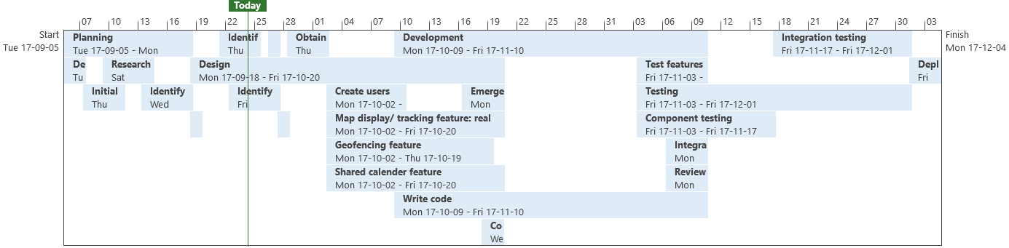

Figure : Initial Project Schedule

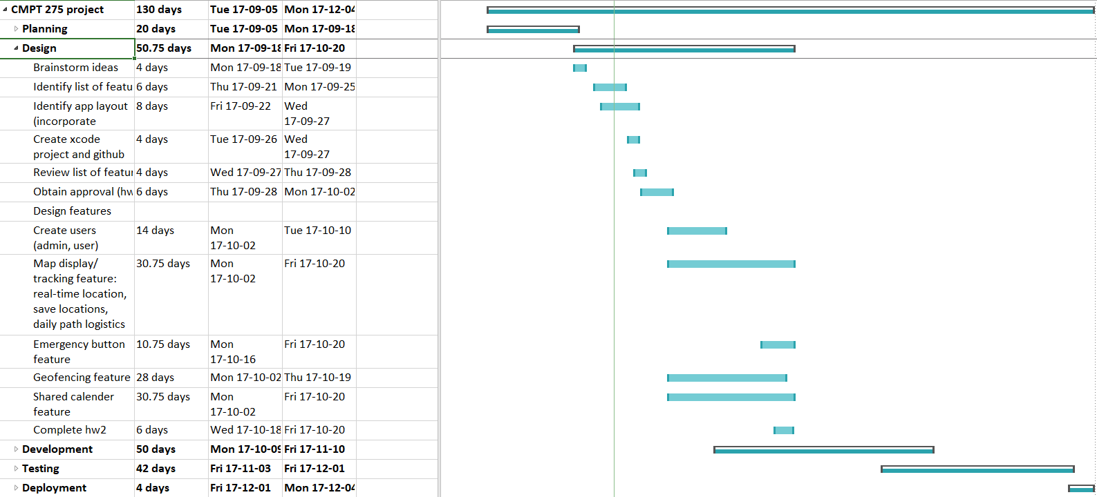

Figure : Feature Development Breakdown

After homework 2 is completed (requirements document + design document and quality assurance plan) the design stage of our project will end (Oct. 20). Concurrently, we will complete the full design of features and begin development to give more time to learn Swift and development practices with XCode and iOS, considering that from Oct. 20 to Nov. 6 we have a limited 3 weeks to develop a functioning app and create a presentation. Version 2 of the app and homework 3 is another milestone (Nov. 20) as well as the Final Presentation and Version 3 (Dec 4).

# Risk Management

## Reference Headers:

*Likelihood*:

|  |  |
| --- | --- |
| Low | Rare and negligible chance of occurring |
| Medium | Possible of occurring |
| High | Almost certain of occurring, likely with repeated offenses |

*Impact*:

|  |  |  |
| --- | --- | --- |
| 5 | Severe | One or more critical objectives will not be achieved, project delayed |
| 4 | Significant | One or more objectives will be below acceptable levels, project could be delayed, or released with issues or missing features |
| 3 | Moderate | One or more objectives are only met with minimal acceptable levels, project will not likely be delayed, but released sub-optimally |
| 2 | Minor | Minor impact on objectives, highly unlikely project will be delayed |
| 1 | Minimal | Little or no impact, no delay to project deadlines |

## Potential Problems that can Hinder the Progress of this Project:

## 

|  |  |  |  |  |
| --- | --- | --- | --- | --- |
| **Risks** | **Impact** | **Likelihood** | **Impact Area** | **Mitigation** |
| **Technology** |  | | | |
| Use of public APIs contains defects or does not execute as desired | 5 | Medium | Application development | - Ensure that there is compatibility between the APIs being exercised before using them  - Create a quick prototype with it executing the basics of what we want, before investing time into the specifics |
| Merge conflicts | 4 | High | Application development | - Merge trunk with local workspace frequently  - Assign dedicated trunk manager to resolve all merge conflicts  - Merge local changes to trunk (after review) as early as possible  - Have developers work on separate features |
| Unexpected Bugs | 3 | High | Application development | - Code with testing in mind  - Start QA early to identify flaws in code before they pile up  - Assign developer with QA for co-development of code and test code |
| Security concerns regarding location tracking and information collection | 1 | Low | Consumer | - Confirm that iOS privacy filters are strong enough to prevent leakage of location tracking information  - Confirm that database server is acceptably secure to hacks |
| iPhone battery is depleted rapidly in testing | 1 | Low | Consumer | - Off-load processing to the server-side  - Check that optimal APIs are being used that minimize battery usage  - Only update location when significant movement of the iPhone is detected |
| **People** |  | | | |
| Lost of team member (sick, drops class, etc.) | 4 | Medium | Entire project or deliverables for HW due | - Assign secondary roles to all members, so that a missing member’s role can be quickly covered  - Start project early to minimize the potential time lost to cover said role |
| Members not pulling their weight | 4 | Low | Deliverables for HW due | - Have members exercise their secondary roles  - Have a member communicate with those having trouble, to see if they are being blocked  - Setup 1:1 or physical meeting to work with member having trouble |
| Lack of experience in iOS development | 3 | High | Application Development | - Make use of tutorials on iOS development online  - Start coding early to identify potential issues that could arise with development  - Seek help for TA, Professor, other students, or online forums as soon as the problem becomes a blocker |
| **Tools** |  | | | |
| Lack of development platform (Mac) | 3 | Low | Application Development | - Occupy Macs in CSIL earlier to ensure that there is availability  - Install Hackintosh on Windows for remote development  - Purchase a Mac (worst case scenario) |
| **Requirements** |  | | | |
| Project Idea is rejected | 5 | Low | Entire project | - Talk with Professor to ensure that project idea is one that is acceptable before submission of HW1 |
| **Estimation** |  | | | |
| Underestimation of work to be done | 4 | Medium | Deliverables for HW due | - Set deadline earlier than that of the submission deadline to allow an extra buffer for corrections  - Start working on deliverables ASAP |

# Project Organization and Staffing Plan

|  |  |
| --- | --- |
| **Project Lead** |  |
|  | **Nathan Tannar** ([ntannar@sfu.ca](mailto:ntannar@sfu.ca))  Mobile development is my jam. I did a one year Co Op with SAP where I worked on remote System Support and iOS development. I have experience with Swift from some personal projects I work on. With that I have learned how to setup a backend system for mobile apps that support a wide arrangement of cloud services including push notifications. |
| **Developers** |  |
|  | **Jason Tsang** ([jrtsang@sfu.ca](mailto:jrtsang@sfu.ca))  I am a 4th year Computer Engineering student with an industry background primarily in firmware. In addition to firmware, I have experience working with automation, regression testing and build and CI. I have been exposed to the Apple development environment before, having created a status-bar application for macOS. |
| **../../../../Desktop/22047381_1949237778687921_965336757_o.jpg** | **Philip LeBlanc** ([paleblan@sfu.ca](mailto:paleblan@sfu.ca))  I am a fourth-year computer engineering student with experience with c++, javascript, python. Previously had a co-op at Simba technologies/ Magnitude Software on the Build and Test Automation Team. Had me working on an internal webpage using Angular.js and python but I am more comfortable with VS c++ through courses at sfu. Outside of school, I enjoy soccer, hiking, and skiing. |
| **QA** |  |
|  | **Josh Shercliffe** ([jshercli@sfu.ca](mailto:jshercli@sfu.ca))  I am a SFU student pursuing a degree in computer engineering. I am competent in computer hardware, and have built several personal computers. I have worked in IT at ICBC, as well as taken several computing courses at SFU such as CMPT 128, 225, and ENSC 251. |
|  | **Kim Youjung** ([youjungk@sfu.ca](mailto:youjungk@sfu.ca))  My name is Youjung Kim, I am a senior student in Computer Engineering. So far in my academic career, I have completed 5 co-op terms at 2 different companies as a R/D associate and software tester. I am currently finishing my last terms at SFU as I am seeking post graduate opportunities. |

# Works Cited

|  |  |
| --- | --- |
| [1] | A. Association, "Alzheimer's Association," 2017. [Online]. Available: http://www.alz.org/care/alzheimers-dementia-wandering.asp. |
| [2] | A. Association, "Alzheimer's Association," 2009. [Online]. Available: http://www.alz.org/alzheimers\_disease\_10\_signs\_of\_alzheimers.asp. |
| [3] | A. Asociation, "2017 ALZHEIMER'S DISEASE FACTS AND FIGURES," 2017. [Online]. Available: http://www.alz.org/facts/. |