Table of Contents

Cross-Sector Correlation Regimes and Their Impact on the Predictive Accuracy of Equity Price Forecasting Models
A quantitative study of U.S. sector ETFs (2015–2026)

Abstract
This study asks whether the accuracy of short-horizon equity price forecasting models depends on the prevailing cross-sector correlation regime, and — crucially — whether any such dependence survives once market volatility is controlled for. Using more than eleven years of daily data for four S&P 500 sector ETFs (Technology, Health Care, Energy, Financials) and the broad-market SPY ETF, we build a rolling measure of average pairwise sector correlation, classify each day into a high-, low-, or mid-correlation regime by quartiles, and evaluate five one-step-ahead forecasting models (a naive random walk, an AR(1), a linear regression on lagged returns, and Ridge and Lasso regressions) in a strict walk-forward, out-of-sample design.
We find a strong descriptive result: absolute return-forecast errors are roughly 58–62% larger in high-correlation regimes than in low-correlation regimes, and both parametric and non-parametric tests reject the hypothesis that accuracy is independent of the correlation regime (p ≪ 0.001 for every model). However, this association does not represent an independent correlation effect. High correlation is collinear with high volatility in our sample (r = 0.64). When the daily mean absolute error is regressed on both the lagged correlation and a lagged volatility proxy (90-day realized volatility of SPY, Newey–West standard errors), the correlation coefficient collapses from significant (p ≈ 0.017) to indistinguishable from zero (p ≈ 0.72–0.79) and even changes sign, while volatility remains strongly significant (p ≈ 3×10⁻⁶) and absorbs essentially all of the explanatory power (R² essentially unchanged, ≈ 0.11–0.12 across models). A 2×2 double sort confirms this: within a fixed volatility bucket the correlation effect is small and flips sign. The correlation regime therefore appears to matter only because it proxies for volatility — consistent with Forbes and Rigobon (2002), who show that measured correlation is itself inflated by volatility.
We are equally candid about the volatility half of the story. Because our models predict returns near zero, absolute error is nearly equal to the size of the move, so the “volatility explains the error” result is partly mechanical rather than a discovery. The honest test is directional accuracy, a scale-free metric that does not inflate with volatility — and there we find that predictive skill is weak in every cell of the double sort (45–54%, hovering near the 50% coin-flip), with no clean ordering by either volatility or correlation. The paper’s real contribution is therefore methodological: an effect that looks statistically bulletproof on a scale-dependent metric (p ≪ 0.001, every model, two tests) can be a volatility shadow, and the cure — add one lagged volatility control and read the coefficient, then re-check on a scale-free metric — is cheap and decisive. A tiny p-value certifies neither a real effect nor genuine forecast skill.

1. Introduction
A recurring theme in empirical finance is that the statistical structure of markets is not constant — it shifts between regimes (Hamilton, 1989). One of the most studied regime variables is cross-asset correlation: in calm markets, individual sectors are driven largely by their own sector-specific news, whereas in crises a single systematic factor dominates and “everything moves together” (Ang and Bekaert, 2002; Ang and Chen, 2002). This phenomenon — higher co-movement precisely when diversification is most needed — has direct consequences for risk management and, potentially, for forecasting.
It is worth stating the backdrop plainly: short-horizon equity return predictability is weak to begin with. Welch and Goyal (2008) show that popular predictors struggle to beat the historical mean out of sample, and Campbell and Thompson (2008) find that even statistically detectable predictability translates into only slim out-of-sample gains. Any regime-conditional “edge” must be read against this low baseline — a point that becomes central to our conclusions.
A signal-to-noise view. Short-horizon linear forecasting models exploit weak, sector-specific structure in returns — mild autocorrelation and cross-sector lead–lag relationships. In low-correlation regimes, prices track sector-specific fundamentals, and that idiosyncratic structure is exactly the signal a linear model can pick up. In high-correlation regimes, a single systematic factor dominates the cross-section, the sector-specific component of returns shrinks relative to common market noise, and the signal the model relies on collapses. This intuition predicts that models should forecast less accurately when cross-sector correlation is high.
This paper tests that prediction — and then interrogates it. The hypothesis is:
- H₀ (null): Prediction accuracy is independent of the correlation regime.
- H₁ (alternative): Prediction accuracy differs between the high- and low-correlation regimes.
Testing H₁ alone, however, is not enough, and this is the central methodological point of the paper. High correlation and high volatility are tightly linked, and Forbes and Rigobon (2002) show that estimated correlation coefficients are themselves mechanically inflated during high-volatility periods. A naive finding that “accuracy is worse in high-correlation regimes” could therefore be nothing more than “accuracy is worse when moves are large.” We confront this confound head-on by asking a sharper question:
Does the correlation regime carry any information about forecast accuracy beyond what volatility already explains?
As we report below, the answer in our sample is essentially no. We present the descriptive regime result in full, and then show honestly that it is a volatility artifact.

2. Data
We use daily adjusted-close prices (which account for dividends and splits) from Yahoo Finance for 2 January 2015 – 12 June 2026 (2,878 trading days). The universe is:
Ticker | Sector | Economic character | Role
XLK | Technology Select Sector SPDR | Secular growth, long-duration | Sector
XLV | Health Care Select Sector SPDR | Defensive growth | Sector
XLE | Energy Select Sector SPDR | Inflation / commodity-sensitive | Sector
XLF | Financials Select Sector SPDR | Interest-rate-sensitive, cyclical | Sector
SPY | SPDR S&P 500 ETF | Broad market | Market / target
These four sectors are deliberately chosen to span distinct macro drivers — secular growth (Tech), rate sensitivity (Financials), inflation/commodity exposure (Energy), and defensive growth (Health Care). Because they respond to different forces, their pairwise correlations vary meaningfully over the cycle, which is exactly what makes them a useful laboratory for a correlation-regime study. SPY serves as a broad-market reference and an additional forecasting target.
Series are aligned on common trading dates, short internal gaps are forward-filled, and any remaining missing rows are dropped, yielding a fully populated common window. Prices are converted to continuously compounded (log) returns:
$$r_{t}=ln​\left(\frac{P_{t}}{P_{t−1}}\right).$$
Descriptive statistics (annualized). Technology was the strongest and Energy the weakest sector; all series show the negative skew and heavy tails that are among the well-documented stylized facts of asset returns (Cont, 2001).
Asset | Annual return | Annual volatility | Naive Sharpe | Skew | Excess kurtosis
XLK (Tech) | 20.4% | 23.9% | 0.85 | −0.32 | 9.3
XLV (Health) | 8.7% | 16.8% | 0.52 | −0.39 | 8.7
XLE (Energy) | 7.1% | 29.4% | 0.24 | −0.87 | 15.6
XLF (Financials) | 10.4% | 21.8% | 0.48 | −0.56 | 15.1
SPY (S&P 500) | 12.9% | 17.7% | 0.73 | −0.58 | 14.5
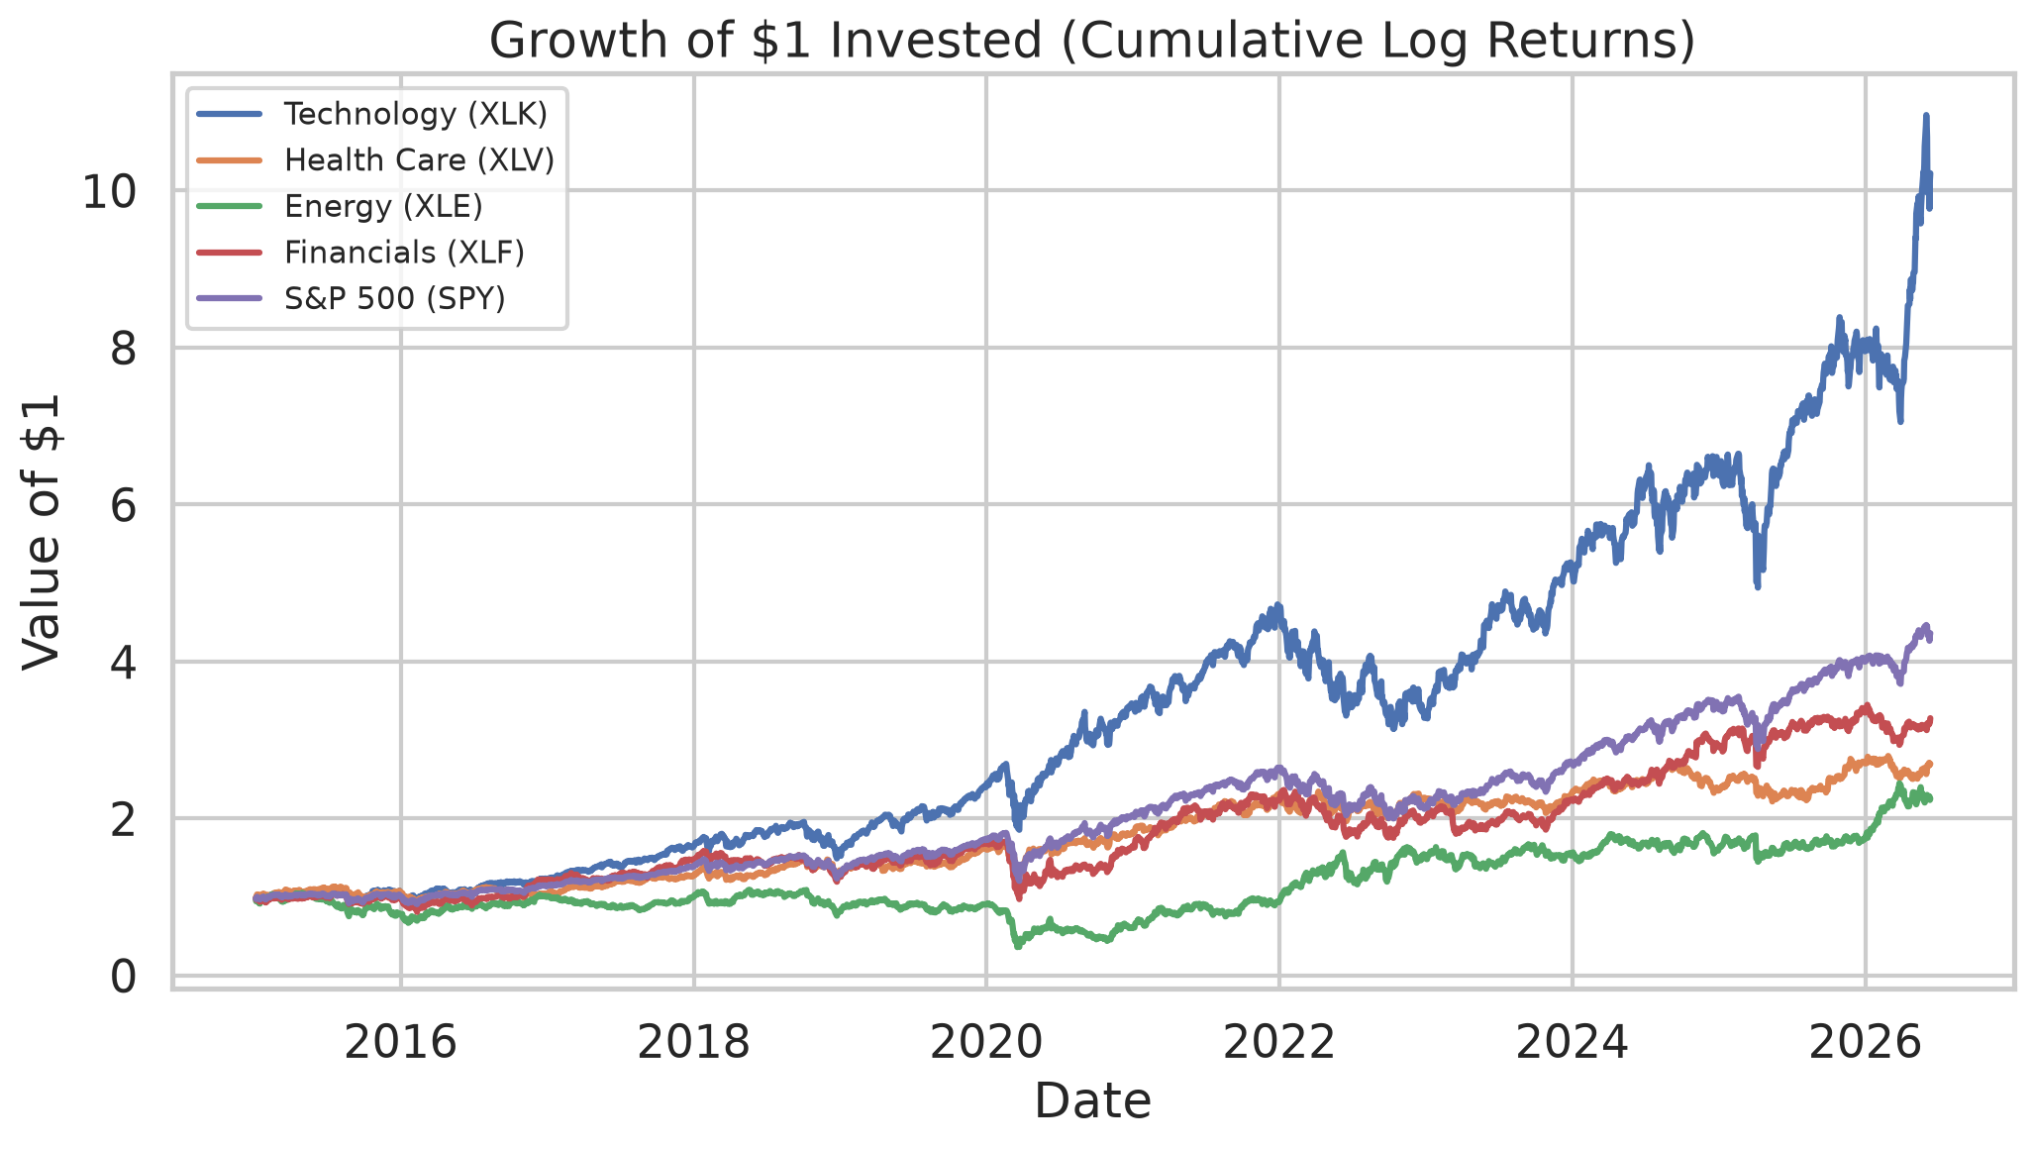
Figure 1. Growth of one dollar invested per asset (cumulative log returns).
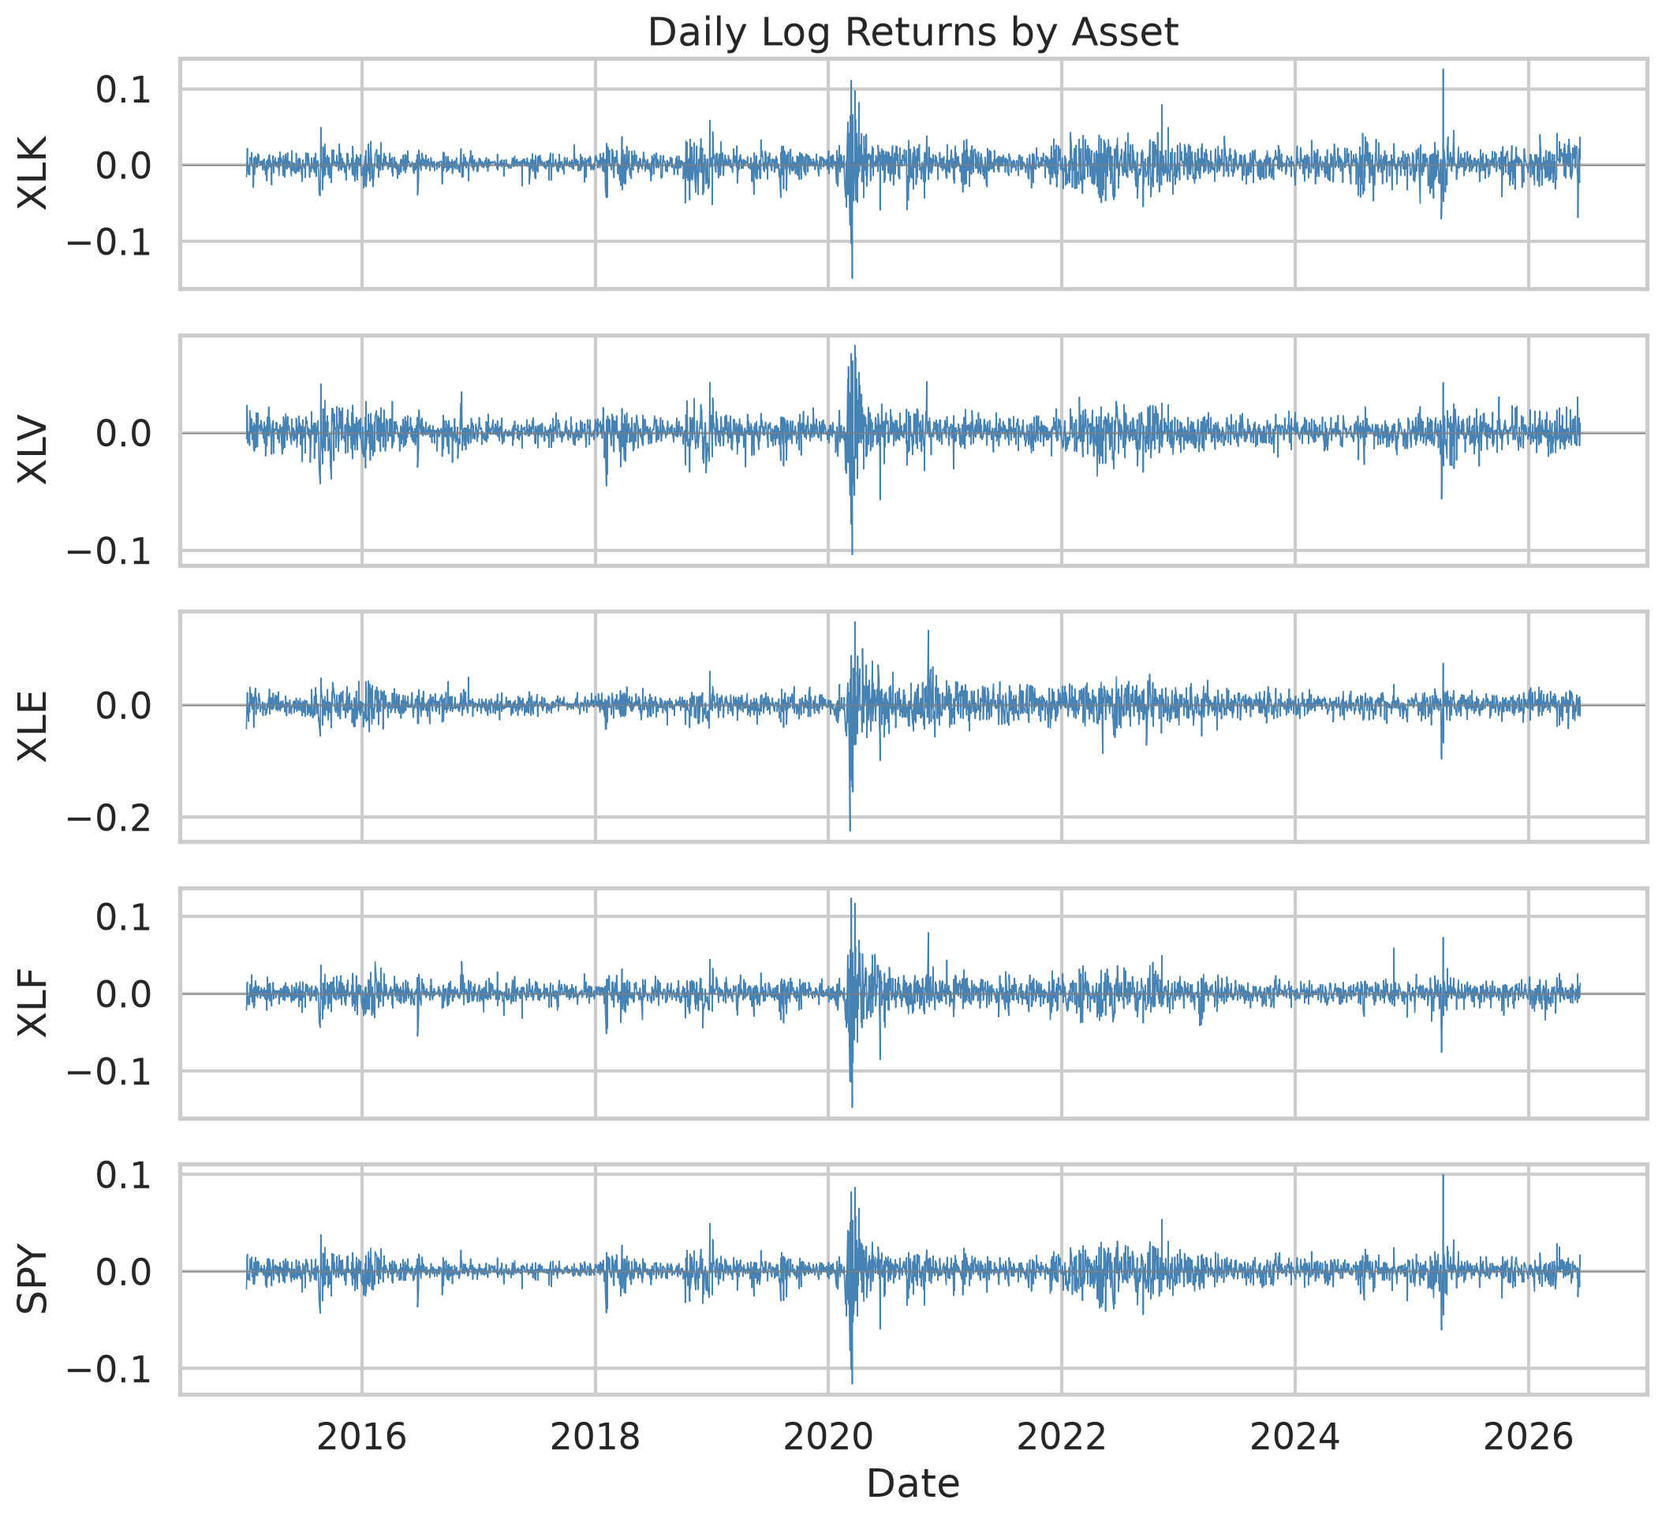
Figure 2. Daily log returns by asset.

3. Methodology

3.1 Correlation-structure analysis
For each trading day we estimate the Pearson correlation between every pair of the four sector ETFs over a trailing 90-day window (within the 60–120-day range common in the literature). With four sectors there are C(4,2) = 6 pairs; their mean is the day’s average pairwise cross-sector correlation. Over the full sample the sectors are strongly co-moving (Figure 3).
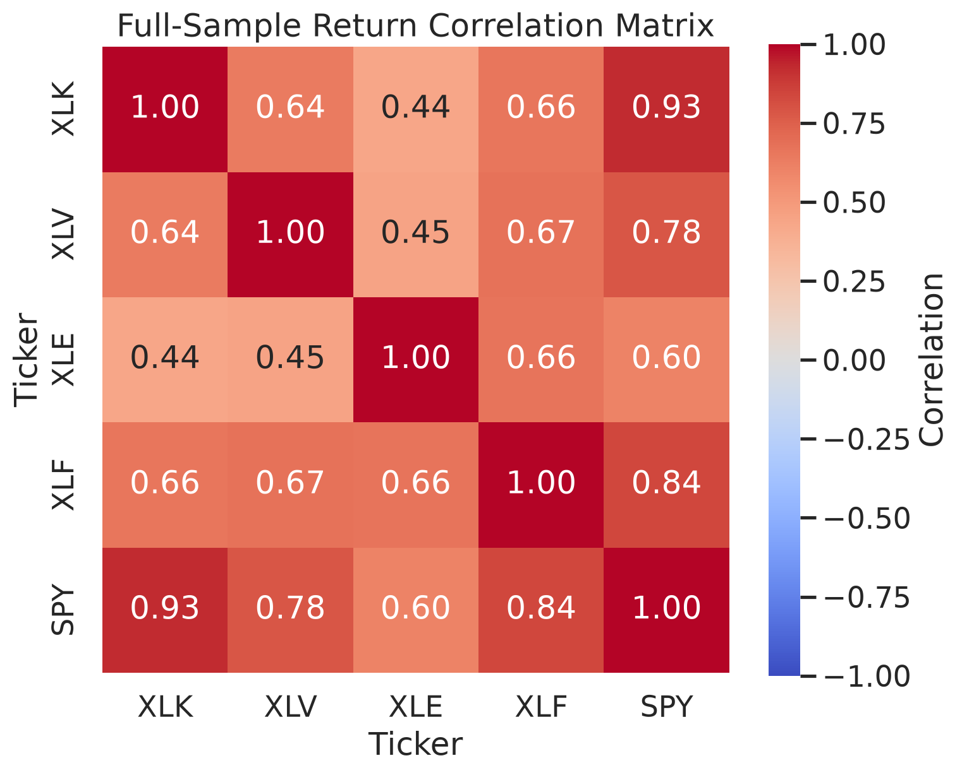
Figure 3. Full-sample return correlation matrix.
Regime classification. Using the empirical distribution of the average correlation over the full sample, we label each day high (≥ 75th percentile, threshold ≈ 0.670), low (≤ 25th percentile, threshold ≈ 0.337), or mid. This yields 697 high, 697 low, and 1,394 mid days. Figure 4 shows the correlation series with the regime bands; high-correlation episodes cluster around well-known stress periods (the 2018 volatility spike, the 2020 COVID crash, the 2022 drawdown), while the later part of the sample is markedly less correlated. Figure 5 shows the resulting regime label for each day.
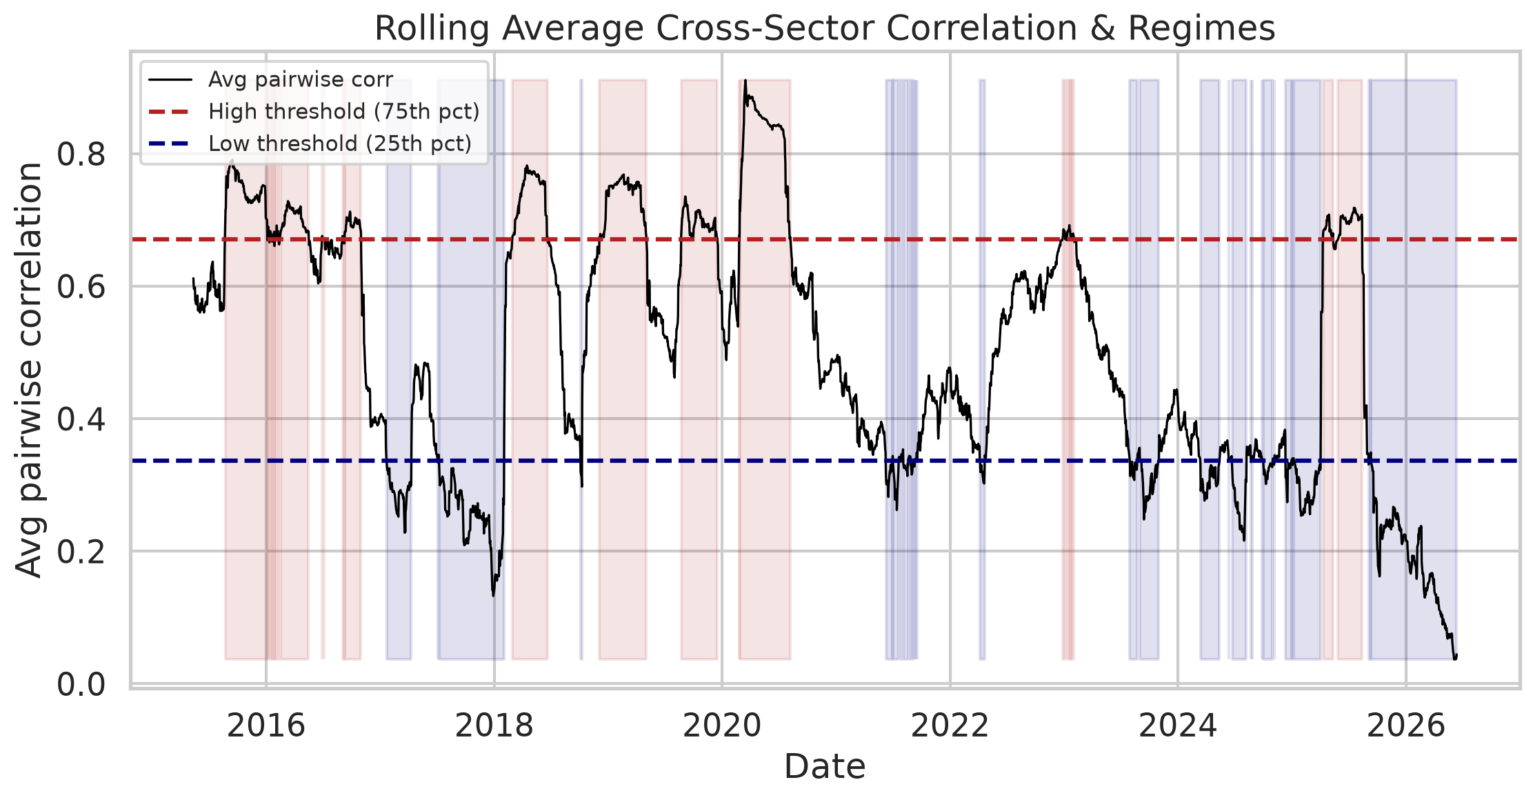
Figure 4. Rolling average cross-sector correlation with high/low regime shading.
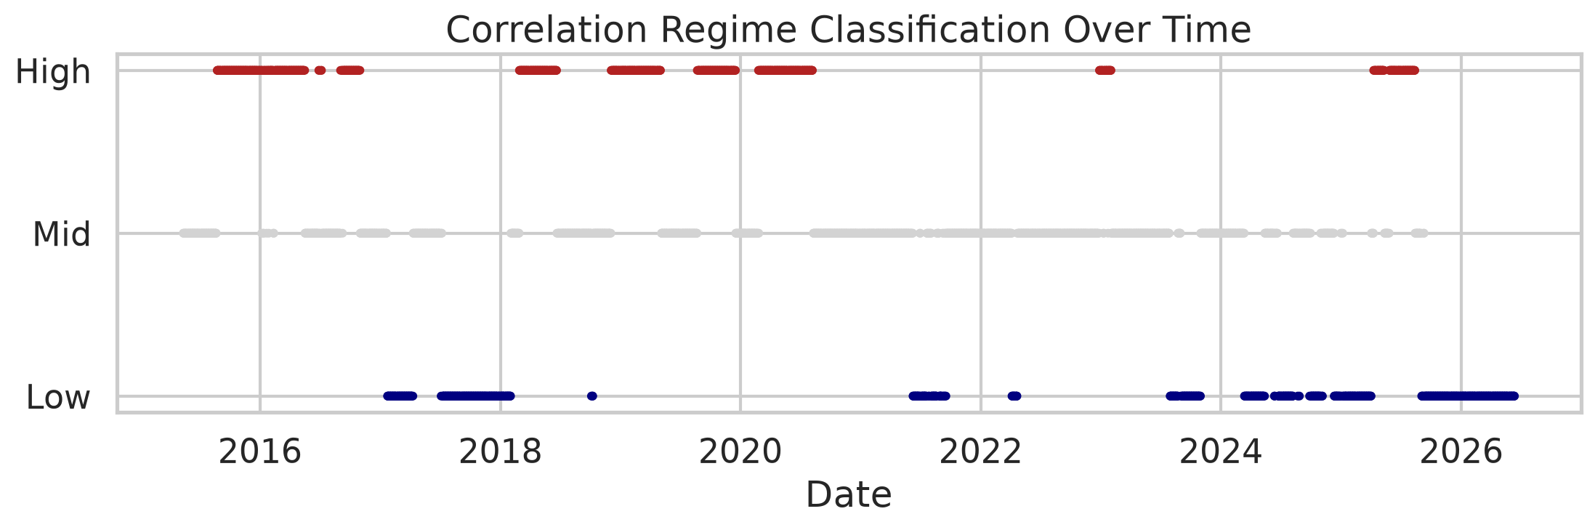
Figure 5. Correlation regime classification over time.
Principal Component Analysis. As a complementary market-wide co-movement gauge we run PCA on the standardized sector returns. Over the full sample the first principal component explains 69.3% of total variance (PC1+PC2 = 85.0%), confirming a single dominant systematic factor. A rolling PC1 variance share (Figure 6) tracks the average correlation closely.
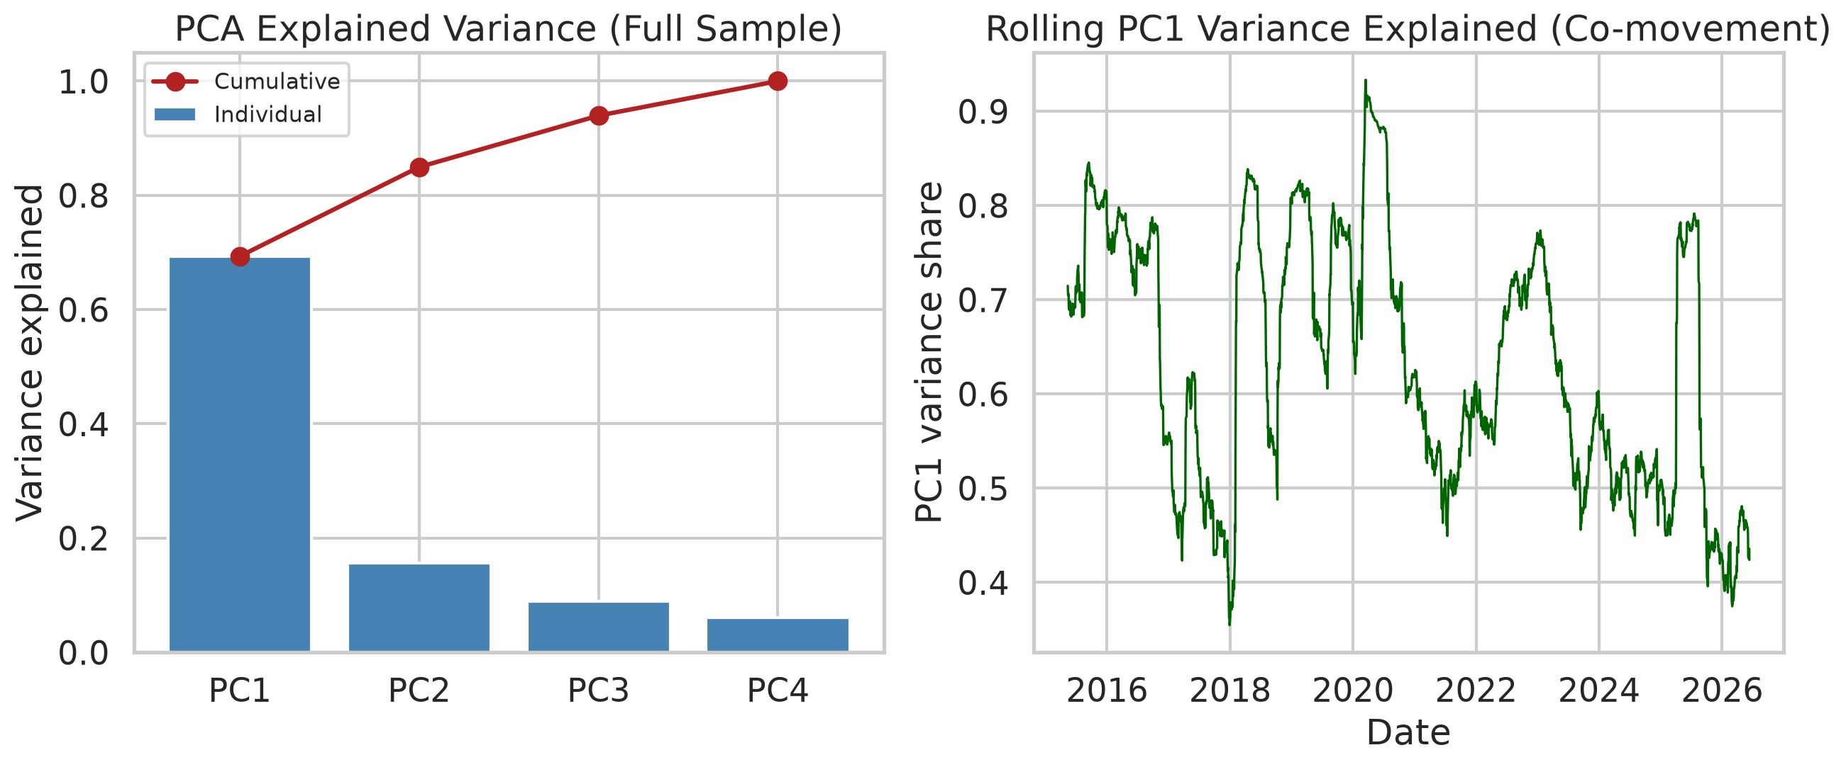
Figure 6. PCA explained variance (scree) and rolling PC1 co-movement.

3.2 Forecasting models
All models generate one-step-ahead, walk-forward, out-of-sample forecasts.
Model | Specification
RandomWalk (Model A) | ${\hat{P}}_{t}=P_{t−1}$ (predicted return = 0); naive direction = sign of the previous return
AR(1) (Model B) | $r_{t}$ on a single lag $r_{t−1}$
LinearRegression (Model C) | $r_{t}$ on lags $r_{t−1},…,r_{t−5}$
Ridge (extension) | Model C’s design matrix with an L2 penalty (α = 1.0)
Lasso (extension) | Model C’s design matrix with an L1 penalty (α = 5×10⁻⁴)
Predicted returns are converted to a price forecast via ${\hat{P}}_{t}=P_{t−1} e^{{\hat{r}}_{t}}$. The random walk is a deliberately demanding benchmark: beating a no-change forecast out of sample is known to be hard for short-horizon equity returns (Campbell and Thompson, 2008).
No look-ahead bias. For each day t the model is fit only on data through t−1 using a 252-day rolling training window (≈ one trading year). The rolling correlation series, the 252-day training window, and the regime boundaries are all computed using data strictly up to t−1; nothing on day t enters any quantity used to forecast day t.
On the regularized models and their penalties. Ridge and Lasso are included because regularized linear models are a standard, well-motivated linear benchmark in empirical asset pricing, where shrinkage methods have been systematically evaluated as part of the machine-learning toolkit (Gu, Kelly, and Xiu, 2020, who report that nonlinear methods can improve further still). We do not tune the penalties: the sample begins in January 2015, so there is no earlier validation window to tune on without either introducing look-ahead bias or sacrificing data. We therefore fix the penalties at conventional defaults (Ridge α = 1.0; Lasso α = 5×10⁻⁴) and, rather than claim a tuned optimum, provide an explicit alpha-robustness check (Section 4.6) showing the regime finding does not hinge on the exact penalty.

3.3 Evaluation metrics
For each model, regime, and asset we compute MAE and RMSE of the return forecast, the same for the price forecast, and directional accuracy (fraction of days the predicted return sign matches the realized sign; zero-return days excluded). Errors are pooled across the five assets and tagged by the regime of each day.
Why return-space errors, not price-MAE? Price levels drift over the sample, so a raw price MAE conflates forecasting difficulty with the price level on a given day. The absolute return error is comparable across assets and regimes.
A caution about MAE that shapes the whole analysis. Because every model predicts a return close to zero (the random walk predicts exactly zero), the absolute return error is nearly equal to the size of the realized move — i.e. it tracks realized volatility almost by construction, and realized volatility is itself persistent and clustered (Engle, 1982; Bollerslev, 1986). Return-MAE is therefore not invariant to volatility, and any “volatility explains the error” result in Section 4 is partly mechanical. The metric that is genuinely invariant to move size is directional accuracy: getting the sign right is neither easier nor harder simply because moves are large. We treat directional accuracy as the load-bearing, non-trivial test (Section 4.5).

3.4 Hypothesis testing
For each model we compare absolute return errors in the high vs low regime using Welch’s t-test (unequal variance) and the Mann–Whitney U test (distribution-free, robust to the heavy-tailed error distribution). More broadly, formally testing whether one set of forecasts is more accurate than another is the problem introduced by Diebold and Mariano (1995); here we compare a single model’s errors across regimes rather than two models against each other. Directional accuracy is compared with a two-proportion z-test — a simple sign-based assessment in the spirit of the directional-predictability test of Pesaran and Timmermann (1992) — and we report Cohen’s d as a standardized effect size.
Caveat on independence. The pooled observations are not independent — regimes persist for many consecutive days and the five assets are correlated — so the extremely small p-values below overstate the true statistical certainty. We report them for transparency but do not lean on their magnitude; the confound analysis in Section 3.5, which uses HAC standard errors, is the more rigorous inferential test.

3.5 Confound analysis: correlation vs. volatility
This is the paper’s core robustness section. To separate a genuine correlation effect from a volatility effect, we:
- Add a volatility proxy — 90-day annualized realized volatility of SPY (realized volatility in the sense of Andersen, Bollerslev, Diebold, and Labys, 2003), computed through day t−1 (a VIX-based proxy was considered but is not used here, to keep the pipeline fully reproducible from the price data alone).
- Regress the daily mean absolute error on the lagged predictors (both z-scored), using Newey and West (1987) heteroskedasticity- and autocorrelation-consistent (HAC) standard errors with 21 lags to account for the strong persistence of the series:
$$|\text{error}|_{t}=b_{0}+b_{1} {\text{corr}}_{t−1}+b_{2} {\text{vol}}_{t−1}+e_{t}.$$
- We estimate three specifications — correlation only, volatility only, and joint — so the shrinkage of $b_{1}$ when volatility is added is directly visible.
- Build a 2×2 double sort — Low/High correlation (25th/75th percentile) × Low/High volatility (median split) — and report MAE and directional accuracy in each cell. The critical comparison is high-volatility/low-correlation vs high-volatility/high-correlation, which isolates the correlation effect with volatility held high.

4. Results

4.1 Descriptive accuracy by regime
Pooled return-error metrics and directional accuracy by model and regime (full table in results/metrics_by_regime.csv):
Model | Regime | MAE (return) | RMSE (return) | Directional accuracy
RandomWalk | high | 0.01162 | 0.01924 | 46.6%
RandomWalk | low | 0.00734 | 0.01009 | 50.6%
AR(1) | high | 0.01157 | 0.01915 | 50.6%
AR(1) | low | 0.00734 | 0.01013 | 52.0%
LinearRegression | high | 0.01209 | 0.02032 | 49.3%
LinearRegression | low | 0.00746 | 0.01027 | 50.6%
Ridge | high | 0.01162 | 0.01925 | 51.1%
Ridge | low | 0.00732 | 0.01012 | 53.1%
Lasso | high | 0.01163 | 0.01928 | 50.9%
Lasso | low | 0.00732 | 0.01011 | 53.2%
Descriptively, errors are roughly 58–62% larger in the high-correlation regime for every model, and directional accuracy is lower — falling to chance or below (the naive random-walk direction is 46.6%, worse than a coin flip, in the high regime). Figure 7 shows a representative predicted-vs-actual price track.
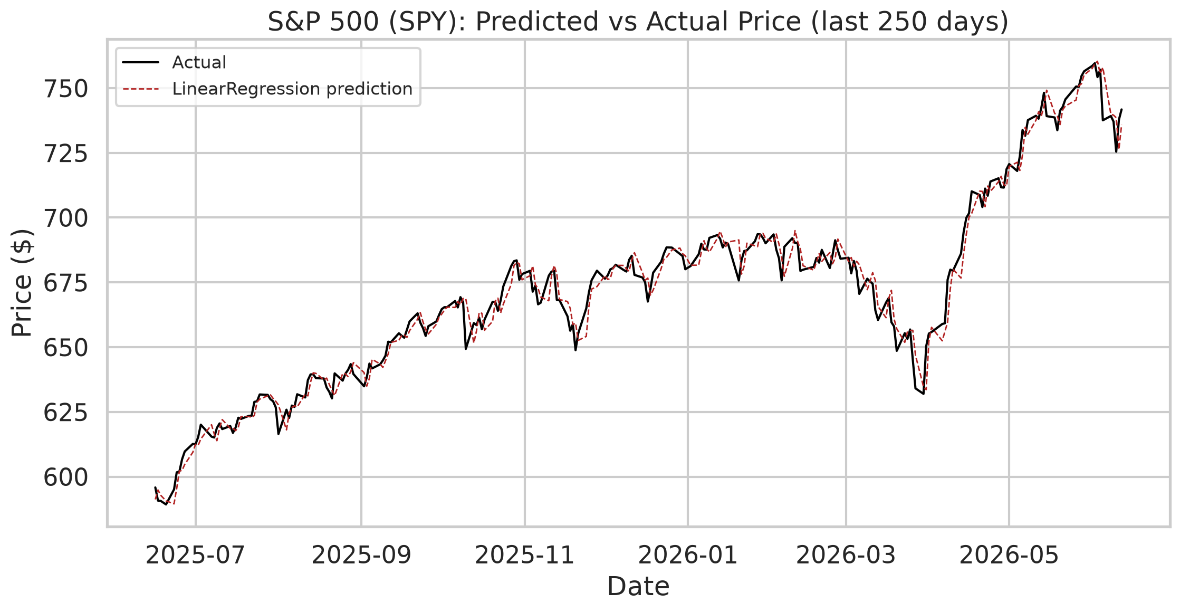
Figure 7. Predicted vs actual SPY price (linear regression, last 250 trading days).

4.2 Hypothesis tests (high vs low regime)
Model | Mean |err| high | Mean |err| low | Welch t p-value | Mann–Whitney p-value | Cohen’s d
RandomWalk | 0.01162 | 0.00734 | 2.3×10⁻⁴⁴ | 2.0×10⁻²⁹ | 0.37
AR(1) | 0.01157 | 0.00734 | 1.2×10⁻⁴³ | 3.0×10⁻²⁸ | 0.37
LinearRegression | 0.01209 | 0.00746 | 3.4×10⁻⁴⁶ | 4.5×10⁻³³ | 0.38
Ridge | 0.01162 | 0.00732 | 2.1×10⁻⁴⁴ | 4.0×10⁻³⁰ | 0.37
Lasso | 0.01163 | 0.00732 | 1.1×10⁻⁴⁴ | 1.8×10⁻³⁰ | 0.37
Both tests reject H₀ for every model (small-to-medium effect, Cohen’s d ≈ 0.37). The error distributions for the two regimes are compared in Figure 8. Taken at face value this says accuracy is not independent of the correlation regime. Section 4.3 shows why that face-value reading is misleading.
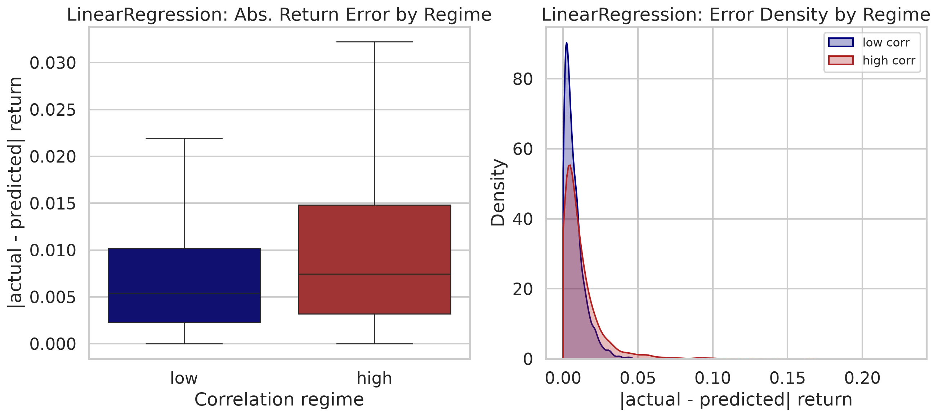
Figure 8. Absolute return-error distribution: high vs low correlation regime.

4.3 The confound: correlation vs. volatility (the key result)
In our sample, lagged correlation and lagged volatility are strongly collinear: r = 0.64 (Figure 9). The regression of daily mean absolute error on the two lagged predictors (z-scored; Newey–West SE, 21 lags; n = 2,620) is decisive. Results are near-identical across models; the LinearRegression row is representative (full table in results/confound_regression.csv):
Specification | b (correlation) | p (corr) | b (volatility) | p (vol) | R²
Correlation only | +0.00190 | 0.017 | — | — | 0.045
Volatility only | — | — | +0.00309 | 5.3×10⁻⁵ | 0.119
Joint | −0.00015 | 0.794 | +0.00319 | 6.0×10⁻⁶ | 0.119
The pattern is the same for all five models: in the joint specification the correlation coefficient is statistically insignificant (p ≈ 0.72–0.79 across models) and economically ≈ 0 (it even flips slightly negative), while volatility remains highly significant (p ≈ 3–6×10⁻⁶). Adding correlation on top of volatility moves R² by essentially nothing (0.1189 → 0.1190 for the linear model; the joint R² ranges 0.109–0.119 across the five models). In plain terms: once volatility is accounted for, the correlation regime tells us nothing more about the error magnitude. The significant marginal association in Sections 4.1–4.2 is a volatility effect wearing a correlation costume.
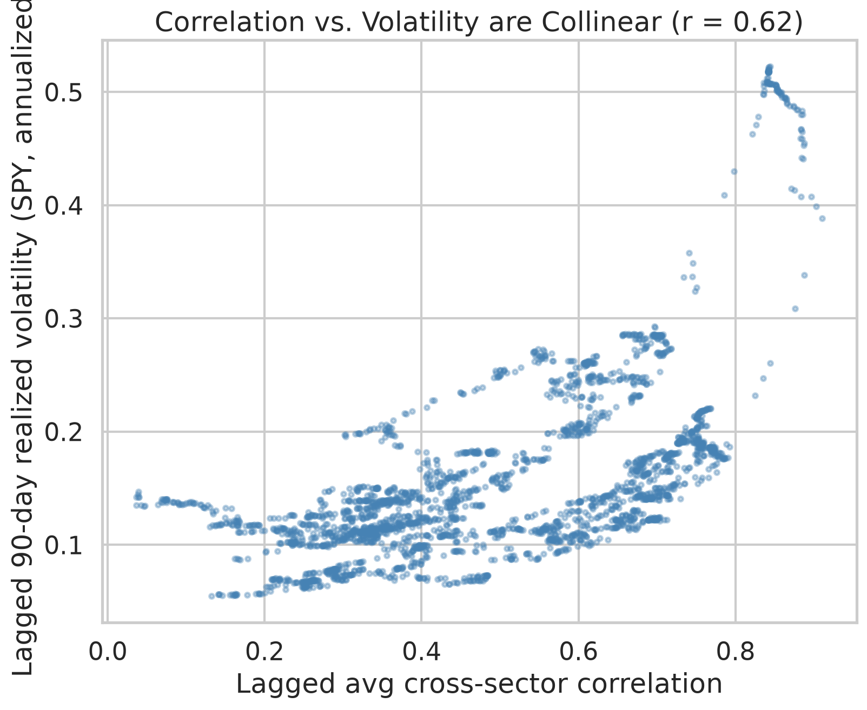
Figure 9. Lagged correlation vs lagged volatility — the two are collinear (r = 0.64).
One caveat we return to below: the dependent variable here is absolute return error, which — because forecasts are near zero — is close to the size of the move itself. So this regression establishes that the correlation effect is spurious, but the surviving volatility coefficient is partly mechanical and should not be read as “volatility predicts skill.” Section 4.5 puts that to a scale-free test.

4.4 Double sort (volatility held fixed)
The 2×2 sort tells the same story visually and numerically. Cells use lagged correlation quartiles (thresholds 0.337 / 0.670) and a lagged-volatility median split (0.137). LinearRegression shown (all models in results/double_sort.csv; Figure 10):
 | Low volatility | High volatility
Low correlation | MAE 0.00734 (n=3,095) | MAE 0.01032 (n=390)
High correlation | MAE 0.00657 (n=250) | MAE 0.01216 (n=2,760)
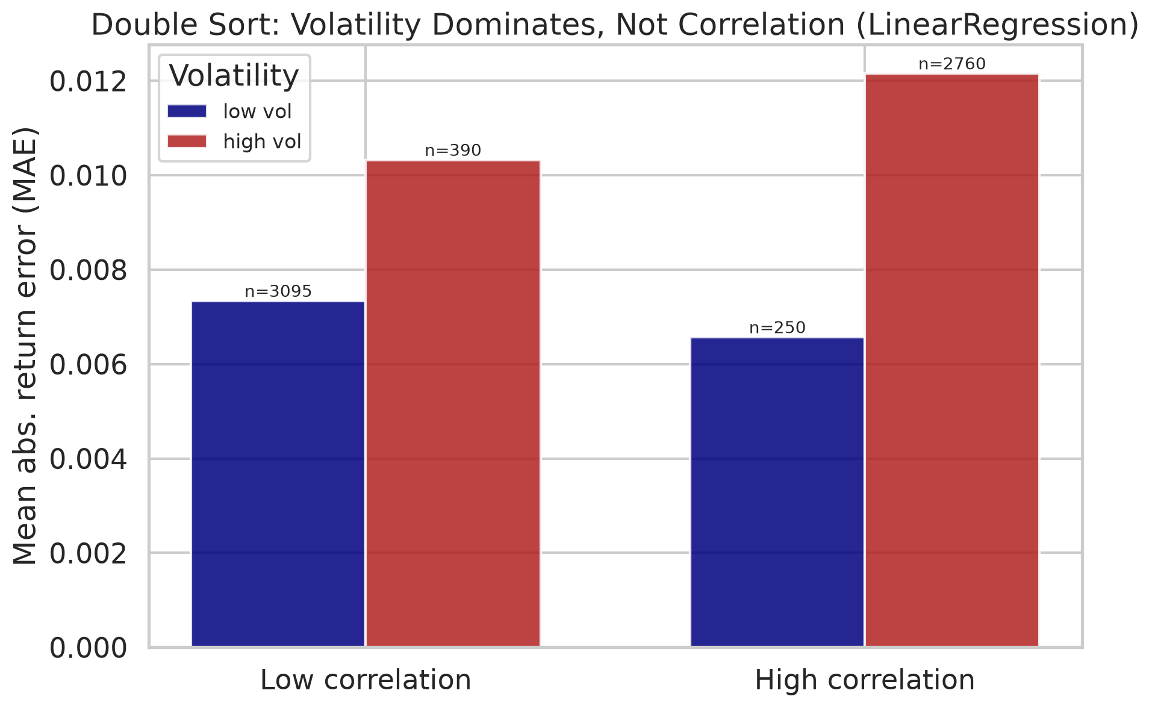
Figure 10. 2×2 double sort of mean absolute error — volatility dominates, not correlation.
Two things stand out. First, volatility dominates: moving from low to high volatility roughly doubles MAE within each correlation column (e.g. within low-correlation, +41%; within high-correlation, +85%). Second, the correlation effect is inconsistent once volatility is fixed: within the low-volatility row, high correlation actually has a lower MAE than low correlation (0.00657 vs 0.00734), whereas within the high-volatility row it is somewhat higher (0.01216 vs 0.01032). The sign flips — the hallmark of a variable with no robust independent effect.
Two honest caveats on the double sort: (i) the off-diagonal cells are thin (n = 250 and 390) precisely because correlation and volatility co-move, so those means are noisier; and (ii) within the coarse “high-volatility” bucket the high-correlation days still tend to be the very highest-volatility days, which is why a residual gap remains there. The continuous-control regression in Section 4.3, which does not suffer from a coarse split, is the cleaner test and attributes that residual gap to volatility. But note again that all of these cells are measured in MAE — the metric that tracks move size. Section 4.5 asks whether the pattern survives on a metric that does not.

4.5 Directional accuracy: the scale-free test (the load-bearing result)
MAE is contaminated by the mechanical link to move size, so the honest question is whether the models get the direction right more often in any regime — a metric that does not inflate with volatility. We re-ran the 2×2 double sort using directional accuracy for all five models (full table in results/double_sort.csv):
Model | Low-corr / Low-vol | Low-corr / High-vol | High-corr / Low-vol | High-corr / High-vol
RandomWalk | 51.7% | 45.2% | 45.5% | 46.8%
AR(1) | 52.2% | 53.0% | 52.8% | 50.5%
LinearRegression | 51.1% | 48.8% | 50.8% | 48.7%
Ridge | 53.3% | 53.0% | 48.4% | 51.7%
Lasso | 53.5% | 52.4% | 48.4% | 51.4%
Here the strong story dissolves. Every number sits between 45% and 54% — a whisker around the 50% coin-flip. No model is meaningfully skillful in any cell, and the naive random walk’s direction rule is actually below 50% in three of four cells. Crucially, the clean volatility ordering that dominated the MAE results does not reappear: for Ridge and Lasso the worst cell is high-correlation/low-volatility (48.4%), not a high-volatility cell, and AR(1) is essentially flat everywhere. Because correlation and volatility are collinear, their marginal orderings coincide (both “low” cells edge out their “high” counterparts by ~1–5 percentage points), and this scale-free metric cannot cleanly credit either one.
The honest reading is therefore weaker than the MAE tables suggest, and we state it plainly: on the metric that is not mechanically inflated by volatility, there is little genuine directional skill to allocate to any regime. The models are near coin-flips throughout. This is the load-bearing evidence, and it disciplines every claim in the Discussion. Figure 11 shows the directional accuracy by model and regime.
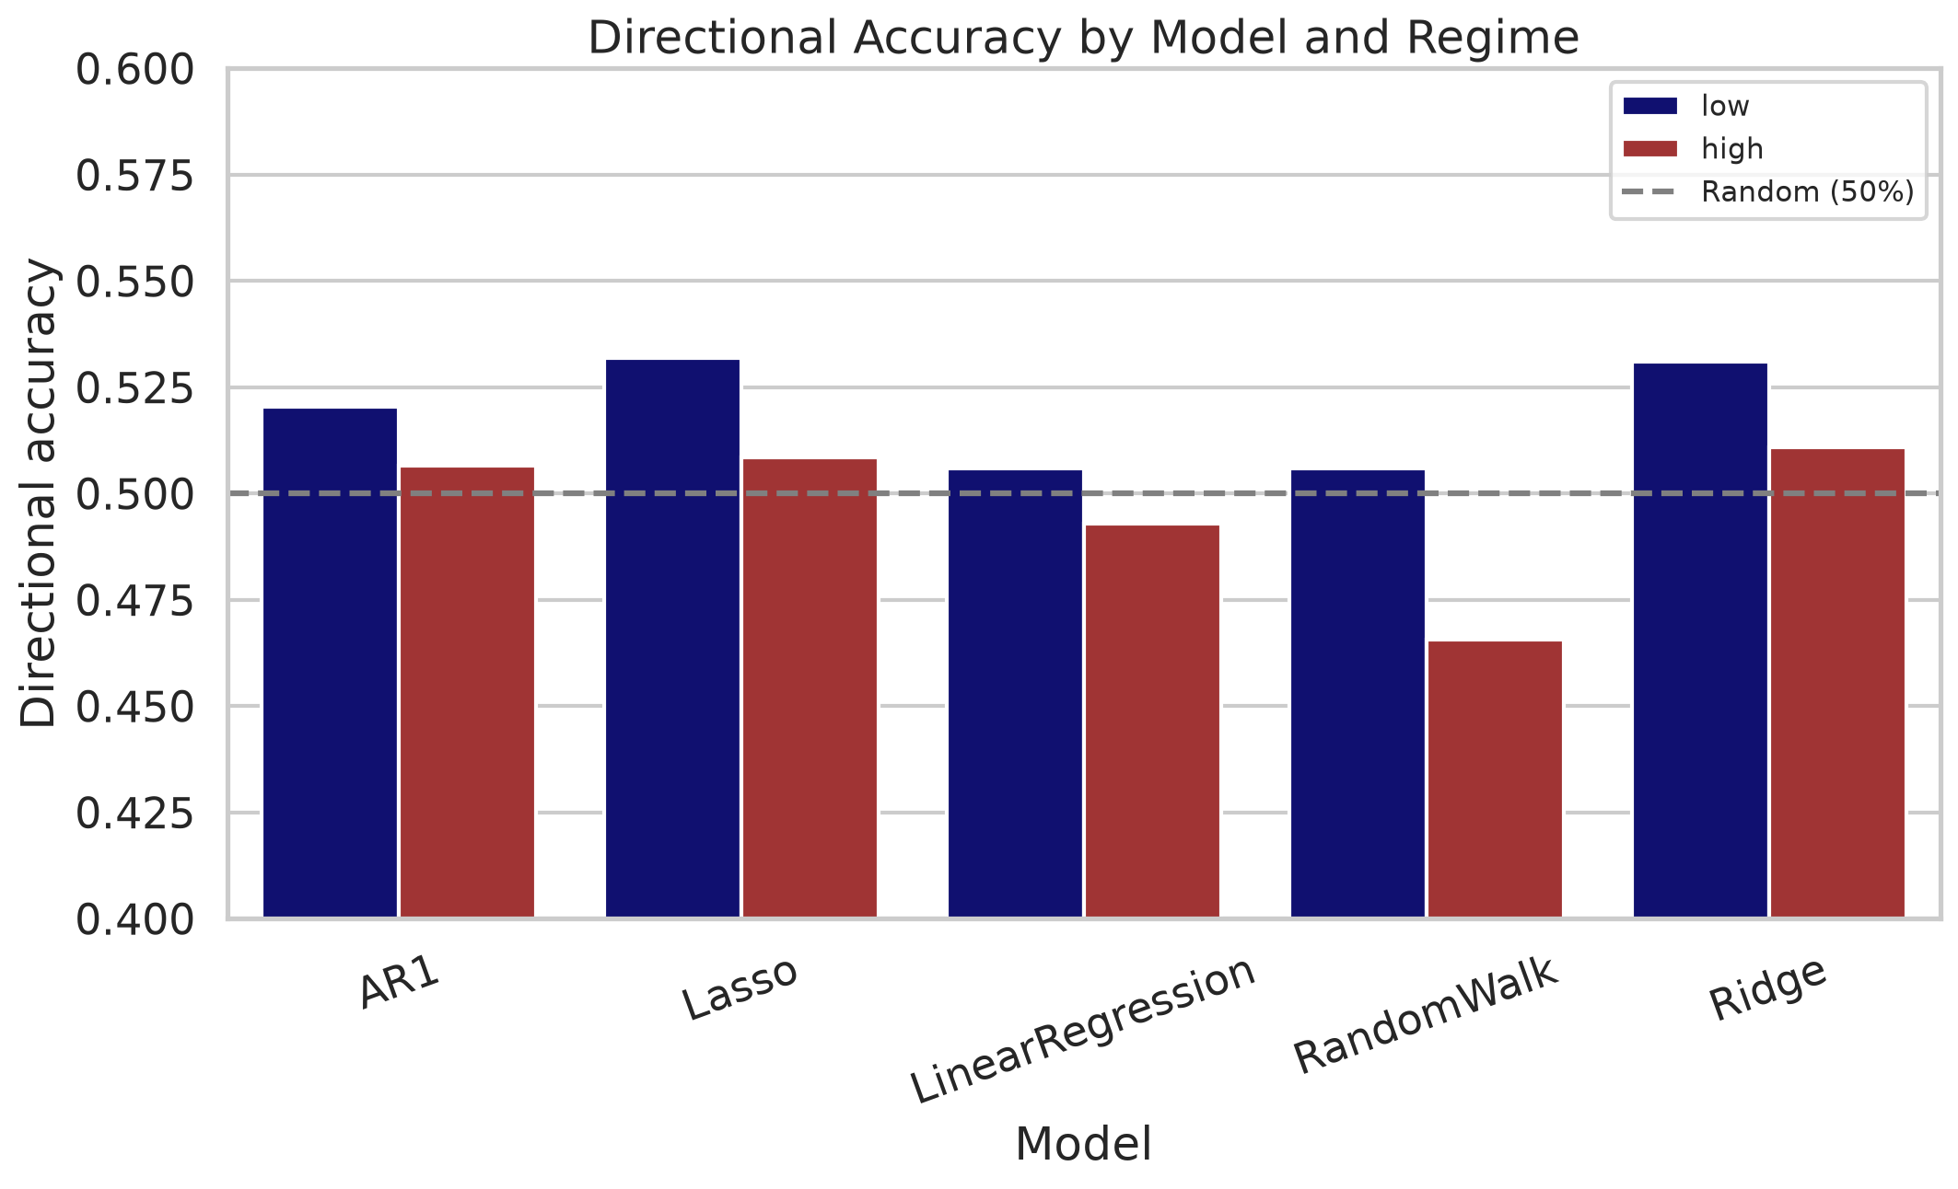
Figure 11. Directional accuracy by model and correlation regime (dashed line = 50% chance).

4.6 Alpha robustness
To confirm the regularized-model results are not an artifact of the chosen penalties, we re-ran Ridge and Lasso on SPY across an alpha grid (full table in results/alpha_robustness.csv). The high/low-regime MAE ratio is flat:
Model | α values | high/low MAE ratio
Ridge | 0.1, 1.0, 10.0 | 1.70, 1.71, 1.72
Lasso | 1×10⁻⁴, 5×10⁻⁴, 1×10⁻³ | 1.71, 1.72, 1.72
The descriptive regime gap is essentially invariant to the penalty, so nothing in the paper depends on a specific tuned alpha. (These SPY-only ratios differ in level from the pooled five-asset figures because they cover a single asset; the point is their stability across α.)

5. Discussion
These results have to be read carefully, because two different things are true at two different levels of rigor.
On error magnitude, the correlation effect is a volatility artifact. The descriptive regime effect is real — errors genuinely are ~60% larger in high-correlation regimes — but it is not evidence of a correlation mechanism. Once we control for volatility with a lagged, look-ahead-free proxy, the correlation regime adds no explanatory power (joint p ≈ 0.72–0.79), and the double sort shows the correlation effect changing sign across volatility buckets. This is exactly the trap Forbes and Rigobon (2002) identified: because measured correlation is mechanically higher when volatility is higher, an apparent “correlation regime effect” can be a volatility effect in disguise. Forbes and Rigobon studied cross-country contagion rather than cross-sector co-movement; we extend their heteroskedasticity-bias mechanism to a cross-sector, forecasting setting, which is a natural analogy rather than a like-for-like replication of their result.
But we must not over-claim the volatility side either. The surviving volatility coefficient is measured on absolute return error, and because our forecasts are near zero, that error is close to the size of the move itself — so “volatility explains the error” is partly mechanical, not a discovery about forecast skill. This is precisely why we lean on directional accuracy (Section 4.5), a metric that is invariant to move size. On that metric the strong story evaporates: skill sits between 45% and 54% in every cell, the volatility ordering does not cleanly reappear (for Ridge/Lasso the worst cell is low-volatility), and neither correlation nor volatility earns a robust edge. In other words, there is little genuine directional predictability in any regime to begin with — consistent with the broader evidence that short-horizon equity returns are hard to forecast out of sample (Welch and Goyal, 2008; Campbell and Thompson, 2008). The signal-to-noise intuition from the introduction is best restated as a null: the sector-specific signal these linear models can exploit is faint everywhere, and no regime turns it into a reliable edge.
Practical implication. The usable takeaway is modest and honest. Volatility is the right variable to watch for how large forecast errors will be — it is observable at t−1 and dominates the error magnitude — and cross-sector correlation adds nothing beyond it. But large errors are not the same as lost skill: on a scale-free basis the models are near coin-flips regardless of regime, so neither correlation nor volatility should be sold as a switch that turns short-horizon forecasts on or off. The most defensible advice is to size positions by volatility and to distrust any single headline accuracy number.

5.1 Limitations
- Correlation and volatility cannot be fully separated observationally. They are collinear by nature (r = 0.64), and the cells that would most cleanly separate them (high-vol/low-corr, low-vol/high-corr) are the sparsest (n = 390, 250). Our conclusion — no independent correlation effect — is well supported by the continuous-control regression, but the double sort’s thin off-diagonal cells are a genuine data limitation.
- One volatility proxy. We use 90-day realized volatility of SPY. Alternative proxies (VIX, GARCH-based conditional volatility) could shift the exact coefficients, though the collinearity and the direction of the result are unlikely to reverse.
- Linear, short-horizon models only. Non-linear models (gradient boosting, LSTMs) might behave differently, though they face the same noisy data in high-volatility states.
- Equity ETFs, U.S. only, 2015–2026. Generalization to other asset classes, horizons, or periods is untested.
- Overlapping, dependent observations. The Section 4.2 p-values overstate certainty; the HAC-based Section 4.3 inference is the reliable one.
- MAE is partly mechanical. Because forecasts are near zero, absolute return error ≈ move size, so the volatility result on MAE is partly definitional. We rely on directional accuracy (Section 4.5) to avoid this trap — but that metric, being near 50% everywhere, offers little skill to explain in the first place.

5.2 Future work
Promising extensions: (i) a heteroskedasticity-corrected correlation measure à la Forbes and Rigobon to test whether volatility-adjusted correlation has any residual predictive content; (ii) a regime-switching / HMM regime definition (Hamilton, 1989; Ang and Bekaert, 2002) instead of static quartiles; (iii) adding non-linear forecasters and forecast-combination schemes, which have improved out-of-sample equity prediction elsewhere (Rapach, Strauss, and Zhou, 2010); and (iv) testing whether a volatility-aware meta-model (scaling back forecasts in high-volatility states) improves realized accuracy.

6. Conclusion
This study set out to test whether cross-sector correlation regimes shape the accuracy of equity forecasting models. The answer is more interesting than a simple yes: correlation regimes appear to matter enormously, but that appearance is a mirage — and the lesson is in how the mirage forms and how cheaply it dissolves.
Three findings, in order of what they teach:
- The naive result is striking and real — descriptively. Across five models and eleven years of data, short-horizon forecast errors are ~58–62% larger and directional accuracy falls to chance in high cross-sector correlation regimes. Every parametric and non-parametric test rejects the null that accuracy is independent of the regime. Taken alone, this looks like a clean, publishable “correlation kills predictability” story.
- That story does not survive contact with its own confound. High correlation is collinear with high volatility (r = 0.64), and estimated correlation is itself inflated by volatility (Forbes and Rigobon, 2002). When we control for a lagged, look-ahead-free volatility proxy, the correlation regime’s explanatory power vanishes — its coefficient falls to zero and loses significance (joint-regression p ≈ 0.72–0.79 across all models; R² unchanged), while volatility stays overwhelmingly significant (p ≈ 3–6×10⁻⁶). The double sort drives the point home: hold volatility fixed and the correlation effect shrinks to noise and even flips sign.
- What survives is a caveat, not a new predictor. Stripping away the correlation mirage does not leave a shiny “volatility predicts skill” result in its place — and claiming one would repeat the very mistake the paper warns against. Volatility dominates the error magnitude, but that is partly mechanical: with forecasts near zero, absolute error is essentially move size. On directional accuracy — the metric that does not inflate with volatility — skill is 45–54% in every regime, a whisker from a coin flip, with no clean ordering by volatility or correlation. The blunt truth is that there is little short-horizon directional predictability here for any regime to switch on or off, exactly as the out-of-sample predictability literature would lead us to expect (Welch and Goyal, 2008; Campbell and Thompson, 2008).
The real contribution is methodological, and it is the headline. A correlation-regime effect that looked statistically bulletproof — a ~60% error gap, p ≪ 0.001, replicated across five models and two tests — turned out to be a volatility shadow. The cure was cheap and decisive: add one lagged volatility control and read the coefficient (it fell to zero), then re-check on a scale-free metric (the pattern vanished). This generalizes. Regime studies that sort on correlation, dispersion, or breadth are all exposed to the same volatility confound, and often to a mechanical-metric trap on top of it. A tiny p-value certifies neither a real effect nor genuine forecast skill. Before believing a regime “controls” predictability, control for volatility and test on a metric that move size cannot inflate. When we did both, the impressive result dissolved — and saying so plainly is the point.

References
Andersen, T. G., T. Bollerslev, F. X. Diebold, and P. Labys. 2003. “Modeling and Forecasting Realized Volatility.” Econometrica 71 (2): 579–625. https://doi.org/10.1111/1468-0262.00418
Ang, A., and G. Bekaert. 2002. “International Asset Allocation With Regime Shifts.” The Review of Financial Studies 15 (4): 1137–1187. https://doi.org/10.1093/rfs/15.4.1137
Ang, A., and J. Chen. 2002. “Asymmetric Correlations of Equity Portfolios.” Journal of Financial Economics 63 (3): 443–494. https://doi.org/10.1016/S0304-405X(02)00068-5
Bollerslev, T. 1986. “Generalized Autoregressive Conditional Heteroskedasticity.” Journal of Econometrics 31 (3): 307–327. https://doi.org/10.1016/0304-4076(86)90063-1
Campbell, J. Y., and S. B. Thompson. 2008. “Predicting Excess Stock Returns Out of Sample: Can Anything Beat the Historical Average?” The Review of Financial Studies 21 (4): 1509–1531. https://doi.org/10.1093/rfs/hhm055
Cont, R. 2001. “Empirical Properties of Asset Returns: Stylized Facts and Statistical Issues.” Quantitative Finance 1 (2): 223–236. https://doi.org/10.1088/1469-7688/1/2/304
Diebold, F. X., and R. S. Mariano. 1995. “Comparing Predictive Accuracy.” Journal of Business & Economic Statistics 13 (3): 253–263. https://doi.org/10.1080/07350015.1995.10524599
Engle, R. F. 1982. “Autoregressive Conditional Heteroscedasticity with Estimates of the Variance of United Kingdom Inflation.” Econometrica 50 (4): 987–1008. https://doi.org/10.2307/1912773
Forbes, K. J., and R. Rigobon. 2002. “No Contagion, Only Interdependence: Measuring Stock Market Comovements.” The Journal of Finance 57 (5): 2223–2261. https://doi.org/10.1111/0022-1082.00494
Gu, S., B. Kelly, and D. Xiu. 2020. “Empirical Asset Pricing via Machine Learning.” The Review of Financial Studies 33 (5): 2223–2273. https://doi.org/10.1093/rfs/hhaa009
Hamilton, J. D. 1989. “A New Approach to the Economic Analysis of Nonstationary Time Series and the Business Cycle.” Econometrica 57 (2): 357–384. https://doi.org/10.2307/1912559
Newey, W. K., and K. D. West. 1987. “A Simple, Positive Semi-Definite, Heteroskedasticity and Autocorrelation Consistent Covariance Matrix.” Econometrica 55 (3): 703–708. https://doi.org/10.2307/1913610
Pesaran, M. H., and A. Timmermann. 1992. “A Simple Nonparametric Test of Predictive Performance.” Journal of Business & Economic Statistics 10 (4): 461–465. https://doi.org/10.1080/07350015.1992.10509922
Rapach, D. E., J. K. Strauss, and G. Zhou. 2010. “Out-of-Sample Equity Premium Prediction: Combination Forecasts and Links to the Real Economy.” The Review of Financial Studies 23 (2): 821–862. https://doi.org/10.1093/rfs/hhp063
Welch, I., and A. Goyal. 2008. “A Comprehensive Look at the Empirical Performance of Equity Premium Prediction.” The Review of Financial Studies 21 (4): 1455–1508. https://doi.org/10.1093/rfs/hhm014
Note on citations. All fifteen references were verified against publisher, Econometric Society, Wiley, or RePEc records, and each carries a resolvable DOI; every reference is attached to a specific claim it directly supports. Two page ranges that appear inconsistently across secondary indexes were resolved to the journal of record: Pesaran and Timmermann (1992) is 461–465 (the Taylor & Francis record; a RePEc handle mis-encodes it as 561–565), and Engle (1982) is 987–1008 (the Econometric Society closing page; some JSTOR headers show 987–1007).

Appendix A — Reproducibility
pip install -r requirements.txt
python -m src.main # main pipeline: data, regimes, models, metrics, tests, figures
python -m src.confound_analysis # volatility-confound regressions, double sort, alpha robustness
Key parameters (date range, correlation window, regime quantiles, model hyperparameters) are centralized in src/config.py. The annotated notebook notebooks/research_analysis.ipynb walks through the analysis interactively.

Appendix B — Output artifacts
Artifact | Location
Raw adjusted-close prices | data/raw/adj_close_prices.csv
Cleaned prices & log returns | data/processed/
Rolling correlations & regimes | data/processed/regimes.csv, rolling_pairwise_corr.csv
Lagged predictors (corr, vol) | data/processed/lagged_predictors.csv
Summary statistics | results/summary_statistics.csv
Accuracy by regime / per asset | results/metrics_by_regime.csv, metrics_per_asset.csv
Hypothesis tests | results/hypothesis_tests.csv
Confound regressions | results/confound_regression.csv
2×2 double sort | results/double_sort.csv
Alpha robustness | results/alpha_robustness.csv
PCA variance | results/pca_static_variance.csv
Figures 1–11 (inline in the paper; source PNGs) | figures/

