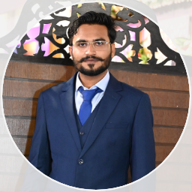

SAEED IQBAL

|  |  |  |
| --- | --- | --- |
|  | Personal Info |  |
|  |  |
| Name : Saeed Iqbal  Father Name : Muhammad Iqbal Cast : Channa  NIC : 41204-3211491-1  Domicile: Kotri  District : Jamshoro  Contact No: 0342-0744885  Email : iqbalsaeed84@gmail.com Address : Shah Latif Colony Kotri Jamshoro | | |

|  |  |  |
| --- | --- | --- |
|  | Education |  |
|  |  |
| SSC  Ishat-ul- Islam High School  kotri Jamshoro  2013  Diploma In Electronics  3 Year  2016 | HSC  Degree College Of Kotri Jamshoro 2015  Diploma In Software Engineering  3 Year  Aptech  2018 | Graduation  BS Information Technology  University Of Sindh  4 Year  2021 |

|  |  |  |
| --- | --- | --- |
|  | Key Skills |  |
|  |  |
| * PHP Developer * PHP Laravel * Wordpress * My Sql * HTML 5 * CSS3 * Javascript |  |  |

|  |  |  |
| --- | --- | --- |
|  | Languages |  |
|  |  |

* Sindhi
* English
* Urdu

|  |  |  |
| --- | --- | --- |
|  | Experience |  |
|  |  |
| Apex  (Computer Education)  As Teacher  2018 (6 Months) | GBS  (Ghani Business Solution)  Internship  2022 (2 Months) | Wamtsol  (Digital And Technology)  As Php & Laravel Developer  2020 (4 Months) |
| GBS  (Ghani Business Solution)  As Php Laravel & Wordpress Developer  2022(Currently Work) |  |  |