Assignment – 02

Question – WAP to calculate the GCD Number using normal loop and with Euclidean method and then compare their complexities.

Using while Loop method

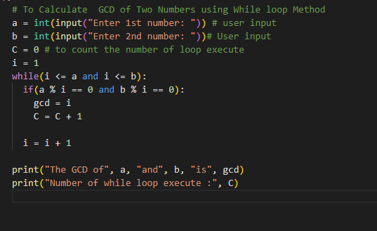

Output

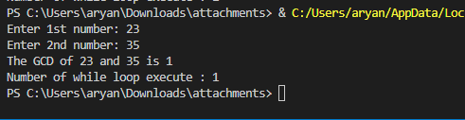

Using Euclidean method

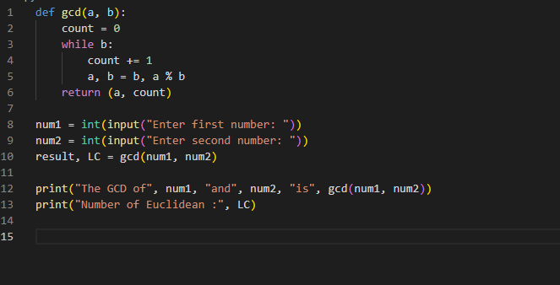

Output

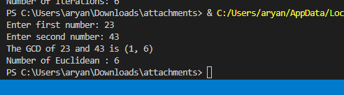

Analysis

I provided will return the correct GCD of two numbers, but the second one using Euclidean algorithm is considered to be more efficient and faster than the first one.

The first program uses a while loop to repeatedly apply the Euclidean algorithm until the remainder is 0. While this method is simple and easy to understand, it can take a long time to find the GCD of large numbers because the loop will continue to run until the remainder is zero.

The second program uses recursion to apply the Euclidean algorithm. This method is more efficient because it reduces the number of operations required to find the GCD by repeatedly applying the algorithm until one of the numbers becomes zero. The Euclidean algorithm reduces the problem size on each step by dividing the larger number by the smaller number, and this leads to a faster convergence to the final solution. This method is usually faster for large numbers.

Overall, the second program using the Euclidean algorithm is considered to be more efficient and faster than the while loop