*2. To prepare the Schema-Document of below SCD’s. (Specify the Columns out of the above Tables for better Candidate for it).*

*a. Type I changing Dimension*

*b. Type II changing Dimension*

*c. Type III changing Dimension*

*Type1 – SCD Type 1 changing Dimension*

|  |  |
| --- | --- |
| ***Column*** | ***Data Type*** |
| *UserID* | *INT* |
| *Username* | *VARCHAR (50)* |
| *Email* | *VARCHAR (100)* |
| *First Name* | *VARCHAR (50)* |
| *Last Name* | *VARCHAR (50)* |
| *Age* | *INT* |
| *Gender* | *VARCHAR (10)* |
| *Location* | *VARCHAR (100)* |
| *Subscription Status* | *VARCHAR (20)* |

1. *User Profile table -*
2. *User Play History:*

|  |  |
| --- | --- |
| ***Column*** | ***Data Type*** |
| *PlayID* | *INT* |
| *UserID* | *INT* |
| *SongID* | *INT* |
| *Timestamp* | *TIMESTAMP* |
| *Duration* | *INT* |

1. *Playlist:*

|  |  |
| --- | --- |
| ***Column*** | ***Data Type*** |
| *LikeID* | *INT* |
| *UserID* | *INT* |
| *SongID* | *INT* |

*4) User Liked Songs:*

|  |  |
| --- | --- |
| ***Column*** | ***Data Type*** |
| *PlaylistID* | *INT* |
| *UserID* | *INT* |
| *Playlist Name* | *VARCHAR (100)* |
| *Description* | *TEXT* |

*5) User Ratings:*

|  |  |
| --- | --- |
| ***Column*** | ***Data Type*** |
| RatingID | INT |
| UserID | INT |
| SongID | INT |
| Rating | INT |
| Timestamp | TIMESTAMP |

1. 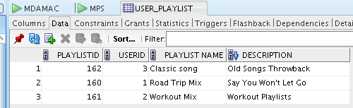***User Playlist***
2. 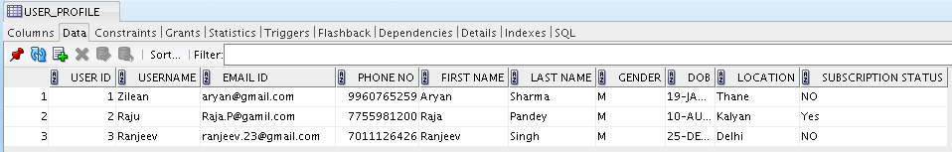***User Profile***
3. 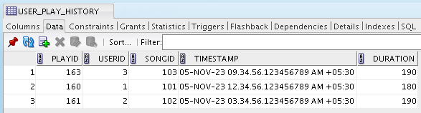***User Play History***
4. 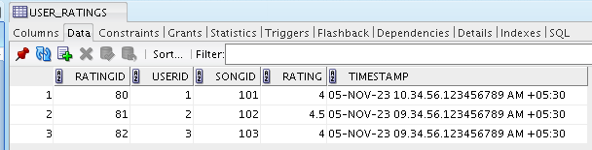***User Rating***
5. 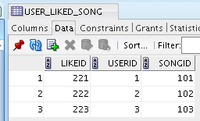***Liked song***

*Type 2 – SCD Type II changing Dimension*

*Song Library Table*

|  |  |
| --- | --- |
| **Column** | **Data Type** |
| SongID | INT |
| Title | VARCHAR (100) |
| ArtistID | INT |
| GenreID | INT |
| Release Date | DATE |
| Duration | INT |
| Album | VARCHAR (100) |
| Language | VARCHAR (50) |
| Play Count | INT |
| URL | VARCHAR (200) |
| Valid From | DATE |
| Valid To | DATE |

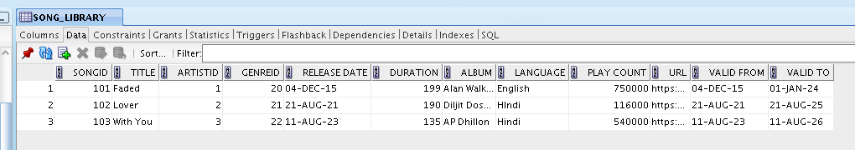

*Type 3- SCD Type III Changing Dimension*

*Music Platforms Table*

|  |  |
| --- | --- |
| ***Column*** | ***Data Type*** |
| *Platform ID* | *INT* |
| *Platform Name* | *VARCHAR (100)* |
| *Country* | *VARCHAR (50)* |
| *Contact Information* | *VARCHAR (200)* |
| *lastContact* | *VARCHAR (200)* |
| *Prev-Contact* | *VARCHAR (200)* |

