*1. To create a Data Warehouse Instance document, along with Necessary Tables.*

*a. To create Instance of Oracle*

*b. Design the Tables Architecture*

*c. Populate data in the Tables, as per the Project Requirement. Only 2 entries per table.*

*d.* *Create document for Roll-up and Drill-down, to get higher level information and granular level information, respectively. Use Slicing &amp; dicing Strategies.*

***database configuration assistant is used to perform any of the following tasks:***

*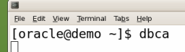 To create the Database configuration assistant type dbca in the terminal*

1. *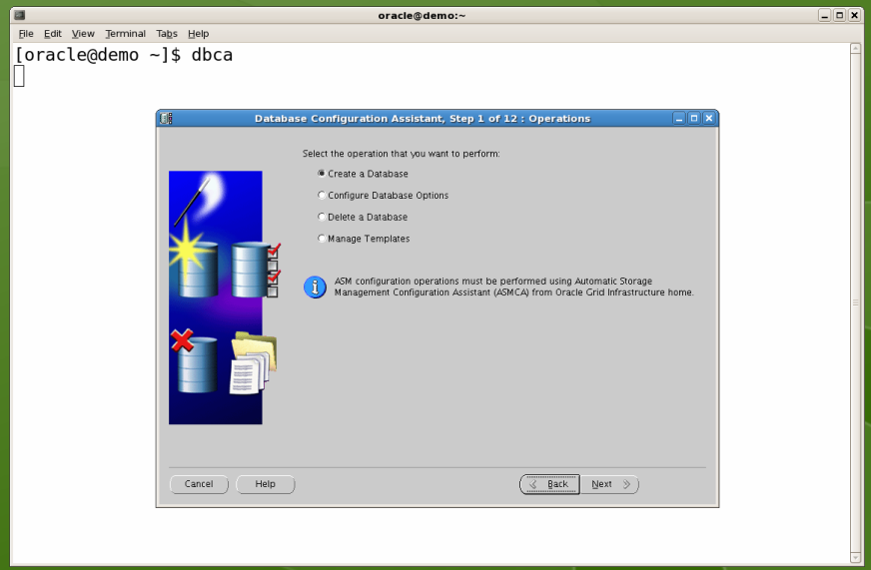Create a new database*
2. *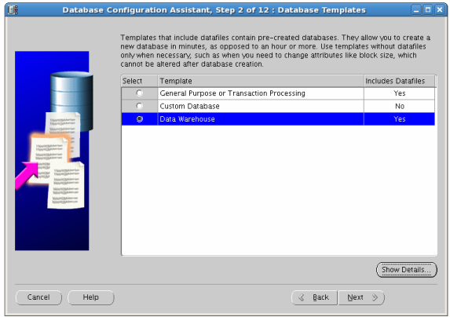Select database warehouse*
3. *Database Identification*
4. *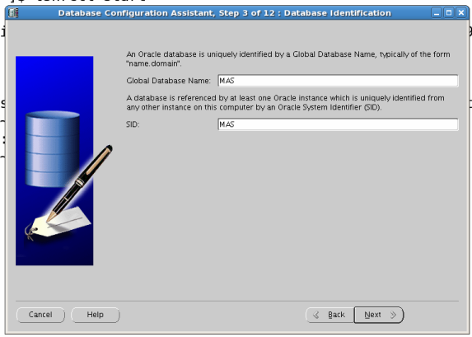Set the Database Credentials*

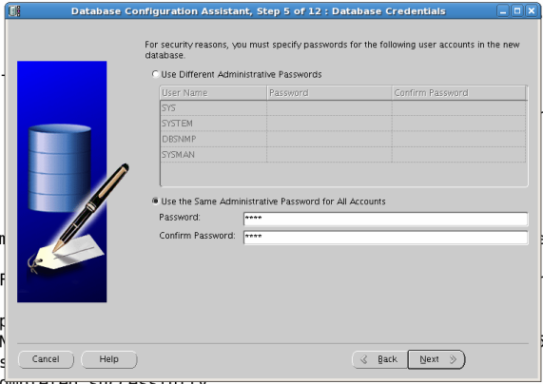

1. *File location Variable*

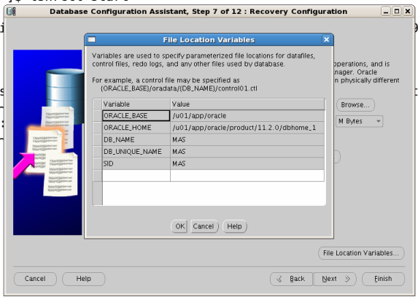

1. *Recovery Configuration*

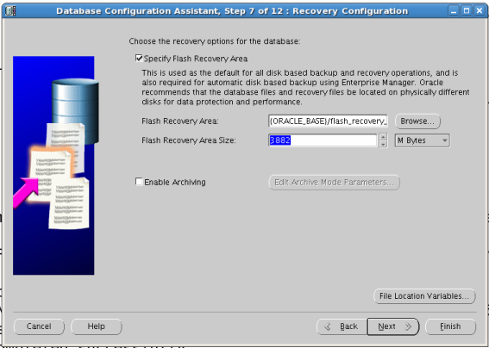

1. *Initialization Parameters – Memory*

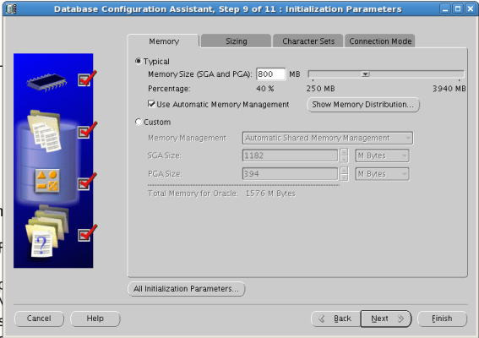

1. *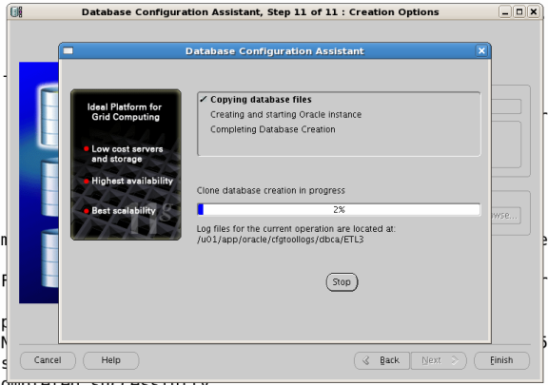Database Creation Complete*

***To create Instance of Oracle***

*To start the Sql program before that you need to start listener - the listener control utility*

1. *Type - lsnrctl start*

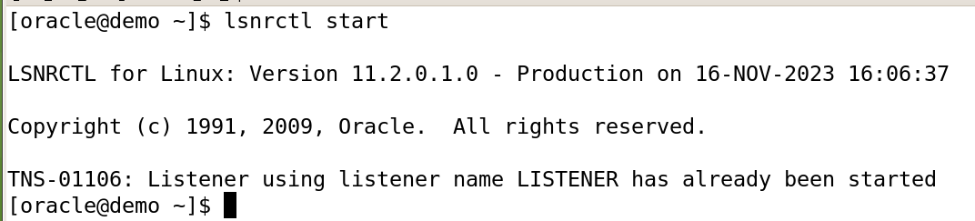

*To connect the Sql program –*

1. *Type sqlplus “/as sysdba”*

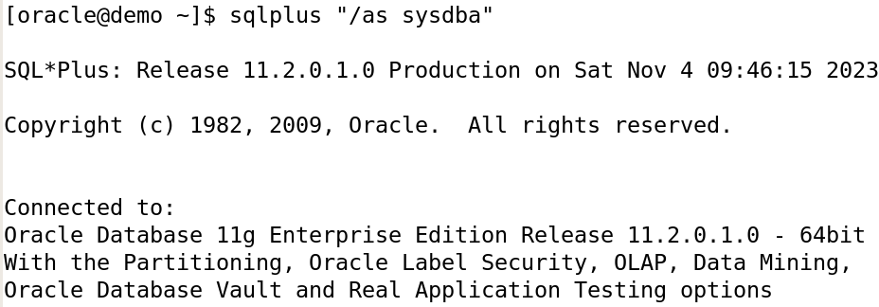

*To managing user access and privileges in a SQL database.*

1. *Type create user <username> identified by <password>;*

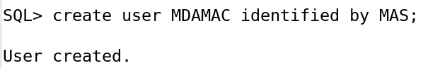

1. 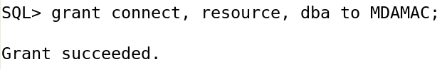*Type grant connect, resource, dba to <username>;*

***Design the Tables Architecture***

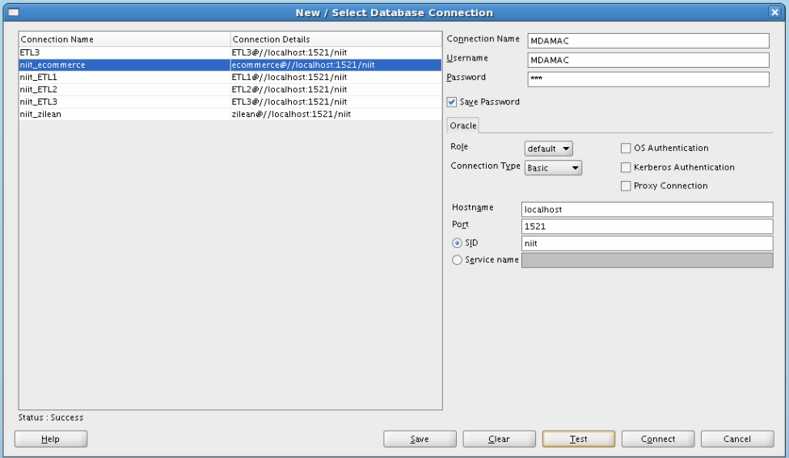

*Once, the connection estimation successfully*

***User Side***

|  |  |
| --- | --- |
| ***Column*** | ***Data Type*** |
| *UserID* | *INT* |
| *Username* | *VARCHAR (50)* |
| *Email* | *VARCHAR (100)* |
| *First Name* | *VARCHAR (50)* |
| *Last Name* | *VARCHAR (50)* |
| *Age* | *INT* |
| *Gender* | *VARCHAR (10)* |
| *Location* | *VARCHAR (100)* |
| *Subscription Status* | *VARCHAR (20)* |

1. *User Profile table -*
2. *User Play History:*

|  |  |
| --- | --- |
| ***Column*** | ***Data Type*** |
| *PlayID* | *INT* |
| *UserID* | *INT* |
| *SongID* | *INT* |
| *Timestamp* | *TIMESTAMP* |
| *Duration* | *INT* |

1. *Playlist: 4) User Liked Songs:*

|  |  |
| --- | --- |
| ***Column*** | ***Data Type*** |
| *PlaylistID* | *INT* |
| *UserID* | *INT* |
| *Playlist Name* | *VARCHAR (100)* |
| *Description* | *TEXT* |

|  |  |
| --- | --- |
| ***Column*** | ***Data Type*** |
| *LikeID* | *INT* |
| *UserID* | *INT* |
| *SongID* | *INT* |

*5) User Ratings:*

|  |  |
| --- | --- |
| ***Column*** | ***Data Type*** |
| RatingID | INT |
| UserID | INT |
| SongID | INT |
| Rating | INT |
| Timestamp | TIMESTAMP |

***Admin (Music Company side)***

1. *ad tracking*

|  |  |
| --- | --- |
| ***Column*** | ***Data Type*** |
| *Ad_ID* | *INT* |
| *SongID* | *INT* |
| *Advertiser* | *VARCHAR (100)* |
| *Ad Duration* | *VARCHAR (20)* |
| *Ad Revenue* | *DECIMAL (10, 2)* |
| *Timestamp* | *TIMESTAMP* |

1. *Artists*

|  |  |
| --- | --- |
| ***Column*** | ***Data Type*** |
| Artist_ID | INT |
| Artist Name | VARCHAR (100) |
| Country | VARCHAR (50) |
| Biography | TEXT |
| Social Media Links | VARCHAR (200) |

|  |  |
| --- | --- |
| ***Column*** | ***Data Type*** |
| User_ID | INT |
| Username | VARCHAR (50) |
| Email | VARCHAR (100) |
| Registration Date | DATE |
| Subscription Status | VARCHAR (20) |

1. *music platform*
2. *music studio*

|  |  |
| --- | --- |
| ***Column*** | ***Data Type*** |
| Studio_ID | INT |
| Studio Name | VARCHAR (100) |
| Location | VARCHAR (100) |
| Contact Information | VARCHAR (200) |

1. *playlist*

|  |  |
| --- | --- |
| ***Column*** | ***Data Type*** |
| *PlaylistID* | *INT* |
| *User_id* | *INT* |
| *Playlist Name* | *VARCHAR (100)* |
| *Description* | *TEXT* |

1. *revenue*

|  |  |
| --- | --- |
| ***Column*** | ***Data Type*** |
| Revenue_ID | INT |
| SongID | INT |
| Date | DATE |
| Revenue Amount | DECIMAL (10, 2) |

1. *song library*

|  |  |
| --- | --- |
| ***Column*** | ***Data Type*** |
| *SongID* | *INT* |
| *Title* | *VARCHAR (100)* |
| *ArtistID* | *INT* |
| *GenreID* | *INT* |
| *Release Date* | *DATE* |
| *Duration* | *INT* |
| *Album* | *VARCHAR (100)* |
| *Language* | *VARCHAR (50)* |
| *Play Count* | *INT* |
| *URL* | *VARCHAR (200)* |

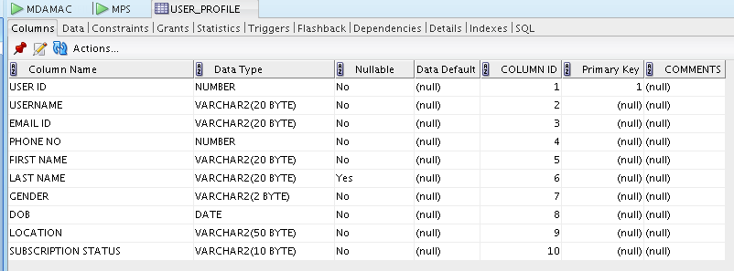

*Populate data in the Tables, as per the Project Requirement.* ***Only 2 entries per table.***

***User Side –***

1. 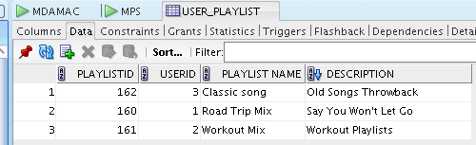***User Playlist***
2. 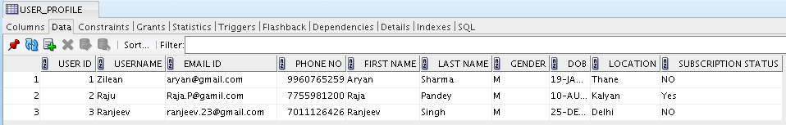***User Profile***
3. 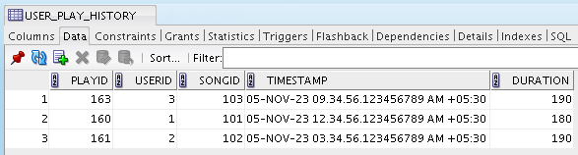***User Play History***
4. 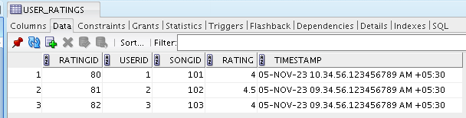***User Rating***
5. 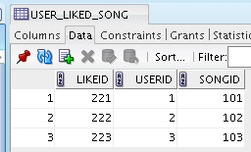***Liked song***

***Admin (Music Company side)***

1. 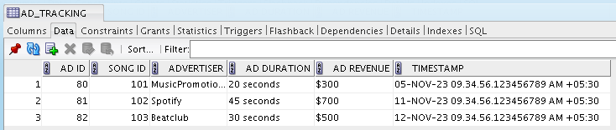***ad tracking***
2. ***Artists***

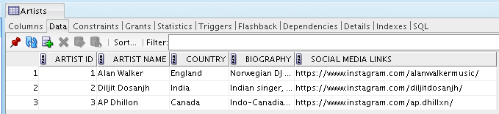

1. ***Genre***

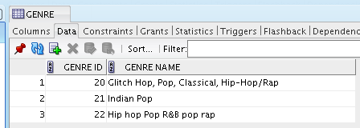

1. ***music platform***

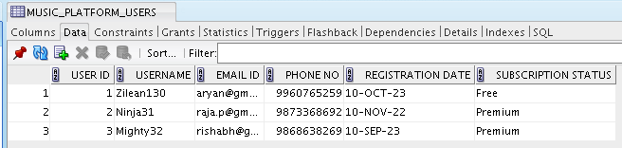

1. ***music studio***

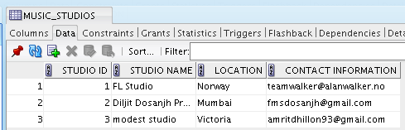

1. ***playlist***

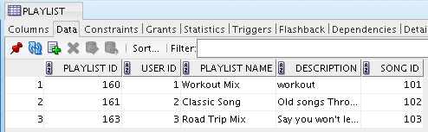

1. ***revenue***

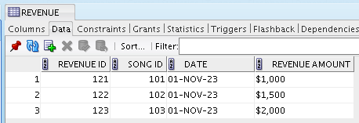

***viii)Song Library***

