***Name – Aryan Sharma***

***Enrollment No – BT21GCS161***

***Dimensional and NoSQL Databases***

***Assignment 05***

***REDIS Configurations***

***Step 1:*** *Download the Redis Software by the link:*

[***https://github.com/microsoftarchive/redis/releases***](https://github.com/microsoftarchive/redis/releases)

***Step 2:*** *Click on the “Redis-x64-3.0.504.msi” file and download it****.***

***Step 3:*** *After downloading.*

***Follow this step to Install Redis***

*1)Now click on that file and install Redis.*

*1)First, you need to run this file. Click the Run button*

*2) Then Click Next,*

*3)Accept the terms in the License Agreement and Click Next,*

*4)Now Make sure to tick the “Add the Redis installation folder to the PATH environment variable”. And click Next,*

*5)Now it will give you a default port to the server, Just Click Next*

*6)Now the system will ask to set the memory limit for the Redis server (default 100MB given)*

*7)Now continue the installation process. Click the "Install" button to begin the installation process.*

*8) Once the installation is complete, click the "Finish" button to close the installer.*

***Step 4:*** *Go to* ***C drive → Program Files → Redis → redis-cli.exe*** *(right-click on it and select run as administrator)*

***Step 5:*** *Now perform the CRUD operations.*

##### *Redis Command/CRUD Operations*

***Keys \****



***get name***

**

*Set Command*

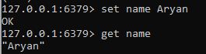

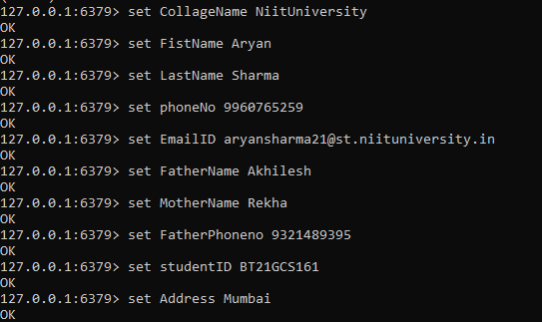

***Checking the keys now once we set the set***

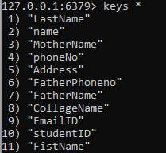

***exists rollno***



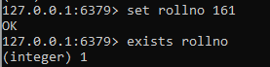

***del rollno***



***TTl (time to leave) or we can say (expire)***

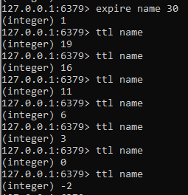

***Flushall***

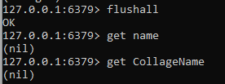

***Update command***

