Zihan Chen-IE598-Machine Learning in Finance

F18-HW1-Iris Flower Species

**Jupyter version**

<https://github.com/ZileanZC/IE-598-Machine-Learning-in-Finance/blob/IE598_F18_HW1/iris%20classification_ZileanWindows.ipynb>

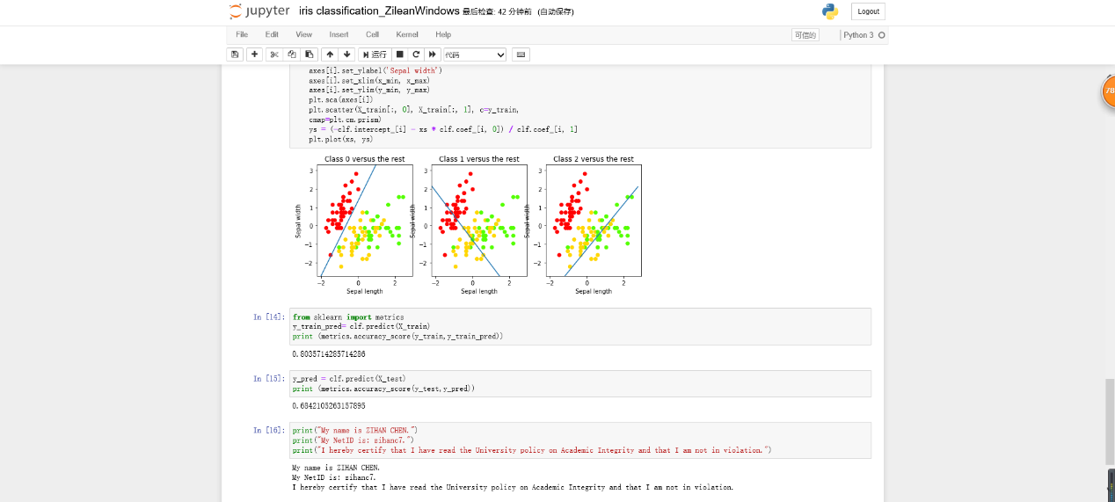

**Spyder version**

<https://github.com/ZileanZC/IE-598-Machine-Learning-in-Finance/blob/IE598_F18_HW1/iris.py>

