APPENDIX: Instructions for the Schedule of Events

The purpose of the Schedule of Events (SOE) is to identify items and services, which are considered, in good faith, to be either routine care (billable) or research only (non-billable) for the typical participant. For the purposes of these instructions, “good faith” is defined as the absence of malice or any intention to deceive. The information on the SOE will provide documentation to support the billing of a third party payer by Allina, if applicable, and will also be used by Allina in the auditing and monitoring of the project.

If the project does not require billing of routine care services to a third party, the Schedule of Events is not required. In eProtocol however, the option (shown below) on the SPA Form General Checklist must be checked if the Schedule of Events will not be submitted.

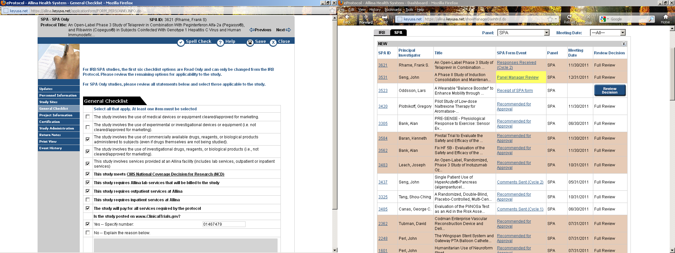

Once the Schedule of Events is completed, it should be uploaded to the Attachments section (Page 6) of the SPA Form in eProtocol prior to submission.

Definitions:
Schedule of Events is a plan of care that the typical participant will receive during his or her participation in the research protocol. The plan may also be referred to as a study matrix, protocol table, schedule of study evaluation, study of activities, etc.

Routine Care is care that is medically reasonable, necessary, and ordinarily furnished (absent of any research programs) in the treatment of patients by providers under the supervision of physicians as indicated by the medical condition of the patients. By this definition, the appropriate level of care criteria must be met for the costs of this care to be reimbursable. Such care may be diagnostic, therapeutic, rehabilitative, medical, psychiatric, skilled nursing and other related professional health services. Terms synonymous with routine care and used interchangeably are: usual patient care, billable, standard of care, or routine costs.

Billable Items or Services are items or services provided to research participant which are allowed to be billed to Medicare or other third party payer.

Non-Billable Items or Services are items or services provided to the research participant that do not meet allowable (routine care or cost) criteria and cannot be billed to Medicare or other third party payer. This may be referred to as “research only.”

Protocol-Directed/Research-Related Care is the routine care items and services listed on the schedule events. The use of the term protocol directed care is often used in relation to Medicare coding requirements (i.e.,V70.7).

See SPA Research Billing Guidance for the expanded definition of what is billable, non-billable, and considered routine costs according to the type of study and the Medicare Clinical Trial Policy (CTP).
Applying Routine Care definition versus Non-billable Items and Services

When completing the identification of billable and non-billable services, the Principal Investigator should ask themselves, “Would I routinely order this item or service for a person with this condition if he or she were not participating in the protocol?” If the answer is yes, then the item or service is routine care and billable. If the answer is no, the item or service is non-billable.

Example: The participant's routine care plan calls for a chest X-ray every six months, for a total of two per year. The protocol schedule of events calls for a chest X-ray every two months, for a total of six per year. The X-rays received at six and 12 months are considered "routine care." In this case, the X-rays received at two, four, eight, and 10 months would be considered “non-billable” or “research only”.

Note: Consult SPA Research Billing Guidance for the type of study being submitted and subsequent billable (routine cost) and non-billable guidelines prior to completing the SOE.

Using one of the following options, identify the billable and non-billable items and services for the project being submitted to SPA:
OPTION A. The Schedule of Events included in the protocol
- OR
OPTION B. The Allina Schedule of Events Worksheet
OR
OPTION C. In some instances, it may be necessary to use both the Protocol Schedule of Events and the Allina Schedule of Events.

OPTION A. Using the Schedule of Events (SOE) included in the study protocol to identify billable and non-billable items and services

The SOE included in the sponsor protocol must be in table format and include a study timeline. If the protocol includes a SOE for each study arm, identify the items and services as discussed below. However, if the protocol combines study arms and it is difficult to distinguish the different items and services, you may need to follow the instructions in Option C.

If all items and services are non-billable and paid for by the study, check “The study will pay for all services required by the protocol” in the eProtocol SPA General Checklist (no SOE is required).

Step 1 – Mark the Schedule of Events as follows according to what is true for the study:
If all items and services are routine care (billable), write “All services are routine care” on the top of the SOE
OR;
If some of the items and services are billable and some are non-billable,
- Identify non-billable items and services to be performed in an Allina facility with a circle;
- Identify non-billable items and services not provided at Allina facility with a triangle;
- Tests that will not generate a charge or billed service, such as participant weight do not need to be marked;
- Items without a circle or triangle are considered billable (routine care) according to the guidelines identified in the SPA Research Billing Guidance and the Medicare Clinical Trial Policy.

SAMPLE of Manually Edited/”Marked” Schedule of Events
The non-billable Allina services have been circled. The non-billable, non-Allina services have a triangle.
Protocol # 123456 | Week  1 | Week  2 | Week  4 | Week  6 | Week  8 | Week  10 | Week  12
Pregnancy Test | X |  |  |  |  |  | X
Hemaglobin Level | X |  |  | X |  |  | X
CT Scan | X |  | X |  |  |  | X
Physical Exam | X | X | X | X | X | X | X
Table SOE - 1
If the protocol has a different SOE for each study arm, each arm should be marked according to Step 1. If the protocol does not include a SOE for each study arm, but uses a combined SOE, you do not need to complete Allina’s SOE provided that the items and services are easily distinguishable for the different arms.

Step 2 - Copy and scan the marked schedule of events and upload to the Attachments section of the SPA Form in eProtocol.

Note:
- Items or services that have been bundled or packaged into a single line entry on the protocol SOE must be listed and identified separately on another table. (See Section C for additional information.)
- Any items or services that are not included in the Protocol Schedule of Events must be listed on the Allina SOE worksheet. (See Section C for additional information).

Step 3 – All items and services identified as non-billable and to be performed in an Allina facility (circled items) must be added to the SPA eProtocol Form in either the Lab or Service Pricing table(s). See SPA eProtocol User Guide for instructions.

OPTION B. Using the Allina Schedule of Events (SOE) Worksheet to identify billable and non-billable items and services

NOTE: You only need to complete the Allina SOE Worksheet if the protocol doesn’t have a SOE in table format.

Step 1 – Download the Allina SOE Worksheet and save a copy.
The Allina SOE Worksheet can be accessed from the SPA Forms page on Allina Research Administration website.

Step 2 – Enter the Study Title to the “Project Title:” cell.
If Study Title does not fit in the main “Project Title” cell, continue the Project Title in the spreadsheet cell below.

SOE Figure 1 - Sample Project Title:
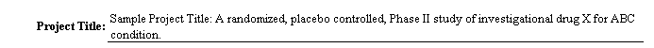

Step 3 - Identify the Study Timeline (Row 8, Column C-X)
Enter the study visit timeline according to the visit schedule. Enter the time period when the participant will be receiving an item or service required by the protocol in the table (day, week, cycle, etc.). Include both Allina and non-Allina services.

SOE Figure 2 - Sample Study Timeline:
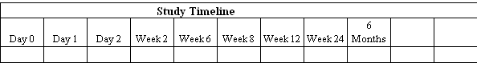

Step 4 - Identify the Service Categories and Procedures (Column A) – Identify all services from the study protocol. It is suggested to use categories to group similar items, but it is not necessary.
  - Enter any applicable categories in BOLD.
  - Enter the item or service in the rows underneath the bolded category title.
  - Rows may be added or deleted from the worksheet as necessary

SOE Figure 3 - Sample Service Categories, Items, and Procedures:
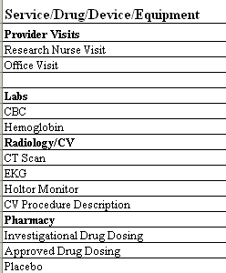

Step 5 - Classify the Item or Service for each study visit according to Service Category Key.
- For Routine Care (billable) items and services, enter “RC” in the table
- For Non-Billable items and services provided at an Allina facility, enter “NB” in the table
- For Non-Allina, non-billable items and services, enter “NANB” in the table
- If no item or services provided during a visit, leave cell blank

SOE Figure 4 – Sample Classification of Items & Services
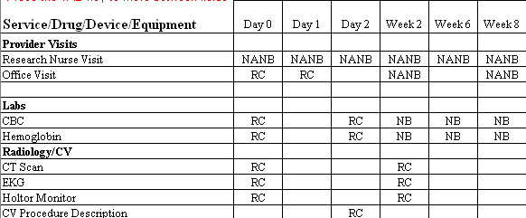

Step 6 - In “Arm of Study (Column B)” – Enter the arm of the study (e.g., Control, Treatment, Arm 1, etc.) or enter “ALL” if true for all arms of the study.

Optional – Complete a new worksheet for each Study Arm. Each subsequent SOE sheet is lab labeled SOE (2), SOE (3), etc.
- In order to access the copies, click on the tab at the bottom of the worksheet you wish to adjust.
- Enter the Arm of the Study for each worksheet at the top (i.e. Arm 1, Arm 2, Treatment, etc.).
- Complete Steps 2 through 5 above for each Arm of the Study worksheet.

SOE Figure 5 – Sample of Completed Schedule of Events Worksheet

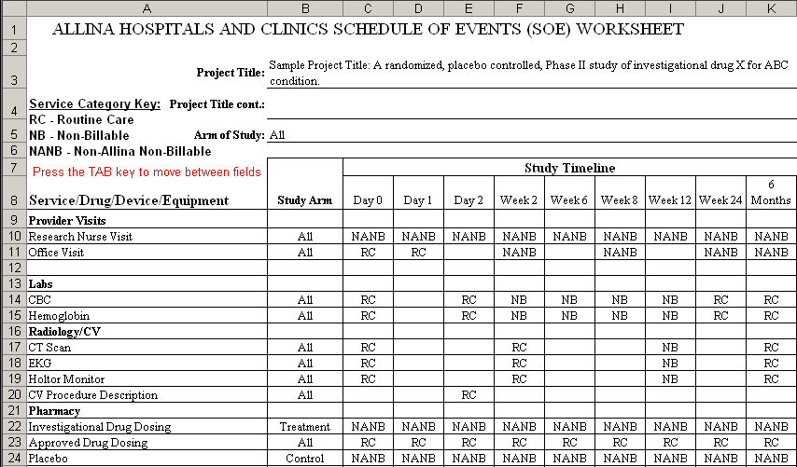

Step 7 – All items and services identified as non-billable and to be performed in an Allina facility (identified as “NB”) must be added to the SPA eProtocol Form in either the Lab or Service Pricing table(s). See SPA eProtocol User Guide for instructions.

OPTION C. Using the Allina SOE Worksheet as a supplement to the Schedule of Events included in the protocol to identify billable and non-billable services

There may be some cases in which you may need to use the protocol’s schedule of events and Allina’s SOE worksheet concurrently. The following scenarios describe when to use both types of schedule of events:

- The schedule of events from the protocol does not include all routine care or non-billable items and services.

Instructions:
To report items or services which are not included on the schedule of events from the protocol,
- Manually write “See attached” on the bottom of the SOE from the protocol.
- List the item(s) on the Allina SOE worksheet using the steps outlined in Option B.

- The schedule of events from the protocol, combines protocol-induced cost and routine care into a single line item or category.

Example: If the protocol schedule combines two or more drugs (one is the approved drug and one is the experimental drug) into one category called “Study Medications,” each drug must be listed separately on the Allina SOE worksheet.

Instructions:
- Draw a line through the combined items or services listed on the SOE from the protocol.
- Using Steps from Option B, list the items or services as separate line items on the Allina SOE.

Sample of “Marked” Schedule of Events
Protocol # 98765 | Week  1 | Week  2 | Week  3 | Week  5 | Week  7 | Week  9 | Week  10 | Week  12
Lab | X |  | X |  | X |  |  | X
Global Assessment
Study Medications | X |  | X |  | X |  |  | X

Sample of Allina Schedule of Events Form
Protocol # 98765 | Week1 | Week3 | Week 7 | Week 12
Clinical
Study Drug A  Separate the combined costs | RC | RC | RC | RC
Study Drug B | NB | NB | NB | NB

Note: All items and services identified as non-billable and to be performed in an Allina facility (circled or identified as “NB”) must be added to the SPA eProtocol Form in either the Lab or Service Pricing table(s). See SPA eProtocol User Guide for instructions.

