**Iteration 4#**

## Requirements Statement

1. Create a Single Page Application (SPA) using Vuejs and JavaScript ES2018.
2. Write a program to play a number guessing game. The USER mentally selects a number between 0 and 99 and the computer ties to guess it. The computer outputs its guess, and the User response with "COLD" if the guess is more than 40 from the target number, "COOL" if the guess is within 20-39 of the target number, “WARM” if the guess is within 10-19 of the target number, “HOT” if the guess is within 1-9 of the target number or “correct”. The computer should keep count of the number of guesses. The computer should complain if the USER has lied.

## Iteration Plan

|  |  |  |  |  |  |
| --- | --- | --- | --- | --- | --- |
| Milestone | Planned Start Date | Actual Start Date | Planned End Date | Actual End Date | Task |
| Iteration |  |  |  |  |  |
| Planning | 1/9/2019 | 1/9/2019 | 1/9/2019 | 1/9/2019 | 1. Write a program to play a number guessing game. The USER mentally selects a number between 0 and 99 and the computer ties to guess it. The computer outputs its guess, and the User response with "COLD" if the guess is more than 40 from the target number, "COOL" if the guess is within 20-39 of the target number, “WARM” if the guess is within 10-19 of the target number, “HOT” if the guess is within 1-9 of the target number or “correct”. The computer should keep count of thenumber of guesses. The computer should complain if the USER has lied  2.Coding and test. 3.Think about the final literation, consider how to lay out all the code. |
| Analysis | 1/9/2019 | 1/9/2019 | 1/9/2019 | 1/9/2019 | Analyze project requirements. List the required functionality for the project. |
| Design | 2/9/2019 | 2/9/2019 | 2/9/2019 | 2/9/2019 | 1.Design the Single Page Application’s website Layout.  2. Storyboard for the programming. |
| Coding | 5/9/2019 | 5/9/2019 | 5/9/2019 | 5/9/2019 | Coding for the second literation. |
| Testing | 6/9/2019 | 6/9/2019 | 6/9/2019 | 6/9/2019 | Make a testing plan and do the test.  Record the result of the test. |

## Task Summary

|  |  |  |  |  |  |  |
| --- | --- | --- | --- | --- | --- | --- |
| **Time in Phase (hr.)** | **Plan** | **Actual** | **Start** | **Stop** | **To Date** | **To Date %** |
| Planning | 0.5hr | 10min | 20:00 | 20:10 | 1/9/2019 | 4% |
| Analysis | 0.5hr | 20min | 20:10 | 20:30 | 1/9/2019 | 8% |
| Design | 0.5hr | 0.5hr | 13:00 | 13:30 | 2/9/2019 | 11% |
| Coding | 1.5hr | 1.5hr | 9:00 | 10:30 | 5/9/2019 | 33% |
| Test | 1.5hr | 1.5hr | 12:00 | 13:30 | 6/9/2019 | 33% |
| Postmortem | 0.5hr | 0.5hr | 20:00 | 20:30 | 8/9/2019 | 11% |
| Total | 4.5hr | 4.5hr |  |  |  | 100% |

## Class Diagram

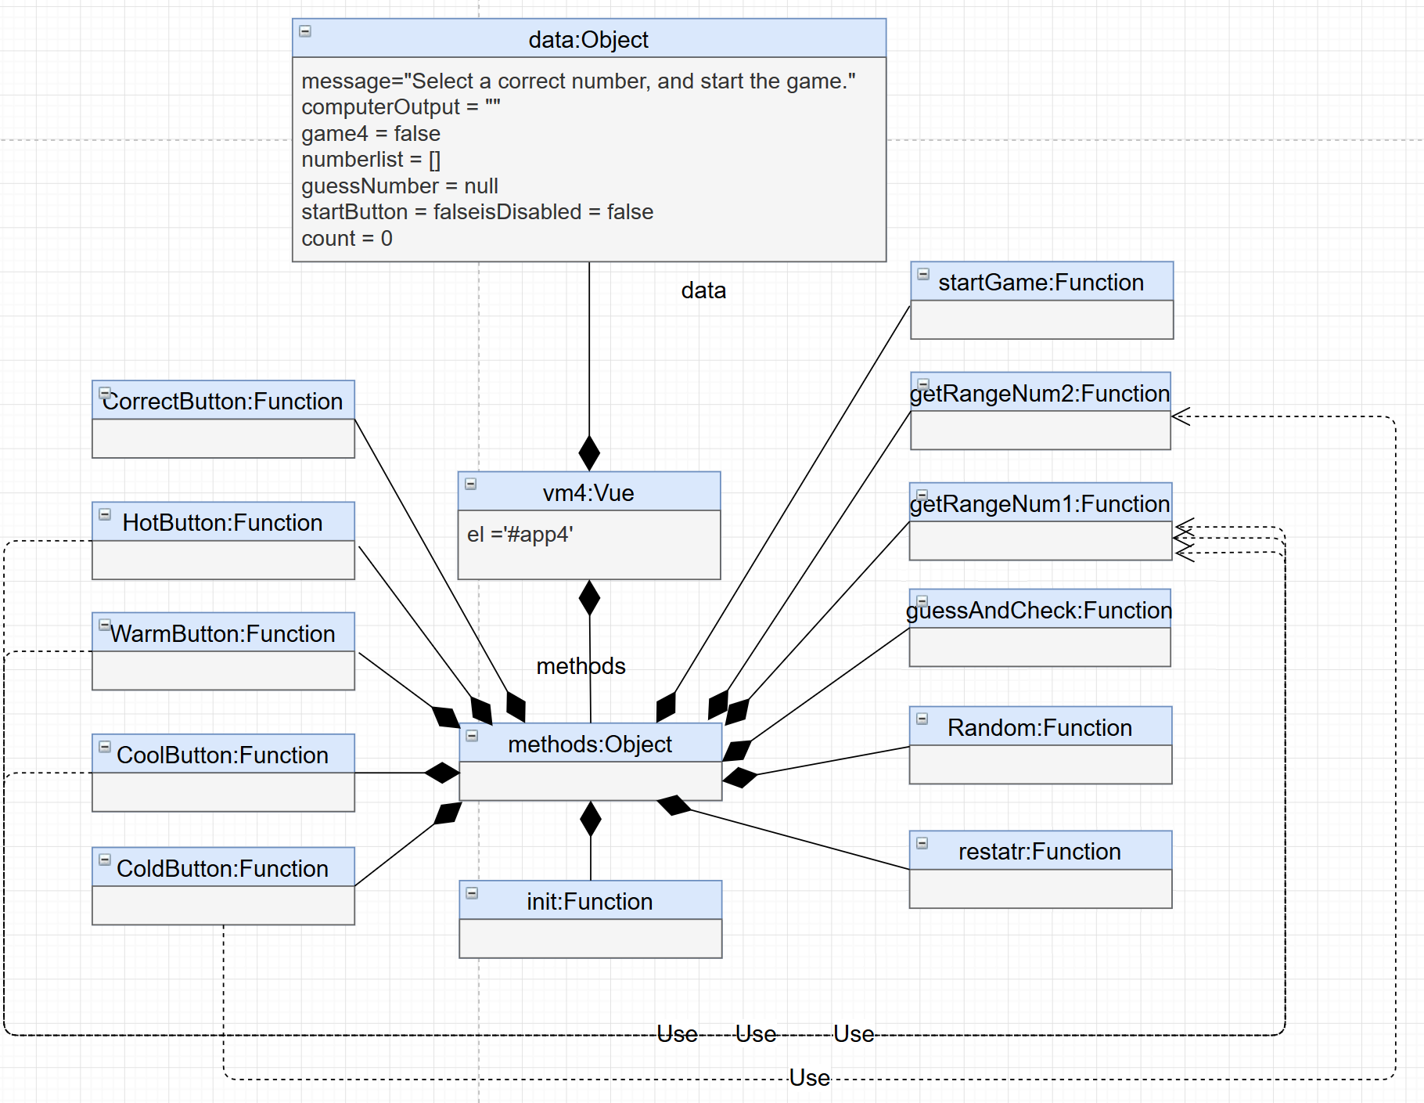

## Plan for how feature works: Storyboard

## Test Plans:

|  |  |  |
| --- | --- | --- |
|  | Test Plans | Expected Results |
| 1 | Test the function of button “Start Game”. | When the user enters click the “Start Game” button, computer begin to guess. The guess number is in the range of 0-99, counter value is1, and a int array[0-99] be created. |
| 2 | Test the function of button “Restart Game”. | When the user clicks the button “Restart Game”, the game returns to its original state. |
| 3 | Test the function of “COLD”, “COLD”, “WARM”, “HOT”. | When user click the buttons, the numbers that out of range should be removed from the int array.  When user telling a lie, which means there will no number in the int array when all nonconforming Numbers are deleted, computer complain it. |
| 4 | Test the function of “Correct”. | When user click the correct button. Message out put the “Well done!”, and the start game button available. |
| 5 | Test the counter. | Play the game and record the number of guesses. Compare with the final output. |

## Test Report Template

|  |  |
| --- | --- |
| Test Name/Number | 1 |
| Test Objective | Test the function of button “Start Game”. |
| Test Description | When the user clicks a button, the game is initialized and the computer guesses the number for the first time. |
| Test Conditions | No options are given, default options apply. |
| Expected Results | When the user enters click the “Start Game” button, computer begin to guess. The guess number is in the range of 0-99, counter value is1, and an int array [0-99] be created. |
| Actual Results |  |
| Test Name/Number | 2 |
| Test Objective | Test the function of button “Restart Game”. |
| Test Description | When the user clicks the button “Restart Game”, the game returns to its original state. |
| Test Conditions | No options are given, default options apply. |
| Expected Results | Clicks the button “Restart Game”, the game returns to its original state.  Message is restored to the original game state. Computer Output is empty. Counter value is 0. Number array is empty. Start Button is available. Guess buttons are unavailable. Guess Number value is null. |
| Actual Results |  |
| Test Name/Number | 3 |
| Test Objective | Test the function of “COLD”, “COLD”, “WARM”, “HOT”. |
| Test Description | User can use the buttons “COLD”, “COLD”, “WARM”, “HOT”.to tell the computer whether its guess correct. |
| Test Conditions | No options are given, default options apply. |
| Expected Results | When user click the buttons, the numbers that out of range should be removed from the int array.When user telling a lie, which means there will no number in the int array when all nonconforming Numbers are deleted, computer complain it. |
| Actual Results |  |
| Test Name/Number | 4 |
| Test Objective | Test the function of “CORRECT” and count. |
| Test Description | User can use the buttons “CORRECT” to tell the computer whether its guess correct.  Play the game and record the number of guesses. Compare with the final output. |
| Test Conditions | No options are given, default options apply. |
| Expected Results | When user click the correct button. Message out put the “Well done!”, and the start game button available.  The record number is equal to final output. |
| Actual Results |  |

## Error Logs

|  |  |  |  |  |  |  |  |
| --- | --- | --- | --- | --- | --- | --- | --- |
| **Date** | **No.** | **Type** | **Inject** | **Remove** | **Fix Time** | **Fix Ref** | **Description** |
| **5/9/2019** | 1 | 20 | Code |  | 1 | 1 | Vm3 is not defined |
| **29/8/2019** | 2 | 20 | code | Add “,” | 1 | 1 | Unexpected token”,” |
| **31/8/2019** | 3 | 20 | code | Change the condition of the If judgment from” this.mixnum == 0” to “this.guessNumber == this.mixnum”. | 1 | 1 | Keep clicking the “try lower” button, the last guess number is negative. |
| **31/8/2019** | 4 | 20 | code | Make a logical judgment of what is entered. Invalid input cannot start the game. | 1 | 1 | Enter non-numeric or out-of-range Numbers, the game is still work. |
| **31/8/2019** | 5 | 20 | code | When the game started, disable the “begin to guess” and “set number” buttons. If user want to restart the game, the only way is clicking the “Restart Game” button. | 1 | 1 | When the game started, button” begin to guess” is still available, click it the counter added. |
| **31/8/2019** | 6 | 20 | code | When user click the “Correct” button, disable guess buttons. | 1 | 1 | When user click the “Correct”, the game still works. “Try higher”, “Try lower”, “Begin to guess” buttons still work, computer can continue guess, and counter add. |

## PSP Process Improvement Proposal (PIP)

|  |
| --- |
| Problem Description |
| Briefly describe the problems that you encountered. |
| The setNum function cannot tell whether user input is valid or not. |
| The "begin to guess" button is not disabled once click it. When the game started, user clicking this button does not do anything useful but increases the value of the counter. |
| The conditions of tryhigher(), trylower() functions are wrong. The error resulted in inaccurate output of the "you lied to me" message and the guess number can be negative. |
| Click “Correct” button should end the game. |
| Error Syntax. |
| Proposal Description |
| Briefly describe the process improvements that you propose. |
| Add logical judgment to avoid invalid input. |
| Disable certain buttons during the game to make the game run smoothly. |
| Trouble shooting, fix the wrong logic. |
| Fix the “Correct” button’s function. |
| Trouble shooting, fix the Error syntax. |
| Other Notes and Comments |
| Note any other comments or observations that describe your experiences or improvement ideas. |
| 1. Found some bug in literation 1 and literation 2. In next literation should fix them. |
| 1. The coding structure may be change to the popular one, like MVC. |
| 1. Use some new method of Vue. |