
Kolej PERMATA@Pintar Negara, Universiti Kebangsaan Malaysia Digital Innovator Programme (D.I.P.)
Semester 2 Part 2 2024/2025

Computer Science Foundation 1
Task 3: SQL Exercise - Library Database (10%)

Prepared by: M. Zill Al Furqan Bin Mohd Zulkhairi | 1K6

TABLE OF CONTENTS

HEIDISQL Query Commands: 2
1. Creating databases and table 2
2. Adding data to table 3
3. Selecting certain data 4
a) Finding books by certain author 4
b) Finding books published on a certain date 4
c) Finding books published after a certain date 4
4. Updating data in tables 5
a) Updating borrowed_date 5
b) Deleting a book 5
c) Re-adding a deleted book 6

HEIDISQL Query Commands:

1. Creating databases and table

Command:

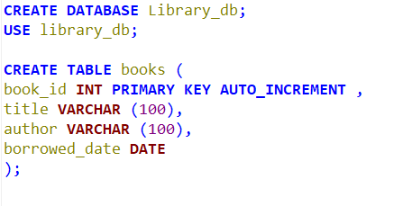

Results:

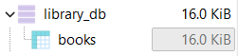

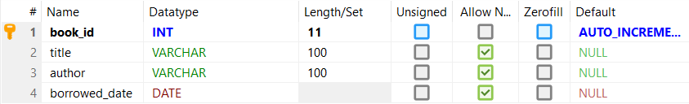

2. Adding data to table

Command:

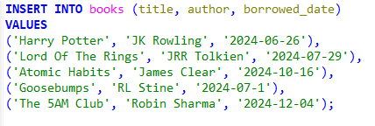

Results:

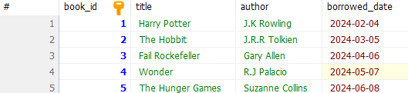

3. Selecting certain data

a) Listing all books

Command:
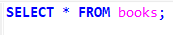

Results:

b) Finding books by certain author

Command:



Results:

c) Finding books published on a certain date

Command:



Results:

d) Finding books published after a certain date

Command:

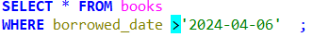

Results

4. Updating data in tables

a) Updating borrowed_date

Before command:

Command:

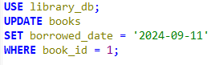

Results:

b) Deleting a book

Before command:

Command:

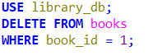

Results:

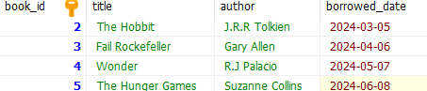

c) Re-adding a deleted book

Before command:

Command:

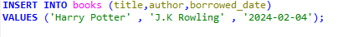

Results:

