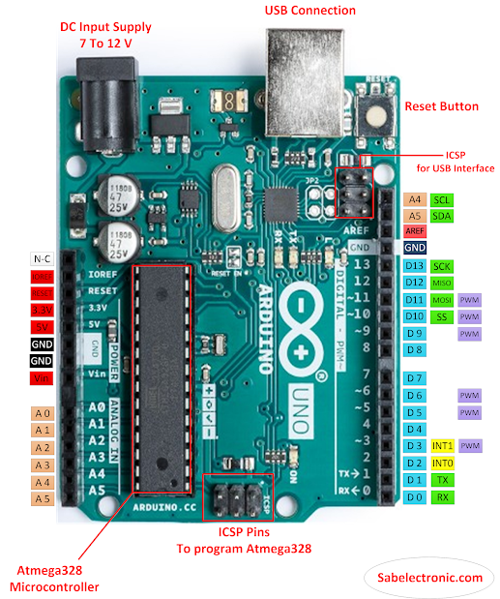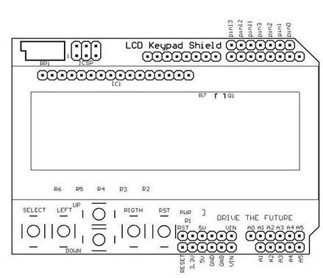
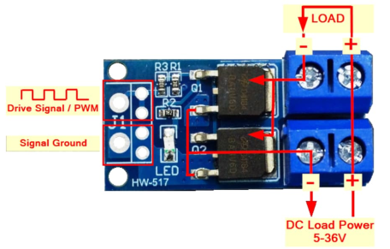
57.25mm x 55.25 hole spacing 52.25 x 54 Hole size 3mm holes spacing 49.25 x 51.25 height 21.5
Pins used
Arduino Function
A0 Buttons(Select, Up, Down, Left, Right)
4 LCD DB4
5 LCD DB5
6 LCD DB6
7 LCD DB7
8 LCD Register Select
9 LCD Enable
10 PWM LCD Brightness

Pins for
D3 – Peristaltic pump
D11 – Stirrer
A2 – Pot position Reading
Parts –
Bulk Head Fitting 14mm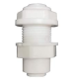
Link->https://www.amazon.com/dp/B013ZVURHQ?ref=ppx_yo2ov_dt_b_fed_asin_title
Mosfet Board 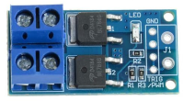
Link->https://www.amazon.com/dp/B07NWD8W26/?coliid=ID7KEFZKDDQZA&colid=RN0HY8FVC0B&ref_=list_c_wl_gv_ov_lig_pi_dp&th=1
Stirrer 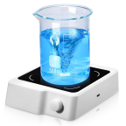
Link -> https://www.amazon.com/dp/B0D6Y3CG6Y?ref=ppx_yo2ov_dt_b_fed_asin_title
Lcd Keypad shield 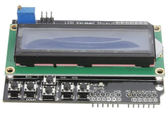
Jar 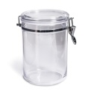
Link - > https://www.walmart.com/ip/Mainstays-Round-Plastic-Food-Storage-Canister-Small-5-12-W-x-6-5-D-x-5-H/2754411374

¼” Tubing vinyl 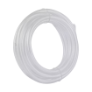
Link -> https://www.lowes.com/pd/EZ-FLO-1-4-in-Inner-Diameter-x-10-ft-PVC-Clear-Vinyl-Tubing/1000365025
Rigid ¼” tubing, I had some scrap from my ro/di unit. 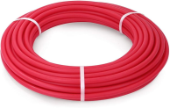
Link -> https://www.amazon.com/dp/B07D632X1R/?coliid=I31E5VBOW0WOA0&colid=RN0HY8FVC0B&ref_=list_c_wl_gv_ov_lig_pi_dp&th=1
Peristaltic pump 5v/6v 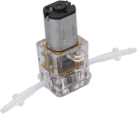
Link -> https://www.amazon.com/dp/B0CZKRRVJR?ref_=ppx_hzsearch_conn_dt_b_fed_asin_title_1&th=1
3d Printer to print case and pump holder

