Report exercise session 1 SVM Willem Melis

Summary
1 Question 1 3
2 The Stanford demo 4
2.1 Part1 4
2.2 What is the influence of adding data points to each class 4
2.3 Role of the c regularization hyper parameter 4
2.4 Linear vs nonlinear classification 5
2.5 The sigma hyper parameter 5
2.6 A linearly non-separable dataset with an overlapping region 6
2.7 What is the role of the support vectors 7
2.8 When does the importance of a support vector change 8
3 Using LS-SVM lab 9
3.1 intro 9
3.1.1 What happens if the degree changes 9
3.1.2 Focus on RBF kernel 11
3.1.3 Regularization constant gamma 11
3.2 Choice of the hyper parameters 12
3.2.1 Validation set 12
3.2.2 Cross validation 12
3.2.3 Optimizing the hyper parameters 13
3.2.4 Receiver operating characteristic (ROC) 14
4 Homework assignment 1: The Ripley Data-Set 16
4.1 Visualize data set 16
4.2 Linear model 16
4.3 RBF kernel 17
4.4 ROC curve 17
4.5 Final model 17
5 Homework assignment 2: Breast cancer Data-Set 18
5.1 Performance 18
5.2 ROC 18
5.3 Feedback 18
6 Homework assignment 2: Breast cancer Data-Set 19
6.1 Performance 19
6.2 ROC 19
6.3 Feedback 19

Question 1
We Generate two classes with Gaussian random point in them. Figure 1-1 contains data from 2 classes as requested in the assignment. It contains the most logical classifier considering that the average is (1,1) or (-1,-1) Figure 1-2 Contains the same distribution but with twice as much variance. It clear from Figure 1-2 that the classifier won’t work very well when the data is not separable.

Figure 1-1 plot of 2 random generated Gaussian data sets

Figure 1-2 variance is large, the classifier has a lot of miss classifications

The Stanford demo

Part1
If you add data points inside its own region there is no problem. But if you add them to far into the opposite region the boundary can change drastically. So it depends on the on number of points already set.

What is the influence of adding data points to each class
The classifier will change drastically if you add relatively large amounts of data points into the opposite class. But if you add data to its own class then it will stabilize.

Role of the c regularization hyper parameter
We know that in order to get out classification we need to solve the optimization problem from equation 1. The slack variable $ϵ_{k}$ has a weight c, this means that the influence of $ϵ_{k}$ is determined by c. The slack variable tolerates miss classifications, if we allow more miss classifications, then we can get a better margin. Remember we want to get an as width as possible margin.

If C is large, then the solution of the linear classification will have a smaller margin. If C is small, then the margin will be larger and we will need less support vectors. C is the weight of the slack variable.

$$\min_{w,b,ε}{J_{p}\left(w,ε\right)=\frac{1}{2}w^{T}w+c \sum_{k=1}^{N}{ϵ_{k}}}$$ | (1)
It is obvious that if the data is nicely clustered far away from each other than the slack variable is less of a concern.

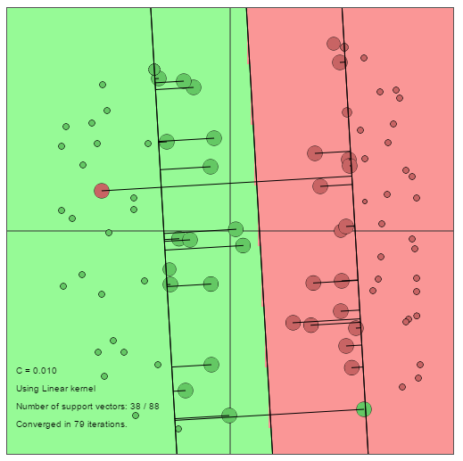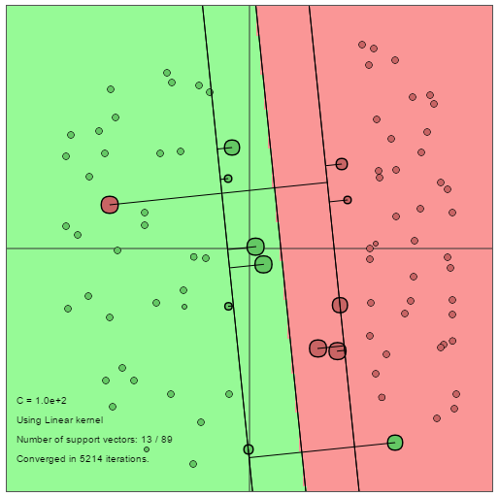
Figure 2-1 data with outlier and small c on the left and large c on the right

Linear vs nonlinear classification
The error margin has disappeared with the non-linear kernel, its way more flexible. This could produce a more accurate Classifier. But it complicates the classifier as we have an extra parameter sigma to optimize.
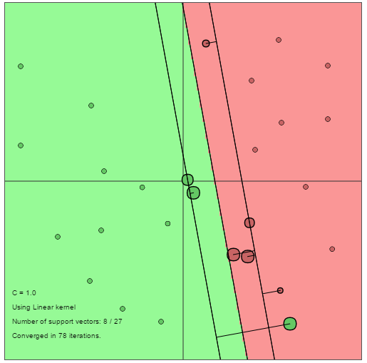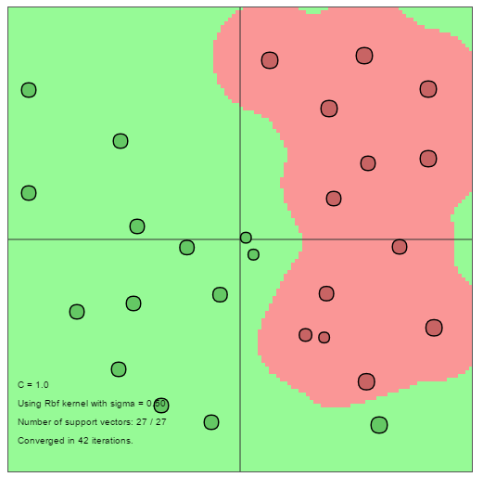
Figure 2-2 linear model vs non-linear

The sigma hyper parameter
The sigma parameter determines how depended the classifier is on clustering. We know that each point in fact has its own Gaussian curve that can touch the others if its width enough. A big sigma will create large isolated zones and a small sigma will create small zone around each point. If sigma is large we get a very linear thing , and if sigma is very low we get something very nonlinear this is illustrated on the dataset from Figure 2-3. Which is an example dataset. Figure 2-4 contains an example with a large and small sigma.

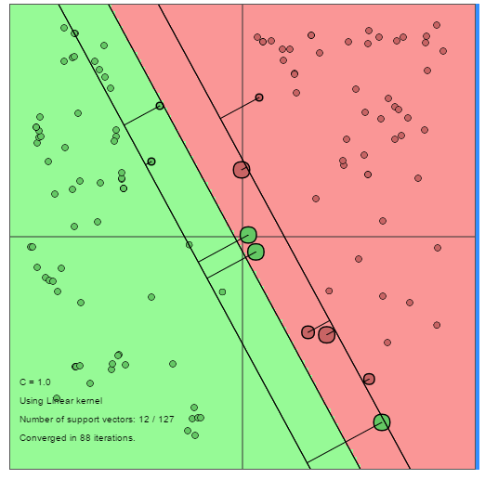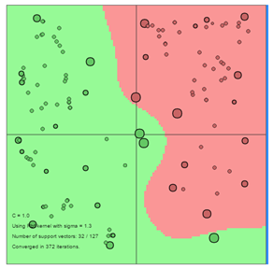
Figure 2-3 dataset linear and nonlinear case

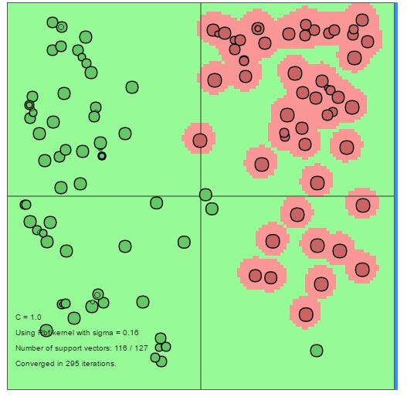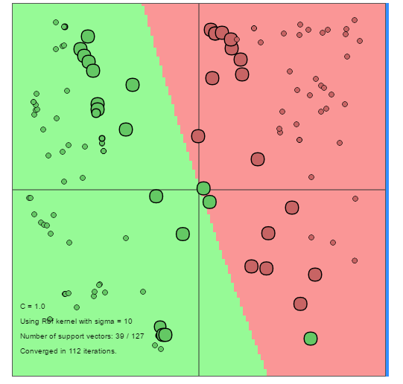
Figure 2-4 left is small sigma right is large sigma

A linearly non-separable dataset with an overlapping region
The Gaussian kernel makes sure that a point only influence the area close to it surrounding it. The sigma should be large enough to make sure that the classifier is “smooth” and C should be large enough to learn of the clusters and not too small so it still learns from the individual points. And C also makes sure its noise resistant.

The support vectors determine the shape of the borders. If C is small then there are few support vectors if c is large then there are a lot of support vectors. If sigma is increased then the amount of support vectors will increase.

If c and sigma are constant then the influence of a support vector will change when points are added that force the border to change.

What is the role of the support vectors
The role of the support vectors is to determine the borders of the classifier. The more support vectors the more $α_{k}$ values one should calculate.
$$\min_{w,b,ε}{J_{p}\left(w,ε\right)=\frac{1}{2}w^{T}w+c \sum_{k=1}^{N}{ϵ_{k}}}$$ | (2)
If c is very small, then we will get a lot of support vectors and if c is large we will only get a few support vectors. This is visible from Figure 2-5 where both situations are illustrated. Figure 2-6 illustrates the neutral situation with a c of 1. This effect is visible from the definition
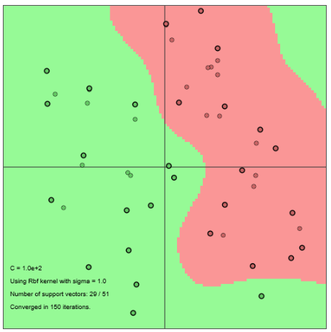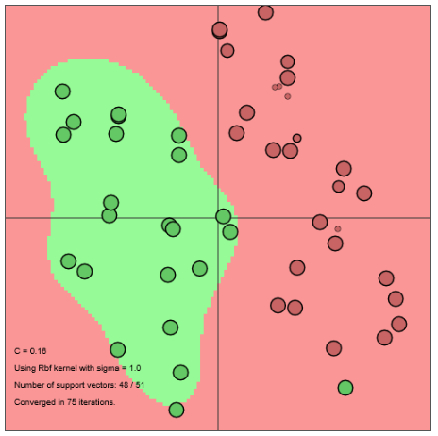
Figure 2-5 left is a large sigma(100) and right is small sigma(0.16)
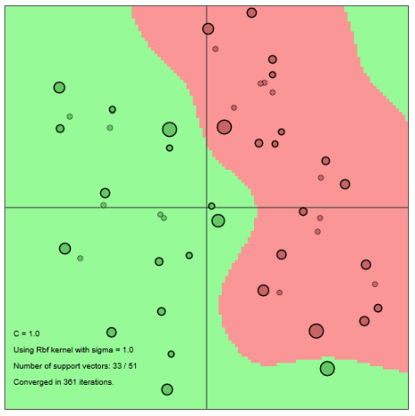
Figure 2-6 sigma is 1, neutral position
The second parameter we can change is sigma, Figure 2-7 illustrates what happens is sigma is to large or small. The classifier is broken and we get a ton of support vectors. Figure 2-8 contains a SVM with a sigma of 1.3, the elegance/simplicity of this SVM seems to be related to the low number of support vectors.
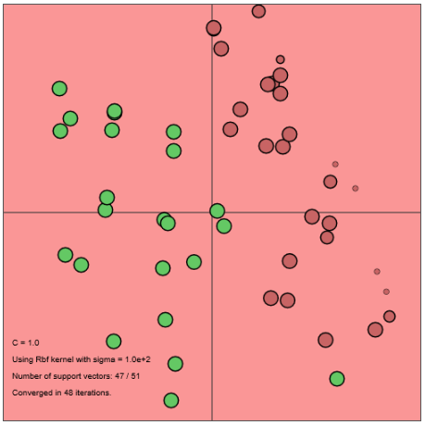  Figure 2-7 sigma = maximum or minimum c=1 | 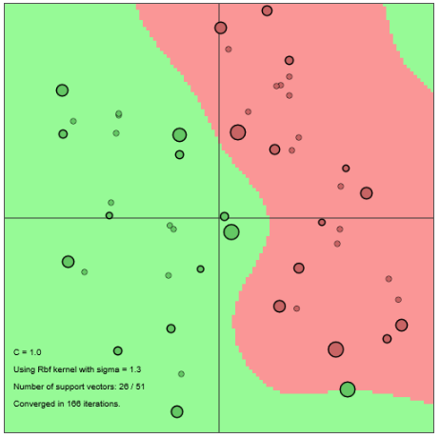  Figure 2-8 sigma=1.3 c=1

When does the importance of a support vector change
The support vectors change of importance if an new points takes over it role. This is illustrated in Figure 2-9 in which two point are added to the red part and a certain support vector disappears and two other support vectors take over its role.
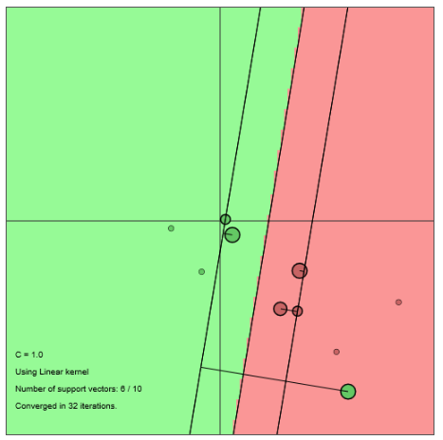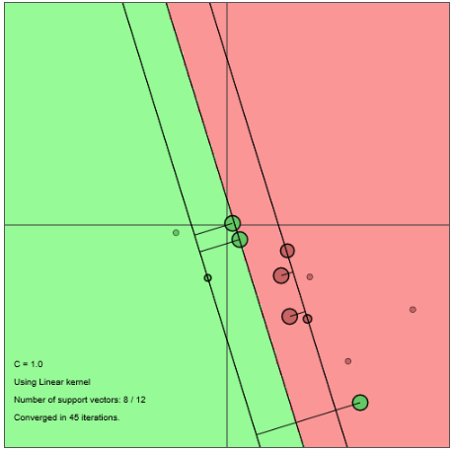
Figure 2-9 SVM illustrating a support vector disappearing
The importance of a support vector can also change by changing c or sigma, but this was illustrated in the previous section.

Using LS-SVM lab

intro

What happens if the degree changes
When the degree of the polynomial changes, the flexibility of the classifier changes. The higher the degree the more flexible the classifier becomes.
Figure 3-1 left has a degree of 1 and right has a degree of 2
Figure 3-2 left is with a degree of 3 and right has a degree of 4
Figure 3-3 polynomial of degree 8 on the left and polynomial degree 20 on the right

degree | error rate | degree | error rate
1 | 0.55 | 11 | 0
2 | 0.05 | 12 | 0.05
3 | 0 | 13 | 0.05
4 | 0 | 14 | 0.05
5 | 0 | 15 | 0.05
6 | 0 | 16 | 0.15
7 | 0 | 17 | 0.1
8 | 0 | 18 | 0.1
9 | 0 | 19 | 0.15
10 | 0 | 20 | 0.2
Table 3-1 error rate different polynomials
Changing the polynomial degree makes the classifier more flexible, but one can make the whole thing way to flexible. Which results in a worse performance. This is sort of the same thing you get with changing the sigma. This is illustrated in Figure 3-3 which contains a plot of the SVM with a polynomial of degree 20. We can clearly see that the whole thing is clustering up again.

Focus on RBF kernel
It clear from Figure 3-4 that the kernel needs to be flexible enough, but shouldn’t be to flexible either.

Figure 3-4 error rate RBF kernel with different sigma

Regularization constant gamma
Gamma need to be large enough to allow some error this will drastically improve the performance. But once gamma is large enough, the difference is performance will not change much. A gamma between 0.5 and 1000 seems to be good. Maybe even higher, but we have to stop at some point.

Figure 3-5 error rate RBF kernel with different gamma

Choice of the hyper parameters

Validation set
The validation set that is used to optimize parameters in the system cannot be used as test data. As the model is optimized to be good for these points. This does not mean that the system is good, new data points might be badly classified. That’s why we need the test data as a separate set, in order to measure if the system is properly tuned. These cannot also be the validation set.

Figure 3-6 performance with respect to gamma or sigma2, left has constant sigma2 and right has constant gamma
It is clear from Figure 3-6 that there is some optimum in which the classifier is better for a certain value of sigma and gamma. By testing with new values we can tune the sigma and gamma of the LS-SVM to be close to the optimal value.

Cross validation
10 fold cross validation means that we divide the data in 10 parts. Isolate one part to use for validation and use the rest as data to learn from. This is done 10 times with a different part of the data. So all the data is used as training data and validation data. The different results are then averaged and we have out sigma and gamma.

The leave one out cross validation simply leaves out 1 piece of data when training the system. This piece of data is then used to validate the system.

performance_cross_10_fold = crossvalidate({X,Y,'c',gam,sig2,'RBF_kernel'},10,'misclass');
performance_one_out = leaveoneout({X,Y,'c',gam,sig2,'RBF_kernel'},'misclass');

Figure 3-7 cross validation and leave one out code

The leave one out requires less calculations and is the “cheapest” method to validate. The 10 fold cross validation requires a lot more calculations but is not as sensitive to the unlucky choice of a validation data set. As all the data is used to validate the system.

 |  | sigma
 |  | 1 | 2 | 3 | 4 | 5 | 6 | 7 | 8 | 9 | 10
gamma | 1 | 0 | 0.01 | 0 | 0 | 0 | 0 | 0.01 | 0 | 0 | 0
gamma | 2 | 0 | 0 | 0.01 | 0.01 | 0 | 0.01 | 0 | 0.01 | 0.02 | 0
gamma | 3 | 0 | 0 | 0.01 | 0.01 | 0.01 | 0 | 0 | 0 | 0 | 0.01
gamma | 4 | 0 | 0 | 0 | 0.01 | 0 | 0 | 0 | 0 | 0 | 0
gamma | 5 | 0 | 0 | 0 | 0.02 | 0.01 | 0.01 | 0 | 0.01 | 0.01 | 0
gamma | 6 | 0 | 0 | 0 | 0.02 | 0 | 0.01 | 0 | 0.01 | 0 | 0.01
gamma | 7 | 0.01 | 0 | 0 | 0.02 | 0 | 0 | 0.01 | 0 | 0.01 | 0
gamma | 8 | 0 | 0 | 0 | 0.01 | 0.01 | 0 | 0.01 | 0.01 | 0 | 0.01
gamma | 9 | 0 | 0 | 0.01 | 0.02 | 0 | 0 | 0 | 0.02 | 0.01 | 0
gamma | 10 | 0 | 0 | 0 | 0.01 | 0.02 | 0.01 | 0 | 0 | 0 | 0
Table 3-2 difference 2 validation methods with different gamma and sigma

Optimizing the hyper parameters
Gridsearch will try different parameter combinations and retain the best one. This is a brute force way of finding the optimized parameters. This is easily to parallelize as you could simulate the different possible values parallel and compare the cost in the end.

The simplex method is an improvement upon the gridsearch. It will adapt its step size as its searches And it will perform fewer function evaluation to save time. This is an iterative algorithm.
Source: http://people.eecs.berkeley.edu/~jrs/4/lec/23

Coupled Simulated Annealing (CSA) , determines suitable parameters according to some criterion. Second, these parameters are then given to a second optimization procedure (simplex or gridsearch) to perform a fine-tuning step. An alternative to the CSA algorithm is the randomized directional search, this algorithm produces worse starting values.

The csa algorithm takes quiet bit of time which is noticeable when executing the tune function. It does however give us a better starting value which makes the simplex algorithm significantly better. The randomized directional search is less depended on this starting value as it uses a fixed step size.

Table 3-3 contains the cost of each optimization algorithm, it’s clear that the gridseach depends very little on the starting value. But The simplex method is better when csa is used to determine the starting value.
 | csa | ds
simplex | 0.03-0.04 | 0.04-0.05
gridsearch | 0.02-0.04 | 0.02-0.04
Table 3-3 range of the cost
The hyperparameters differ a lot with the simplex and ds combination because the starting value aren’t that good and the simplex method works iterative from the starting point.

Receiver operating characteristic (ROC)
It is not good practice to use the ROC curve on the training data because the model is optimized to give the best separation possible on that specific data. The validation data works exactly like new data, and will give us a better idea of how good the classifier separates the data.

For example if there was not enough training data then the classifier will be good on the training data. But bad on new data. The ROC curve will be very good with the training data but bad with the validation data. Obviously if the classifier is good with the validation data it will be good with the training data.

TP=true positive rate aka sensitivity and FP=false positive aka aka specificity.
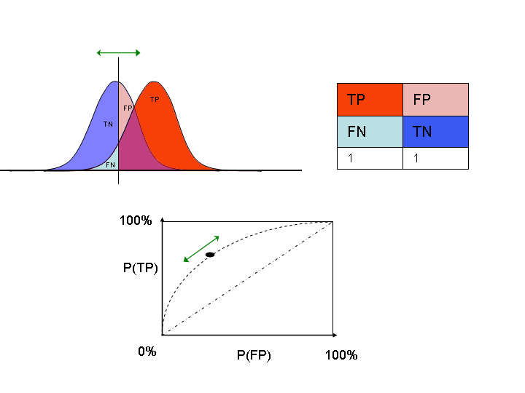
Figure 3-8 graphical illustration of ROC, from wikipedea
It’s clear from Figure 3-9 and Figure 3-10 that using these optimizing algorithm we do get a better classifier. It’s very noticeable.

Figure 3-9 ROC curve with sigma=20 and gamma=0.1
Figure 3-10 ROC with optimized with simplex and csa
It is very clear that the classifier with the ROC curve from Figure 3-10 is way less depended on the position of the threshold ! And is therefore a much better classifier.

Homework assignment 1: The Ripley Data-Set

Visualize data set
Figure 4-1 scatter plot data red and blue are the two different classes
Figure 4-1 illustrates the data plotted out on a scatter plot, it’s very clear that is hard to separate perfectly as the data points overlap. The border of the overlap is not a straight line, so this data will probably not have a good performance with the linear model.

Linear model
Figure 4-2 is a scatter plot of the linear model optimized model. This model has been optimized with the tunelssvm function. It has an error rate of approximately 10,3%. Which is rather large as this is $\frac{1}{10}$^{th} of the samples that is wrongly classified. So it might be a good idea to try a nonlinear kernel such as the RBF kernel.
Figure 4-2 optimized linear classifier
performance_cross_10_fold | error_rate_test data | gam
14.8% | 10.7% | 0.0900

RBF kernel
The nonlinear RBF kernel is not much better than the linear kernel with an error rate of 9%. The tunelssvm is ran multiple times the performance will slightly change (around 0.5%) . Which is neglect able .The performance (10 fold cross validation) changes significantly it varies between 11% and 14%. Which is not that good, switching from simplex to gridsearch makes this even worse.

Figure 4-3 LS-SVM with optimized RBF kernel

ROC curve
Figure 4-4 ROC curve linear model | Figuur 4-1 ROC curve RBF kernel
Both the ROC curve with RBF kernel and with the Linear kernel are quiet bad, the RBF kernel is a little better than the linear model. But I would not state that its significantly better.

Final model
If an error of about 10% is good enough then this model might be fit for purpose. The nonlinear model does not pay of much compared to the linear one. And one might consider using the linear model as its simpler and is almost as good as the nonlinear one.

Homework assignment 2: Breast cancer Data-Set
The data set used in this part has 8 dimensions and is therefore very hard to plot. This also means that we cannot plot out the training data with the classifier. We will have to rely on some ratio’s and the ROC.

Performance
Kernel: | Linear | RBF
Test data: | 21.43% | 21.43%
Cross validation: | 25.00% | 26.33%
Table 5-1
It is clear that the performance of the linear kernel is not better than the RBF kernel.

ROC
Figuur 5-1 linear kernel | Figuur 5-2 RBF kernel

Feedback
The ROC curves are nearly the same, and the performance is nearly the same as well. It would conclude from this that the linear model is the logical choice. It’s simple and elegant and its performance is excellent compared to the RBF.

Homework assignment 2: Breast cancer Data-Set

Performance
Kernel: | Linear | RBF
Test data: | 4.73% | 1.78%
Cross validation: | 3.25% | 1.50%
Table 6-1
It is clear that the performance of the linear kernel is not better than the RBF kernel.

ROC
Figure 6-1 linear kernel | Figure 6-2 RBF kernel

Feedback
This time the linear model has an error rate of about 5% on the test data. This could be sufficient for certain application but we can do better. The RBF kernel gives us a performance of about 2% on the test data The two ROC curves have a similar shape, but off course the RBF kernels ROC is better.

My preference goes to the model with RBF kernel, however the linear model is also quite good. And depending on how correct the input data was, one might consider using the linear model as its way simpler.

