Sequence Diagram: UC-01: Register Account
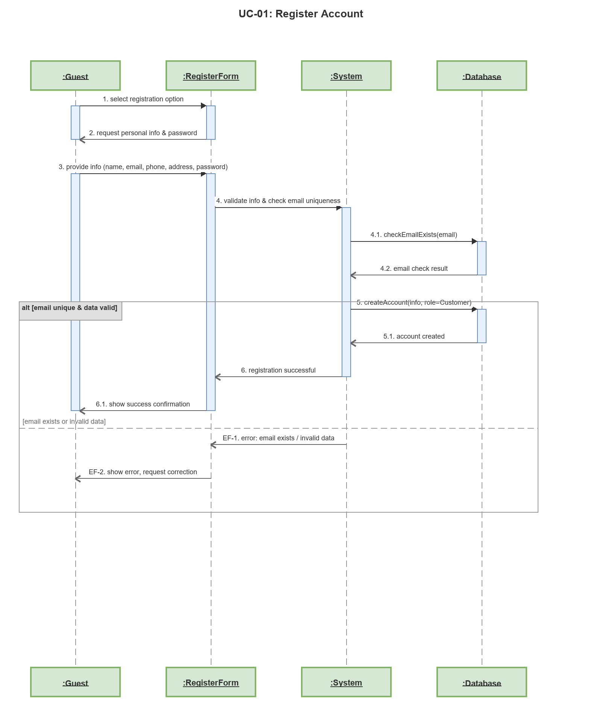

Sequence Diagram: UC-02: Login
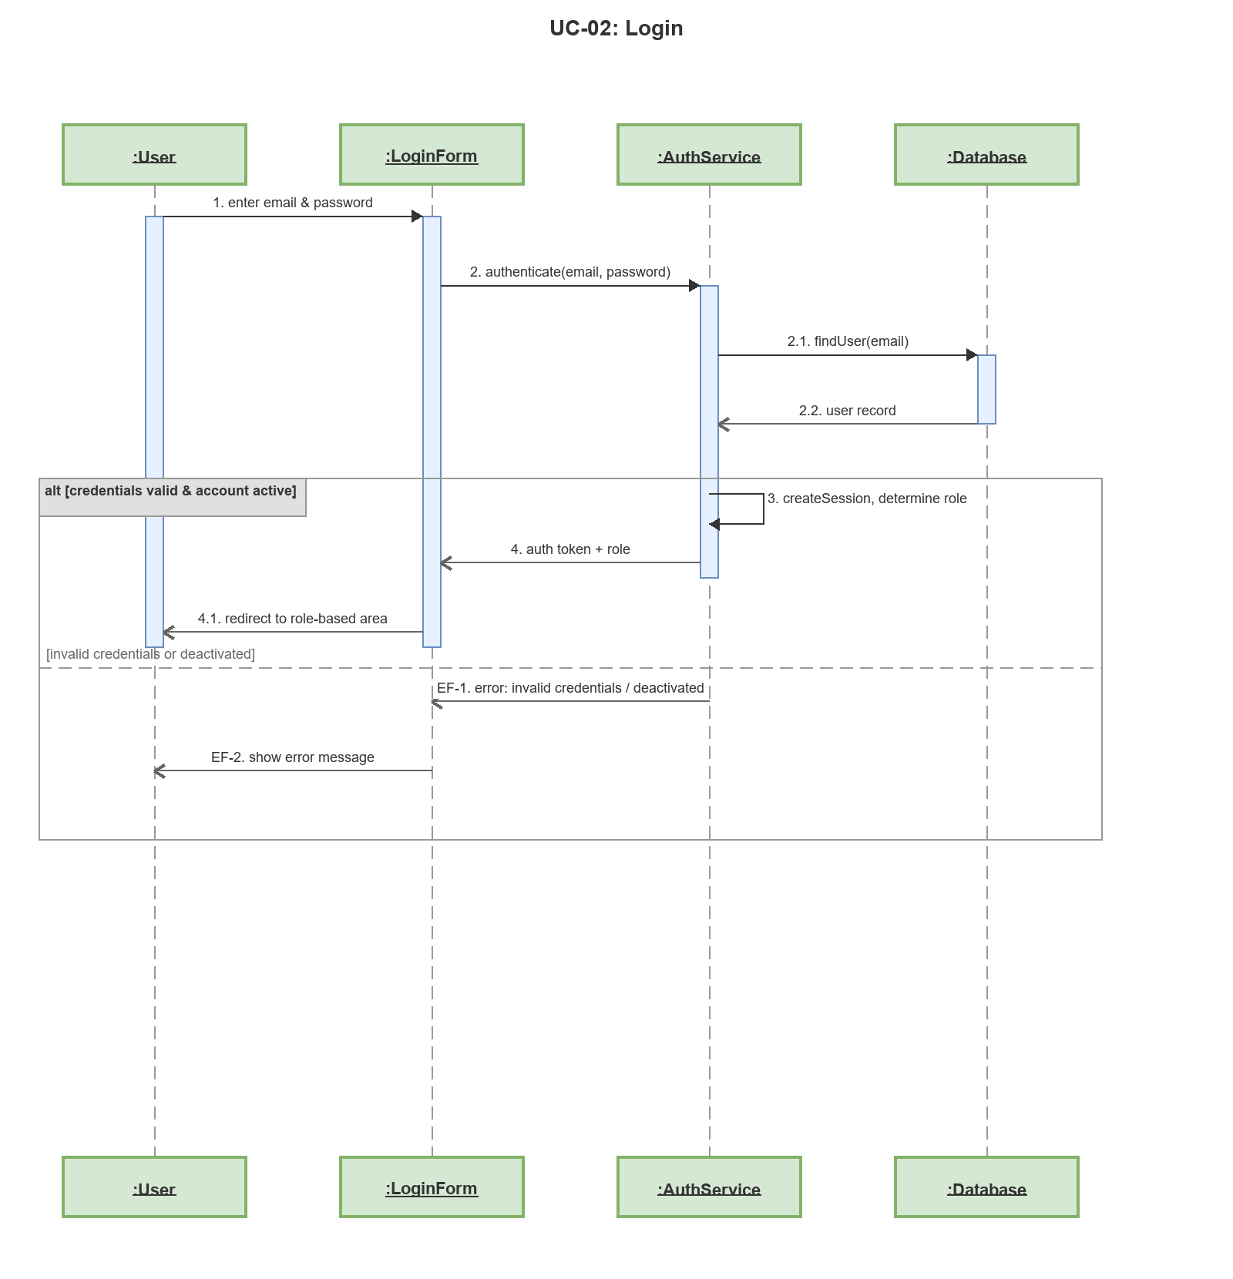

Sequence Diagram: UC-03: Forgot Password
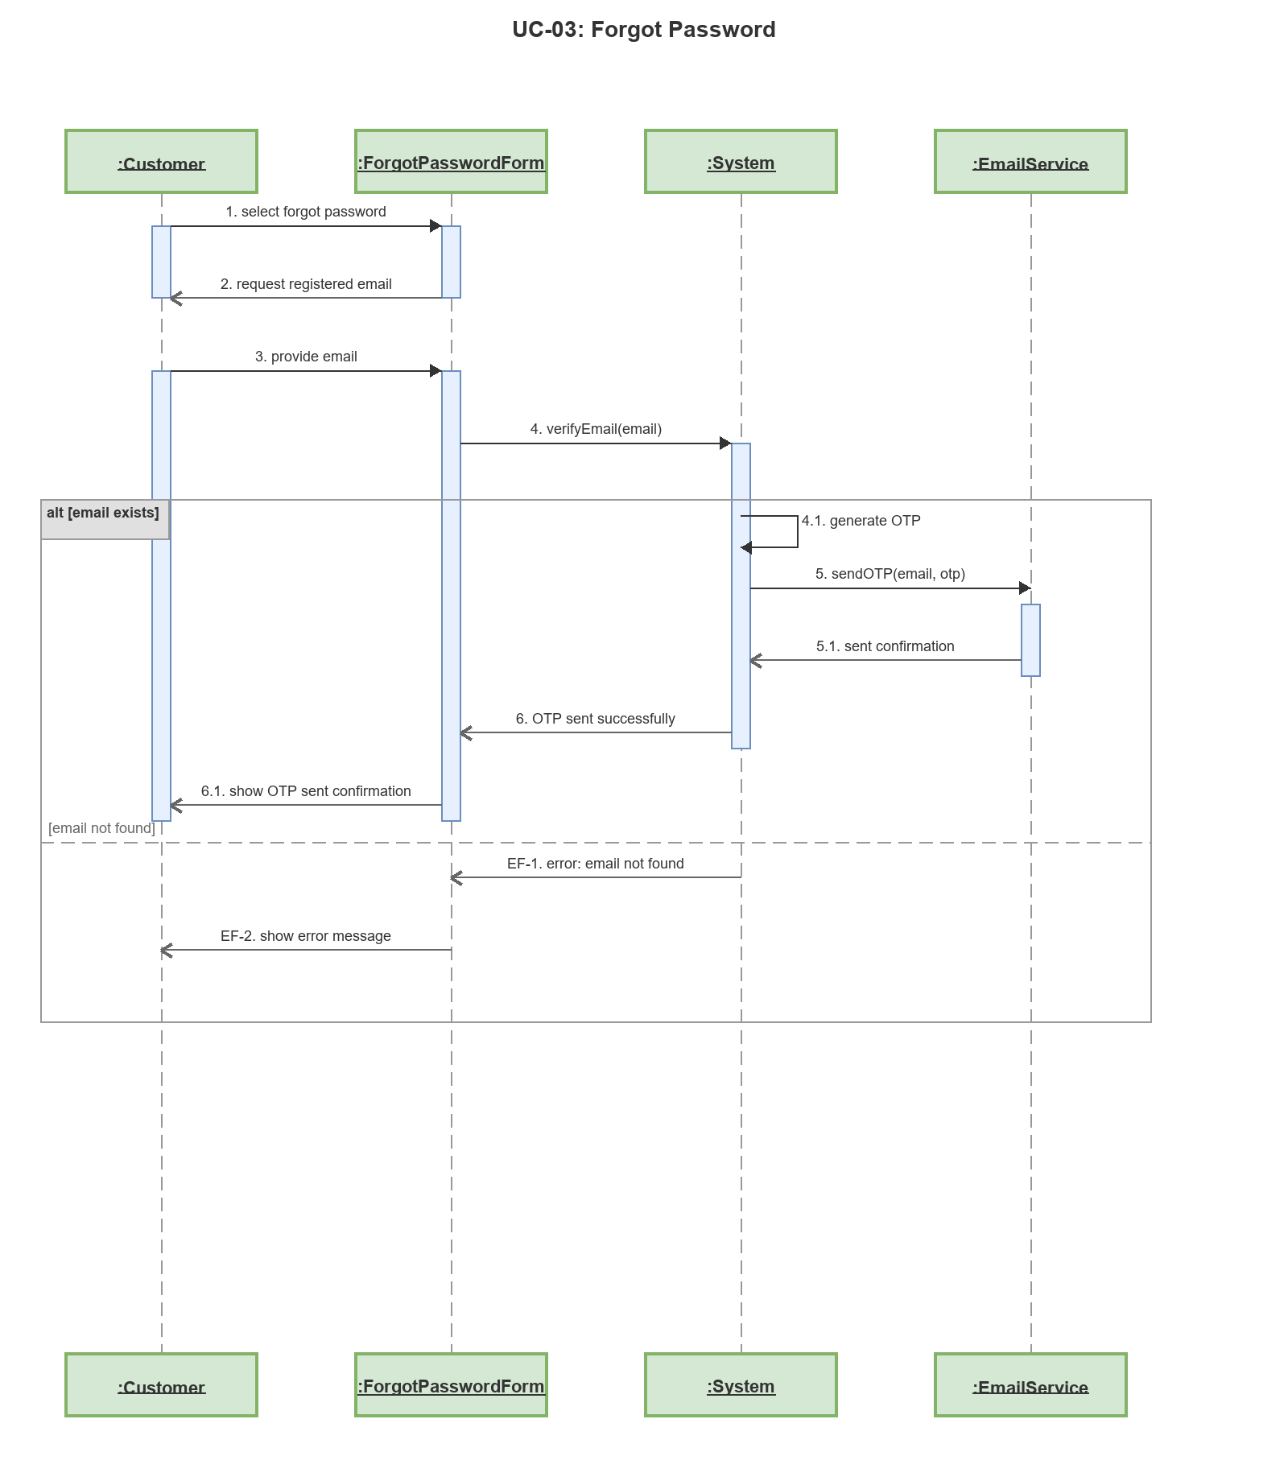

Sequence Diagram: UC-04: Verify OTP
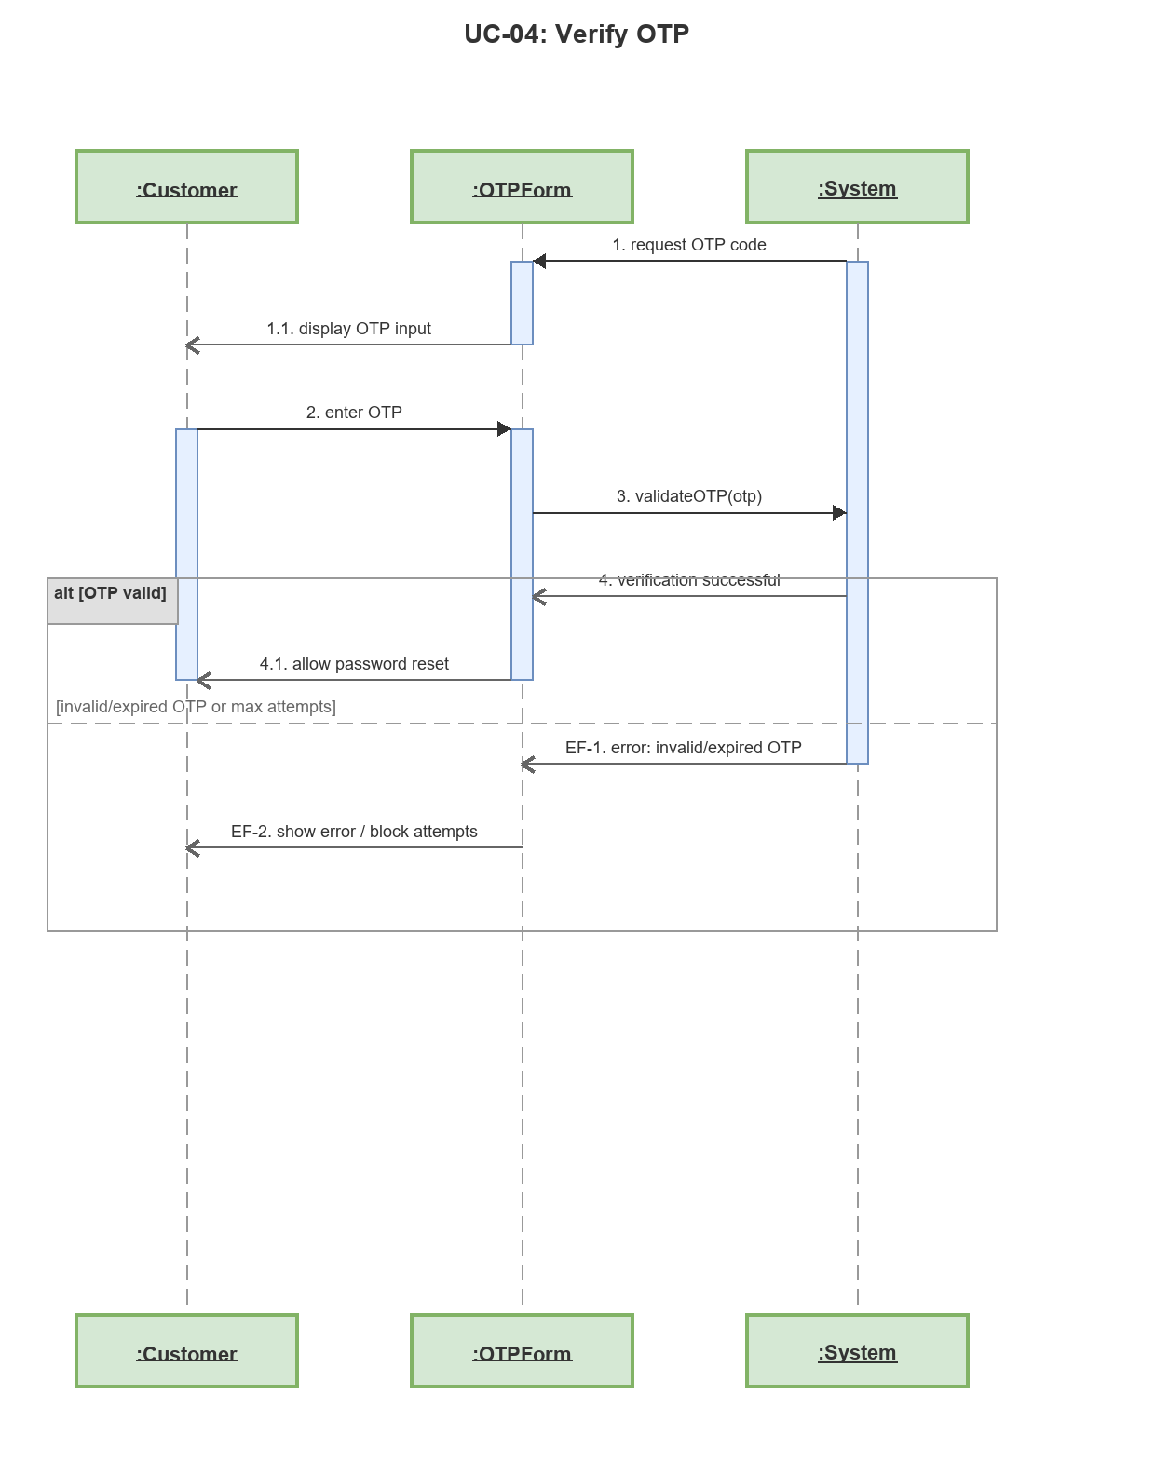

Sequence Diagram: UC-05: Reset Password
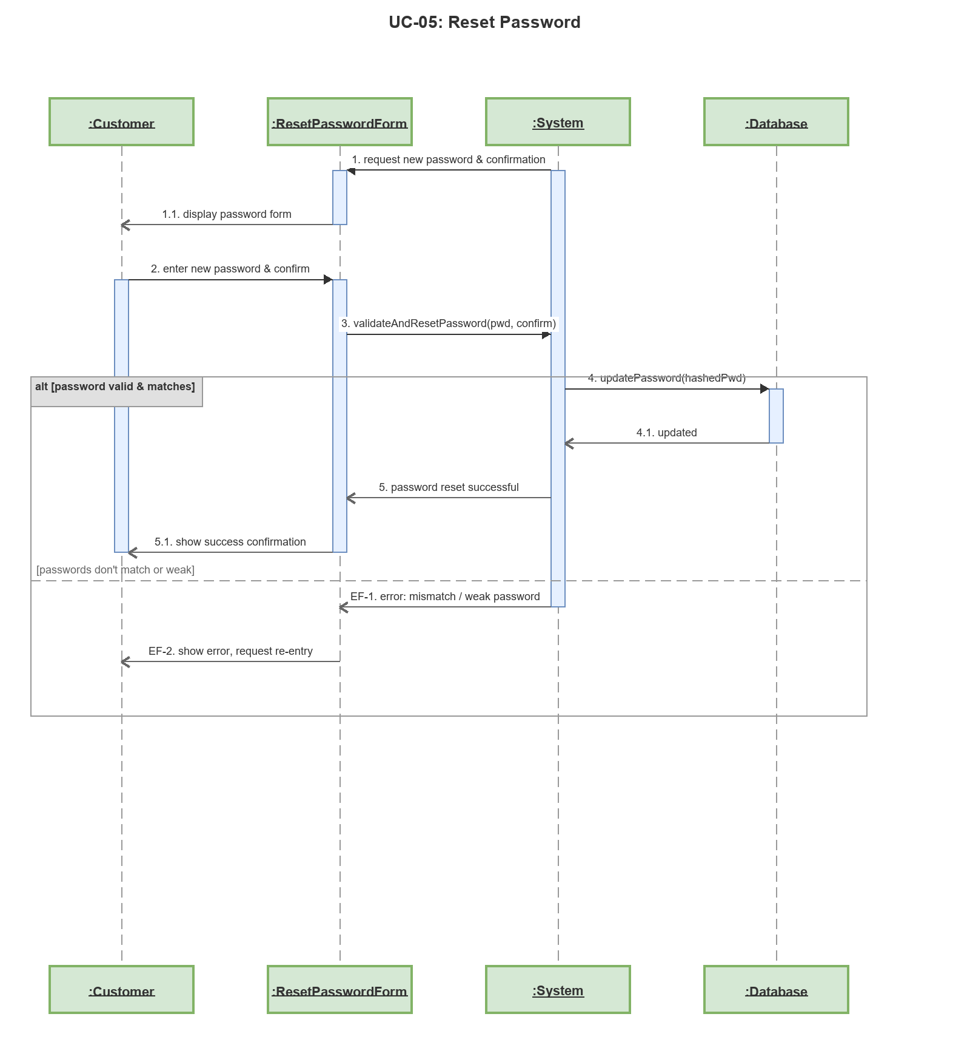

Sequence Diagram: UC-06: Change Password
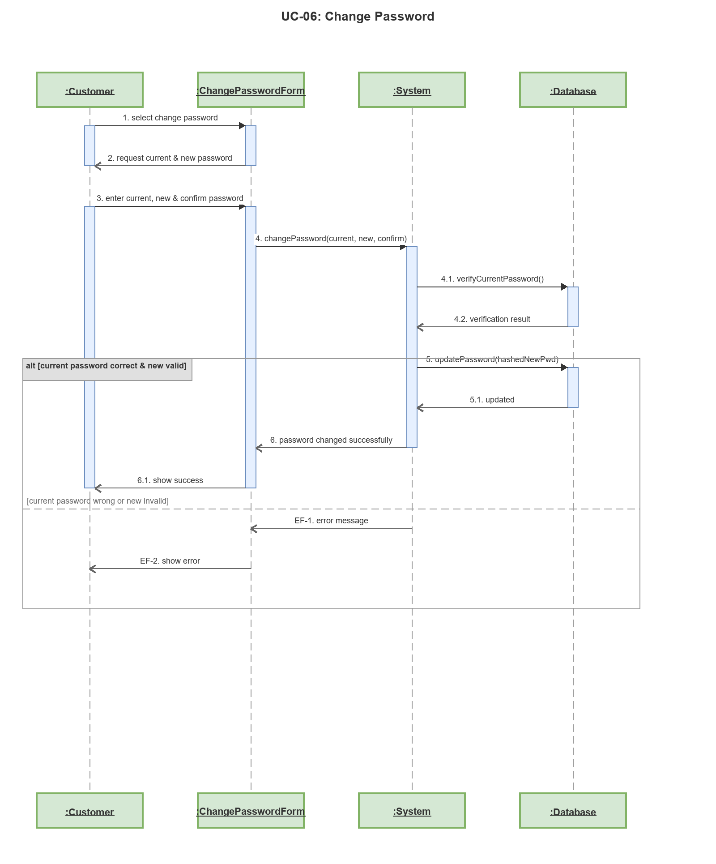

Sequence Diagram: UC-07: Complete Profile
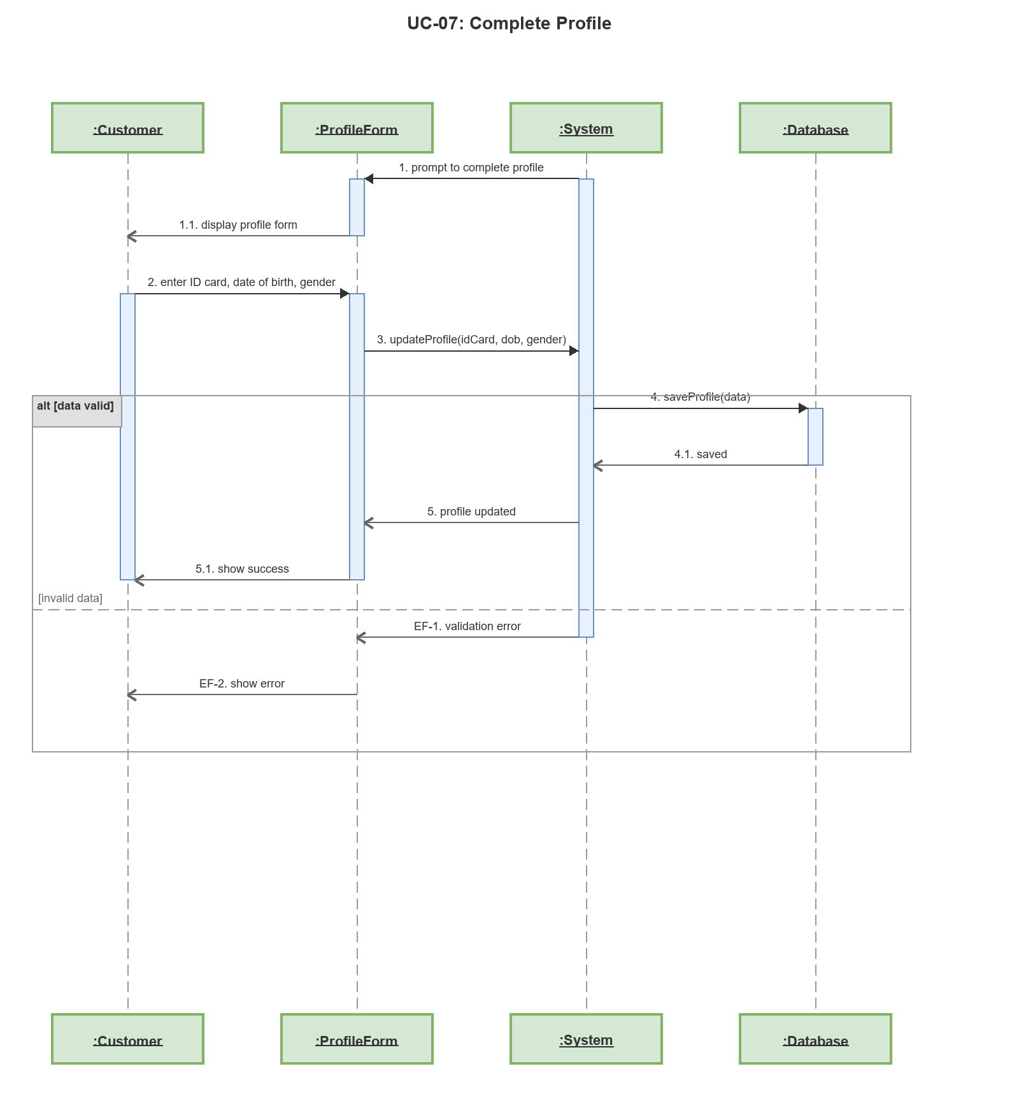

Sequence Diagram: UC-08: Browse Available Rooms
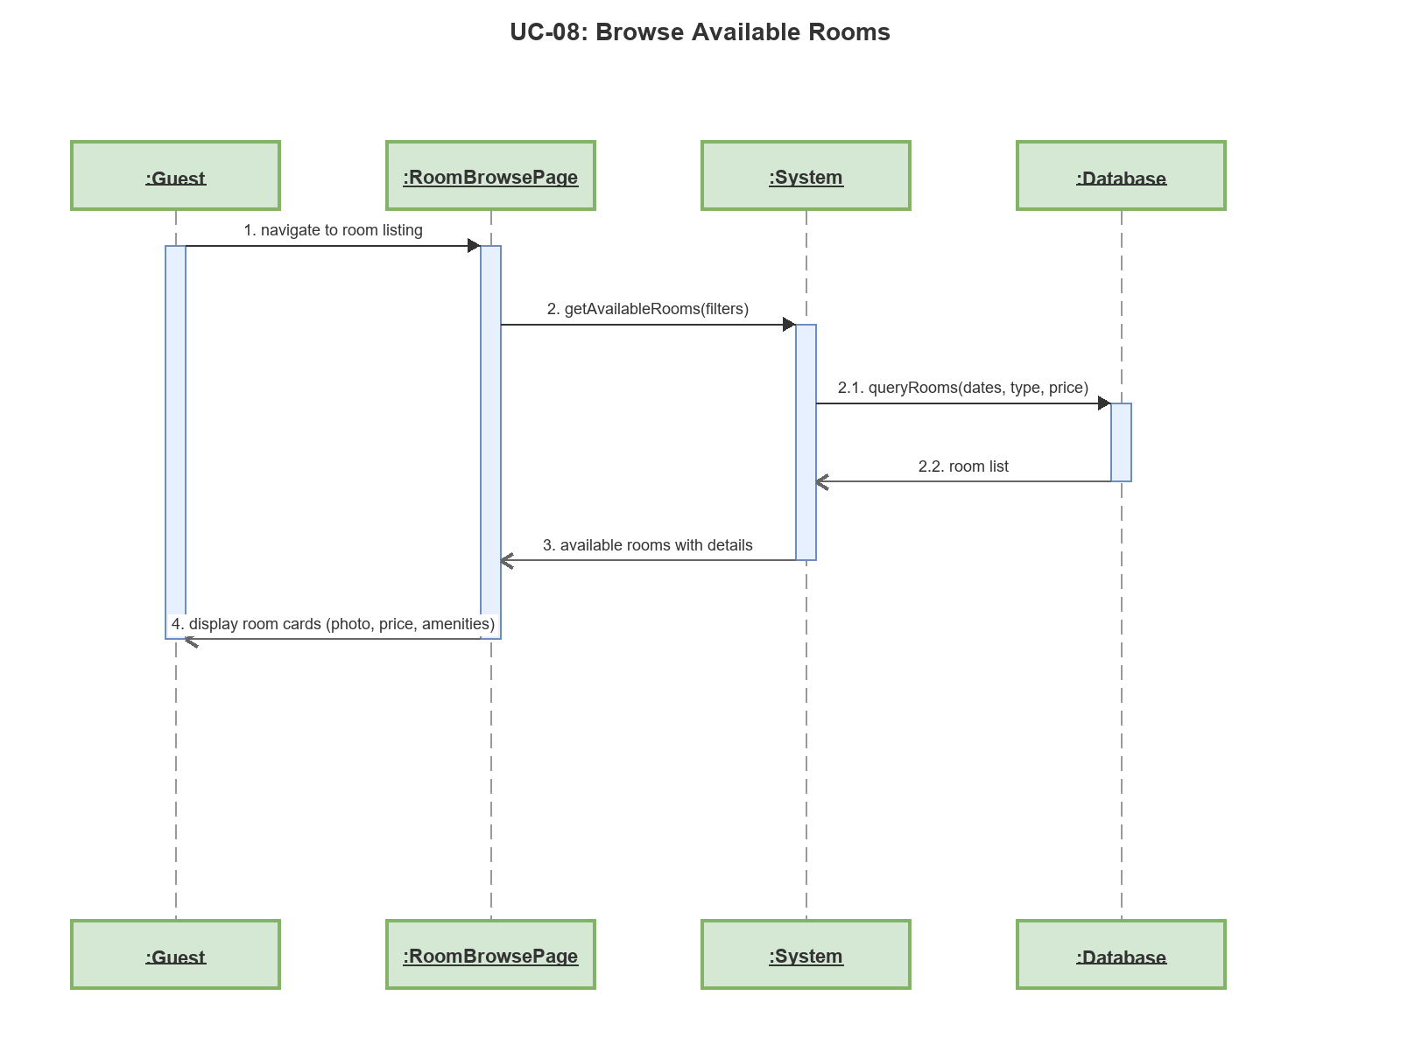

Sequence Diagram: UC-09: View Room Detail
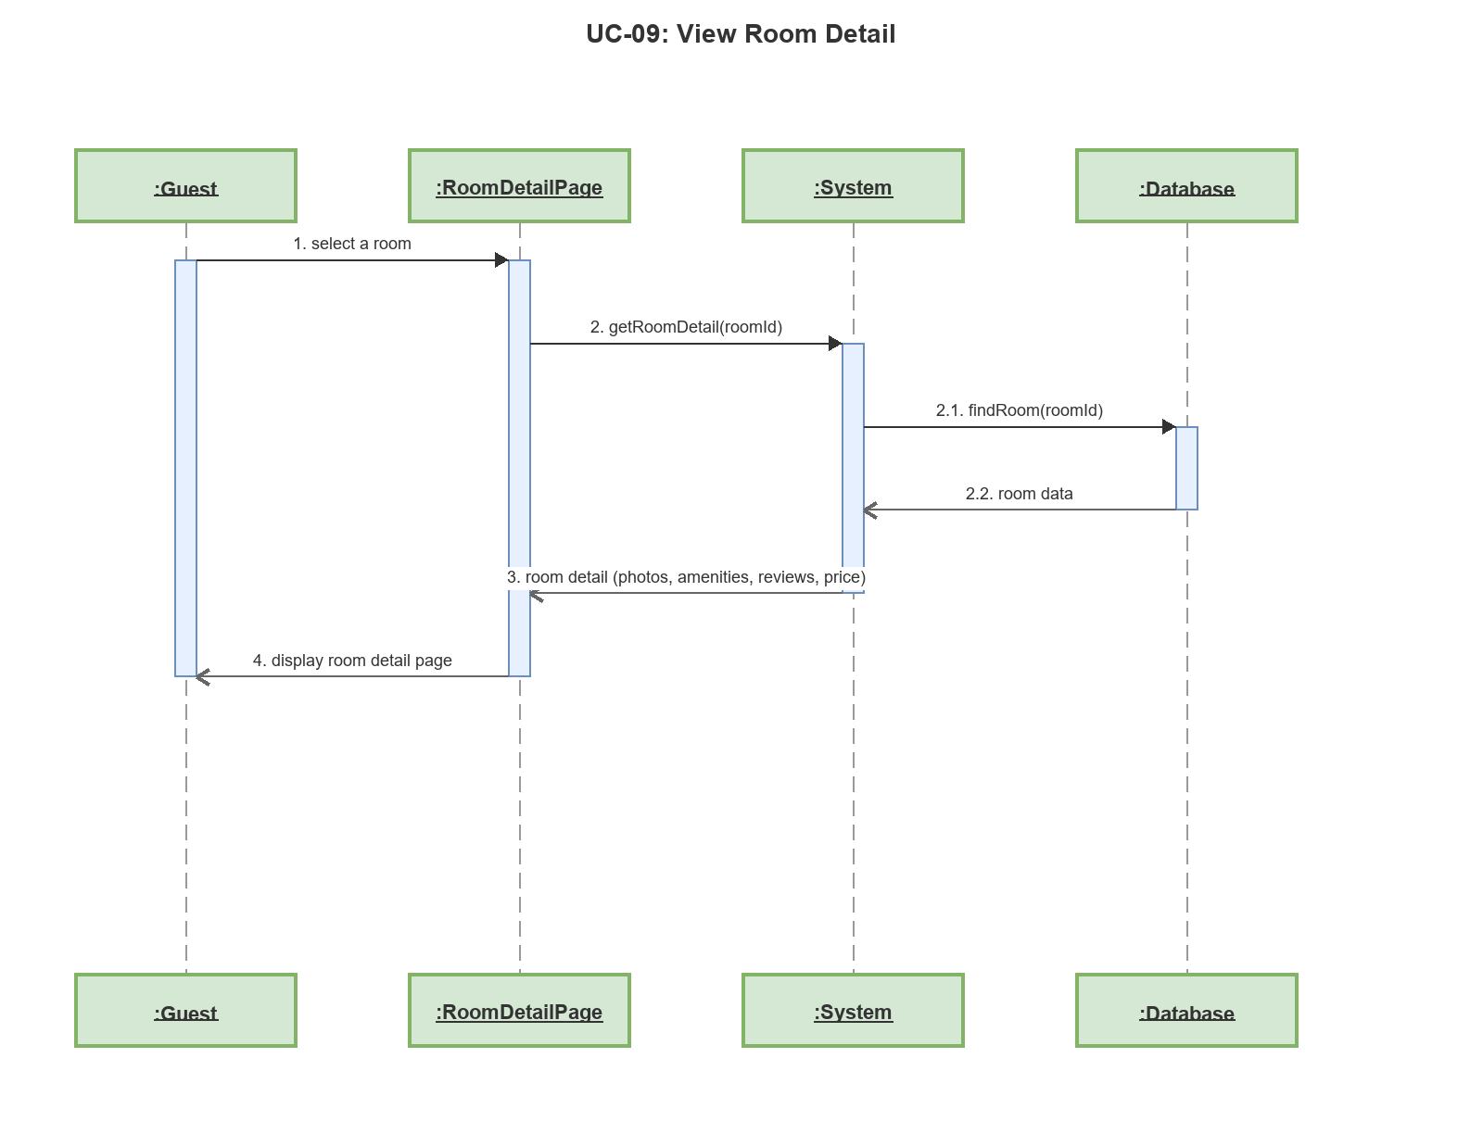

Sequence Diagram: UC-10: Create Booking
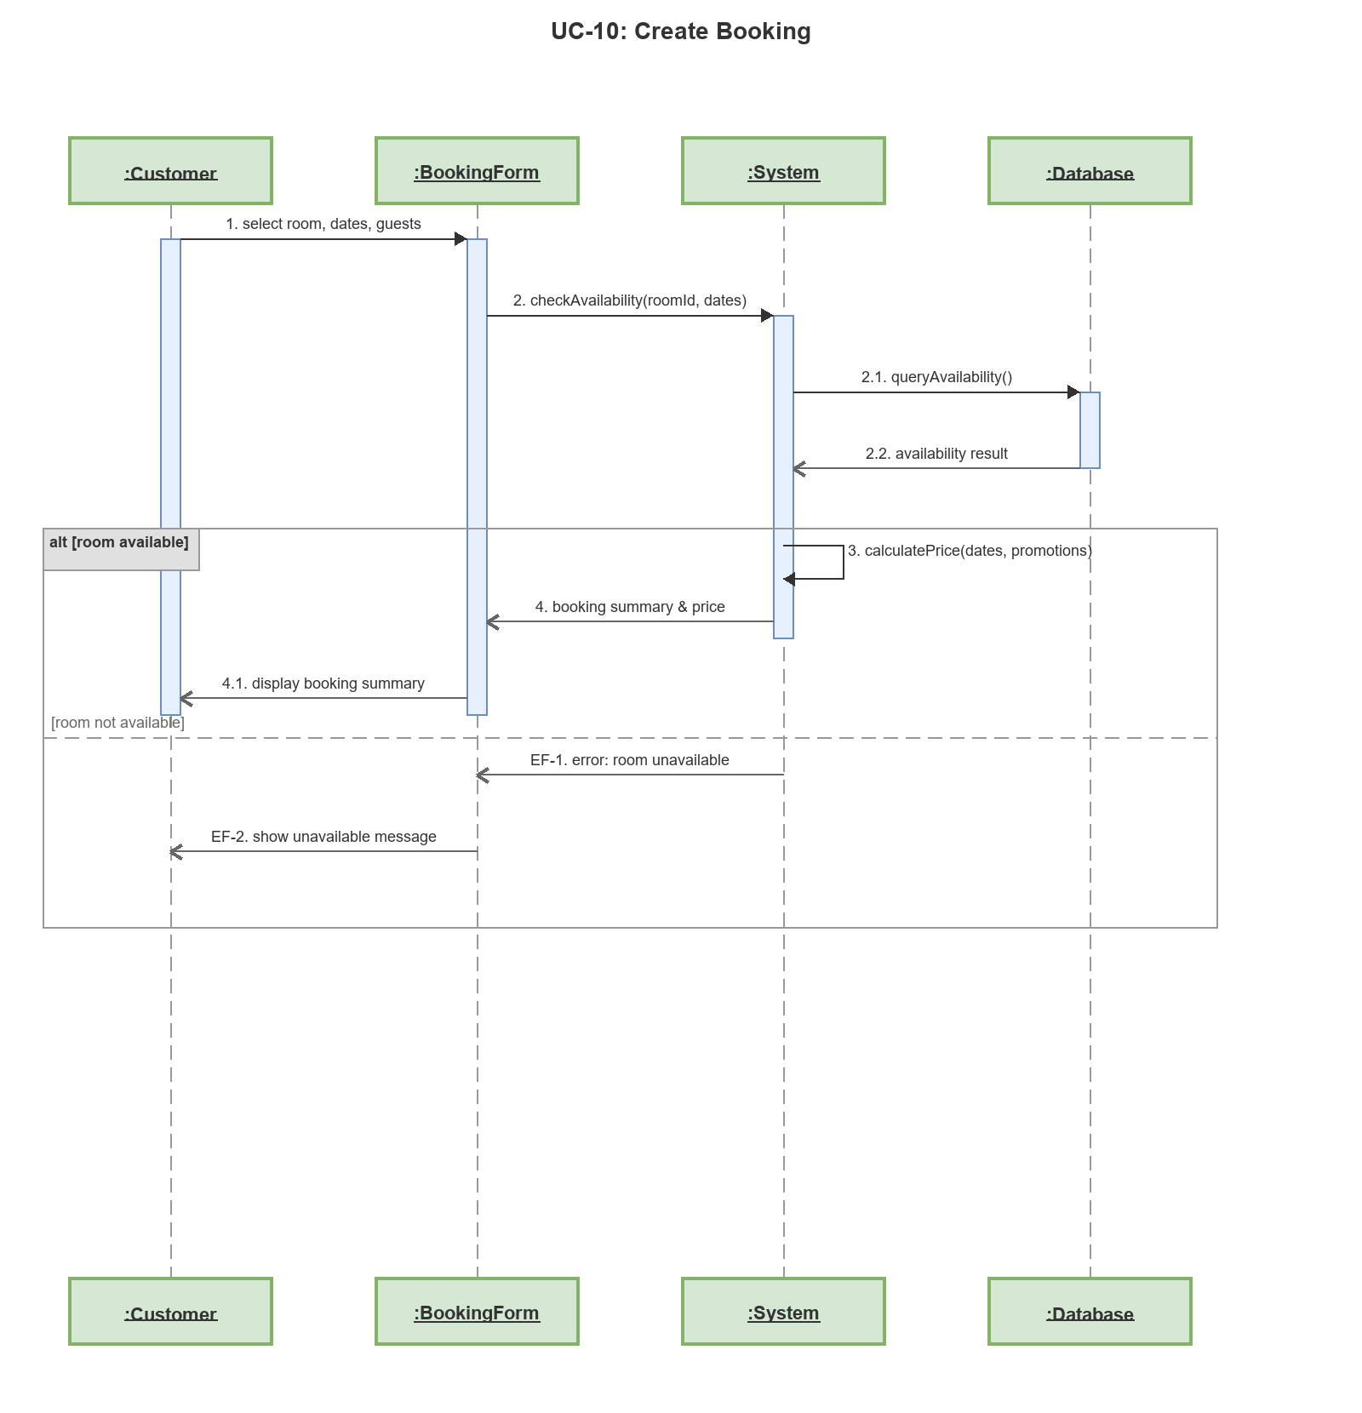

Sequence Diagram: UC-11: Confirm Booking
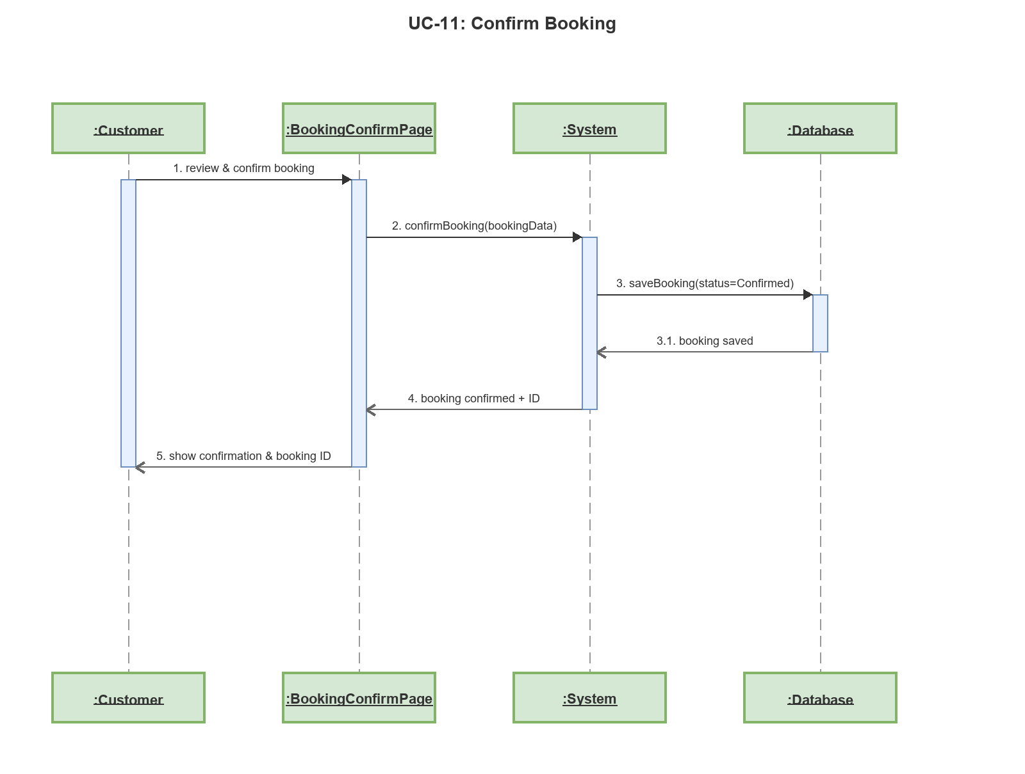

Sequence Diagram: UC-12: View Booking Status
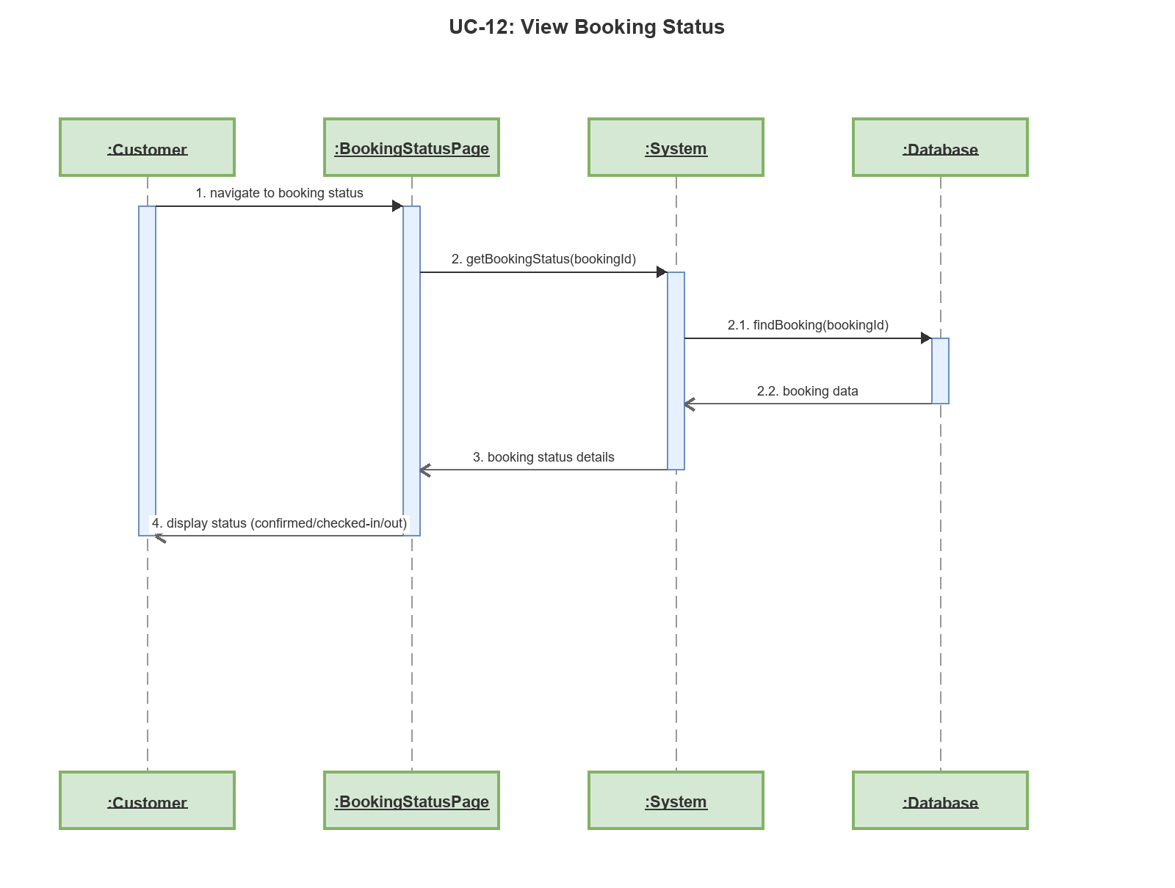

Sequence Diagram: UC-13: Extend Booking
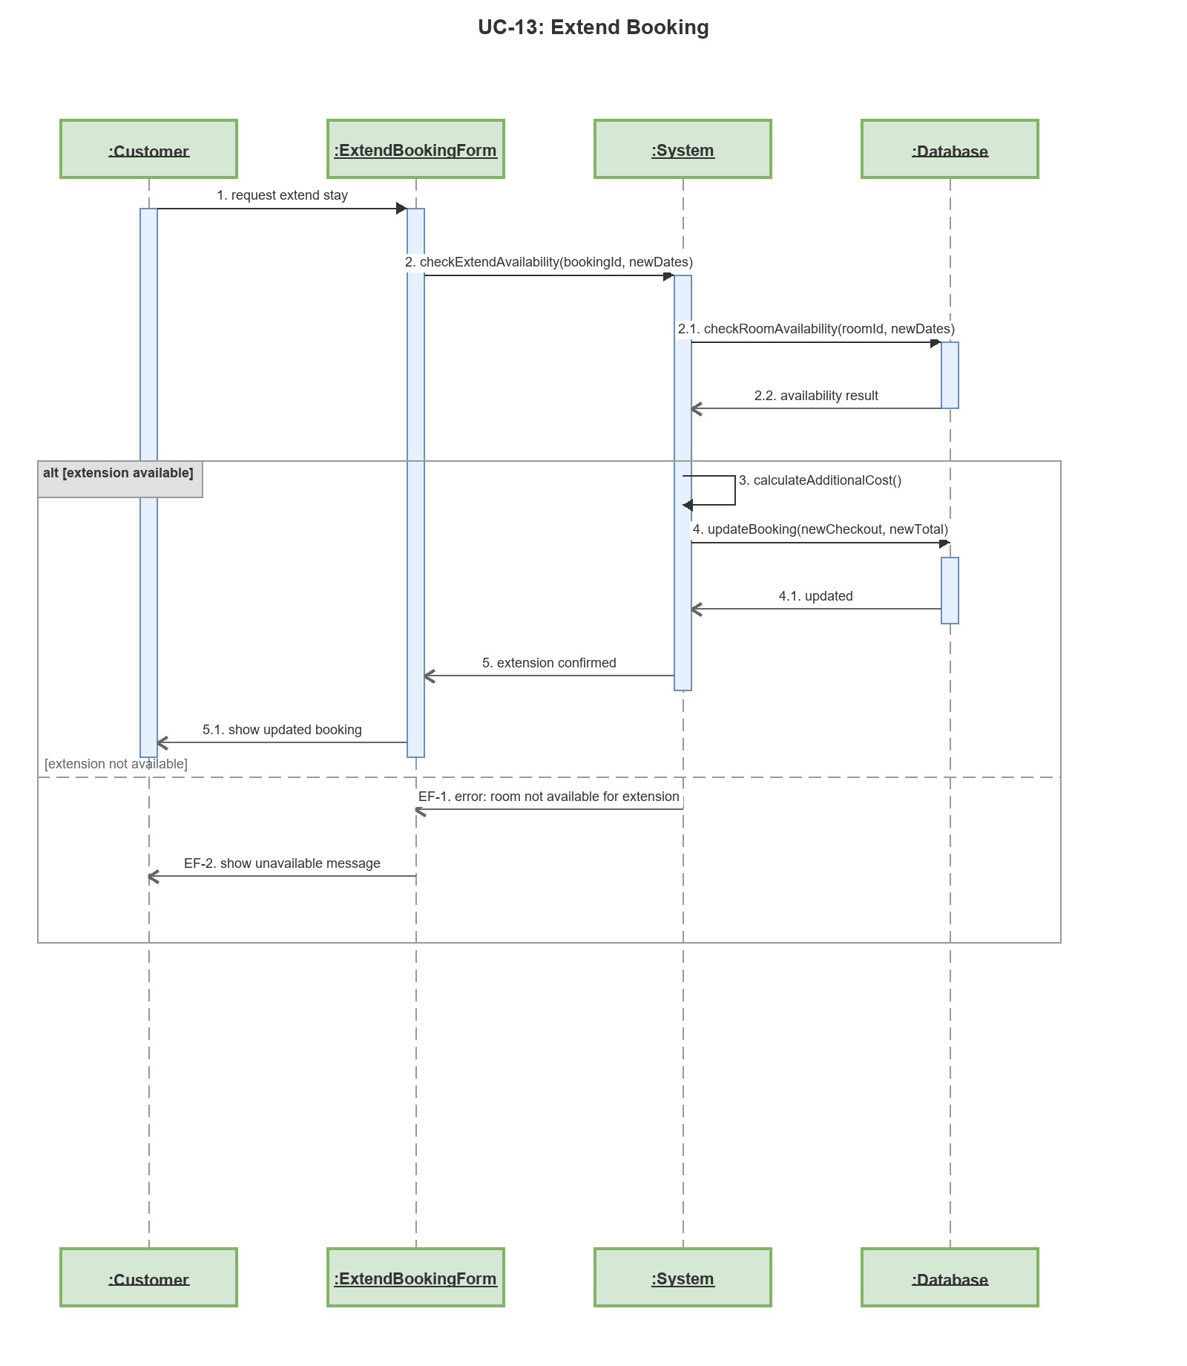

Sequence Diagram: UC-14: View Booking History
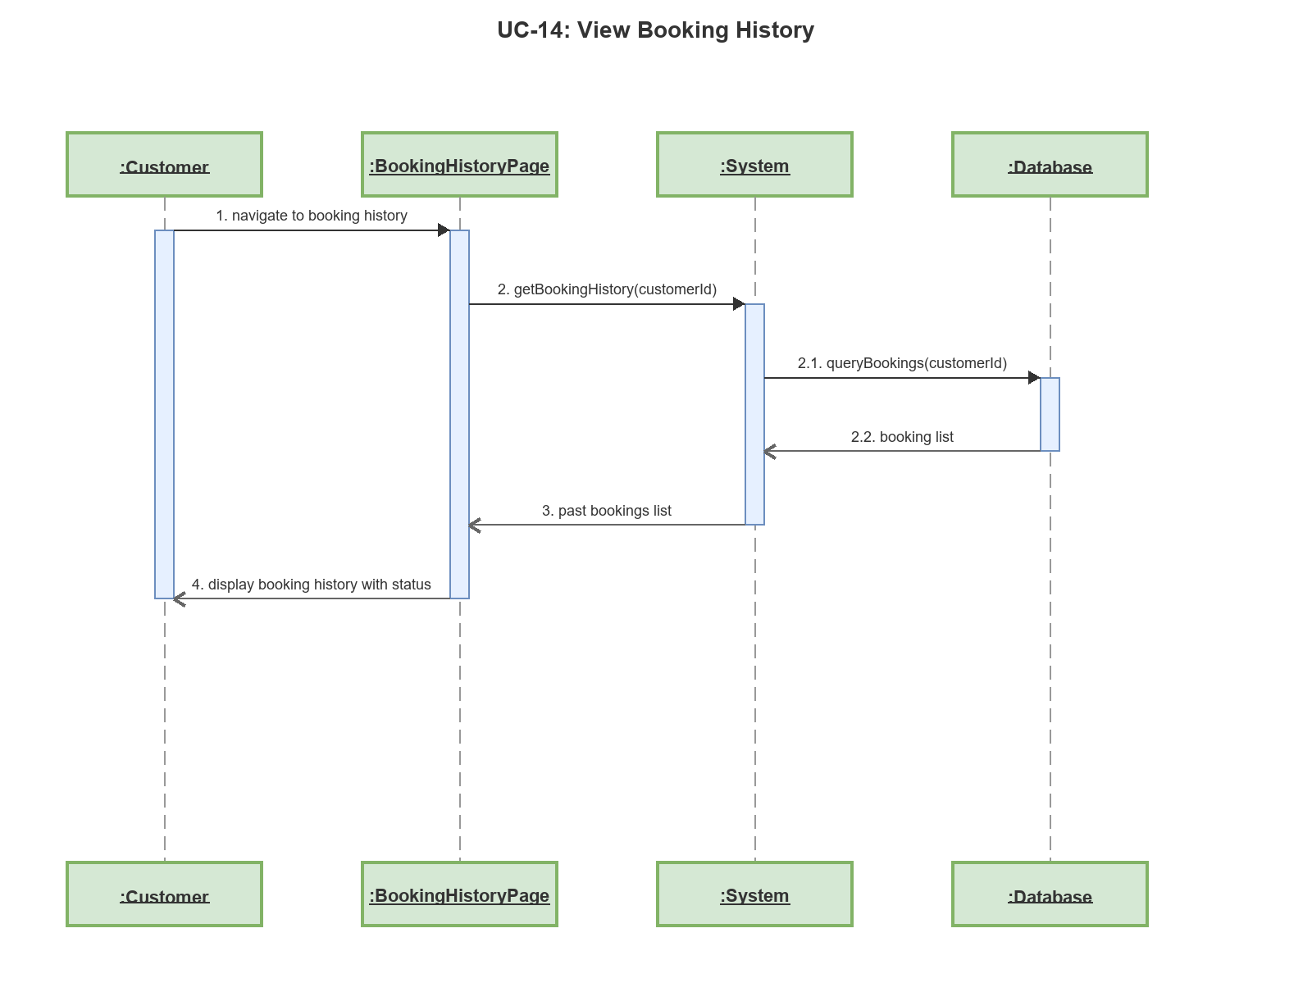

Sequence Diagram: UC-15: View Booking Detail
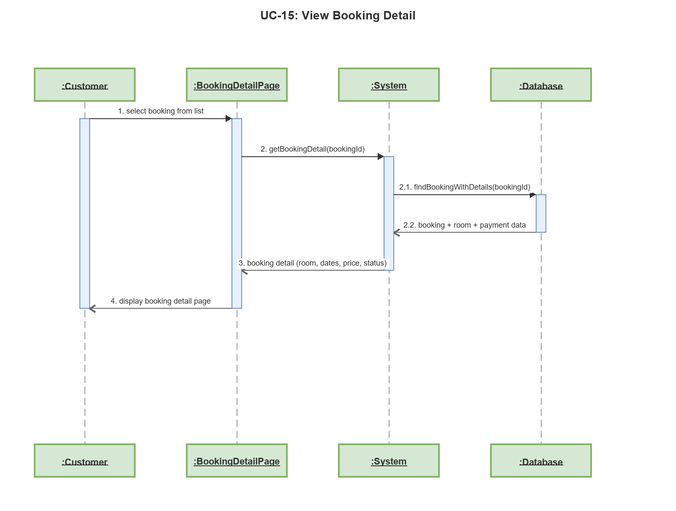

Sequence Diagram: UC-16: Make Online Payment
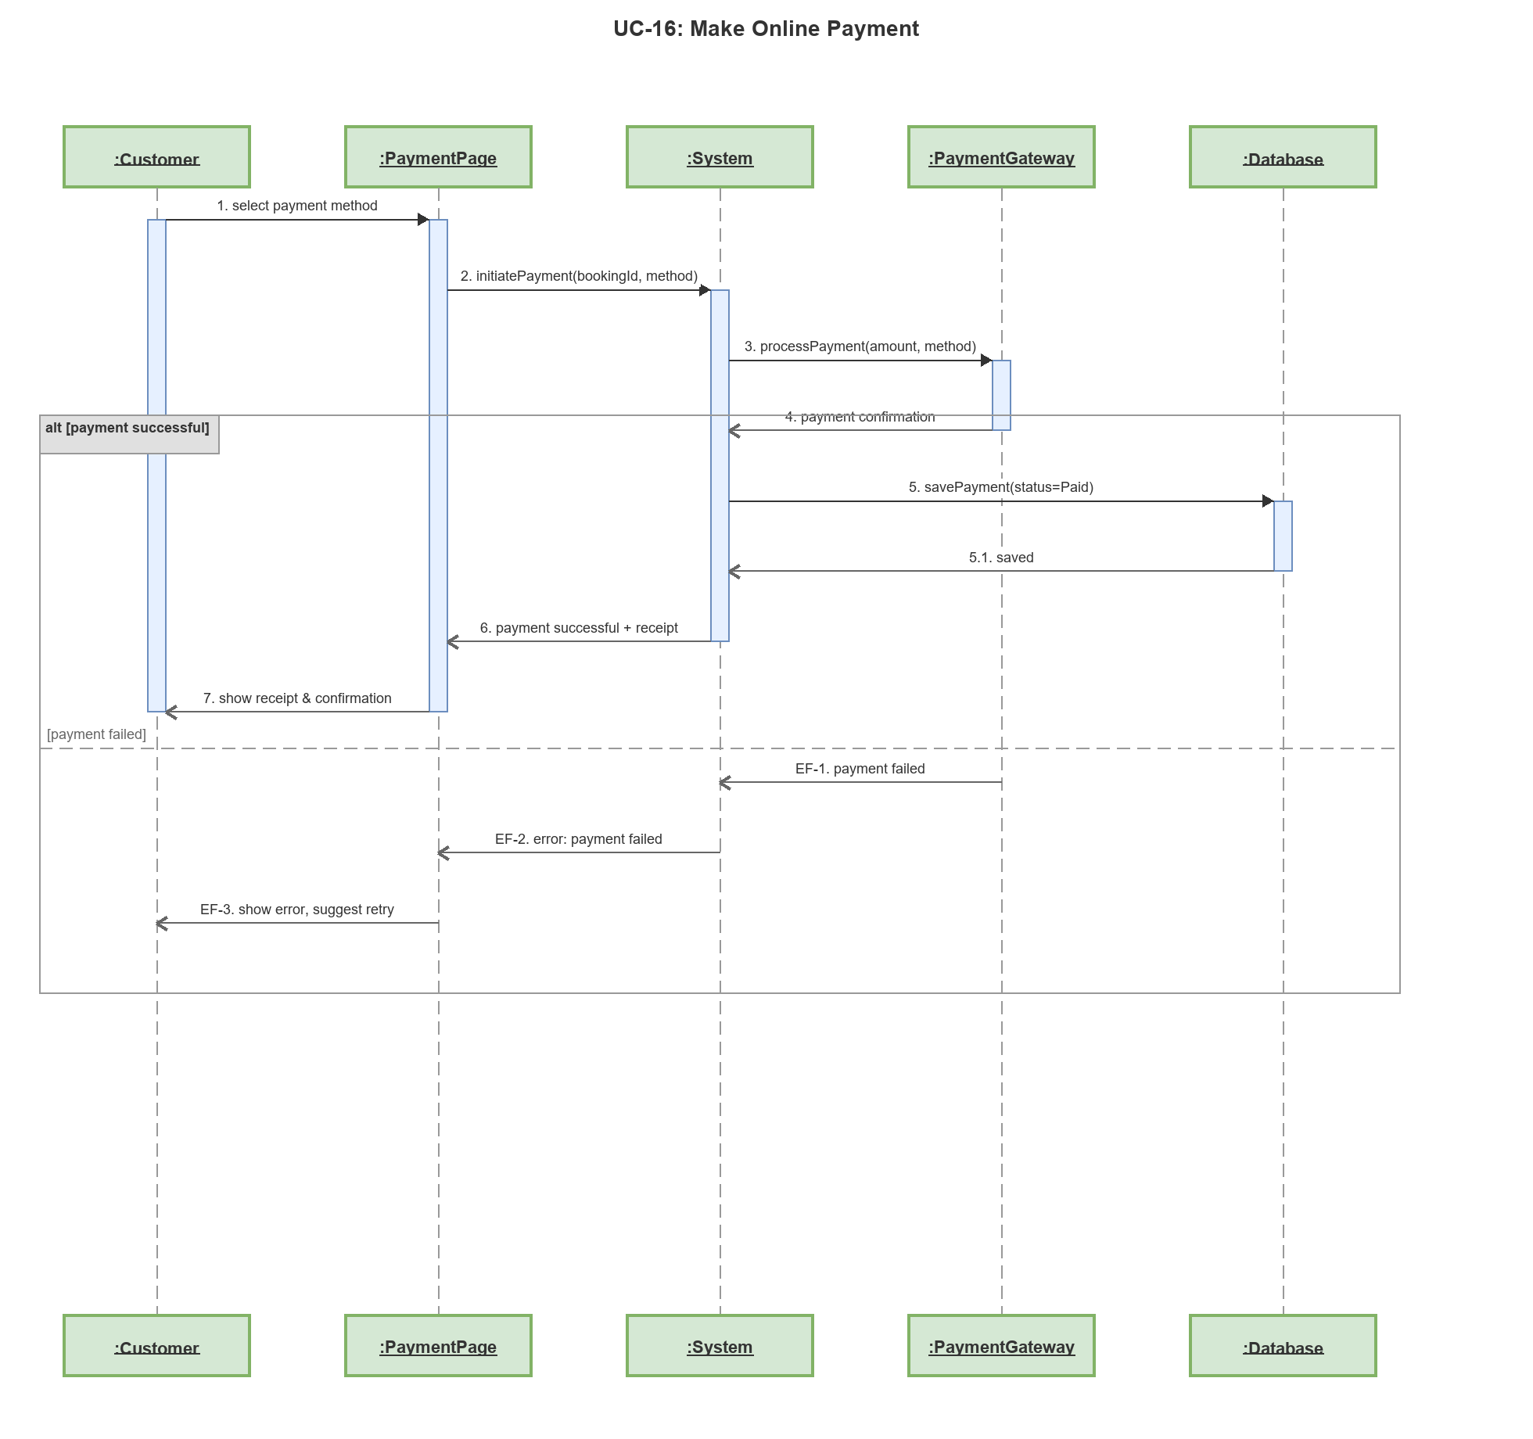

Sequence Diagram: UC-17: View Profile
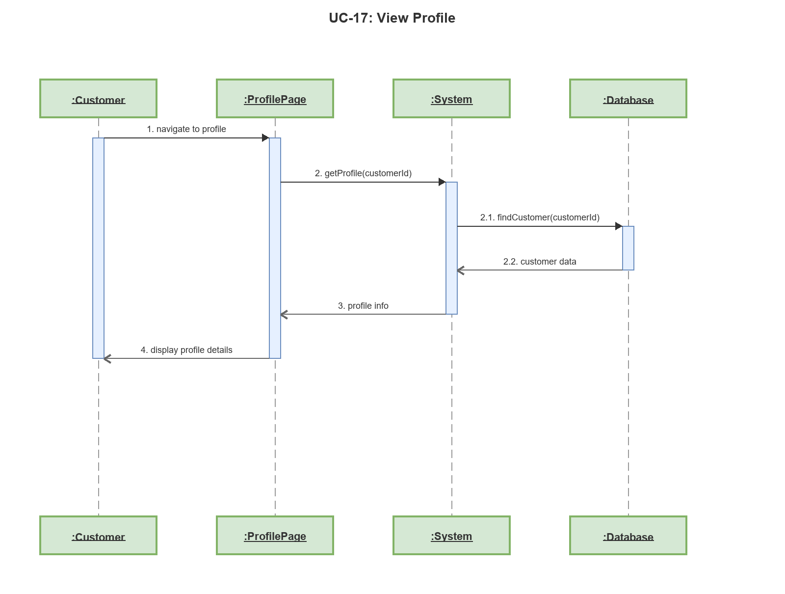

Sequence Diagram: UC-18: Edit Profile
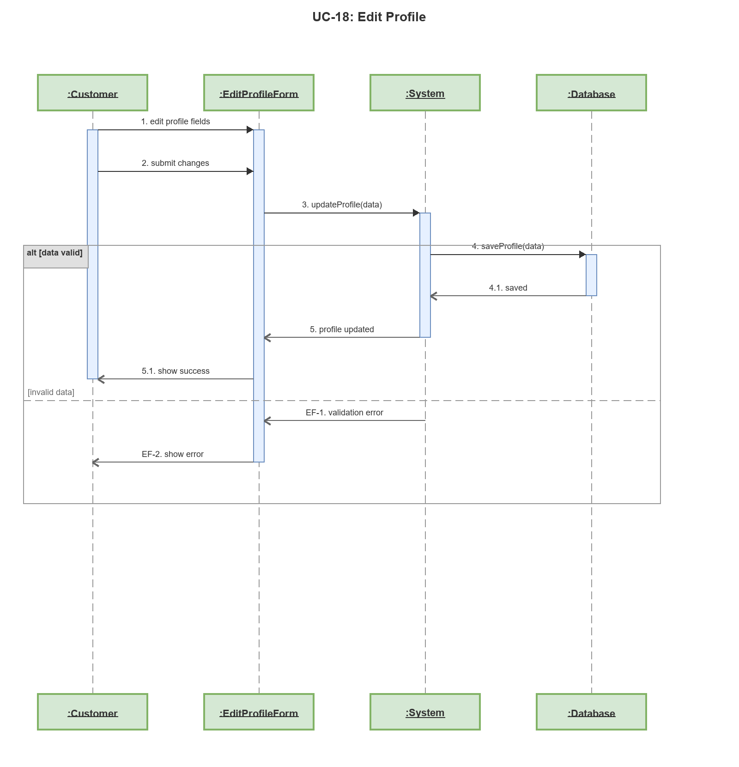

Sequence Diagram: UC-19: Submit Feedback
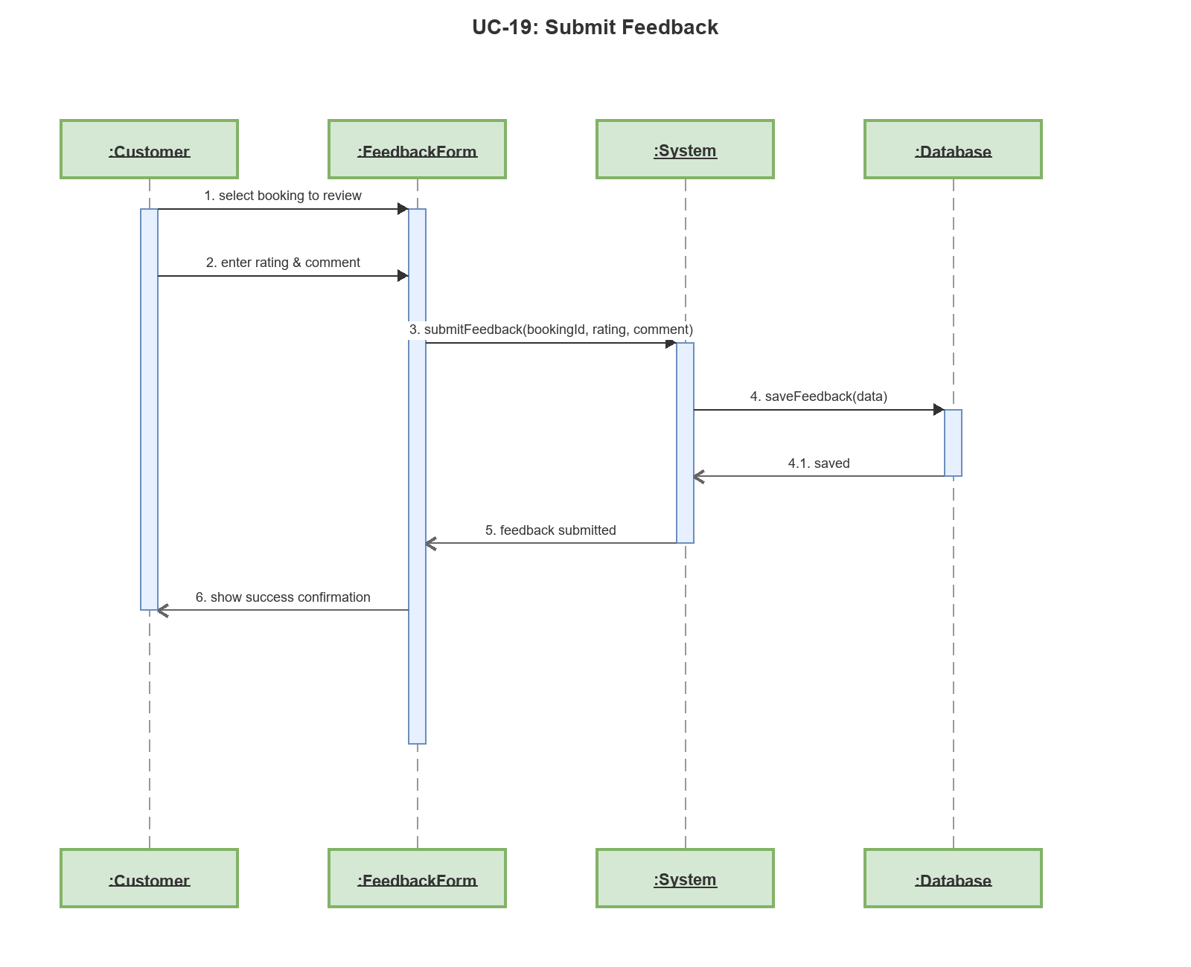

Sequence Diagram: UC-20: View My Reviews
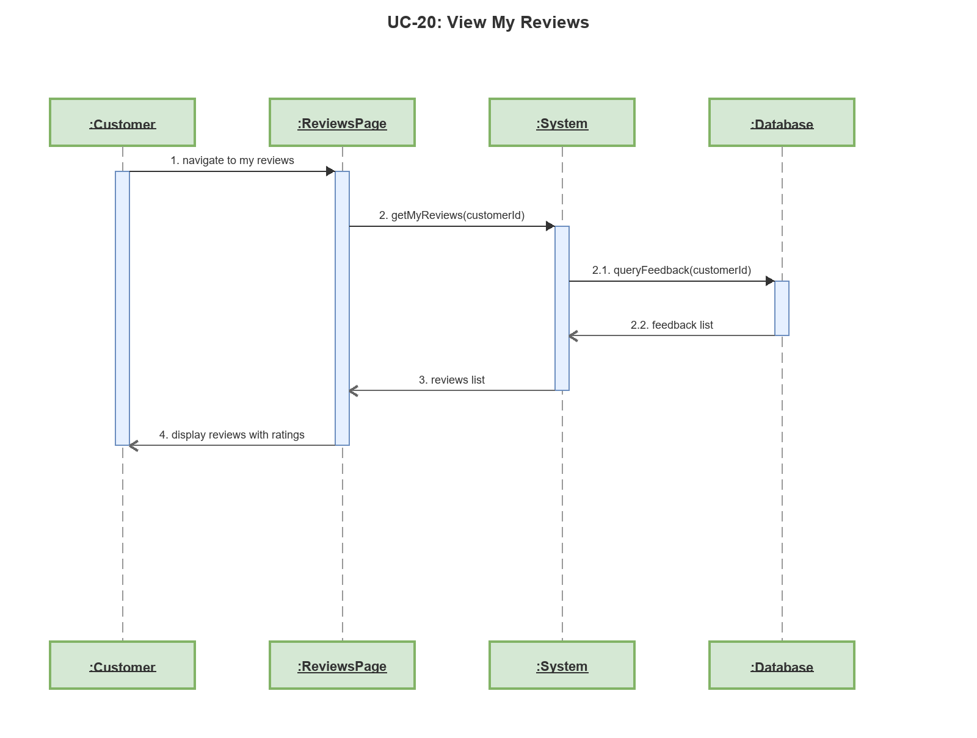

Sequence Diagram: UC-21: Submit Service Request
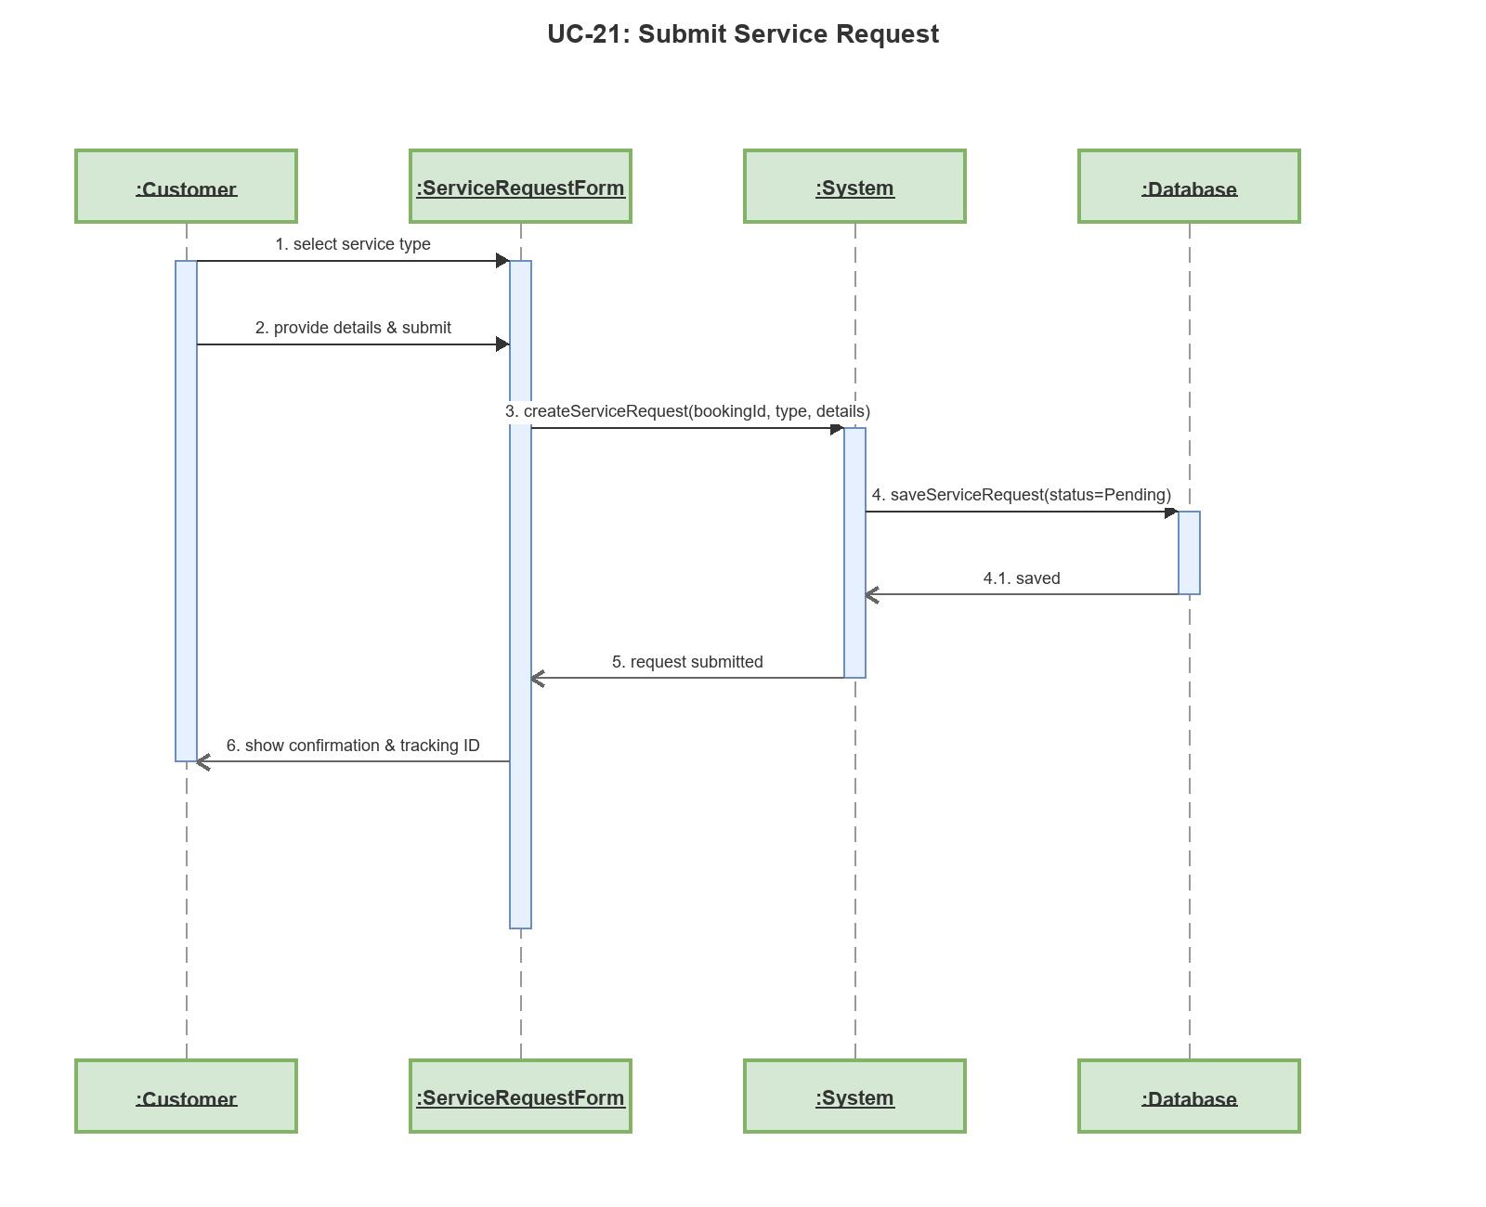

Sequence Diagram: UC-22: View My Service Requests
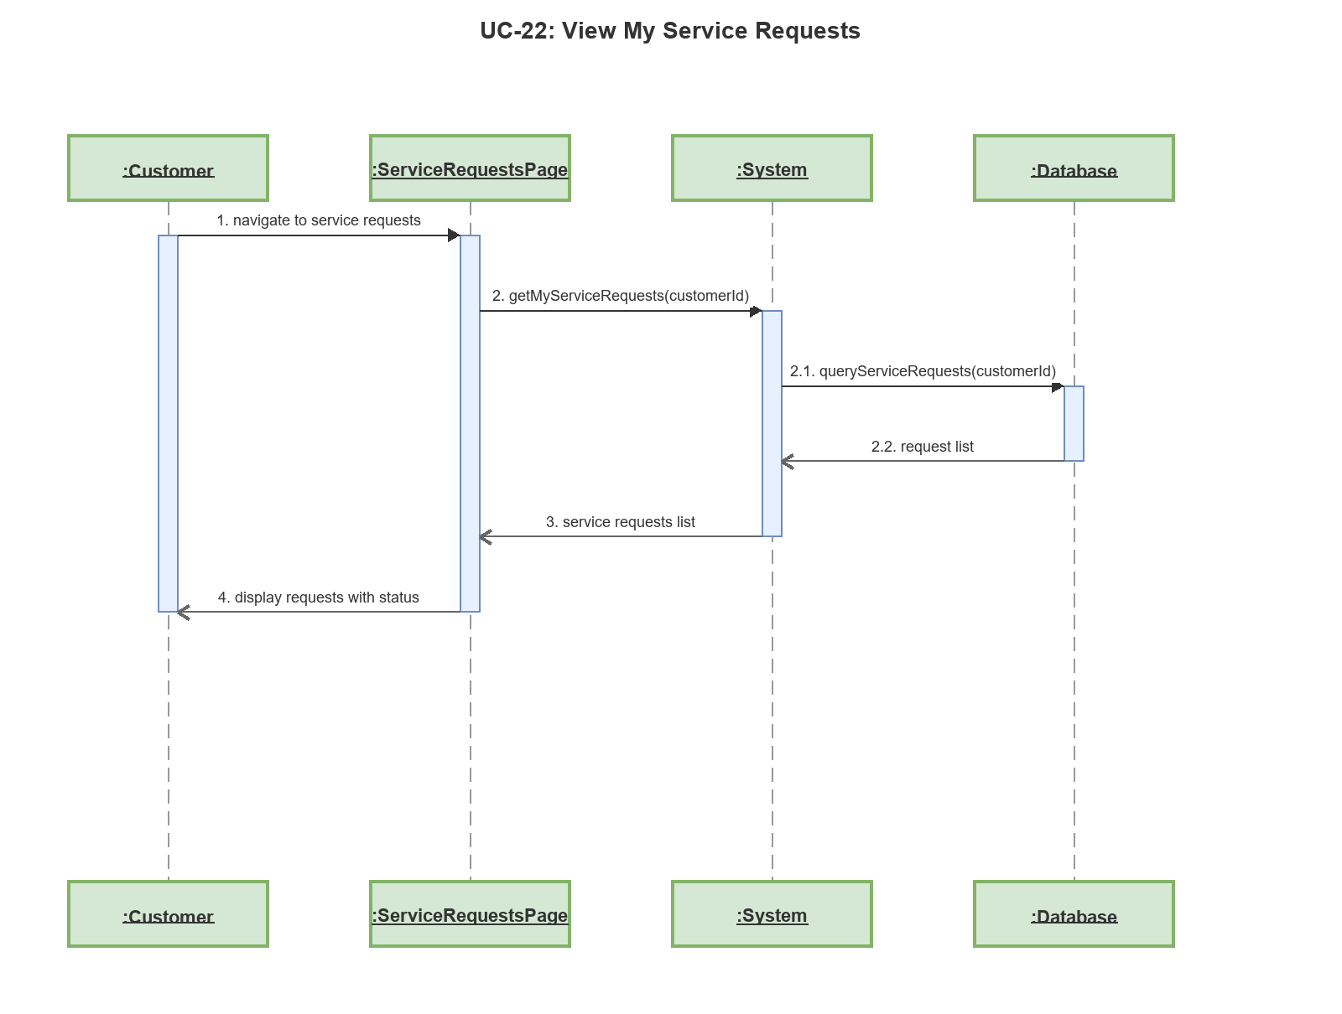

Sequence Diagram: UC-23: View Booking List (Staff)
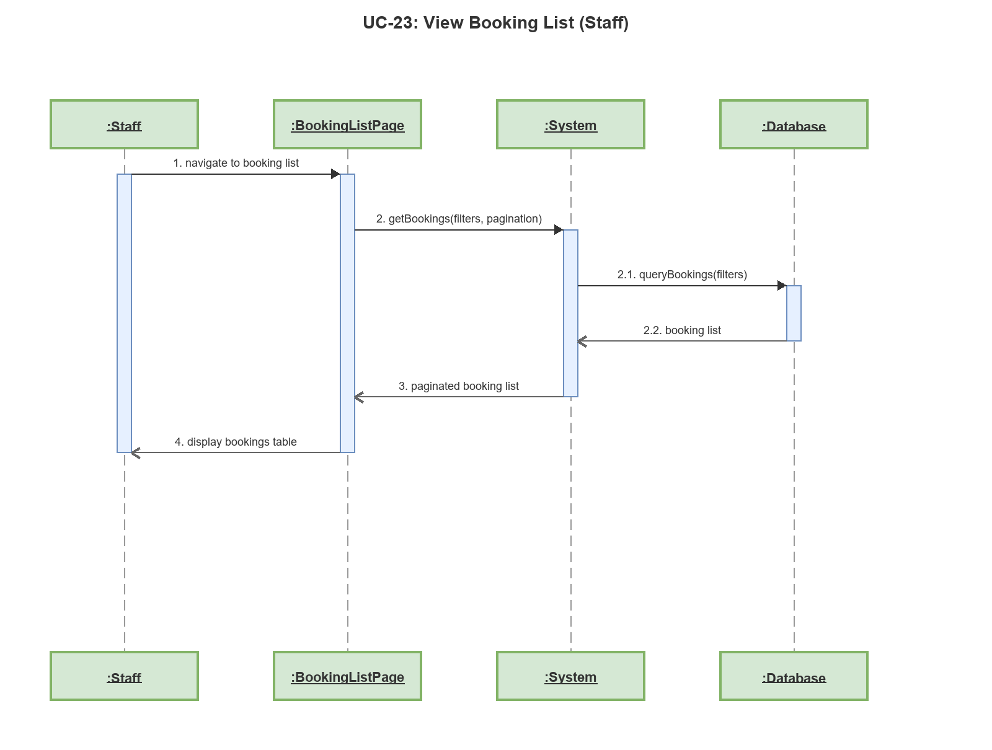

Sequence Diagram: UC-24: View Booking Detail (Staff)
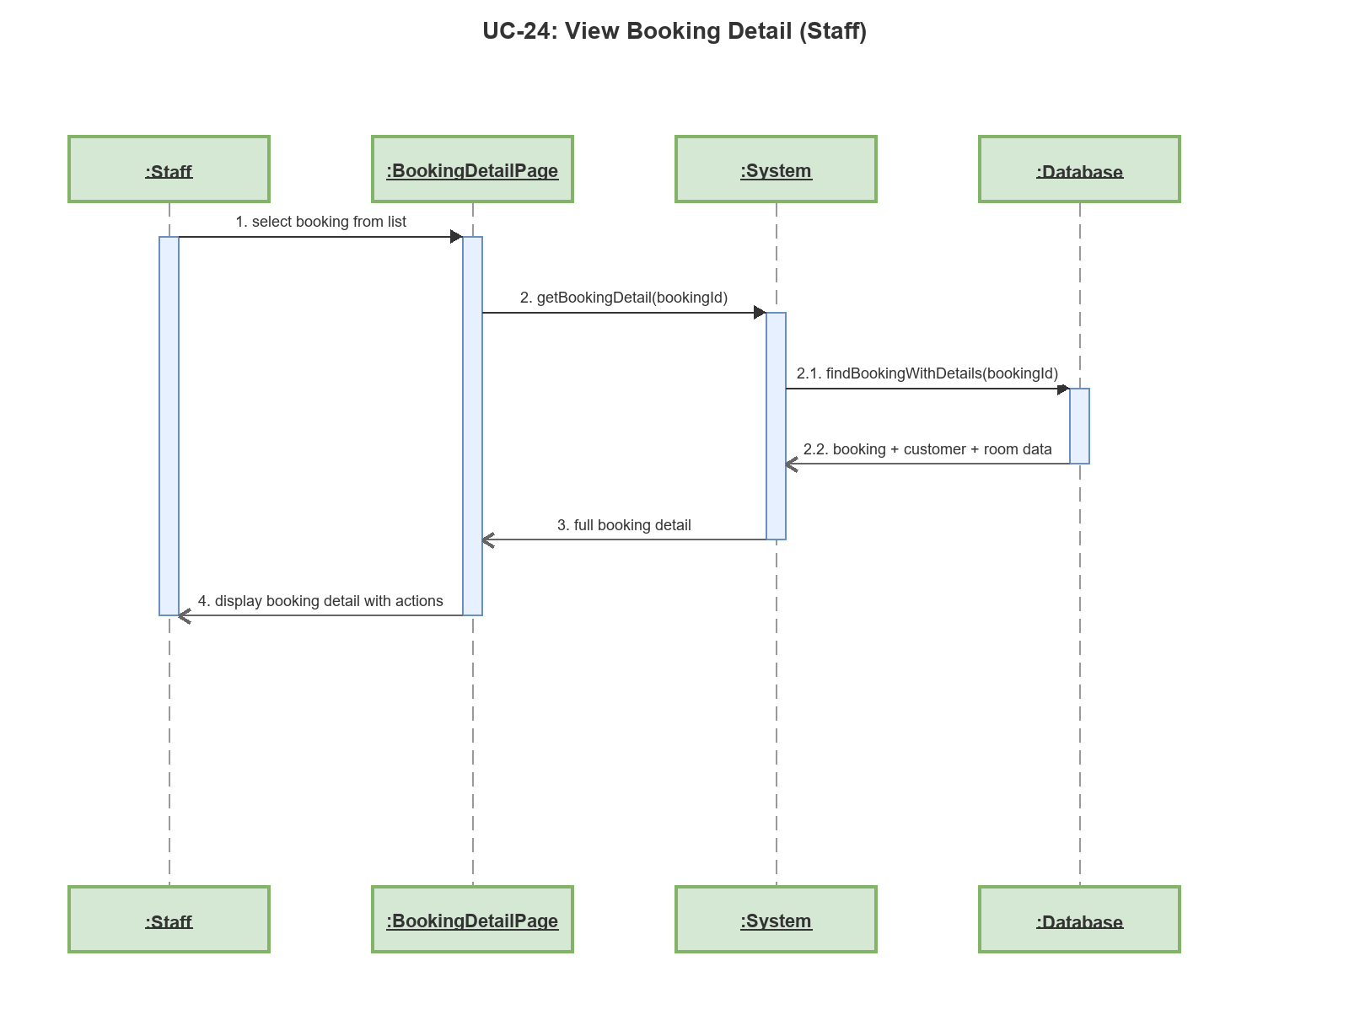

Sequence Diagram: UC-25: Assign Room to Booking
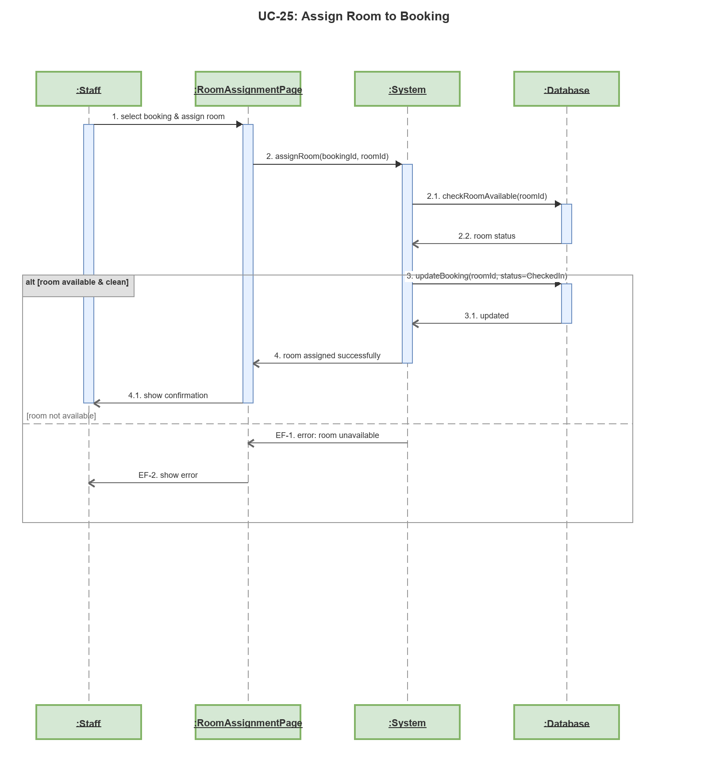

Sequence Diagram: UC-26: Check Out Booking
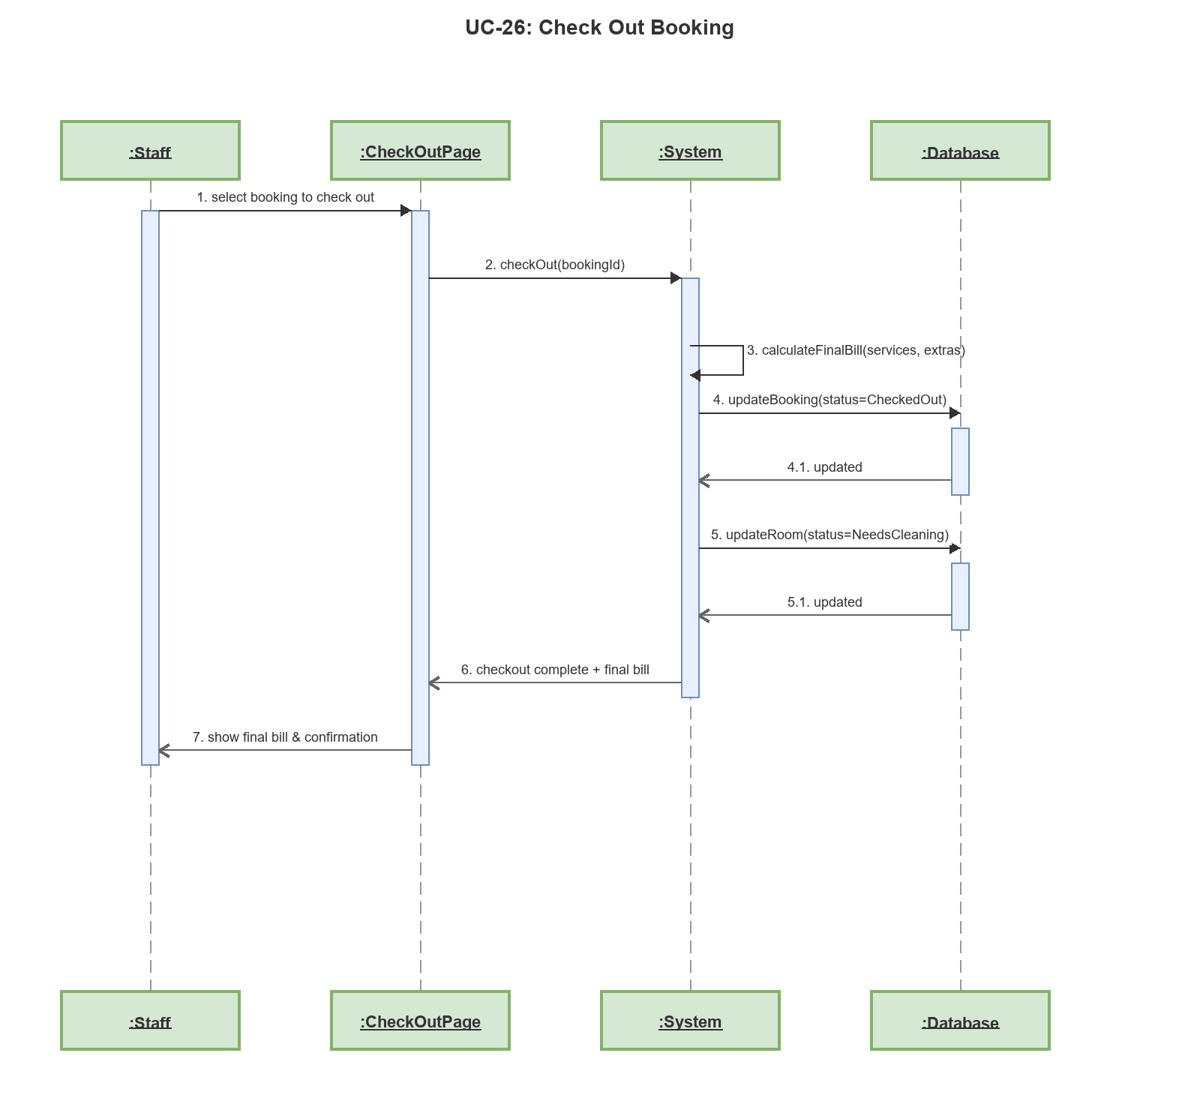

Sequence Diagram: UC-27: Create Walk-in Booking
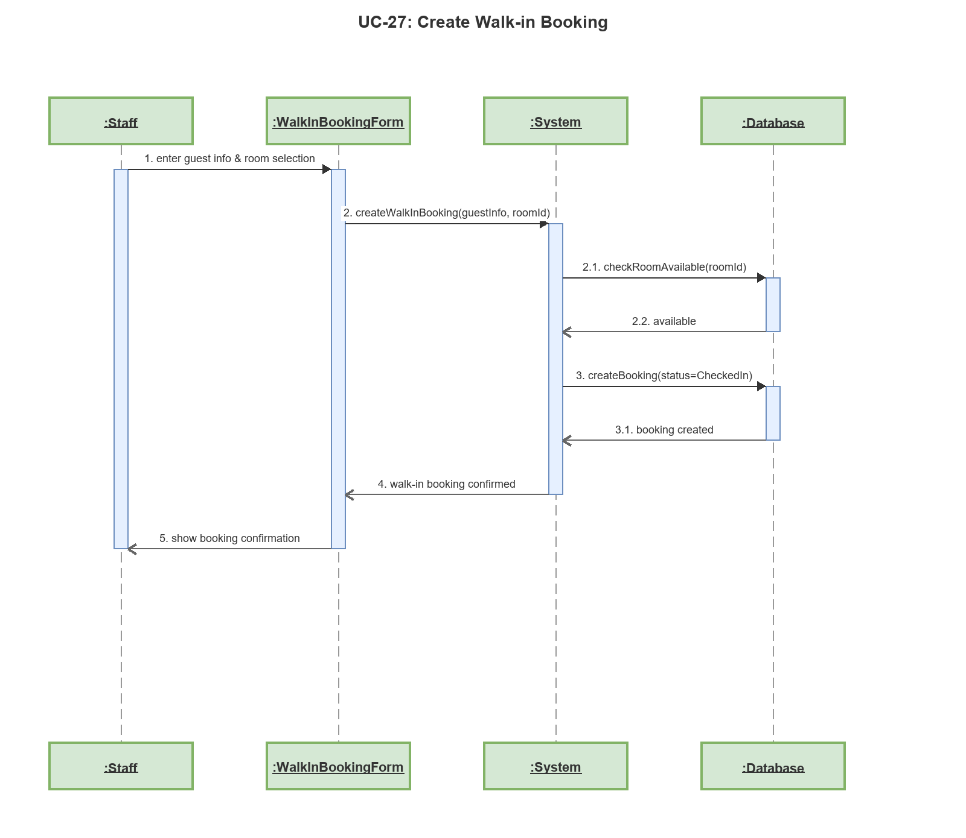

Sequence Diagram: UC-28: Record Occupants
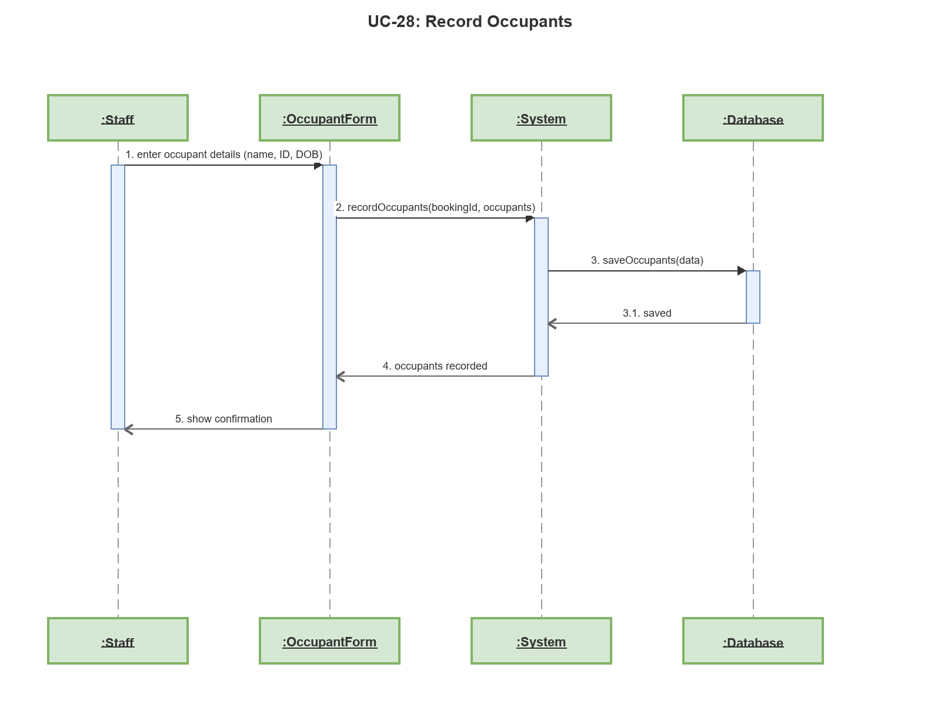

Sequence Diagram: UC-29: View Room Map (Staff)
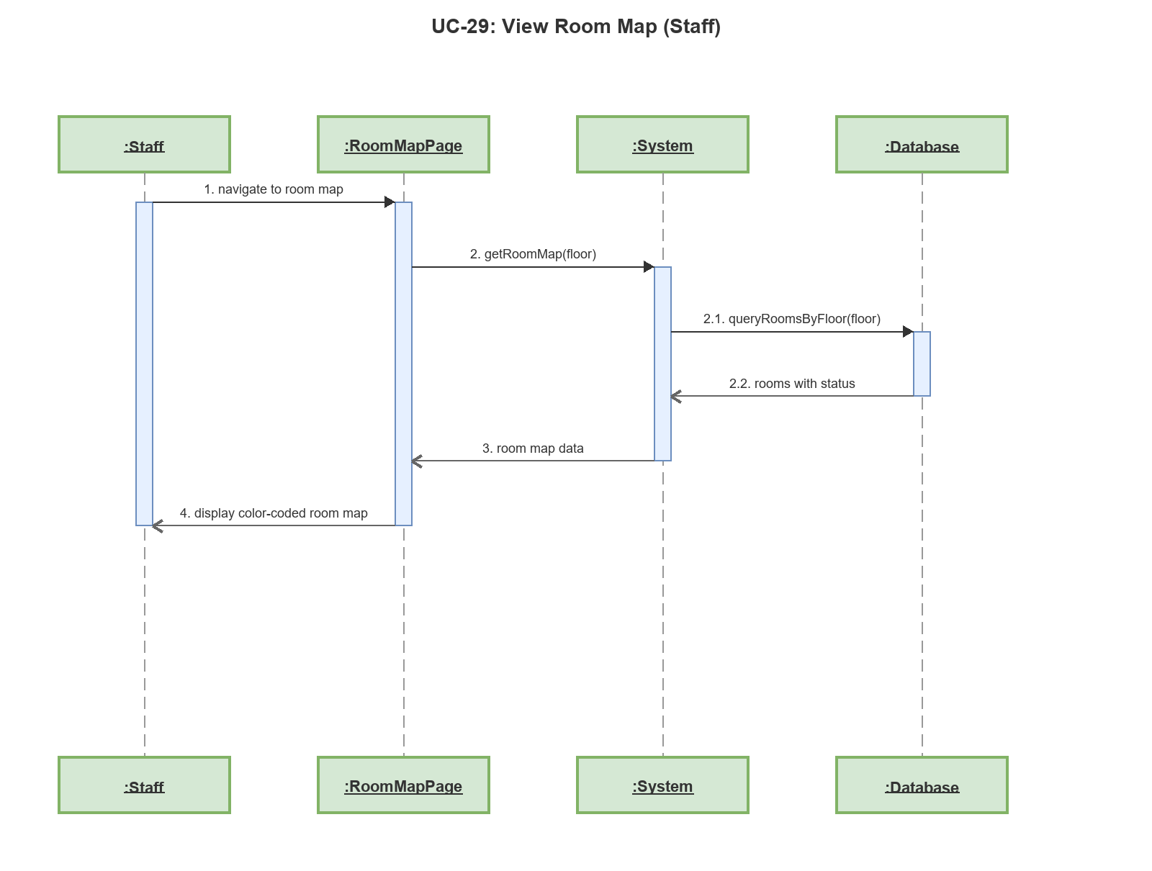

Sequence Diagram: UC-30: View Room Detail (Staff)
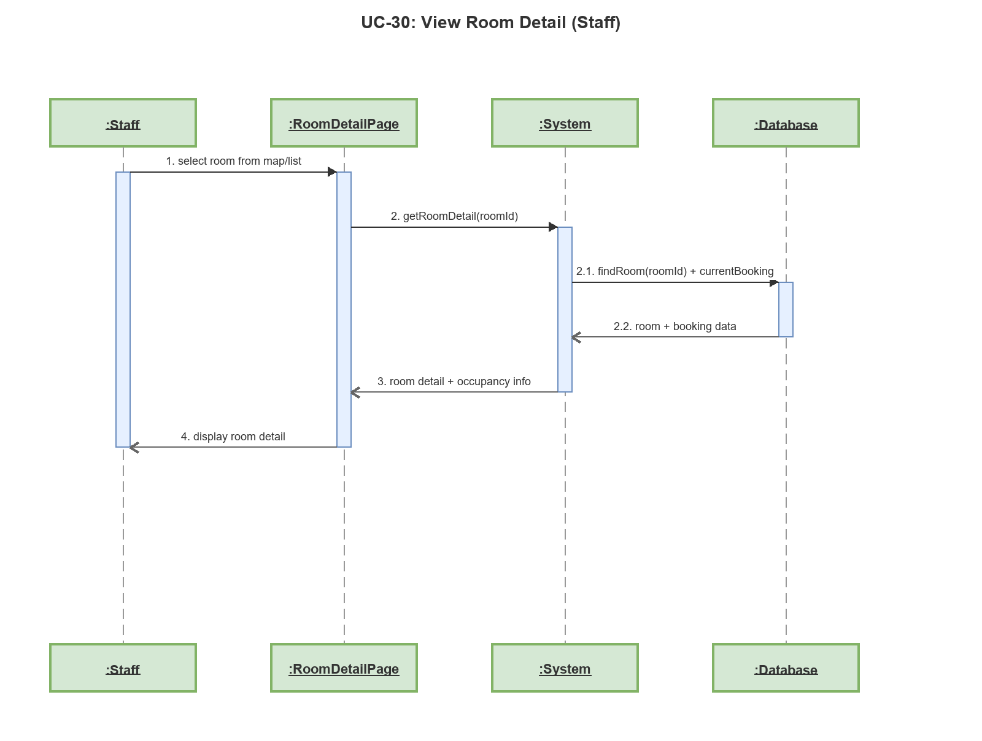

Sequence Diagram: UC-31: View Room History (Staff)
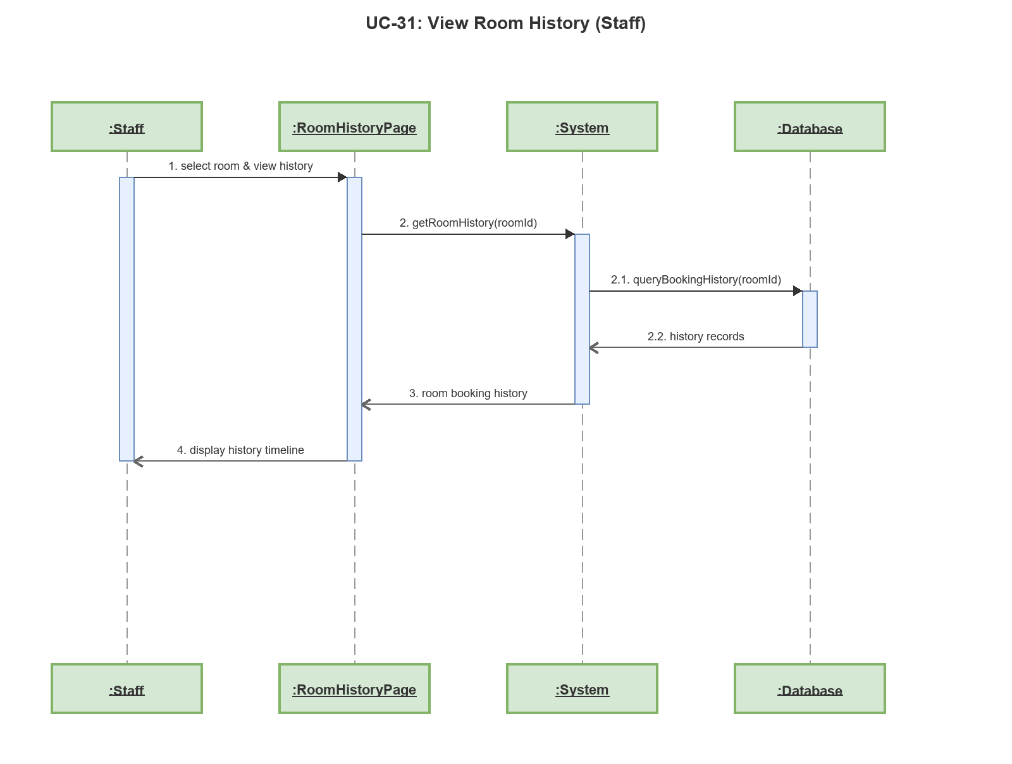

Sequence Diagram: UC-32: View Cleaning Tasks
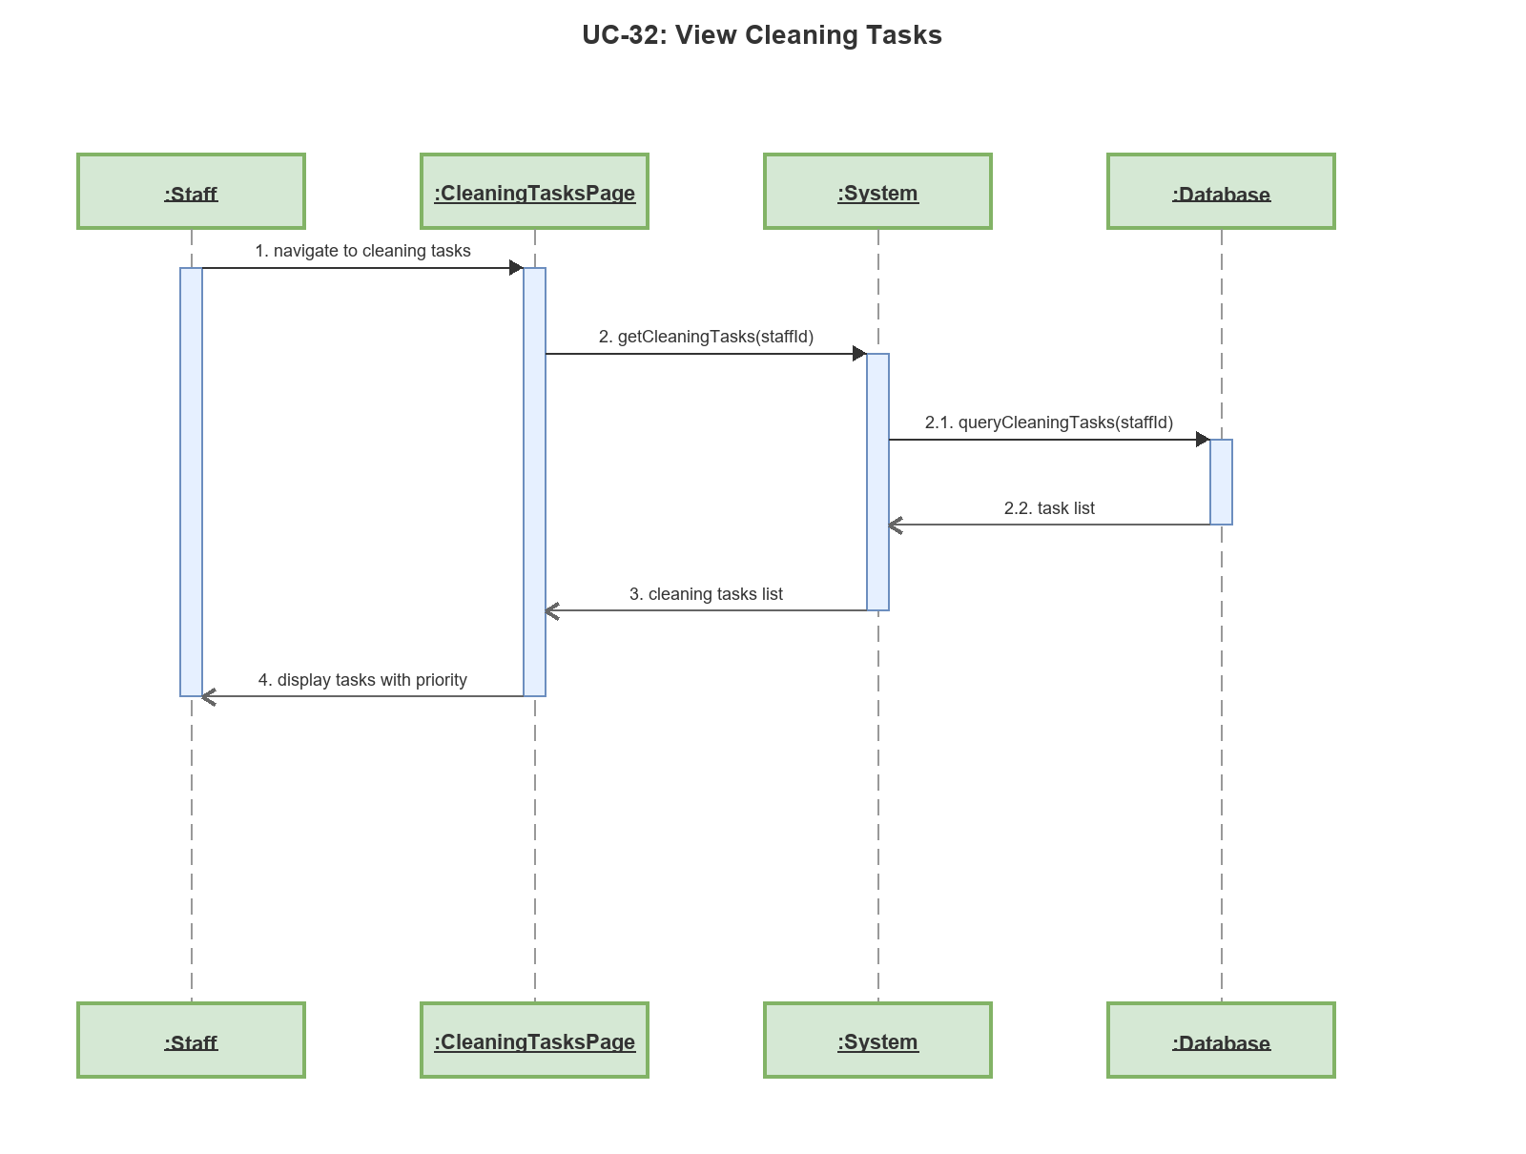

Sequence Diagram: UC-33: Update Cleaning Status
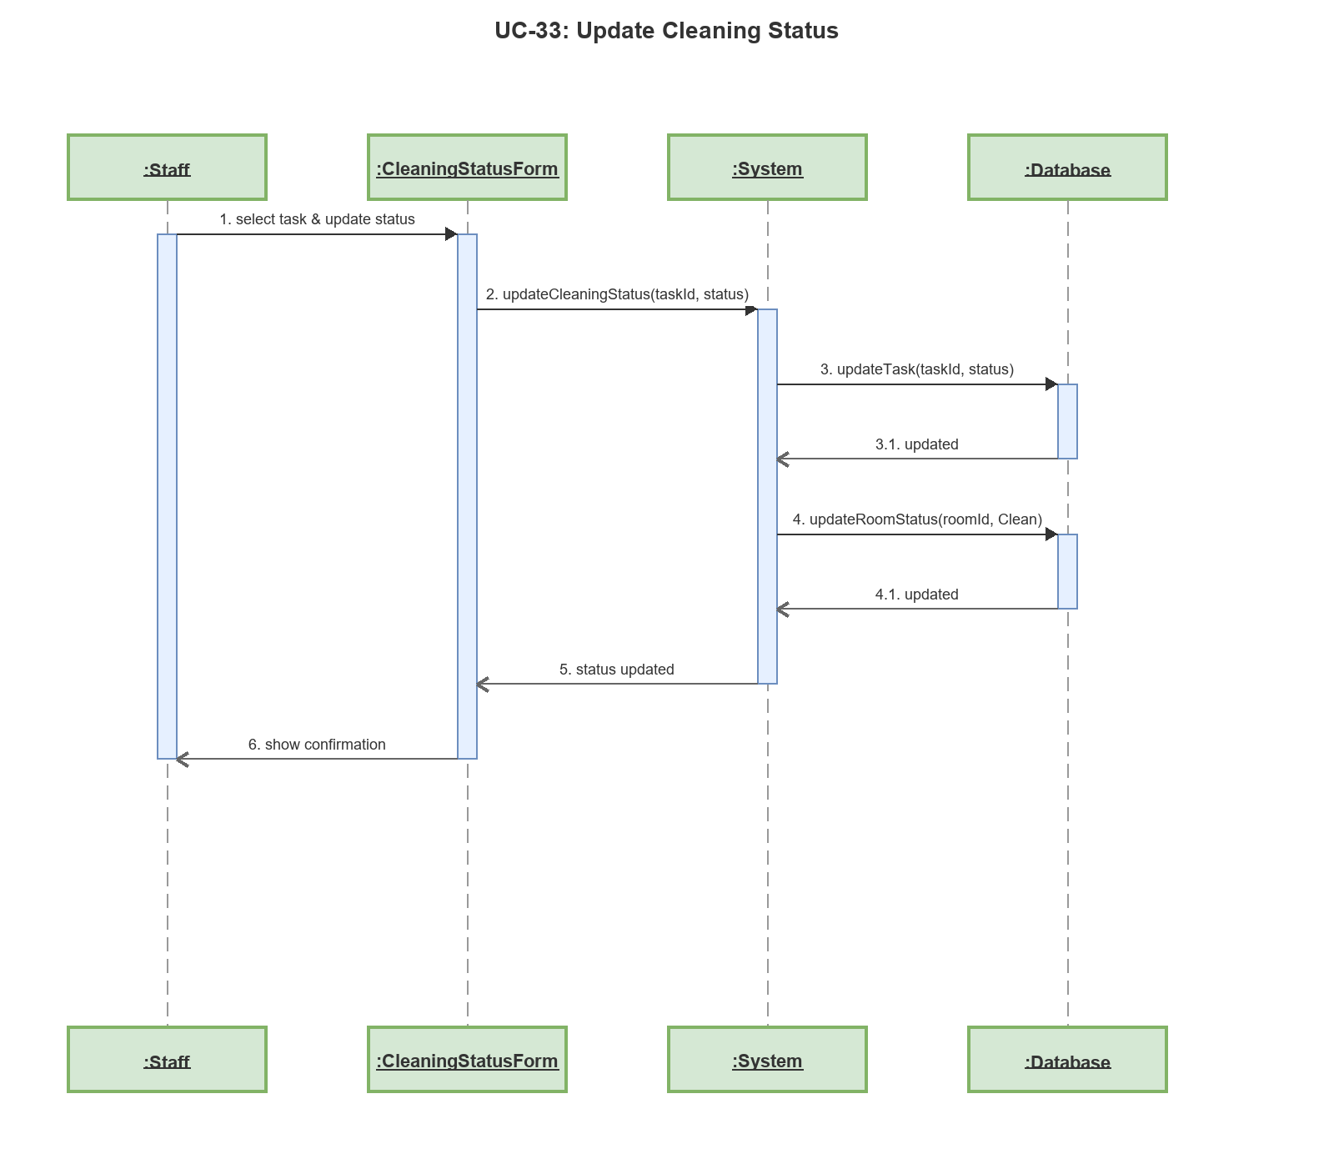

Sequence Diagram: UC-34: Process Staff Payment
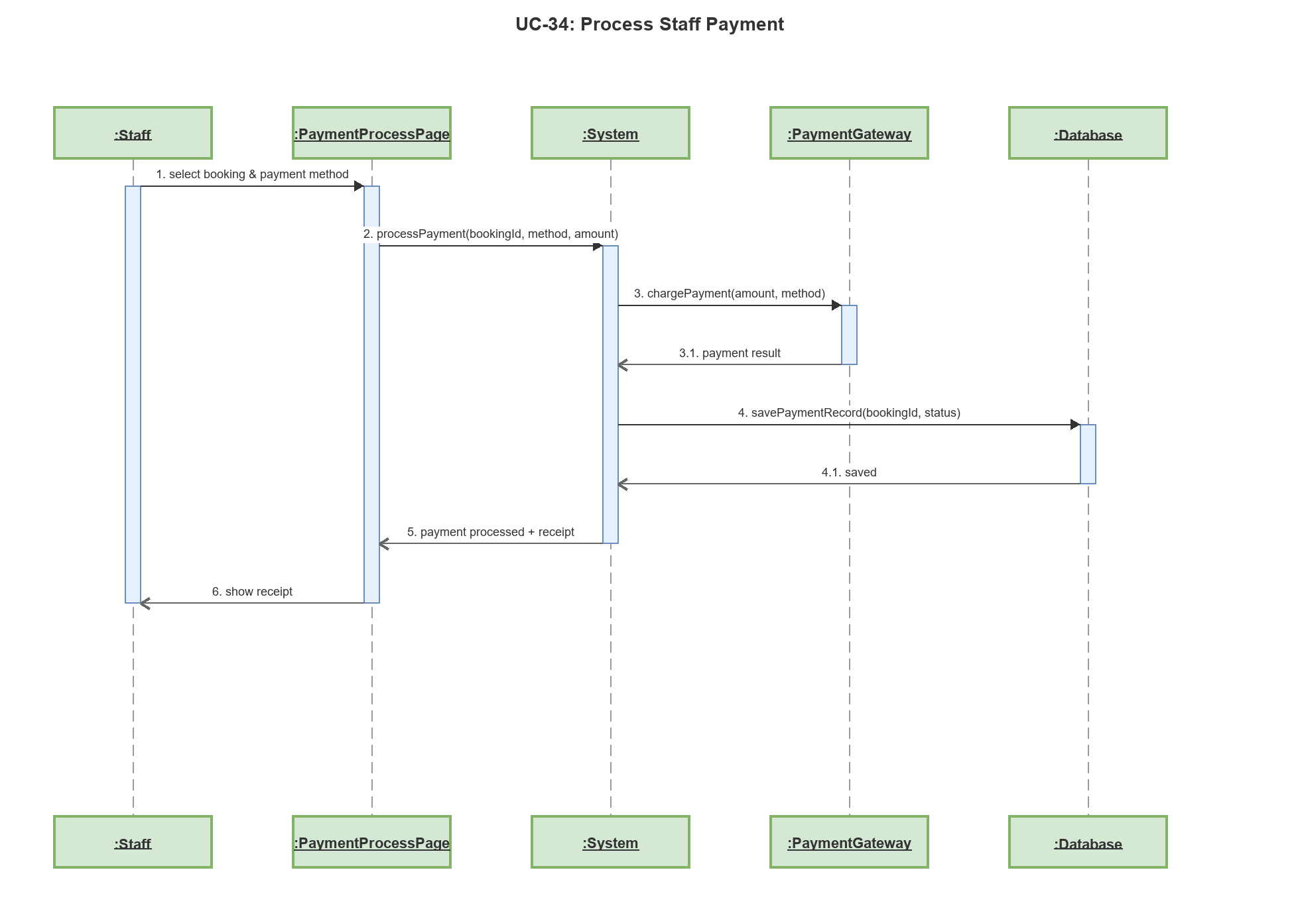

Sequence Diagram: UC-35: View Service Requests (Staff)
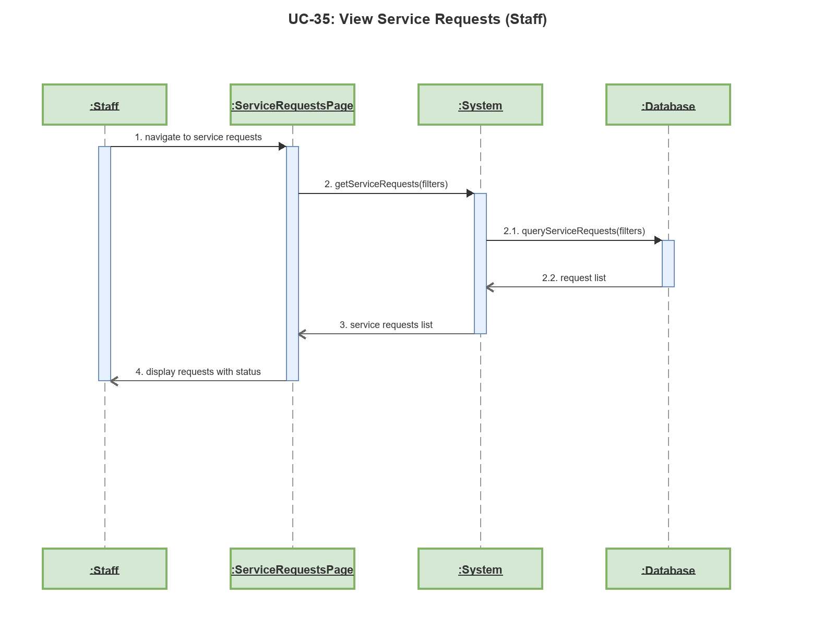

Sequence Diagram: UC-36: Update Service Request Status
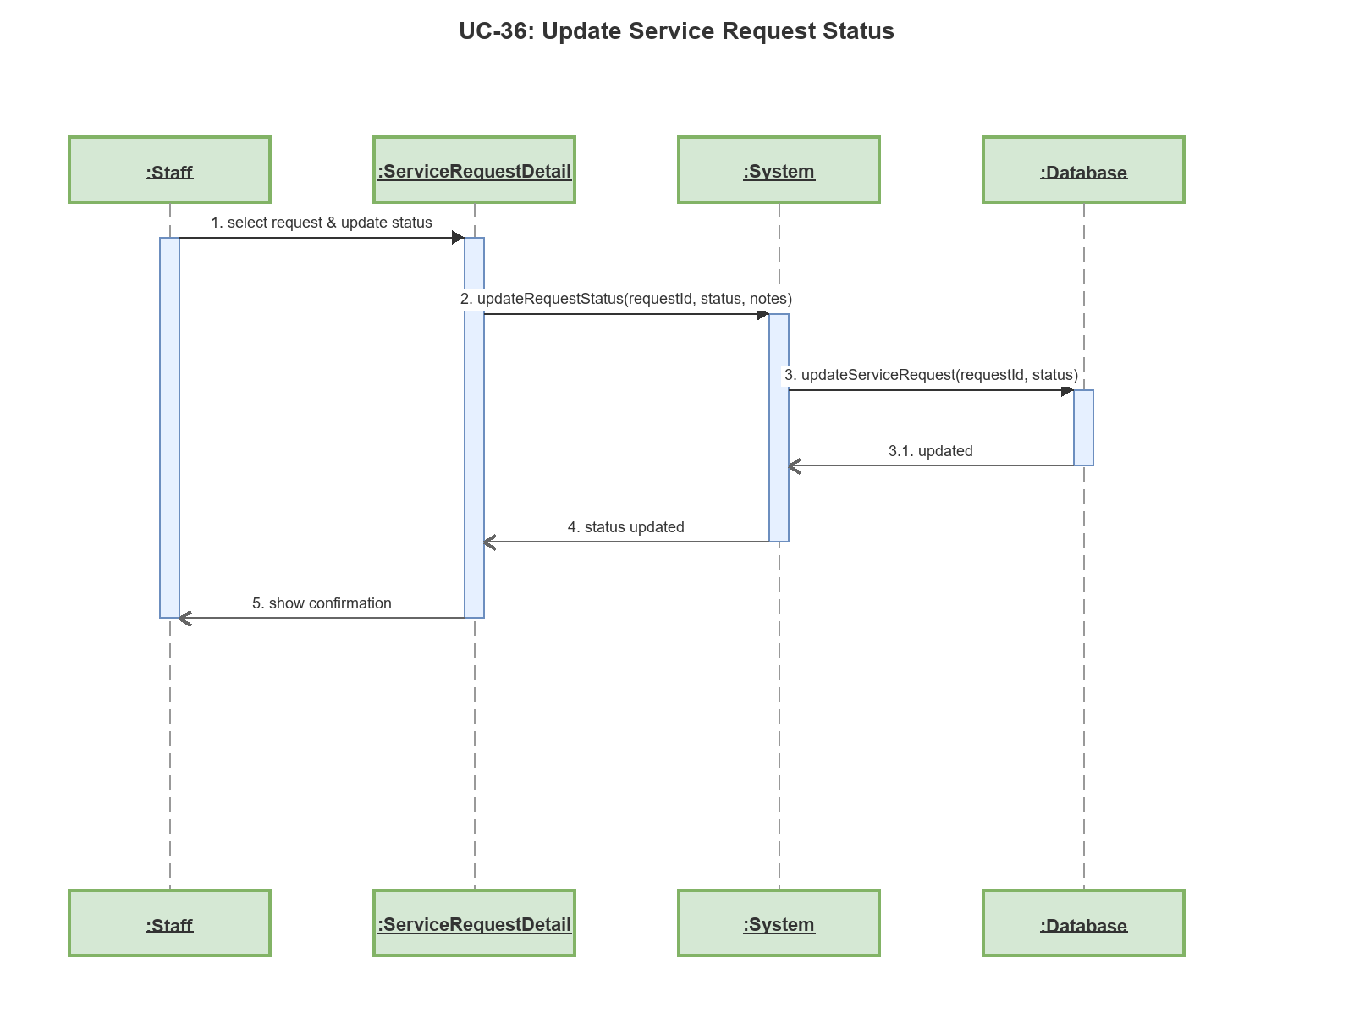

Sequence Diagram: UC-37: Staff Login
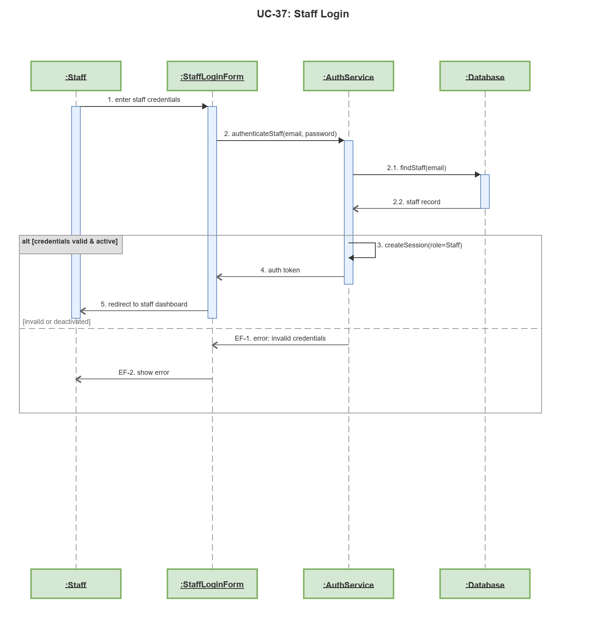

Sequence Diagram: UC-64: View Staff Dashboard
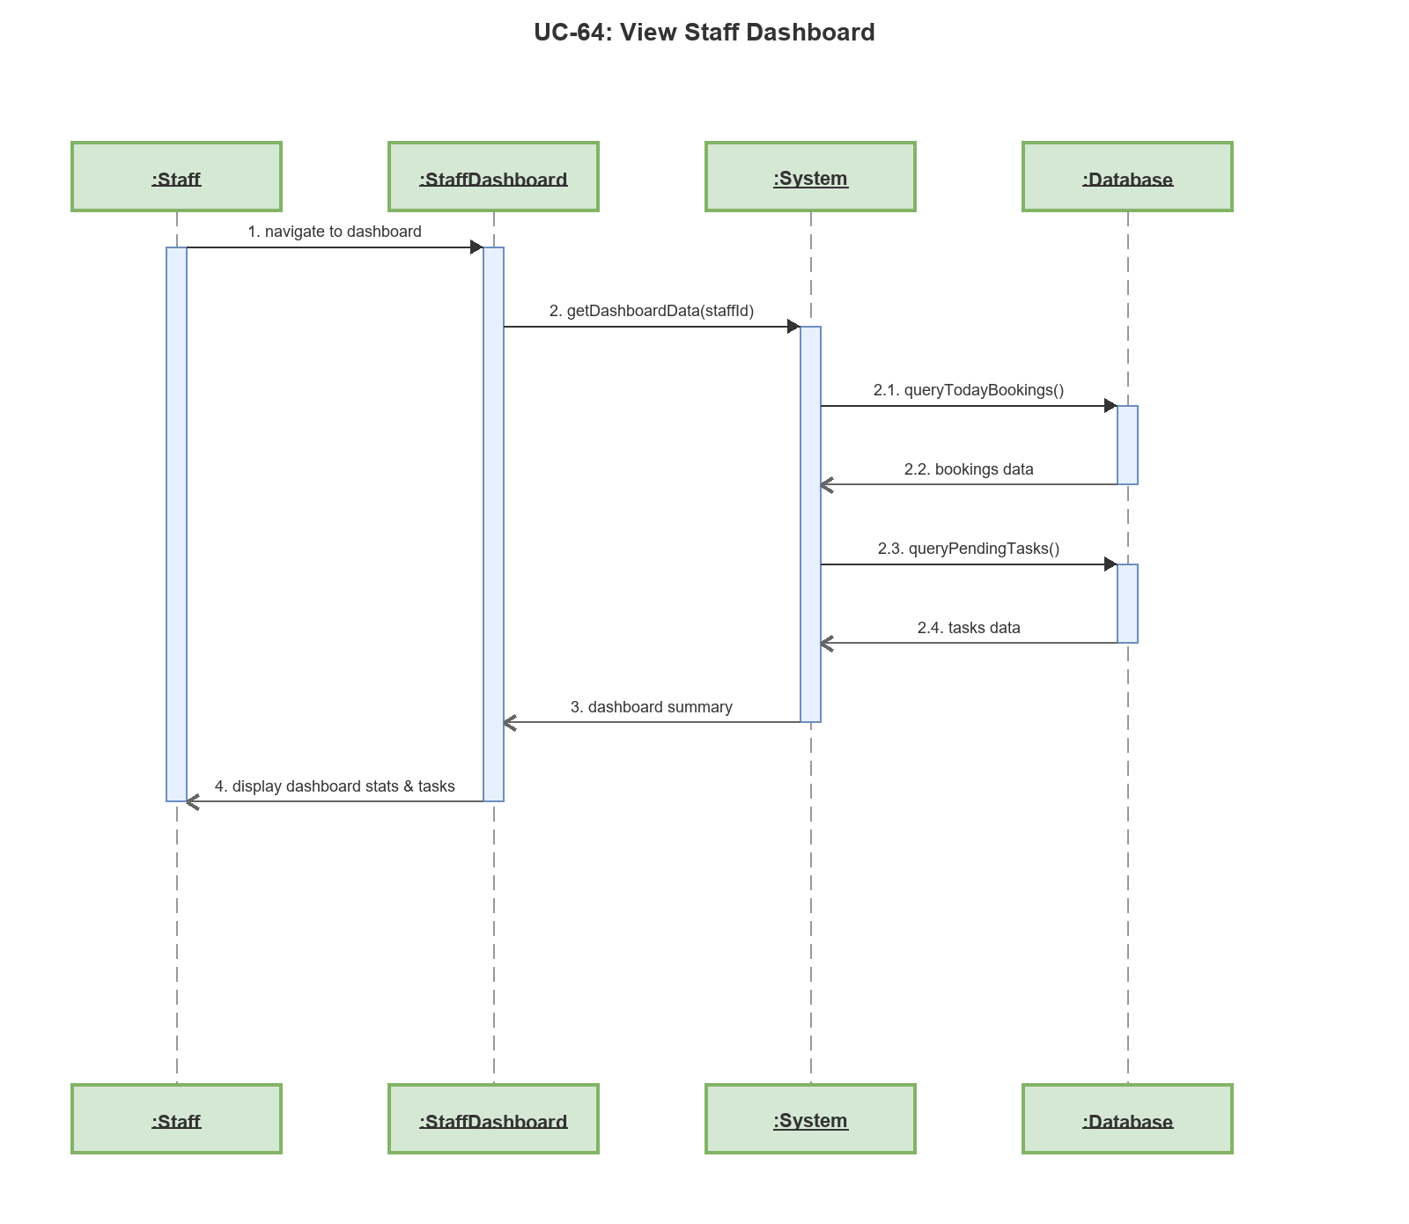

Sequence Diagram: UC-38: Add Room
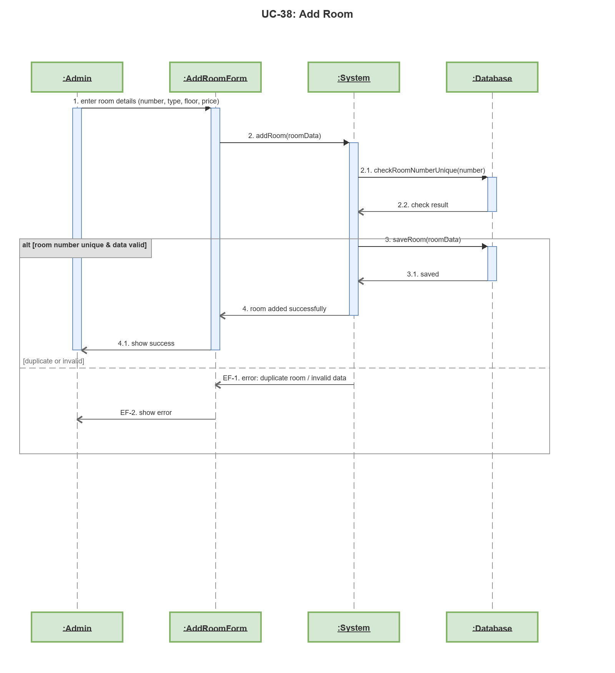

Sequence Diagram: UC-39: Edit Room
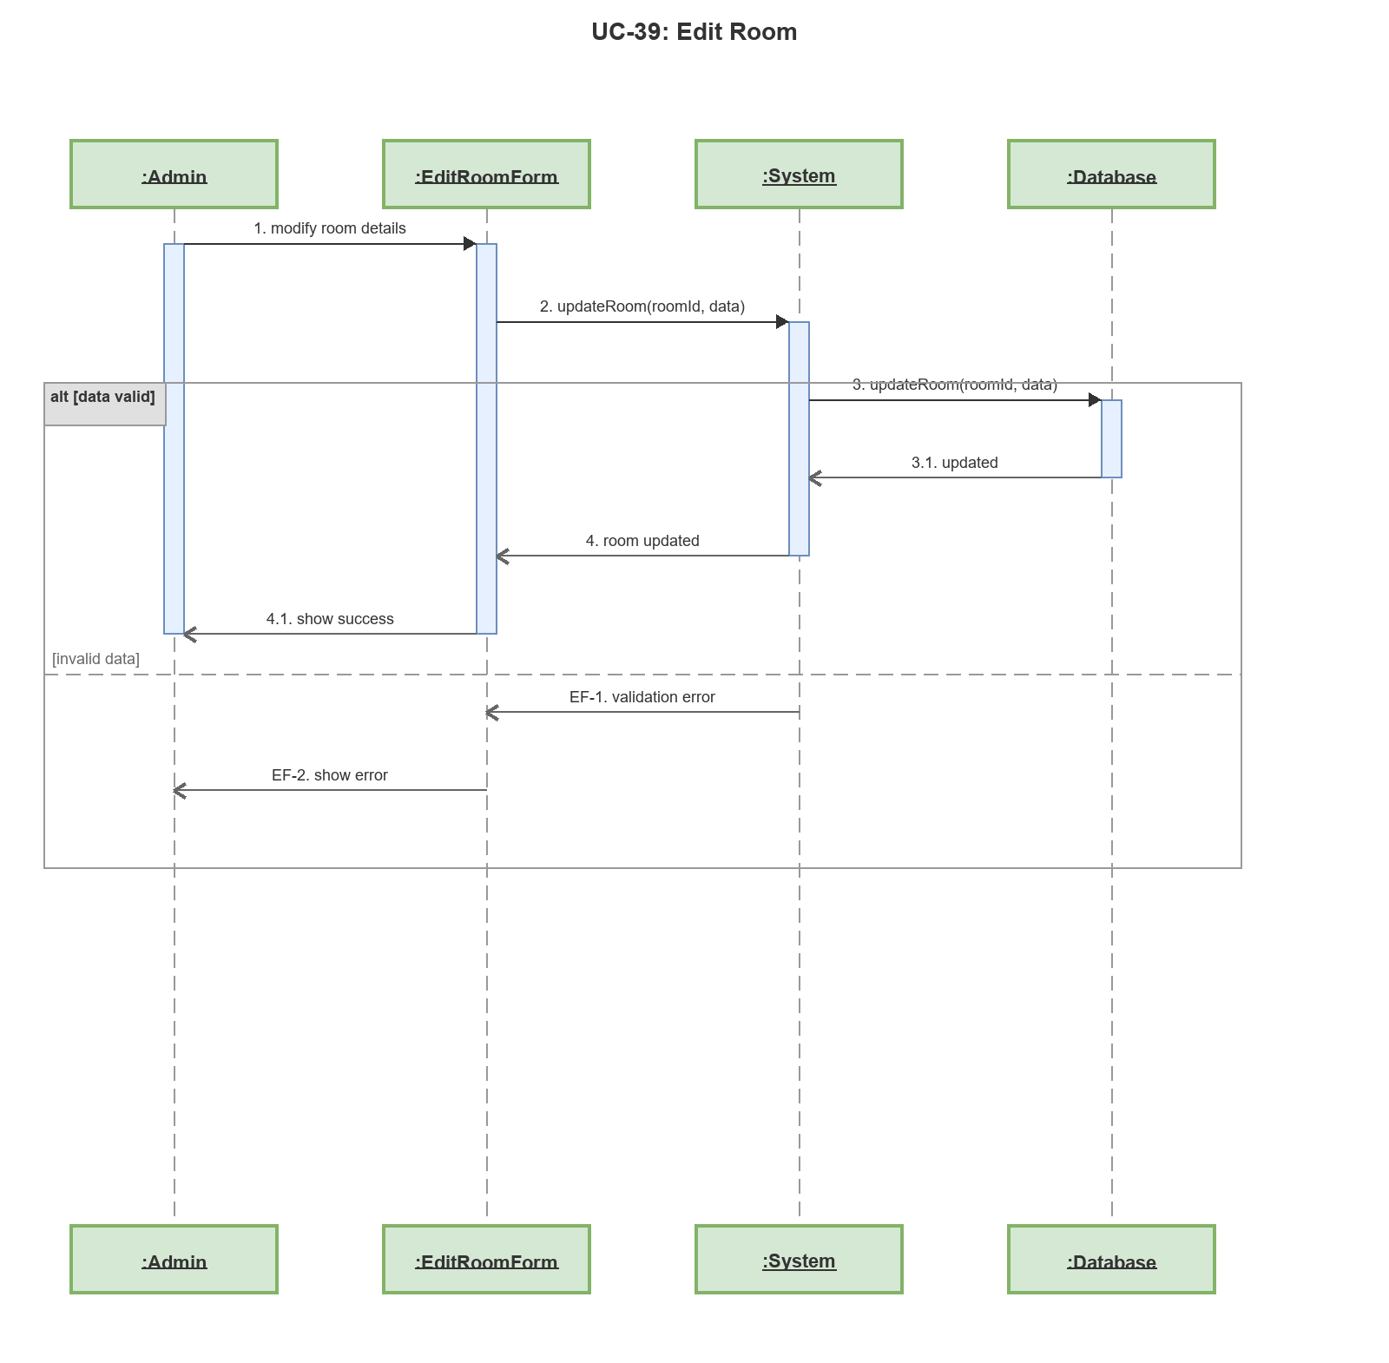

Sequence Diagram: UC-40: View Room List (Admin)
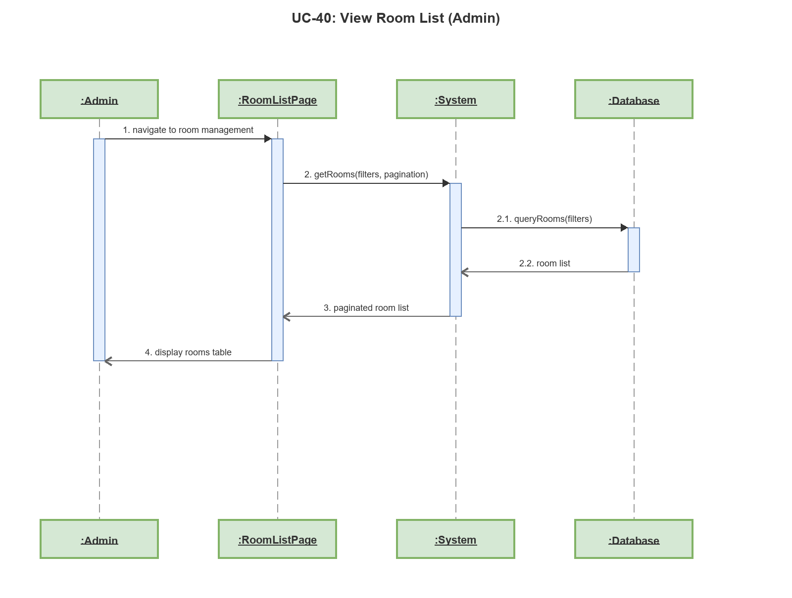

Sequence Diagram: UC-41: View Room Map (Admin)
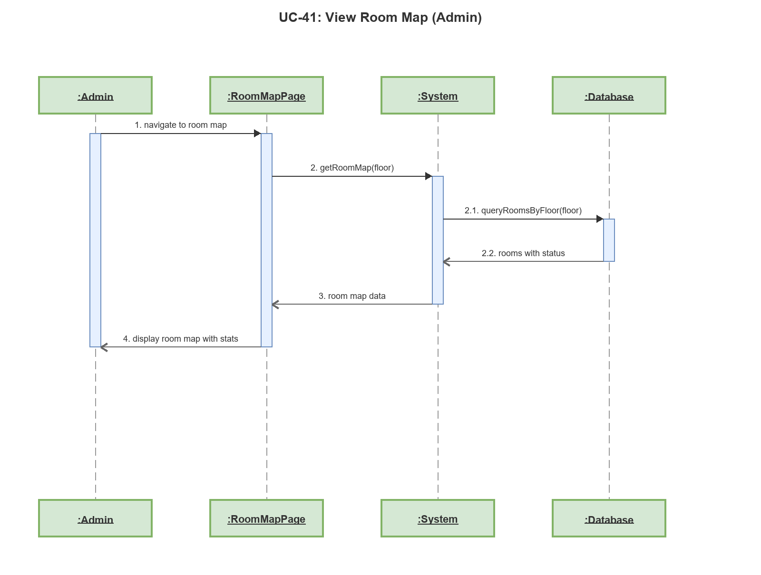

Sequence Diagram: UC-42: View Room History (Admin)
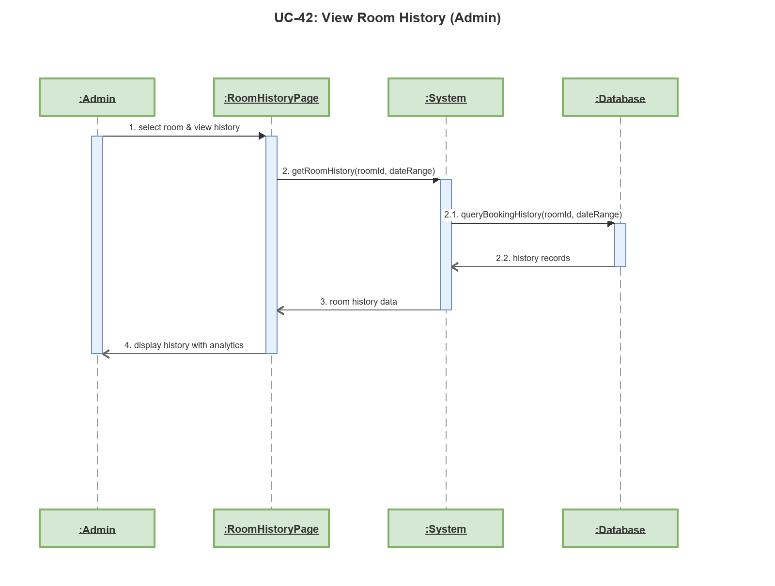

Sequence Diagram: UC-43: Add Room Type
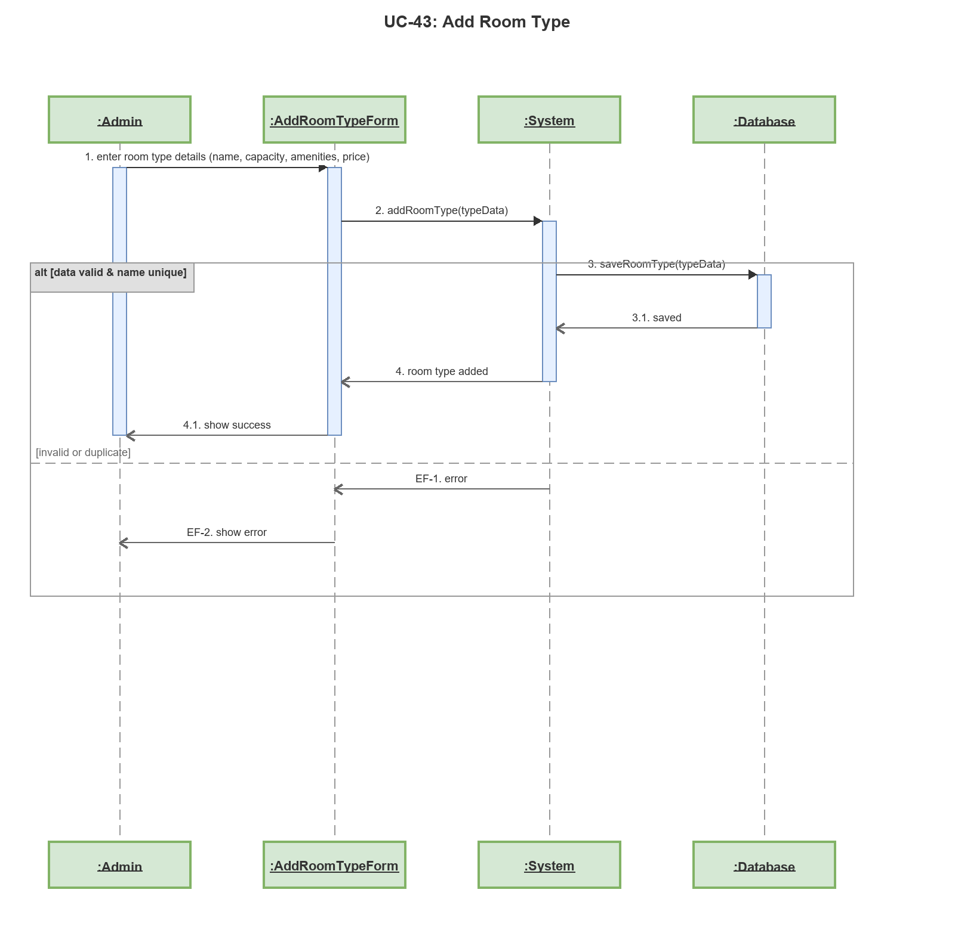

Sequence Diagram: UC-44: Edit Room Type
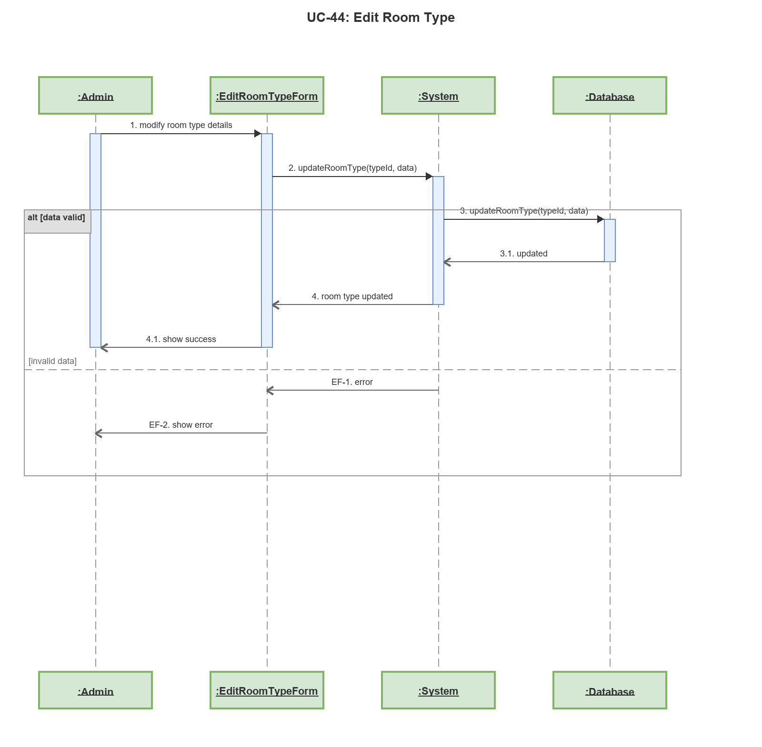

Sequence Diagram: UC-45: View Room Type List
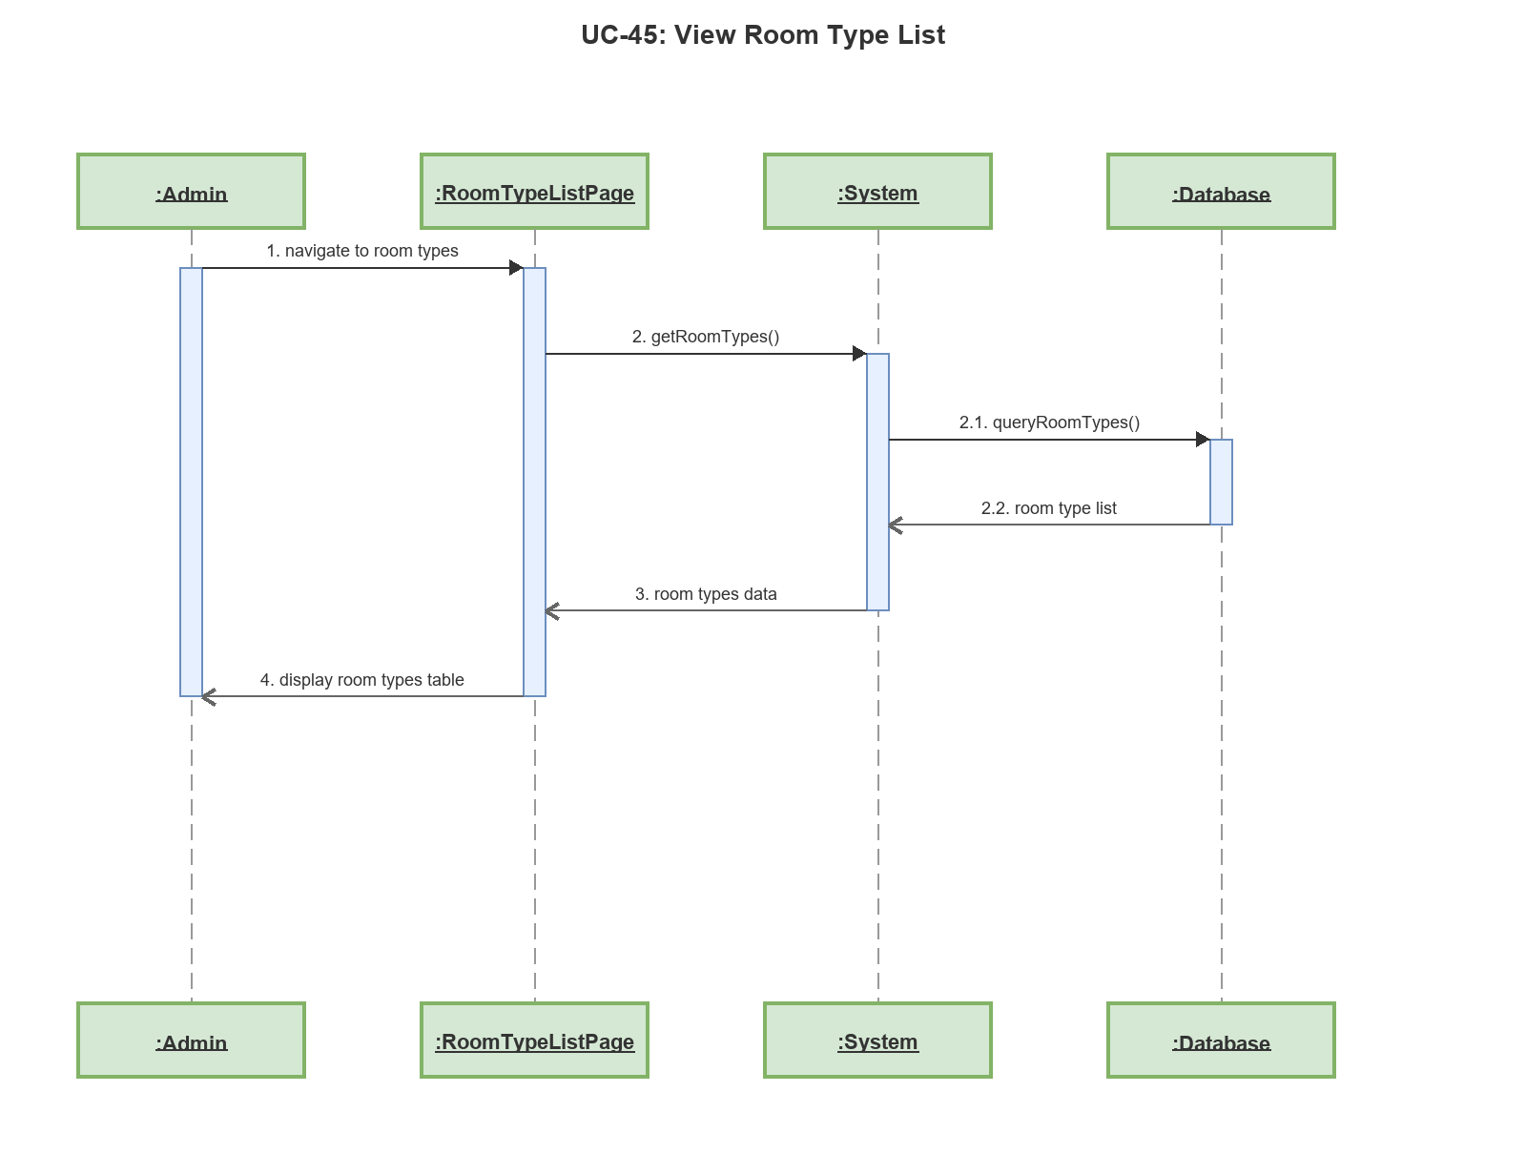

Sequence Diagram: UC-46: Add Staff
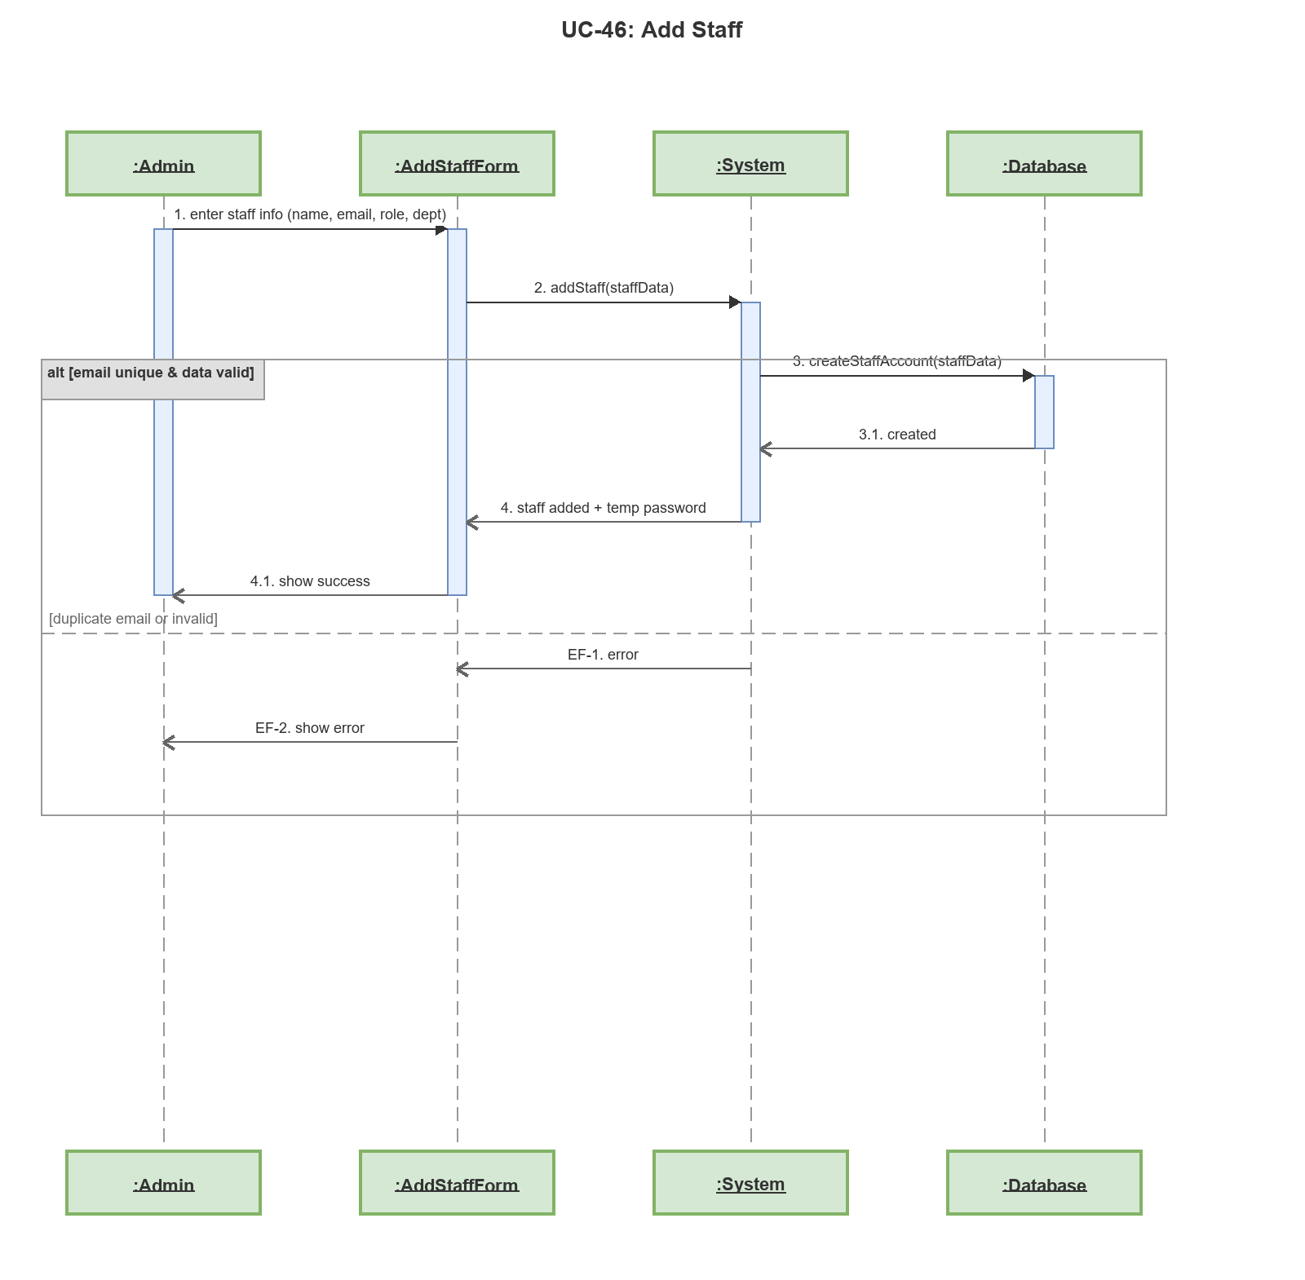

Sequence Diagram: UC-47: Edit Staff
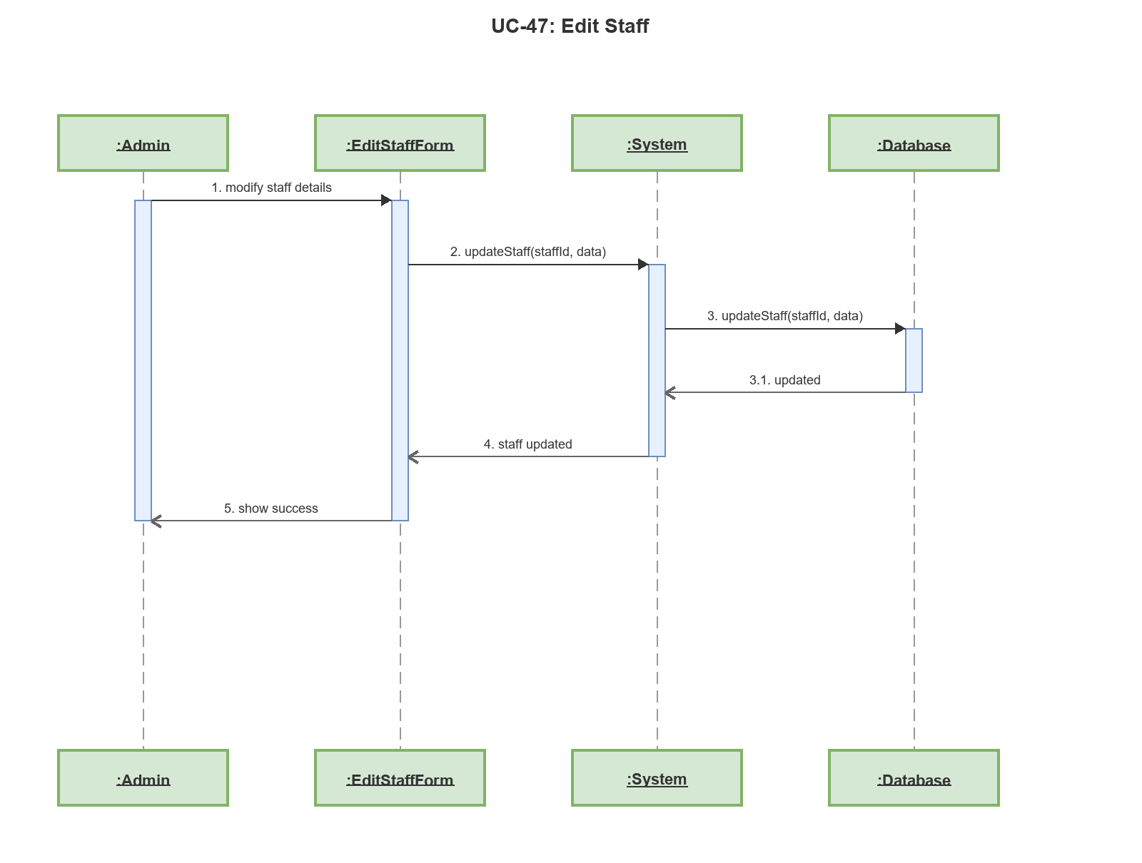

Sequence Diagram: UC-48: View Staff List
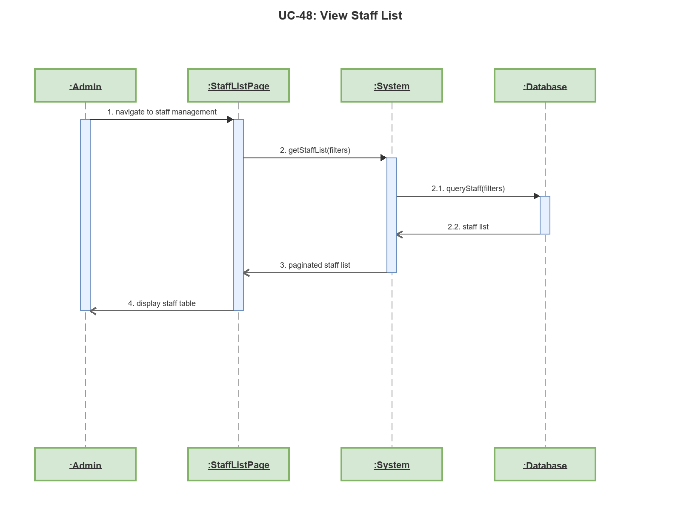

Sequence Diagram: UC-49: View Customer List
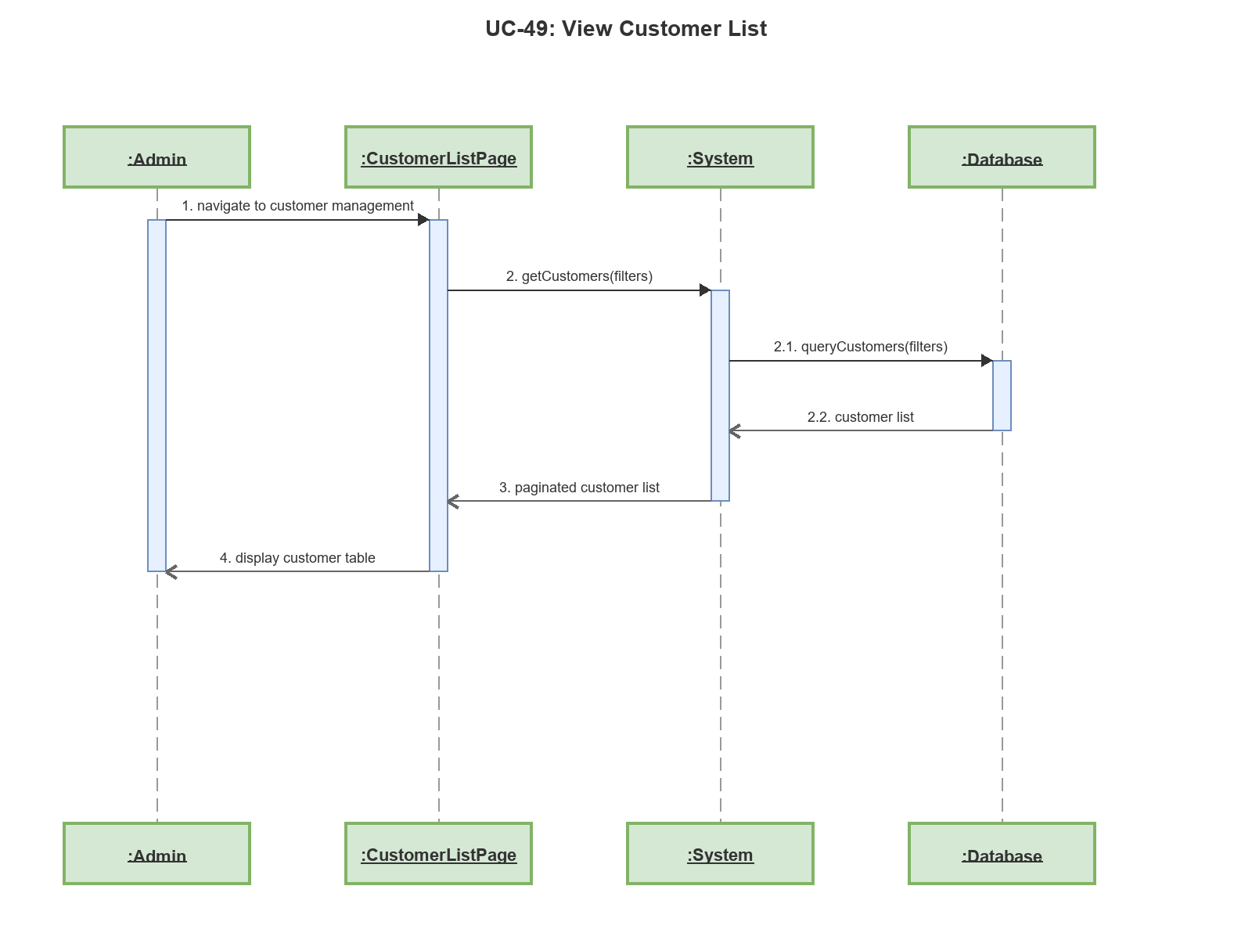

Sequence Diagram: UC-50: Edit Customer
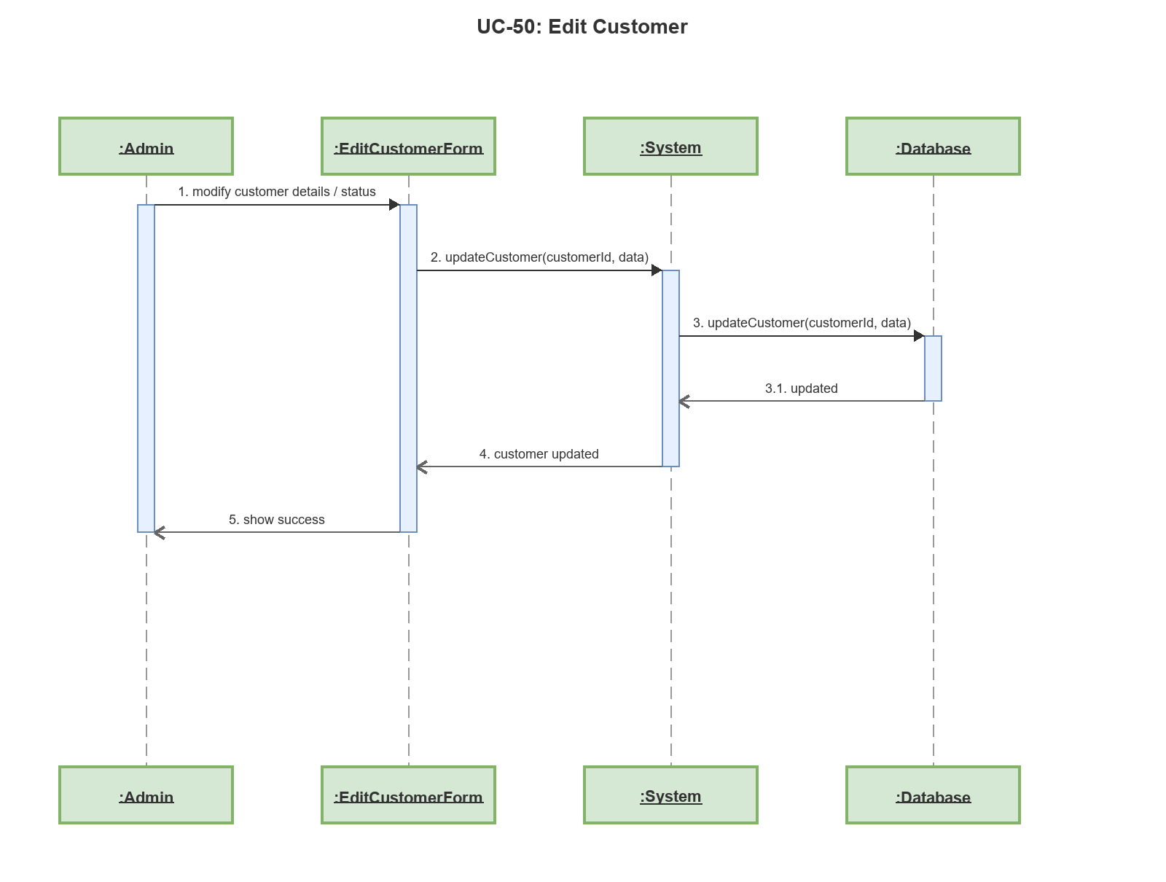

Sequence Diagram: UC-51: Add Promotion
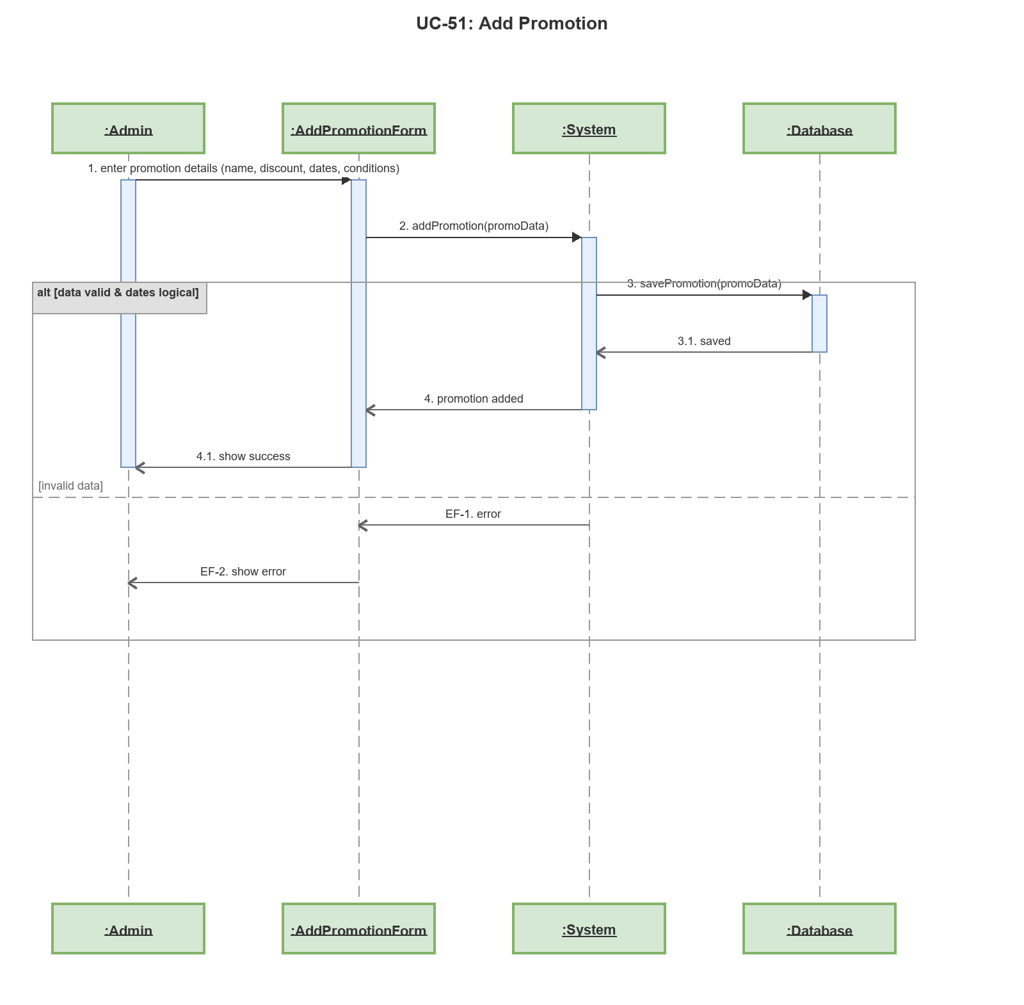

Sequence Diagram: UC-52: Edit Promotion
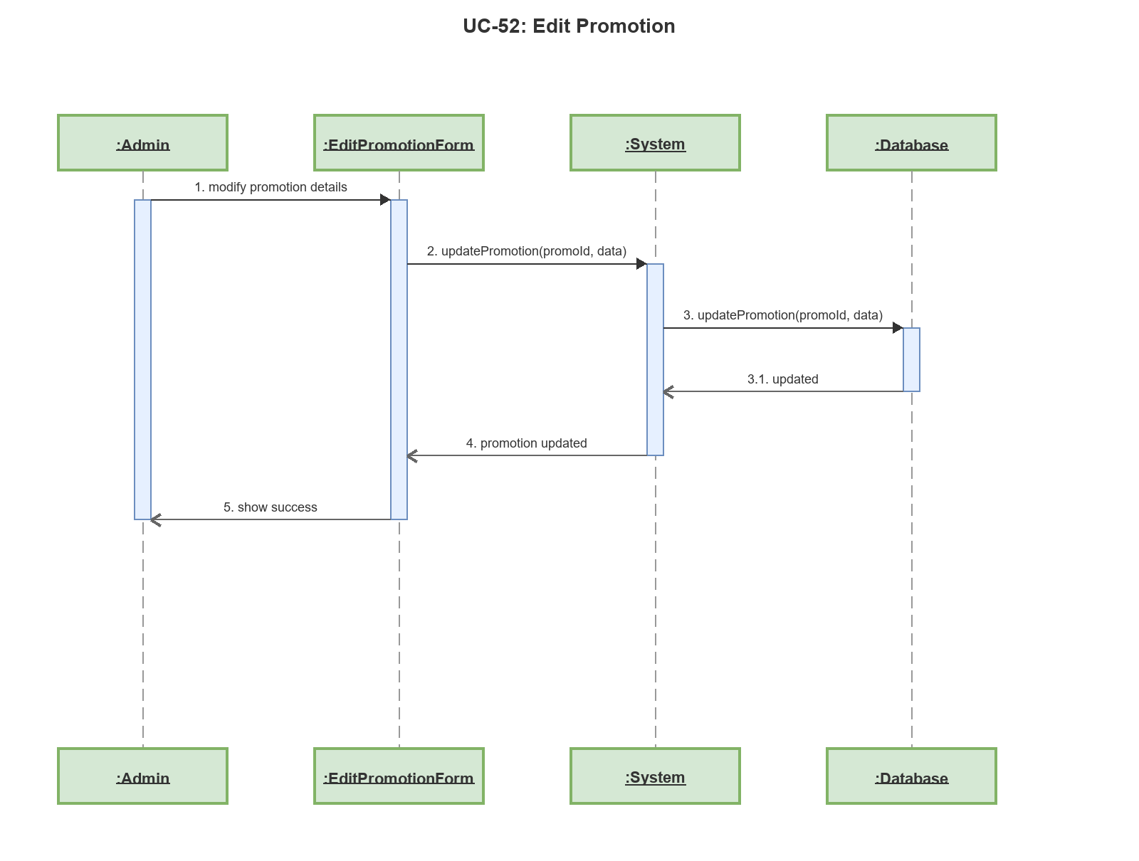

Sequence Diagram: UC-53: View Promotion List
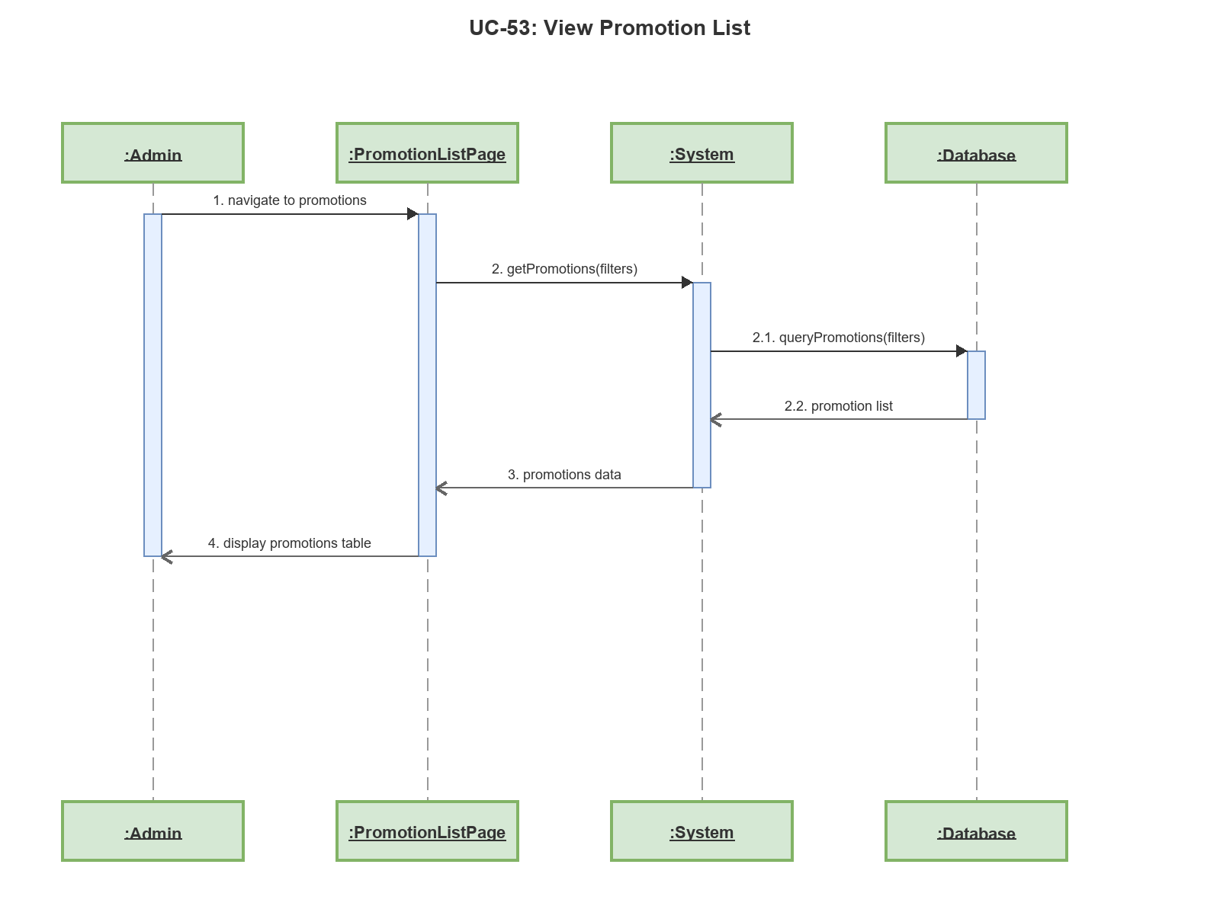

Sequence Diagram: UC-54: Add Voucher
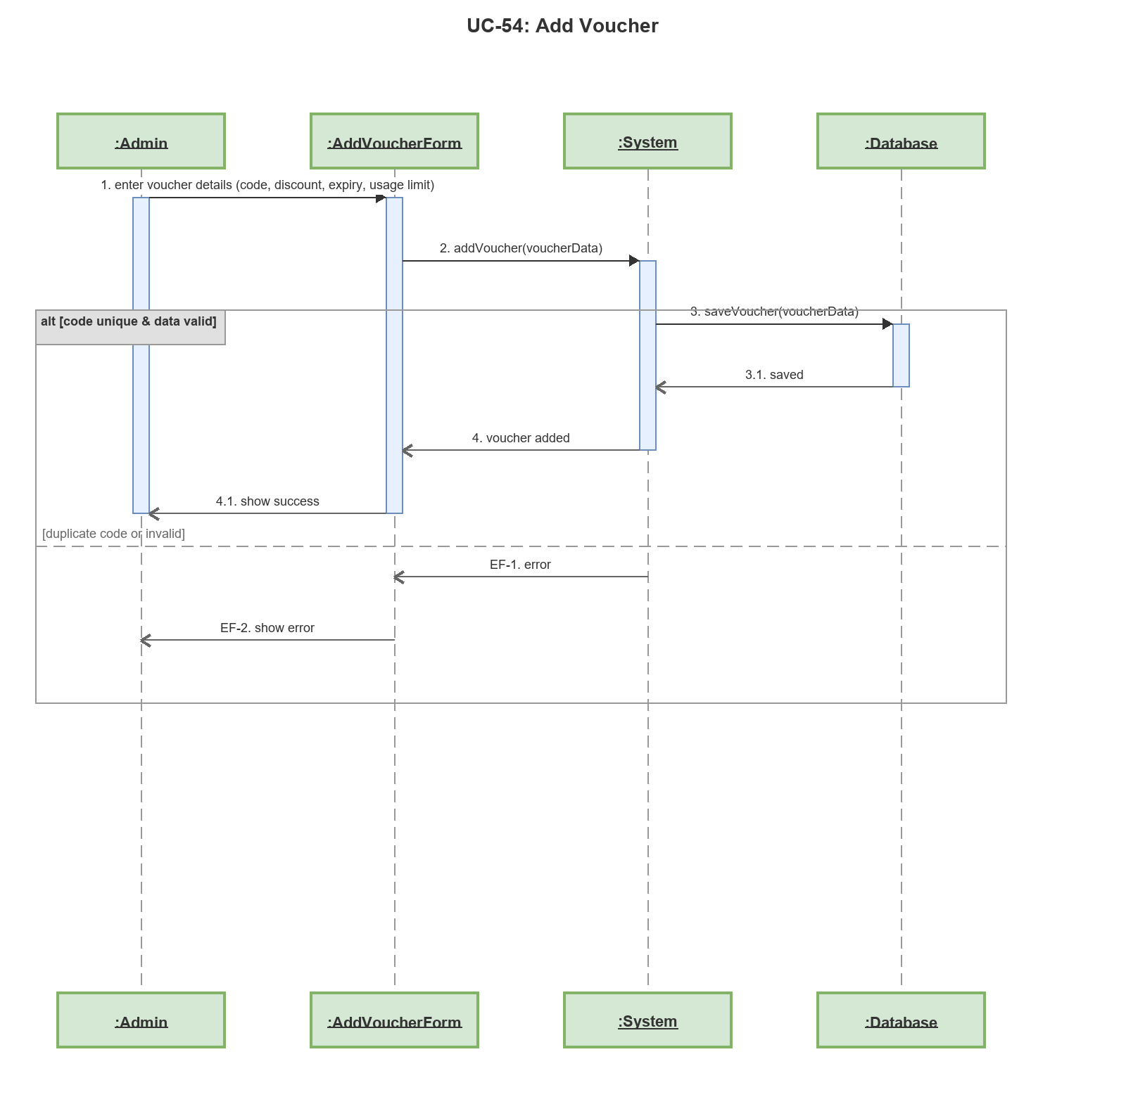

Sequence Diagram: UC-55: Edit Voucher
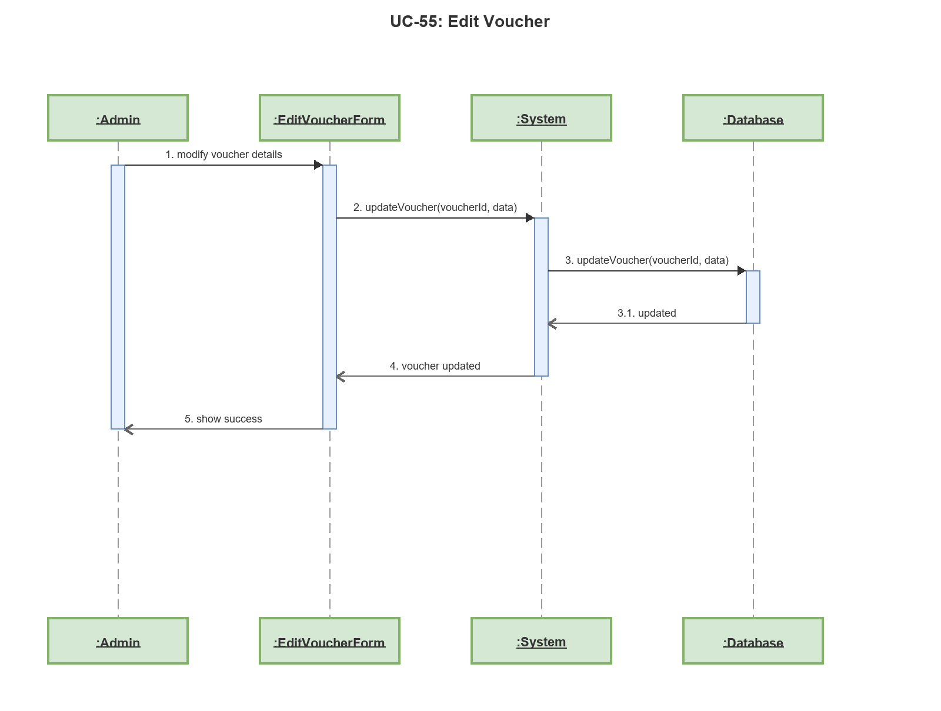

Sequence Diagram: UC-56: View Voucher List
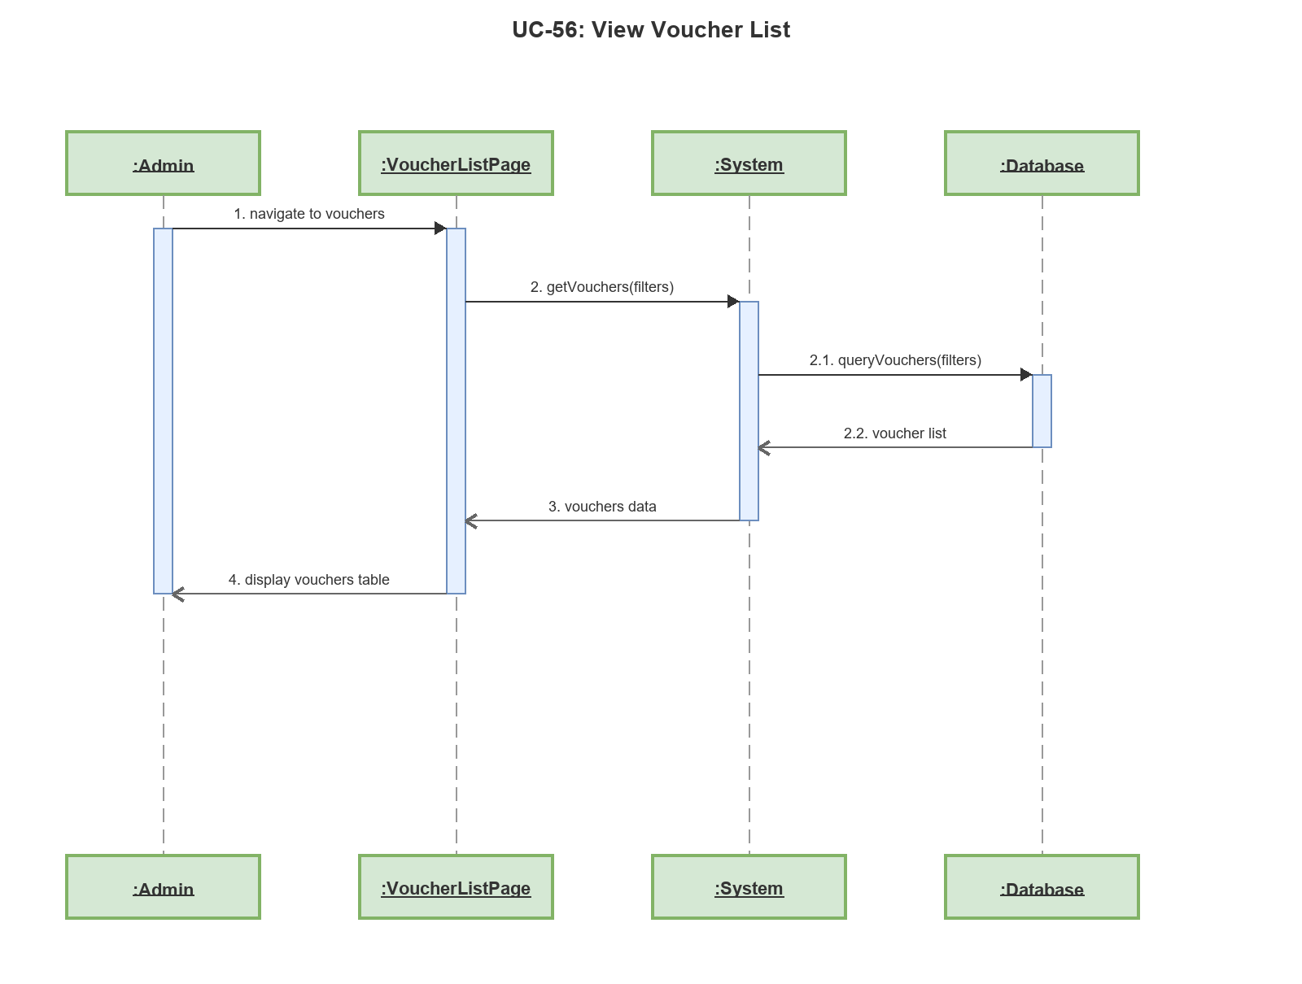

Sequence Diagram: UC-57: View Feedback List
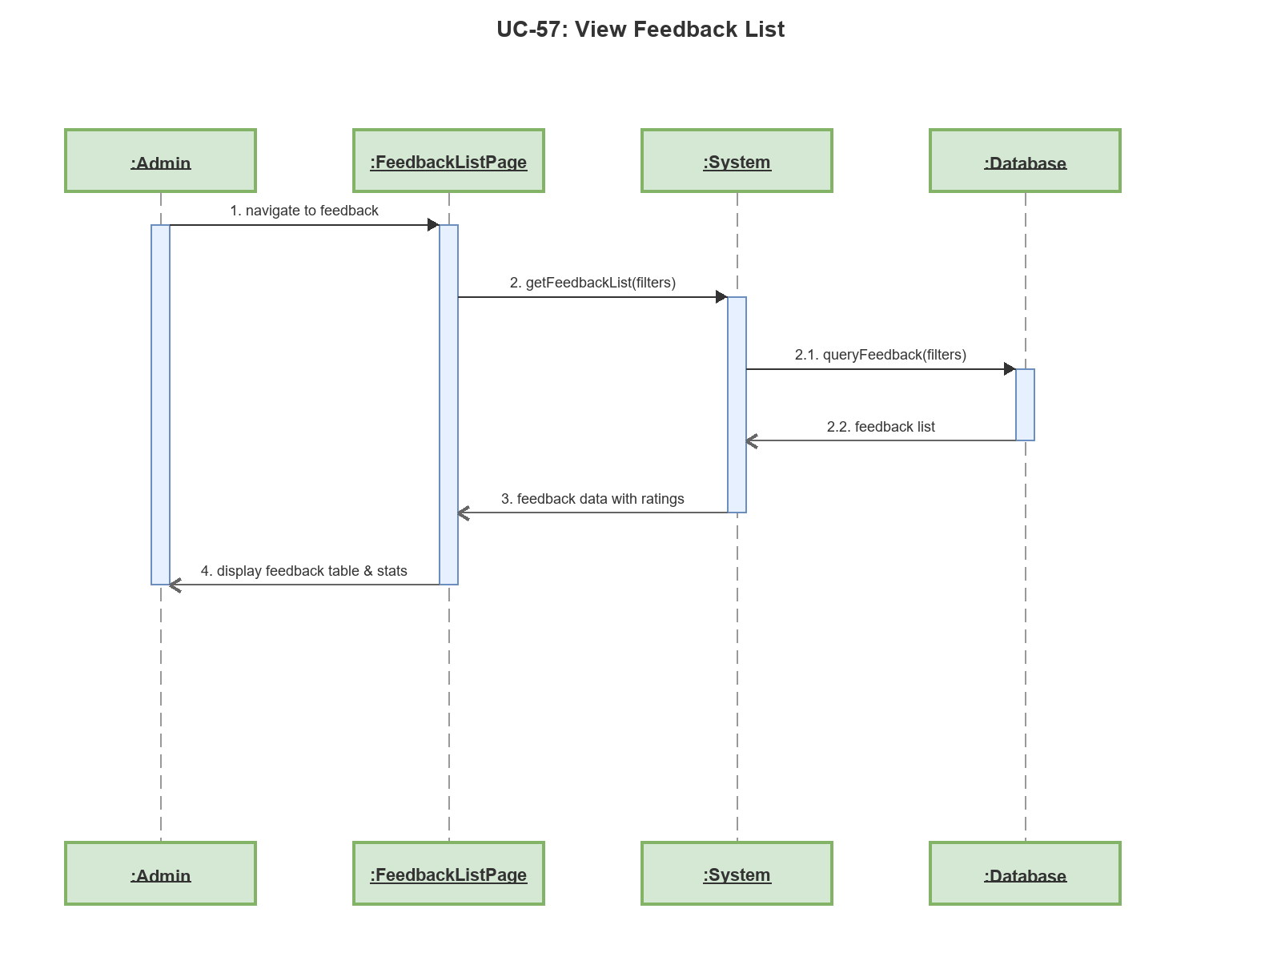

Sequence Diagram: UC-58: View Revenue Report
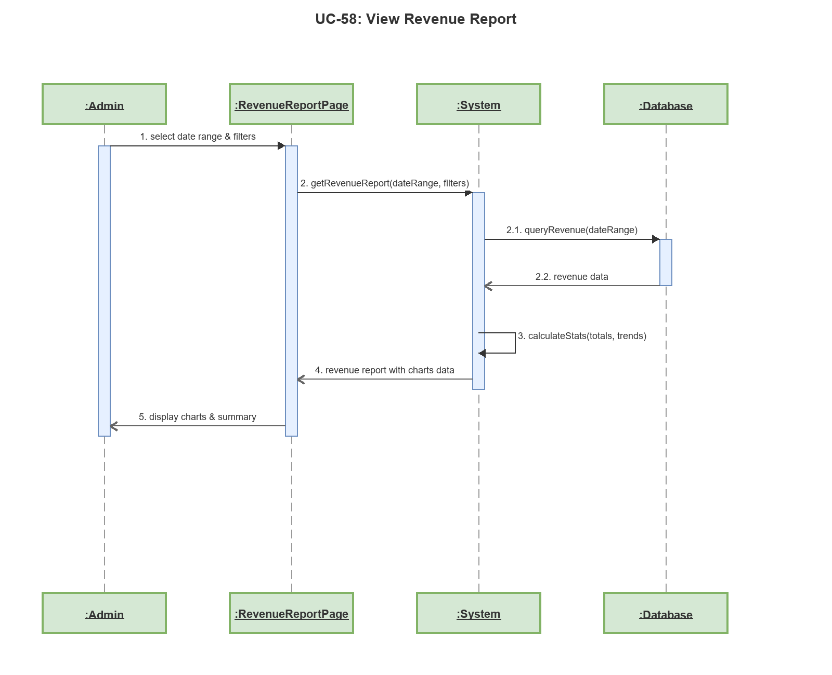

Sequence Diagram: UC-59: View Room Utilization Report
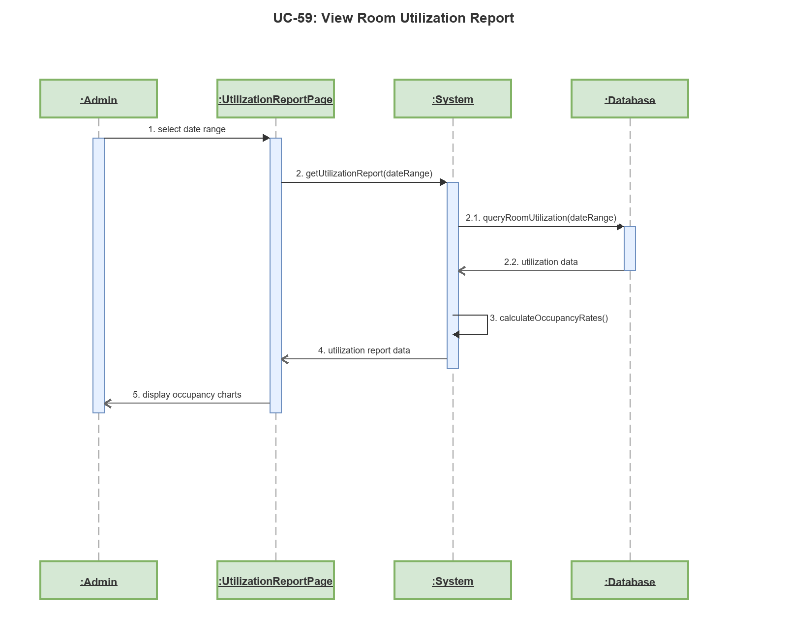

Sequence Diagram: UC-60: Update Hotel Information
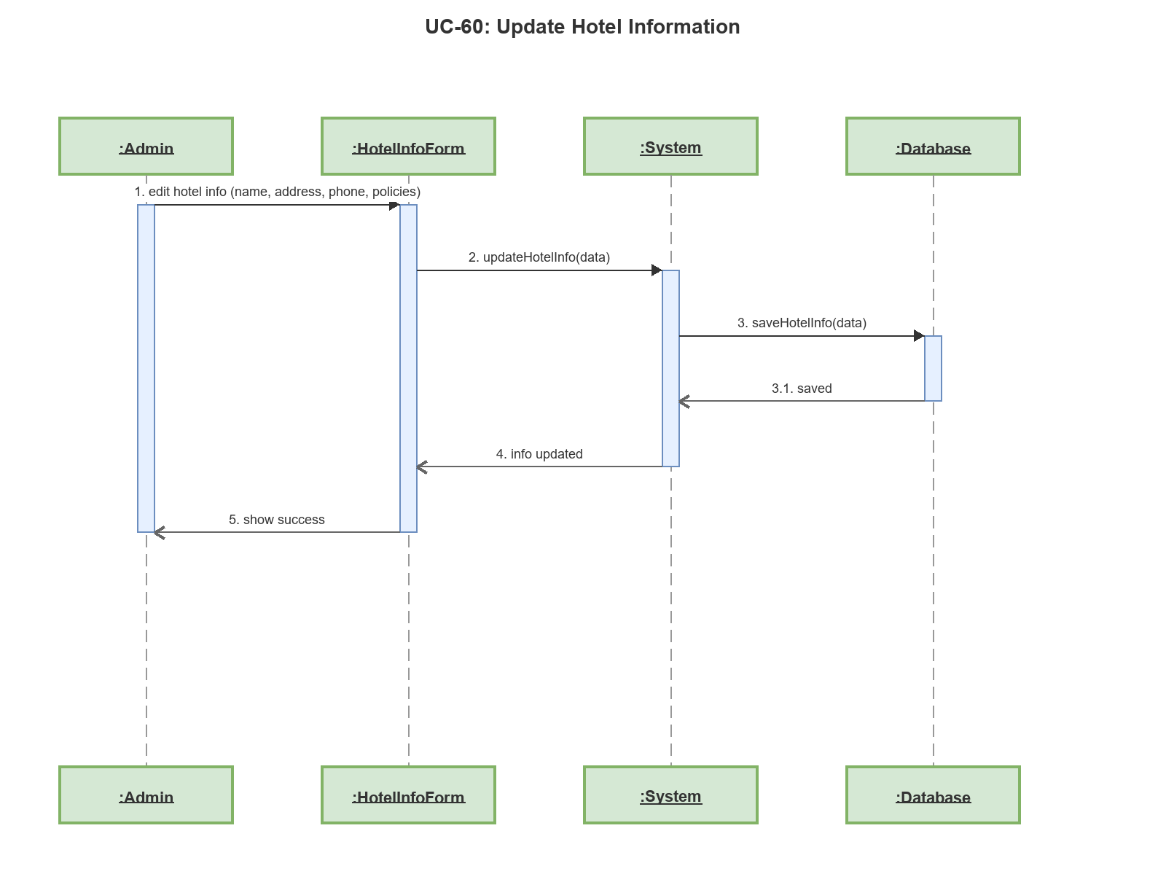

Sequence Diagram: UC-61: View Admin Dashboard
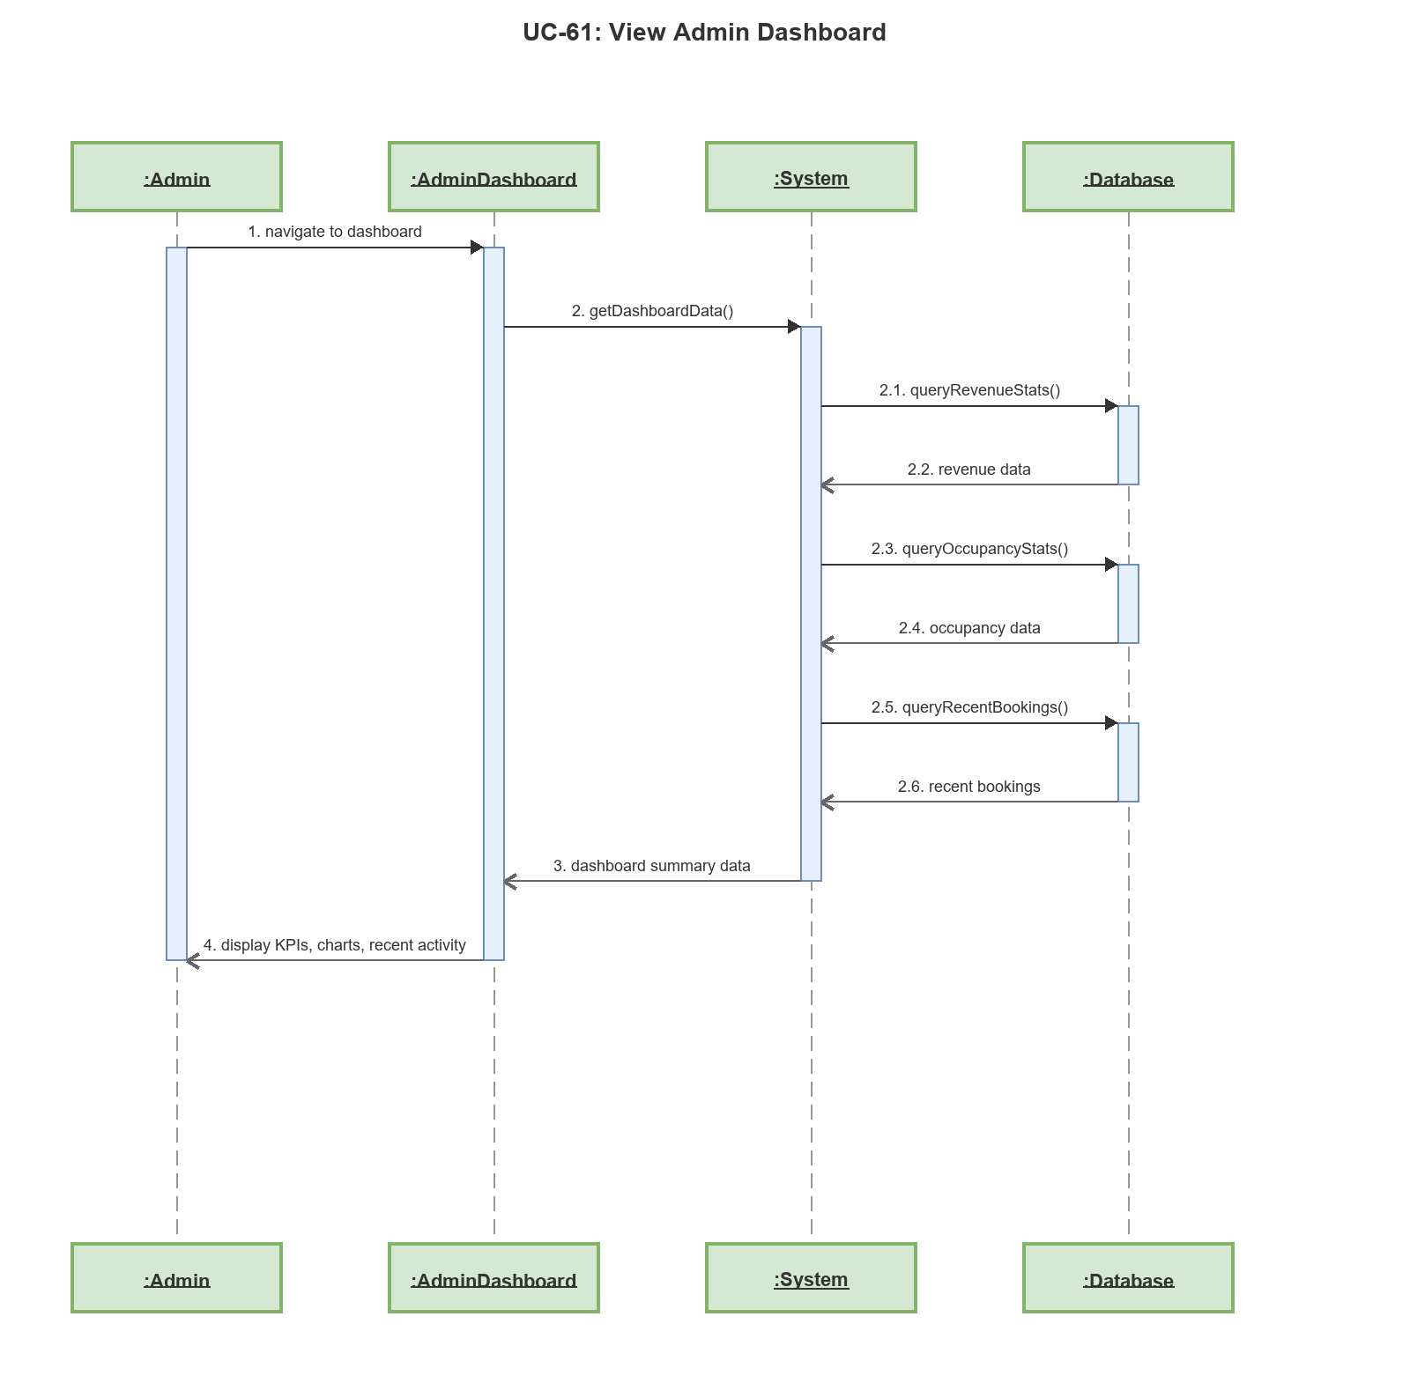

Sequence Diagram: UC-62: View User List
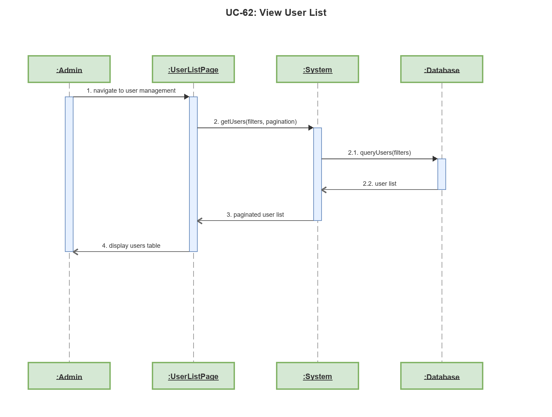

Sequence Diagram: UC-63: View Service Requests (Admin)
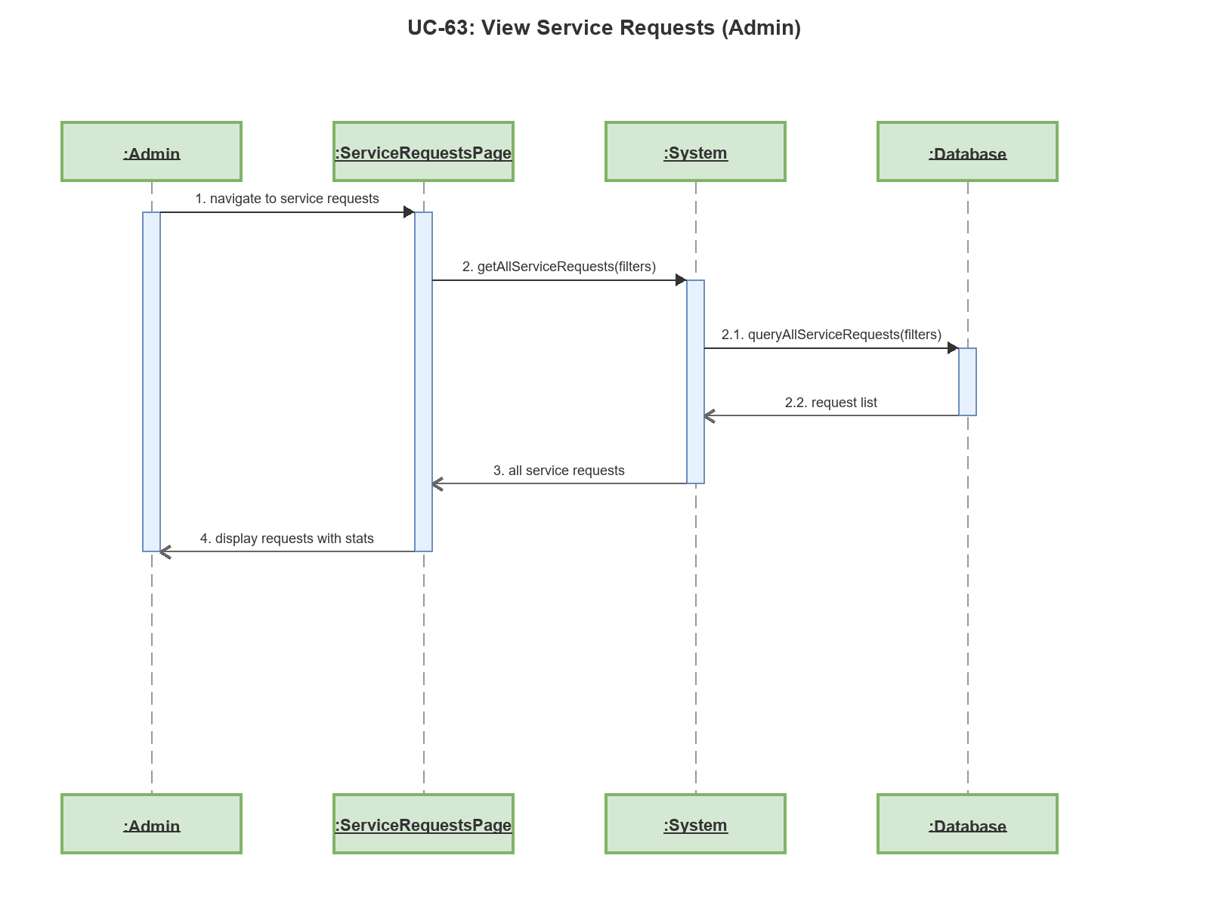

Sequence Diagram: UC-65: View Home Page
