SHOUT LAN
THE ACOUSTIC NETWORK
Complete workflow • Concepts • Architecture • Implementation roadmap

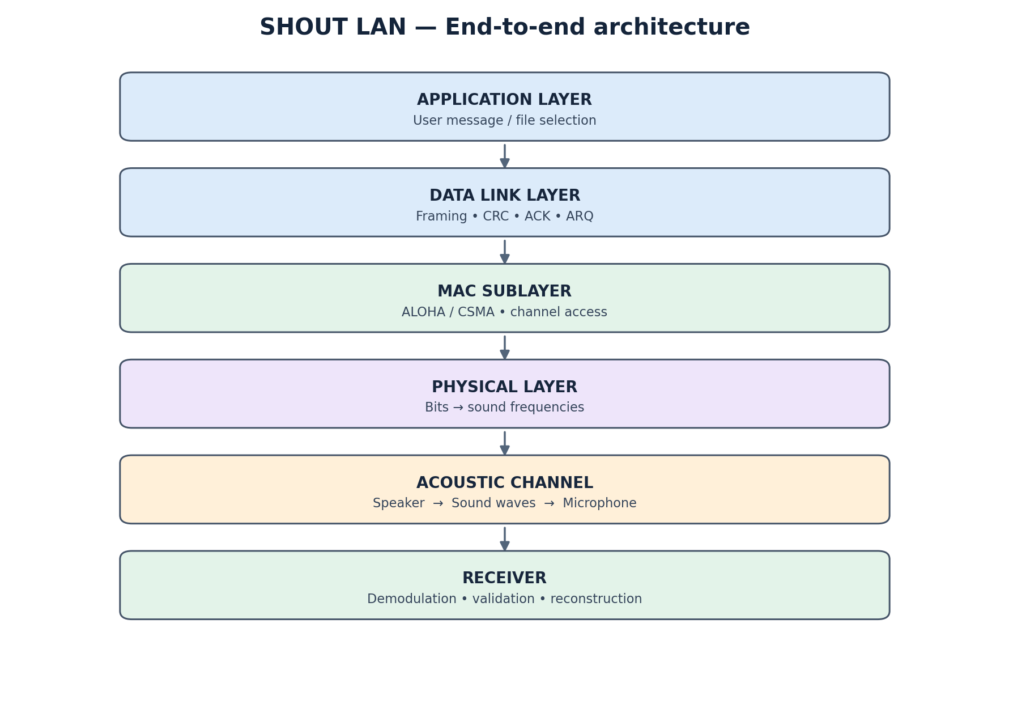
Figure 1. Conceptual end-to-end architecture of SHOUT LAN.
A step-by-step, beginner-friendly project guide

How to read this guide
This document explains the complete proposed workflow for SHOUT LAN in simple language. It follows a message from the sender's application, through framing and acoustic transmission, to reception and delivery. It then explains reliability, multiple-device access, relaying, IP/ICMP-style testing, multithreading, sockets, NS-2 and the implementation plan.
Important project-status note
This is a design and implementation plan, not a claim that every feature is already built. The acoustic sender–receiver path is the heart of the project. Advanced features should be added only after the basic acoustic link works.

1. What is SHOUT LAN?
SHOUT LAN is a proposed local communication system in which computers exchange digital information using sound. A sender converts bits into audio tones and plays them through a speaker. A receiver captures those tones through a microphone, decodes them back into bits, checks the data and reconstructs the original message.
The simplest demonstration uses two laptops in the same room: Laptop A sends a text message; Laptop B receives and displays it. The project extends this basic link with networking mechanisms such as frames, CRC, acknowledgements, retransmission, medium access, relaying and performance measurement.

2. The five-stage architecture
Figure 2. The main logical stages. The receiver performs the reverse of the sender's processing.
Stage | What it does | Example
Application layer | Accepts user data and displays received data | Type “HELLO”
Data Link layer | Creates frames and provides error detection/reliability | Frame + CRC + ACK
MAC sublayer | Controls which device may transmit | CSMA or ALOHA
Physical layer | Converts bits to sound and sound back to bits | BFSK tones
Receiver/application | Validates, reassembles and delivers the message | Display “HELLO”

The physical layer carries the acoustic signal. The data-link layer handles frame structure and link reliability. The MAC sublayer coordinates access to the shared acoustic medium. The application layer is what the user sees.

3. Complete workflow at a glance
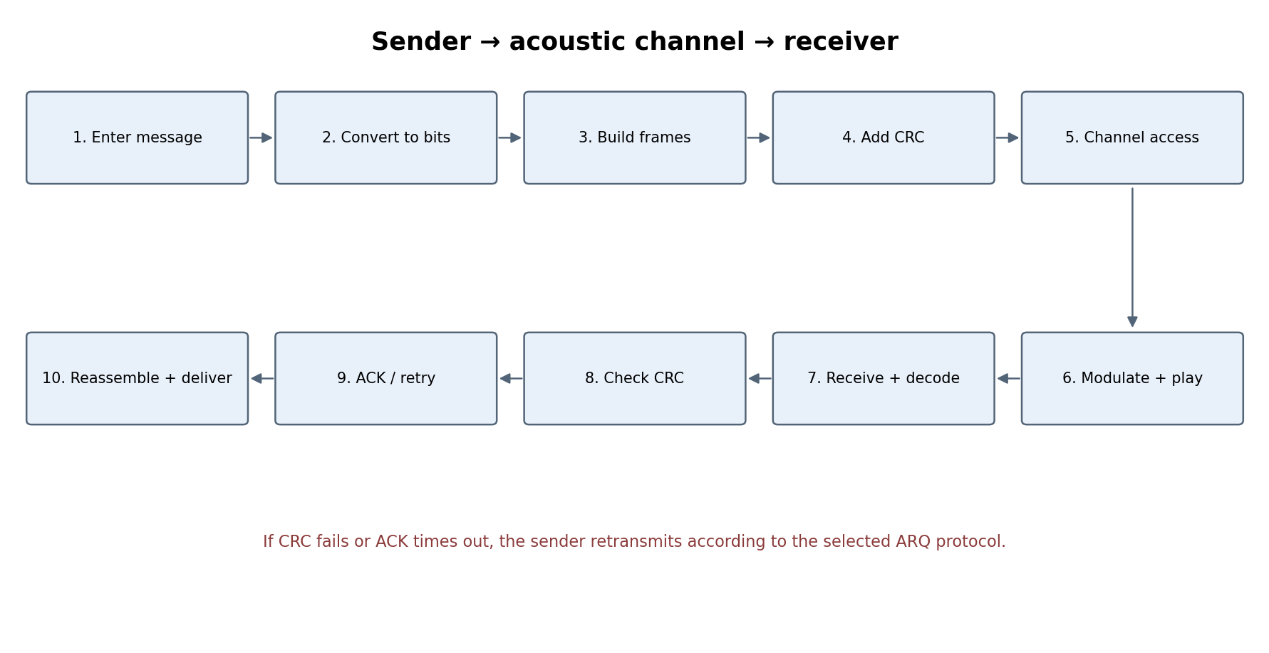
Figure 3. A message passes through sender processing, acoustic transmission and receiver processing.
If the CRC check fails, or if the sender does not receive an acknowledgement before its timer expires, the selected ARQ protocol triggers retransmission. Once all required frames are received and verified, the receiver reassembles and delivers the original message.

4. Complete workflow — step by step

Step 1 — Establish communication
Two computers run the SHOUT LAN application. One is configured as the sender and the other as the receiver. The receiver opens its microphone and listens; the sender prepares its speaker for playback. Both sides must agree on parameters such as modulation method, tone frequencies, bit duration, frame format and preamble. For a first test, place the laptops in the same room and keep the volume moderate.
Syllabus mapping
Syllabus connection: physical transmission medium, communication architecture and endpoint roles.

Step 2 — Enter a message
The sender types a message such as HELLO WORLD. The application treats it as text data. Before it can be carried as a digital signal, the text is represented as bytes and then as bits. For example, the ASCII byte for H is 01001000. The application may also accept a file, but text is the easiest first milestone.
Syllabus mapping
Syllabus connection: data representation, encapsulation and application-layer communication.

Step 3 — Framing
A long message is split into manageable units called frames. A frame can contain a start marker or preamble, source ID, destination ID, sequence number, payload length, payload and CRC. Sequence numbers help the receiver detect duplicates, missing frames and ordering. Length information tells the receiver where a frame ends.
Syllabus mapping
Syllabus connection: framing, Data Link Layer, packetization and encapsulation.

Step 4 — CRC error detection
The sender calculates a Cyclic Redundancy Check value over the frame's protected fields and attaches it. The receiver performs the same calculation after decoding. If the calculated value matches the received CRC, the frame passes the check; otherwise, it is rejected. CRC detects many accidental transmission errors but does not repair corrupted data.
Syllabus mapping
Syllabus connection: error detection and CRC.

Step 5 — Choose access to the shared channel
Before sending, the MAC mechanism decides whether the sender can use the acoustic channel. In a simple two-device first version, a fixed sender/receiver arrangement may be enough. With multiple transmitters, the project can add CSMA or ALOHA. This is important because overlapping sound transmissions can interfere.
Syllabus mapping
Syllabus connection: MAC sublayer, ALOHA and CSMA.

Step 6 — Modulation converts bits into sound
The sender maps binary data to audio signals. A beginner-friendly option is Binary Frequency Shift Keying (BFSK): one tone represents bit 0 and another tone represents bit 1. The selected tones are illustrative and must be tested with the actual speakers, microphones and room. A preamble can help the receiver detect the beginning and timing of a frame.
Syllabus mapping
Syllabus connection: Physical Layer, digital transmission and signal encoding/modulation.

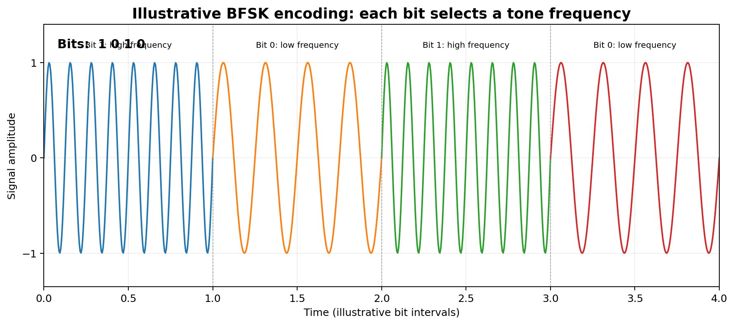
Figure 4. Illustrative BFSK waveform. The two frequencies are examples only.

Step 7 — Speaker transmits; microphone captures
The sender plays the generated audio through its speaker. The sound travels through the air. The receiver's microphone records the signal. Real-world noise, reverberation, distance, speaker frequency response and microphone quality can all affect reception. The receiver should process short audio chunks rather than waiting for a complete recording.
Syllabus mapping
Syllabus connection: physical medium, noise and transmission errors.

Step 8 — Demodulation recovers bits
The receiver analyzes the captured audio and decides which tone was sent during each bit interval. It converts those tone decisions back into 0s and 1s, then groups the bits into bytes and frames. Frequency analysis, such as FFT-based detection, is one possible way to distinguish the tones. Synchronization and a known preamble are needed to identify bit boundaries reliably.
Syllabus mapping
Syllabus connection: Physical Layer and digital signal recovery. FFT is an implementation technique, not necessarily a named syllabus topic.

Step 9 — Verify CRC
After reconstructing a frame, the receiver calculates the CRC again. A valid frame is accepted for further processing. A frame with a CRC mismatch is discarded or marked as damaged. The receiver must not deliver corrupted payload as if it were valid.
Syllabus mapping
Syllabus connection: error detection and CRC.

Step 10 — Send an acknowledgement
When a frame is received correctly, the receiver sends an ACK frame back acoustically. The ACK should identify which frame it confirms, usually by sequence number. If the sender does not receive the expected ACK before a timeout, it assumes the frame or ACK may have been lost and follows the retransmission rule.
Syllabus mapping
Syllabus connection: acknowledgements, timers, ARQ and reliable transmission.

Step 11 — Stop-and-Wait ARQ
The sender sends one frame and waits for its ACK before sending the next. If the ACK arrives, it moves on. If the timer expires, it retransmits. Sequence numbers are needed so duplicate frames can be recognized. This is simple to implement and ideal for the first reliable version, although it can be slow because only one unacknowledged frame is in flight.
Syllabus mapping
Syllabus connection: Stop-and-Wait ARQ and basic flow control.

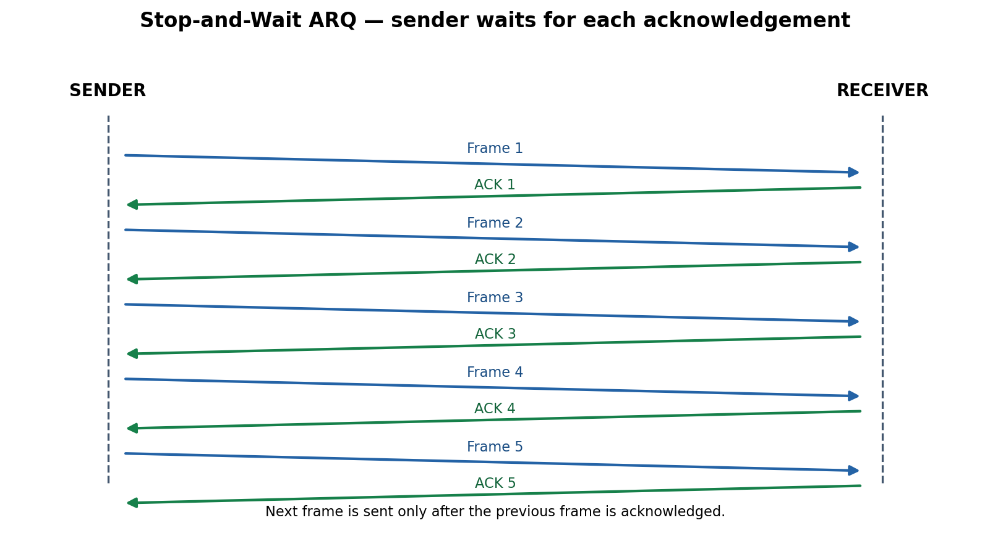
Figure 5. Stop-and-Wait: each frame is followed by its acknowledgement.

Step 12 — Selective Repeat ARQ
For better efficiency, the sender can transmit several frames within a sliding window. The receiver individually acknowledges valid frames and buffers out-of-order frames. If Frame 3 is lost but Frames 4 and 5 arrive correctly, only Frame 3 needs retransmission. The receiver later reassembles frames in sequence order. This requires more state and careful handling of sequence-number wraparound and duplicate frames.
Syllabus mapping
Syllabus connection: sliding-window flow control and Selective Repeat ARQ.

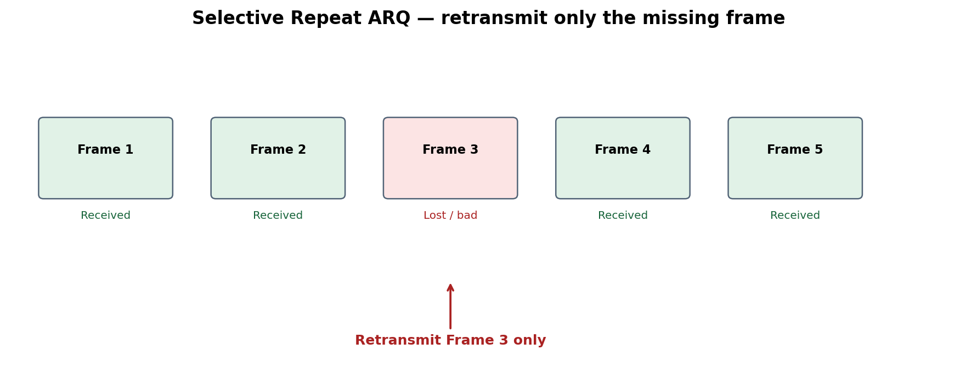
Figure 6. Selective Repeat retransmits only the missing or damaged frame.

Step 13 — ALOHA for multiple transmitters
ALOHA is a random-access MAC protocol. A device transmits when it has data. If a collision or failed transmission occurs, it waits for a random backoff interval and retries. In SHOUT LAN, a missing ACK can be used as an indication that a transmission may have failed. Pure ALOHA and Slotted ALOHA can be demonstrated as protocol modes or simulations.
Syllabus mapping
Syllabus connection: MAC sublayer and ALOHA.

Step 14 — CSMA: listen before transmitting
CSMA means Carrier Sense Multiple Access. A device first senses whether the channel appears busy. If it is idle, the device transmits; if busy, it waits and checks again. In an acoustic implementation, the microphone can estimate whether another device is transmitting. Acoustic sensing is imperfect, so collisions can still happen, especially when devices cannot hear one another.
Syllabus mapping
Syllabus connection: MAC sublayer, CSMA and channel access.

Step 15 — Multi-hop relay
If A cannot reach C directly but can reach B, B can relay the message. A sends a frame to B; B validates it, checks the destination and forwards the payload toward C. Each hop is a separate acoustic transmission and should have its own link-level acknowledgement. A later extension can use a routing table to choose the next hop when multiple relays exist.
Syllabus mapping
Syllabus connection: network topology, addressing, routing and forwarding.

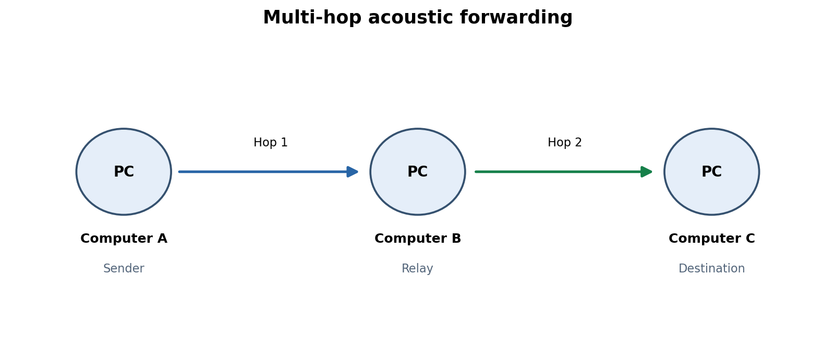
Figure 7. Computer B relays traffic from A to C.

Step 16 — IP/ICMP-style ping and RTT
A can send an Echo Request-like message to C. C returns an Echo Reply-like message. A measures the elapsed time between sending the request and receiving the reply; this is round-trip time (RTT). At first, this should be implemented as a simplified ICMP-like message inside SHOUT LAN's own frames. It is not automatically native IP or ICMP. Native IP integration is an advanced extension.
Syllabus mapping
Syllabus connection: Network Layer concepts, IP addressing, ICMP ping and RTT.

Step 17 — Multithreading
The application can run separate threads for audio capture, decoding, outgoing transmission, ACK handling and UI/log updates. This allows one task to continue while another is running. Shared queues and state must be protected using synchronization mechanisms such as mutexes. A producer-consumer design is useful: the audio-capture thread produces audio chunks and the decoder consumes them.
Syllabus mapping
Syllabus connection: multithreading, concurrency, producer-consumer and synchronization.

Step 18 — Socket programming as a supporting module
The acoustic path itself uses speaker and microphone audio I/O; TCP/UDP sockets are not what physically carry the sound. However, sockets can support a separate control/monitoring interface between the user interface and the acoustic engine, or a conventional-network comparison mode. A TCP client-server demonstration and a UDP test can be included as a distinct syllabus-aligned module.
Syllabus mapping
Syllabus connection: TCP/UDP socket programming and multithreaded client-server architecture.

5. One complete example: A sends a message to C through B
Assume Computer A wants to send “HELLO COMPUTER C” to Computer C. Computer B is in between and acts as a relay.
- 1. The user enters HELLO COMPUTER C on A.
- 2. A converts the text into bytes and bits.
- 3. A divides the message into frames and adds source, destination, sequence and length fields.
- 4. A calculates and attaches a CRC.
- 5. A uses the configured MAC rule to access the channel.
- 6. A modulates the bits into audio tones and plays them through its speaker.
- 7. B captures the sound through its microphone and demodulates it into bits.
- 8. B checks the frame's CRC. If invalid, it rejects the frame; if valid, it continues.
- 9. B sends an ACK to A for the correctly received frame.
- 10. B checks the destination address and determines that C is the final destination.
- 11. B prepares the outgoing transmission and sends the data acoustically to C.
- 12. C captures and decodes the signal, verifies the CRC and acknowledges the frame.
- 13. C orders the frames by sequence number and reconstructs the original message.
- 14. C displays HELLO COMPUTER C to the user.
Successful delivery
The message has travelled over two acoustic hops: A → B and B → C. Each hop needs its own reliable link-level handling.

Figure 8. Two-hop relay path.

6. Syllabus coverage map
The following table maps the project components to the Computer Networks topics discussed for your course. It separates features that are directly implemented from features that are best demonstrated in a simulator or supporting module.
Syllabus topic | Where it appears in SHOUT LAN | How to demonstrate it
Network topology | Multiple acoustic devices and relay nodes | Show A–B–C topology and forwarding path
NS-2 topology design | Separate network simulation | Create nodes/links, generate traffic and inspect trace/animation
Socket programming | Control/monitoring interface or separate TCP/UDP test mode | Run client and multithreaded server
Multithreading | Audio capture, decode, transmit, ACK and UI tasks | Show concurrent worker threads and logs
Framing | Split application data into structured frames | Inspect frame fields and sequence numbers
CRC | Detect corrupted frames | Inject a bit error and show CRC failure
ACK and ARQ | Reliable delivery | Show ACK, timeout and retransmission
Stop-and-Wait | One outstanding frame at a time | Show sender waiting for each ACK
Sliding Window / Selective Repeat | Multiple outstanding frames and selective retry | Drop one frame and retransmit only that frame
ALOHA | Random channel access | Simulate simultaneous transmissions and backoff
CSMA | Sense channel before sending | Show busy/idle sensing and deferral
Routing / forwarding | Relay chooses next hop | Send A-to-C traffic through B
IP / ICMP concepts | Echo Request and Echo Reply-like messages | Show ping-style request and RTT
Physical Layer | Speaker and microphone link | Transmit and receive tones

Important NS-2 distinction
NS-2 is a simulator. It can demonstrate topology, traffic, packet loss, delay and protocol behaviour in a model. It does not automatically make the real acoustic signal travel through the simulator. Keep the NS-2 experiment clearly labelled as simulation.

7. What the final application could contain
Dashboard section | What it displays
Network Overview | Active devices, node IDs, topology and link status
Send Message | Message/file input and destination selection
Live Transmission | Audio activity, decoded bits and transmission state
Packet Monitor | Frame contents, sequence numbers, CRC status and ACKs
Reliability | Stop-and-Wait, Selective Repeat, timers and retransmissions
MAC Simulator | ALOHA and CSMA demonstrations
Network Topology | Devices, relay paths and next-hop decisions
Performance | Packet delivery ratio, packet loss, throughput and RTT
System Logs | Timestamped internal events and errors

These are proposed interface sections. They should be added after the underlying networking engine works; a dashboard should display real engine state rather than simulated success messages.

8. Recommended implementation roadmap
Phase | Build | Definition of done
1. Audio proof of concept | Play a known tone pattern and record it on another device | Receiver can distinguish the test tones
2. Bit recovery | Implement timing, preamble and bit decisions | Known bit sequence is recovered reliably at short range
3. Frames + CRC | Define frame format and CRC calculation | Valid frames pass; deliberately corrupted frames fail
4. ACK + Stop-and-Wait | ACK frames, timeout and retransmission | A message is delivered despite a dropped frame or ACK
5. Selective Repeat | Sliding window, buffering and selective retransmission | Only missing/damaged frames are retried
6. MAC modes | ALOHA and CSMA | Multiple simulated or real transmitters follow access rules
7. Multithreading | Capture, decode, transmit and ACK workers | Concurrent tasks run without corrupting shared state
8. Multi-hop | Relay node and next-hop table | A sends a message to C through B
9. Ping/RTT | Echo Request/Reply-like messages | RTT is measured and displayed
10. NS-2 + sockets | Separate simulator and TCP/UDP module | Course evaluation concepts are independently demonstrable
11. Dashboard + testing | Visualize actual state and metrics | End-to-end demo is repeatable

9. Suggested final demonstration
- Open SHOUT LAN on two laptops and start the receiver before the sender.
- Send a short text message and show the speaker-to-microphone acoustic link.
- Show the decoded bits and the frame fields.
- Show a successful CRC check.
- Introduce a controlled error or drop a frame and show rejection/retransmission.
- Demonstrate Stop-and-Wait, then Selective Repeat.
- Use multiple transmitters or a controlled demonstration to show ALOHA and CSMA behaviour.
- Add a third device and demonstrate A → B → C forwarding.
- Run the ping-like test and display measured RTT.
- Show the separate NS-2 topology experiment and socket-programming module.
- Finish with delivery ratio, retransmission count, throughput and logs.

10. Simple glossary
Term | Simple meaning
Bit | A 0 or 1
Frame | A structured unit of data sent over one link
Payload | The actual user data inside a frame
CRC | A calculated value used to detect accidental corruption
Modulation | Converting digital bits into a signal suitable for transmission
Demodulation | Recovering bits from the received signal
BFSK | A method that represents 0 and 1 using two different frequencies
ACK | A confirmation that a frame was received
ARQ | A reliability method that uses acknowledgements and retransmissions
Stop-and-Wait | Send one frame, then wait for its ACK
Selective Repeat | Retransmit only the frames that are missing or damaged
ALOHA | Transmit when ready; retry after a random wait if transmission fails
CSMA | Check whether the channel is busy before transmitting
Relay | A device that receives data and forwards it onward
RTT | Time for a request to reach a destination and its reply to return
Thread | An independent execution path within a program
Socket | A software endpoint used by programs to communicate

11. Practical design cautions
- Start with a short-range two-device acoustic link. Do not begin with routing, multi-hop or a complex dashboard.
- Audio timing and synchronization are difficult. Use a preamble, known bit duration and repeated tests.
- Choose tone frequencies only after testing the hardware. The illustrative 1 kHz and 2 kHz values are not guaranteed to work best.
- Use a clear frame boundary and length field so the receiver knows where a frame ends.
- CRC detects corruption but does not correct it. ARQ handles recovery by requesting retransmission.
- An ACK can itself be lost. Sequence numbers and duplicate detection are essential.
- Acoustic CSMA is only an estimate of channel occupancy. Hidden transmitters and room acoustics can still cause collisions.
- Treat native IP/ICMP tunnelling as an advanced extension. An ICMP-like message inside a custom acoustic frame is a simpler first implementation.
- Keep NS-2 experiments separate from physical acoustic tests and label measured versus simulated results accurately.
- Measure real performance: bit error rate, packet delivery ratio, retransmissions, throughput and RTT.

12. Final recommendation
The strongest version of SHOUT LAN is one that proves the acoustic link works first, then adds networking features in layers. The core project should be a real two-computer speaker–microphone communication system with framing, CRC, ACK and reliable delivery. The advanced project can add Selective Repeat, multiple transmitters, ALOHA, CSMA, multithreading and multi-hop forwarding. NS-2 and socket programming should be included as clearly identified supporting demonstrations for the course evaluation.
The central idea
SHOUT LAN is not just a messaging interface. It is an experimental communication system that uses sound as its physical medium and demonstrates networking mechanisms above that medium.

