
Image Enhancement Using Spatial, Fourier and Hybrid Techniques

python-docx
[Company Name]

CS867 - COMPUTER VISION

Assignment 1
Image Enhancement Using Spatial, Fourier and Hybrid Techniques
Group Members | 1. Maheen Fatima ID: ____________  2. Zimal Fatima ID: ____________  3. Nida Munir ID: ____________
Instructor | ____________________________
Due Date | Sunday, 4 October 2026
Total Marks | 50
Submission | Word report + separate commented Python source files
Input images: Chest.bmp and Skeleton.bmp

Contents
1. Abstract
2. Problem Statement and Objectives
3. Experimental Setup and Implementation
4. Part (a): Spatial-Domain Enhancement
5. Part (b): Fourier-Domain Enhancement
6. Part (c): Spatial-Fourier Hybrid Enhancement
7. Part (d): Comparison and Analysis
8. Discussion
9. Conclusion
10. References
Appendix A: Final Parameters
Appendix B: Code Structure and Reproducibility

1. Abstract
This assignment compares three ways of improving the visibility of two low-contrast grayscale images: a purely spatial pipeline, a purely Fourier-domain pipeline, and two spatial-Fourier hybrid pipelines. Rather than selecting parameters from a single numerical score, we used controlled parameter sweeps together with visual inspection. The final spatial method combines robust percentile stretching, gamma correction, CLAHE, edge-preserving denoising and unsharp masking. The Fourier method uses high-frequency emphasis (HFE) with a Butterworth high-pass component, while a plain Gaussian high-pass is retained as a negative baseline. The sequential hybrid first performs homomorphic frequency processing and then applies local spatial enhancement; the second hybrid fuses the final spatial and Fourier outputs.
The experiments show that the strongest numerical score is not always the most natural-looking result. For the chest image, Hybrid 1 gives the highest contrast and entropy among the final methods, while the spatial result is visually cleaner and much faster. For the skeleton image, the spatial method gives the best natural visibility; Hybrid 1 creates the strongest edge response but also raises noise and edge density substantially. The results therefore support a balanced selection based on visibility, artifacts, and runtime rather than metric maximization alone.

2. Problem Statement and Objectives
The required task was to enhance Chest.bmp and Skeleton.bmp in three different ways and then compare the outputs. The assignment specifically asks for spatial-only processing, Fourier-only processing, a combined hybrid approach, and an analysis supported by both visual results and objective measures.
- Part (a): maximize visible detail using spatial-domain operations only.
- Part (b): maximize visible detail using Fourier-domain filtering only.
- Part (c): combine spatial and frequency-domain processing in a hybrid method.
- Part (d): compare image quality, artifacts, objective metrics and execution time.
A key design decision was to keep the Fourier-only final method genuinely spectral. The inverse-transform result is displayed using affine min-max scaling, but no CLAHE, gamma correction or local spatial enhancement is applied to the final Fourier HFE output. Spatial point operations are introduced only in the hybrid stage.

3. Experimental Setup and Implementation

3.1 Input handling and preprocessing
Both images were loaded as grayscale and converted to floating-point intensity values in the range [0,1]. A narrow saturated white frame at the image boundary was removed before filtering. This step was important because a bright border can create artificial high-frequency energy and stronger wrap-around artifacts in the DFT, and it can also distort percentile-based contrast statistics. After this border removal, the stored original-result images are 697 x 482 pixels for Chest and 469 x 680 pixels for Skeleton (width x height).
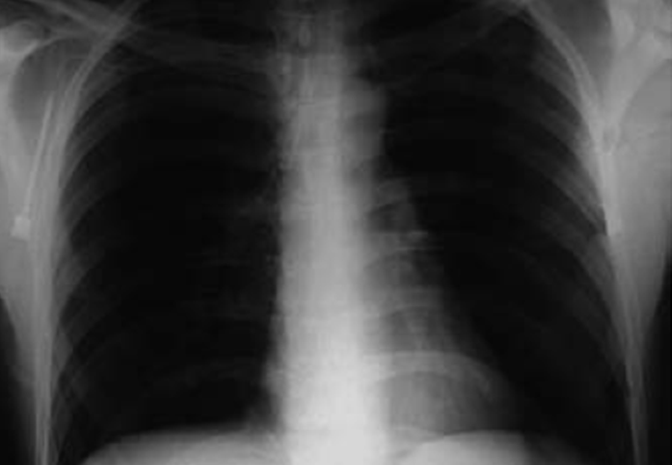 | 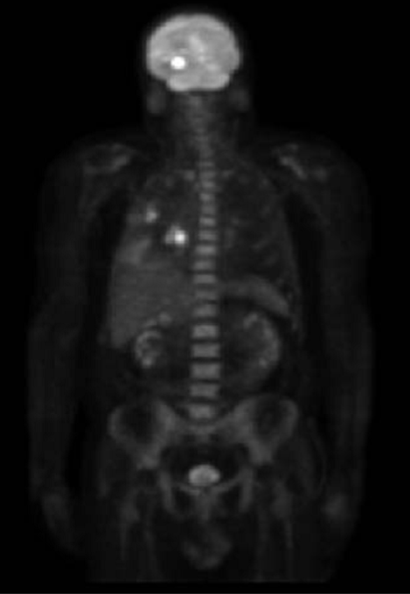
Chest input | Skeleton input
Figure 1. Input images used throughout the experiments.
Comment: The two inputs require different enhancement strength. The chest image already contains visible structure but has dark lung regions and coarsely quantised low-intensity areas (an 8-bit palette of 219 grey levels, only about 20 of which fall in the darkest 40% of the image), which local contrast enhancement can turn into visible contour banding. The skeleton image is much darker overall (about 9 levels across its darkest 40%), so a stronger gamma lift is needed to reveal anatomical detail without turning the black background grey.

3.2 Software organization
File | Purpose
common.py | Image loading, normalization, border removal, percentile stretch, metrics and runtime measurement.
spatial.py | Histogram equalization baseline and the complete spatial enhancement pipeline.
fourier.py | FFT utilities, Gaussian/Butterworth high-pass filters, HFE and homomorphic filtering.
hybrid.py | Sequential homomorphic + spatial pipeline and weighted spatial/Fourier fusion.
main.py | Runs parameter sweeps, saves figures, measures 15-run runtimes and exports metrics/results.
Runtime measurements exclude image loading, plotting and saving. Each method is warmed up once and then executed 15 times; the median is used because it is less sensitive to occasional timing spikes than the mean.

3.3 Objective measures
The comparison uses measures that capture different aspects of enhancement. No single measure is treated as a complete image-quality score.
Measure | Interpretation
Standard deviation (contrast) | Global spread of intensities; higher values usually indicate stronger global contrast.
Shannon entropy | Distributional information content in the 8-bit image. It can increase when useful detail is revealed, but also when noise is amplified.
Average gradient | Mean local intensity change; useful as a general detail/edge indicator.
Tenengrad / Sobel strength | Average Sobel gradient magnitude; larger values indicate stronger edges and fine structure.
Noise sigma | Fast noise estimate based on the Immerkær operator; lower is preferred if visibility is maintained.
Canny edge density | Fraction of pixels detected as edges. A large increase can represent either useful detail or unwanted texture/artifacts.
Runtime | Median processing time over 15 runs after one warm-up run.
PSNR and SSIM against the original were intentionally not used as the main quality criteria. Enhancement is supposed to change contrast and edge appearance, so being numerically close to the low-visibility original is not necessarily desirable.

4. Part (a): Spatial-Domain Enhancement

4.1 Method
The spatial pipeline was designed as a sequence of small, interpretable operations. Each step solves a different problem instead of forcing one aggressive transform to do everything.
- Optional Gaussian pre-smoothing to dither the coarse intensity quantisation of the source images, which local contrast enhancement would otherwise turn into visible posterisation (contour banding).
- Robust percentile stretch to map the useful intensity range to [0,1] without letting a few extreme pixels dominate the scale.
- Gamma correction. Since gamma < 1, darker tones are lifted more strongly than already-bright tones.
- CLAHE for local contrast enhancement with a limited clip value to control noise amplification.
- Bilateral filtering to reduce small fluctuations while preserving major edges.
- Unsharp masking as the final detail-restoration step.
Percentile stretch: y = clip((x - P_low) / (P_high - P_low), 0, 1)
Gamma correction: y = x^gamma
Unsharp masking: I_out = I + k ( I - G_sigma * I )
Global histogram equalization was also evaluated as a baseline. It is very fast, but it applies the same global remapping everywhere, which is not ideal for these images with very different local brightness regions [1], [2].

4.2 Parameter selection
Image | Stretch | Gamma | CLAHE clip | Tiles | Unsharp sigma / k | Pre-smooth sigma
Chest | 1-99.5% | 0.8 | 1.5 | 6 x 6 | 1.5 / 0.7 | 1.0
Skeleton | 0.5-99.5% | 0.6 | 1.5 | 6 x 6 | 1.5 / 0.7 | None
The gamma/CLAHE sweep tested gamma values 0.6, 0.8, 1.0 and 1.2 against CLAHE clip limits 1.5, 2.0 and 3.0. Final values were chosen after checking visibility and artifacts, not by selecting the row with the largest metric value.
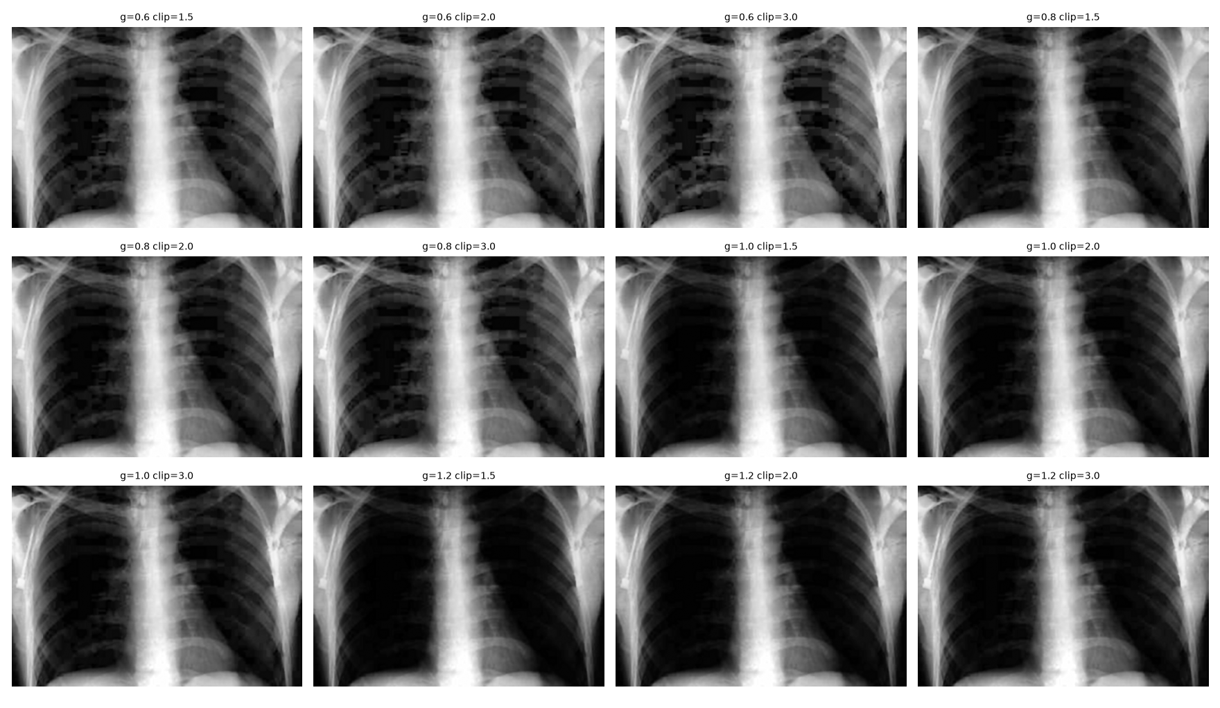
Figure 2. Chest spatial sweep: gamma versus CLAHE clip limit.
Comment: Gamma 0.6 makes the chest too bright and makes the block pattern in the lung fields more obvious. Gamma 1.0-1.2 preserves darkness but loses some low-contrast structure. Gamma 0.8 with clip 1.5 is the most balanced setting, which is why it was selected.

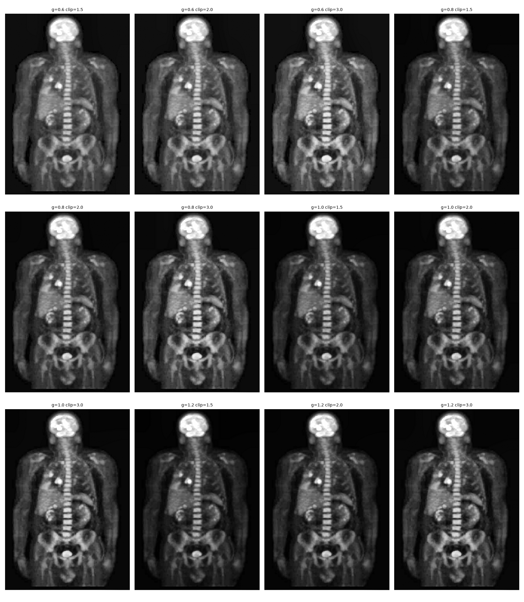
Figure 3. Skeleton spatial sweep: gamma versus CLAHE clip limit.
Comment: The skeleton starts from a much darker intensity distribution. Gamma 0.6 is useful here because it lifts the torso and skeletal structures while the black background remains largely dark. Raising the CLAHE clip beyond 1.5 adds texture but gives little extra useful visibility.

4.3 Step-by-step spatial results
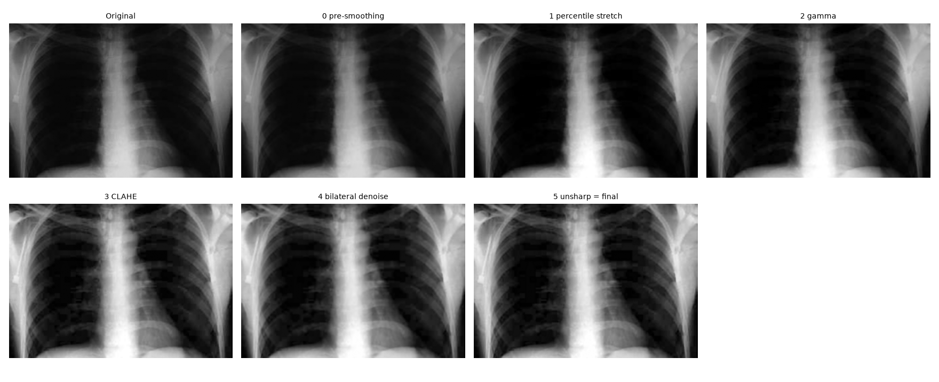
Figure 4. Chest spatial pipeline, shown after each processing stage.
Comment: The largest visibility gain occurs at the CLAHE stage, but the later bilateral filter is important because it softens local texture amplification. The final unsharp mask restores rib and vessel definition without the severe haloing that would result from a stronger sharpening amount.

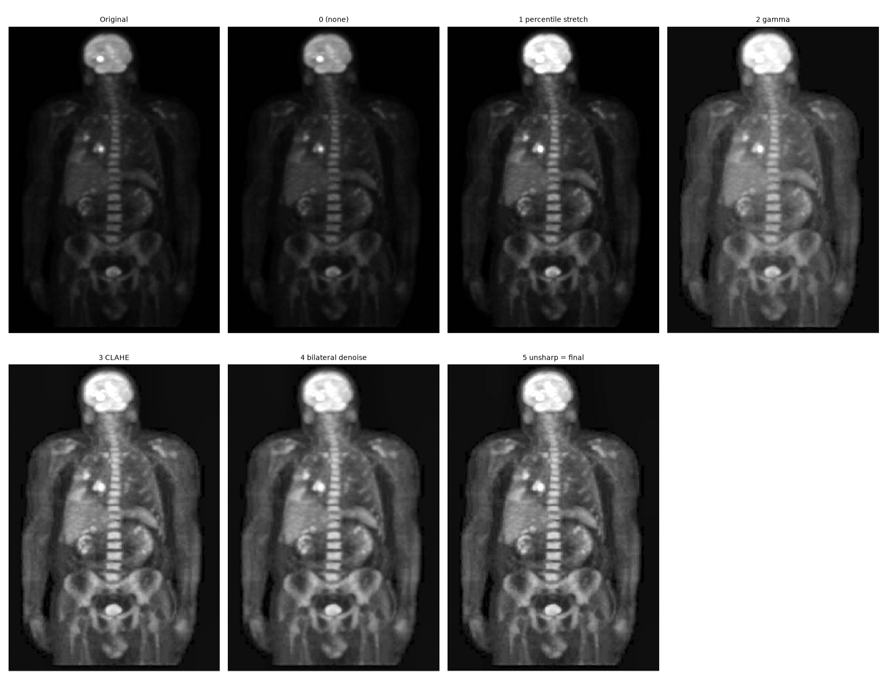
Figure 5. Skeleton spatial pipeline, shown after each processing stage.
Comment: Percentile stretching and gamma correction expose the torso, spine and pelvic region. CLAHE then adds local structure. The denoise/sharpen pair is useful because direct local enhancement alone makes the low-intensity background and organ texture look rough.

5. Part (b): Fourier-Domain Enhancement

5.1 Frequency-domain design
The image is transformed with a 2-D FFT, shifted so that the low frequencies are at the centre, multiplied by a frequency response H(u,v), and then reconstructed with the inverse transform. A 10% reflected padding is applied before the FFT to reduce boundary discontinuities and circular wrap-around artifacts [1], [3].
F(u,v) = FFTshift{ FFT2[I(x,y)] }
Butterworth HP: H_HP(D) = 1 / (1 + (D0 / (D + epsilon))^(2n))
High-frequency emphasis: H_HFE(D) = a + b H_HP(D)
I_F = Re{ IFFT2[ IFFTshift( H_HFE F ) ] }
The final HFE settings are the same for both images: D0 = 5% of the minimum image dimension, Butterworth order n = 2, a = 0.8 and b = 1.5. This keeps the low-frequency component instead of deleting it. A plain Gaussian high-pass with the same approximate cutoff is included as a deliberate negative baseline because it removes DC/low-frequency content and therefore produces an edge-dominant image rather than a useful visibility enhancement.

5.2 Spectrum and filter response
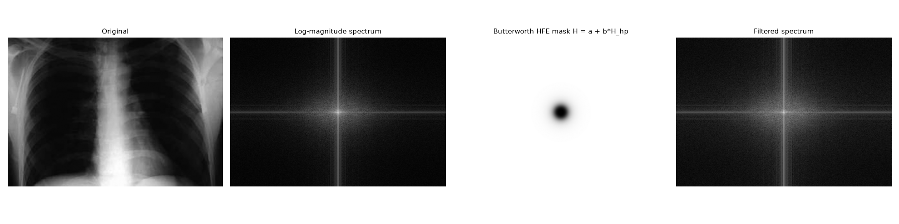
Figure 6. Chest: original image, log-magnitude spectrum, Butterworth HFE mask and filtered spectrum.
Comment: The centre of the spectrum contains most of the low-frequency energy. The HFE mask does not set the centre to zero; it preserves a base gain a while gradually increasing the gain toward higher spatial frequencies. This is why the result retains anatomy instead of becoming an edge-only image.

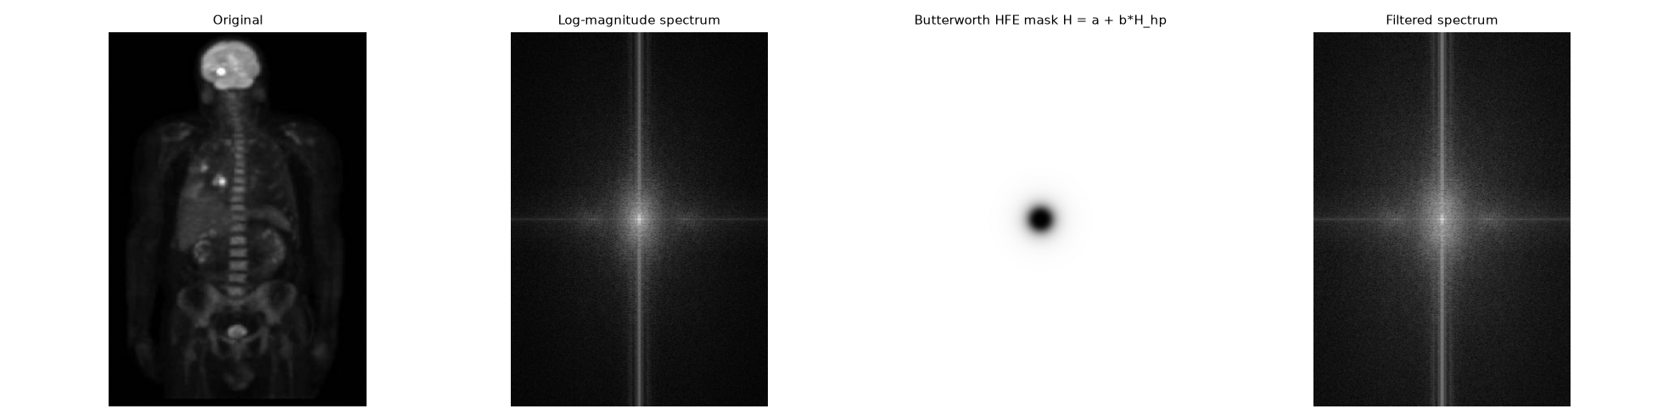
Figure 7. Skeleton: original image, spectrum, HFE mask and filtered spectrum.
Comment: The skeleton spectrum is strongly concentrated near the centre and along the horizontal/vertical axes. HFE strengthens the outer-frequency detail, but because the original image is very dark, a linear frequency-domain emphasis alone cannot provide the same local brightness lift as gamma + CLAHE.

5.3 Fourier parameter sweep and results
The sweep compared Gaussian HFE with Butterworth orders 1, 2 and 4 at cutoff fractions 0.02, 0.05 and 0.10. A middle cutoff and moderate Butterworth order gave the best balance. Very small cutoffs flatten brightness too much; very large cutoffs give weaker useful enhancement, while higher order filters can make the transition more abrupt and increase the risk of ringing.
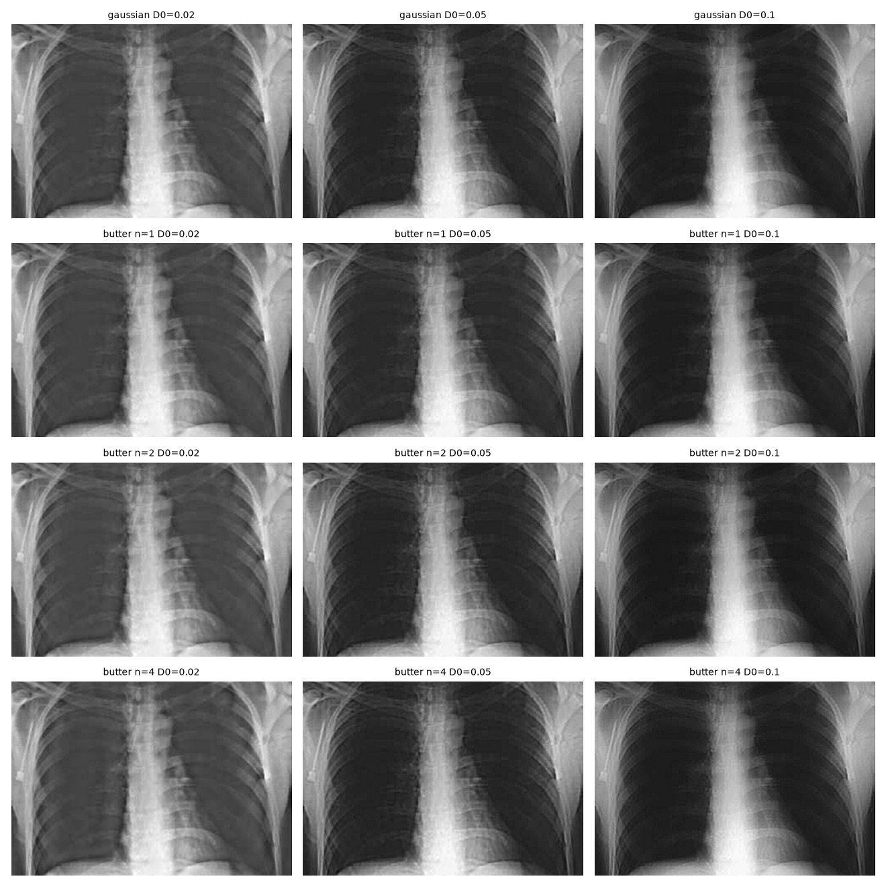
Figure 8. Chest Fourier HFE sweep across filter type, cutoff and Butterworth order.
Comment: For the chest image, D0 = 0.05 with Butterworth n = 2 gives visible rib/vertebral sharpening without making the result as flat as the lowest-cutoff settings. The differences are subtle because the HFE operation is linear and is not allowed to apply local spatial tone mapping in Part (b).

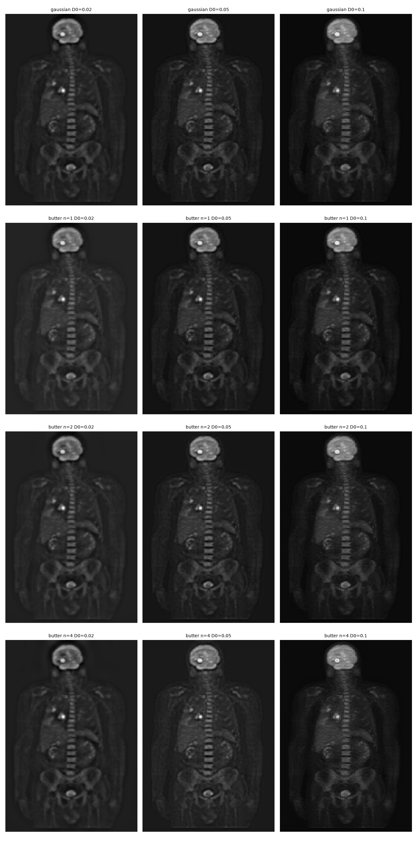
Figure 9. Skeleton Fourier HFE sweep across filter type, cutoff and Butterworth order.
Comment: All Fourier-only candidates preserve a dark overall appearance. This is expected: HFE strengthens spatial detail but does not perform the strong dark-tone lift achieved by gamma correction. The chosen n = 2, D0 = 0.05 setting preserves the skeleton structure with a moderate edge boost and avoids a very harsh transition.

5.4 Homomorphic experiment
A homomorphic filter was also tested because the images contain slowly varying illumination/brightness components. The image is first transformed to the logarithmic domain so that multiplicative illumination and reflectance can be treated approximately as additive components. Low frequencies are attenuated using gamma_L, while higher frequencies are amplified using gamma_H [1].
H_homo(D) = (gamma_H - gamma_L) [1 - exp(-c D^2 / D0^2)] + gamma_L
For the standalone Fourier experiment, D0 = 4%, gamma_L = 0.4 and gamma_H = 1.8 were used. The result improves local structure but also tends to flatten large-scale brightness and increase estimated noise. It therefore works better as the first stage of the hybrid method than as the final output by itself.

6. Part (c): Spatial-Fourier Hybrid Enhancement

6.1 Hybrid 1 - sequential processing
Hybrid 1 uses the frequency domain first and the spatial domain second. A log-domain homomorphic filter corrects slow illumination variation, after which percentile stretching, gamma, CLAHE, bilateral denoising and mild unsharp masking recover local detail. Finally, the processed image is blended with a robustly stretched version of the original. This last blend prevents the pipeline from drifting too far from the original tonal structure.
I_H1 = alpha I_processed + (1 - alpha) I_original(stretched)
The selected blend factor is alpha = 0.8 for both images. The Chest hybrid uses gamma = 0.9, pre-smoothing sigma = 1.8 and unsharp k = 0.5. The Skeleton hybrid uses gamma = 0.7, no pre-smoothing and a slightly milder unsharp amount k = 0.4. Both use CLAHE clip = 1.2, 4 x 4 tiles and unsharp sigma = 2.0.

6.2 Hybrid 2 - weighted fusion
Hybrid 2 is intentionally simpler. It combines the already-computed final spatial image and final Fourier HFE image. The selected weight w = 0.6 gives slightly more importance to the spatial output while retaining the additional frequency-domain edge information.
I_H2 = w I_spatial + (1 - w) I_Fourier, w = 0.6
The fusion operation itself is extremely cheap (about 0.54 ms for Chest and 0.46 ms for Skeleton), but its end-to-end cost includes generating both source images.

6.3 Hybrid parameter sweep
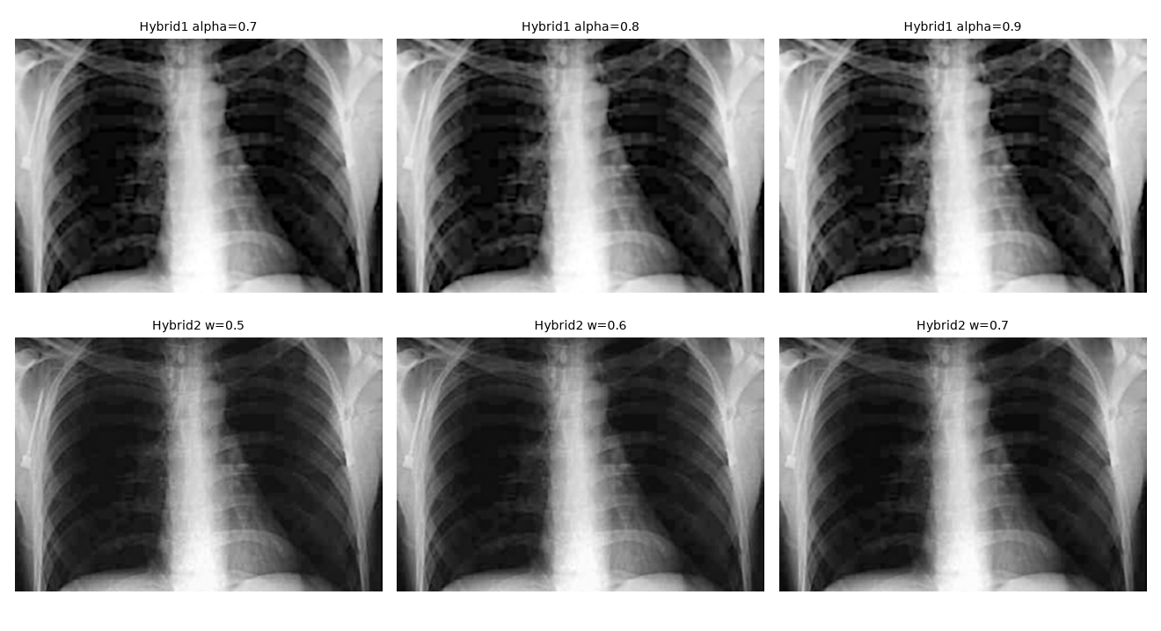
Figure 10. Chest hybrid sweep: sequential alpha and fusion weight w.
Comment: Alpha 0.8 gives a useful compromise between the processed chest and the original tonal structure. Alpha 0.9 exposes slightly more detail but also makes contour banding more obvious. For Hybrid 2, w = 0.6 keeps the natural appearance of the spatial result while adding some Fourier sharpness.

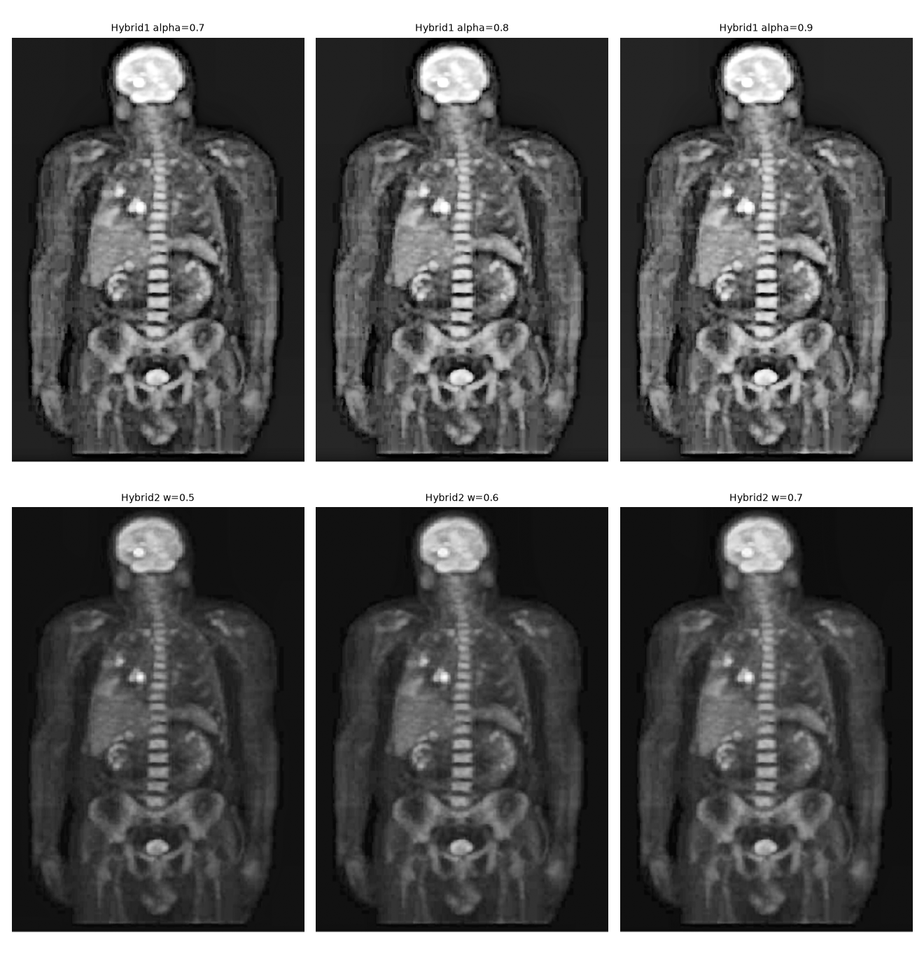
Figure 11. Skeleton hybrid sweep: sequential alpha and fusion weight w.
Comment: The sequential hybrid is much more aggressive on Skeleton than the fusion method. Increasing alpha toward 0.9 raises local texture and edge strength further. Alpha 0.8 was kept because it still reveals substantial anatomy without pushing the image as far into the harsh-looking regime.

7. Part (d): Comparison and Analysis

7.1 Full visual comparison
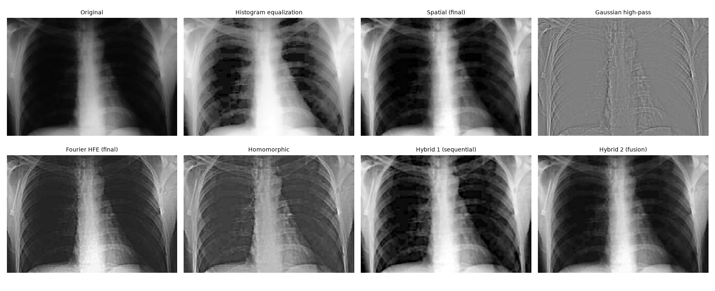
Figure 12. Chest - visual comparison of all tested outputs.
Comment: Histogram equalization strongly brightens the image but also exposes visible contour banding in the lung fields. The Gaussian high-pass is not a usable enhancement because most low-frequency tissue information is removed. Fourier HFE and homomorphic filtering sharpen structure but remain relatively flat. The spatial result is clean and natural, while Hybrid 1 gives the strongest overall visibility and Hybrid 2 is a smoother compromise.

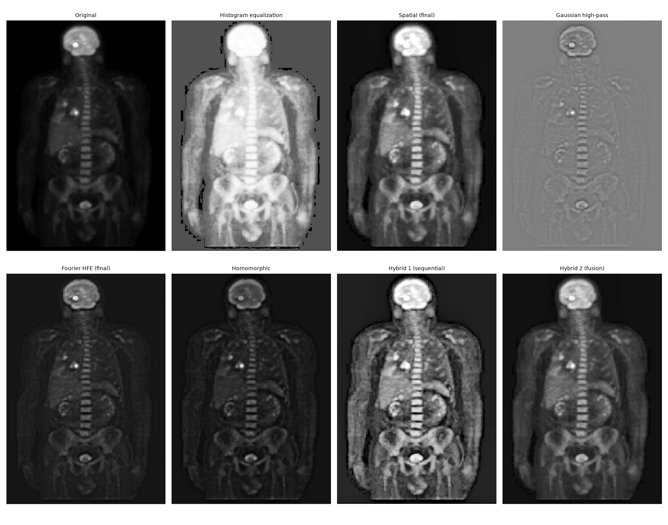
Figure 13. Skeleton - visual comparison of all tested outputs.
Comment: The skeleton case makes the trade-off clearer. Histogram equalization lifts the background and clips bright regions. Pure Fourier HFE keeps the background dark but does not reveal enough low-contrast anatomy. The spatial output gives the best natural balance. Hybrid 1 reveals the most structure but looks grainier/stronger, whereas Hybrid 2 is smoother and more conservative.

7.2 Quantitative results - Chest
Method | Contrast (std) | Entropy | Tenengrad | Noise sigma | Median ms
Original | 0.2197 | 6.8044 | 0.0452 | 0.0006 | -
Histogram equalization | 0.2803 | 6.5900 | 0.0833 | 0.0015 | 1.33
Spatial (final) | 0.2898 | 7.6901 | 0.0808 | 0.0017 | 14.30
Gaussian high-pass | 0.0396 | 5.0785 | 0.1015 | 0.0021 | 83.84
Fourier HFE (final) | 0.2239 | 6.9564 | 0.0909 | 0.0016 | 96.15
Homomorphic | 0.1640 | 6.8830 | 0.1079 | 0.0019 | 85.97
Hybrid 1 (sequential) | 0.2994 | 7.8229 | 0.1032 | 0.0014 | 107.17
Hybrid 2 (fusion) | 0.2608 | 7.4725 | 0.0806 | 0.0013 | 111.41
For Chest, the final spatial pipeline increases global contrast by 31.9% and entropy by 13.0% relative to the original. Hybrid 1 increases contrast by 36.3% and entropy by 15.0%, while Tenengrad rises by 128.0%. Its estimated noise rises by 145.4%, which is the smallest increase of the three final methods: it stays below both the Fourier-only HFE (+189.3%) and the final spatial pipeline (+206.1%). These percentages look large only because the source BMP is already very clean (sigma = 0.0006); in absolute terms all three stay at or below 0.0017. This combination explains why Hybrid 1 performs well both visually and numerically on Chest.
The Fourier HFE result more than doubles the Tenengrad edge-strength measure (+100.9%) but improves global contrast by only 1.9%. This demonstrates that edge enhancement and overall visibility are not the same objective. The Gaussian high-pass is the clearest example: it raises edge measures while reducing contrast by 82.0% and entropy by 25.4%, producing an edge-only appearance.

7.3 Quantitative results - Skeleton
Method | Contrast (std) | Entropy | Tenengrad | Noise sigma | Median ms
Original | 0.1092 | 5.1092 | 0.0410 | 0.0008 | -
Histogram equalization | 0.2385 | 4.9495 | 0.1257 | 0.0037 | 1.48
Spatial (final) | 0.2067 | 6.4947 | 0.1027 | 0.0015 | 13.55
Gaussian high-pass | 0.0290 | 3.9829 | 0.0536 | 0.0015 | 46.39
Fourier HFE (final) | 0.0769 | 4.9053 | 0.0580 | 0.0014 | 57.17
Homomorphic | 0.0679 | 5.0183 | 0.0680 | 0.0016 | 52.52
Hybrid 1 (sequential) | 0.2080 | 6.9377 | 0.1679 | 0.0023 | 74.92
Hybrid 2 (fusion) | 0.1524 | 6.1413 | 0.0828 | 0.0011 | 71.26
For Skeleton, the spatial method increases contrast by 89.4% and entropy by 27.1%, while Tenengrad rises by 150.3%. The final image still keeps a dark background and readable anatomy, so this is a strong practical result. Hybrid 1 produces even larger numerical gains: +90.5% contrast, +35.8% entropy and +309.2% Tenengrad. However, its estimated noise also increases by about 194.6% and Canny edge density becomes much larger, which matches the visibly stronger texture in the image.
Hybrid 2 is the conservative option for Skeleton. It increases entropy by 20.2% and Tenengrad by 101.9% with a smaller noise increase (+48.7%) than either the spatial result (+90.1%) or Hybrid 1 (+194.6%). Its visual result is smoother, but some of the local contrast gained by the spatial method is averaged away.

7.4 Histogram comparison
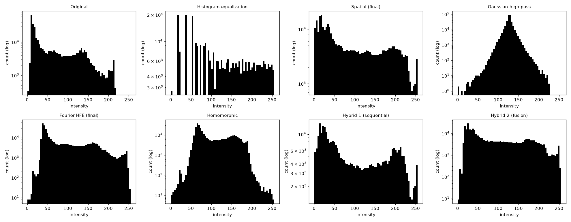
Figure 14. Chest intensity histograms for all outputs (log count scale).
Comment: The original chest histogram is concentrated toward darker values. Histogram equalization spreads levels aggressively and creates a comb-like distribution, while the Gaussian high-pass collapses around a mid-grey display level. The spatial and hybrid methods use a broader intensity range without losing the strong dark/bright separation that is useful for anatomy.

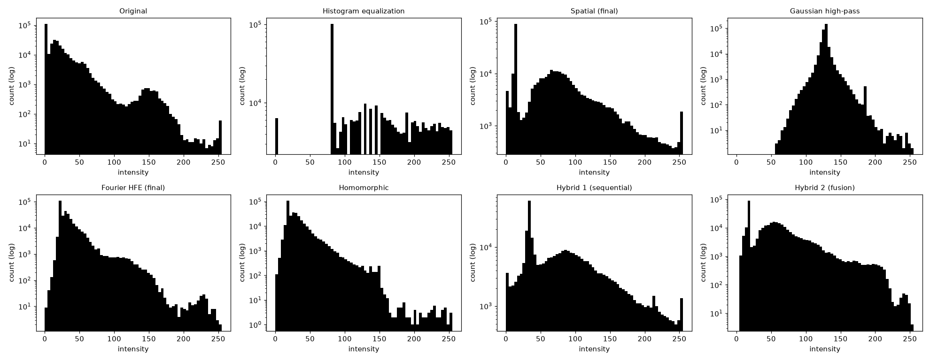
Figure 15. Skeleton intensity histograms for all outputs (log count scale).
Comment: The original skeleton has a very large dark-background population. Histogram equalization shifts a major part of this population into grey, explaining the bright background. The spatial and hybrid histograms expand useful mid-tones while still retaining a strong low-intensity component.

7.5 Zoomed-detail comparison
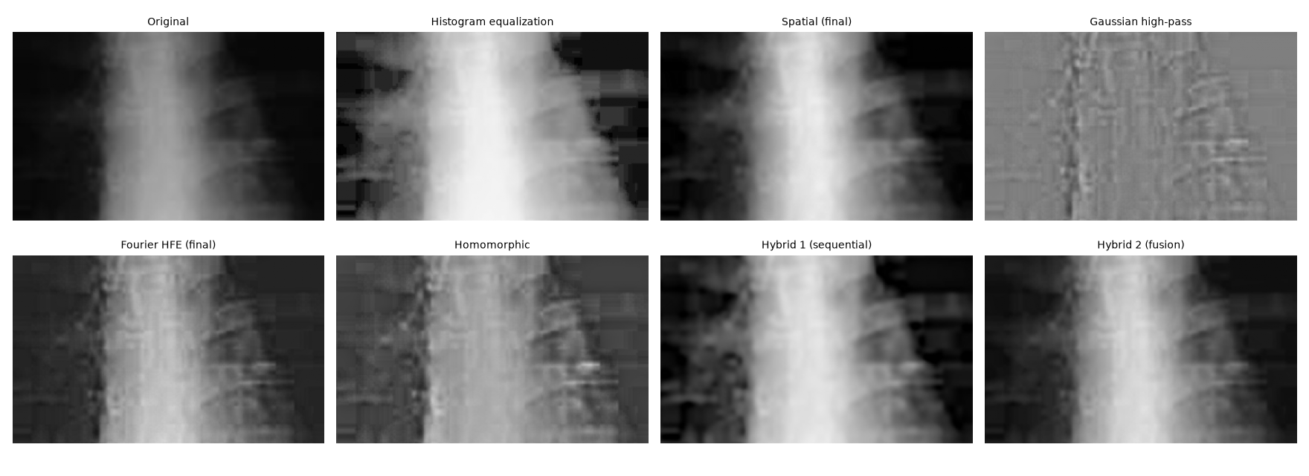
Figure 16. Chest central crop for closer inspection of edge/detail behavior.
Comment: The crop shows why the metric values must be interpreted carefully. Histogram equalization and Hybrid 1 reveal structure but also expose block boundaries. Fourier HFE gives sharper rib/vertebral edges but a flatter tissue appearance. The spatial and fusion outputs are visually smoother.

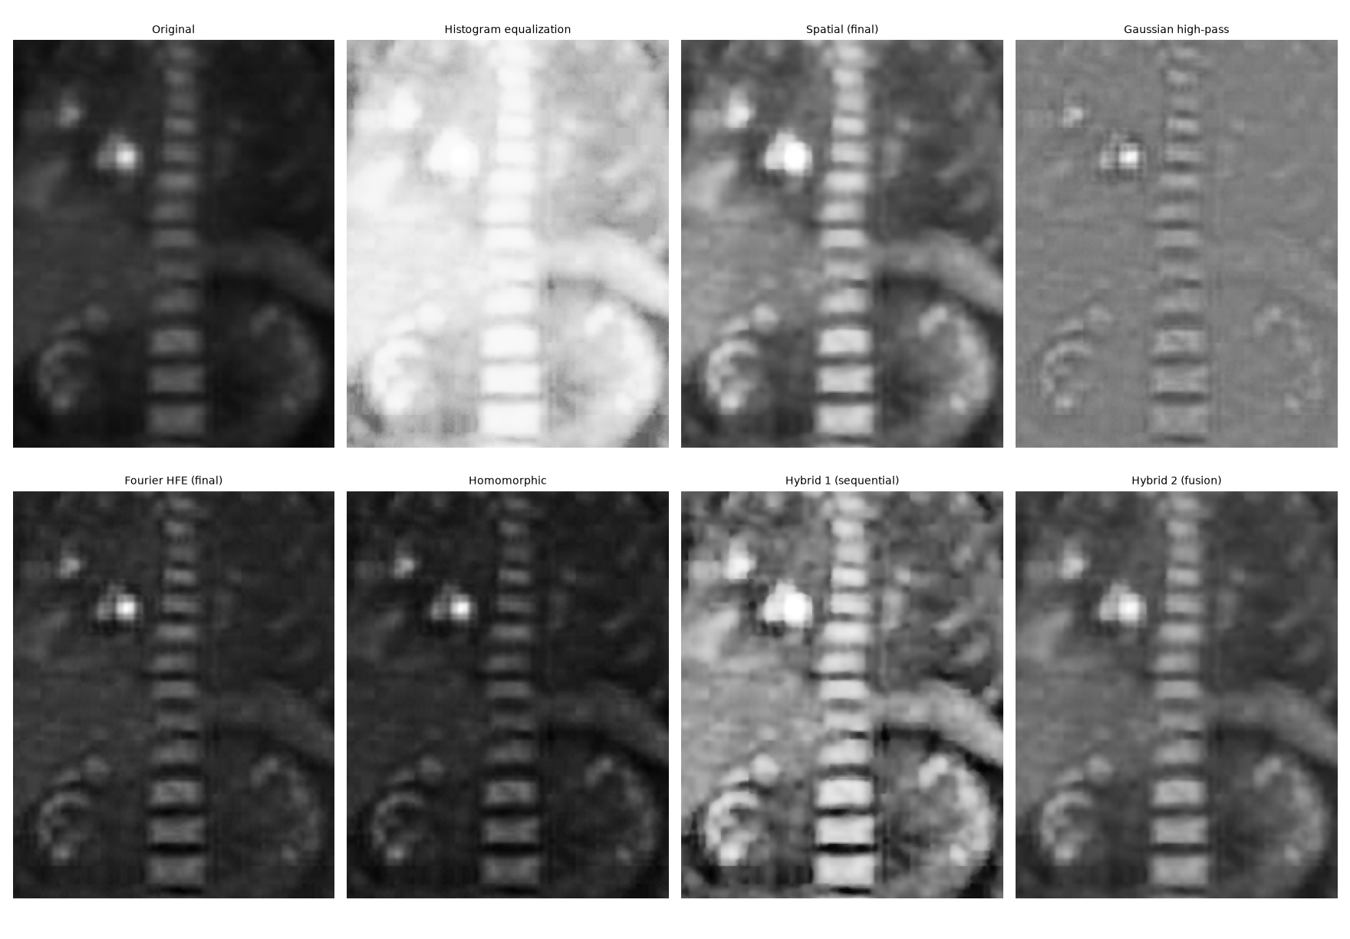
Figure 17. Skeleton central crop for closer inspection of vertebral and organ detail.
Comment: Spatial enhancement improves vertebral and organ visibility without turning the whole crop into an edge map. Hybrid 1 produces the strongest edge separation but also the most texture. Hybrid 2 gives a softer, lower-noise compromise.

7.6 Runtime comparison
Method | Chest median (ms) | Skeleton median (ms)
Histogram equalization | 1.33 | 1.48
Spatial (final) | 14.30 | 13.55
Gaussian high-pass | 83.84 | 46.39
Fourier HFE (final) | 96.15 | 57.17
Homomorphic | 85.97 | 52.52
Hybrid 1 (sequential) | 107.17 | 74.92
Hybrid 2 (fusion) | 111.41 | 71.26
Histogram equalization is by far the fastest but gives poor visual control. The final spatial pipeline is the best speed-quality compromise at about 14.30 ms for Chest and 13.55 ms for Skeleton. FFT-based methods are slower because they require padding, transforms and filter construction. Hybrid 1 is the most computationally expensive. Hybrid 2 is cheap only at the final blending step; the end-to-end time still includes computing both the spatial and Fourier source images. Absolute timings are hardware- and library-dependent; the relative ordering is the meaningful result.

7.7 Final method selection
Image | Recommended method | Why it works | Main limitation
Chest | Hybrid 1 (sequential) | Highest final-method entropy and contrast; strong anatomy visibility; noise estimate remains controlled. | Slower; faint contour banding from the source quantisation can still be seen in dark lung regions.
Chest | Spatial (final) | Very natural appearance and much faster than FFT/hybrid methods. | Slightly lower information/edge measures than Hybrid 1.
Skeleton | Spatial (final) | Best natural-looking balance of brightened anatomy, preserved dark background and acceptable noise. | Less aggressive detail than Hybrid 1.
Skeleton | Hybrid 2 (fusion) | Smooth compromise with lower estimated noise than the spatial result. | Fusion softens some local contrast.
Both | Fourier HFE (best Fourier-only) | Demonstrates controlled spectral sharpening without destroying low-frequency content. | Limited local brightness improvement, especially on Skeleton.

8. Discussion

8.1 Why histogram equalization was not selected
Histogram equalization improves brightness and edge measures very quickly, but in both images it over-remaps the intensity distribution. On Chest it exaggerates the posterisation of the dark lung field, and on Skeleton it lifts the background into grey and saturates bright regions. The entropy result also decreases slightly for both images, which is a useful reminder that a visually aggressive histogram is not automatically more informative.

8.2 Why a plain high-pass filter is not an enhancement solution by itself
The Gaussian high-pass baseline is intentionally included to show a common mistake. A high-pass filter removes the low-frequency/DC information that carries most of the image brightness and slowly varying tissue structure. The result contains edges but not a visually usable image. High-frequency emphasis fixes this by preserving a base low-frequency gain a and adding extra gain only to the higher frequencies.

8.3 Metrics versus visual quality
The Skeleton Hybrid 1 result has the strongest Tenengrad and entropy, but it is not automatically the best final image. Its edge density and noise estimate also rise sharply. In contrast, the final spatial image gives slightly weaker numerical enhancement but a cleaner appearance. For this reason, the final ranking uses the metrics as evidence rather than as an automatic objective function.

8.4 Artifact control and implementation choices
- Reflect padding in the Fourier functions reduces the discontinuity between opposite image borders and therefore reduces wrap-around artifacts.
- A smooth Butterworth transition was preferred over a hard ideal cutoff to reduce ringing.
- CLAHE clip limits were kept low because stronger local equalization amplified texture/noise.
- Chest uses light pre-smoothing because local contrast enhancement exposes the coarse intensity quantisation of the source data as posterisation. Chest.bmp stores an 8-bit palette of only 219 grey levels, and just about 20 distinct levels fall in the darkest 40% of the image (Skeleton.bmp: about 9), so CLAHE stretches those few levels into wide flat plateaus.
- Unsharp parameters were deliberately moderate to avoid halos around strong bone boundaries.
- Hybrid blending with the original provides a simple safeguard against over-processing.

8.5 Limitations
The study has only two input images, so the selected parameters should not be treated as universal medical-image settings. The objective measures are no-reference indicators and can reward both useful structure and unwanted high-frequency noise. A stronger evaluation would include more images, a task-specific observer study, and potentially anatomical-region analysis. The goal here is image visibility for the assignment, not clinical diagnosis.

9. Conclusion
The experiments demonstrate that spatial and Fourier enhancement solve different parts of the visibility problem. Spatial processing is very effective for local contrast and dark-tone recovery, especially when gamma correction and CLAHE are combined with controlled denoising and sharpening. Fourier HFE is effective for strengthening edges while preserving low-frequency content, but by itself it cannot match the local tone adjustment of the spatial pipeline on very dark data.
For Chest, the sequential hybrid gives the strongest overall result: it reaches the highest contrast and entropy among the final methods while maintaining a relatively low noise estimate. The final spatial result is a close second and is much faster. For Skeleton, the spatial method is the preferred final output because it reveals the anatomy clearly while keeping the background dark and avoiding the stronger texture introduced by Hybrid 1. Hybrid 2 is useful when a smoother compromise is preferred.
The most important conclusion is that enhancement quality should be judged from several viewpoints at once. A method that maximizes edge strength can easily amplify noise or destroy low-frequency structure. The best result therefore comes from combining visual inspection, histogram behavior, objective measures, artifact analysis and computation time.

10. References
[1] R. C. Gonzalez and R. E. Woods, Digital Image Processing, 4th ed., Pearson, 2018.
[2] K. Zuiderveld, “Contrast Limited Adaptive Histogram Equalization,” in Graphics Gems IV, Academic Press, 1994, pp. 474-485.
[3] A. V. Oppenheim and R. W. Schafer, Discrete-Time Signal Processing, 3rd ed., Pearson, 2010.
[4] J. Immerkær, “Fast Noise Variance Estimation,” Computer Vision and Image Understanding, vol. 64, no. 2, pp. 300-302, 1996.
[5] J. Canny, “A Computational Approach to Edge Detection,” IEEE Transactions on Pattern Analysis and Machine Intelligence, vol. PAMI-8, no. 6, pp. 679-698, 1986.
[6] OpenCV, Image Processing documentation (histogram equalization, CLAHE, bilateral filtering, Sobel and Canny), https://docs.opencv.org/.

