**Q.1 CLO: 1; Bloom Taxonomy Level: [5]**

**Consider distributing a file of F = 20 Gbits to N peers. The server has an upload rate of us = 30 Mbps, and each peer has a download rate of di = 2 Mbps and an upload rate of u. For N = 10, 100, and 1,000 and u = 300 Kbps, 700 Kbps, and 2 Mbps, prepare a chart giving the minimum distribution time for each of the combinations of N and u for both clientserver distribution and P2P distribution.**

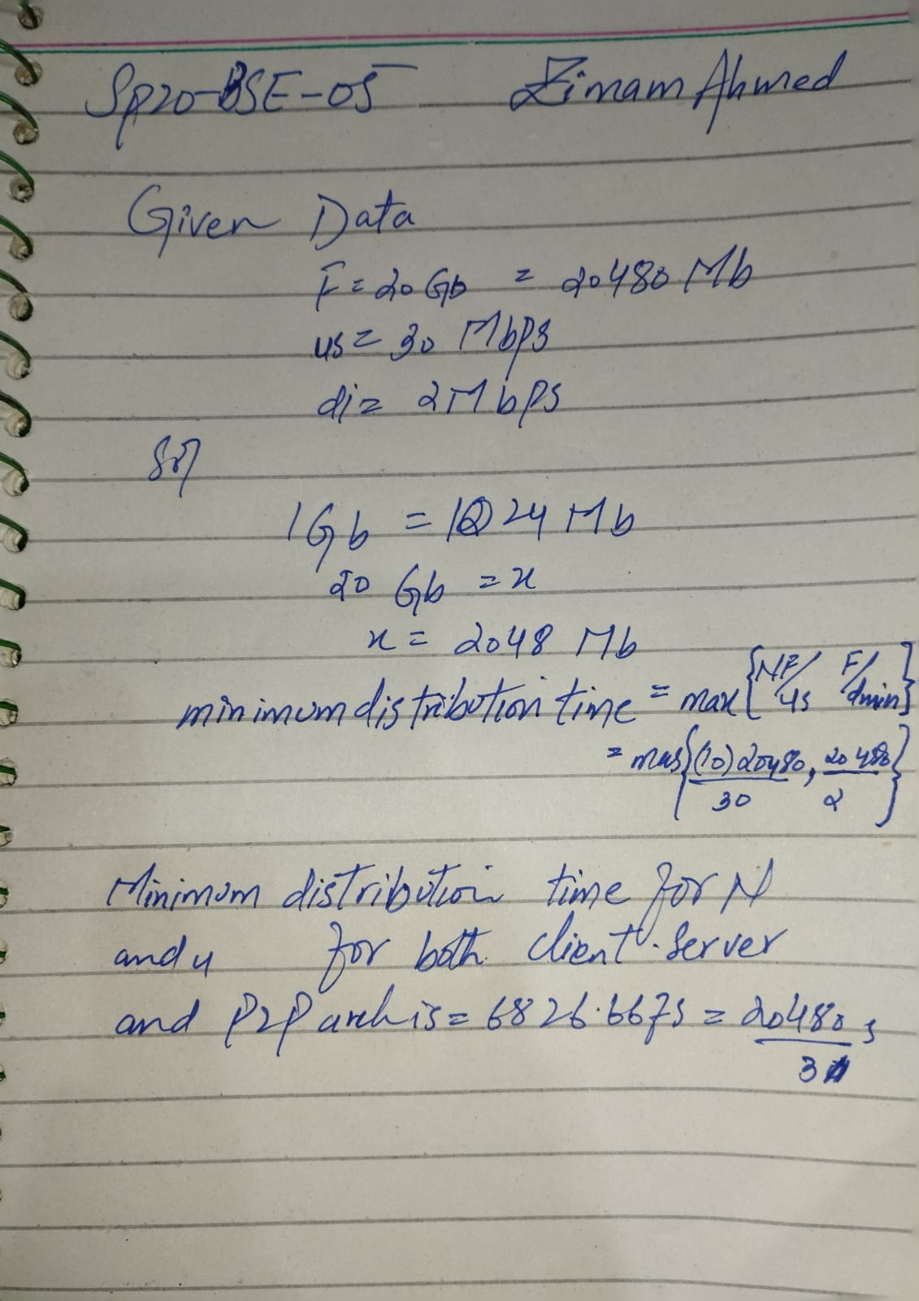

**Q.2 CLO: 1; Bloom Taxonomy Level: [5]**

**Consider an e-commerce site that wants to keep a purchase record for each of its customers.Describe how this can be done with cookies.**

Ans:

when a client at visits a web site, the server creates a unique identification number which enters into the database, and afterward returns it as a cookie number. The browser controls this cookie number, which is kept on the client's host. The browser communicates the cookie number back to the website with each transaction.

**Q.3 CLO: 1; Bloom Taxonomy Level: [5]**

**Describe how Web caching can reduce the delay in receiving a requested object. Will Web caching reduce the delay for all objects requested by a user or for only some of the objects?Why?**

Web caching:

* Web caching is the temporary storing of files like photos, videos, and HTML pages to save bandwidth.
* It responds to queries made by users' browsers that may be sent to the origin server and saves the same content in cache files.
* The copies of the client-requested objects are stored in the web cache.

Examples of how web caching speeds up delivery of requested objects:

* When the bottleneck bandwidth between the client and the server is substantially lower than the bottleneck bandwidth between the client and the cache, web caching can speed up the response time to a client's request.
* If the cache memory size is large, it can swiftly handle lots of requests. As a result, response time is shortened.
* Lastly, there is a significant overall decline in internet traffic. As a result, web caching shortens the time it takes to receive all the user's requested objects.

**Q.4 CLO: 1; Bloom Taxonomy Level: [5]**

**TCP can be enhanced with TLS to provide process-to-process security services, including encryption. Does TLS operate at the transport layer or the application layer? If the applicationdeveloper wants TCP to be enhanced with TLS, what does the developer have to do?**

Between the TCP/IP layer and the application protocol layer, where they can secure and deliver application data to the transport layer, exist the TLS protocol. TLS can support a variety of application layer protocols since they operate between the application layer and the transport layer. At the application layer, TLS functions. Data from the application layer that isn't encrypted is taken by the TLS socket, encrypted, and then passed to the TCP socket. The application developer must add the TLS code in the application if developer wants TCP to benefit from TLS.