**Q1:**

2. **Cyclomatic Complexity:** E-N+2 = 14-14+2 = 2
3. **Path Coverage:**

Path 1: 1-2-3-4-5-6-12-13-14

Path 2: 1-2-3-7-8-9-10-11-13-14

2/2*100 =100%

1. **Statement Coverage:**

Let record field 1 =1

And record field 2 = 2

Then statement coverage is

7/14*100 =50%

**Q2:**

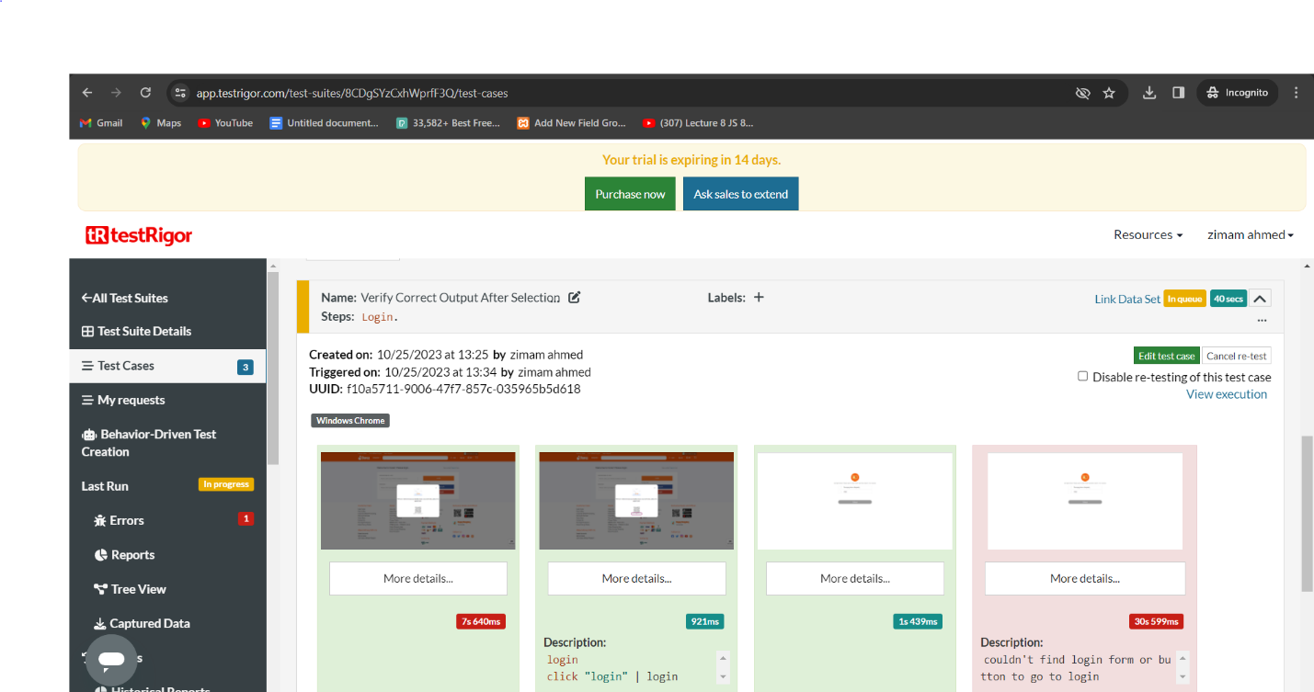

**Q3:**

**A: Equivalence class portioning:**

|  |  |  |  |  |
| --- | --- | --- | --- | --- |
| **Inputs** | **0-300** | **301-600** | **601-1000** | **Value>1000** |
| 100 | 9/kh |  |  |  |
| 400 |  | 8/kh |  |  |
| 800 |  |  | 6/kh |  |
| 1500 |  |  |  | 5/kh |
| -10 | NA |  |  |  |
| 3000 |  |  |  | 5/kh |

**B: Boundary Values:**

|  |  |  |  |  |
| --- | --- | --- | --- | --- |
| **Boundary values** | **0-300** | **301-600** | **601-1000** | **Value>1000** |
| -1-300 | 9/kh |  |  |  |
| 301-600 |  | 8/kh |  |  |
| 601-1000 |  |  | 6/kh |  |
| 1001-2001 |  |  |  | 5/kh |

**C: Decision Table:**

|  |  |  |  |
| --- | --- | --- | --- |
| **inputs** | **Actual result** | **Expected result** | **Decision** |
| -1 | NA | Na | Fail |
| 0-300 | 9/kh | 9/kh | pass |
| 301-600 | 8/kh | 8/kh | pass |
| 601-1000 | 6/kh | 6/kh | Pass |
| 1001-2001 | 5/kh | 6/kh | pass |