Pinout to telescope from UART

|  |  |  |  |  |  |  |  |  |
| --- | --- | --- | --- | --- | --- | --- | --- | --- |
| RJ45 | 1 | 2 | 3 | 4 | 5 | 6 | 7 | 8 |
| RJ11 RPi |  |  | 1 | 2 | 3 | 4 | 5 | 6 |
| Signal |  |  |  | GND | Rx | Tx | 12V |  |
| Cable color |  |  | Brown | Red | Yellow | Green | blue |  |

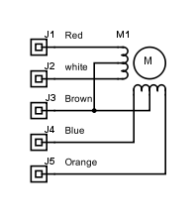140 Ohm per spoel

Software:

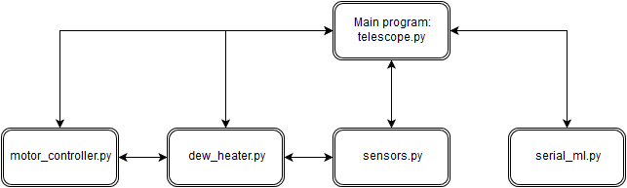

Software for GPIO for encoder: http://abyz.co.uk/rpi/pigpio/index.html