1. download docker toolbox and install

https://github.com/docker/toolbox/releases/download/v1.12.0/DockerToolbox-1.12.0.exe

Check:

docker-machine ls

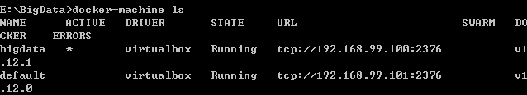

2. install python 2.7.10

https://www.python.org/ftp/python/2.7.10/python-2.7.10.msi

Check:

python --version



3. install pip

create new file:

get-pip.py

https://bootstrap.pypa.io/get-pip.py

Check:

pip –version



4. download scala and install

http://www.runoob.com/scala/scala-install.html

Check:

scala –version



5. download sbt and install

http://www.scala-sbt.org/0.13/docs/zh-cn/Installing-sbt-on-Windows.html

Check:

sbt sbtVersion

Everything set up!



6. create virtual machine from virtual box and play with it

Please refer to the latest slices of August 21.