1. DockerToolBox:

<https://www.google.com/url?sa=t&rct=j&q=&esrc=s&source=web&cd=1&ved=0ahUKEwjGr83U29jOAhUIxmMKHYOSB4gQFggcMAA&url=https%3A%2F%2Fwww.docker.com%2Fproducts%2Fdocker-toolbox&usg=AFQjCNE88HV6oVoN12vorIR9ScMJw9THGQ&sig2=4HHewEdB4qdKOEEFTbc8nQ&bvm=bv.129759880,d.cGc>

Download DockerToolBox via the link above. Choose mac version. Then double click the icon to start installation. Check installation successful by typing docker version in terminal.

1. Install python:
   1. Install homebrew on mac first:

Go to this site <http://brew.sh/> to install homebrew first.

* 1. Then do “brew install python”, python will be installed on your machine.
  2. Do “Python”:

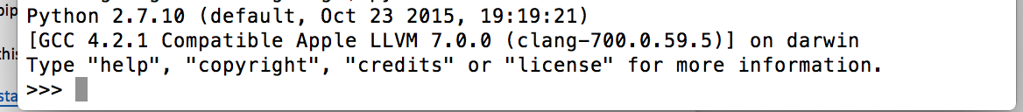

This means the installation succeeds.

1. Install pip:

Check this thread:

<http://stackoverflow.com/questions/17271319/installing-pip-on-mac-os-x>

First two answers are to answer the installation with and without brew.

Do “pip”:

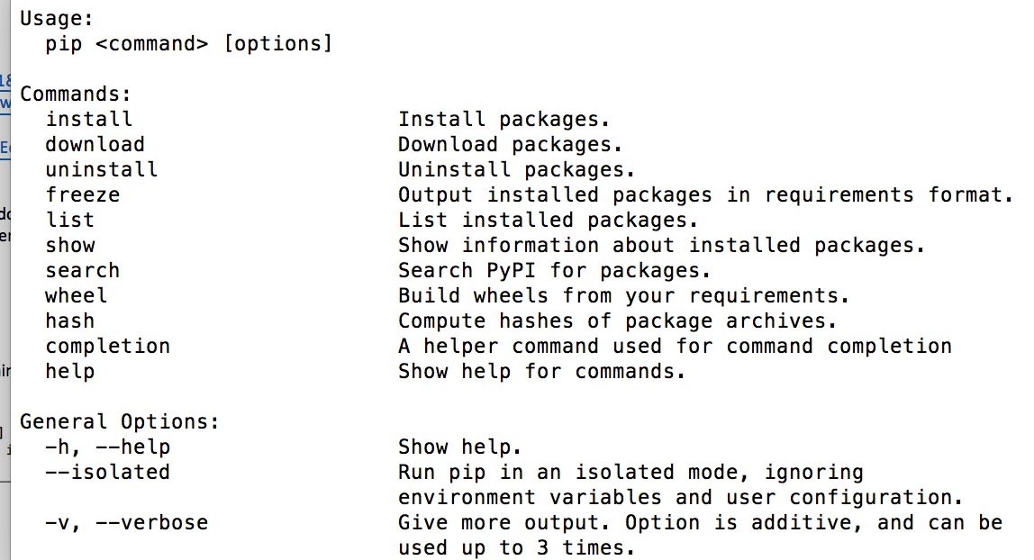

This means installation succeeds.

1. Install scala:

Do “brew install scala” to install scala on your machine.

Do “scala”:

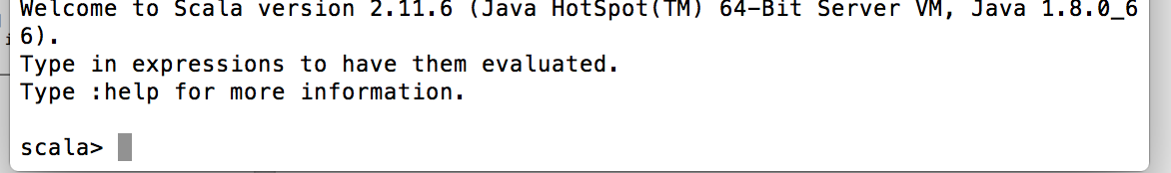

This means installation succeeds.

1. Install sbt:

Do “brew install sbt” to install sbt on your machine.

Do “sbt”:

[info] Set current project to “USER NAME” (in build file:/Users/USERNAME)

>