TECHNICAL PROJECT REPORT
Satellite-Based Land-Cover Classification
A Deep Learning Approach Using Sentinel-2 Satellite Imagery and ResNet-18

Submitted by:
Zimran Sohail
Institution:
Superior University
Programme:
Bachelor of Science in Computer Science

ABSTRACT
Land-cover classification is an important application of remote sensing and computer vision. It involves identifying the physical characteristics of the Earth's surface, such as forests, agricultural areas, urban settlements, bare land, and water bodies. Accurate land-cover information can support environmental monitoring, urban planning, agricultural assessment, and natural resource management.
This project presents a deep learning-based approach to classifying satellite image patches into five land-cover categories using Sentinel-2 imagery and transfer learning. The dataset consists of 2,500 RGB satellite image patches, with 500 samples per class. The imagery uses Sentinel-2 bands B4 (red), B3 (green), and B2 (blue), which have a native spatial resolution of 10 metres. The corresponding land-cover labels are derived from the European Space Agency's (ESA) WorldCover product.
Three dataset configurations were prepared: 64×64, 128×128, and 128×128 aligned. The aligned configuration enables comparisons between image sizes while preserving the same geographic locations and data splits. A ResNet-18 architecture was evaluated under three configurations: training from scratch, using a frozen pretrained feature extractor, and fine-tuning a pretrained model.
The best-performing configuration was the fine-tuned pretrained ResNet-18 model, which achieved 97.00% test accuracy on the aligned 128×128 dataset, correctly classifying 356 out of 367 test images. It also achieved a macro F1-score of 96.94%. These results demonstrate the effectiveness of transfer learning for the selected land-cover classification task.
Finally, a Streamlit-based web application was developed to provide an accessible interface for testing the trained classification model.
Keywords: Remote Sensing, Land-Cover Classification, Sentinel-2, Deep Learning, Transfer Learning, ResNet-18, Computer Vision, ESA WorldCover.
TABLE OF CONTENTS
ABSTRACT 1
1. INTRODUCTION 1
1.1 Background 1
1.2 Problem Statement 1
1.3 Project Objectives 1
1.4 Scope 1
2. BACKGROUND AND RELATED CONCEPTS 1
2.1 Remote Sensing 1
2.2 Sentinel-2 Satellite Imagery 1
2.3 ESA WorldCover 1
2.4 Convolutional Neural Networks 1
2.5 ResNet-18 1
2.6 Transfer Learning 1
3. DATASET DESCRIPTION 1
3.1 Dataset Overview 1
3.2 Land-Cover Categories 1
3.2.1 Tree Cover 1
3.2.2 Cropland 1
3.2.3 Built-up 1
3.2.4 Bare / Sparse Vegetation 1
3.2.5 Permanent Water 1
3.3 Dataset Preparation and Sampling 1
3.4 Dataset Configurations 1
3.5 Dataset Splitting 1
4. METHODOLOGY 1
4.1 Overall Workflow 1
4.2 Image Representation 1
4.3 Model Architecture 1
4.4 Model Training Configurations 1
4.4.1 ResNet-18 Trained from Scratch 1
4.4.2 Frozen Pretrained ResNet-18 1
4.4.3 Fine-Tuned Pretrained ResNet-18 1
4.5 Evaluation Metrics 1
Accuracy 1
Precision 1
Recall 1
F1-Score 1
Macro F1-Score 1
Weighted F1-Score 1
5. EXPERIMENTAL RESULTS 1
5.1 Model Performance Comparison 1
5.2 Class-Wise Performance 1
5.3 Discussion of Results 1
5.4 Interpretation of Transfer Learning 1
6. APPLICATION DEVELOPMENT AND DEPLOYMENT 1
6.1 Streamlit Application 1
6.2 Application Workflow 1
6.3 Project Resources 1
7. LIMITATIONS AND FUTURE WORK 1
7.1 Limitations 1
7.1.1 Limited Number of Classes 1
7.1.2 Dataset Size 1
7.1.3 Image-Level Classification 1
7.1.4 Resampled Image Dimensions 1
7.1.5 Geographic Generalization 1
7.1.6 Reference Label Limitations 1
7.2 Future Work 1
8. CONCLUSION 1
REFERENCES 1
APPENDIX A: DATASET SPLIT DETAILS 1
APPENDIX B: FINAL MODEL METRICS 1
APPENDIX C: PROJECT LINKS 1

1. INTRODUCTION

1.1 Background
Earth observation satellites provide large amounts of imagery that can be used to study the Earth's surface. These images contain valuable information about vegetation, agricultural land, urban development, water bodies, and other geographical features.
Land-cover classification is the process of assigning a land-cover category to a geographical area based on its observed characteristics. Traditionally, this task has involved manual interpretation, rule-based methods, and conventional machine learning techniques. However, the increasing availability of satellite imagery has created opportunities for automated approaches.
Deep learning, particularly convolutional neural networks (CNNs), has become an important technique for image classification. CNNs can automatically learn visual patterns and hierarchical features from images, reducing the need for manually designed feature extraction methods.
This project applies deep learning to satellite image classification using Sentinel-2 imagery. It focuses on five land-cover categories and investigates how transfer learning can improve classification performance.

1.2 Problem Statement
Satellite imagery contains complex visual patterns. Different land-cover categories may have similar colours, textures, and spatial characteristics, making automated classification challenging.
For example, bare land and built-up areas may contain similar surface colours, while different vegetation categories can share comparable visual textures. These similarities can lead to classification errors when a model relies only on basic visual features.
Developing an effective classification model therefore requires a suitable dataset, a reliable labelling approach, and a model capable of learning meaningful image representations.
The main problem addressed in this project is:
How can deep learning and transfer learning be used to accurately classify Sentinel-2 satellite image patches into selected land-cover categories?

1.3 Project Objectives
The primary objectives of this project are:
- To prepare a labelled satellite image dataset using Sentinel-2 RGB imagery and ESA WorldCover labels.
- To organize the dataset into five land-cover categories.
- To prepare multiple image-resolution configurations for experimentation.
- To investigate ResNet-18 as a deep learning architecture for satellite image classification.
- To compare training from scratch, frozen pretrained feature extraction, and pretrained fine-tuning.
- To evaluate model performance using accuracy, precision, recall, and F1-score.
- To develop a web-based application that allows users to interact with the trained classification model.

1.4 Scope
The project focuses on image-level classification of satellite image patches. Each input image is assigned one of five predefined land-cover labels.
The project does not attempt to perform pixel-level semantic segmentation, detect geographical boundaries, or produce a complete land-cover map. Its primary purpose is to classify individual satellite image patches and demonstrate the use of transfer learning in remote sensing.

2. BACKGROUND AND RELATED CONCEPTS

2.1 Remote Sensing
Remote sensing refers to collecting information about the Earth's surface without direct physical contact. Satellite sensors capture electromagnetic radiation reflected or emitted by objects on the ground.
Different land-cover types interact with electromagnetic radiation in different ways. Vegetation, water, soil, and artificial surfaces can therefore exhibit distinct spectral characteristics.
Satellite imagery provides a practical way to observe large geographical areas and monitor changes over time.

2.2 Sentinel-2 Satellite Imagery
Sentinel-2 is an Earth observation mission developed as part of the European Union's Copernicus programme.
The dataset used in this project relies on three visible spectral bands:
Band | Colour | Native spatial resolution
B4 | Red | 10 m
B3 | Green | 10 m
B2 | Blue | 10 m

These bands are combined to create natural-colour RGB imagery.
Each image patch represents approximately 640 metres × 640 metres of ground area. The imagery therefore provides a consistent geographical context for the classification task.
The Sentinel-2 documentation identifies B02, B03, and B04 as the blue, green, and red bands respectively, each with a 10-metre ground sampling distance [1].

2.3 ESA WorldCover
ESA WorldCover is a global land-cover product developed by the European Space Agency. It provides land-cover information at approximately 10-metre resolution.
In this project, WorldCover is used as the source of reference labels for the satellite image patches.
Although the WorldCover product contains more land-cover categories, the project selects five classes for classification.
The selected class codes are:
Class code | Land-cover category
10 | Tree Cover
40 | Cropland
50 | Built-up
60 | Bare / Sparse Vegetation
80 | Permanent Water

These class codes correspond to the ESA WorldCover classification scheme [2].

2.4 Convolutional Neural Networks
Convolutional Neural Networks are deep learning models designed to process grid-like data, particularly images.
CNNs learn visual features through convolutional operations. Earlier layers typically learn relatively simple patterns, such as edges and textures, while deeper layers can represent more complex visual structures.
This hierarchical feature-learning capability makes CNNs suitable for image classification tasks.

2.5 ResNet-18
ResNet-18 is a convolutional neural network based on the residual learning architecture introduced by He et al. [3].
Residual networks use shortcut connections that allow information to pass across layers. These connections help address optimization difficulties associated with training deeper neural networks.
ResNet-18 was selected as the classification architecture for this project.

2.6 Transfer Learning
Transfer learning is a machine learning technique in which knowledge learned from one task is reused for another related task.
Instead of learning all visual features from randomly initialized parameters, a model can begin with weights learned from a large image dataset.
For this project, three ResNet-18 configurations were investigated:
- Training from scratch: The network is trained without using pretrained weights.
- Frozen pretrained model: Pretrained feature extraction layers are kept frozen while the classification component is adapted.
- Fine-tuned pretrained model: Pretrained weights are adapted to the satellite image classification task.
The purpose of these configurations is to investigate how previously learned visual representations affect classification performance.

3. DATASET DESCRIPTION

3.1 Dataset Overview
The project dataset contains 2,500 labelled satellite image patches distributed equally across five land-cover categories.
Each class contains 500 images.
Property | Description
Dataset size | 2,500 image patches
Number of classes | 5
Images per class | 500
Image source | Sentinel-2
Input bands | B4, B3, B2
Native spatial resolution | 10 metres
Label source | ESA WorldCover
Geographic coverage | Pakistan
Approximate patch footprint | 640 m × 640 m

The dataset covers sampled locations across Punjab, Sindh, and Northern Pakistan.

3.2 Land-Cover Categories
The classification task includes five categories.

3.2.1 Tree Cover
This class represents areas primarily covered by trees and forest vegetation. Such areas may exhibit characteristic vegetation patterns and textures in satellite imagery.

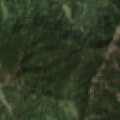
Figure 1: Example of a Tree Cover satellite image patch.

3.2.2 Cropland
Cropland represents agricultural areas used for cultivation. These regions may contain visible field boundaries, vegetation patterns, and variations in surface appearance.
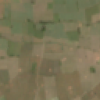
Figure 2: Example of a Cropland satellite image patch.

3.2.3 Built-up
Built-up areas include urban and constructed surfaces such as buildings, roads, and other infrastructure.
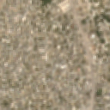
Figure 3: Example of a Built-up satellite image patch.

3.2.4 Bare / Sparse Vegetation
This category represents areas with exposed soil or limited vegetation coverage. Depending on the location, these areas may contain a mixture of soil, rock, and sparse plant cover.
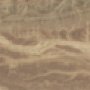
Figure 4: Example of a Bare / Sparse Vegetation satellite image patch.

3.2.5 Permanent Water
This category represents permanent water bodies, including lakes, reservoirs, and other water-covered areas.
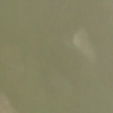
Figure 5: Example of a Permanent Water satellite image patch.

3.3 Dataset Preparation and Sampling
The dataset was prepared using Sentinel-2 imagery and ESA WorldCover labels.
A label-purity requirement of at least 70% was applied when selecting image patches. This means that a selected patch had to meet the minimum required proportion of its target land-cover category.
A minimum centre-to-centre separation of approximately 640 metres was also used during sampling. This helped reduce excessive spatial overlap between selected patches.
The approximate patch footprint is 640 m × 640 m, corresponding to the selected image coverage at the native 10-metre resolution.
Geographic grouping and a canonical split manifest were used to organize the dataset splits.

3.4 Dataset Configurations
Three dataset configurations were prepared:
Configuration | Image dimensions | Description
landcover_dataset | 64×64 | Original lower-resolution configuration
landcover_dataset_128 | 128×128 | 128×128 configuration
landcover_dataset_128_aligned | 128×128 | 128×128 configuration aligned with the 64×64 dataset

The aligned configuration is particularly important because it preserves the same geographic locations, labels, sampling regions, geographic groups, and data splits as the 64×64 configuration.
This allows comparisons between the two image dimensions without changing the underlying geographic sample selection.
It is important to clarify that the 128×128 images are resampled outputs. They do not introduce additional native spatial detail. The original imagery remains at a native spatial resolution of 10 metres.
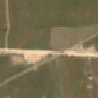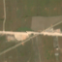
Figure 6: Comparison of the same geographical sample at 64×64(left) and 128×128(right) dimensions.

3.5 Dataset Splitting
The dataset was divided into training, validation, and testing subsets.
The three configurations have the following splits:
Dataset configuration | Training | Validation | Testing | Total
64×64 | 1,766 | 367 | 367 | 2,500
128×128 | 1,749 | 375 | 376 | 2,500
128×128 aligned | 1,766 | 367 | 367 | 2,500

The training set is used to fit the model, the validation set is used to monitor model performance during development, and the test set is used for final evaluation.
The aligned 128×128 configuration uses the same split structure and geographic samples as the 64×64 configuration.

4. METHODOLOGY

4.1 Overall Workflow
The project follows a pipeline that begins with satellite imagery and reference land-cover labels and ends with a deployed image-classification application.
The major stages are:
- Satellite imagery acquisition and preparation.
- Reference label association using ESA WorldCover.
- Image patch selection and dataset organization.
- Dataset splitting and resolution configuration.
- ResNet-18 model development.
- Model evaluation.
- Web application development.

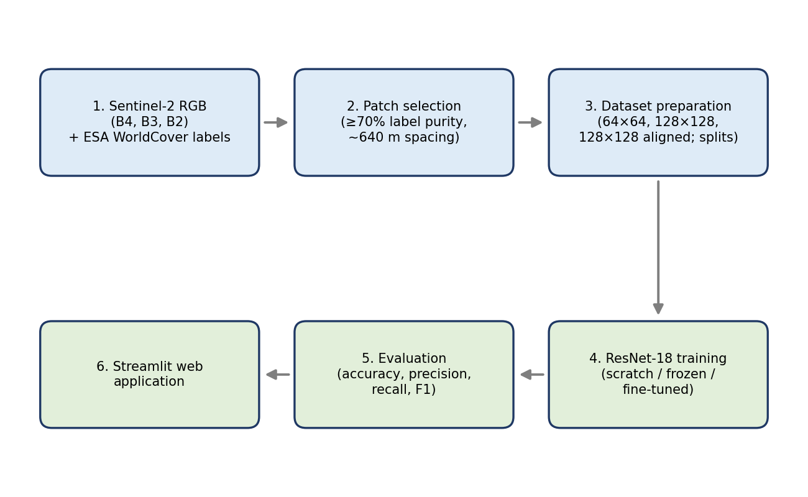
Figure 7: Overall project workflow.

4.2 Image Representation
The model receives RGB satellite image patches as input.
The RGB channels correspond to Sentinel-2 bands B4, B3, and B2.
The selected image dimensions depend on the dataset configuration being evaluated.
The classification task can be represented as:
f(X) → ŷ
where:
- X represents an input satellite image patch.
- f represents the trained classification model.
- ŷ represents the predicted land-cover category.
The model produces a prediction belonging to one of the five predefined classes.

4.3 Model Architecture
ResNet-18 was selected as the primary model architecture.
It is a convolutional neural network containing residual connections. These connections allow the network to learn residual functions and support the optimization of deeper architectures.
The architecture extracts visual features from the input image and uses a classification component to produce predictions for the five land-cover categories.
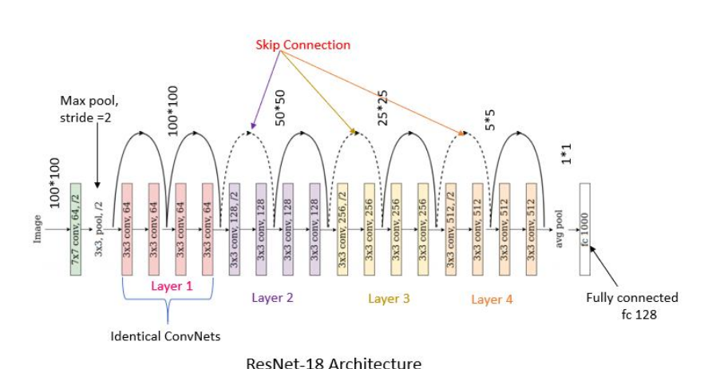
Figure 8: ResNet-18 architecture overview.

4.4 Model Training Configurations
Three model configurations were evaluated.

4.4.1 ResNet-18 Trained from Scratch
In the first configuration, ResNet-18 was trained without using pretrained weights.
The model had to learn the visual representations required for the satellite image classification task from the project dataset.
This configuration provides a baseline for evaluating the effectiveness of pretrained representations.

4.4.2 Frozen Pretrained ResNet-18
In the second configuration, pretrained weights were used to initialize the model.
The pretrained feature extraction layers were frozen, while the classification component was adapted to the five target classes.
This approach allows the model to reuse previously learned image features without updating all network parameters during training.

4.4.3 Fine-Tuned Pretrained ResNet-18
In the third configuration, a pretrained ResNet-18 model was fine-tuned for the satellite image classification task.
Unlike the frozen configuration, fine-tuning allows pretrained network parameters to be adapted to the characteristics of the target dataset.
This configuration achieved the highest test accuracy among the three evaluated approaches.

4.5 Evaluation Metrics
The models were evaluated using classification metrics.

Accuracy
Accuracy measures the proportion of correctly classified samples among all evaluated samples.
Accuracy = Number of Correct Predictions ÷ Total Predictions

Precision
Precision measures how many predictions assigned to a particular class were correct.
Precision = TP ÷ (TP + FP)

Recall
Recall measures how many actual samples belonging to a class were correctly identified.
Recall = TP ÷ (TP + FN)

F1-Score
The F1-score is the harmonic mean of precision and recall.
F1 = 2 × (Precision × Recall) ÷ (Precision + Recall)

Macro F1-Score
Macro F1 calculates the F1-score independently for each class and then averages the class scores equally.

Weighted F1-Score
Weighted F1 calculates the average F1-score while accounting for the number of samples in each class.

5. EXPERIMENTAL RESULTS

5.1 Model Performance Comparison
The three ResNet-18 configurations were evaluated on the aligned 128×128 dataset.
The results are summarized below.
Model configuration | Best validation accuracy | Test accuracy
ResNet-18 trained from scratch | 92.80% | 95.10%
Frozen pretrained ResNet-18 | 95.37% | 95.37%
Fine-tuned pretrained ResNet-18 | 95.91% | 97.00%

The fine-tuned pretrained model achieved the highest test accuracy of 97.00%.
Out of 367 test samples, it correctly classified 356 images.
This indicates that fine-tuning the pretrained model was the most effective of the three evaluated configurations on this dataset.
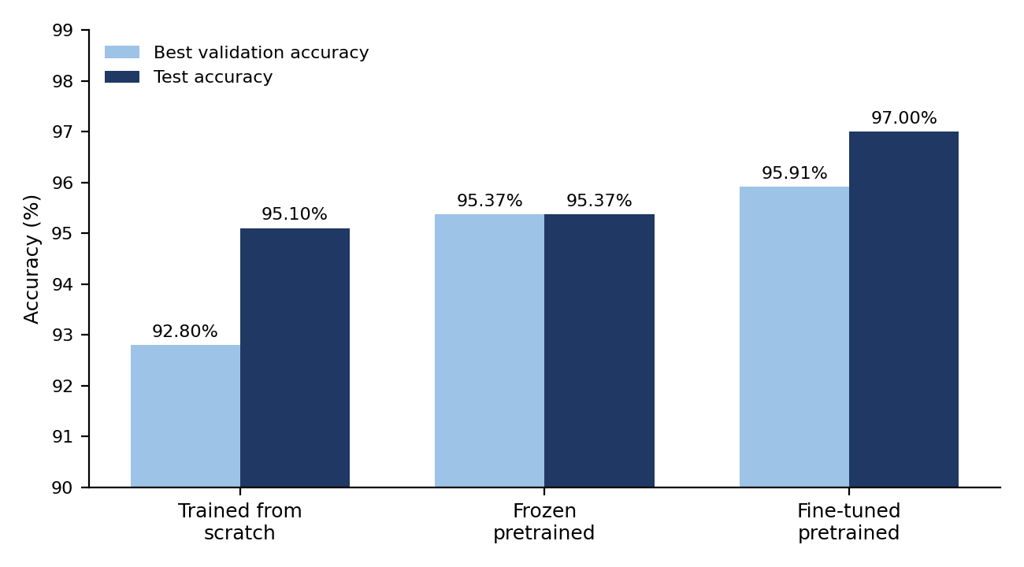
Figure 9: Comparison of model performance (validation and test accuracy). Note: the y-axis starts at 90%.

5.2 Class-Wise Performance
The fine-tuned pretrained ResNet-18 model was also evaluated using class-wise precision, recall, and F1-score.
Land-cover class | Precision | Recall | F1-score
Bare / Sparse Vegetation | 97.50% | 100.00% | 98.73%
Built-up | 98.55% | 100.00% | 99.27%
Cropland | 91.78% | 95.71% | 93.71%
Permanent Water | 98.73% | 97.50% | 98.11%
Tree Cover | 98.48% | 91.55% | 94.89%

The model achieved a macro F1-score of 96.94% and a weighted F1-score of 97.00%.

5.3 Discussion of Results
The results show that all three evaluated configurations achieved strong classification performance.
The model trained from scratch achieved 95.10% test accuracy. The frozen pretrained configuration achieved 95.37%, while the fine-tuned pretrained model achieved 97.00%.
The fine-tuned model therefore outperformed the other configurations in terms of test accuracy.
The class-wise results also reveal differences in classification performance.
Built-up areas achieved an F1-score of 99.27%, while Bare / Sparse Vegetation achieved 98.73%. Permanent Water achieved 98.11%, and Tree Cover achieved 94.89%.
Cropland achieved the lowest class-wise F1-score at 93.71%. This suggests that Cropland was comparatively more challenging for the model to distinguish from the other categories.
Tree Cover achieved a high precision of 98.48% but a lower recall of 91.55%. This indicates that predictions assigned to Tree Cover were generally reliable, although some actual Tree Cover samples were classified as other categories.
The results demonstrate that the fine-tuned model performs well across all five categories, although some classes remain more challenging than others.

5.4 Interpretation of Transfer Learning
The comparison between the three configurations provides evidence of the value of pretrained representations for this classification task.
The frozen pretrained model achieved slightly higher test accuracy than the model trained from scratch. The fine-tuned pretrained model achieved the strongest result.
This suggests that previously learned visual representations can provide a useful starting point for satellite image classification, while adapting those representations to the target dataset can further improve performance.
The experiment does not establish that transfer learning will always outperform training from scratch. The findings are limited to the dataset and configurations evaluated in this project.

6. APPLICATION DEVELOPMENT AND DEPLOYMENT

6.1 Streamlit Application
A web-based application was developed using Streamlit to make the trained classification model accessible through a graphical interface.
The application allows users to interact with the image classification system without directly executing model-training code.
The deployed application uses the fine-tuned 128×128 model weights stored in the project's GitHub repository.
Application URL: https://satellite-landcover-classifier.streamlit.app/

6.2 Application Workflow
The application follows a straightforward prediction workflow:
- The user provides a satellite image.
- The image is prepared for model input.
- The trained classification model processes the image.
- The model generates a predicted land-cover category.
- The application displays the prediction.
The application demonstrates how the trained model can be integrated into a usable software interface.
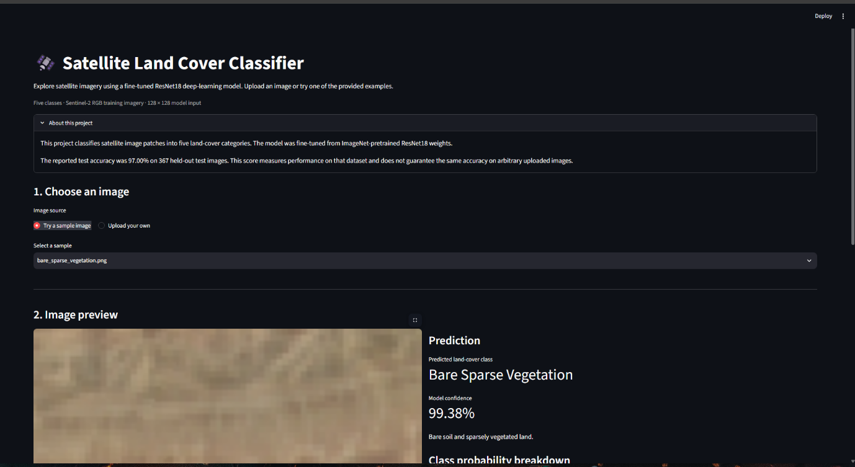
Figure 10: Streamlit application interface.
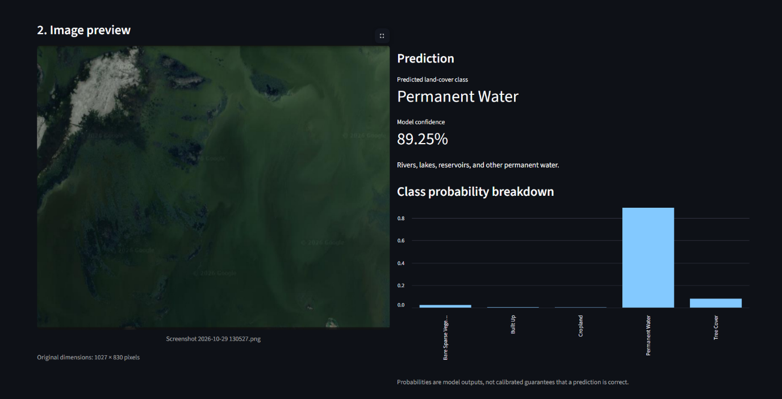
Figure 11: Example classification result.

6.3 Project Resources
The project is supported by the following resources:
Resource | Link
GitHub repository | https://github.com/ZimranSohail/Land-Cover-Classifier
Kaggle dataset | https://www.kaggle.com/datasets/zimransohail/satellite-land-cover-classification
Streamlit application | https://satellite-landcover-classifier.streamlit.app/
Google Drive dataset folder | https://drive.google.com/drive/folders/1pbd0O_leqiqgH5Fl_mIwgITlKaM3ycgP?usp=sharing

7. LIMITATIONS AND FUTURE WORK

7.1 Limitations
Despite the strong classification results, the project has several limitations.

7.1.1 Limited Number of Classes
The project focuses on five land-cover categories. ESA WorldCover contains additional categories that are not included in the current classification task.
Extending the dataset to cover more land-cover categories could increase the range of applications.

7.1.2 Dataset Size
The dataset contains 2,500 image patches. Although the dataset is balanced across the five classes, a larger dataset could provide additional geographical and visual diversity.

7.1.3 Image-Level Classification
The current model predicts one land-cover category for an entire image patch.
It does not identify the precise location of individual land-cover types within an image. Mixed land-cover patches may therefore be difficult to represent using a single label.

7.1.4 Resampled Image Dimensions
The 128×128 configuration is produced through resampling and does not contain additional native spatial detail compared with the original 10-metre imagery.
Higher pixel dimensions should therefore not be interpreted as higher satellite sensor resolution.

7.1.5 Geographic Generalization
The dataset covers sampled locations in Pakistan. Further testing would be required to determine how well the trained model performs in geographically different regions, environmental conditions, and satellite acquisition periods.

7.1.6 Reference Label Limitations
The classification labels are derived from ESA WorldCover. As with any reference land-cover product, the labels represent a mapped classification rather than direct verification of every individual image patch.
The model's predictions should therefore be interpreted in the context of the reference labels used during dataset preparation.

7.2 Future Work
Several improvements could extend the current project.
- Additional land-cover categories: Expand the classification task to include more ESA WorldCover categories.
- Larger geographical coverage: Include samples from additional regions to improve geographical diversity.
- Multispectral classification: Investigate the use of additional Sentinel-2 spectral bands beyond RGB.
- Semantic segmentation: Explore pixel-level land-cover classification instead of assigning one class to an entire image patch.
- Model comparison: Evaluate additional architectures such as ResNet-34, EfficientNet, or other suitable CNN models.
- Explainable AI: Investigate methods such as Grad-CAM to visualize which image regions contribute to model predictions.
- Application improvements: Add prediction confidence, class descriptions, and more detailed result visualization to the Streamlit application.
These improvements could make the system more comprehensive and useful for practical remote-sensing applications.

8. CONCLUSION
This project presented a deep learning-based approach to satellite land-cover classification using Sentinel-2 imagery and ESA WorldCover labels.
A dataset of 2,500 satellite image patches was prepared across five land-cover categories: Tree Cover, Cropland, Built-up, Bare / Sparse Vegetation, and Permanent Water.
Three dataset configurations were developed, including an aligned 128×128 version designed to preserve the same geographic samples and splits as the 64×64 dataset.
ResNet-18 was evaluated using three configurations: training from scratch, frozen pretrained feature extraction, and pretrained fine-tuning.
Among these configurations, the fine-tuned pretrained model achieved the best performance, with a test accuracy of 97.00% and a macro F1-score of 96.94% on the aligned 128×128 test set.
The project also demonstrated the deployment of the trained model through a Streamlit web application, making the classification system accessible through a graphical interface.
Overall, the findings demonstrate the potential of transfer learning for satellite image classification and provide a foundation for further work involving additional land-cover categories, multispectral imagery, semantic segmentation, and explainable artificial intelligence.

REFERENCES
[1] European Space Agency / Copernicus Data Space Ecosystem. “Sentinel-2 – Documentation.” https://documentation.dataspace.copernicus.eu/Data/SentinelMissions/Sentinel2.html
[2] European Space Agency. “ESA WorldCover Product User Manual, Version 2.0.” https://esa-worldcover.s3.eu-central-1.amazonaws.com/v200/2021/docs/WorldCover_PUM_V2.0.pdf
[3] K. He, X. Zhang, S. Ren, and J. Sun, “Deep Residual Learning for Image Recognition,” Proceedings of the IEEE Conference on Computer Vision and Pattern Recognition (CVPR), 2016, pp. 770–778. https://doi.org/10.1109/CVPR.2016.90

APPENDIX A: DATASET SPLIT DETAILS
The following table summarizes the number of samples used in each dataset configuration.
Configuration | Training | Validation | Testing
64×64 | 1,766 | 367 | 367
128×128 | 1,749 | 375 | 376
128×128 aligned | 1,766 | 367 | 367

The aligned 128×128 configuration shares its geographic locations and split assignments with the 64×64 configuration.

APPENDIX B: FINAL MODEL METRICS
Item | Value
Best-performing model | Fine-tuned pretrained ResNet-18
Evaluation dataset | 128×128 aligned
Test samples | 367
Correct predictions | 356
Test accuracy | 97.00%
Macro F1-score | 96.94%
Weighted F1-score | 97.00%

Class | Precision | Recall | F1-score
Bare / Sparse Vegetation | 97.50% | 100.00% | 98.73%
Built-up | 98.55% | 100.00% | 99.27%
Cropland | 91.78% | 95.71% | 93.71%
Permanent Water | 98.73% | 97.50% | 98.11%
Tree Cover | 98.48% | 91.55% | 94.89%

APPENDIX C: PROJECT LINKS
- GitHub: https://github.com/ZimranSohail/Land-Cover-Classifier
- Kaggle: https://www.kaggle.com/datasets/zimransohail/satellite-land-cover-classification
- Streamlit: https://satellite-landcover-classifier.streamlit.app/
- Google Drive: https://drive.google.com/drive/folders/1pbd0O_leqiqgH5Fl_mIwgITlKaM3ycgP?usp=sharing
- Youtube: https://youtu.be/N6JswO3h2qc

