**Lab3 – AI**

**Zinat Abo Hgool 206721714**

**Elie Hadad**

**How we translated the input:**

**In order to implement our algorithms according to the input samples we have got, we added a new file 'GetInput' that help us with taking the relevant information from the samples file and assign the propitiate values to the arguments.**

**Here is a little bit of our code: (you can check the source file for the full code)**

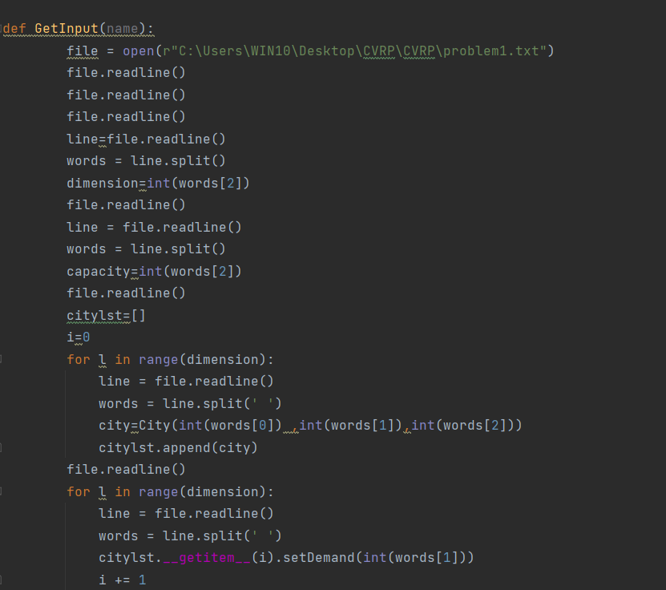

**In order to translate the problem that was given in the assignment "CVRP", we added new file 'CVRP' which included the following functions:**

**1)function to calculate the distance between two cities in the map and to place this distance in the propriate indices in the distance matrix.**

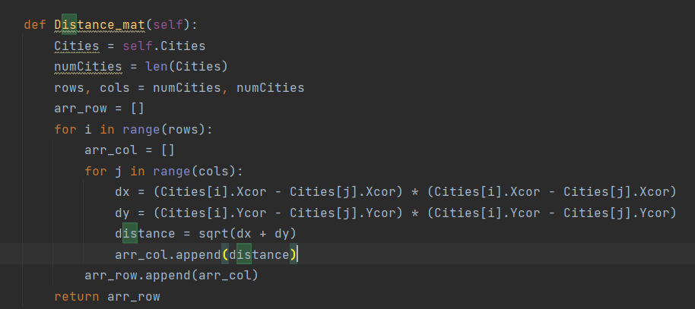

**2) function to print the output in the specific order(matrix) as the instruction given in the assignment**

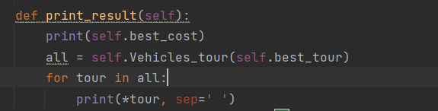

**3)** **function that returns the path for every vehicle given the whole path permutation.**

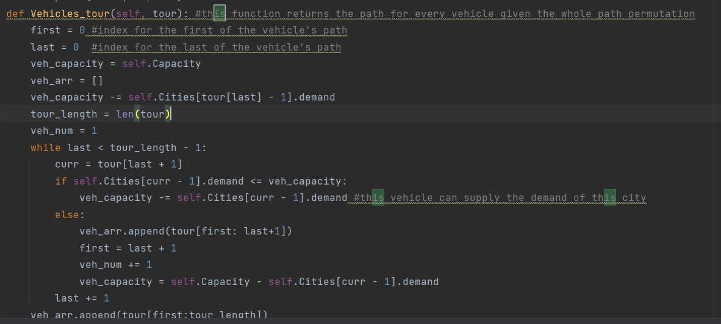**Here is a little bit of the code:**

**4)** **function that calculates the cost of a given a tour**

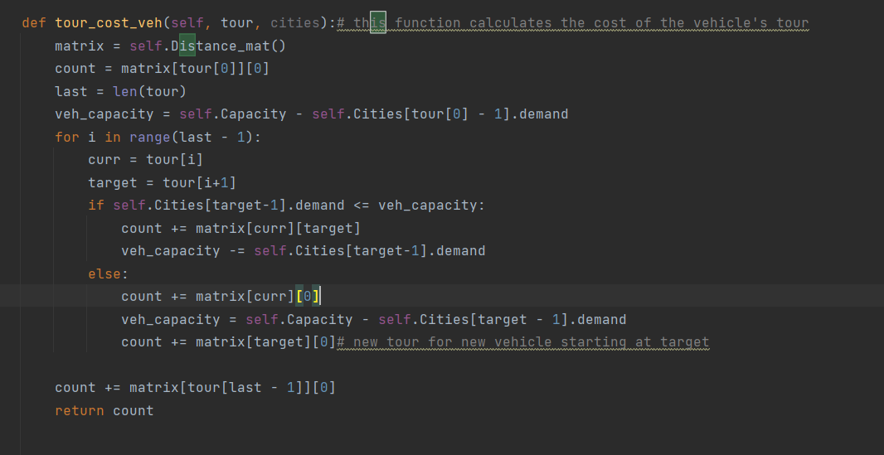

**Heuristics we used:**

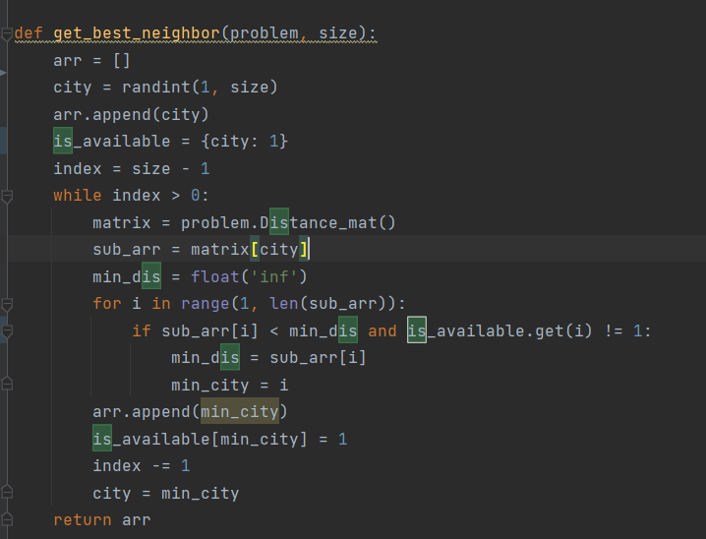**We added new file named 'heuristic' with in it we declared the nearest neighbor heuristic that we learned, using this heuristic we select at first random member of the permutation and apply inverse mutation that we used in previous lab, here is a little bit of the code:**

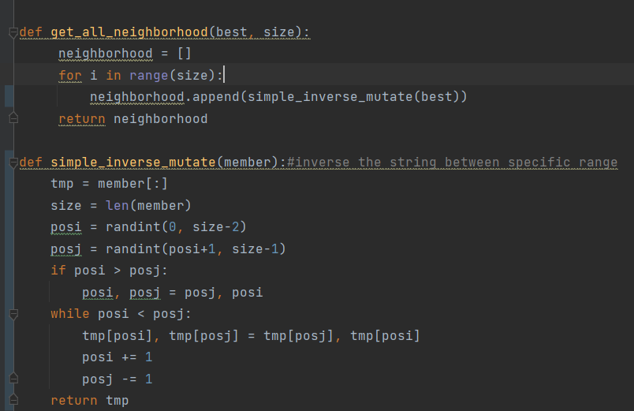

**Simulated Annealing:**

**Here is a little bit of our code implementing the simulated annealing algorithm:**

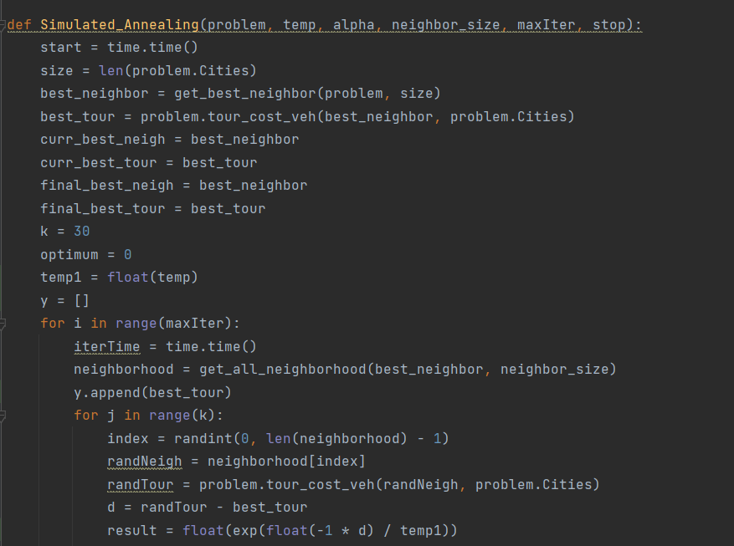

**And when we run our code on the 'sample 1' file (E-n22-k4) we have got the following output, with the following elapsed and CPU time:**

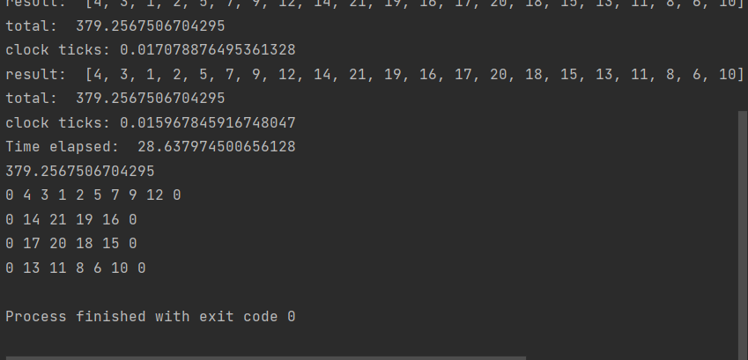

Here is a graph that shows the relation between the fitness(cost) and the num of the iteration:

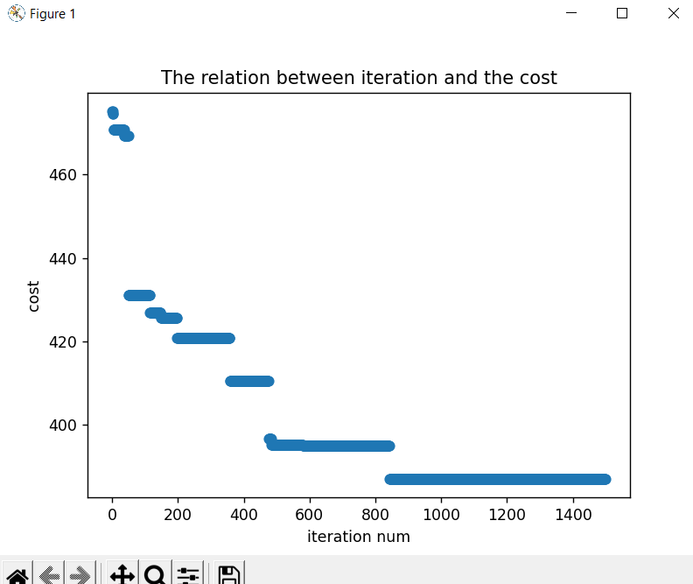

**PSO:**

**In order to implement cooperative PSO algorithm that we learned in the lecture we updated the velocity of each particle and the position to be equal to:**

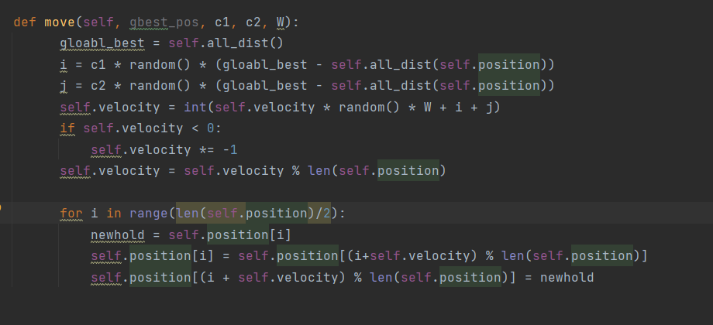

**And we updated the PSO parameters as the equation we saw in the lecture:**

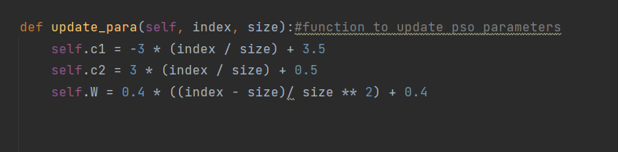

**Here is the output of PSO on file (E-n22-k4) :**

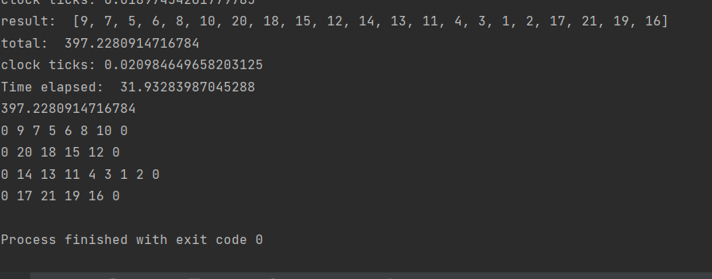

Here is the graph:

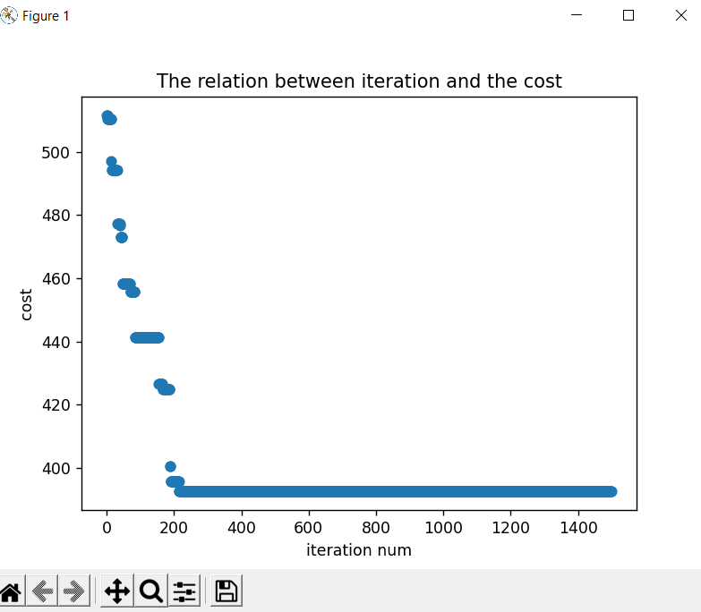

**TabuSearch:**

**here is a little bit of our code implementing Tabu search algorithm:**

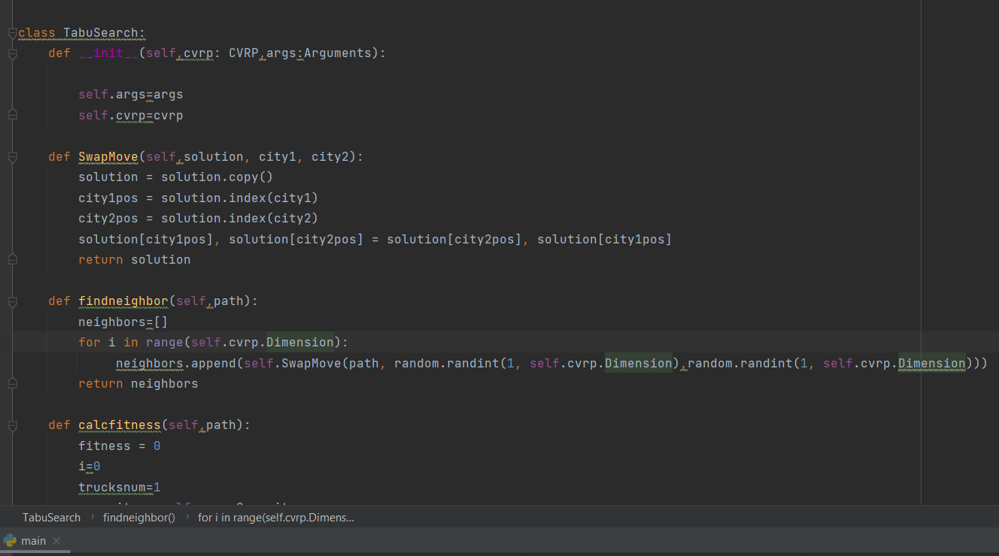

**Here is the output:**

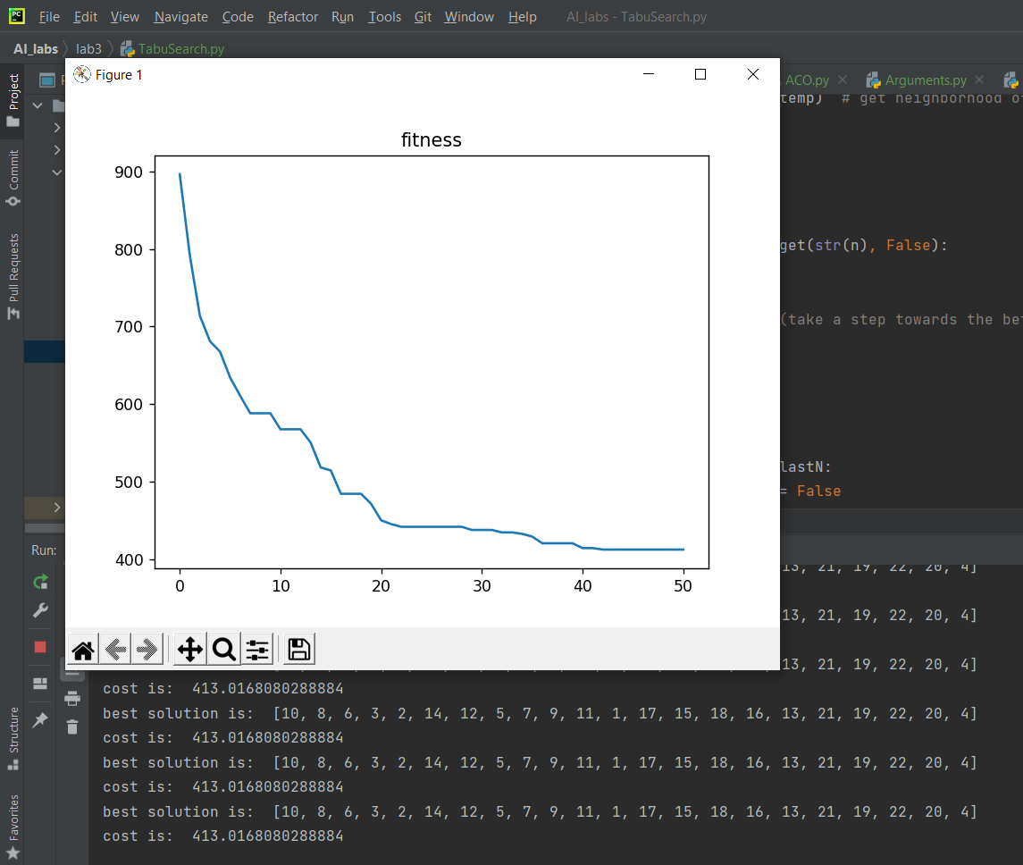

**GA- Island model:**

**Here is a little bit of our code implementing GA in island model.**

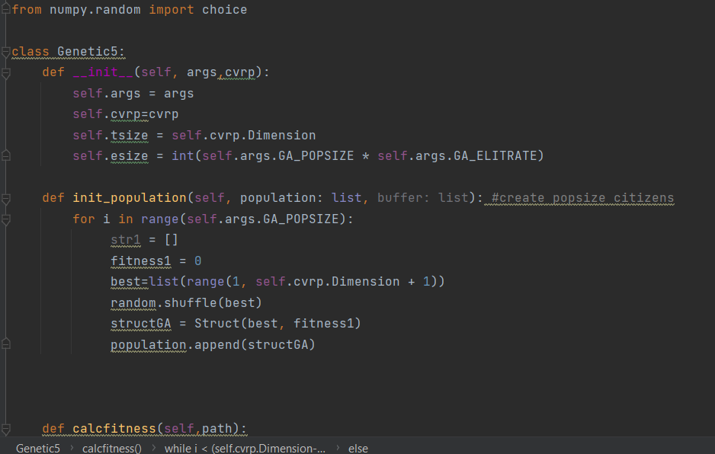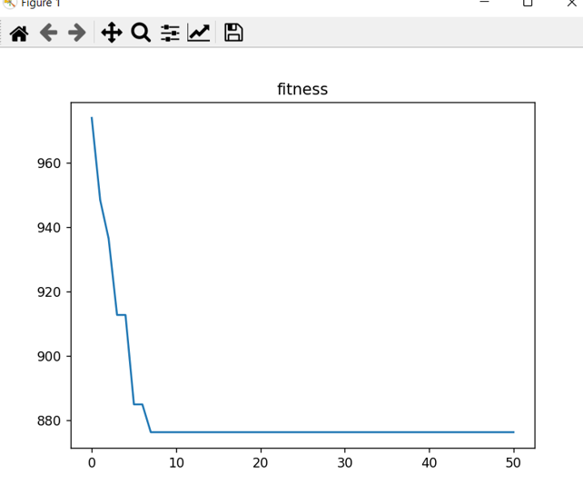

**ACO:**

**Here is a little bit of our code implementing ACO**

