**Excel Basics**

Basics

* Each ***workbook*** (Excel file) is comprised of one or more *worksheets*
* Each ***worksheet*** is made up of individual *cells*
* ***Cells*** are the intersection of a ***rows*** (horizontal) and a ***column*** (vertical)
* Each *cell* contains a *value*, a *formula*, or *text* and can only hold one value at a time
* ***Cell reference***, identifies each cell in the worksheet and is a combination of letters and numbers such as A1, F456, or AA34.
* Each worksheet in a workbook is accessible by clicking the *tab* at the bottom of the workbook window.

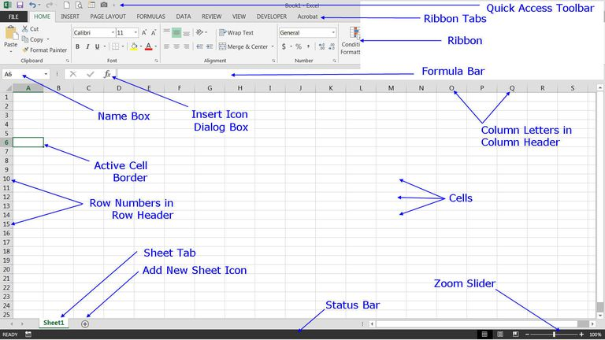

Elements you are already familiar with:

* The ***quick access toolbar***
* The ***ribbon***
* The ***zoom slider***
* The ***status bar***

The ***formula bar*** is located below the Ribbon. This area displays the contents of the active cell. It can also be used for entering or editing data and formulas.

Located to the left of the formula bar, the ***insert icon dialog box*** helps the user identify and implement ***functions***, a type of formula that performs specialized and group calculations.

Located to the left of the formula bar, the ***name box*** displays the cell reference or the name of the active cell.

Mouse or cursor appearance and functions in Excel

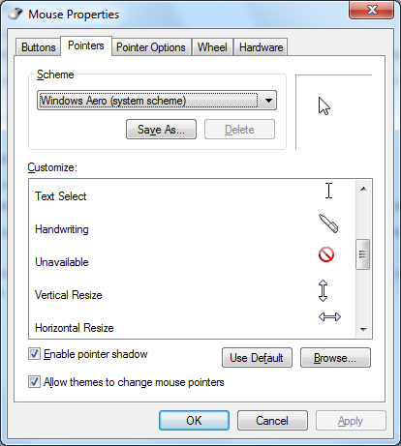Text select (may be a flashing vertical line) – shows where cursor is in preparation to type in text.



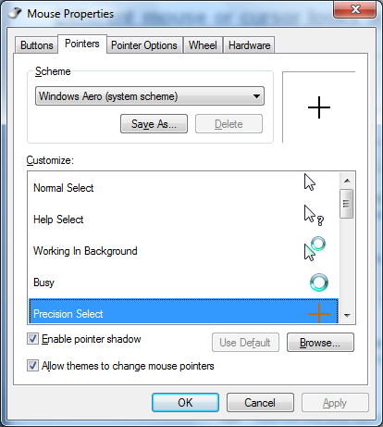 Basic select icons – shows you were the cursor is located. Click to select a cell.

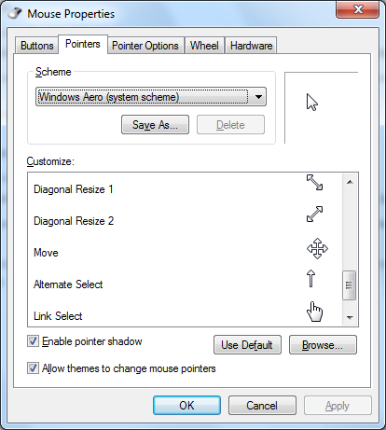

Resize handles – will resize a window when clicked and dragged.



Link selector – this shows an active link that when you click on it, you will go to another

Web page or document.

**Excel Move Pointer**

Move Pointer – moves a cell or group of cells from one position to another.

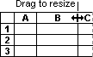

Resize – used to resize a column or row

**[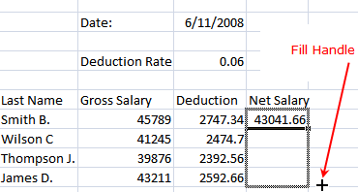](http://0.tqn.com/d/spreadsheets/1/0/p/6/-/-/fill_handle.gif)**

Fill handle – used to drag and copy cell values or formulas.

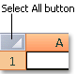

The select All button selects all the cells in the worksheet.

Move the cursor after entering data

After entering data in a worksheet cell, you can press ENTER, TAB, or any arrow key to move the cursor to another adjacent cell.

|  |  |
| --- | --- |
| **Press this key** | **To move the cursor** |
| ENTER | Down one cell. |
| TAB or SHIFT+TAB | To the adjacent cell on the right (tab) or the left (shift+tab). |
| Any arrow key | To the adjacent cell in the direction of the arrow. |