1. <Title name>
   1. Analysis of physiological aspects of fetal ECG

Heart defects are among the most common birth defects and the leading cause of birth defect-related deaths. Every year, about one of 125 babies are born with some form of congenital heart defects. The defect may be so slight that the baby appears healthy for many years after birth, or so severe that its life is in immediate danger. Congenital heart defects originate in early stages of pregnancy when the heart is forming and they can affect any of the parts or functions of the heart. Cardiac anomalies may occur due to a genetic syndrome, inherited disorder, or environmental factors such as infections or drug misuse [1].

There are at least two ways of fECG assessment. The key features in are FHR rhythm-related, and FECG morphology related. The second one includes changes in ST and QT segments. It is known that QT interval reacts to situations of stress and exercise. It has been shown that a significant shortening of the QT interval was associated with intrapartum hypoxia irrespectively of changes in FHR [2], whereas in normal labor these changes do not occur.

However, for fECG recordings, it is unclear how robust these measures are, particularly when accompanied by:

* noise/artefacts;
* fetal movements;
* different electrode configurations;
* undesired distortions caused by extraction algorithms.

Moreover, even when using modern monitoring equipment like STAN [3], it is not possible to assess how well the morphology of the fetal signal is preserved. This because the reference (invasive FECG) is based on a different lead, which represents another projection of the cardiac electrical activity.

* + 1. Fetal QT interval feature

A small number of researches conducted on the association between the fetal QT interval and newborn outcome. Although, many studies note QT interval abnormalities during the fetal and newborn period with serious events, including sudden death [4].

A prolonged QT interval, either genetic or acquired, predisposes to ventricular tachycardia and sudden death. Changes in the QT interval have also been shown during exercise, stress, infection and heart failure [5]. A QT shortening was noticed in conjunction with an increase in T-wave amplitude. It seemed logical to assume that the QT shortening would depend on the ability of the fetal myocardium to enhance its performance in response to a catecholamine surge and on h-receptor activation known to elicit the rise in T-wave amplitude.

* + 1. Fetal ST interval feature

The ST interval comprises the ST segment and the T wave, and both relate to the repolarization of myocardial cells in preparation for the next contraction, an energy-intensive process. An increase in T-wave height (fig. 1), quantified by the T/QRS ratio, occurs when cellular energy production within myocardial cells begins to decline, that is, when the oxygen supply is inadequate to maintain metabolic activity so that cells are forced to generate energy by ß-adrenoceptor-mediated anaerobic breakdown of glycogen reserves.

ST interval depression indicates an imbalance between the endocardium and epicardium because of the difference between the lower blood perfusion pressure of the endocardium and the higher mechanical strain, which delays myocardial repolarization.

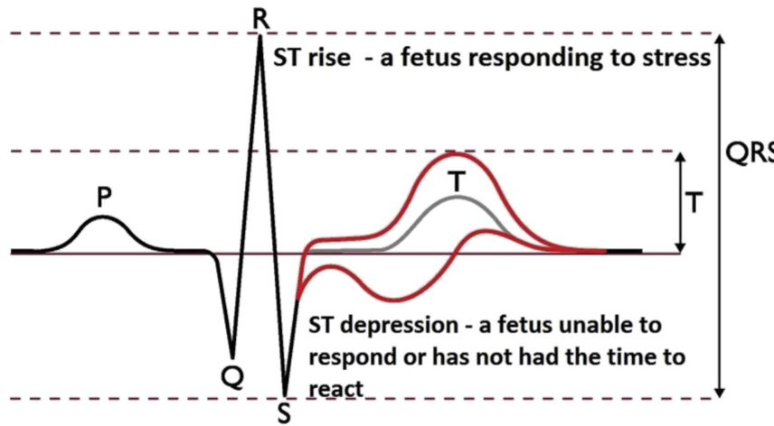

Figure 1. Changes in fetal ST segment

All the factors that modify the performance characteristics of the myocardial wall, including hypoxia, prematurity, infections, maternal fever, myocardial dystrophy, maternal diabetes and cardiac malformations may depress the ST interval.

* + 1. Fetal heart rate

The basic premise underlying FHR as a tool is that patterns reflect the oxygen status of the fetal brain. The changes and patterns seen in the FHR in response to changes in oxygenation and acid/base status should be considered as the fetal organism attempting to maintain homeostasis [7].

There are both accelerations and decelerations exist in the life of fetus. The first ones appear as exposure to external influence such as tactile or acoustic actions. In addition, accelerations could be served as a manifestation of short spontaneous increase in sympathetic activity. The presence of heart boosts indicates the absence of severe hypoxia or acidosis. However, accelerations may not be appeared in different cases, during fetal sleep, arrhythmia, exposure to certain medications, and extreme prematurity.

Decelerations usually serve as an alarm indicator depending on the temporal relationship to contraction. They can be early, late, variable or prolonged. Early decelerations remain the state without certain mechanism description. They appear quite rare and do not serve as a decease alarm.

One of the mechanisms of variable deceleration is a compression in umbilical cord. At first, as an exposure on decreased blood flow heart becomes beating more often. Further cord compression leads to occlusion of both the umbilical vein and arteries, leading to a marked increase in peripheral vascular resistance and a resulting abrupt decrease in the heart rate. However, another mechanism, which shows deceleration/acceleration, exists [7]. Late decelerations are most consistently associated with a response to a reduction in fetal oxygenation. The normal fetus will tolerate this brief reduction well. In contrast, when oxygen tension is already low, the loss of oxygen tension leads to vasoconstriction. Baroreceptors recognize this increase in fetal blood pressure and instigate a lowering of the FHR.

The final type of deceleration is the prolonged deceleration, defined as more than 2 minutes in duration but less than 10. The most likely mechanism in this type of deceleration is a sudden and prolonged reduction in oxygen delivery. Experts speculate that the decrease in FHR is an attempt to conserve oxygen in cases of severe debt. Thus, such type of deceleration became the most bright in problem indication.