**Saint Petersburg Electrotechnical University**

**(ETU)**

|  |  |  |
| --- | --- | --- |
| **Field of study** | 12.04.04 – Биотехнические системы и технологии (Biotechnical Systems and Technologies) | |
| **Programme** | Systems and Technologies in Digital Healthcare | |
| **Faculty** | Faculty of Information Measurement and Biotechnical Systems | |
| **Department** | Department of Bioengineering Systems | |
| *Accepted for defense* |  | |
| Head of the department |  | Prof. Yuldashev Z.M. |

**MASTER THESIS**

**Topic: Алгоритм анализа фетальной ЭКГ для выявления тревожных состояний**

**(AlgorIthmIc AnalysIs of ECG for DIscoverIng Fetal CrItIcal CondItIons)**

|  |  |  |  |  |
| --- | --- | --- | --- | --- |
| Student |  |  |  | Токарчук Т. С.  (Tokarchuk T. S.) |
|  |  | *signature* |  |  |
| Research supervisor | Cand. Sci. (Eng.), Assoc. Prof. |  |  | Anisimov A. A. |
|  | *(academic degree, title)* | *signature* |  |  |
| Advisors | Cand. Sci. (Eng.), Assoc. Prof. |  |  | Bobrova Y. O. |
|  | *(academic degree, title* | *signature* |  |  |
|  | Cand. Sci. (Eng.), Assoc. Prof. |  |  | Ivanov A. N. |
|  | *(academic degree, title)* | *signature* |  |  |
|  |  |  |  | Rovsha M. V. |
|  | *(academic degree, title)* | *signature* |  |  |

Saint Petersburg

2021

**Master’s Thesis task**

|  |  |
| --- | --- |
|  | Approved by |
|  | Head of the BTS department |
|  | ____________ Yuldashev Z.M. |
|  | «__» __________20__ |

|  |  |  |  |  |  |  |  |  |
| --- | --- | --- | --- | --- | --- | --- | --- | --- |
| Student | Tokarchuk T. S. | | | |  | Group | 5500 | |
| Topic: Алгоритм анализа фетальной ЭКГ для выявления тревожных состояний (Algorithmic analysis of ECG for discovering fetal critical conditions) | | | | | | | | |
| Institution: department of Bioengineering Systems, SPbSETU, Russia | | | | | | | | |
| Initial data (technical requirements):  Library sources, ADFECG database. | | | | | | | | |
| Contents of the thesis:  Fetal ECG algorithms and devices analysis, Feta heart rate extraction and analysis algorithm development, Evolution of fetal ECG extraction algorithm. | | | | | | | | |
| List of report materials: explanatory note, illustrations. | | | | | | | | |
| Additional sections: special aspects of safety | | | | | | | | |
|  | | | | | | | | |
| Task assigned on | | | Thesis submitted for defense on | | | | | |
| «08» February 2021. | | | «25» May 2021. | | | | | |
|  | | |  | | | | | |
| Student | |  | | Tokarchuk T. S. | | | |
| Research supervisor | | Cand. Sci. (Eng.),  Assoc. Prof. | | Anisimov A. A. | | | |
|  | | *(academic degree, title)* | |  | | | |
| Advisor | | Cand. Sci. (Eng.),  Assoc. Prof. | | Bobrova Y. O. | | | |
|  | | *(academic degree, title)* | |  | | | |

**THESIS CALENDER PLAN**

|  |  |
| --- | --- |
|  | Approved by |
|  | Head of the BTS department |
|  | ____________ Yuldashev Z. M. |
|  | «__»______________20___ . |

|  |  |  |  |  |
| --- | --- | --- | --- | --- |
| Student | Tokarchuk T. S. |  | Group | 5500 |
| Topic: Алгоритм анализа фетальной ЭКГ для выявления тревожных состояний (Algorithmic analysis of ECG for discovering fetal critical conditions) | | | | |

|  |  |  |
| --- | --- | --- |
| No | Stages | Deadline |
| 1 | Fetal ECG algorithms and devices analysis | 08.02 – 01.03 |
| 2 | Fetal heart rate extraction and analysis | 02.03 – 17.03 |
| 3 | Fetal ECG extraction and analysis algorithm evaluation | 18.03 – 18.04 |
| 4 | Special safety issues | 10.04 – 29.04 |
| 5 | Explanatory note | 30.04 – 10.05 |
| 6 | Illustrations | 11.05 – 25.05 |

|  |  |  |
| --- | --- | --- |
| Student |  | Tokarchuk T. S. |
| Research supervisor | Cand. Sci. (Eng.),  Assoc. Prof. | Anisimov A. A. |
|  | *(academic degree, title)* |  |
| Advisor | Cand. Sci. (Eng.),  Assoc. Prof. | Bobrova Y. O. |
|  | *(academic degree, title)* |  |

**SUMMARY**

Explanatory note: 88 pages, 41 figures, 4 tables, 54 references.

FETAL ECG EXTRACTION, FHRV ANALYSIS FASTICA, TEMPLATE SUBTRACTION, PYTHON, SCIPY, DIGITAL PROCESSING.

Goal: To Develop algorithm for fetal heart rate extraction and analysis from abdominal signals

**Research object:** Fetal monitoring system, which includes fECG recording.

**Research subject** – Fetal ECG extraction and analysis algorithm.

**Scientific novelty**: The improvement of FastICA and template subtraction methods and FHR analysis system development.

**Result**: As part of the master’s thesis implementation, an analysis was made of the current state of the problem of developing algorithms for fetal ECG isolation. The first stages of filtering were performed to remove high frequency noise and removing baseline wander. The advantages of choosing and improving the BSS method FastICA together with TS were justified. An algorithm for analyzing fetal heart rate with indication of alarm levels was developed.

As a result, the extraction techniques showed excellent results with noisy signals from the abdominal surface. However, using the algorithm without artifacts removed in advance is not possible. The algorithm for assessing the state of the fetus was demonstrated on 5 different signals with acceleration, soft and prolonged decelerations.

**АННОТАЦИЯ**

Целью работы является разработка алгоритмов выделения фетального ЭКГ из абдоминальных сигналов и анализа сердечного ритма плода.

В рамках выполнения ВКР был проведен анализ современного состояния проблемы разработки алгоритмов выделения ЭКГ плода. Первые этапы фильтрации были проведены для удаления высокочастотных шумов и смещения базовой линии. Преимущество выбора и усовершенствования BSS метода FastICA вместе TS были обоснованы. Был разработан алгоритм фильтрации и анализа сердечного ритма плода с индикацией уровней тревоги.

В результате методы выделения показали превосходный результат с зашумленными сигналами с поверхности живота. Однако использования алгоритма без заранее убранных артефактов не представляется возможным. Алгоритм оценки состояния плода был продемонстрирован на 5-ти разных сигналах с акселерациями, мягкими и длительными декселерациями.

**TABLE OF CONTENT**

DEFINITIONS, SYMBOLS AND ABBREVIATIONS 8

INTRODUCTION 9

1 FETAL ECG ALGORITHM AND DEVICES ANALYSIS 11

1.1 Analysis of physiological aspects of fetal ECG 11

1.1.1 Fetal QT interval feature 12

1.1.2 Fetal ST interval feature 12

1.1.3 Fetal heart rate 13

1.2 Methods for registration fetal heart activity 14

1.2.1 Magnetocardiography 15

1.2.2 Fetal electrocardiography 16

1.3 Instrumental methods for fECG registration 17

1.3.1 Monica AN24 18

1.3.2 Monica Novii 19

1.3.3 Meridian M110 21

1.3.4 Patents for fetal ECG acquisition systems 22

1.4 Algorithmic methods for fECG evaluation 23

1.4.1 Fetal heart rate extraction and analysis 24

1.4.2 Morphological analysis 27

1.5 Setting goal and objectives 30

2 FETAL HEART RATE EXTRACTION AND ANALYSIS 31

2.1 Biomedical system structure 31

2.1.1 Patient interaction model 31

2.1.2 Biotechnical model 32

2.2 Fetal signal extraction 34

2.2.1 Signal properties 34

2.2.2 Abdominal signal preprocessing 38

2.2.3 Abdominal baseline wander removal 42

2.2.4 Independent component analysis 45

2.2.5 Template subtraction 48

2.3 Fetal heart rate analysis 53

2.3.1 FHR extraction and processing 53

2.3.2 Discovering fetal critical conditions 55

2.4 Conclusion 60

3 FETAL ECG EXTRACTION AND ANALYSIS ALGORITHM EVALUATION 61

3.1 Signal registration instrumental requirement 61

3.2 Fetal ECG extraction algorithm evaluation 63

3.2.1 Evaluation metrics 63

3.2.2 Algorithm evaluation 66

3.3 Approbation of the fetal assessment algorithm 68

3.4 Conclusion 70

4 SPECIAL SAFETY ISSUES 71

4.1 Algorithm’s area of use 71

4.2 Software safety 72

4.3 Software ergonomics 73

4.3.1 Dialogue principles 74

4.3.2 Individualization 74

4.3.3 Software accessibility 75

4.3.4 Research comfort 77

4.4 Conclusion 80

CONCLUSION 81

LIST OF REFERENCES 83

DEFINITIONS, SYMBOLS AND ABBREVIATIONS

ECG – Electrocardiogram

mECG – Mother’s ECG

fECG – Fetal ECG

CTG – Cardiotocography

CHD – Congenital heart defects

FHR – Fetal heart rate

HR – Heart rate

MHR – Mother’s heart rate

EMD – Empirical mode decomposition

ICA – Independent component analysis

UA – Uterine activity

CNN – Convolutional neural network

CWT – Continues wavelet transform

SVM – Support vector machines

AUC – Area under curve

SNR – Signal-to-Noise ratio

BSS – Blind source separation

TS – Template subtraction

HRV – Heart rate variability

INTRODUCTION

The world’s population is 7.9 billion and growing. Although the birth rate is high, the death rate shows almost the same numbers. According to the same sources, one person dies every 1.5m in the Russian Federation. Fetuses and newborn babies account among those deaths. The most common birth deaths are as a result of Congenital Heart Defects. They are problems presented at birth that affect the structure and function of the heart. Besides blood circulation, these anomalies can affect the growth of the rest of the body.

The most common type of congenital heart defects is the Ventricular Septal Defect. Detection of cardiac anomalies can suggest the presence of other anomalies, which can be conducted only if we record and analyze fetal heart rate and RR intervals.

The costs for the antenatal care, including one scan during the second trimester, is covered by the public health care insurance. The most used techniques to monitor the baby and to discover any problems are ultrasound and cardiotocography devices. Both these machines are ultrasound based, relatively big in size, only available in hospitals and not for continuous use.

The number of ultrasound and CTG screenings depend on the parent’s health history, the mother’s age, and at least until the first ultrasound scan on 18th week, also called as the fetal anomaly ultrasound scan, for normal pregnancies. Nevertheless, for many parents the relatively long waiting period until the first ultrasound checkup, and fetal heartbeat confirmation can be quite unpleasant.

The early and more effective detection of abnormal fetal health state can help obstetrics and pediatric cardiologists to prescribe proper medications in time, or to consider the necessary precautions during delivery or after birth.

Fetal heart monitoring is not the only useful for diagnosing and monitoring CHD fetuses, but it also may improve the diagnosis of other heart-related pathologies such as hypoxia, growth restriction and anemia. Such complications can happen prior to or during birth and may have long lasting effects on the newborn’s health, if exposure is prolonged. As mothers progressively decide to postpone their first pregnancy, there is a higher risk for the fetal health. Indeed, increasing the effectiveness and reducing costs of prenatal monitoring on risk pregnancies is a priority for both developed and underdeveloped worlds.

Limitations on the current techniques have instigated the pursuit for alternative fetal monitoring methods over the last few decades. Particularly, because of its potential to bit in efficiency prenatal diagnostic information, for example non-invasive fetal electrocardiogram.

ECG is one of the oldest methods to detect and monitor the heart rate, but it is usually used on adults or during labor, invasively. Recent studies recommend ECG to be used in fetal monitoring as well. An ECG based device will be comfortable enough to not disturb the mother and to be safe for the baby, even when used daily throughout pregnancy.

Unfortunately, non-invasively recorded fetal ECG signals are usually corrupted by many interfering noise sources, most significantly by maternal electrocardiogram whose amplitude is usually much greater than those of the fetal ECG. The generally low signal-to-noise ratio of the resultant fetal ECG makes the extraction, or as it called, separation and subsequent detection of the fetal QRS complexes a challenging task.

The **main goal** for current paper is to develop fetal ECG extraction and analysis algorithm for discovering critical conditions.

The **object** is a fetal monitoring system, which can record fECG data. The **subject** is fetal extraction and analysis algorithm. Since main **purpose** is the algorithm development, **tasks** include: analysis of fetal ECG extraction and analysis algorithms; development of fetal ECG extraction and analysis software; algorithm evaluation.

1. FETAL ECG ALGORITHM AND DEVICES ANALYSIS
   1. Analysis of physiological aspects of fetal ECG

Heart defects are among the most common birth defects and the leading cause of birth defect-related deaths. Every year, about one of 125 babies are born with some form of congenital heart defects. The defect may be so slight that the baby appears healthy for many years after birth, or so severe that its life is in immediate danger. Congenital heart defects originate in early stages of pregnancy when the heart is forming and they can affect any of the parts or functions of the heart. Cardiac anomalies may occur due to a genetic syndrome, inherited disorder, or environmental factors such as infections or drug misuse [1].

There are at least two ways of fECG assessment. The key features in are FHR rhythm-related, and FECG morphology related. The second one includes changes in ST and QT segments. It is known that QT interval reacts to situations of stress and exercise. It has been shown that a significant shortening of the QT interval was associated with intrapartum hypoxia irrespectively of changes in FHR [2], whereas in normal labor these changes do not occur.

However, for fECG recordings, it is unclear how robust these measures are, particularly when accompanied by:

* noise/artefacts;
* fetal movements;
* different electrode configurations;
* undesired distortions caused by extraction algorithms.

Moreover, even when using modern monitoring equipment like STAN [3], it is not possible to assess how well the morphology of the fetal signal is preserved. This because the reference (invasive FECG) is based on a different lead, which represents another projection of the cardiac electrical activity.

* + 1. Fetal QT interval feature

A small number of researches conducted on the association between the fetal QT interval and newborn outcome. Although, many studies note QT interval abnormalities during the fetal and newborn period with serious events, including sudden death [4].

A prolonged QT interval, either genetic or acquired, predisposes to ventricular tachycardia and sudden death. Changes in the QT interval have also been shown during exercise, stress, infection and heart failure [5]. A QT shortening was noticed in conjunction with an increase in T-wave amplitude. It seemed logical to assume that the QT shortening would depend on the ability of the fetal myocardium to enhance its performance in response to a catecholamine surge and on h-receptor activation known to elicit the rise in T-wave amplitude.

* + 1. Fetal ST interval feature

The ST interval comprises the ST segment and the T wave, and both relate to the repolarization of myocardial cells in preparation for the next contraction, an energy-intensive process. An increase in T-wave height (fig. 1.1), quantified by the T/QRS ratio, occurs when cellular energy production within myocardial cells begins to decline, that is, when the oxygen supply is inadequate to maintain metabolic activity so that cells are forced to generate energy by ß-adrenoceptor-mediated anaerobic breakdown of glycogen reserves.

ST interval depression indicates an imbalance between the endocardium and epicardium because of the difference between the lower blood perfusion pressure of the endocardium and the higher mechanical strain, which delays myocardial repolarization.

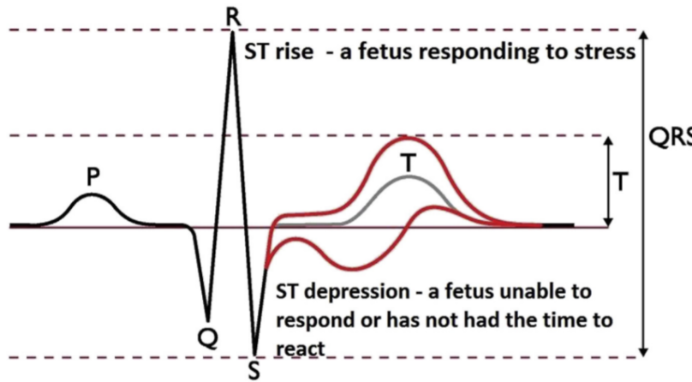

Figure 1.1 – Changes in fetal ST segment

All the factors that modify the performance characteristics of the myocardial wall, including hypoxia, prematurity, infections, maternal fever, myocardial dystrophy, maternal diabetes and cardiac malformations may depress the ST interval.

* + 1. Fetal heart rate

The basic premise underlying FHR as a tool is that patterns reflect the oxygen status of the fetal brain. The changes and patterns seen in the FHR in response to changes in oxygenation and acid/base status should be considered as the fetal organism attempting to maintain homeostasis [7].

There are both accelerations and decelerations exist in the life of fetus. The first ones appear as exposure to external influence such as tactile or acoustic actions. In addition, accelerations could be served as a manifestation of short spontaneous increase in sympathetic activity. The presence of heart boosts indicates the absence of severe hypoxia or acidosis. However, accelerations may not be appeared in different cases, during fetal sleep, arrhythmia, exposure to certain medications, and extreme prematurity.

Decelerations usually serve as an alarm indicator depending on the temporal relationship to contraction. They can be early, late, variable or prolonged. Early decelerations remain the state without certain mechanism description. They appear quite rare and do not serve as a decease alarm.

One of the mechanisms of variable deceleration is a compression in umbilical cord. At first, as an exposure on decreased blood flow heart becomes beating more often. Further cord compression leads to occlusion of both the umbilical vein and arteries, leading to a marked increase in peripheral vascular resistance and a resulting abrupt decrease in the heart rate. However, another mechanism, which shows deceleration/acceleration, exists [7]. Late decelerations are most consistently associated with a response to a reduction in fetal oxygenation. The normal fetus will tolerate this brief reduction well. In contrast, when oxygen tension is already low, the loss of oxygen tension leads to vasoconstriction. Baroreceptors recognize this increase in fetal blood pressure and instigate a lowering of the FHR.

The final type of deceleration is the prolonged deceleration, defined as more than 2 minutes in duration but less than 10. The most likely mechanism in this type of deceleration is a sudden and prolonged reduction in oxygen delivery. Experts speculate that the decrease in FHR is an attempt to conserve oxygen in cases of severe debt. Thus, such type of deceleration became the brightest in problem indication.

* 1. Methods for registration fetal heart activity

Electronic fetal monitoring techniques can be invasive or non-invasive with intermittent or continuous assessment; these techniques include fetal phonocardiography, Doppler ultrasound, cardiotocography, fetal magnetocardiography and fetal electrocardiography [8].

Cardiotocography is a technical means of recording the fetal heartbeat and the uterine contractions during pregnancy. It uses both ultrasonic measurement sensor for fetal heart rate and electrodes for uterine contractions. However, cardiotocography may also include fetal activity measurement devices [9]. All the transducers

* + 1. Magnetocardiography

Fetal magnetocardiography, the magnetic analog of fetal ECG, is an emerging technology that is uniquely suited for investigation of fetal cardiac electrophysiology. Owing to its ability to assess fetal heart rate, rhythm, and conduction with efficacy similar to that of postnatal ECG.

Despite its advantages, fetal MCG is not widely used. A major barrier to clinical adoption is the high cost and complexity of Superconducting Quantum Interference Device technology. However, recent researches changed the situation. The demonstration of a new type of optically pumped magnetometer (OPM) can achieve SQUID sensitivity in a room temperature device [10], and thus, be a much cheaper and simpler in use method for fetal MCG acquisition. Signals obtained by both acquisition methods are presented in figure 1.2.

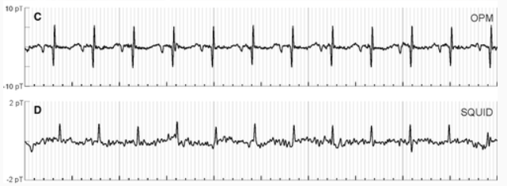

Figure 1.2 – Fetal magnetocardiography with different acquisition methods

Characterization of normal fetal behavior is fundamental to neurodevelopmental research and to clinical fetal evaluation. The compromised fetus restricts its activity [11]. Fetal magnetocardiography allows FHR extraction, fetal heart activity assessment and its own morphology evaluation. Figure 1.3 presents changes in fetal magnetocardiography during gestation.

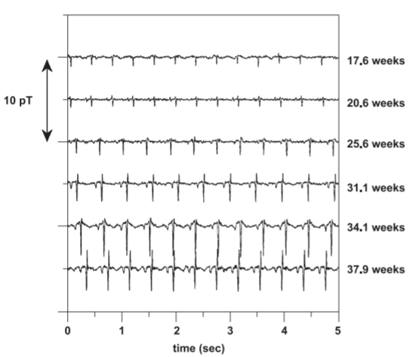

Figure 1.3 – Fetal magnetocardiography during gestation

Magnetocardiography morphology and amplitude difference is clearly seen between ages, so it has a real potential in future investigations with more advanced and apparently cheap sensors.

* + 1. Fetal electrocardiography

Two methods of fetal electrocardiogram acquisition exist: invasive and non-invasive. First one includes scalp electrode to obtain direct contact with fetus body. This way provides quite clear signal without any significant interference. However, baseline drift, electrode contact noise, electronic noises, power interference and movements with uterine contractions present in signal [12] and in figure 1.4.

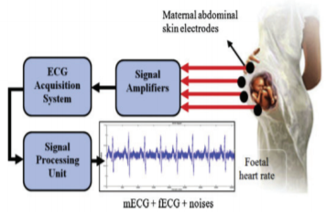

Figure 1.4 – Fetal electrocardiography model

The fetal heart signal requires a method to process the signal source so that signal separation can be done from one signal to another. Signals recorded on several recording devices often disrupt the signal, which is in the form of noise and artifacts.

The signal obtained can result in analysis errors. Mother’s signals are the most influential signals on fECG signals originating from abdominal signals, because of the frequency spectrums of each signal source intercept. The filtering process to reduce the noise level is less effective to do. Therefore, other advanced techniques are usually used necessary to obtain a better fECG signal acquisition.

In addition, usually fetal monitoring systems includes more lead with other different purposes, for example, myographic measurements such as uterine contractions and channels for amplified mother ECG. They can be used for feature extraction and analyzing methods as well as alarm indicators.

* 1. Instrumental methods for fECG registration

The most frequently used fetal monitoring technology uses a Doppler ultrasound device to obtain fetal cardiac activity, either the fetal heart itself or arterial flow through a major fetal vessel. An algorithm in the device calculates the time interval between the loudest points in the cardiac cycle and displays a heart rate. Fetal electro cardio signals are much harder to obtain clearly and analyses, thus, in many cases only fetal heart rate measurement is used.

Nevertheless, the majority of attempts keep stepping on the road of technology and methodology improvement. Several monitors and remote biomedical devices for fetal heart rate or ECG waveform acquirement are used widely.

* + 1. Monica AN24

The first FHR monitor using noninvasive fetal ECG technology to arrive in the American clinic was the Monica AN24 monitor. It collects fetal ECG data from five electrodes placed on the laboring woman’s abdomen. The technical challenge for the Monica AN24 and other similar monitors is that, at the point where the electrodes are placed on the maternal abdomen, the fetal ECG waveform is overwhelmed by the maternal ECG, which has a voltage 100 times greater than its tiny fetal counterpart [13].

Monica AN24 is able to obtain 4 channels with 5 electrodes where one common is placed on the referenced point, usually close to the back. The main unit uses advanced technics to extract MHR, FHR and uterine activity. And thus, there is no way to present fetal or mother ECG itself. The device is presented in figure 1.5.

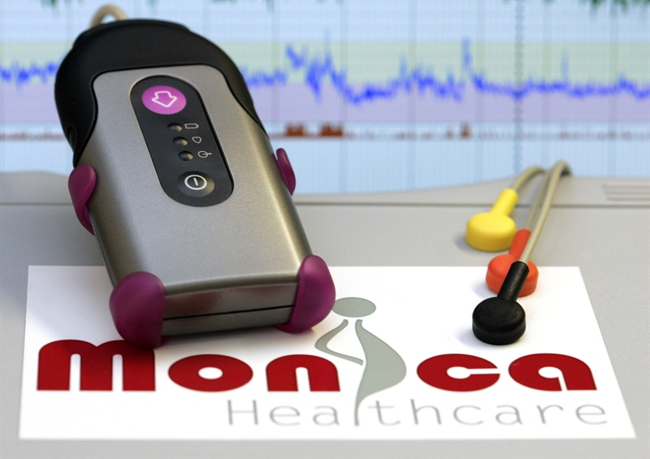

Figure 1.5 – Monica AN24

In addition, researches proved supremacy of use Monica AN24 over basic CTG technics for obtaining fetal heart rate and uterine contractions. Moreover, woman with big Body Mass Index raises difference in result with the use of electrodes and ultrasound sensors, that has been shown in [14, 15].

* + 1. Monica Novii

Monica Novii is a device developed to improve the labor and birthing experience with remote monitoring. Wireless Patch System is an intrapartum fetal monitor that non-invasively measures and displays the FHR, maternal heart rate, and uterine activity with only five electrodes that communicate all maternal and fetal information to the Novii Pad through Bluetooth technology. The device detects the fetal ECG and maternal ECG rather than FHR through Doppler on a separate device when using standard EFM as it shown in figure 1.6 [16].

For contractions, the Novii uses electromyogram signals from the uterine muscle to detect uterine activity rather than external tocometry. The suggested benefits of this device include reliable tracing on high body mass index patients and patient comfort as the user has a wireless experience during labor and child birth which can increase satisfaction for those who desire frequent position changes and movement [17].

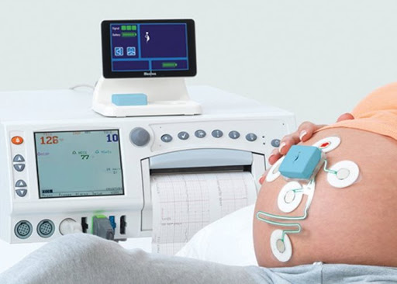

Figure 1.6 – Monica Novii patch system with interface

Despite the fact that monitor provides FHR and MHR it doesn’t use any complex techniques for fetal ECG morphological analysis. However, there is a possibility to show signals from Novii pod.

The Novii Interface is an accessory to the Novii Pod which provides a means of interfacing the wireless output of the Novii Pod to the transducer inputs of a CTG Fetal monitor. The Novii Interface enables signals collected by the Novii Pod to be printed and displayed on a CTG Fetal Monitor and sent on to a central network, if connected [18].

Novii pod system with patches contains 5 electrodes that is shown in figure 5. The positioning of electrodes has been chosen that way to amplify their individual signals. Thus, electrode 4 is implied as neutral one; 3rd significantly important for detection of uterine contractions. Second one for mother’s ECG, it places in the closest location to mothers’ heart among others (fig 1.7). Electrode number gives significant contribution to fetal ECG analysis, and thus, FHR extraction.

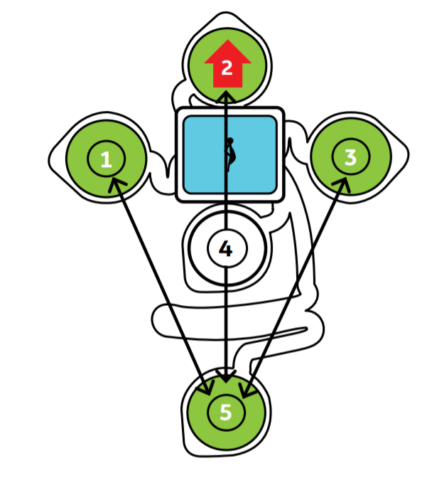

Figure 1.7 – Novii pod system

One significant contraindication exists Monica Novii is used only with woman over 36 completed weeks of pregnancy. That is usually the last month of gestation.

* + 1. Meridian M110

Meridian system includes monitor and electrode patch. In my opinion, the most significant advantage of a patch is focused in usability comfort. The Meridian Electrode Patch eliminates the need for skin preparation and replaces the fetal scalp electrode, intrauterine pressure catheter, Doppler, and TOCO sensors with a single non-invasive disposable system, while maintaining the same accuracy and sensitivity performance expected of today’s monitoring devices.

Meridian M110 Electrode Patch consists of four patches (fig 1.8), two for the mother’s abdomen and one for each of her sides, which provides continuous fetal ECG signal pick up for any fetal position or movement [19].

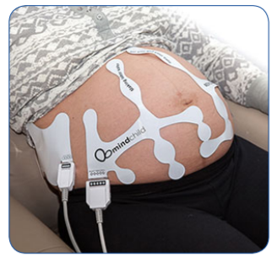

Figure 1.8 – Mindchild Meridian electrode patch

Meridian monitor is a main computational unit for channel processing and indicators extraction. Market has small number of devices for fetal monitoring, however, all of them have personal unique features. Current device is considered to be the one which can perform well for woman with obesity.

MERIDIAN M110 is the only fetal monitor on the market that performs as well in obese patients as it does in lean patients (fig 1.9). Both the fetal heart rate signal and the contraction signal deteriorate when BMI increases, compromising obstetric safety [20].

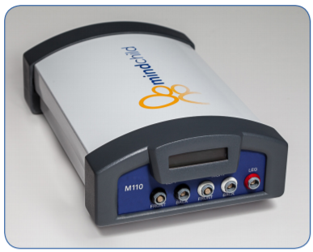

Figure 1.9 – Mindchild Meridian monitor

Moreover, The Meridian M110 demonstrated in a clinical trial: 96.7% correct fetal heart rate as compared to the fetal scalp electrode; 98.0% agreement of a contraction event as compared to the intrauterine pressure catheter and 98.3% correct maternal heart rate as compared to the pulse oximeter.

* + 1. Patents for fetal ECG acquisition systems

There are a lot of fetal monitoring devices exists, however, only a few of them are considered to be reliable, robust and standard. Nowadays, public market mostly includes devices for FHR assessment with ultrasound principle of operation. But, other medical inventory is still slowly filling the market, replacing outdated samples.

First system is described in [11], it contains of 3 electrodes and measurable unit with display. Electrode displacement allows the extraction of fetal heart rate and mothers heart rate from abdominal signals. One of wires are connected two the back, where signals are less seemed to be mixed.

The structure of main unit is pretty simple. Signals from leads had to be preprocessed. Then, mothers and fetal contents are derived from the mixed signal and analyzed to retrieve following indicators, their heart rates.

In addition to display block, device also has storage to save final result and preprocessed data for future outer analysis. There is more than one device version, it differs in number of leads. However, an average result for abd2012 database in most of channels seems great (F1 score > 94%)

Another device that is described in [22] has the similar architecture except. Initial device purpose is a prevention of respiratory disease outcomes from abdominal signals. It can measure a bunch of parameters, from mother/fetus physical activity to both ECGs.

The main distinctive feature of this system is an integration of several units in one complex sensor environment. Units can be mounted in some ways: with adhesive, tape. In addition, garments with sensors within are used for special conditions.

* 1. Algorithmic methods for fECG evaluation

After extracting the fECG from maternal abdominal recordings, the next step is to extract clinical parameters from the fECG. Adult ECG is different in SNR from fetal one. Thus, some improved techniques are used for signal enchasing, feature extraction and analysis.

Nowadays, the most common feature for fetal health evaluation is FHR. However, there are some important morphological metrics physiologically described in previous subchapters. Several advanced and not so techniques are presented in following subchapters.

* + 1. Fetal heart rate extraction and analysis

It is important to note that most techniques for FHR extraction contains additional part of fECG extraction from abdominal signals. The main idea of rate obtaining is to find locations of R-peaks; however, signal appearance can be performed in different unrecognizable ways.

Classical R-peak detection methods such as local peak search and the Pan-Tompkins method can be used for both adult and fetal R-peak detection. However, due to the lower SNR of the fetal ECG component improved methods used. The one described in [23].

Proposed R-peak algorithm is divided in stages, that are presented in figure 1.10. In the first stage, the selected fECG component is passed through a matched filter with a narrow fetal QRS template (of width b1) used as its impulse response. The template can be selected from the data by visual inspection, or as proposed in [24], by using predefined fixed QRS-like functions.

The output is squared and time-averaged with a moving average window of length w1, to obtain the energy envelope. The same procedure is repeated by using a wider fetal ECG template containing the entire PT-interval with a length b2 more than b1, followed by squaring and temporal averaging with window length w2 more than w1.

While, the first stage detects sharp QRS— and QRS-like— peaks of the signal, the second stage targets wider events. Right after the compensation of the group delays of the moving average filters and multiplying the two energy envelopes, the local peaks of this product can be considered as the fetal R-peaks.

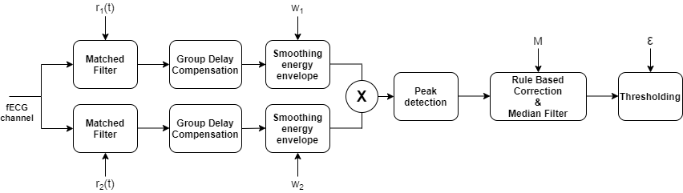

Figure 1.10 – Double matched filter R-peak detection scheme

Having detected the fetal R-peaks, in order to refine the calculated heart rate time series and the excess or missing R-peaks, a rule-based correction and conditional median filter is applied as post processing, which corrects the outlier R-peaks, while keeping the normal beats unchanged.

Another approach is described in [25], author uses empirical mode decomposition. More specifically, they assess different EMD technologies for channel selection. EMD is a fully data-driven method for non-linear and nonstationary real-world signals; it decomposes a signal into a finite set of intrinsic mode functions that represent its inherent oscillatory modes. However, R peaks are extracted with wavelet coefficients both for mother and fetus out of noise signals.

There is a standard for evaluation of fetal heart tracings; it emphasizes following parameters and patterns:

* Baseline
* Baseline variability
* Early decelerations
* Variable decelerations
* Late Decelerations

Different techniques are used for health evaluation with FHR, it is important to admit, that uterine contraction event is a significant time point for observation the changes of FHR. However, UA has low frequency, thus, FHR tracings should be quite long in time, hence, it is a rough task to obtain enough amount of clean data for right assessment.

Ones were using FHR for predicting fetal acidemia. They used useful approach with convolutional neural network (CNN) [26]. Actually, CNNs in their structure take some n-dimensional signal as input and underline useful features by itself. Another, important step they’ve done was transferring FHR curve to 2D form with continues wavelet transform (CWT) which also reflects time and frequency features in a single signal. In conclusion, the average accuracy achieved is 98% with area under ROC about 97%, that is explicit success.

Another useful review presented open access software for detection anxious fetal state [27]. Group used a bunch of parameters that a shown in figure 1.11 as features for training different classifiers. Predictive value was the absence a fetal distress, however, they estimated if cord artery pH more less than 7.2 or not.

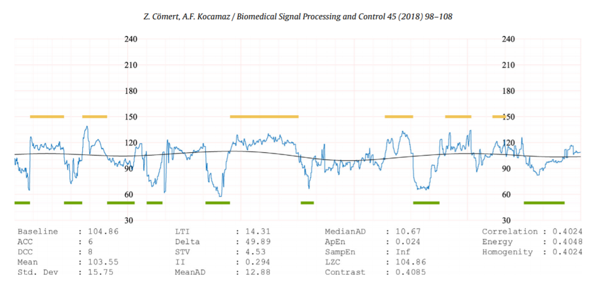

Figure 1.11 – Analysis report produced by CTG-OAS

Features can be divided in 4 groups:

* Morphological (up to DCC)
* Linear (up to MedianAD)
* Non-linear (up to LZC)
* Image-based time-frequency

Authors investigated 3 classifiers: Support vector machine, k nearest neighbours and artificial neural network (presumably n-Dense layers NN). Results were presented in different parameters; however, actual performance is evaluated by AUC, which SVM has about 84% (98% max, 68% min). Much more studies reviewed the use of CTG-OAS with different datasets; some of them are private. But outcome is poor, as for assessment parameter geometric mean of sensitivity and specificity all values are about 80%.

* + 1. Morphological analysis

Entire morphological analysis is built on the ECG segments, which include amplitudes and intervals. Thus, while the first step of FHR based methods was the detection of time location of R-peaks, segments requires higher level of algorithms to be received that makes this field is extremely tough to be pushed forward. Elimination of noises and artifacts becomes one of the most important tasks for data analysis with successful outcome.

Researchers have extracted parameters such as the QT-interval and the ST-segment. The typical benchmark for these studies is commonly the invasive fECG obtained from the fetal scalp electrodes acquired during labor. Furthermore, it is currently difficult to evaluate the fECG parameters independently since there are very few open-access fECG databases with expert annotations.

Early attempts of the extraction a fetal ECG from abdominal signals were proposed in previous decade, one used Bayesian filtering neural network for morphological features extraction in [2]. A Bayesian Filtering Framework based on an Extended Kalman Filter for extracting the FECG from a single abdominal channel was used with training database of 20 one minute maternal-fetal mixtures and evaluated on 200, one-minute mixtures. A single pass of the EKF was performed to cancel out the maternal ECG in order to build an average FECG morphology. A dual EKF was then applied to separate the three sources present in the signal mixture.

Another recent approach is presented in [28], they use LSTM network with different structure, which is shown in figure 1.12. The main feature of the is covered under “Fast” LSTM cell in architecture. The architecture of LSTM was originally designed for long term dependencies in data sequences, such as speech recognition and machine translation, which frequently utilize the dependencies between words with long word span.

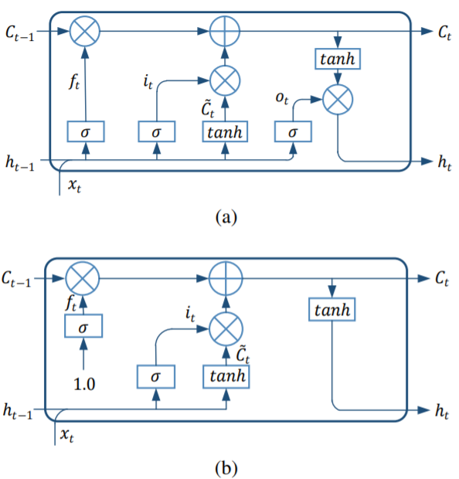

Figure. 1.12 – Architecture comparisons of cell units. (a) The original architecture of LSTM; (b) The proposed architecture of the fast LSTM.

However, the internal mapping system of the FECG signals is causal and locally consistent on the timeline. Thus, the attenuation coefficient of the hidden state should be smoothly variant or constant, which is different from the mechanism controlled by the original forget gate.

More concretely, the forget gate is switched to a relatively constant value, which obtains the gate value without taking xt and ht as input. They also abandoned the output gate, since they found that the output gate has little effect on the function of LSTM in the FECG enhancement stage, which has also been proved in other applications [29]. The definition of the input gate is kept intact to maintain the function and flexibility of LSTM.

For evaluation purposes they used two datasets: Database for the Identification of Systems (‘DaISy’, 1987) [30] and Fetal ECG Synthetic Database (‘FECGSYNDB’, 2016) [31]. Real data don’t have fECG separated signal, thus, it was used for quantitative evaluation, while DaISy was used for qualitive evaluation in comparison with other methods.

Slow-fast LSTM achieves higher means of SNR (about ~8 with high 12dB noise), and smaller standard deviations indicating the highly adaptive ability. Other channels with mean are presented in Table 1.1.

Table 1.1 – SNRout of Methods on Records from FECGSYNDB

|  |  |  |  |  |  |  |  |
| --- | --- | --- | --- | --- | --- | --- | --- |
| SNR | C0 | C1 | C2 | C3 | C4 | C5 | Mean ± Std. |
| 00 | 2.84 | 6.07 | 5.33 | 3.61 | 6.01 | 5.02 | 4.81 ± 1.20 |
| 03 | 6.67 | 5.76 | 5.99 | 5.46 | 6.19 | 6.03 | 6.02 ± 0.38 |
| 06 | 5.93 | 7.94 | 6.11 | 4.94 | 8.49 | 5.80 | 6.54 ± 1.25 |
| 09 | 7.78 | 8.95 | 9.09 | 6.67 | 9.13 | 8.01 | 8.27 ± 0.89 |
| 12 | 8.48 | 9.45 | 10.34 | 8.34 | 8.73 | 9.75 | 9.18 ± 0.73 |

Qualitative outcome is shown in figure 1.13, waveform seems to be more accurate than other methods. However, FastICA algorithm provided successful outcome in some channels as well as ESN.

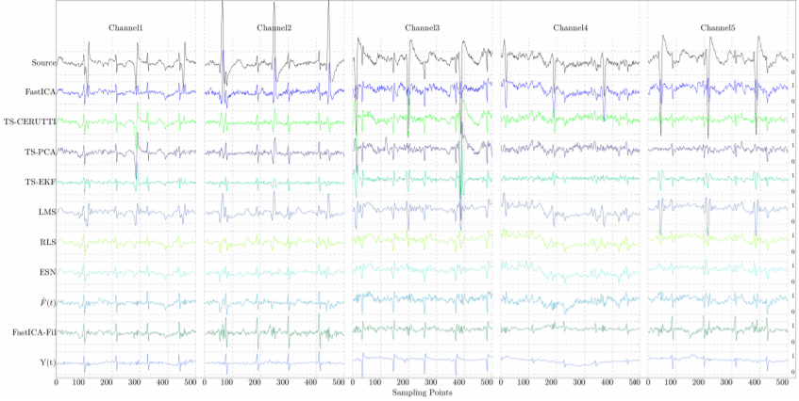

Figure 1.13 – SFLSTM outcome Y(t) in comparison with other methods, all outputs are normalized by the same certain value.

Finally, to date, morphological features are not used in the field of NI-FECG because todays algorithms do not provide required signal quality and medical fundamentals are not ready yet.

* 1. Setting goal and objectives

Fetal Heart Rate (FHR) monitoring based on the analysis of the fetal heart rate signal is the most common method of medical assessment of fetal condition during pregnancy. Visual analysis of FHR signals demonstrates a challenge due to the complicated shape of the waveforms [32].

Thus, computer-aided fetal monitoring systems provide a number of parameters that are the result of the measurable investigation of the registered signals. These parameters are the basis for a qualitative analysis of the fetal instant condition. The methods for the interpretation of FHR values provided by a Doppler device are commonly used in clinics for determining the fetal’s condition: died in the womb, caesarean section is needed or normally progressing.

Another way of fetal ECG assessment is morphological analysis, but todays researches are still should be investigated more in the field of clean ECG extraction and the whole methodology creation. Thus, it is not used in current master’s thesis.

So, the **goal** of master’s thesis is *to develop algorithm for discovering fetal critical conditions*. This purpose requires several tasks presented above:

**Tasks:**

* Preprocessing abdominal ECG
* Fetal ECG extraction
* FHR calculation
* FHR analysis.

1. FETAL HEART RATE EXTRACTION AND ANALYSIS
   1. Biomedical system structure
      1. Patient interaction model

Humans body is a complicated system, it includes lots of functional units which influence one on another. For instance, arterial system and neural one in the question of blood pressure maintenance. However, it can be described by modeling with the determination of an accuracy.

Woman’s system during gestation period become even more complicated. It unites her self-system and developing fetus one. In that way, there are many connections between organs of woman and fetal growth at all. In general, whole unity can be described in model presented in figure 2.1.

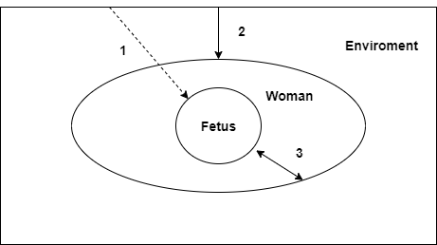

Figure 2.1 – Common patient system model

There are 3 model parts, it included environment woman system and fetus one. And all of parts are connected with each other. All the connections are divided in 3 groups:

1. Direct environment influence.
2. Indirect environment influence.
3. Woman-fetus interaction.

First connection describes direct environment influences. For example, heatwaves in the form of air flows, electromagnetic radiation, including infrared waves, vibrations and physical exposures.

Second connection describes environment-mother interaction. Most factors of first paragraph may indirectly influence on fetus through the mother. Furthermore, breathing system that is in charge of fetal oxygen supply is able to get bad impact from environment, for instance, air composition content.

Third connection describes the main interaction, it is between mother and fetus. Most of changes of fetus during pregnancy influence on mother health, moreover, patient’s health determines the state of her “baby”. Thus, maintaining of woman wellbeing is one of the most important ways to make fetus healthy.

* + 1. Biotechnical model

Any biotechnical system includes patient or biological object with some technical extension. Project to be done has direct medical diagnostic direction. Thus, second part should contain the following modules:

* Acquiring module.
* Signal preprocessing module
* Transducing module.
* Signal processing and Analysis module.
* Data performing module.

In general, there are much more blocks could be included, for example, alarm subsystem, parts with patient notification like smartphone algorithms. However, actual problem is located in theoretical knowledge about data processing and analysis, module placement. Approximate structure contains of microcontroller as the overall module for signal preprocessing and transducing and others that shown in figure 2.2.

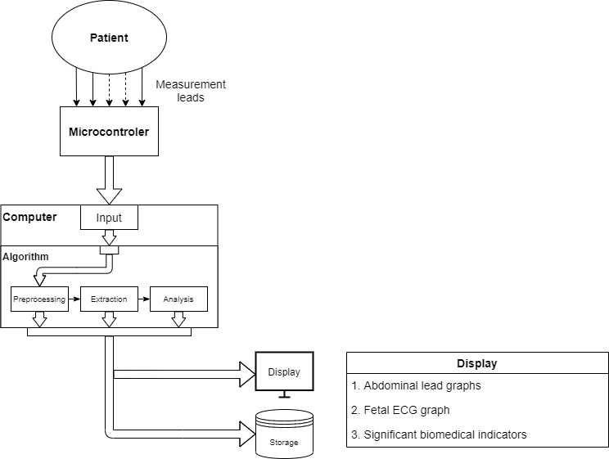

Figure 2.2 – Biotechnical system structure

Computer as well as microcontroller takes preprocessing role, though, it is much deeper. If microcontroller completes all necessary steps for signal transferring, then computer’s part plays preparation role for signal analysis.

Algorithmic module has also extraction and analysis subsystems their results are sent to storage and shows in display. Server can serve as for storage for signals and significant biomedical indicators.

It should contain fundamentals of signal preprocessing from electrodes such as some low frequency noises or human artifacts. However, powerline interference and high frequency noises should be excluded with simple notch and low pass filters.

Other parts require more attention. The main signal to be extracted is fetal electrocardiogram, but it has small amplitude and intersected frequency bands, so it can’t be separated in simple way. However, some advanced methods and their ensembles are used successfully. The main idea is signal separation in several different independent sources, for instance, mother ECG, fECG and noise.

* 1. Fetal signal extraction
     1. Signal properties

Electrode location takes huge place in fetal ECG acquisition systems. They dictate the next steps of processing and analysis. There were investigations in the field of electrode location, most of them fit unique group of methods. However, there are some fundamentals for proper electrode placement in the field of fetal ECG evaluation, which developers follow.

Basic principles of electrode placement are described in Monica HealthCare researches. They used following scheme which is shown in figure 2.3. Electrodes 1, 2 and 3 are positioned on the maternal abdomen approximating an arc which is Substantially the same as the arc of the subject’s uterus fundus. Electrode 4 is placed at a location approximating the symphis pubis of the Subject [33].

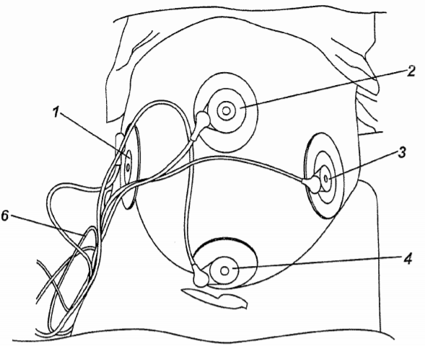

Figure 2.3 – Electrode placement

The positioning of the electrodes 1 to 4 is important to the quality of the fECG signal detected. A fifth electrode is optionally attached to the back or side of the subject for use as a right leg driver electrode.

Another approach includes thoracic electrodes. It is clear that the maternal heart signal is extending from the thoracic area to the abdominal area of the pregnant woman, so signal measured in the abdominal area is composed of a maternal fetal component. The ECG signal measured on the pregnant woman’s chest is considered to be a pure maternal ECG signal because it theoretically does not contain the fetal component [34].

Thus, lets divide electrodes in groups with their assignment. First group contains abdominal electrodes for fetal electrocardiogram extraction; second one includes mostly mother’s ECG component; Third as reference, where almost none of signals appears. Last group should contain electrodes with different assignment such as uterine contraction measures.

Abdominal signals represent the mixture of sources, they include mECG, fECG and noise component. In the time dimension the problem of fetal ECG identification established with confidence. Figures 2.4, 2.5 show possible tasks, that are faced. First of all, mothers and fetal QRS complexes are similar in amplitude and sometimes appears in one time.

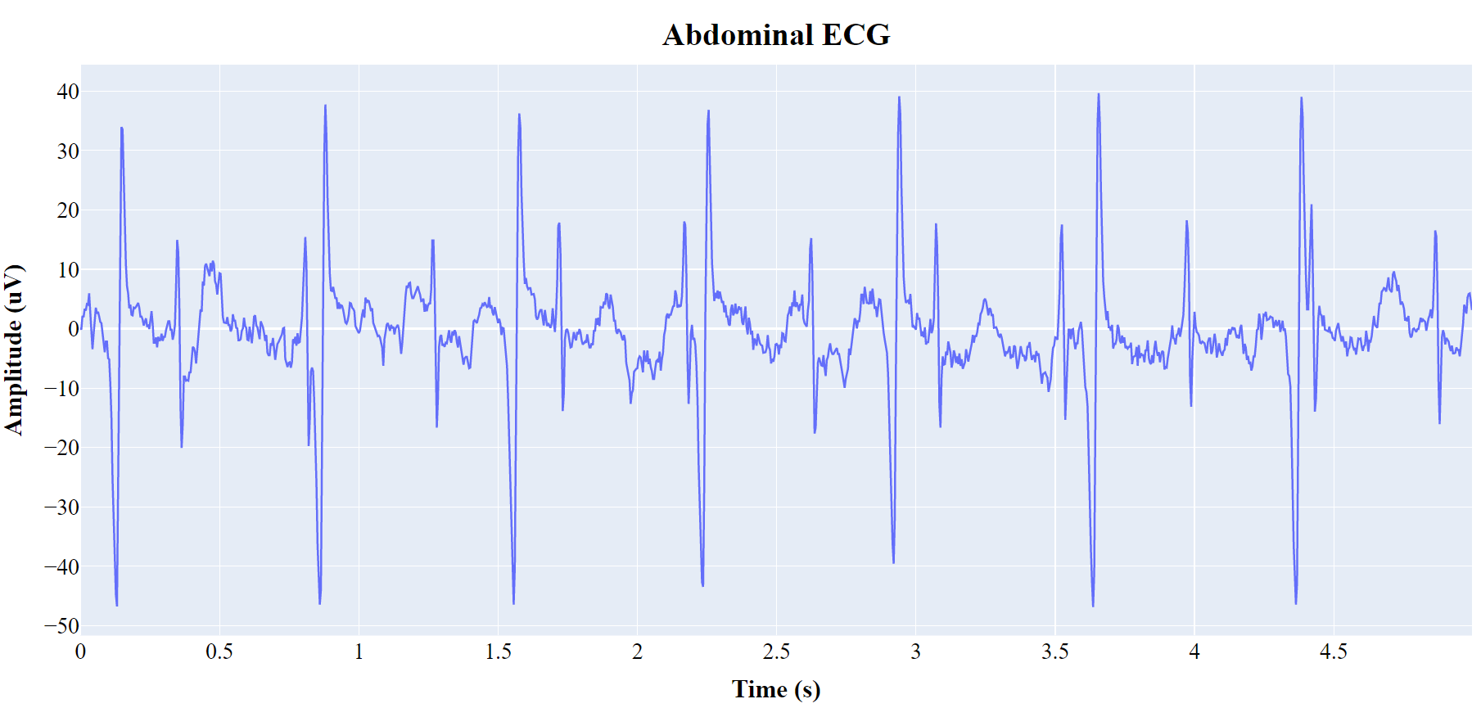

Figure 2.4 – Abdominal ECG without digital preprocessing

Nowadays, basic preprocessing steps, like powerlines interreference removal or electronic noise elimination is done before the signals reach computer point. However, in some ways digital adaptive filters can help delete 50 or 60 Hz noises, while the setting of right sampling frequency will align other wide band interferences.

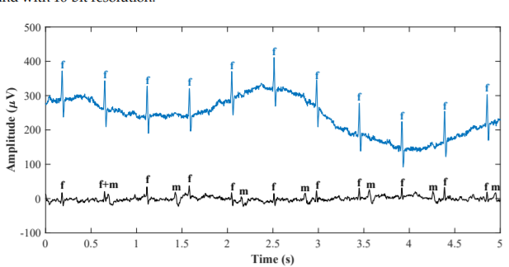

Figure 2.5 – Abdominal and mother’s ECG signals

Moreover, spectrum analysis shew that mother’s and fetal components are in the common frequency band. As well as the whole signals, their QRS complexes are still intercepted, that is shown in figure 2.6.

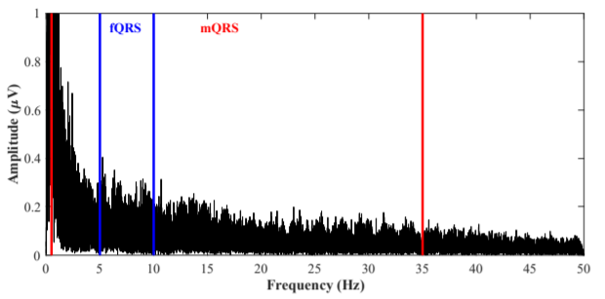

Figure 2.6 – Abdominal and mothers signal spectrums

There are several types of extraction algorithms, but, in general they can be divided in two types:

* Adaptive methods
* Non-adaptive methods

First type of methods requires mother’s signal which is used for signal separation, they include template subtraction, adaptive filtering (e.g. recursive least square, least mean square), and advanced techniques with recursive neural networks.

Non-adaptive filtering methods eliminate the undesired signals to yield the fECG signal without filter adaptation. More specifically, in some of these methods, filter weights are determined by using some initial training data and remain constant. These methods can use either a single-channel or multichannel signal source. Techniques utilizing a multi-channel signal source include multiple and single-source methods [35].

Single channel signal source methods are based on for example Wavelet Transform, Correlation Techniques, Averaging Techniques, Template Subtraction, Singular Value Decomposition, Adaptive Noise Canceler, and so on.

The multi-source methods are based on Subspace Denoising or Blind Source Separation, namely: Independent Component Analysis; Principal Component Analysis, and so on.

Blind source separation methods are a frequently used approach for fetal ECG signal filtering. It assumes the statistical independence of the two processed signals: fECG and mECG. It can be applied in the case of multi-channel abdominal recording with the assumption that the signals from different leads are a linear combination of independent signal sources generated by the maternal and fetal hearts [36].

The challenge, however, is that the relationship between the mECG recorded on the maternal chest and the mECG in the abdominal signal is rather nonlinear in nature. It is important to emphasize that the greater the number of channels, the better the quality of the extracted fECG signal. However, a large number of electrodes is clinically difficult to use and, moreover, they are unpleasant for the patient [37].

As it was shown, many fetal electrocardiogram techniques exist. However, only a few of them become popular and ‘general’ I would say. The list of common methods was described above. Nowadays, ICA as blind source separation method is used more often than others, it was also improved in many researches.

Neural networks in our days became the state of art in the field of signal processing and analysis, though, they can’t be generally used everywhere because of algorithm computation costs and method privacies. Researches were carried out contain unique structure and set of hyperparameters, which sometimes can be implemented by 3rd person, but with unreliable outcome.

The evaluation of different extraction methods was shown in figure 1.13 and [28] on synthetic and real fetal ECG datasets. The FastICA algorithm presented has satisfying outcome among advanced adaptive techniques and neural networks. However, it can be improved with technique described in [38].

* + 1. Abdominal signal preprocessing

First steps of digital signal processing are powerline interference elimination and bandpass filtering. However, while the main goal is an extraction of the fetal heart rate, the signal morphology doesn’t have significant value on the choice of methods. Thus, main powerline frequency can be removed with notch IIR filter appropriate frequency, which amplitude response is shown in figure 2.7.

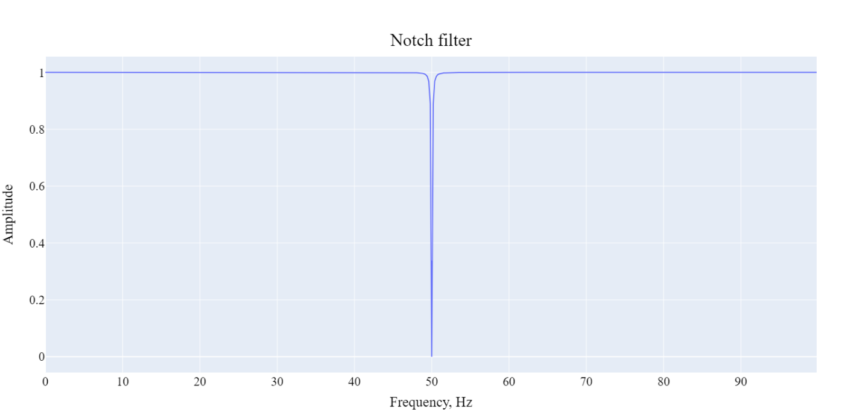Figure 2.7 – Notch filter amplitude response, Q = 250

Human electrocardiogram is placed in the range from 0.05 up to 150Hz. This band serve for extraction an adult morphology as well as fetal ECG. However, morphology components are not required, and thus the exact high band can be lowered to the point of 100 Hz. White noise is distributed in frequency area in the whole band, but with small amplitude. This fact makes him noticeable and even significant in huge frequency band signals, however, heart ones can be samples in low values and thus the whole noise is rejected. This project includes bandpass Butterworth filter with frequency band from 0.05 to 100, it has small computation cost, because of type and order of 3-5. Amplitude response of bandpass filter is shown in figure 2.8.

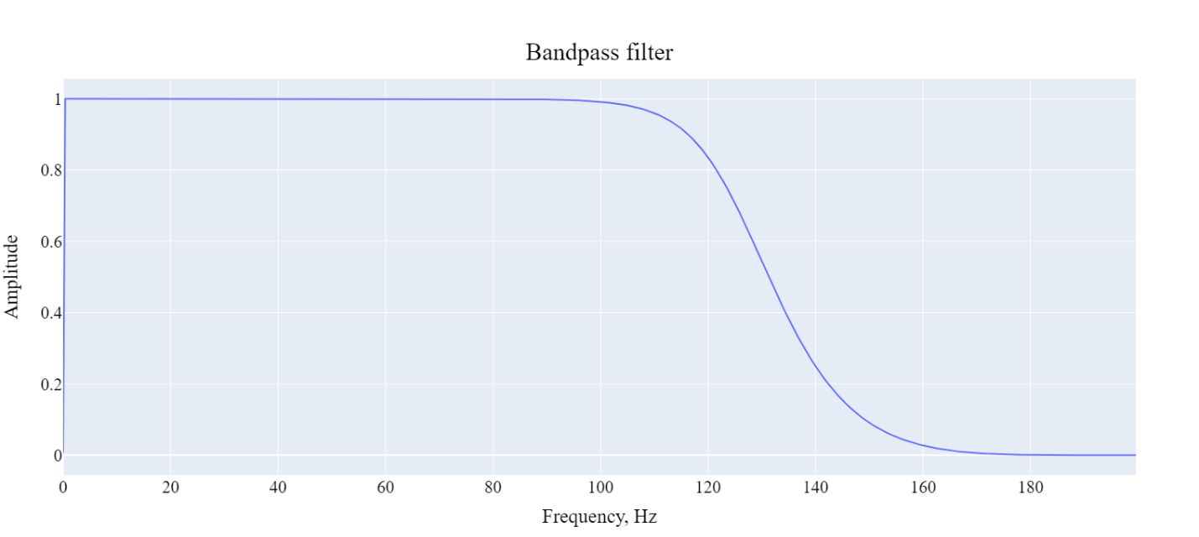Figure 2.8 – Butterworth bandpass filter, order: 3

There are also Chebyshev filter type 1 and 2 with ripples in the pass and reject bands respectively. They have higher tilt by the cost of computation speed and irregularities in bands. Figures 2.9-2.10 shows the main difference in filter families.

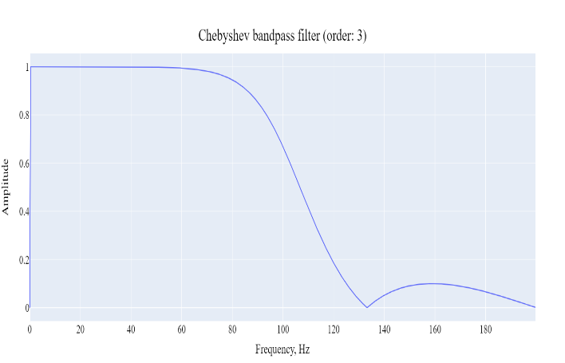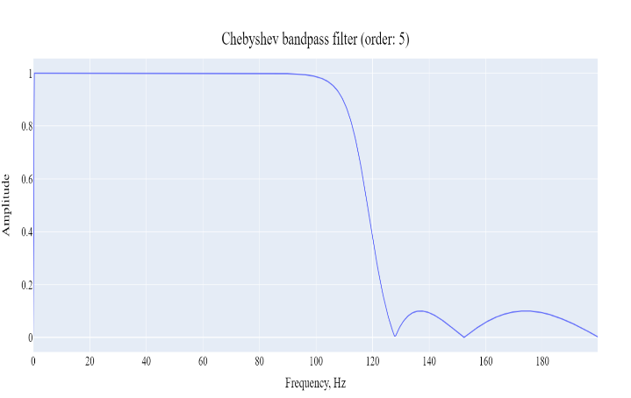

Figure 2.9 – Chebyshev bandpass filters, order: 3/5

Maximum ripple reduction is about 20 dB, as can be seen in the picture higher incline lead to more ripples in stopband (filter type 2). The difference in tilts between Chebyshev and Butterworth bandpass filters of 7 order is shown in the figure 2.10

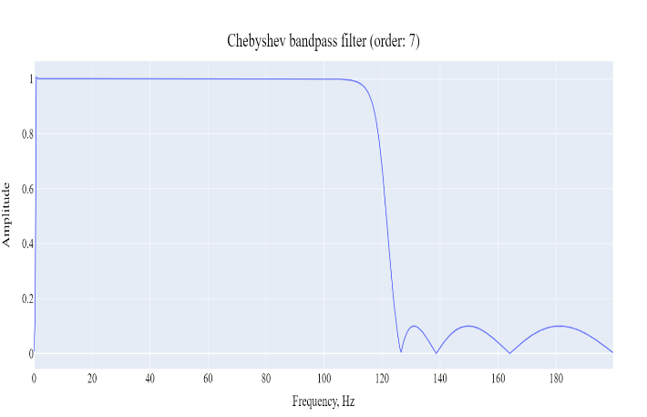

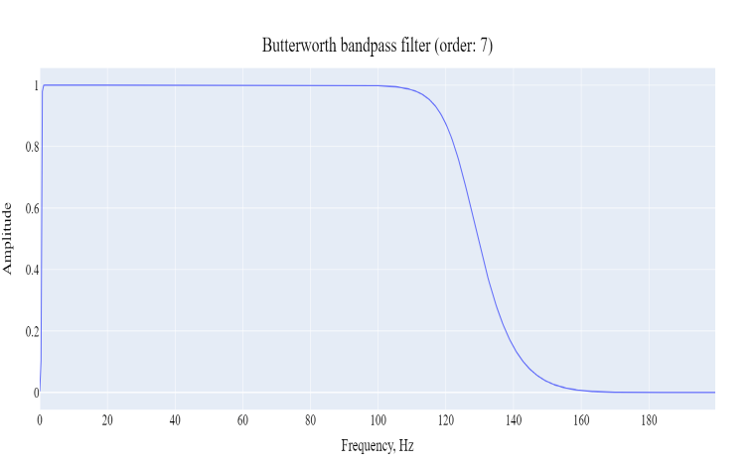

Figure 2.10 – Chebyshev and Butterworth bandpass filters, order: 7

Actually, higher stop frequency of the filters is in the point of 125 Hz, hence, Butterworth decreases signal level to the 0.707, while Chebyshev to 0.1 amplitude. Ripples in high band contains basically noise, which amount should be decreased on the first place. Chebyshev filter type 1 can change morphology in unpredictable way, although, QRS complexes of both signals is in the range of 0.5 – 35 Hz (fig 2.6).

Finally, Butterworth bandpass filter of 3rd order has been chosen with not as fast incline as in Chebyshev one, but, without ripples and satisfied amplitude response.

* + 1. Abdominal baseline wander removal

Low frequency interference rejection is the part of signal preprocessing step, although, it usually requires advanced processing steps because they have non-linear and non-stationary nature. Baseline wanders appears as a result of patient movements are breathing.

To remove this effect, ones estimated a baseline signal applying a low pass first order Butterworth filter (cutoff frequency at 5 Hz) in forward and backward directions [38]. The resulting filter had no phase distortion and a cutoff frequency at 3.17 Hz. Final signal was obtained by baseline subtraction. However, due to the lack of zero phase filter baseline wander had time delay from the signal one. This produces small high frequency distortions on the output.

Another idea consists of using median filter, this method is more efficient than linear filtering. In addition, powerful QRS waves may produce small deviations after linear filtering. Median filter with moving window about 250-300 milliseconds reveals baseline drift with small time delay after delay estimation.

Final approach is based on the Wavelet Transformation. Wavelet transform is a wonderful mathematical tool for signal and image processing due to its multi-resolution nature and computational efficiency. Wavelet schemes are especially suitable for applications where scalability and tolerable degradation are the important considerations. Wavelet transform decomposes a signal into a set of basic functions [39].

Wavelet appears in a form of function with a number of restrictions. An orthogonal wavelet is entirely defined by the scaling filter – a low-pass finite impulse response filter of length 2N and sum 1. In biorthogonal wavelets, separate decomposition and reconstruction filters are defined [40].

In addition to low pass filtering, signal also is filtered with high pass quadrature mirror filter. One filtered step is called as one level of decomposition and presented in following formulas:

|  |  |
| --- | --- |
|  | (1) |

Where, *g* – low pass filter response. Same form of equation compute high filter outcome.

However, since half the frequencies of the signal have now been removed, half the samples can be discarded according to Nyquist’s rule. The filter output of the low-pass filter *g* in the diagram above is then subsampled by 2 and further processed by passing it again through a new low- pass filter *g* and a high – pass filter *h* with half the cut-off frequency of the previous one. Thus, the number of wavelet coefficients decrease by two for every cycle.

Proposed algorithm uses Daubechies wavelet of the 4th order. It transforms low band filter output until following inequation:

|  |  |
| --- | --- |
|  | (2) |

Where *E* is the energy of filter output, the idea is to the find local minimum of high frequency coefficients. As soon as ***i***is defined low frequency filter component is considered to be a baseline.

Next step is to make inverse wavelet transform with the same wavelet function and low filter component *N* times, where *N* – the number of wavelet transformations done. Inverse wavelet transformation is described in a formula below:

|  |  |
| --- | --- |
|  | (3) |

Where and are reversed filters (wavelets) and is the component of zeroes, because the one we going to obtain is baseline wander.

The final step is a simple subtraction between input signal and baseline wander, it shown in formula 4.

|  |  |
| --- | --- |
|  | (4) |

The whole baseline removal algorithm can be presented in a scheme, which is shown in figure 2.11.

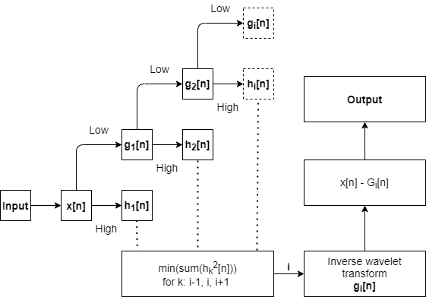

Figure 2.11 – Wander searching process of wavelet transformation

In conclusion, the overall wavelet baseline wander removal algorithm contains 3 phases. First one is signal decomposition N times while searching local minimum of energy in high frequency component, which shows the significance of low component. Second stage includes only low frequency component recomposition, which produces baseline in real time values. Third phase includes only signal subtraction. The result of 3rd phases is shown in figure 2.12 on the scalp electrode signal.

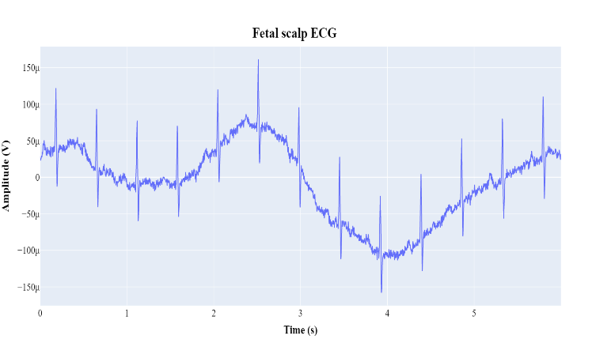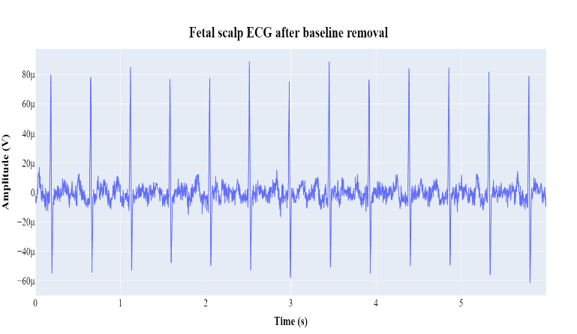

Figure 2.12 – Fetal scalp signal before and after baseline removal base on wavelet decomposition

As it is shown in the figure above baseline wander successfully removed, traces of group delay are not detected. High frequency noise observed is in the band up to 70 Hz and can be eliminated on scalp signal, but not for the abdominal signals, which contain mECG within.

* + 1. Independent component analysis

Among the huge number of invented methods for fetal ECG extraction blind source separation one was chosen as the first step in the sequence of methods. Independent component analysis is a mathematical technique for recovering unobserved source signals from observed signal mixtures.

Proposed algorithm uses the use of FastICA improved version with higher sustainability to additive noise. FastICA is a fixed-point iterative algorithm, minimizing common information between estimated components. Separation of independent components is accomplished when the maximum of non-Gaussianity is attained [41].

Before using the FastICA algorithm, the observed signal should be centralized and whitened. The mean removal process is required to simplify the method, increasing computational speed. Whitening means zeroing of all correlation dependencies between signals, this process can be done for example with principal component analysis whitening. There is also a zero-phase component analysis whitening, but the difference is not important for current paper.

Decentralization and whitening are performed according to the formula below:

|  |  |
| --- | --- |
|  | (5) |

Where – diagonal matrix with eigenvalues on the diagonal, matrix gives a rotation needed to de-correlate the data. Mean vector of input sequences is presented as .

Maximum of non-Gaussianity means the minimum of some objective function *J* by selecting weights of transforming matrix W, that is shown in formula 6.

|  |  |
| --- | --- |
|  | (6) |

Where, G’ = g, which is a non-quadratic function and is gaussian variable. Both *y* and *v* are assumed to be zero mean and with unit variance.

According to the feature of vector *w* to be normalized the calculation of matrix components wk is presented in formulas below:

|  |  |
| --- | --- |
|  | (7) |

Where is derivative of function G and is constant, which can be found as , with – initial weight vector.

After using Newton iterative formula and additional assumption, because of whitened data, one step of calculation of weight vector with step normalization is shown in formula 8.

|  |  |
| --- | --- |
|  | (8) |

There are a lot of non-quadratic functions used for independent component analysis, however, all of them must fit the conditions. The set of functions must have derivative. In the current paper a several nonlinear functions have been checked. They are shown if formulas below in the form of g(u):

|  |  |
| --- | --- |
|  | (9) |

They called from first to third: ‘*logcosh*’, ‘*exp*’, ‘*cube*’. However, the difference on the extraction of abdominal components are not noticeable, thus first ‘*logcosh*’ was chosen.

For the evaluation of method Abdominal and Direct Fetal ECG Database was used, it consists of 5 signals with features described in the list below [42]:

* Signals recorded in labor, between 38 and 41 weeks of gestation
* Four signals acquired from maternal abdomen
* Direct electrocardiogram recorded simultaneously from fetal head
* Positioning of electrodes was constant during all recordings
* Ag-AgCl electrodes (3M Red Dot 2271) and abrasive material to improve skin conductance (3M Red Dot Trace Prep 2236)
* Bandwidth: 1Hz - 150Hz (synchronous sampling of all signals)
* Additional digital filtering for removal of power-line interference (50Hz) and baseline drift
* Sampling rate: 1 kHz
* Resolution: 16 bits

Signal bandwidth equals 1-150Hz, so there is no need in high pass filtering or filtering in lower range of frequencies. The result of FastICA algorithm with all preprocessing steps, which include baseline wander removal, signal centering and whitening is shown in figure 2.13. It is important to notice that only abdominal signals were passed.

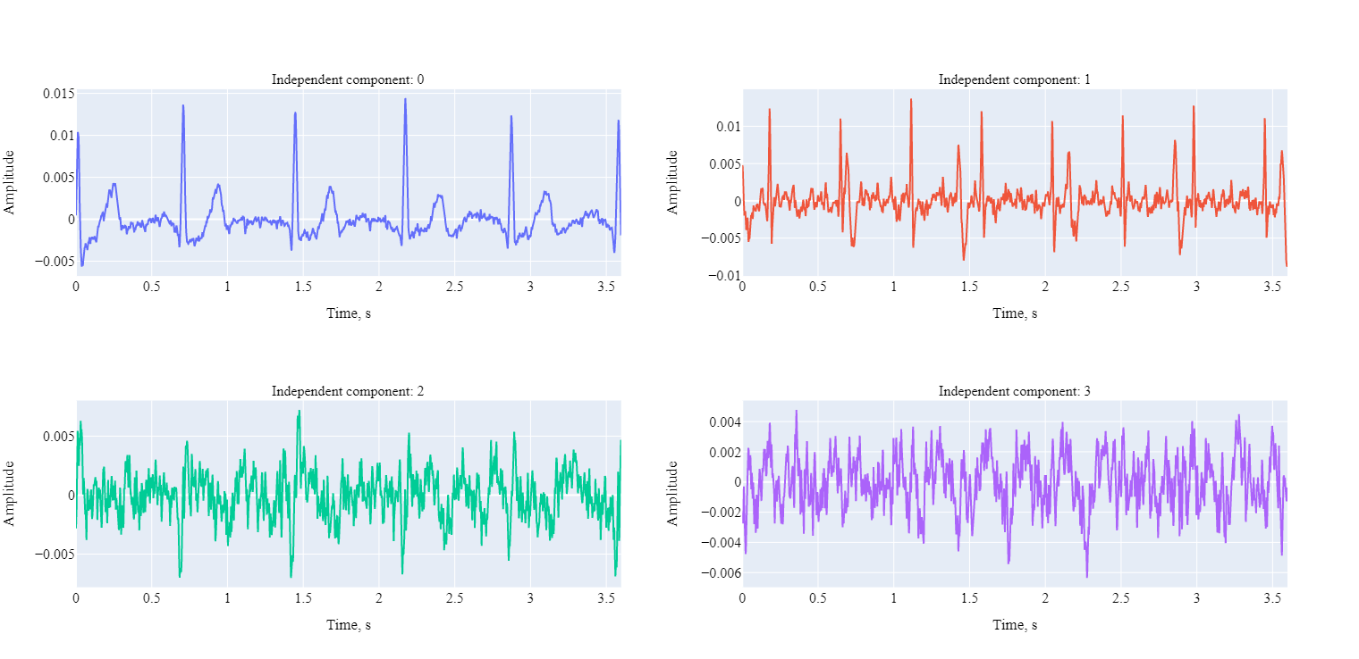

Figure 2.13 – Independent components obtained from 4 abdominal signals

It is clear to see that first two components are served as mothers and fetal electrocardiograms. However, fetal one, which is second include explicit effect from mother’s QRS component.

Important fact to be discussed is that the order of components is completely randomized. The order of ones shown in the figure 2.13 depends on the signal sum for the whole signal, it is not the robust way to estimate which one is mother’s component or fetal. Hence, there are a lot of individual ways of estimation the order which are not described in current paper. However, in order to make investigation more automatic and convenient a single threshold method was used to determine which component is *main*. For example, mother component was extracted with simple inequation presented below:

|  |  |
| --- | --- |
|  | (10) |

Where *0* and *1* are the numbers of components. Decision rule takes maximum absolute values of two independent component and choose which is higher.

* + 1. Template subtraction

The presence of mother’s electrocardiogram in the form of individual component provides the ability to subtract it from the abdominal signal. But the process of subtraction means the definition of QRS complexes, building the template for each component and template subtraction.

The most popular method for location QRS complexes is Pan and Tompkins search algorithm. In addition to the algorithm itself it has several processing steps. They include bandpass filtering, derivation, squaring and moving window integration [43].

As a part of fetal ECG extraction algorithm, template subtraction must have nearly perfect accuracy to the peak location. The problem appears is the group delay, because of filtering, deriving and processing moving window integration. Firstly, the group of approaches were used to eliminate delay for providing accurate template building and subtraction.

* Zero phase filtering
* Derivation phase delay subtraction (~2 points)
* Mowing window delay subtraction (~ N / 2)

A few steps of playing with numbers and implementation methods for moving window integration led to the use of complete another approach, which will be discussed later in this paper.

The main features of the Pan and Tompkins algorithm is the use of signal and noise levels for determine which peak can be decided to be signal and the use of back checking for a missed peak with evaluation of 8 recent RR intervals.

After definition of the peak or noise pick the algorithm calculates following values, which are shown in formulas 11-12.

|  |  |
| --- | --- |
|  | (11) |

Where SPKI is a signal level and NPKI is a noise level. Every time peak is considered to be signal or noise corresponding values updates.

|  |  |
| --- | --- |
|  | (12) |

Where *Threshold 1* serves for primary definition of signal peak values and *Threshold 2* for finding QRS complexes from missing peaks (RR search).

Finally, the first peak possible peak which is usually considered as noisy one is calculated with the rule of SPKI. This approach finds the location of maximum value within first window (usually 250 ms) and compares the value with SPKI. Current approach can lead to unpredictable first peak detections; however, it requires for the task of template subtraction. The whole algorithm of mothers QRS complexes search is presented in figure 2.14.

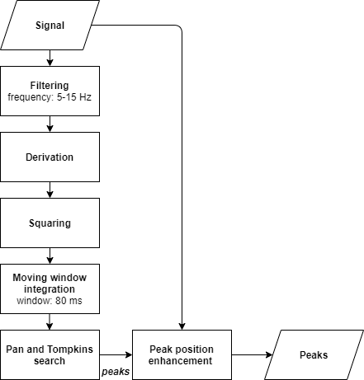

Figure 2.14 – Peak location search algorithm

Filtering and moving window integration contribute a lot in the performance of peak detection algorithm. As for filter purposes several filter parameters were used, for example, Chebyshev 1-2 type with lower frequency band. It led to dirty graph with some noise peaks, which better would be deleted. Thus, Butterworth was used with frequency band of 5-15 Hz, where higher cutoff frequency is about 11 Hz, that is likely the same as the use of Butterworth filter higher orders than 1.

Moving window was chosen to be the lowest time of complete QRS complex, usually T waves are hardly detected in abdominal signals. Thus, the requirement of huge window is not appeared, in addition, it provides better computation speed, but in very low value.

Peak position enhancement is a simple algorithm which takes peaks, signal and window. It runs for every peak and finds the maximum value, that is considered to be an accurate peak. However, time delay means the shift of wave in seconds in the past. Thus, there is no need to make window symmetric, hence, the relation is following: 25% for backward and 75% for forward search in percent of window size.

The main idea of template subtraction is to regenerate mECG and then subtracting it from the abdominal signals. Based on maternal QRS detection, i identified each mother’s ECG cycle belonging to 0.25 s before and 0.45 s after maternal R peak positions with respect to the duration of the whole cardiac cycle. The template maternal ECG then was formed by taking the average of all mECG cycles, and the new mECG was obtained by replicating.

The entire process of template subtraction is not harder than searching algorithm described. However, it has some features, for example, which signal should be changed: FastICA result or Abdominal signal itself? Independent component analysis can extract some component really precise. So precise, that fetal one is not appeared in them or the amplitude so small, that it is was not detected by Pan and Tompkins search algorithm. The idea of template subtraction is shown in figure 2.15.

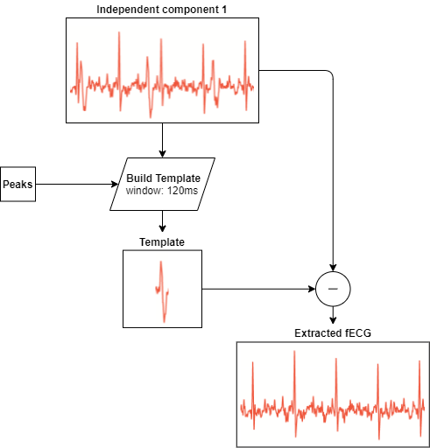

Figure 2.15 – Template subtraction algorithm

Small algorithm enhancement has been done in order to increase subtraction performance during the signal. Window approach allows template consider the rest of baseline changes and interferences. However, there is no need to build accurate template with moving window, thus, method includes stationary window with given size as presented in formula 13.

|  |  |
| --- | --- |
|  | (13) |

Since fetal electrocardiogram extracted one possibility appears. Current signal is not an abdominal one, but independent component, there is no sense of talking about morphological analysis. Finally, variability of fetal heart rate can be clearly obtained and analyzed.

* 1. Fetal heart rate analysis
     1. FHR extraction and processing

Heart rate extraction is a simple process of calculating the time difference between subsequent QRS complexes. Since we have fetal electrocardiogram, several steps are needed to perform:

* Find peaks from fetal ECG.
* Enhance peak positions.
* Calculate RR intervals
* Apply median filter

Assuming extraction method to work perfectly, no preprocessing steps are required. However, sometimes peak search algorithm can consider one noise peak before the actual one, decreasing RR interval, hence, increasing BPM value. This leads to spikes in fetal heart rate tracings. They can be shown in figure 2.16.

In addition, external sources of Fetal Heart Rate data (from cardiotocography or ultrasound) exist as databases. They in general face with problems like heart rate artifacts, the lack of data or missed data and highly noised segments [44]. So, it should have additional ways of processing. For example, artifact elimination methods and interpolation. However, not all of data can be processed successfully, thus, segment deletion is also applied in this situation.

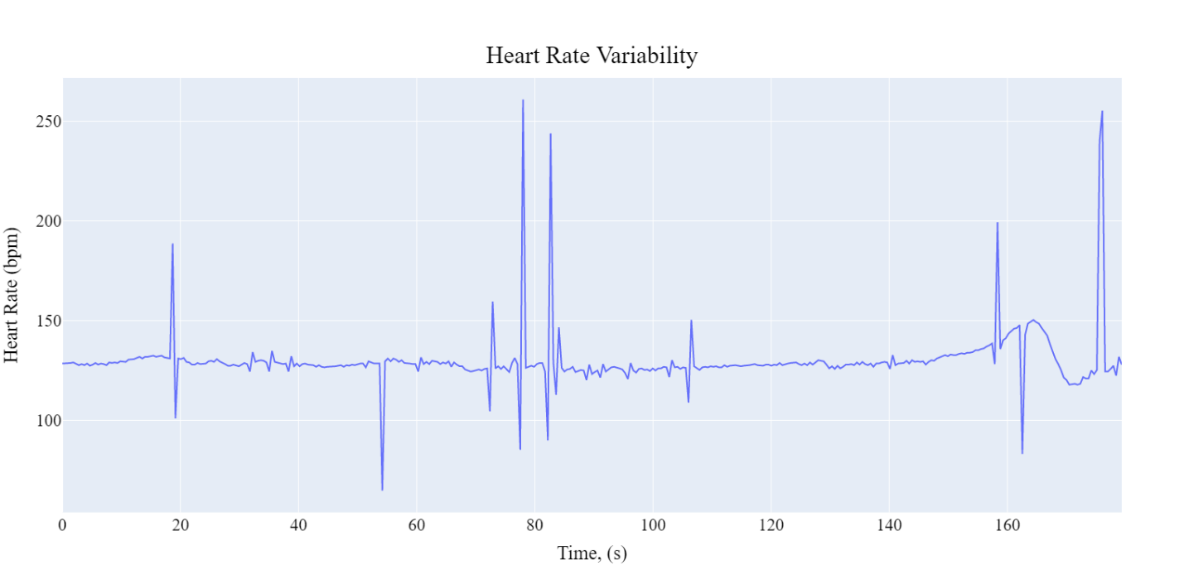

Figure 2.16 – Fetal heart rate without processing

There are a lot of easy to notice spikes, single values or sets with abnormally high values. However, some baseline change can be detected too, for example, close to 160s increase in bpm.

Sometimes it is useful to perform calculations in milliseconds instead of bpm. Converting is pretty easy and is presented in the formula below:

|  |  |
| --- | --- |
|  | (14) |

Where *RR* is an interval between QRS complexes and bpm is a generally used value for reflection of heart rate. This formula can be reversed; hence, one method can be used to convert values in both ways.

Although, spikes are indicators of missing values, they have a point, thus, interpolation is not required, there is no need to *connect* values by adding points. Smooth filters are the best approach for spikes rejection, one way to perform smooth filter is to apply low pass filtering, but it can highly interrupt morphology. Another approach is to use wavelet decomposition, but this operation consumes computation time drastically.

Simple algorithm was used; median filtering with small window about (3-6 points) will reject most of peaks and make a group delay in couple of seconds. Filtration is performed in the way very close to convolution operation, but instead of summation it uses the choice of central element in ordered list with window size. Results after median filtration with golden signal are presented in figure 2.17 – 2.18

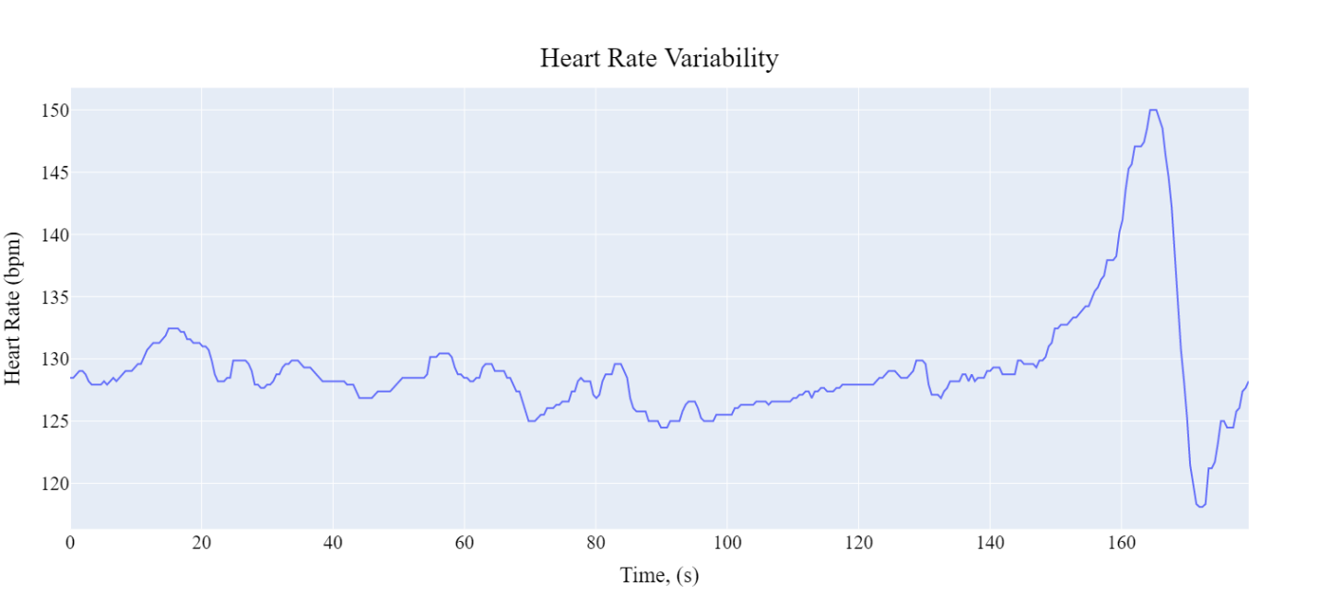Figure 2.17 – Standard Fetal Heart Rate signal

It is highly noticed that signal contains low resolution, or adjacent values are similar or with very small difference. However, on the tracing of 3 minutes wave rhythm is detected.

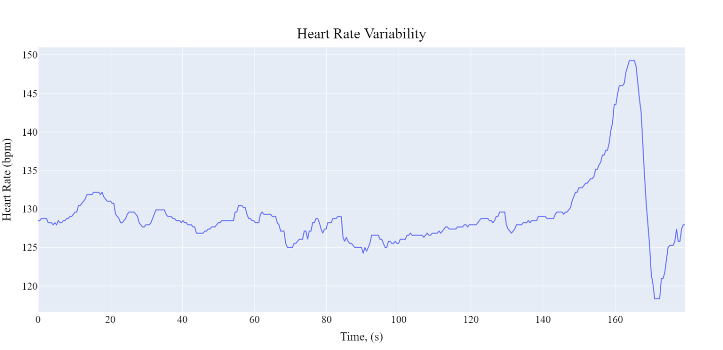Figure 2.18 – Obtained Fetal Heart Rate signal

Both traces are similar with small insignificant differences in values. While signals use the same kernel size for medial filtration, there are still more details can be detected in standard figure.

* + 1. Discovering fetal critical conditions

There are no exact methods for discovering fetal state with fetal electrocardiogram, although, the fundamentals of fetal heart rate were built. Several feature types are used for health assessment. They all are divided by nature of indicators described in the list below [45]:

* Morphological features
* Time-domain
* Frequency-domain
* Non-linear

However, this paper includes morphological features and time-domain ones. Time domain features are more interpretable and easier to find; however, all methods should be considered in future for an algorithm improvement.

Fetal heart rate is presented in the form of RR intervals, or intervals between subsequent QRS complexes. Adult human has change of heart rate with age. Fetus, since it is fast growing, have heart rate changes significantly with weeks of life: more weeks it is, lower average rate it has and higher variability. These parameters are called *baseline* and *heart rate variability*. Baseline can be calculated in different ways; however, it means the same physical value. For examples, ones use simple average techniques, others use advanced, robust methods for make this parameter stable.

In the current paper a histogram method has been used. The idea is simple and contains only the calculation of elements for each bin. The bin with maximum elements defines a value, which is considered to be the baseline. Histogram approach provide parameter to be similar to median value of fetal heart rate, but bin settings, including number of bins or their ranges, increase value understanding of baseline. The process of baseline calculation is presented in formula below:

|  |  |
| --- | --- |
|  | (14) |

Where *argmax* function means argument of maximum value in the set. *Hist* builds histogram and outputs number of elements for each bin array. The number of bins used is 15, which provide more resolution for baseline value.

Fetal heart rate variation amplitude is a deviation from a baseline, all human beings should have it as adaptive heart mechanism. It can be calculated from the formula 15. In addition, should be cleared from artifacts and accelerations/decelerations first.

|  |  |
| --- | --- |
|  | (15) |

Where *AmpStd* is fetal heart rate variation amplitude and std is function defines standard deviation. It is calculated as shown below:

|  |  |
| --- | --- |
|  | (16) |

Where is an average value of fetal heart rate. In this paper it is considered as baseline, and thus, was subtracted before.

Other heart rate variability parameters used are mostly statistical and do not used in the current paper for decision making. They include:

* SDSD – standard deviation of subsequent RR intervals differences.
* SDNN – standard deviation of RR intervals.
* RMSSD – The root mean square of successive differences between normal heartbeats.

There are a bunch of variables more, but they are not used here. Although, two important values can provide a lot information of signal obtained. In this paper they are called:

* Outhigh.
* Outlow.

They present the percent of signal, which is out of some limits. For example, variability for fetuses with age more than 32 weeks is considered to be from 6 to 25 bpm. However, with *outhigh* value we can assess the amount of signal variability out of high limit, and then make a better decision.

The use of time domain features has been tested on the fetal heart rate tracing presented in the figure 2.18; the result is shown in table 2.1.

Table 2.1 – Time domain features

|  |  |
| --- | --- |
| Feature | Value |
| Baseline | 468.5 ms |
| AmpStd | 3 bpm |
| SDSD | 2.43 ms |
| SDNN | 15.6 ms |
| RMSSD | 2.43 ms |
| Outhigh (500 ms) | 9 % |
| Outlow (450 ms) | 1 % |

Morphology features include accelerations and decelerations. Fetuses with critical conditions are frequently defined with exactly these measures. Accelerations and decelerations are the reaction for some exposure, for example, movement activity or uterine contractions.

One popular method called CTG uses parallel recording of uterine contractions with fetal heart rate changes. Hence, there can be clearly seen how contraction influences on heart rate variability. Successful techniques include analysis an interaction. For example, the time delay between events or time of deceleration after contraction occurs. However, current thesis includes only analysis of the presence of these changes, and calculation their number.

Search algorithm is built on threshold method. Signal in bpm values and acceleration/deceleration is more than 15 bpm in amplitude. While amplitude of fetal heart rate variability in normal fetuses can be about 6-25 bpm, accelerations should also include duration time that was set at least 15 seconds. Mean amplitude change, which are shown in formula 15 is calculated on pure signal, or signal without accelerations, due to more adequate value.

One decision making algorithm was implemented for defining level of danger to the fetus by fetal heart rave variability analysis. It divides fetuses in 3 states:

* Green.
* Yellow.
* Red.

From the health side it is ordered from secure to danger, where yellow means the requirement of a doctor to make more advanced decision. There are several features are observed to make the decision. They are accelerations and decelerations, variability amplitude and baseline. Each limit and algorithm at all is presented in figure 2.19.

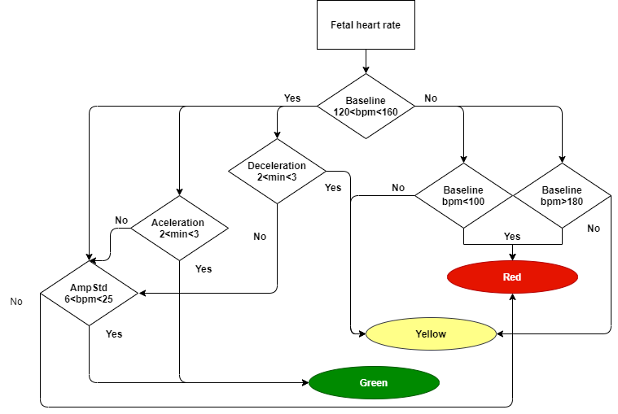

Figure 2.19 – Scheme of fetal heart rate decision algorithm

Reasons of defining fetus in the red zone are the small baseline variation change or the absence of tachycardia or bradycardia, which means baseline less than 100 bpm and higher than 180. Decelerations are abnormal as it is, unless they don’t have bad pattern in a shape of repetitiveness or with contraction delays. The presence of accelerations leads to green level, because it is a normal reaction for some influences.

* 1. Conclusion

Abdominal channels have a lot of influences and useful signals, which must be rejected in order to extract fetal heart rate signal. However, preprocessing steps, like Butterworth bandpass and notch filtration for eliminating of powerline interference and high frequency noises.

Abdominal channel is a set of mother’s and fetus’s signals, and thus, they were separated with FastICA method. Well defined dominant mothers’ content has been subtracted from the all independent components to be sure its peaks are not involved in fetal heart rate detection.

Fetal heart rate analysis presented in current paper is pretty poor, however, it includes fundamental time-domain and morphological features and decision-making algorithm based on them.

1. FETAL ECG EXTRACTION AND ANALYSIS ALGORITHM EVALUATION
   1. Signal registration instrumental requirement

Fetal electrocardiogram is a very small signal in amplitude among the sources, which abdominal channel contains. Thus, registration systems must provide data with enough signal-noise ratio. Or minimize the number of external interferences, decrease the level of artifact influence and so on.

One important limit due to the fetal ECG extraction methods used exists. Since Fast ICA can be performed with low number of channels, system will perform better with higher number of channels, because all of them will have the same sources with differences. However, previous projects shew that usually signal contains several at least one channel with high visual quality for both fetal and mother’s electrocardiogram; example of such channel is shown in figure 3.1

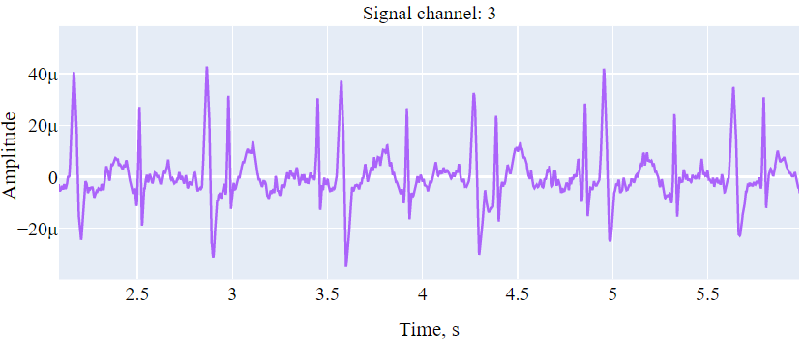

Figure 3.1 – Abdominal channel with low noise component

However, there are can be channels with high noise amplitude in comparison with both signal amplitudes. An example of such channel is shown in figure 3.2. While it is full of noise, fetal and mother’s electrocardiogram here are quite similar in amplitude, thus, this channel may improve the performance of FastICA greatly, but for the cost of additional noise.

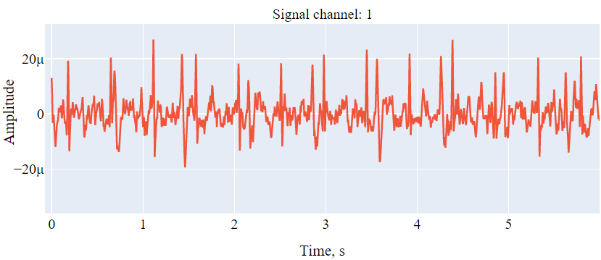

Figure 3.2 – Abdominal channel with high noise amplitude

Since FastICA takes several signals, there is a possibility to obtain two channels with very low noise content, and then divide signal in two independent sources, where mother’s and fetal components may include themselves in highly different proportions.

The search of right electrode alignment is mostly practical task, because there is too hard to find source location in uterus for building right signal propagation model. However, it is briefly described in chapter 2.2.1 of current paper.

Any channels are obtained by the list of sequent operations, they should include amplifying, analog-digital converting, although, ECG analog frontend, may include both of these elements with additional filter or digital signal processing units.

Amplifiers are needed to increase the level of signal for passing it through the ADC. The amplitude of the fECG can vary typically in a range between 3 and 20uV, however, mother’s component is decreased rapidly with a distance from the heart. Figures 3.1-3.2 shows, that mother’s QRS level is about 20-50 uV in amplitude. However, for example, 8-bit ADC can resolve about 13mV and 16-bit ADC is about 50 uV with 3.3V supply. Hence, amplification about 1000 times is required, it is also can be called as 30 dB gain. Amplifiers has working frequency band, since there is no need in amplifying high frequency noise, the band about 1-200 Hz is enough for the task of fetal heart rate extraction.

In conclusion, overall system should contain at least two acquiring electrodes with small signal to noise ratio and clear manifestation of fetal and mother’s electro cardio activity. Channels are directed right into the low noise amplifiers with gain, which should allow analog to digital converting; for example, 30 dB with 16-bit ADC. Since we have our fetal signal in range about 200 Hz, sample frequency can be set from 500 Hz for detailed versions and 250 might be enough for fetal heart rate extraction purposes. Then signal directs on the transmission line, for example Bluetooth low energy device, which provides high speed and consumes small amount of energy for mobile gadgets. The whole system is shown in figure 3.3.

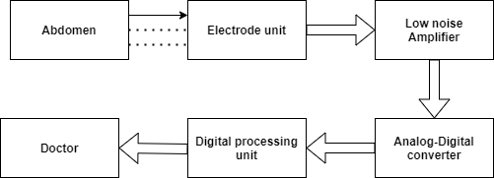

Figure 3.3 – Scheme of fetal ECG measurement unit

Electrode unit means a box with electrodes; however, it also can be implemented as belt or electrode patch system, depends on electrode placement. Digital processing unit is a personal computer for current research. Other approaches use microcontroller units with chain of operations, which leads to Fetal heart rate variability features directly to the doctor.

* 1. Fetal ECG extraction algorithm evaluation
     1. Evaluation metrics

Results to be analyzed is presented as list of points with detected QRS complexes. A lot of datasets don’t have marked list of R waves, in case it has. One should understand, that the golden standard of peaks detected is fetal scalp electrode, which can also have noises and artifacts.

List of points can be presented as binary data, with *N* – number of points in abdominal signal, and True is the value of point location. However, the deviation in 4-5 points or several milliseconds is okay due to the method error. This approach allows calculate all basic value for binary data:

* True positives
* True negatives
* False positives
* False negatives

These values are the fundamentals of several metrics, here we are interested in two on evaluation values:

* True Positive rate.
* Positive Predicted value.

Addition metrics like accuracy and F1 score are used to estimate general performance of the system. Operations for the first 2 approaches are presented in following formulas:

|  |  |
| --- | --- |
|  | (17) |
|  | (18) |

Where *TP* is true positives and *P* is all positive values, which include True Positives and False Negatives. *FP* means false positives.

According to evaluation of fetal heart rate algorithm extraction *TPR* will show the rate of right predicted QRS complexes among of all presented in the signal. While *PPV* will show the number ofright predicted QRS complexes between all of predicted. There are some more metrics can be used for assessment of negative outcome, however, it is not interesting, because the difference between zeroes and ones is immense.

General performance is evaluated with two metrics, they are presented in formulas 19-20. Accuracy takes into account negative predictions, while F1 score is mostly not.

|  |  |
| --- | --- |
|  | (19) |
|  | (20) |

Where *N* is the number of all negatives. True negatives are not used.

Accuracy shows how correctly we find R peaks and detecting places without them. Harmonica mean or F1 score provides overall performance of the built system as well as Accuracy, but it operates PPV and TPR relation between these values.

While we can use peak array as well as binary one, there is need to choose how to perform evaluation. Since true negatives do not have sense for algorithm assessment, the use of peak arrays is chosen.

Peaks exist as QRS complexes point number array, hence, here can be differences for a couple of points or 5-10 milliseconds (sample frequency is 1000 Hz) between corresponding peaks. Thus, decision for each peak to be the part of true positives or false positives is presented in figure 3.4.

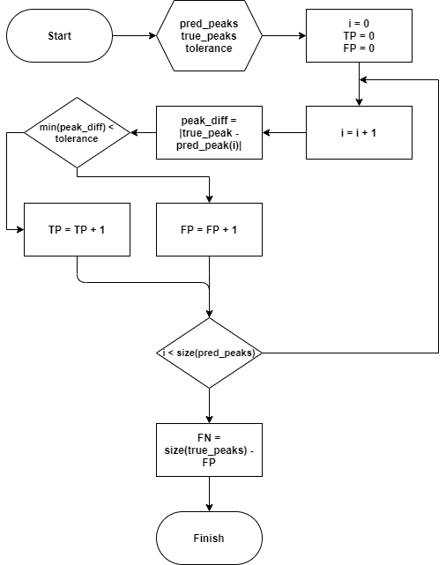

Figure 3.4 – Bloch scheme of TP, FN, FP calculation

The only dataset with market QRS complexes I found is the abdominal and direct fetal electrocardiogram database or ADFECGDB [42]. It is described clearly in the chapter 2.2.4. Most of datasets provides actual FHR data and features, or abdominal signals with fetal scalp electrode ones, which do not allow to evaluate algorithm fully on them.

* + 1. Algorithm evaluation

Signals to be evaluated are the part of ADFECG database. There are 5 signals with same algorithm acquirement but different quality. Apparently, fetus position changed between measurement objects. It led to low signal quality for some channels, and thus, for algorithm.

Table 3.1 – Algorithm evaluation on ADFECG dataset

|  |  |  |  |  |  |
| --- | --- | --- | --- | --- | --- |
|  | R01 | R04 | R07* | R08** | R10** |
| TP | 609 | 372 | 438 | 296 | 268 |
| FP | 36 | 253 | 203 | 31 | 55 |
| FN | 35 | 260 | 189 | 33 | 55 |
| TPR | 0.95 | 0.59 | 0.70 | 0.90 | 0.83 |
| PPV | 0.95 | 0.59 | 0.68 | 0.91 | 0.83 |
| Acc | 0.90 | 0.42 | 0.53 | 0.82 | 0.71 |
| F1 | 0.94 | 0.59 | 0.63 | 0.90 | 0.83 |

Table 3.1 has record with stars, which mean difference from original record. R07 record has first abdominal channel broken, apparently, electrode contact was violated. Thus, this channel was deleted from final algorithm by hands. From this moment one fact became clear, there is need for channel selection algorithm in the operation chain in order to reject these signals from the beginning.

Records 8 and 10 have a lot of artifacts through the signal, however, very significant parts start after 150s. Thus, algorithm takes only half of full 300ms record, in addition, it led to smaller number of TP values. An example of successful signal extraction for record 10 is presented in figure 3.5.

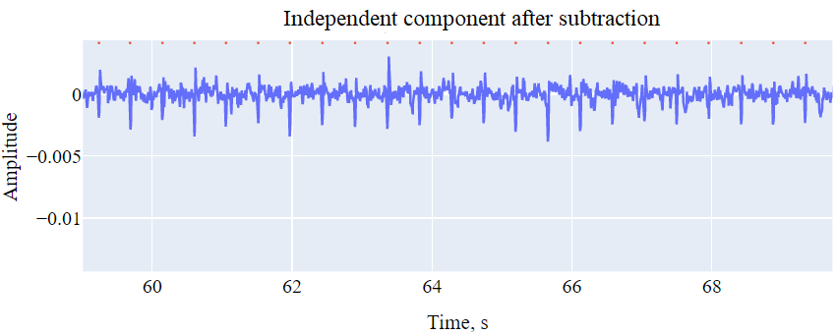

Figure 3.5 – Independent component after subtraction (record 10)

Record number 4 passed through algorithm without changes. Since it was contaminated with noise, outcome is overwhelming even with unreadable parts in signal as well as in some independent components.

* 1. Approbation of the fetal assessment algorithm

Fetal heart rate serves as a strong method for fetal health evaluation. There are a lot of features, which can be extracted from FHR tracings, they are briefly described in section 2.3.2. Algorithm built contains several of them to make a decision about fetal risk level; it is annotated in three levels.

Since, there is the low number of tracings with marked health state, furthermore, algorithm described in this paper do not detect the certain health disability, but only indicates the level of danger for a doctor, FHRMA dataset was chosen [54]. Tools they used to obtain features output the number of accelerations and decelerations, if exists, and baseline tracing by linear interpolating of these regions.

Figure 3.6 shows the graph fetal tracing looks after median filtration with kernel of 4. All tracings are sampled with 4 Hz frequency and have average duration of 90 minutes.

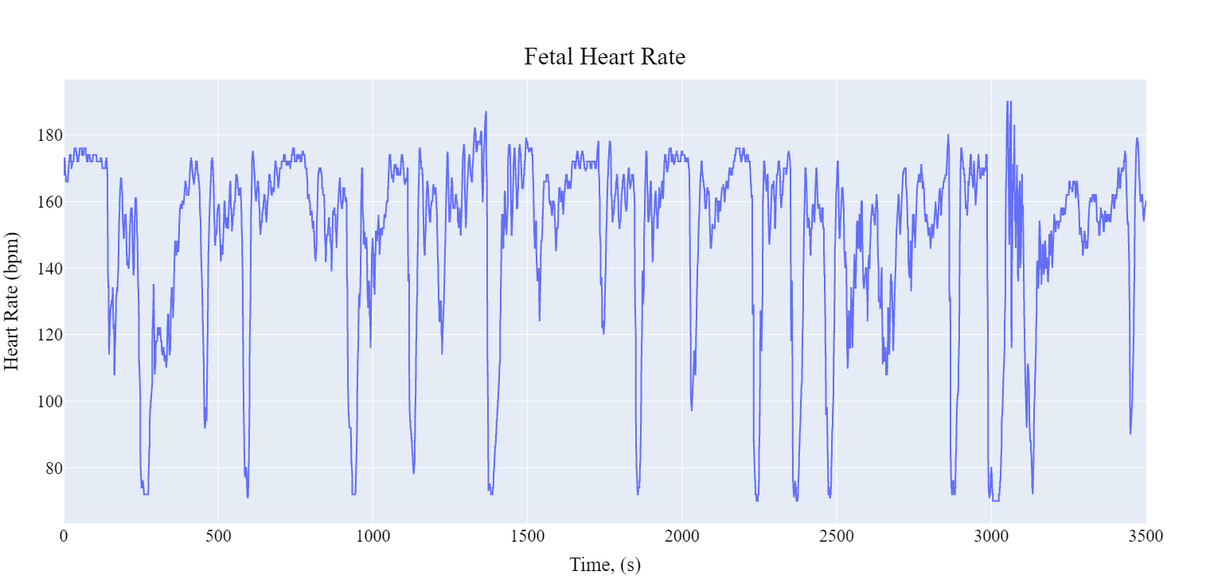

Figure 3.6 – Fetal heart rate tracing (FHRMA dataset)

Most of decelerations observed from figure above achieve 80 bpm level and below, which does not reflect the real state. However, proposed algorithm does not take into account bpm level, because, there duration is the main feature to be observed. Since, baseline calculates by histogram and variability from the signal without decelerations and accelerations there is no need of additional filtration.

Only a small number of tracings were investigated, but they include several with decelerations and accelerations in different proportions. The algorithm decisions with predicted number of decelerations and accelerations are presented in Table 3.2.

Table 3.2 – Algorithm decisions (FHRMA traces)

|  |  |  |  |  |  |
| --- | --- | --- | --- | --- | --- |
|  | trace 1 | trace 2 | trace 10 | trace 26 | trace 28 |
| Level | 1 | 1 | 1 | 0 | 0 |
| Baseline | 170 | 161 | 177 | 118 | 139 |
| amp_vhr, bpm | 7.4 | 7.0 | 5.3 | 6.2 | 8 |
| Acc_num | 0 | 0 | 0 | 13 | 17 |
| Dec_Mild | 29 | 19 | 8 | 0 | 38 |
| Dec_Prolonged | 1 | 2 | 0 | 0 | 0 |
| Dec_Severe | 0 | 0 | 0 | 0 | 0 |

Several traces were investigated with different baseline and acceleration/ decelerations numbers. The presence of prolonged decelerations indicates yellow level or there is a need of professional trace observation. Severe decelerations are met very rear, so in this research they are considered as decelerations with more than 5 minutes in duration. *Amp_vhr* value became very unstable with imperfect acceleration/deceleration rejection algorithm, however, it can detect small variability level with pretty well accuracy. In addition, the presence of accelerations usually indicates normal fetus, thus, if algorithm finds any it decreases level to zero.

* 1. Conclusion

Signal quality significantly influence the whole algorithm performance; thus, good build of acquisition system is one of fundamentals in fetal electrocardiogram extraction and analysis. Although, electrode placement is not less important, because, location changes of a fetal heart affect dramatically on the channel contribution. Since some channels are highly contaminated, there is also a requirement in channel selection algorithm for eliminating trash ones.

Algorithm metrics was set to underline positive predictions, because the task is to find single R peaks in the whole signal. Unfortunately, the lack of marked data and real datasets from modern acquisition systems led to small number of qualitative assessment cases.

Outcome presented in table 3.1 shew the difference of signal quality and how algorithm can adjust to it. Actually, there is no way to cope with fetal heart rate extraction task without noise removal with hands or automotive solution.

1. SPECIAL SAFETY ISSUES
   1. Algorithm’s area of use

Fetal monitoring is a part of health assessment methods for biological system, containing mother and her baby. The method described here receive a bit of information in the whole feature dimension. Fetal electrocardiogram as well as methods which include signals obtained from electrodes evaluate the work of organs and system in general.

Fetal electrocardiography is a promising alternative to cardiotocography continuous fetal monitoring. Robust extraction of the fetal signal from the abdominal mixture of maternal and fetal electrocardiograms presents the greatest challenge to effective fECG monitoring.

Fetal heart rate monitoring in its early form was based on the auscultation methods, i.e. intermittent observations of the fetal heart sounds. Progress in electronics and computers science brought to the introduction of the first fetal monitors based on phonocardiography in the middle of the 20th century. Yet these inventions were still challenged by the need to automatically distinguish between the maternal and fetal heart sounds. Consequently, in 1953, the first attempt was made to continuously monitor fetal heart rate by means of non-invasive fetal electrocardiography [46].

To the time, the number of successful attempts in fetal electrocardiography, fetal monitors is in the tens. Overall, they can be divided in two categories:

1. Stationary fetal monitors (ex. Meridian Mindchild,)
2. Mobile fetal monitors (ex. Monica AN24)

Main difference of categories in their number of features to be extracted, their quality and comfort of use. The idea of their use presented in figure 4.1. It is important to notice the size of calculation modules.

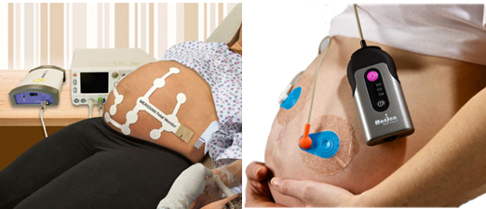

Figure 4.1 – Fetal monitors a) Meridian Mindchild stationary monitor

b) Monica AN24 Mobile monitoring system

While those are ready to use devices, my algorithm is intended to use in computer systems first of all. However, there are a lot of common parts, methods which can be used both in mobile, stationary or not lifetime systems.

For example, filter methods, including wavelet baseline removal, are ready to use in practically most of systems with little limitations. Fetal heart rate analysis, which is described in 2.3 intended mostly on telemedicine fetal monitors, while still can be used on non-lifetime data.

* 1. Software safety

Software to be developed do not complete any safety functions and activities which can directly hurt operator or patient. However, the field of biotechnology and medical science tightly communicated with human health.

Fetal heart rate analysis algorithm as well as other diagnosis tools perform assessment tasks and outputs biomedical indicators and decisions. Algorithm presented in current master’s thesis may harm people with imprecise data in case of unforeseen situations, which are mostly depend on the data acquired.

1. Complex high electrical interferences.
2. Continues artifacts with morphology similar to ECG
3. Non-compliant data acquisition

Algorithm as the list of instructions cannot misbehave, hence, difficult noises and problems described above should be eliminated in future releases.

* 1. Software ergonomics

Software ergonomics is a subcategory of ergonomics that concerns the software design, rather than the hardware design, of systems. Software ergonomics includes the determination of user needs, interface design, user support and usability testing.

Software-ergonomics standards contain guidance which assists both the specification of user requirements and the design and evaluation of the user interface of an interactive system. These standards do not aim at standardizing the user interface; rather, they give recommendations that should be applied in order to ensure the usability of the user interface of the product and eliminate design solutions which can be predicted to cause usability problems to users [47].

There is a list of fields in standards, which describes the most of features connected with software ergonomics

1. General guidance on software ergonomics (ISO 9241-110 to ISO 9241-119);
2. input, output and interaction (ISO 9241-120 to ISO 9241-129);
3. performance support (ISO 9241-130 to ISO 9241-139);
4. interaction techniques (ISO 9241-140 to ISO 9241-149);
5. topic-specific guidance (ISO 9241-150 to ISO 9241-159);
6. interface control components (ISO 9241-160 to ISO 9241-169);
7. cross-topic guidance on accessibility (ISO 9241-170 to ISO 9241-179).

Fetal heart rate algorithm analysis is mostly hand written and code is for personal use, but some parts could be extended and used by other people. Thus, there is a sense to describe ergonomic part of human-software communication in the way of updates and research.

In addition, the absence of a graphical user interface makes unnecessary item 3, performance support. Which describes element and field highlighting and other features for intuitive program use. Interface control components as well as graphical interface is completed in algorithm is optional and not realized, thus, items 5 and 6 do not relate to the project done.

* + 1. Dialogue principles

Seven principles have been identified as being important for the design and evaluation of interactive systems, which serve as a set of general goals for the design and evaluation of dialogues [47]:

1. Suitability for the task;
2. self-descriptiveness;
3. conformity with user expectations;
4. suitability for learning;
5. controllability;
6. error tolerance;
7. suitability for individualization.

Algorithm is presented as a number of intuitive functions gathered together in the order of doing the task step by step. However, there is no graphical user interface for people to easy follow these steps. The majority of functions are presented in the way of providing user comfort, default parameters are set, all function are called with clear understandable names.

In addition, items 4 and 5 are mostly depends on the development environment and still cannot be achieved by code perfection. While the program is intended for qualified people, for example, in programming language it is written in, items 6 and 7 may be performed.

* + 1. Individualization

Individualization is used in a wide variety of ways to enhance applications both for users. The wide variety of different implementations includes many instances where individualization creates considerable challenges for the users that it ought to be helping. This becomes an even greater challenge when users have to deal with different individualization approaches in each of the several applications that they use [48].

Individualization is a very delicate question. Algorithm for fetal extraction and analysis like a constructor, where signal flows through the independent blocks. To this time, researched can adjust block parameters, rework some of them or even exclude from the algorithm. However, huge changes should be performed with rules. First of all, dependencies must be fit and not violates in any way. Signal flow are not to be changed, because of algorithm interruption.

From the other hand, human factor may impact on the code changes badly, because of misunderstanding that is shown in [49] chapter 6.3. For example, a number of nonsense commands might lead to increase of computational cost and accessibility to other functions.

* + 1. Software accessibility

It is important to incorporate accessibility goals and features into the design as early as possible, when it is relatively inexpensive compared to the cost of modifying products to make them accessible once they have been designed.

The majority of graphs are used with *plotly* framework. Plotly is a technical computing company headquartered in Montreal, Quebec, that develops online data analytics and visualization tools. Plotly provides online graphing, analytics, and statistics tools for individuals and collaboration, as well as scientific graphing libraries for Python, R, MATLAB, Perl, Julia [50].

Despite they provide graphical user interface framework called *Dash,* current project was done only with offline version of graphs that were plot [51]. User interface presented in the figure 4.2.

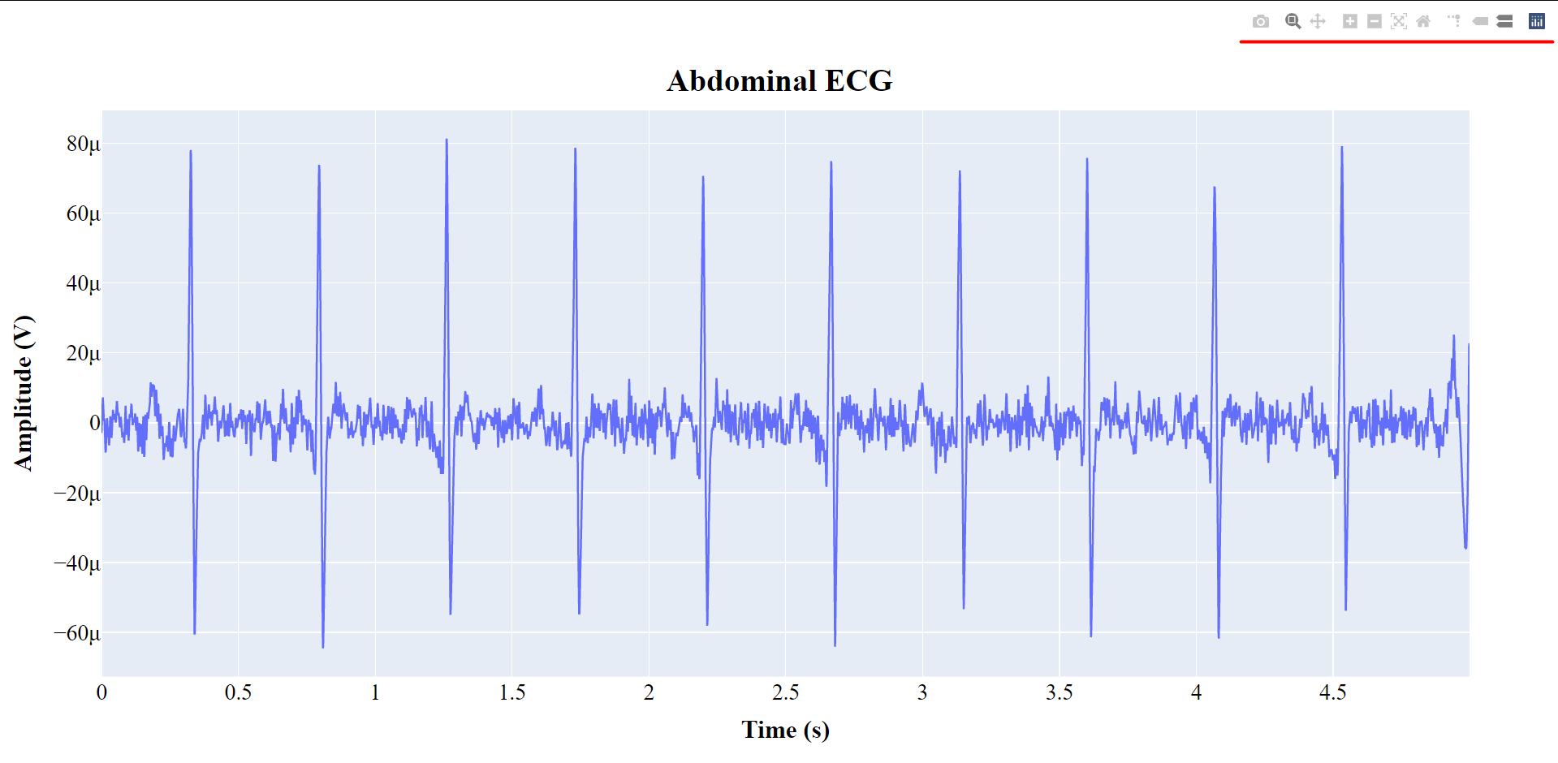Figure 4.2 – Graph representation with plotly

Framework provide base intuitive buttons in the right top angle. There is a possibility to make screenshot, zoom the data and go through the plot with an ability to come back to the initial settings.

Standard ISO 9241-171 is based on the current understanding of the characteristics of individuals who have particular physical, sensory or cognitive impairments. However, accessibility is an issue that affects many groups of people. The intended users of interactive systems are consumers or professionals – people at home, at school, engineers, clerks, salespersons, Web designers, and so on. The individuals in such target groups vary significantly as regards physical, sensory and cognitive abilities and each target group will include people with different abilities.

Thus, people with disabilities do not form a specific group that can be separated out and then disregarded. The differences in capabilities can arise from a variety of factors that serve to limit the capability to engage in the activities of daily living, and are a “universal human experience”. Therefore, accessibility addresses a widely defined group of users including [52].

Plotly interface satisfies most of items in standard. Names are done with idea of being short, meaningful and uniqueness in the separated field they are placed. The whole name rules are presented in list below:

* Each element has a name.
* Names are unique in the field of use.
* Names have clear meaning.
* Names should be short.
* Names are available to assistive technologies.
* Names have proper position related to other elements.

For the graph display plotly interface provide different abilities to work with diagrams, they are presented in a list below:

* Support *Copy* (save) operation.
* Support *Undo* operation.
* Support elements to move the graph.

To conclude, plotly framework provide standardized way to draw graphs and diagrams with a clear ability to save, move and zoom operations. Despite figure elements are done by default, graph elements can be adjusted only with program code. So, there is no graph inspector to change title, text style and so on in the completed figure, that can lead to some difficulties.

* + 1. Research comfort

There are lots for programming language that are known but all of them need to follow some strategy when they are implemented and this methodology/strategy is paradigms. Apart from varieties of programming language there are lots of paradigms to fulfil each and every demand. In general programming paradigms can be divided in two groups:

* Imperative.
* Declarative.

Main difference is in the way of performing the task. Imperative paradigm works by changing the program state through assignment statements. It performs step by step task by changing state. The main focus is on how to achieve the goal. The paradigm consists of several statements and after execution of all the result is stored [53].

While declarative paradigm focuses on what needs to be done rather how it should be done basically emphasize on what code is actually doing. It just declares the result we want rather how it has been produced.

Fetal heart rate algorithm has been done with imperative programming paradigm, or rather object-oriented programming. Actually, if I had a chance to make if from scratch I would build well defined class-method structure. However, there are no dedicated classes, just functions which usually take the common parameters:

* Sampling frequency
* Data

Right representation should contain methods which take these data as attributes of class and perform filters, processing algorithms, etc. So, it leads to disadvantage in code structure, makes it more complex and disorganized.

Another drawback of an algorithm as a research tool is the absence of graphical user interface or availability of pipeline implantation. There are a lot of parameters to change in order to influence on the signal in algorithm flow. For example, filters can have following parameters:

* Type (realization).
* Order.
* Frequency range (or single value for low/high filtration).

Graphical user interface could provide online change of parameters without relaunching the whole algorithm. Thus, computation speed for one test is much higher for the cost of a small amount of building time.

More complex processing and analysis parts would have the same amount of performing time. However, there is one significant interface that requires a lot of time compared with common methods. Graph building on the base of *plotly* framework requires two objects to show the outcome:

* Figure.
* Graph.

Figure is the place where graphs are located, it has the number of attributes like title text, alignment, styling elements and so on. Graph is the object that includes data and description within. Overall computational cost is distributed in these objects in the proportions of about 80 and 20%. Thus, predefined figure object with graphical user interface would decrease the amount of time to be used for research.

From the other hand, current program code contains several required comfort improvements. First of all, program is separated in four modules:

* Main.
* Dataset extraction.
* Processing.
* Analysis.

Strict structure sets the terms of use, for example, *analysis* can inherit variables and functions from processing, but not in another way. *Main* module inherits all other modules, while, *dataset extraction* is done only for data conversion in the form the whole algorithm performs. User module dependencies are shown in figure 4.3.

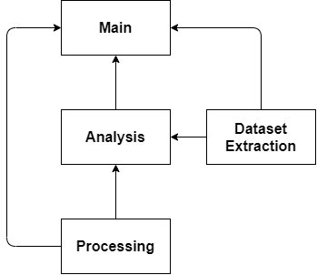

Figure 4.3 – User module dependencies

Second advantage is hidden in the input of the functions, despite the absence of right object-oriented paradigm, all of functions have predefined default values. For example, there is no need to set all parameters to make the project working, moreover, some values like *sampling frequency* are inherited from processing block and can be changed for all functions by default. This approach provides making functions independent for other applications with comfortable performance within project.

* 1. Conclusion

The project to be evaluated in terms of safety and ergonomics consists of two parts:

* Programming code
* Graph interface

Graphs and figures are only the part of chosen framework, thus, most of tools they provide couldn’t be changed or individualized. However, it satisfies standards of naming and alignment for comfortable use with clear element understanding.

Program code is mostly user developed, thus, it consists of a number of drawbacks in structure (complexity) as well as in repeatable research activity. However, there are a bunch of features done for convenience in the built structure. For example, some disadvantages from the absence of classes is neutralized with global variables and module inheritance.

CONCLUSION

Telemedicine is becoming more popular now, just like smart bands or ECG monitors, fetal heart monitoring became available. However, the process of extraction fetal ECG is highly differing, because abdominal signals are contaminated with external noises as well as with mother’s component, which is higher in about of 10 times.

There are some ready to use solutions, which companies like General Electric or MindChild have. They provide both patch system and measurement unit. Perfect electrode placement with unique computing module in bundle allow them achieve great results.

A bunch of methods exist for fetal ECG extraction, some of them use mother’s ECG additional channel for adaptive filtering and subtraction methods, other use a lot of abdominal only channels for independent extraction. Independent component analyze is used in current paper to reveal independent sources, which include mother’s and fetal component. Noise content is also extracted; however, other channels have interference noticeable.

Algorithm developed contains a small chain of operations, pipeline include preprocessing step, which include bandpass, notch filtering and baseline wander removal with the use of wavelet decomposition. Fetal signal extraction includes complicated FastICA-TS-FastICA approach, with improved Pan-Tompkins algorithm for QRS complexes search.

Fetal ECG provides information about fetal heart rate; hence, corresponding analysis was done. Imperfect behavior of methods that reflected in FHR tracing was aligned so well that both tracings from proposed algorithm and standard one looks quite similar; they are presented in figures 2.17-2.18. Simple decision rule was implemented to classify tracings for 3 levels, from green or safe to red or special help needed. The example of fetal heart rate analysis was presented, the number of decelerations and accelerations can serve great for doctor’s view as well as baseline and alarm value.

Algorithm evaluation was done on a single ADFECG database, unfortunately it is one source found with marked fetal QRS complexes. However, there are only 5 records and 4 from them are highly contaminated with noise and artifacts. Since no artifact removal approaches used, there was need to fix the problem with hands.

Finally, algorithm outcome shew itself greatly with noisy signals, but not with signals contained a lot of artifacts. Table 3.1 presents performance of an algorithm for signals with same channel placement, but different fetus locations and events, like artifacts, bad electrode contact (record 10) and so on.

Since huge work has been done, there are a lot of elements can be improved and added. For example, channel selection algorithm for rejection very noise influenced channels (e.g. record 7 channel 1). In addition, there are also many artifact eliminating approaches and fetal ECG enhancement methods can be implemented in future works.

LIST OF REFERENCES

1. Sameni, Reza, and Gari D. Clifford. "A review of fetal ECG signal processing; issues and promising directions." The open pacing, electrophysiology & therapy journal 3 (2010): 4.
2. Su, Pei-Chun, et al. "Recovery of the fetal electrocardiogram for morphological analysis from two trans-abdominal channels via optimal shrinkage." Physiological measurement 40.11 (2019): 115005.
3. Liu, Chengyu, and Peng Li. "Systematic methods for fetal electrocardiographic analysis: Determining the fetal heart rate, RR interval and QT interval." Computing in Cardiology 2013. IEEE, 2013.
4. Behar, Joachim, et al. "Evaluation of the fetal QT interval using non-invasive fetal ECG technology." Physiological measurement 37.9 (2016): 1392.
5. Oudijk, Martijn A., et al. "The effects of intrapartum hypoxia on the fetal QT interval." BJOG: An International Journal of Obstetrics & Gynaecology 111.7 (2004): 656-660
6. Amer-Wåhlin, Isis, et al. "Fetal electrocardiography ST-segment analysis for intrapartum monitoring: a critical appraisal of conflicting evidence and a way forward." American journal of obstetrics and gynecology 221.6 (2019): 577-601.
7. Heuser, Cara C. "Physiology of Fetal Heart Rate Monitoring." Clinical Obstetrics and Gynecology 63.3 (2020): 607-615.
8. Clifford, Gari D., et al. "Non-invasive fetal ECG analysis." Physiological measurement 35.8 (2014): 1521.
9. “Cardiotocography.” Wikipedia, Wikimedia Foundation, 19 Feb. 2021, en.wikipedia.org/wiki/Cardiotocography. [Access granted: 20.03.2021]
10. Strand, Sarah, et al. "Low‐cost fetal magnetocardiography: a comparison of superconducting quantum interference device and optically pumped magnetometers." Journal of the American Heart Association 8.16 (2019): e013436.
11. Wakai, Ronald T. "Assessment of fetal neurodevelopment via fetal magnetocardiography." Experimental neurology 190 (2004): 65-71.
12. Hasan, Muhammad Asfarul, et al. "Detection and processing techniques of FECG signal for fetal monitoring." Biological procedures online 11.1 (2009): 263-295.
13. Adam, J. "The future of fetal monitoring." Reviews in obstetrics and gynecology 5.3-4 (2012): e132.
14. Reinhard, Joscha, et al. "Comparison of non-invasive fetal electrocardiogram to Doppler cardiotocogram during the 1st stage of labor." Journal of perinatal medicine 38.2 (2010): 179-185.
15. Sänger, N., et al. "Prenatal Foetal Non-invasive ECG instead of Doppler CTG–A Better Alternative?." Geburtshilfe und Frauenheilkunde 72.7 (2012): 630.
16. “Novii Wireless Patch System - US.” US | GE Healthcare (United States), www.gehealthcare.com/products/maternal-infant-care/fetal-monitors/novii-wireless-patch-system. (Access date: 01.04.2021)
17. Knupp, Rubymel Jijón, William W. Andrews, and Alan TN Tita. "The future of electronic fetal monitoring." Best Practice & Research Clinical Obstetrics & Gynaecology (2020).
18. Clinical Application Guide, “Novii™ Wireless Patch System”, 2017 Monica Healthcare.
19. Mindchild datasheet, “MERIDIAN M110 Disposable Electrode Patch”, 2017 Mindchild Medical Inc.
20. Mindchild datasheet, “MERIDIAN M110 Monitor”, 2017 Mindchild Medical Inc.
21. Martin G. Frasch, Hau-Tieng Wu, “Efficient fetal-maternal ECG signal separation from two maternal abdominal leads via diffusion-based channel selection”, WO2018160890A1, 07 December 2018.
22. Stephen Dugan, “Systems, Devices, And Methods For Tracking Abdominal Orientation And Activity For Prevention Of Poor Respiratory Disease Outcomes”, US20210077010A1, [Smart Human Dynamics Inc](https://patents.google.com/?assignee=Smart+Human+Dynamics+Inc), 18 March 2021.
23. Jamshidian-Tehrani, Fahimeh, and Reza Sameni. "Fetal ECG extraction from time-varying and low-rank noninvasive maternal abdominal recordings." Physiological measurement 39.12 (2018): 125008.
24. Biglari, Hadis, and Reza Sameni. "Fetal motion estimation from noninvasive cardiac signal recordings." Physiological measurement 37.11 (2016): 2003.
25. Gupta, Praveen, Kamlesh Kumar Sharma, and S. D. Joshi. "Fetal heart rate extraction from abdominal electrocardiograms through multivariate empirical mode decomposition." Computers in biology and medicine 68 (2016): 121-136.
26. Zhao, Zhidong, et al. "DeepFHR: intelligent prediction of fetal Acidemia using fetal heart rate signals based on convolutional neural network." BMC medical informatics and decision making 19.1 (2019): 1-15.
27. Cömert, Zafer, and Adnan Fatih Kocamaz. "Open-access software for analysis of fetal heart rate signals." Biomedical Signal Processing and Control 45 (2018): 98-108.
28. Zhou, Ziqun, et al. "Morphology Extraction of Fetal Electrocardiogram by Slow-Fast LSTM Network." (2020).
29. R. Jozefowicz, W. Zaremba, and I. Sutskever, “An empirical exploration of recurrent network architectures,” in Proceedings of the 32nd International Conference on Machine Learning, vol. 37. PMLR, 07–09 Jul 2015, pp. 2342–2350
30. De Moor, Bart, et al. "DAISY: A database for identification of systems." JOURNAL A 38 (1997): 4-5.
31. Andreotti, Fernando, et al. "An open-source framework for stress-testing non-invasive foetal ECG extraction algorithms." Physiological measurement 37.5 (2016): 627.
32. Ertugrul, Duygu Çelik, et al. "Fetal Heart Rate Monitoring System (FHRMS)." 2016 IEEE 40th Annual Computer Software and Applications Conference (COMPSAC). Vol. 2. IEEE, 2016.
33. Barrie Robert HAYES-GILLCarl William BARRATTJean-Francois Pieri, “Electrode and electrode positioning arrangement for abdominal fetal electrocardiogram detection”, US8880140B2, Minoca Healthcare Ltd, 04 November 2014.
34. Jaros, Rene, Radek Martinek, and Radana Kahankova. "Non-adaptive methods for fetal ECG signal processing: A review and appraisal." Sensors 18.11 (2018): 3648.
35. Martinek, Radek, et al. "Comparative effectiveness of ICA and PCA in extraction of fetal ECG from abdominal signals: Toward non-invasive fetal monitoring." Frontiers in physiology 9 (2018): 648.
36. Sameni, Reza, Christian Jutten, and Mohammad B. Shamsollahi. "What ICA provides for ECG processing: Application to noninvasive fetal ECG extraction." 2006 IEEE International Symposium on Signal Processing and Information Technology. IEEE, 2006.
37. Agostinelli, Angela, et al. "Noninvasive fetal electrocardiography: an overview of the signal electrophysiological meaning, recording procedures, and processing techniques." Annals of Noninvasive Electrocardiology 20.4 (2015): 303-313.
38. Varanini, M., et al. "An efficient unsupervised fetal QRS complex detection from abdominal maternal ECG." Physiological measurement 35.8 (2014): 1607.
39. Sutha, S., E. Jebamalar Leavline, and D. A. A. G. Singh. "A comprehensive study on wavelet based shrinkage methods for denoising natural images." WSEAS Trans. Signal Process. 9.4 (2013): 203-215.
40. Wavelet." Wikipedia: The Free Encyclopedia. Wikimedia Foundation, Inc. 22 July 2004. Web. 09 May. 2021 (en.wikipedia.org/wiki/Wavelet)
41. Yuan, Li, et al. "An improved FastICA method for fetal ECG extraction." Computational and mathematical methods in medicine 2018 (2018).
42. Jezewski, Janusz, et al. "Determination of fetal heart rate from abdominal signals: evaluation of beat-to-beat accuracy in relation to the direct fetal electrocardiogram." Biomedizinische Technik/Biomedical Engineering 57.5 (2012): 383-394.
43. Pan, Jiapu, and Willis J. Tompkins. "A real-time QRS detection algorithm." IEEE transactions on biomedical engineering 3 (1985): 230-236.
44. Chudácčk, Václav, et al. "Fetal heart rate data pre-processing and annotation." 2009 9th International Conference on Information Technology and Applications in Biomedicine. IEEE, 2009.
45. Zhao, Zhidong, Yang Zhang, and Yanjun Deng. "A comprehensive feature analysis of the fetal heart rate signal for the intelligent assessment of fetal state." Journal of clinical medicine 7.8 (2018): 223.
46. Kahankova, Radana, et al. "A review of signal processing techniques for non-invasive fetal electrocardiography." IEEE reviews in biomedical engineering 13 (2019): 51-73.
47. INTERNATIONAL STANDARD, ISO, Ergonomics of human – system interaction – Part 100: Introduction to standards related to software ergonomics, Geneva, Switzerland, ISO 9241- 100, Edition 1.0, 2010-04-01.
48. INTERNATIONAL STANDARD, ISO, Ergonomics of human – system interaction – Part 110: Dialogue principles, Geneva, Switzerland, ISO 9241- 110, Edition 1.0, 2006-04-01
49. INTERNATIONAL STANDARD, ISO, Ergonomics of human – system interaction – Part 129: Guidance on software individualization, Geneva, Switzerland, ISO 9241- 129, Edition 1.0, 2006-04-01
50. “Plotly.” Wikipedia, Wikimedia Foundation, 03 May 2019, (https://en.wikipedia.org/wiki/Plotly).
51. "Collaborative data science." Montreal, QC: Plotly Technologies Inc, 3 May. 2021.
52. INTERNATIONAL STANDARD, ISO, Ergonomics of human – system interaction – Part 171: Guidance on software accessibility, Geneva, Switzerland, ISO 9241- 171, Edition 1.0, 2006-7-15
53. Rani, Bhumika. “Introduction of Programming Paradigms.” GeeksforGeeks, 12 Oct. 2018, www.geeksforgeeks.org/introduction-of-programming-paradigms (access granted 04.05.2021).
54. Boudet, S., Houzé de l’Aulnoit, A., Demailly, R., Delgranche, A., Peyrodie, L., Beuscart, R., Houzé de l’Aulnoit,D. - Fetal heart rate signal dataset for training morphological analysis methods and evaluating them against an expert consensus. Preprints, 2019