1. <Title name>
   1. Analysis of physiological aspects of fetal ECG

Heart defects are among the most common birth defects and the leading cause of birth defect-related deaths. Every year, about one of 125 babies are born with some form of congenital heart defects. The defect may be so slight that the baby appears healthy for many years after birth, or so severe that its life is in immediate danger. Congenital heart defects originate in early stages of pregnancy when the heart is forming and they can affect any of the parts or functions of the heart. Cardiac anomalies may occur due to a genetic syndrome, inherited disorder, or environmental factors such as infections or drug misuse [1].

There are at least two ways of fECG assessment. The key features in are FHR rhythm-related, and FECG morphology related. The second one includes changes in ST and QT segments. It is known that QT interval reacts to situations of stress and exercise. It has been shown that a significant shortening of the QT interval was associated with intrapartum hypoxia irrespectively of changes in FHR [2], whereas in normal labor these changes do not occur.

However, for fECG recordings, it is unclear how robust these measures are, particularly when accompanied by:

* noise/artefacts;
* fetal movements;
* different electrode configurations;
* undesired distortions caused by extraction algorithms.

Moreover, even when using modern monitoring equipment like STAN [3], it is not possible to assess how well the morphology of the fetal signal is preserved. This because the reference (invasive FECG) is based on a different lead, which represents another projection of the cardiac electrical activity.

* + 1. Fetal QT interval feature

A small number of researches conducted on the association between the fetal QT interval and newborn outcome. Although, many studies note QT interval abnormalities during the fetal and newborn period with serious events, including sudden death [4].

A prolonged QT interval, either genetic or acquired, predisposes to ventricular tachycardia and sudden death. Changes in the QT interval have also been shown during exercise, stress, infection and heart failure [5]. A QT shortening was noticed in conjunction with an increase in T-wave amplitude. It seemed logical to assume that the QT shortening would depend on the ability of the fetal myocardium to enhance its performance in response to a catecholamine surge and on h-receptor activation known to elicit the rise in T-wave amplitude.

* + 1. Fetal ST interval feature

The ST interval comprises the ST segment and the T wave, and both relate to the repolarization of myocardial cells in preparation for the next contraction, an energy-intensive process. An increase in T-wave height (fig. 1), quantified by the T/QRS ratio, occurs when cellular energy production within myocardial cells begins to decline, that is, when the oxygen supply is inadequate to maintain metabolic activity so that cells are forced to generate energy by ß-adrenoceptor-mediated anaerobic breakdown of glycogen reserves.

ST interval depression indicates an imbalance between the endocardium and epicardium because of the difference between the lower blood perfusion pressure of the endocardium and the higher mechanical strain, which delays myocardial repolarization.

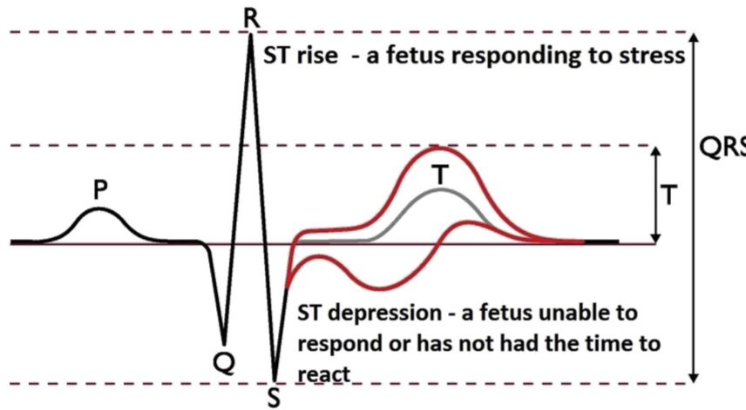

Figure 1. Changes in fetal ST segment

All the factors that modify the performance characteristics of the myocardial wall, including hypoxia, prematurity, infections, maternal fever, myocardial dystrophy, maternal diabetes and cardiac malformations may depress the ST interval.

* + 1. Fetal heart rate

The basic premise underlying FHR as a tool is that patterns reflect the oxygen status of the fetal brain. The changes and patterns seen in the FHR in response to changes in oxygenation and acid/base status should be considered as the fetal organism attempting to maintain homeostasis [7].

There are both accelerations and decelerations exist in the life of fetus. The first ones appear as exposure to external influence such as tactile or acoustic actions. In addition, accelerations could be served as a manifestation of short spontaneous increase in sympathetic activity. The presence of heart boosts indicates the absence of severe hypoxia or acidosis. However, accelerations may not be appeared in different cases, during fetal sleep, arrhythmia, exposure to certain medications, and extreme prematurity.

Decelerations usually serve as an alarm indicator depending on the temporal relationship to contraction. They can be early, late, variable or prolonged. Early decelerations remain the state without certain mechanism description. They appear quite rare and do not serve as a decease alarm.

One of the mechanisms of variable deceleration is a compression in umbilical cord. At first, as an exposure on decreased blood flow heart becomes beating more often. Further cord compression leads to occlusion of both the umbilical vein and arteries, leading to a marked increase in peripheral vascular resistance and a resulting abrupt decrease in the heart rate. However, another mechanism, which shows deceleration/acceleration, exists [7]. Late decelerations are most consistently associated with a response to a reduction in fetal oxygenation. The normal fetus will tolerate this brief reduction well. In contrast, when oxygen tension is already low, the loss of oxygen tension leads to vasoconstriction. Baroreceptors recognize this increase in fetal blood pressure and instigate a lowering of the FHR.

The final type of deceleration is the prolonged deceleration, defined as more than 2 minutes in duration but less than 10. The most likely mechanism in this type of deceleration is a sudden and prolonged reduction in oxygen delivery. Experts speculate that the decrease in FHR is an attempt to conserve oxygen in cases of severe debt. Thus, such type of deceleration became the brightest in problem indication.

* 1. Methods for registration fetal heart activity

Electronic fetal monitoring techniques can be invasive or non-invasive with intermittent or continuous assessment; these techniques include fetal phonocardiography, Doppler ultrasound, cardiotocography, fetal magnetocardiography and fetal electrocardiography [8].

Cardiotocography is a technical means of recording the fetal heartbeat and the uterine contractions during pregnancy. It uses both ultrasonic measurement sensor for fetal heart rate and electrodes for uterine contractions. However, cardiotocography may also include fetal activity measurement devices [9]. All the transducers

* + 1. Magnetocardiography

Fetal magnetocardiography, the magnetic analog of fetal ECG, is an emerging technology that is uniquely suited for investigation of fetal cardiac electrophysiology. Owing to its ability to assess fetal heart rate, rhythm, and conduction with efficacy similar to that of postnatal ECG.

Despite its advantages, fetal MCG is not widely used. A major barrier to clinical adoption is the high cost and complexity of Superconducting Quantum Interference Device technology. However, recent researches changed the situation. The demonstration of a new type of optically pumped magnetometer (OPM) can achieve SQUID sensitivity in a room temperature device [10], and thus, be a much cheaper and simpler in use method for fetal MCG acquisition. Signals obtained by both acquisition methods are presented in figure 2.

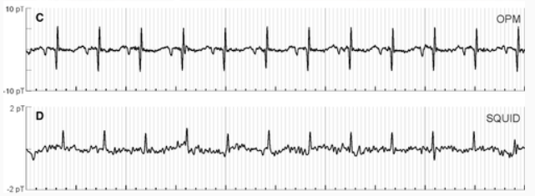

Figure 2. Fetal magnetocardiography with different acquisition methods

Characterization of normal fetal behavior is fundamental to neurodevelopmental research and to clinical fetal evaluation. The compromised fetus restricts its activity [11]. Fetal magnetocardiography allows FHR extraction, fetal heart activity assessment and its own morphology evaluation. Figure 3 presents changes in fetal magnetocardiography during gestation.

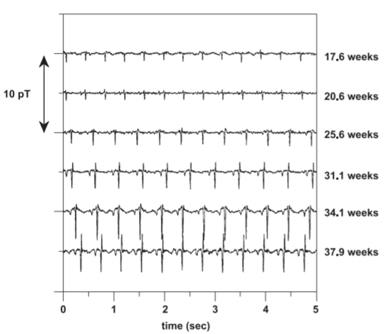

Figure 3. Fetal magnetocardiography during gestation

Magnetocardiography morphology and amplitude difference is clearly seen between ages, so it has a real potential in future investigations with more advanced and apparently cheap sensors.

* + 1. Fetal electrocardiography

Two methods of fetal electrocardiogram acquisition exist: invasive and non-invasive. First one includes scalp electrode to obtain direct contact with fetus body. This way provides quite clear signal without any significant interference. However, baseline drift, electrode contact noise, electronic noises, power interference and movements with uterine contractions present in signal [12] and in figure 1.4.

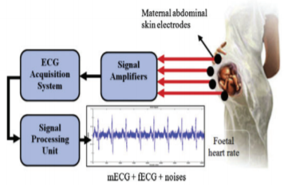

Figure 4. Fetal electrocardiography model

The fetal heart signal requires a method to process the signal source so that signal separation can be done from one signal to another. Signals recorded on several recording devices often disrupt the signal, which is in the form of noise and artifacts.

The signal obtained can result in analysis errors. Mother’s signals are the most influential signals on fECG signals originating from abdominal signals, because of the frequency spectrums of each signal source intercept. The filtering process to reduce the noise level is less effective to do. Therefore, other advanced techniques are usually used necessary to obtain a better fECG signal acquisition.

In addition, usually fetal monitoring systems includes more lead with other different purposes, for example, myographic measurements such as uterine contractions and channels for amplified mother ECG. They can be used for feature extraction and analyzing methods as well as alarm indicators.

* 1. Instrumental methods for fECG registration

The most frequently used fetal monitoring technology uses a Doppler ultrasound device to obtain fetal cardiac activity, either the fetal heart itself or arterial flow through a major fetal vessel. An algorithm in the device calculates the time interval between the loudest points in the cardiac cycle and displays a heart rate. Fetal electro cardio signals are much harder to obtain clearly and analyses, thus, in many cases only fetal heart rate measurement is used.

Nevertheless, the majority of attempts keep stepping on the road of technology and methodology improvement. Several monitors and remote biomedical devices for fetal heart rate or ECG waveform acquirement are used widely.

* + 1. Monica AN24

The first FHR monitor using noninvasive fetal ECG technology to arrive in the American clinic was the Monica AN24 monitor. It collects fetal ECG data from five electrodes placed on the laboring woman’s abdomen. The technical challenge for the Monica AN24 and other similar monitors is that, at the point where the electrodes are placed on the maternal abdomen, the fetal ECG waveform is overwhelmed by the maternal ECG, which has a voltage 100 times greater than its tiny fetal counterpart [13].

Monica AN24 is able to obtain 4 channels with 5 electrodes where one common is placed on the referenced point, usually close to the back. The main unit uses advanced technics to extract MHR, FHR and uterine activity. And thus, there is no way to present fetal or mother ECG itself. The device is presented in figure 3.

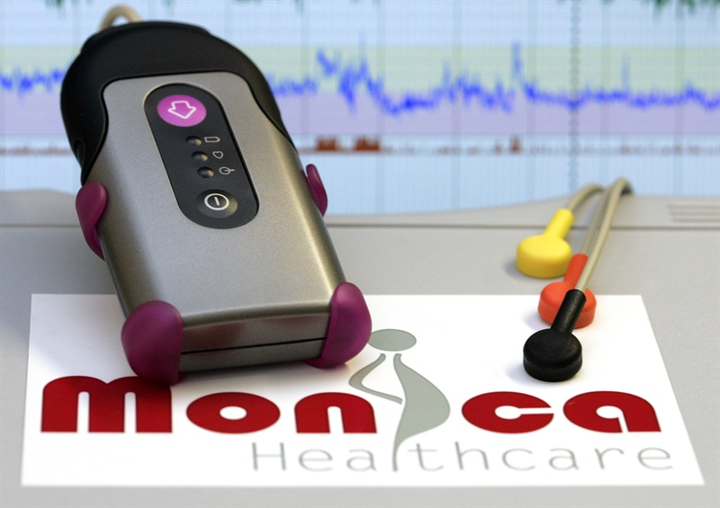

Figure 5. Monica AN24

In addition, researches proved supremacy of use Monica AN24 over basic CTG technics for obtaining fetal heart rate and uterine contractions. Moreover, woman with big Body Mass Index raises difference in result with the use of electrodes and ultrasound sensors, that has been shown in [14, 15].

* + 1. Monica Novii

Monica Novii is a device developed to improve the labor and birthing experience with remote monitoring. Wireless Patch System is an intrapartum fetal monitor that non-invasively measures and displays the FHR, maternal heart rate, and uterine activity with only five electrodes that communicate all maternal and fetal information to the Novii Pad through Bluetooth technology. The device detects the fetal ECG and maternal ECG rather than FHR through Doppler on a separate device when using standard EFM [16].

For contractions, the Novii uses electromyogram signals from the uterine muscle to detect uterine activity rather than external tocometry. The suggested benefits of this device include reliable tracing on high body mass index patients and patient comfort as the user has a wireless experience during labor and child birth which can increase satisfaction for those who desire frequent position changes and movement [17].

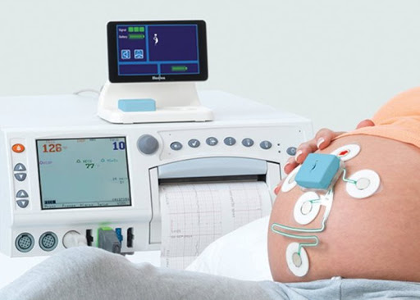

Figure 6. Monica Novii patch system with interface

Despite the fact that monitor provides FHR and MHR it doesn’t use any complex techniques for fetal ECG morphological analysis. However, there is a possibility to show signals from Novii pod.

The Novii Interface is an accessory to the Novii Pod which provides a means of interfacing the wireless output of the Novii Pod to the transducer inputs of a CTG Fetal monitor. The Novii Interface enables signals collected by the Novii Pod to be printed and displayed on a CTG Fetal Monitor and sent on to a central network, if connected [18].

Novii pod system with patches contains 5 electrodes that is shown in figure 5. The positioning of electrodes has been chosen that way to amplify their individual signals. Thus, electrode 4 is implied as neutral one; 3rd significantly important for detection of uterine contractions. Second one for mother’s ECG, it places in the closest location to mothers’ heart among others. Electrode number gives significant contribution to fetal ECG analysis, and thus, FHR extraction.

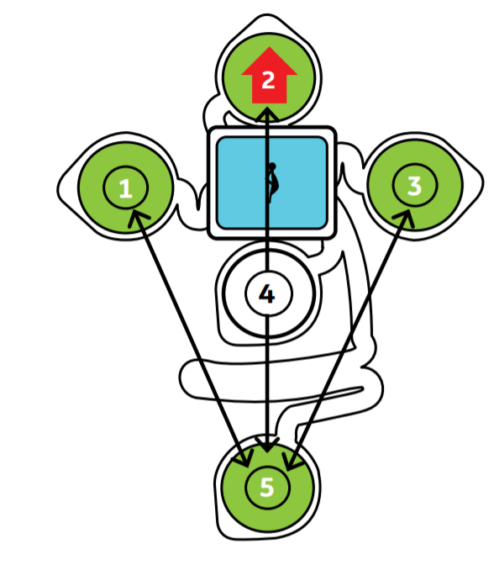

Figure 7. Novii pod system

One significant contraindication exists Monica Novii is used only with woman over 36 completed weeks of pregnancy. That is usually the last month of gestation.

* + 1. Meridian M110

Meridian system includes monitor and electrode patch. In my opinion, the most significant advantage of a patch is focused in usability comfort. The Meridian Electrode Patch eliminates the need for skin preparation and replaces the fetal scalp electrode, intrauterine pressure catheter, Doppler, and TOCO sensors with a single non-invasive disposable system, while maintaining the same accuracy and sensitivity performance expected of today’s monitoring devices.

Meridian M110 Electrode Patch consists of four patches (fig 6), two for the mother’s abdomen and one for each of her sides, which provides continuous fetal ECG signal pick up for any fetal position or movement [19].

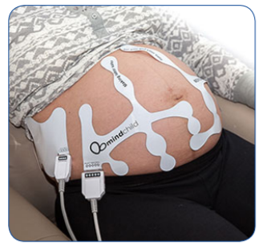

Figure 8. Mindchild Meridian electrode patch

Meridian monitor is a main computational unit for channel processing and indicators extraction. Market has small number of devices for fetal monitoring, however, all of them have personal unique features. Current device is considered to be the one which can perform well for woman with obesity.

MERIDIAN M110 is the only fetal monitor on the market that performs as well in obese patients as it does in lean patients. Both the fetal heart rate signal and the contraction signal deteriorate when BMI increases, compromising obstetric safety [20].

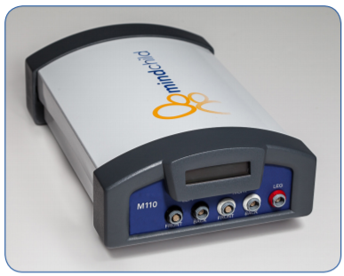

Figure 9. Mindchild Meridian monitor

Moreover, The Meridian M110 demonstrated in a clinical trial: 96.7% correct fetal heart rate as compared to the fetal scalp electrode; 98.0% agreement of a contraction event as compared to the intrauterine pressure catheter and 98.3% correct maternal heart rate as compared to the pulse oximeter.

* + 1. Patents for fetal ECG acquisition systems

There are a lot of fetal monitoring devices exists, however, only a few of them are considered to be reliable, robust and standard. Nowadays, public market mostly includes devices for FHR assessment with ultrasound principle of operation. But, other medical inventory is still slowly filling the market, replacing outdated samples.

First system is described in [11], it contains of 3 electrodes and measurable unit with display. Electrode displacement allows the extraction of fetal heart rate and mothers heart rate from abdominal signals. One of wires are connected two the back, where signals are less seemed to be mixed.

The structure of main unit is pretty simple. Signals from leads had to be preprocessed. Then, mothers and fetal contents are derived from the mixed signal and analyzed to retrieve following indicators, their heart rates.

In addition to display block, device also has storage to save final result and preprocessed data for future outer analysis. There is more than one device version, it differs in number of leads. However, an average result for abd2012 database in most of channels seems great (F1 score > 94%)

Another device that is described in [22] has the similar architecture except. Initial device purpose is a prevention of respiratory disease outcomes from abdominal signals. It can measure a bunch of parameters, from mother/fetus physical activity to both ECGs.

The main distinctive feature of this system is an integration of several units in one complex sensor environment. Units can be mounted in some ways: with adhesive, tape. In addition, garments with sensors within are used for special conditions.

* 1. Algorithmic methods for fECG evaluation

After extracting the fECG from maternal abdominal recordings, the next step is to extract clinical parameters from the fECG. Adult ECG is different in SNR from fetal one. Thus, some improved techniques are used for signal enchasing, feature extraction and analysis.

Nowadays, the most common feature for fetal health evaluation is FHR. However, there are some important morphological metrics physiologically described in previous subchapters. Several advanced and not so techniques are presented in following subchapters.

* + 1. Fetal heart rate extraction and analysis

It is important to note that most techniques for FHR extraction contains additional part of fECG extraction from abdominal signals. The main idea of rate obtaining is to find locations of R-peaks; however, signal appearance can be performed in different unrecognizable ways.

Classical R-peak detection methods such as local peak search and the Pan-Tompkins method can be used for both adult and fetal R-peak detection. However, due to the lower SNR of the fetal ECG component improved methods used. The one described in [23].

Proposed R-peak algorithm is divided in stages, that are presented in figure 8. In the first stage, the selected fECG component is passed through a matched filter with a narrow fetal QRS template (of width b1) used as its impulse response. The template can be selected from the data by visual inspection, or as proposed in [24], by using predefined fixed QRS-like functions.

The output is squared and time-averaged with a moving average window of length w1, to obtain the energy envelope. The same procedure is repeated by using a wider fetal ECG template containing the entire PT-interval with a length b2 more than b1, followed by squaring and temporal averaging with window length w2 more than w1.

While, the first stage detects sharp QRS— and QRS-like— peaks of the signal, the second stage targets wider events. Right after the compensation of the group delays of the moving average filters and multiplying the two energy envelopes, the local peaks of this product can be considered as the fetal R-peaks.

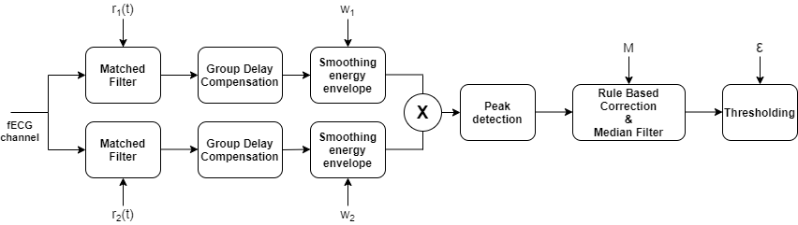

Figure 10. Double matched filter R-peak detection scheme

Having detected the fetal R-peaks, in order to refine the calculated heart rate time series and the excess or missing R-peaks, a rule-based correction and conditional median filter is applied as post processing, which corrects the outlier R-peaks, while keeping the normal beats unchanged.

Another approach is described in [25], author uses empirical mode decomposition. More specifically, they assess different EMD technologies for channel selection. EMD is a fully data-driven method for non-linear and nonstationary real-world signals; it decomposes a signal into a finite set of intrinsic mode functions that represent its inherent oscillatory modes. However, R peaks are extracted with wavelet coefficients both for mother and fetus out of noise signals.

There is a standard for evaluation of fetal heart tracings; it emphasizes following parameters and patterns:

* Baseline
* Baseline variability
* Early decelerations
* Variable decelerations
* Late Decelerations

Different techniques are used for health evaluation with FHR, it is important to admit, that uterine contraction event is a significant time point for observation the changes of FHR. However, UA has low frequency, thus, FHR tracings should be quite long in time, hence, it is a rough task to obtain enough amount of clean data for right assessment.

Ones were using FHR for predicting fetal acidemia. They used useful approach with convolutional neural network (CNN) [26]. Actually, CNNs in their structure take some n-dimensional signal as input and underline useful features by itself. Another, important step they’ve done was transferring FHR curve to 2D form with continues wavelet transform (CFT) which also reflects time and frequency features in a single signal. In conclusion, the average accuracy achieved is 98% with area under ROC about 97%, that is explicit success.

Another useful review presented open access software for detection anxious fetal state [27]. Group used a bunch of parameters that a shown in figure 9 as features for training different classifiers. Predictive value was the absence a fetal distress, however, they estimated if cord artery pH more less than 7.2 or not.

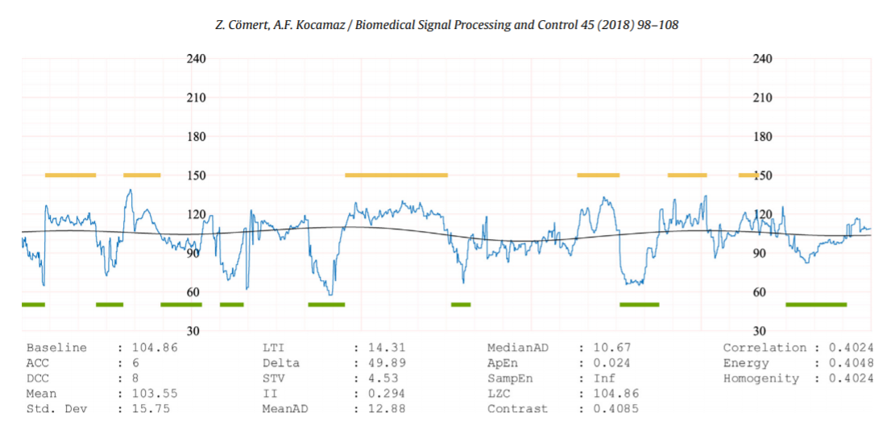

Figure 11. Analysis report produced by CTG-OAS

Features can be divided in 4 groups:

* Morphological (up to DCC)
* Linear (up to MedianAD)
* Non-linear (up to LZC)
* Image-based time-frequency

Authors investigated 3 classifiers: Support vector machine, k nearest neighbours and artificial neural network (presumably n-Dense layers NN). Results were presented in different parameters; however, actual performance is evaluated by AUC, which SVM has about 84% (98% max, 68% min). Much more studies reviewed the use of CTG-OAS with different datasets; some of them are private. But outcome is poor, as for assessment parameter geometric mean of sensitivity and specificity all values are about 80%.

* + 1. Morphological analysis

Entire morphological analysis is built on the ECG segments, which include amplitudes and intervals. Thus, while the first step of FHR based methods was the detection of time location of R-peaks, segments requires higher level of algorithms to be received that makes this field is extremely tough to be pushed forward. Elimination of noises and artifacts becomes one of the most important tasks for data analysis with successful outcome.

Researchers have extracted parameters such as the QT-interval and the ST-segment. The typical benchmark for these studies is commonly the invasive fECG obtained from the fetal scalp electrodes acquired during labor. Furthermore, it is currently difficult to evaluate the fECG parameters independently since there are very few open-access fECG databases with expert annotations.

Early attempts of the extraction a fetal ECG from abdominal signals were proposed in previous decade, one used Bayesian filtering neural network for morphological features extraction in [2]. A Bayesian Filtering Framework based on an Extended Kalman Filter for extracting the FECG from a single abdominal channel was used with training database of 20 one minute maternal-fetal mixtures and evaluated on 200, one-minute mixtures. A single pass of the EKF was performed to cancel out the maternal ECG in order to build an average FECG morphology. A dual EKF was then applied to separate the three sources present in the signal mixture.

Another recent approach is presented in [28], they use LSTM network with different structure. The main feature of the is covered under “Fast” LSTM cell in architecture. The architecture of LSTM was originally designed for long term dependencies in data sequences, such as speech recognition and machine translation, which frequently utilize the dependencies between words with long word span.

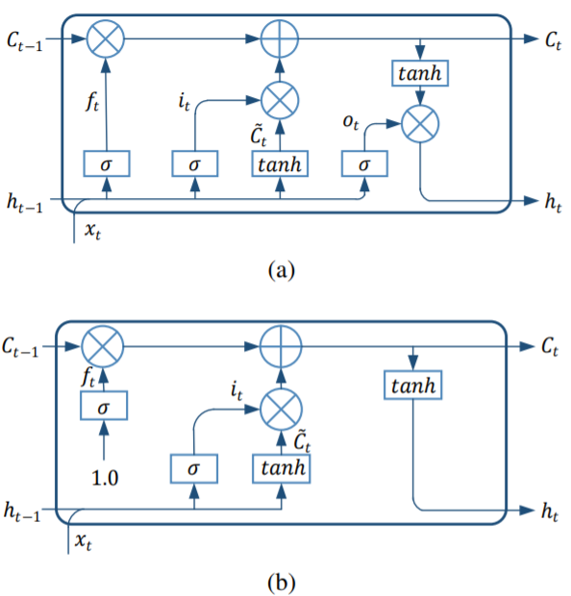

Figure. 12 Architecture comparisons of cell units. (a) The original architecture of LSTM; (b) The proposed architecture of the fast LSTM.

However, the internal mapping system of the FECG signals is causal and locally consistent on the timeline. Thus, the attenuation coefficient of the hidden state should be smoothly variant or constant, which is different from the mechanism controlled by the original forget gate.

More concretely, the forget gate is switched to a relatively constant value, which obtains the gate value without taking xt and ht as input. They also abandoned the output gate, since they found that the output gate has little effect on the function of LSTM in the FECG enhancement stage, which has also been proved in other applications [29]. The definition of the input gate is kept intact to maintain the function and flexibility of LSTM. The architecture of the fast LSTM is shown in Figure 2b.

For evaluation purposes they used two datasets: Database for the Identification of Systems (‘DaISy’, 1987) [30] and Fetal ECG Synthetic Database (‘FECGSYNDB’, 2016) [31]. Real data don’t have fECG separated signal, thus, it was used for quantitative evaluation, while DaISy was used for qualitive evaluation in comparison with other methods.

Slow-fast LSTM achieves higher means of SNR (about ~8 with high 12dB noise), and smaller standard deviations indicating the highly adaptive ability. Other channels with mean are presented in Table 1.1.

Table 1.1 - SNRout of Methods on Records from FECGSYNDB

|  |  |  |  |  |  |  |  |
| --- | --- | --- | --- | --- | --- | --- | --- |
| SNR | C0 | C1 | C2 | C3 | C4 | C5 | Mean ± Std. |
| 00 | 2.84 | 6.07 | 5.33 | 3.61 | 6.01 | 5.02 | 4.81 ± 1.20 |
| 03 | 6.67 | 5.76 | 5.99 | 5.46 | 6.19 | 6.03 | 6.02 ± 0.38 |
| 06 | 5.93 | 7.94 | 6.11 | 4.94 | 8.49 | 5.80 | 6.54 ± 1.25 |
| 09 | 7.78 | 8.95 | 9.09 | 6.67 | 9.13 | 8.01 | 8.27 ± 0.89 |
| 12 | 8.48 | 9.45 | 10.34 | 8.34 | 8.73 | 9.75 | 9.18 ± 0.73 |

Qualitative outcome is shown in figure 10, waveform seems to be more accurate than other methods. However, FastICA algorithm provided successful outcome in some channels as well as ESN.

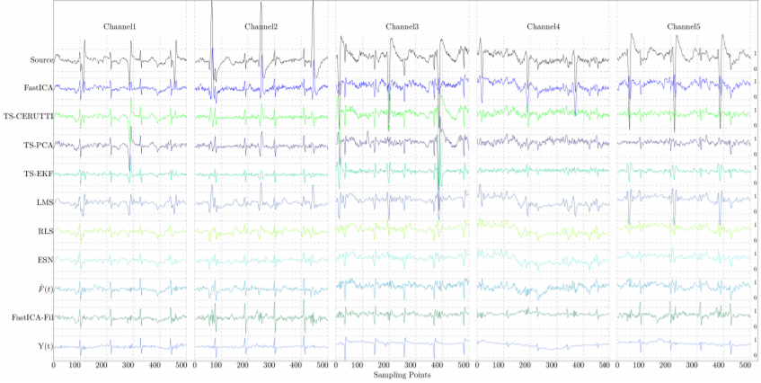

Figure 13. SFLSTM outcome Y(t) in comparison with other methods, all outputs are normalized by the same certain value.

Finally, to date, morphological features are not used in the field of NI-FECG because todays algorithms do not provide required signal quality and medical fundamentals are not ready yet.

* 1. Setting goals and objectives

Fetal Heart Rate (FHR) monitoring based on the analysis of the fetal heart rate signal is the most common method of medical assessment of fetal condition during pregnancy. Visual analysis of FHR signals demonstrates a challenge due to the complicated shape of the waveforms [32].

Thus, computer-aided fetal monitoring systems provide a number of parameters that are the result of the measurable investigation of the registered signals. These parameters are the basis for a qualitative analysis of the fetal instant condition. The methods for the interpretation of FHR values provided by a Doppler device are commonly used in clinics for determining the fetal’s condition: died in the womb, caesarean section is needed or normally progressing.

Another way of fetal ECG assessment is morphological analysis, but todays researches are still should be investigated more in the field of clean ECG extraction and the whole methodology creation. Thus, it is not used in current master’s thesis.

However, the idea of searching the presence or absence of fetus’s critical conditions with FHR requires several steps to be done:

* Preprocessing abdominal ECG
* Fetal ECG extraction
* FHR calculation
* FHR analysis.

1. < Title name >
   1. Biomedical system structure
      1. Patient interaction model

Humans body is a complicated system, it includes lots of functional units which influence one on another. For instance, arterial system and neural one in the question of blood pressure maintenance. However, it can be described by modeling with the determination of an accuracy.

Woman’s system during gestation period become even more complicated. It unites her self-system and developing fetus one. In that way, there are many connections between organs of woman and fetal growth at all. In general, whole unity can be described in model presented in figure 2.1.

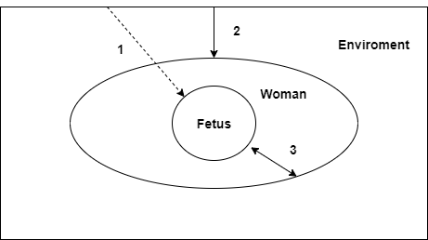

Figure 2.1. Common patient system model

There are 3 model parts, it included environment woman system and fetus one. And all of parts are connected with each other. All the connections are divided in 3 groups:

1. Direct environment influence.
2. Indirect environment influence.
3. Woman-fetus interaction.

First connection describes direct environment influences. For example, heatwaves in the form of air flows, electromagnetic radiation, including infrared waves, vibrations and physical exposures.

Second connection describes environment-mother interaction. Most factors of first paragraph may indirectly influence on fetus through the mother. Furthermore, breathing system that is in charge of fetal oxygen supply is able to get bad impact from environment, for instance, air composition content.

Third connection describes the main interaction, it is between mother and fetus. Most of changes of fetus during pregnancy influence on mother health, moreover, patient’s health determines the state of her “baby”. Thus, maintaining of woman wellbeing is one of the most important ways to make fetus healthy.

* + 1. Biotechnical model

Any biotechnical system includes patient or biological object with some technical extension. Project to be done has direct medical diagnostic direction. Thus, second part should contain the following modules:

* Acquiring module.
* Signal preprocessing module
* Transducing module.
* Signal processing and Analysis module.
* Data performing module.

In general, there are much more blocks could be included, for example, alarm subsystem, parts with patient notification like smartphone algorithms. However, actual problem is located in theoretical knowledge about data processing and analysis, module placement. Approximate structure contains of microcontroller as the overall module for signal preprocessing and transducing and others that shown in figure 2.2.

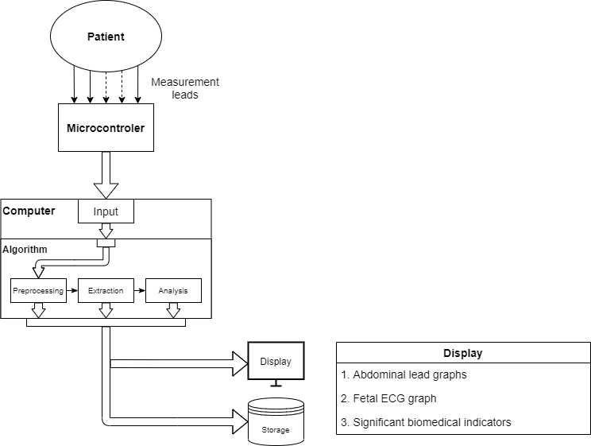

Figure 2.2 Biotechnical system structure

Computer as well as microcontroller takes preprocessing role, though, it is much deeper. If microcontroller completes all necessary steps for signal transferring, then computer’s part plays preparation role for signal analysis.

Algorithmic module has also extraction and analysis subsystems their results are sent to storage and shows in display. Server can serve as for storage for signals and significant biomedical indicators.

It should contain fundamentals of signal preprocessing from electrodes such as some low frequency noises or human artifacts. However, powerline interference and high frequency noises should be excluded with simple notch and low pass filters.

Other parts require more attention. The main signal to be extracted is fetal electrocardiogram, but it has small amplitude and intersected frequency bands, so it can’t be separated in simple way. However, some advanced methods and their ensembles are used successfully. The main idea is signal separation in several different independent sources, for instance, mother ECG, fECG and noise.

* 1. Fetal signal extraction
     1. Signal properties

Electrode location takes huge place in fetal ECG acquisition systems. They dictate the next steps of processing and analysis. There were investigations in the field of electrode location, most of them fit unique group of methods. However, there are some fundamentals for proper electrode placement in the field of fetal ECG evaluation, which developers follow.

Basic principles of electrode placement are described in Monica HealthCare researches. They used following scheme which is shown in figure 2.3. Electrodes 1, 2 and 3 are positioned on the maternal abdomen approximating an arc which is Substantially the same as the arc of the subject’s uterus fundus. Electrode 4 is placed at a location approximating the symphis pubis of the Subject [33].

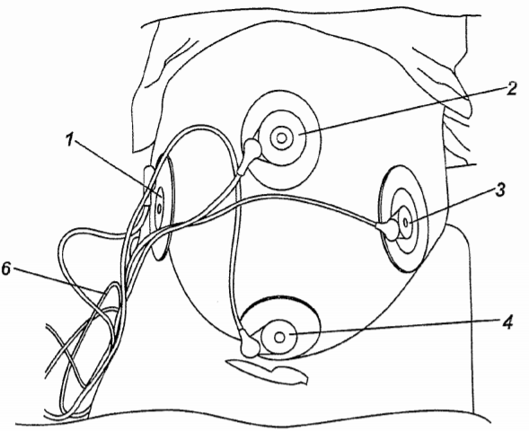

Figure 2.3 – Electrode placement.

The positioning of the electrodes 1 to 4 is important to the quality of the fECG signal detected. A fifth electrode is optionally attached to the back or side of the subject for use as a right leg driver electrode.

Another approach includes thoracic electrodes. It is clear that the maternal heart signal is extending from the thoracic area to the abdominal area of the pregnant woman, so signal measured in the abdominal area is composed of a maternal fetal component. The ECG signal measured on the pregnant woman’s chest is considered to be a pure maternal ECG signal because it theoretically does not contain the fetal component [34].

Thus, lets divide electrodes in groups with their assignment. First group contains abdominal electrodes for fetal electrocardiogram extraction; second one includes mostly mother’s ECG component; Third as reference, where almost none of signals appears. Last group should contain electrodes with different assignment such as uterine contraction measures.

Abdominal signals represent the mixture of sources, they include mECG, fECG and noise component. In the time dimension the problem of fetal ECG identification established with confidence. Figures 2.4, 2.5 show possible tasks, that are faced. First of all, mothers and fetal QRS complexes are similar in amplitude and sometimes appears in one time.

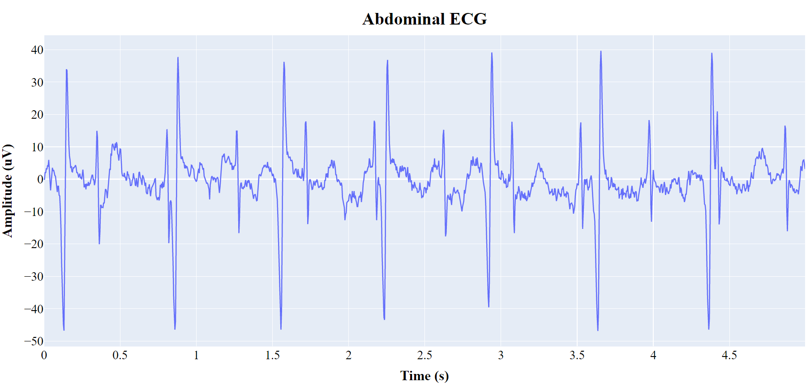

Figure 2.4 – Abdominal ECG without digital preprocessing

Nowadays, basic preprocessing steps, like powerlines interreference removal or electronic noise elimination is done before the signals reach computer point. However, in some ways digital adaptive filters can help delete 50 or 60 Hz noises, while the setting of right sampling frequency will align other wide band interferences.

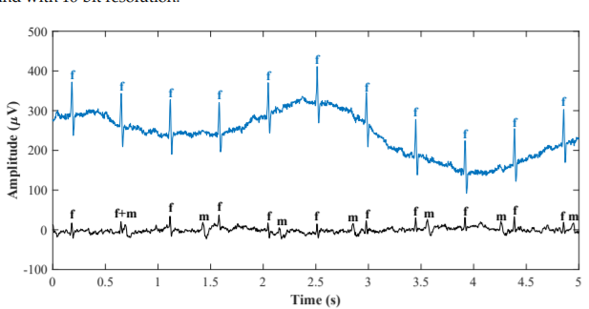

Figure 2.5 – Abdominal and mother’s ECG signals

Moreover, spectrum analysis shew that mother’s and fetal components are in the common frequency band. As well as the whole signals, their QRS complexes are still intercepted, that is shown in figure 2.6.

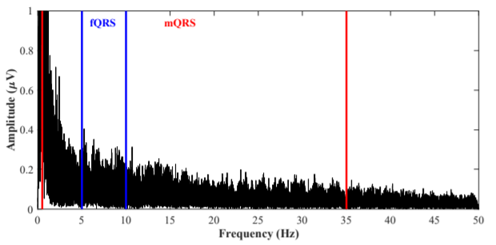

Figure 2.6 – Abdominal and mothers signal spectrums

There are several types of extraction algorithms, but, in general they can be divided in two types:

* Adaptive methods
* Non-adaptive methods

First type of methods requires mother’s signal which is used for signal separation, they include template subtraction, adaptive filtering (e.g. recursive least square, least mean square), and advanced techniques with recursive neural networks.

Non-adaptive filtering methods eliminate the undesired signals to yield the fECG signal without filter adaptation. More specifically, in some of these methods, filter weights are determined by using some initial training data and remain constant. These methods can use either a single-channel or multichannel signal source. Techniques utilizing a multi-channel signal source include multiple and single-source methods [35].

Single channel signal source methods are based on for example Wavelet Transform, Correlation Techniques, Averaging Techniques, Template Subtraction, Singular Value Decomposition, Adaptive Noise Canceler, and so on.

The multi-source methods are based on Subspace Denoising or Blind Source Separation, namely: Independent Component Analysis; Principal Component Analysis, and so on.

Blind source separation methods are a frequently used approach for fetal ECG signal filtering. It assumes the statistical independence of the two processed signals: fECG and mECG. It can be applied in the case of multi-channel abdominal recording with the assumption that the signals from different leads are a linear combination of independent signal sources generated by the maternal and fetal hearts [36].

The challenge, however, is that the relationship between the mECG recorded on the maternal chest and the mECG in the abdominal signal is rather nonlinear in nature. It is important to emphasize that the greater the number of channels, the better the quality of the extracted fECG signal. However, a large number of electrodes is clinically difficult to use and, moreover, they are unpleasant for the patient [37].

As it was shown, many fetal electrocardiogram techniques exist. However, only a few of them become popular and ‘general’ I would say. The list of common methods was described above. Nowadays, ICA as blind source separation method is used more often than others, it was also improved in many researches.

Neural networks in our days became the state of art in the field of signal processing and analysis, though, they can’t be generally used everywhere because of algorithm computation costs and method privacies. Researches were carried out contain unique structure and set of hyperparameters, which sometimes can be implemented by 3rd person, but with unreliable outcome.

The evaluation of different extraction methods was shown in figure 1.13 and [28] on synthetic and real fetal ECG datasets. The FastICA algorithm presented has satisfying outcome among advanced adaptive techniques and neural networks. However, it can be improved with technique described in [38].

* + 1. Abdominal signal preprocessing

First steps of digital signal processing are powerline interference elimination and bandpass filtering. However, while the main goal is an extraction of the fetal heart rate, the signal morphology doesn’t have significant value on the choice of methods. Thus, main powerline frequency can be removed with notch IIR filter appropriate frequency, which amplitude response is shown in figure 2.7.

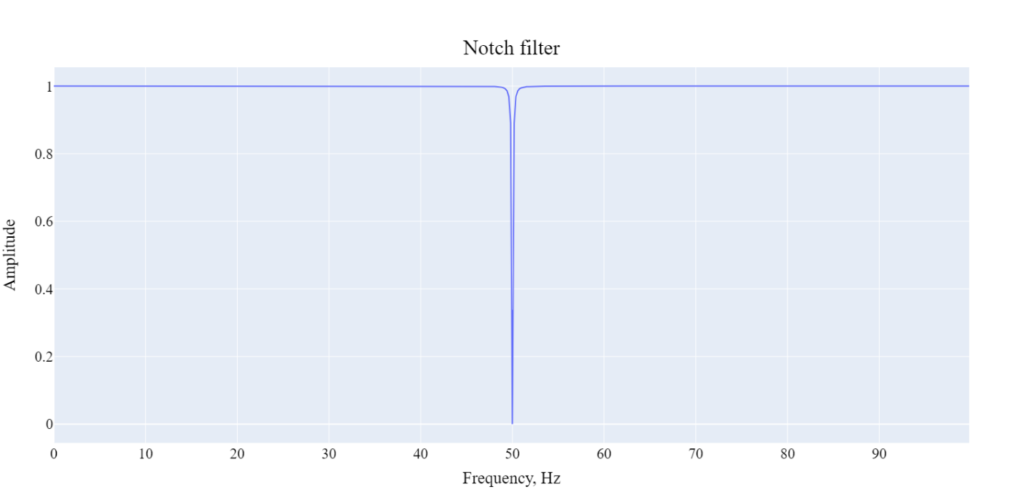Figure 2.7 – Notch filter amplitude response, Q = 250

Human electrocardiogram is placed in the range from 0.05 up to 150Hz. This band serve for extraction an adult morphology as well as fetal ECG. However, morphology components are not required, and thus the exact high band can be lowered to the point of 100 Hz. White noise is distributed in frequency area in the whole band, but with small amplitude. This fact makes him noticeable and even significant in huge frequency band signals, however, heart ones can be samples in low values and thus the whole noise is rejected. This project includes bandpass Butterworth filter with frequency band from 0.05 to 100, it has small computation cost, because of type and order of 3-5. Amplitude response of bandpass filter is shown in figure 2.8.

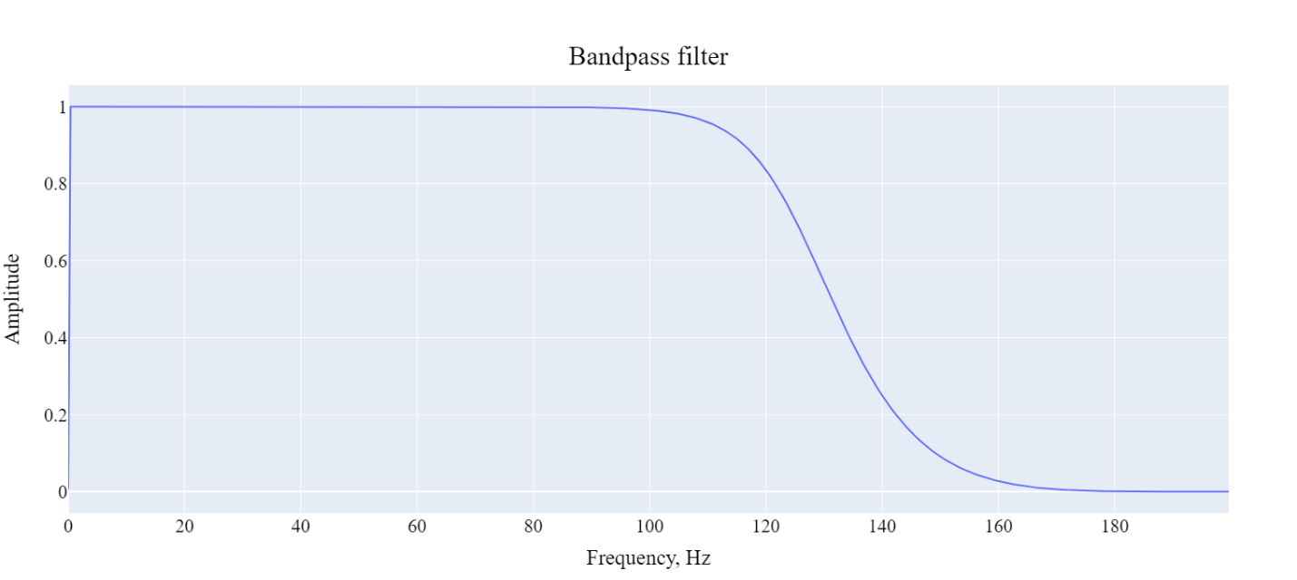Figure 2.8 – Butterworth bandpass filter, order: 3

There are also Chebyshev filter type 1 and 2 with ripples in the pass and reject bands respectively. They have higher tilt by the cost of computation speed and irregularities in bands. Figures 2.9-2.10 shows the main difference in filter families.

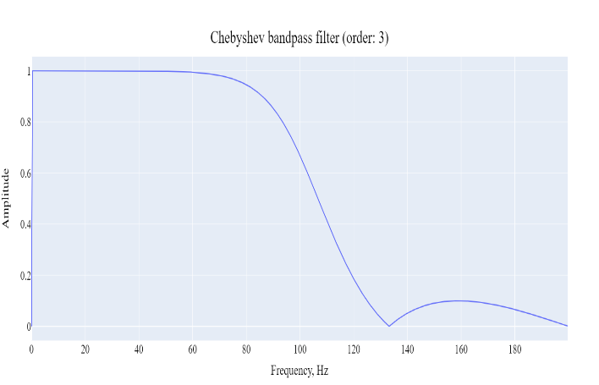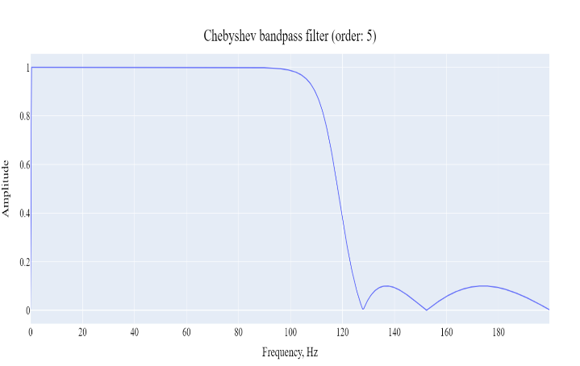

Figure 2.9 – Chebyshev bandpass filters, order: 3/5

Maximum ripple reduction is about 20 dB, as can be seen in the picture higher incline lead to more ripples in stopband (filter type 2). The difference in tilts between Chebyshev and Butterworth bandpass filters of 7 order is shown in the figure 2.10

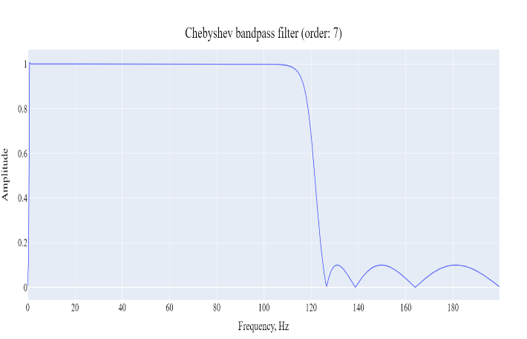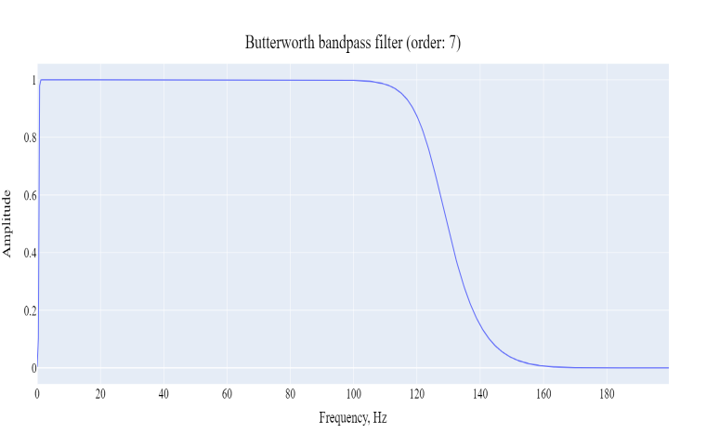

Figure 2.10 – Chebyshev and Butterworth bandpass filters, order: 7

Actually, higher stop frequency of the filters is in the point of 125 Hz, hence, Butterworth decreases signal level to the 0.707, while Chebyshev to 0.1 amplitude. Ripples in high band contains basically noise, which amount should be decreased on the first place. Chebyshev filter type 1 can change morphology in unpredictable way, although, QRS complexes of both signals is in the range of 0.5 – 35 Hz (fig 2.6).

Finally, Butterworth bandpass filter of 3rd order has been chosen with not as fast incline as in Chebyshev one, but, without ripples and satisfied amplitude response.

* + 1. Abdominal baseline wander removal

Low frequency interference rejection is the part of signal preprocessing step, although, it usually requires advanced processing steps because they have non-linear and non-stationary nature. Baseline wanders appears as a result of patient movements are breathing.

To remove this effect, ones estimated a baseline signal applying a low pass first order Butterworth filter (cutoff frequency at 5 Hz) in forward and backward directions [38]. The resulting filter had no phase distortion and a cutoff frequency at 3.17 Hz. Final signal was obtained by baseline subtraction. However, due to the lack of zero phase filter baseline wander had time delay from the signal one. This produces small high frequency distortions on the output.

Another idea consists of using median filter, this method is more efficient than linear filtering. In addition, powerful QRS waves may produce small deviations after linear filtering. Median filter with moving window about 250-300 milliseconds reveals baseline drift with small time delay after delay estimation.

Final approach is based on the Wavelet Transformation. Wavelet transform is a wonderful mathematical tool for signal and image processing due to its multi-resolution nature and computational efficiency. Wavelet schemes are especially suitable for applications where scalability and tolerable degradation are the important considerations. Wavelet transform decomposes a signal into a set of basic functions [39].

Wavelet appears in a form of function with a number of restrictions. An orthogonal wavelet is entirely defined by the scaling filter – a low-pass finite impulse response filter of length 2N and sum 1. In biorthogonal wavelets, separate decomposition and reconstruction filters are defined [40].

In addition to low pass filtering, signal also is filtered with high pass quadrature mirror filter. One filtered step is called as one level of decomposition and presented in following formulas:

|  |  |
| --- | --- |
|  | (1) |

Where, *g* – low pass filter response. Same form of equation compute high filter outcome.

However, since half the frequencies of the signal have now been removed, half the samples can be discarded according to Nyquist’s rule. The filter output of the low-pass filter *g* in the diagram above is then subsampled by 2 and further processed by passing it again through a new low- pass filter *g* and a high – pass filter *h* with half the cut-off frequency of the previous one. Thus, the number of wavelet coefficients decrease by two for every cycle.

Proposed algorithm uses Daubechies wavelet of the 4th order. It transforms low band filter output until following inequation:

|  |  |
| --- | --- |
|  | (2) |

Where *E* is the energy of filter output, the idea is to the find local minimum of high frequency coefficients. As soon as ***i***is defined low frequency filter component is considered to be a baseline.

Next step is to make inverse wavelet transform with the same wavelet function and low filter component *N* times, where *N* – the number of wavelet transformations done. Inverse wavelet transformation is described in a formula below:

|  |  |
| --- | --- |
|  | (3) |

Where and are reversed filters (wavelets) and is the component of zeroes, because the one we going to obtain is baseline wander.

The final step is a simple subtraction between input signal and baseline wander, it shown in formula 4.

|  |  |
| --- | --- |
|  | (4) |

The whole baseline removal algorithm can be presented in a scheme, which is shown in figure 2.11.

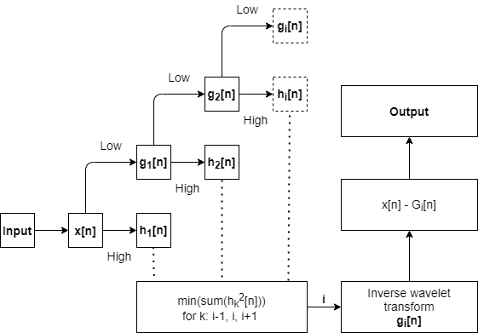

Figure 2.11 Wander searching process of wavelet transformation

In conclusion, the overall wavelet baseline wander removal algorithm contains 3 phases. First one is signal decomposition N times while searching local minimum of energy in high frequency component, which shows the significance of low component. Second stage includes only low frequency component recomposition, which produces baseline in real time values. Third phase includes only signal subtraction. The result of 3rd phases is shown in figure 2.12 on the scalp electrode signal.

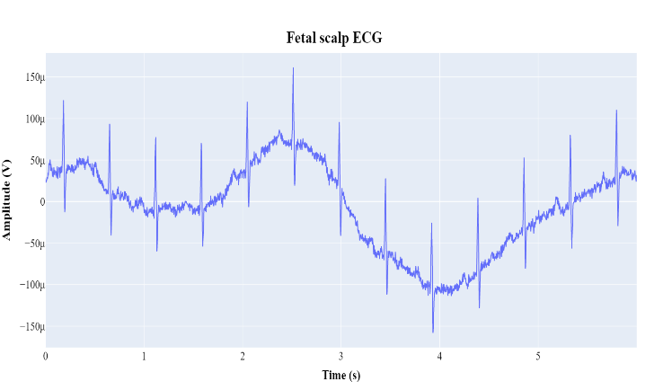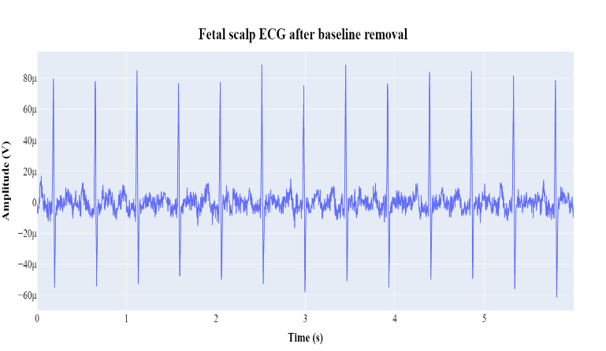

Figure 2.12 – Fetal scalp signal before and after baseline removal base on wavelet decomposition

As it is shown in the figure above baseline wander successfully removed, traces of group delay are not detected. High frequency noise observed is in the band up to 70 Hz and can be eliminated on scalp signal, but not for the abdominal signals, which contain mECG within.

* + 1. Independent component analysis

Among the huge number of invented methods for fetal ECG extraction blind source separation one was chosen as the first step in the sequence of methods. Independent component analysis is a mathematical technique for recovering unobserved source signals from observed signal mixtures.

Proposed algorithm uses the use of FastICA improved version with higher sustainability to additive noise. FastICA is a fixed-point iterative algorithm, minimizing common information between estimated components. Separation of independent components is accomplished when the maximum of non-Gaussianity is attained [41].

Before using the FastICA algorithm, the observed signal should be centralized and whitened. The mean removal process is required to simplify the method, increasing computational speed. Whitening means zeroing of all correlation dependencies between signals, this process can be done for example with principal component analysis whitening. There is also a zero-phase component analysis whitening, but the difference is not important for current paper.

Decentralization and whitening are performed according to the formula below:

|  |  |
| --- | --- |
|  | (5) |

Where – diagonal matrix with eigenvalues on the diagonal, matrix gives a rotation needed to de-correlate the data. Mean vector of input sequences is presented as .

Maximum of non-Gaussianity means the minimum of some objective function *J* by selecting weights of transforming matrix W, that is shown in formula 6.

|  |  |
| --- | --- |
|  | (6) |

Where, G’ = g, which is a non-quadratic function and is gaussian variable. Both *y* and *v* are assumed to be zero mean and with unit variance.

According to the feature of vector *w* to be normalized the calculation of matrix components wk is presented in formulas below:

|  |  |
| --- | --- |
|  | (7) |

Where is derivative of function G and is constant, which can be found as , with – initial weight vector.

After using Newton iterative formula and additional assumption, because of whitened data, one step of calculation of weight vector with step normalization is shown in formula 8.

|  |  |
| --- | --- |
|  | (9) |

There are a lot of non-quadratic functions used for independent component analysis, however, all of them must fit the conditions. The set of functions must have derivative. In the current paper a several nonlinear functions have been checked. They are shown if formulas below in the form of g(u):

|  |  |
| --- | --- |
|  | (9) |

They called from first to third: ‘*logcosh*’, ‘*exp*’, ‘*cube*’. However, the difference on the extraction of abdominal components are not noticeable, thus first ‘*logcosh*’ was chosen.

For the evaluation of method Abdominal and Direct Fetal ECG Database was used, it consists of 5 signals with features described in the list below [42]:

* Signals recorded in labor, between 38 and 41 weeks of gestation
* Four signals acquired from maternal abdomen
* Direct electrocardiogram recorded simultaneously from fetal head
* Positioning of electrodes was constant during all recordings
* Ag-AgCl electrodes (3M Red Dot 2271) and abrasive material to improve skin conductance (3M Red Dot Trace Prep 2236)
* Bandwidth: 1Hz - 150Hz (synchronous sampling of all signals)
* Additional digital filtering for removal of power-line interference (50Hz) and baseline drift
* Sampling rate: 1 kHz
* Resolution: 16 bits

Signal bandwidth equals 1-150Hz, so there is no need in high pass filtering or filtering in lower range of frequencies. The result of FastICA algorithm with all preprocessing steps, which include baseline wander removal, signal centering and whitening is shown in figure 2.13. It is important to notice that only abdominal signals were passed.

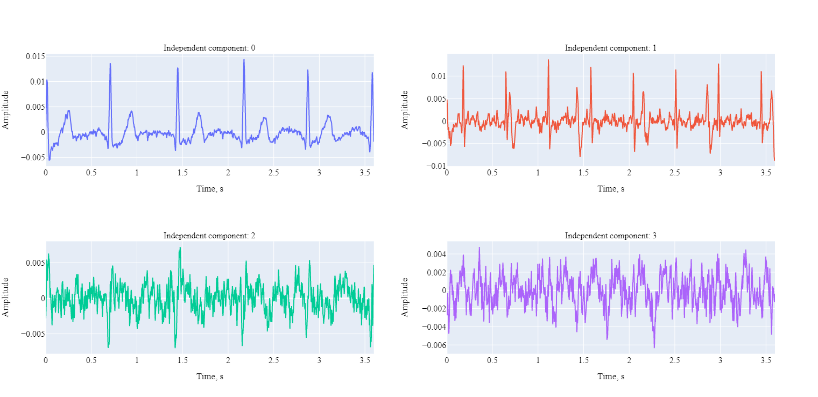

Figure 2.13 – Independent components obtained from 4 abdominal signals

It is clear to see that first two components are served as mothers and fetal electrocardiograms. However, fetal one, which is second include explicit effect from mother’s QRS component.

Important fact to be discussed is that the order of components is completely randomized. The order of ones shown in the figure 2.13 depends on the signal sum for the whole signal, it is not the robust way to estimate which one is mother’s component or fetal. Hence, there are a lot of individual ways of estimation the order which are not described in current paper. However, in order to make investigation more automatic and convenient a single threshold method was used to determine which component is *main*. For example, mother component was extracted with simple inequation presented below:

|  |  |
| --- | --- |
|  | (10) |

Where *0* and *1* are the numbers of components. Decision rule takes maximum absolute values of two independent component and choose which is higher.

* + 1. Template subtraction

The presence of mother’s electrocardiogram in the form of individual component provides the ability to subtract it from the abdominal signal. But the process of subtraction means the definition of QRS complexes, building the template for each component and template subtraction.

The most popular method for location QRS complexes is Pan and Tompkins search algorithm. In addition to the algorithm itself it has several processing steps. They include bandpass filtering, derivation, squaring and moving window integration [43].

As a part of fetal ECG extraction algorithm, template subtraction must have nearly perfect accuracy to the peak location. The problem appears is the group delay, because of filtering, deriving and processing moving window integration. Firstly, the group of approaches were used to eliminate delay for providing accurate template building and subtraction.

* Zero phase filtering
* Derivation phase delay subtraction (~2 points)
* Mowing window delay subtraction (~ N / 2)

A few steps of playing with numbers and implementation methods for moving window integration led to the use of complete another approach, which will be discussed later in this paper.

The main features of the Pan and Tompkins algorithm is the use of signal and noise levels for determine which peak can be decided to be signal and the use of back checking for a missed peak with evaluation of 8 recent RR intervals.

After definition of the peak or noise pick the algorithm calculates following values, which are shown in formulas 11-12.

|  |  |
| --- | --- |
|  | (11) |

Where SPKI is a signal level and NPKI is a noise level. Every time peak is considered to be signal or noise corresponding values updates.

|  |  |
| --- | --- |
|  | (12) |

Where *Threshold 1* serves for primary definition of signal peak values and *Threshold 2* for finding QRS complexes from missing peaks (RR search).

Finally, the first peak possible peak which is usually considered as noisy one is calculated with the rule of SPKI. This approach finds the location of maximum value within first window (usually 250 ms) and compares the value with SPKI. Current approach can lead to unpredictable first peak detections; however, it requires for the task of template subtraction. The whole algorithm of mothers QRS complexes search is presented in figure 2.14.

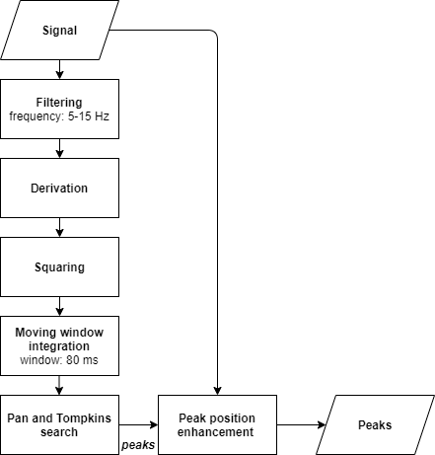

Figure 2.14 – Peak location search algorithm

Filtering and moving window integration contribute a lot in the performance of peak detection algorithm. As for filter purposes several filter parameters were used, for example, Chebyshev 1-2 type with lower frequency band. It led to dirty graph with some noise peaks, which better would be deleted. Thus, Butterworth was used with frequency band of 5-15 Hz, where higher cutoff frequency is about 11 Hz, that is likely the same as the use of Butterworth filter higher orders than 1.

Moving window was chosen to be the lowest time of complete QRS complex, usually T waves are hardly detected in abdominal signals. Thus, the requirement of huge window is not appeared, in addition, it provides better computation speed, but in very low value.

Peak position enhancement is a simple algorithm which takes peaks, signal and window. It runs for every peak and finds the maximum value, that is considered to be an accurate peak. However, time delay means the shift of wave in seconds in the past. Thus, there is no need to make window symmetric, hence, the relation is following: 25% for backward and 75% for forward search in percent of window size.

The main idea of template subtraction is to regenerate mECG and then subtracting it from the abdominal signals. Based on maternal QRS detection, i identified each mother’s ECG cycle belonging to 0.25 s before and 0.45 s after maternal R peak positions with respect to the duration of the whole cardiac cycle. The template maternal ECG then was formed by taking the average of all mECG cycles, and the new mECG was obtained by replicating.

The entire process of template subtraction is not harder than searching algorithm described. However, it has some features, for example, which signal should be changed: FastICA result or Abdominal signal itself? Independent component analysis can extract some component really precise. So precise, that fetal one is not appeared in them or the amplitude so small, that it is was not detected by Pan and Tompkins search algorithm. The idea of template subtraction is shown in figure 2.15.

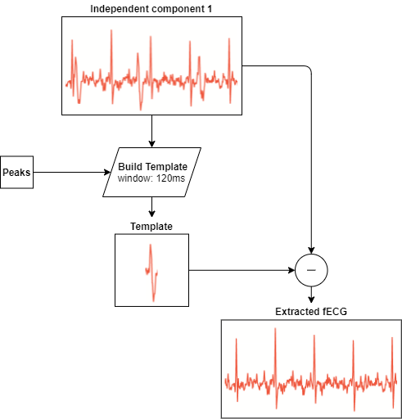

Figure 2.15 – Template subtraction algorithm

Since fetal electrocardiogram extracted one possibility appears. Current signal is not an abdominal one, but independent component, there is no sense of talking about morphological analysis. Finally, variability of fetal heart rate can be clearly obtained and analyzed.