Solution Write-up: agriBORA Commodity Price Forecasting Challenge
Statistics
The competition took place from November 14, 2025 to December 28, 2025. Here are some statistics:
- 1196 participants enrolled
- 8,534 submissions made by 365 participants
- Participants from 84 countries (36 of which are from Africa)
- 15.7 % (similar to our previous Digital Africa competition) of those the participants are female
- 315 participants from Kenya
- Most participants worked individually instead of forming teams.
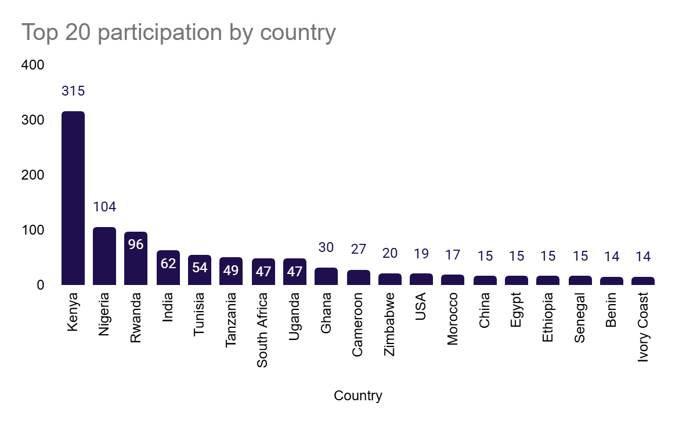

Top prize overall:
- Team name: onepoint
- Username: Yisakberhanu
- Full name: Yisak Bule
- Email: yisberh945@gmail.com
- Country: Ethiopia
- Gender: Male

Second prize: Top female / Top team with female member
- Username: Fatima-Hassan
- Full name: Fadumo Hassan Mohamed
- Email: fatymah110@gmail.com
- Country: Somalia
- Gender: Female

Third prize: Top participant / Team with Kenyan member
- Username: klerk002
- Full name: Chrispinus Owino W
- Email: chrissowino@gmail.com
- Country: Kenya

According to the the challenge guidelines, the prize winners are:
- Yisak Bule (Yisakberhanu, Ethiopia) - top overall winner (4,000 EUR)
- Fadumo Hassan Mohamed ( Fatima-Hassan, Somalia) - top female (2,750 EUR)
- Chrispinus Owino W ( klerk002, Kenya) - top participant Kenya (1,500 EUR)

Top Solution Overview

Public Leaderboard Score (MAE+RMSE): 0.227388884
Private Leaderboard Score(MAE+RMSE): 0.801298488

Solution Summary: Momentum-Based Price Forecasting with LightGBM Ensemble
Overview
This solution addresses short-term maize price forecasting by predicting price momentum rather than absolute price levels. The core hypothesis is that recent week-over-week price changes provide the most reliable signal for near-term forecasts, particularly in volatile agricultural markets. The approach predicts price changes and reconstructs future prices using empirically validated heuristic scaling rules.
Data Strategy
Training data is deliberately restricted to observations from January 2022 onward. Empirical analysis revealed that earlier data (2020–2021) reflected a fundamentally different market regime that degraded forecast accuracy. This regime-aware filtering enhances model responsiveness to current price dynamics and prevents anchoring to outdated patterns.
Feature Engineering
The solution uses a minimal, stable feature set consisting of lag-1 price differences as input features and current week price differences as target variables. Specifically, the input feature is calculated as the difference between the price at time t-1 and the price at time t-2, while the target variable represents the difference between the current price and the previous week's price.
Absolute differences (rather than ratios or raw prices) provide a more stable learning signal and reduce sensitivity to price magnitude variations.
Model Architecture
A LightGBM ensemble combines two complementary regressors. The shallow model uses 50 estimators to capture rapid responses to recent changes, while the deep model uses 500 estimators to learn smoother, longer-term trends. This dual-model design balances short-term responsiveness with stability, mitigating overreaction to noise while maintaining adaptability.
Forecasting Logic
Both target weeks are predicted directly from Week 51 using heuristic scaling, avoiding recursive error accumulation. For Week 52, the forecast applies conservative dampening with a 0.6 multiplier to the predicted difference, limiting short-term overconfidence. For Week 01, a larger multiplier of 2.4 reflects momentum compounding over the two-week horizon.
This direct prediction approach embeds domain knowledge about short-term caution and medium-term continuation while avoiding the error propagation inherent in recursive forecasting.
Rejected Approaches
Several alternatives were systematically tested and discarded. Raw price lags anchored predictions to outdated regimes. Ratio and percentage-based features exhibited excessive volatility at high price levels. Recursive multi-step forecasting led to compounding prediction errors. Complex ensemble methods including SVR, KNN, and MLP added complexity without performance gains. Using the full historical data window diluted the signal with obsolete market dynamics. These findings validate the final design's emphasis on simplicity and regime relevance.
Key Strengths
The solution demonstrates regime-aware data selection focused on current market dynamics, stable momentum-based feature engineering, and a lightweight yet effective dual-model ensemble. The forecasting logic is interpretable and domain-driven, with explicit mitigation of overfitting and error propagation built into the design.
Conclusion
This solution demonstrates a principled, empirically grounded approach to agricultural price forecasting. By prioritising momentum signals, filtering historical noise, and applying transparent heuristics, it achieves robustness and interpretability without unnecessary complexity. The methodology is well-suited for both competition evaluation and practical deployment in agricultural market contexts.

Top Female Solution Overview

Public Leaderboard Score (MAE+RMSE): 0.242612697
Private Leaderboard Score (MAE+RMSE): 0.768069174

1. Objective
Forecast wholesale prices of Dry White Maize for five Kenyan counties (Kiambu, Kirinyaga, Mombasa, Nairobi, and Uasin-Gishu) for Week 52 of 2025 and Week 1 of 2026.
The challenge requires accurate short-term time-series prediction using historical market data and external indicators.

2. Data & Feature Engineering
Data Integration
The model combines multiple data sources to capture recent price volatility and broader market dynamics:

Historical maize price data (primary dataset)
Updated prices for Weeks 46–51 appended to training data
External market indicators from KAMIS, including wholesale, retail, and supply volume trends

This integration ensures both recency and regional market context are incorporated into modelling.
Feature Engineering
Several time-series features were engineered to enhance predictive performance:
Temporal Features:

Log transformation of target (wholesale price) to stabilise variance
Lag features (1–4 weeks) to capture short-term dependencies
Rolling averages (3- and 5-week windows) to smooth volatility

Trend & Seasonality:

Trend indicator (difference between rolling average and prior week price)
Seasonality features (Month, Week of Year) to reflect agricultural cycles

Purpose: Captures momentum, seasonality, and underlying price structure.

3. Modelling Approach
Algorithm Selection
CatBoost Regressor was selected due to:

Strong performance on tabular datasets
Effective handling of categorical variables (County IDs)
Robustness against overfitting in relatively small datasets

Key Hyperparameters

Iterations: 1,200
Learning Rate: 0.05
Depth: 8
Loss Function: RMSE
Random Seed: 42

The model was optimised to minimise Root Mean Squared Error (RMSE).

4. Inference Strategy
The model identifies the most recent complete week (Anchor Week) and generates forecasts for the two required future periods based on the latest available feature state.
Process:

Generate predictions in log-scale
Convert back to original price values using exponential transformation
Output county-level predictions for Week 52 and Week 1

5. Reproducibility
The solution is fully reproducible using:
Environment:

Python 3.x
Libraries: CatBoost, pandas, numpy, scikit-learn

Execution:

Run provided notebook: FINAL_SUBMISSION_WEEK52_WEEK1.ipynb
Pipeline automatically generates submission file with predicted prices

All random seeds are fixed to ensure consistent results across runs.

Overall Assessment
This solution effectively combines:

Historical price lags
Rolling statistics
Seasonal indicators
External market trends

The CatBoost gradient boosting framework provides a stable and production-ready short-term commodity price forecasting solution aligned with challenge objectives.

3rd Solution Overview (Top team with a Kenyan member)

Public Leaderboard Score (F1): 0.216376914
Private Leaderboard Score (F1): 0.780439989

Below is a comprehensive solution summary written in clear, professional language and formatted for direct inclusion in Word documents or formal challenge reports.

Solution Summary: Cascading Market Model for Maize Price Forecasting

Overview

This solution was developed for the agriBORA Commodity Price Forecasting Challenge, focusing on predicting maize prices for five Kenyan counties (Kiambu, Kirinyaga, Mombasa, Nairobi, and Uasin Gishu) from Week 52 (2025) through Week 02 (2026). The approach is distinguished by its explicit modeling of real market structure, recognizing that maize prices propagate from production regions to consumption hubs rather than evolving independently within each county.

Core Strategy: Cascading Prediction Architecture

The defining innovation of this solution is a Cascading Prediction Architecture that explicitly models agricultural supply chain dynamics. Source markets, such as Uasin Gishu (a major production region), are forecast first using temporal and historical features alone. Subsequently, hub and consumer markets, including Nairobi and Mombasa, are forecast using the predicted prices of upstream source markets as dynamic input features.

This sequential forecasting design mirrors real-world commodity flows, allowing upstream price movements in production regions to directly inform predictions for downstream consumption centers. The architecture captures the fundamental economic reality that consumer market prices respond to producer market conditions rather than moving independently.

Data Pipeline and Engineering

The solution integrates KAMIS and agriBORA price data sources through a robust Extract-Transform-Load (ETL) pipeline. Data quality filtering removes excessively noisy or unreliable sources to improve signal clarity. Key pipeline strengths include grain classification via text mining techniques that standardize maize varieties into white, yellow, and traditional categories; weighted aggregation by source reliability that gives greater influence to high-quality agriBORA data while downweighting less reliable sources; and systematic imputation of missing maize type observations using fixed, domain-informed ratios that preserve dataset completeness without introducing arbitrary values.

The output is a clean, consistent county-level weekly price dataset optimized for time-series modeling.

Modeling Approach and Feature Engineering

The solution employs Gradient Boosting Regressor from scikit-learn, selected for its robustness and interpretability on tabular time-series data. The feature set is designed to balance predictive power with generalization, incorporating temporal and seasonal encodings including sine and cosine transformations of month features and binary flags for harvest period timing. Price history features include lagged values from one to four weeks prior, rolling mean prices over four-week and twelve-week windows, and price momentum indicators that capture directional trends.

A distinctive element is the inclusion of neighbor-county features that allow prices in geographically or economically linked counties to influence one another, explicitly capturing spatial price transmission effects observed in agricultural commodity markets.

Validation and Bias Optimization

A notable methodological strength is the explicit bias optimization procedure implemented to handle potential regime shifts or systematic forecast errors. The model is initially trained on all available data prior to Week 46. Predictions are then generated for the validation period spanning Weeks 46 through 51. A systematic grid search evaluates bias correction values ranging from negative 2.0 to positive 2.0 KES per kilogram, identifying the adjustment that minimizes Root Mean Squared Error on the validation set.

The selected optimal bias correction is subsequently applied to final competition forecasts, improving alignment with recent market conditions and mitigating systematic over- or under-prediction tendencies.

Inference Strategy and Operational Characteristics

The solution implements recursive forecasting, where each newly predicted week's values are incorporated into the feature history before generating the subsequent week's forecast. This approach maintains consistency with the training regime while allowing predictions to evolve dynamically. A safety mechanism enforces a minimum price floor to prevent unrealistic downward price shocks that would be implausible given market fundamentals.

Computational requirements are modest, with total runtime of approximately two minutes on standard CPU hardware and no GPU dependencies. The modular design ensures full reproducibility, supports straightforward interpretation of model behavior, and maintains operational simplicity suitable for production deployment.

Key Strengths

The solution demonstrates several distinctive advantages. It models real agricultural supply chain dynamics rather than treating counties as isolated markets, integrating economic structure directly into the prediction framework. The data engineering pipeline implements quality-weighted aggregation and robust imputation strategies that enhance signal-to-noise ratio. Neighbor-aware spatial features explicitly capture price transmission mechanisms between linked markets. The dedicated bias optimization step provides adaptability to regime shifts or systematic forecast biases. The overall design maintains practical reproducibility and offers clear pathways for extension to additional counties or forecast horizons.

Conclusion

This solution is distinguished by its structural understanding of agricultural commodity markets, combining rigorous data engineering, interpretable machine learning techniques, and domain-driven validation procedures. The cascading architecture that models upstream-to-downstream price propagation, coupled with explicit bias optimization, makes the approach particularly well-suited to volatile, short-horizon price forecasting in real-world agricultural market contexts. The methodology provides both competitive forecasting performance and a principled framework that reflects actual market mechanisms.

