Solution Write-up: Côte d’Ivoire Byte-Sized Agriculture Challenge
Statistics
The competition took place from April 25, 2025 to June 16, 2025. Here are some statistics:
- 866 participants enrolled
- Participants from 36 African countries (27 of which are French speaking countries)
- 15.8 % of those the participants are female
- 40 participants from Ivory Coast
- Most participants worked individually instead of forming teams.
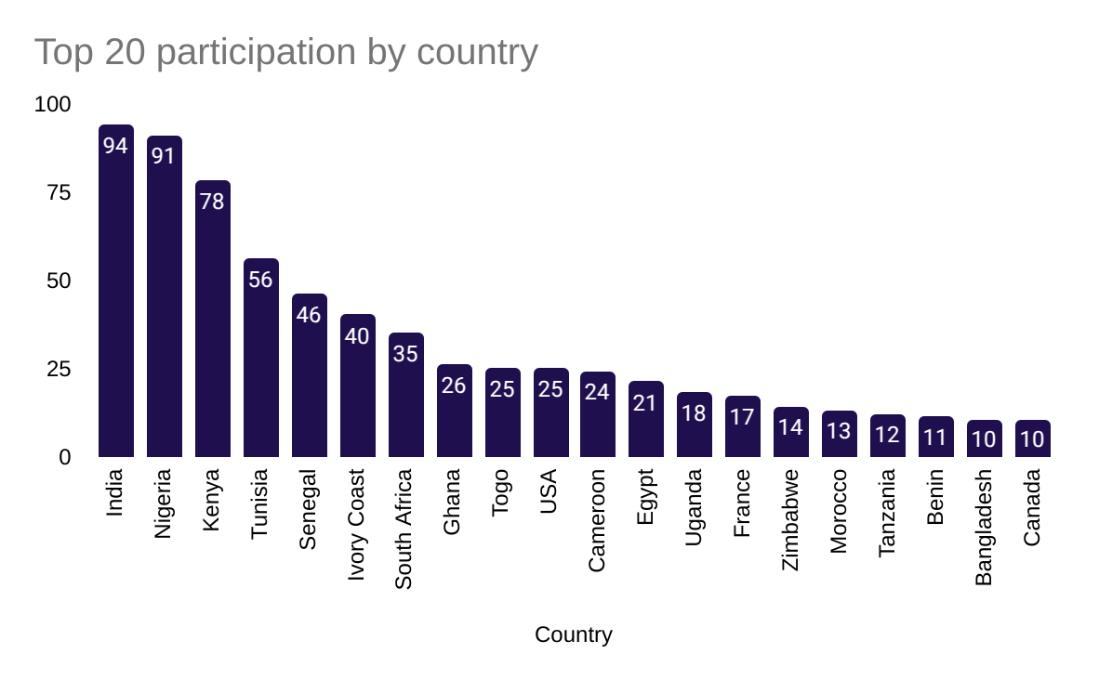

Challenge Winners
1st Place Leaderboard: Top overall winner
- Team name: Team
- Username: Brainiac
- Full name: Darius Moruri
- Email: moruridarius@gmail.com
- Country: Kenya

2nd Place Leaderboard:
- Team name: Central_park
- Username: Koleshjr
- Full name: Stephen Kolesh
- Email: stephenkolesh0601@gmail.com
- Country: Kenya
- Username: nymfree
- Full name: Yves Ngoy
- Email: ngoymutonx@gmail.com
- Country: Democratic Republic of Congo

3rd Place Leaderboard: Top team with a member from Ivory Coast
- Team name: Les Elephants
- Username: ASSAZZIN
- Full name: Azer Ksouri
- Email: azer.ksouri@supcom.tn
- Country: Tunisia
- Username: Muhamed_Tuo
- Full name: Tuo Muhamed
- Email: tuomuhamed@gmail.com
- Country: Ivory Coast

7th Place on LeaderBoard: Top Female on Leaderboard (2nd Winner)
- Username: Jeshen
- Full name: Jane Njuguna
- Email: janenjuguna550@gmail.com
- Country: Kenya

According to the the challenge guidelines, the prize winners are:
- Darius Moruri (Brainiac, Kenya) - top overall winner (3500 EUR)
- Jane Njuguna ( Jeshen, Kenya) - top female (2000 EUR)
- Azer Ksouri and Tuo Muhamed (Les Elephants, ASSAZZIN, Muhamed_Tuo, Tunisia, Ivory Coast) - top team with a member from Ivory Coast (1 500 EUR)

1st Place Solution Overview

Public Leaderboard Score (F1): 0.973978144
Private Leaderboard Score(F1): 0.975995377

This solution addresses the Côte d'Ivoire Byte-Sized Agriculture Challenge, which requires the classification of agricultural land use patterns using 12-band Sentinel-2 satellite spanning 12 months. The proposed approach combines the ConvNeXt deep learning architecture with LightGBM ensemble methods, optimised for multi-temporal agricultural monitoring.

The solution architecture follows this pipeline:
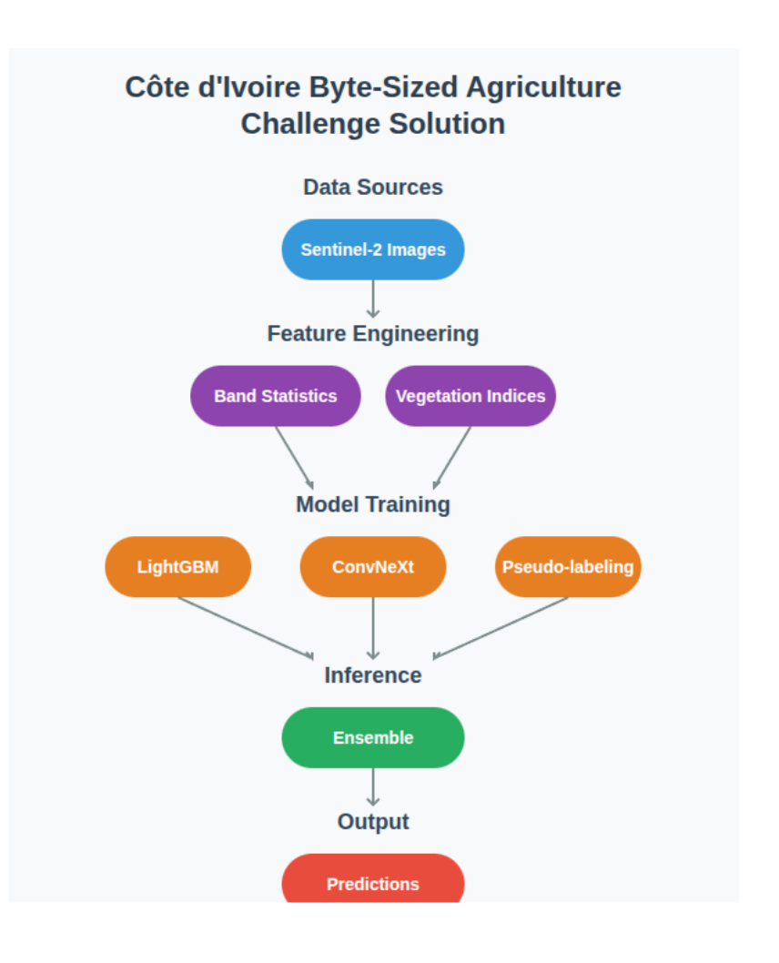
The data comprises 12-band Sentinel-2 satellite imagery, offering rich multispectral information across the visible, near-infrared (NIR), and shortwave infrared (SWIR) spectrum. This enables detailed analysis of land surface characteristics, vegetation health, and other biophysical properties.
Feature extraction
The next step of the pipeline is feature extraction. During this step useful information is extracted from the raw satellite images:
- Band Statistics: summaries like average, standard deviation or differences across the image bands are calculated. 8 statistical measures x 12 bands x 12 months = 1152 features. The statistical measures evaluated are mean, median, min, max, standard deviation, skewness, kurtosis and percentiles.
- Vegetation indices: spectral features (like NDVI) which indicate how healthy or dense the vegetation is are calculated. 101+ indices (NDVI, EVI, SAVI, etc.) are computed using the spyndex Python library.
- Temporal features: Month-wise aggregations and seasonal patterns
- Normalisation: MinMax scaling with outlier handling

Model training
At this step different types of machine learning models are trained using the extracted features.
- LightGBM: A gradient boosting model very good at handling structured (tabular) data.
- ConvNeXt-Small with multi-modal fusion: A modern deep learning model that is good at extracting patterns from images.
- Pseudo-labeling: A technique that helps improve the model when labeled data is limited.
Inference
The trained models are then used to make predictions based on new data (test data). Predictions from multiple models are combined (like taking the average of majority opinion from a panel of experts). This gives better and more stable results.
Setup Instructions
- Hardware Requirements - Colab Pro: A100 40 GB GPU High RAM option
- Model Details
  - Primary Model: LightGBM ensemble
  - Secondary Model: ConvNeXt-Small with multi-modal fusion
  - Input: 144-channel images (12 bands x 12 months)
  - Target: 3 agricultural land use categories (Cocoa, Rubber, Palm)
  - Backbone: ConvNeXt pre-trained on ImageNet
- Configuration:
  - Image size: 64x64 pixels (resized from original)
  - Batch size: 32 (adjusted for GPU memory)
  - Learning rate: 1e-4 with cosine annealing
  - Epochs: 53 (with early stopping)
  - Validation: 15-fold stratified cross-validation
  - Augmentations: rotation, flip, brightness adjustment

How to reproduce:
- Upload Brainiac_1stPlaceck_ByteAgriculture_Solution.ipynb to Colab Pro
- Select A100 40GB GPU with high RAM
- Run all to get the final_submission file.

2nd Place Leaderboard Overview

Public Leaderboard Score (F1): 0.956844558
Private Leaderboard Score (F1): 0.952229512

The central_park team created a solution that uses patches of satellite images to better predict land use. By combining three different gradient boosting machine learning models (LightGBM, Catboost and XGBoost) and focusing on image patches, they made accurate and stable predictions. Their method is also easy to reproduce.

Data Preparation & Feature Engineering

Starting with the provided Train file, they computed aggregated statistics (mean and standard deviation) for each spectral band per month.
Key technique: Patch-Based
- Instead of using the whole image, they focused on a small patch (a square of pixels around the centre of the image).
- This patch-based approach improved training stability and significantly reduced overfitting (the gap between validation and leaderboard scores dropped from 0.4 to 0.02)
- The best patch size was 8 pixels
Additional features
- Vegetation indices (like NDVI) that help identify plant health.
- Interaction features between spectral stats of different months of the year.

See:
- Cote_divoirre_data_preparation.ipynb -> for how the data was prepared
- Catt_byte_sized_challenge_image_satellite_modelling.ipynb -> for the modelling process

Modelling and prediction
The team trained three gradient boosting models:
- LightGBM
- CatBoost
- XGBoost
CatBoost was trained with default parameters whereas LightGBM and XGBoost were fine-tuned using Optuna.

To make the final prediction, a simple average of the three model predictions (simple ensembling) was taken.

How to Reproduce the Solution
- Run cote_divoirre_data_preparation.ipynb; this will generate the processed files:
  - train_monthly_stats_patch_8.csv
  - test_monthly_stats_patch_8.csv ( These files are also provided in the zipped archive.)
- Run Catt_byte_sized_challenge_image_satellite_modelling.ipynb; this trains the models, makes the inference and creates the submission file.

3rd Place Leaderboard Overview (Top team with an Ivorian member)

Public Leaderboard Score (F1): 0.94797466
Private Leaderboard Score (F1): 0.946293406

This solution classifies types of crops (Rubber, Palm, Cocoa) using monthly satellite images (Sentinel-2) over several months.

Data Preparation
For each observation, they stacked the first 7 months of imagery, producing a tensor of shape (7, C, H, W) where C is the number of channels.

Channels
- 13 channels: standard approach using RGB (B4/B3/B2) bands + 10 key vegetation indices (NDVI, EVI, GNDVI, SAVI, NDWI, etc.)
- 16 channels: extended by including raw Sentinel-2 bands B8 (NIR), B11, B12 in addition to the 13 above.
- Vegetation indices: computed per month using normalised bands, providing robust crop-sensitive features

Data Split and Cross-Validation Strategy
In order to maximise model generalisation and minimise “location leak” between train and test, the team designed a stratified spatial split for cross-validation. For spatial clustering, they extracted centroid coordinates from the training geometries.
- Used DBSCAN clustering with haversine distance (10 km radius) to group spatially proximate polygons into clusters, mimicking the spatial structure found in real deployment.
- Stratification to ensure that each fold is balanced for both spatial region and crop class; generate a concatenated label: cluster_class = cluster_id + class_label.
- Performed Stratified K-Fold split (n=5) on the cluster_class to guarantee that each fold contains a representative mix of locations and target crops, without leaking neighbouring parcels across folds.

Modelling Approach
The architecture is built around Swin Transformer Small and ViT backbones.

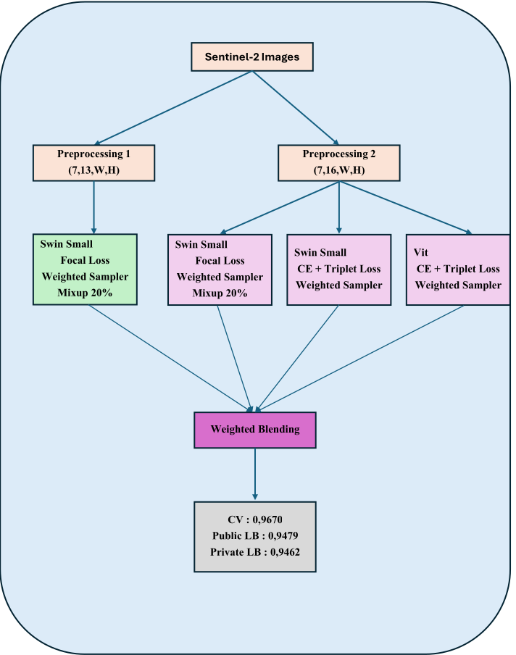
The models used are great at working with images and sequences.

Swin Transformer Small
- A Transformer-based model for processing and extracting features from images
- It learns local patterns first and then combines them for global understanding. (e.g reading small sections of a map and then stitching them together to understand the whole map)
ViT (Vision Transformer)
- Another image model which treats images more like sequences.

Attention Pooling
- After extracting per-month embeddings with the backbone, they applied a custom multi-head attention pooling mechanism, enhanced with positional embedding for months. This allows the model to learn which months and features are the most important.
Handling Difficulties in Learning
- Loss Functions
  - Focal Loss: focuses training more on hard-to-classify examples, especially useful when some crop types are rare or easily confused. This is done by giving higher weight to under-represented or confused classes like Palm and Rubber.
  - Cross Entropy + Triplet Loss: cross entropy helps with standard classification whereas the triplet loss encourages the model to push apart features for confused classes. It pushes similar crops together and dissimilar ones apart (especially useful when Rubber and Palm are similar).
Optimizer and Scheduler: varied between models for diversity in ensemble.
To address class imbalance, the team used a weighted sampler during training. This increased the overall F1 score by 2 to 3 %.

Ensembling (Combining Models)
The team trained 4 different models
- Swin Small - Focal loss, 13 channels (RGB + 10 VIs) [ runtime: 4 hours]
- Swin Small - Focal loss, 16 channels [runtime: 5 hours]
- Swin Small - Cross entropy + Triplet loss, different optimizer & scheduler, 16 channels [runtime: 5 hours]
- ViT - Cross entropy + Triplet loss, different optimizer & scheduler, 16 channels [runtime 9 hours]
This ensemble helps reduce the chance of any single model making a big mistake.

7th Place Leaderboard Overview (Top Female on Leaderboard)

Public Leaderboard Score (F1): 0.94797466 (0.895948616)
Private Leaderboard Score (F1): 0.928157383 (0.85753493)

The solution consists of a fully automated pipeline for classifying crop types (Cocoa, Palm, and Rubber) using Sentinel-2 satellite imagery. The system is designed to extract complex features from remote sensing data, perform extensive feature engineering, and train machine learning models that provide reliable crop type predictions. The major stages of the pipeline are:
- Data extraction (getting the raw data)
- Data preprocessing (cleaning & transforming the data)
- Modelling (training the machine learning model)
- Prediction and Post-Processing (making predictions and improving them manually)

Data Extraction
- Uses the csv files and satellite images (.tif files)
- Extracts pixel information and statistics using rasterio
- Uses multi-threading to handle thousands of images quickly
- Output two files: train_features.csv and test_features.csv

Data Preprocessing
- Spectral bands statistics
- Computes 40+ vegetation indices like (NDVI, EVI, etc) and generates seasonal and texture-related features.
- Cleans the data
  - Remove outliers (beyond three standard deviations)
  - Replaces NaN and infinite values with zeros
  - Standardises the data using StandardScaler
- Outputs two files train_df.csv and test_df.csv
Load
- Transformed data which is saved into csv (train_df.csv & test_df.csv) is loaded from training and testing respectively.

Modelling
The solution uses a Light Gradient Boosting Machine (LightGBM) multiclass model. It assumes that Sentinel-2 spectral bands and derived features are predictive of crop type and that grouping by ID prevents data leakage. The model is trained using GroupKFold cross-validation with 5-folds. The training process includes early stopping (after 50 rounds without improvement) to avoid overfitting. The model is tuned with Optuna to find the best model hyperparameters. The hyperparameters found are:
- Learning rate: 0.018532192293412842
- Number of leaves: 154
- Maximum depth: 7
- Feature fraction: 0.9116533879586213
- Minimum data in leaf: 25
- Lambda L1: 0.9116533879586213
- Lambda L2: 1.0474921105080416e-06
- Minimum gain to split: 0.06283015568879952
- Bagging fraction: 0.8583593350618955
- Bagging frequency: 5
- Boosting type: gbdt
- Objective: multiclass
- Number of Class: 3
- Verbose: -1
- Random state: 42

Post Processing (?)

After generating initial model predictions, a post-processing phase was applied to improve the
final results. Jane experimented with different models and manually analysed their outputs to
identify specific samples where correcting the predicted class led to a higher evaluation score.
Through this analysis, she compiled a list of specific IDs where changing the predicted class
improved performance. These manual fixes were applied to the final submission as part of the
post-processing step. This approach leveraged model disagreements and empirical adjustments to boost the final F1 macro score beyond what the models achieved alone.

Reproducing the solution

The solution consists of three Jupyter notebooks that must be run in the correct order for proper functioning:
1.​ Data Extraction Notebook (Data Extraction.ipynb): This notebook reads and processes input data, extracts band-level statistics and saves feature CSVs: train_features.csv and test_features.csv. It must be run first as it generates the raw features for later steps.

2.​ Data Preprocessing Notebook (Data Preprocessing.ipynb): This notebook loads the features from extraction, applies feature engineering, cleans the data and saves processed datasets: train_df.csv and test_df.csv. It must be run second.

3.​ Modeling Notebook (Modelling.ipynb)

4.​ This notebook loads the processed data, trains the LightGBM model, evaluates its
performance and generates predictions, including submission files. It should be run last.
Following this sequence ensures that each notebook has the necessary inputs generated by the previous step

