Solution Write-up: Rhea Soil Nutrient Prediction Challenge
Challenge Objective

Rhea supports smallholder farmers by providing accessible, real-time soil testing and data driven insights. Improve soil information enables:
- Targeted fertiliser application for higher yields
- Reduced input costs through efficient nutrient use
- Improved resilience through better soil management
- More sustainable and profitable farming
The challenge objective was to predict key soil nutrient levels (Al, B, Fe, Ca, … etc) using geospatial and soil data

Statistics
The competition took place from February 04, 2026 to March 09, 2026. Here are some statistics:
- 610 participants enrolled
- 4, 444 submissions made
- Participants from 82 countries (38 of which are from Africa)
- 18 % (similar to our previous Digital Africa competition) of those the participants are female
- 107 participants from Kenya
- Most participants worked individually instead of forming teams.

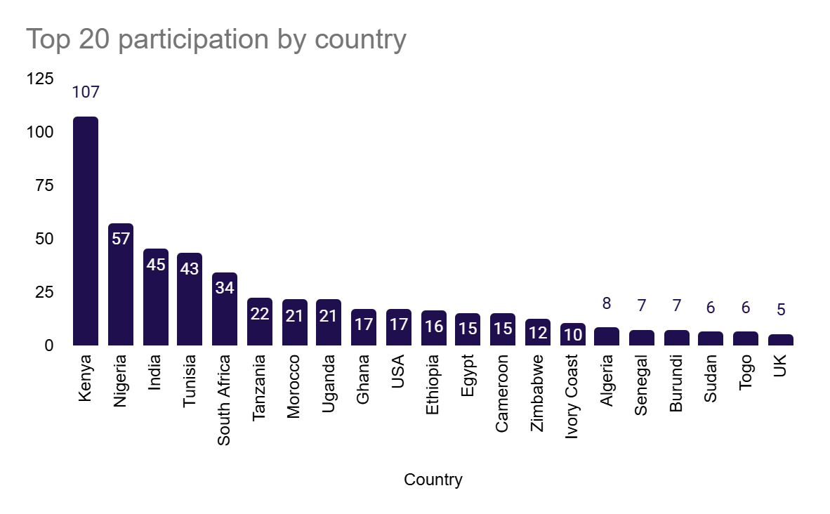
Winners
Top overall winner (1st place leaderboard): Prize € 4 000
- Team name: ML_vibe
- Username: Yisakberhanu
- Full name: Yisak Bule
- Email: yisberh945@gmail.com
- Country: Ethiopia
- Gender: Male
- 1st place on leaderboard

Top female / Team with female members (4th place leaderboard) € 2 750
- Team name: BitsnBytes
  - Username: LosuteGladys
  - Full name: Losute Gladys
  - Email: gladyslosute@gmail.com
  - Country: Kenya
  - Gender: Female

  - Username: Paul_K
  - Full name: Paul Kamau
  - Email: ngangapaulkamau@gmail.com
  - Country: Kenya
  - Gender: Male

Top team with a Kenyan Member (5th place leaderboard) € 1 500
- Username: keystats
- Full name: Jackson Kahungu
- Email: jkahungu3@gmail.com
- Country: Kenya
- Gender: Male

Note: Some participants in the top 10 did not submit their code for review, even after being prompted to do so by email. Hence they are automatically disqualified for prizes.

Top Solution Overview (ML_vibe)

Public Leaderboard Score (Weighted RMSE): 0.631267328
Private Leaderboard Score(Weighted RMSE): 0.55562599

This solution tackles a specific challenge: the training data came from past years, but the test data is from 2025. That gap means the environment may have changed — making models trained on old data less reliable on new data. This is called a temporal domain shift (a mismatch between the time period the model learned from and the time period it is being tested on).

Key Approach

1. Adversarial Feature Engineering
Features are measurable signals extracted from satellite images or environmental datasets. Examples include:
- NDVI (Normalised Difference Vegetation Index): a measure of how green and healthy vegetation is in a given area.
- EVI (Enhanced Vegetation Index): similar to NDVI but more sensitive in dense canopy areas.
- BSI (Bare Soil Index): highlights areas with little or no vegetation cover.
- SAVI (Soil-Adjusted Vegetation Index): like NDVI but corrects for the influence of bare soil beneath sparse vegetation.

After computing these features, the team used adversarial validation — a technique that trains a classifier to distinguish between historical and 2025 data. Features that the classifier can easily separate by time period are considered unstable, and are removed. Only time-stable features (called ultra-safe features) are kept. This ensures the model doesn't rely on signals that change over time.

2. Domain Shift Handling
Even after filtering features, the distributions of some values still differ between historical and 2025 data. Two strategies address this:
- Covariate Subsampling: removes historical data points with extreme values that don't appear in the 2025 dataset, making the training data more representative of current conditions.
- Domain Extrapolation: for nutrient values in the 2025 data that exceed anything seen in training, the model applies a scaling ratio (a calculated multiplier) to adjust predictions into a realistic range.

3. Ensemble Modelling
Rather than relying on a single model, two different algorithms are combined:
- Random Forest: a model that builds many decision trees and averages their outputs. It is good at capturing fine-grained local spatial patterns.
- LightGBM: a gradient boosting model that builds trees sequentially, with each new tree correcting errors from the previous one. It is effective at capturing broader environmental trends.
The final prediction is a 50/50 blend of both models.

4. Inference Strategy
Inference refers to generating predictions using a trained model. A routing-based pipeline ensures there is no data leakage (where information from the test set accidentally influences training):
- Historical data points are predicted using models trained on all available data.
- 2025 data points are predicted using the filtered, time-stable models with calibrated scaling applied.

Key Strength:
This solution explicitly models the time gap between training and test data rather than ignoring it — a robust approach for real-world deployment.
The resulting architecture is shown in the following diagram
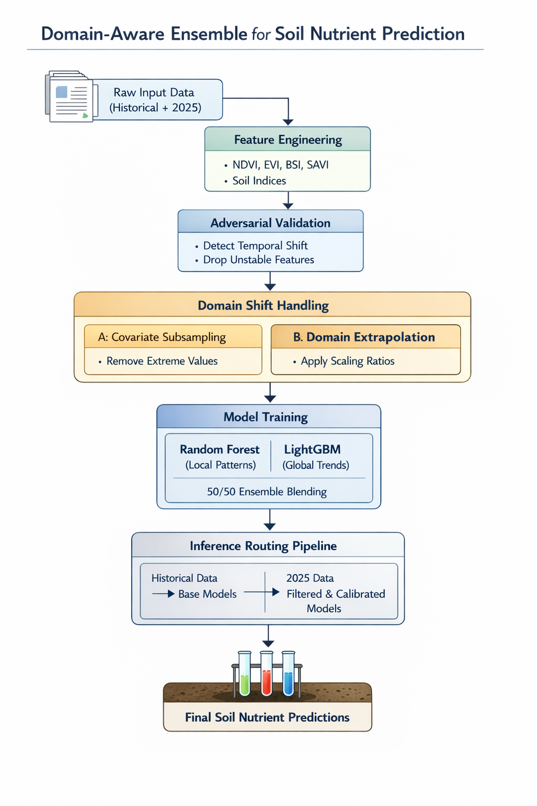

2nd Solution (Top Team with Female members) Overview

Public Leaderboard Score (Weighted RMSE): 0.625591982
Private Leaderboard Score(Weighted RMSE): 0.4839002223

This is a multi-stage geospatial ensemble pipeline — a system that combines many different models and data sources to predict soil nutrients across Africa. It is designed to handle the challenge of predicting over a large, diverse continent with varying climates, terrain, and sparse soil sample coverage.

Key Components

1. Multi-Source Feature Engineering
The team pulls data from several different sources to build a rich set of input features:
- Sentinel-2: a European Space Agency satellite that captures high-resolution optical imagery.
- MODIS: a NASA satellite instrument that captures lower-resolution but frequent global observations.
- CHIRPS: a rainfall dataset combining satellite estimates and ground station data.
- WorldClim: a global climate database providing temperature and precipitation data.
- SRTM: elevation data collected by a Space Shuttle radar mission.
- iSDAsoil / AfSIS: African soil databases providing ground-truth context for soil properties.

From these sources, the team generates spatial embeddings (mathematical representations of location relationships), KNN (K-Nearest Neighbours) distances (measuring how similar each location is to its neighbours), and neighbourhood statistics computed without data leakage.

2. Spatially-Aware Modelling
Several modelling strategies account for geography:
- Köppen–Geiger Climate Zones: a widely used global climate classification system. The team groups locations by their climate zone, then further clusters them into village-level groups using DBSCAN (Density-Based Spatial Clustering of Applications with Noise — an algorithm that finds clusters of nearby points automatically).
- Spatial Cross-Validation (GroupKFold): a method that splits training and test data by geographic group, preventing nearby samples from appearing in both sets simultaneously, which would give the model an unfair advantage.
- Regionalised Modelling (Kenya-specific): Kenya has a known data scarcity issue, so dedicated models are built using auxiliary datasets to fill the gap.
- Legacy Knowledge Transfer: techniques from the winning solution of the 2014 AfSIS soil challenge are incorporated.

3. Ensemble and Hierarchical Predictions
Multiple independent pipelines each produce their own predictions, which are then combined using a weighted ensemble (different models contribute different amounts based on their reliability).
Predictions are also bounded by hierarchical constraints — village-level, climate-zone-level, and global fallback ranges — ensuring results remain physically plausible, even in data-scarce regions.

Key Strength:
Combining climate geography, spatial awareness, and diverse modelling approaches makes this solution highly robust across Africa's varied environments.
The architecture of the second place solution is shown below:
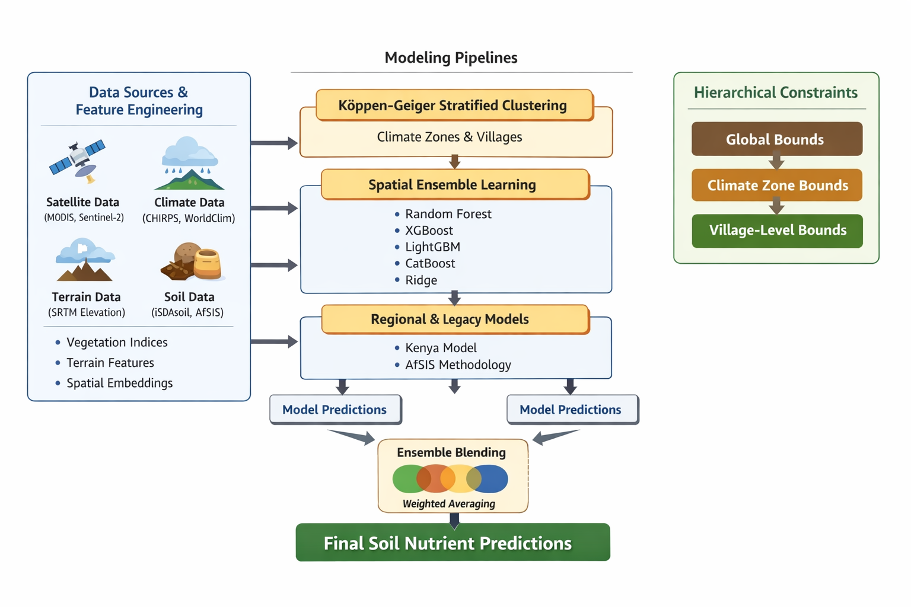

3rd Solution (Top Team with a Kenyan member) Overview

Public Leaderboard Score (Weighted RMSE): 0.451637314
Private Leaderboard Score(Weighted RMSE): 0.472775654

This is the most feature-rich solution in the competition — it builds over 1,000 environmental input variables and uses a highly engineered ensemble of models, incorporating soil science knowledge directly into the modelling pipeline.

Key Components

1. Massive Feature Engineering
Over 1,000 features are derived from satellite, climate, terrain, and soil datasets (MODIS, Sentinel-1/2, CHIRPS, WorldClim, TerraClimate, SRTM, SoilGrids). These include vegetation indices, soil moisture signals, fire frequency, and proxies for human activity.

2. Depth-Pair Matching
64% of test locations share GPS coordinates with training locations — just at a different soil depth. The team exploits this by directly transferring known values and computing depth ratios (how a nutrient changes with depth) and depth differences. This is described as the most powerful predictive signal in the solution.

3. Multi-Scale Spatial Modelling
Inverse Distance Weighting (IDW) is a spatial interpolation technique — it estimates values at unknown locations based on nearby known values, giving more weight to closer points. The team applies IDW at multiple radii (distances) and with varying decay rates (how quickly the influence of nearby points fades with distance).

4. Soil Science Feature Engineering
Rather than relying purely on statistical patterns, the team encodes known chemical relationships between soil properties:
- pH influences iron and aluminium availability.
- Rainfall affects calcium leaching (the washing away of calcium through the soil).
- Organic matter content correlates with nitrogen levels.
This adds 80+ domain-driven features grounded in soil chemistry.

5. Geochemical Chaining
This is a sequential prediction strategy where the predicted value of one nutrient is used as an input feature when predicting the next nutrient. This captures interdependencies — for example, knowing the predicted phosphorus level helps estimate calcium more accurately.

6. Ensemble Modelling Core
Three gradient boosting models are used: LightGBM, XGBoost, and CatBoost. Each of these builds an ensemble of decision trees, but they differ in how they handle data, categorical variables, and regularisation (preventing overfitting). All three are trained using 5-fold cross-validation, producing 195 models in total. Their outputs are combined using Ridge stacking (a linear model that learns the best blend) and Nelder-Mead optimisation (a mathematical method for finding the optimal blend weights).

7. Spatial Safety Mechanism

Key Strength:
A multi-layered system that integrates data science, geography, and soil chemistry — arguably the most comprehensive approach in the competition.

The solution architecture is shown in the Figure below:
