Solution Write-up: DigiCow Farmer Training Adoption Challenge
Challenge Objective

DigiCow supports smallholder farmers through training programmes. Early adoption prediction enables:
- Prioritised follow-up for at-risk farmers
- Tailored support based on likelihood of action
- More effective extension programme design
- Better resource allocation for maximum impact
The challenge objective was to predict the probabilities that a farmer will adopt a practice within 7, 90, and 120 days after training, using only information available at the time of training.

Statistics
The competition took place from January 28, 2026 to March 02, 2026. Here are some statistics:
- 896 participants enrolled
- 20,050 submissions made
- Participants from 83 countries (36 of which are from Africa)
- 16 % (similar to our previous Digital Africa competition) of those the participants are female
- 192 participants from Kenya
- Most participants worked individually instead of forming teams.
- Unusually high participation from Madagascar
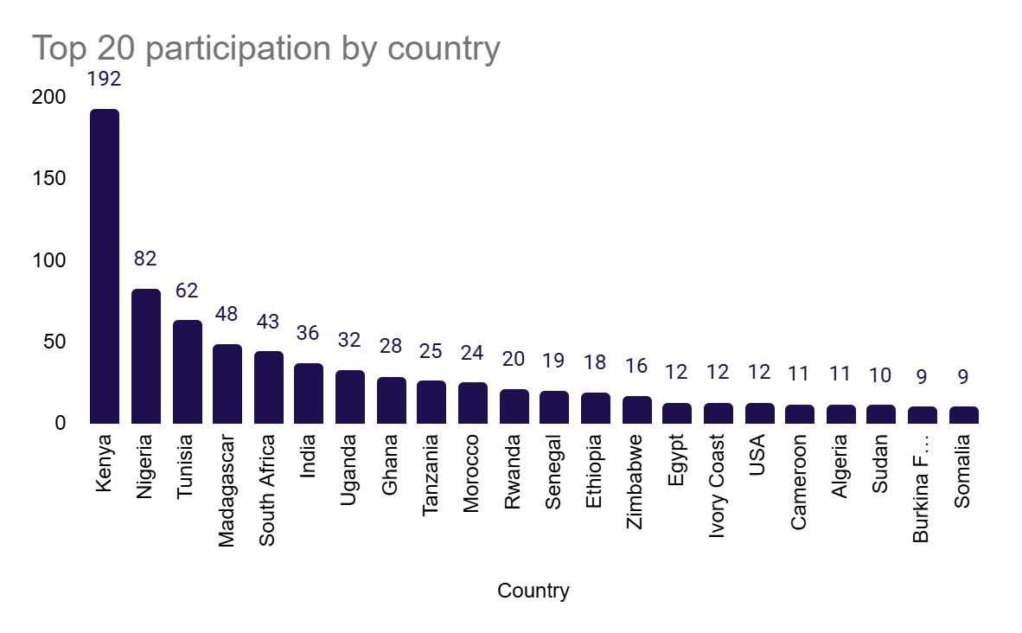

Winners
Top overall winner (2nd place leaderboard): Prize € 4 000
- Username: P_B
- Full name: Missodey Raoul
- Email: raoulmissodey@gmail.com
- Country: Togo
- Gender: Male
- 2nd place on leaderboard

Top female / Team with female members (4th place leaderboard) € 2 750
- Username: biya
- Full name: Abinet Bekele
- Email: bekeleabinet20@gmail.com
- Country: Ethiopia
- Gender: Female

Top team with a Kenyan Member (9th place leaderboard) € 1 500
- Team name: CN-Boost
  - Username: crossentropy
  - Full name: Agbaje Ayomipo
  - Email: agbajeayomipo287@gmail.com
  - Country: Nigeria
  - Gender: Male

  - Username: Nyatuka
  - Full name: Moan Lobago Nyatuka
  - Email: nyatuka2407@gmail.com
  - Country: Kenya
  - Gender: Male

Top Solution Overview

Public Leaderboard Score (0.75 LogLoss +0.25 AUC): 0.969001938
Private Leaderboard Score(0.75 LogLoss +0.25 AUC): 0.961012524
This solution implements a highly advanced ensemble pipeline that combines TabNet, LightGBM, and XGBoost, trained across multiple seeds and blended using metric-specific optimisation for both LogLoss and ROC-AUC.
The approach uses Train.csv alongside Prior.csv to expand the labelled dataset and constructs a rich feature space capturing temporal dynamics, farmer behaviour, trainer effectiveness, peer influence, and topic semantics (via TF-IDF and SVD embeddings). Historical features are carefully engineered using backward-looking joins to minimise leakage, while test-era feature alignment is applied to address temporal distribution shift.
The modelling pipeline employs 5-fold stratified cross-validation, multi-seed averaging, and stability-based feature selection, followed by a sophisticated ensemble strategy:
- LogLoss-optimised blending in logit space
- AUC-optimised blending via Dirichlet search
The architecture of the solution is shown in the following diagram:
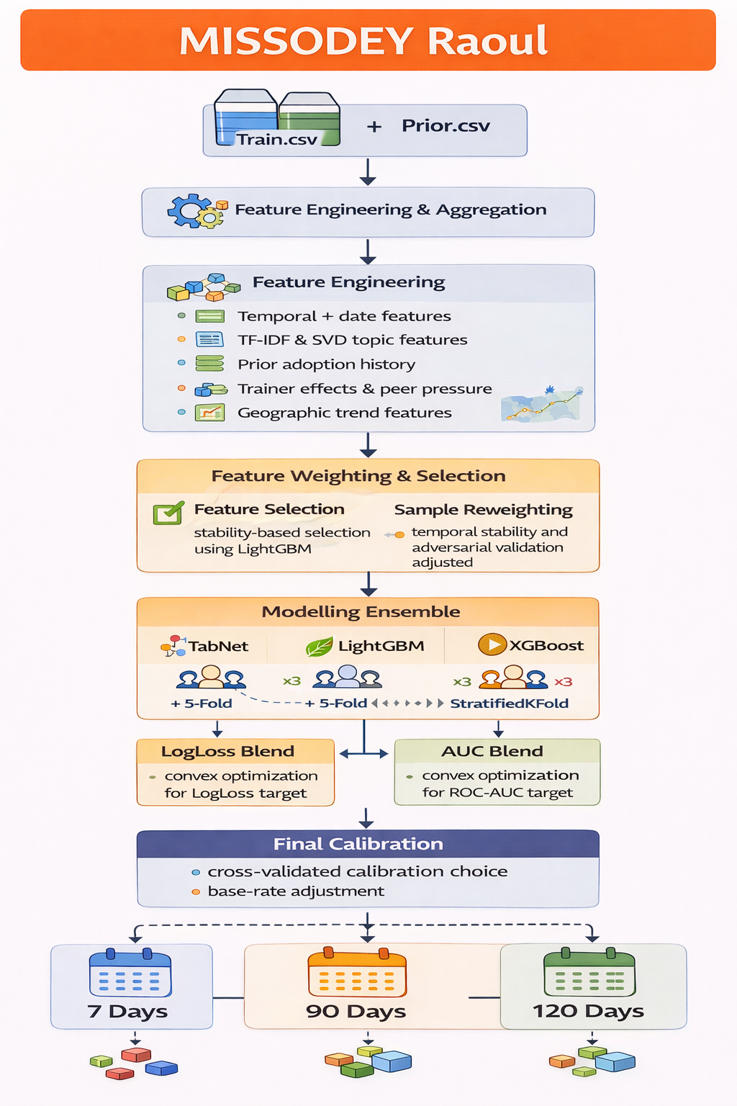
A key strength of the solution is its advanced calibration framework, which automatically selects the best method (e.g. Platt, beta scaling) and applies base-rate alignment to test-era distributions, ensuring well-calibrated probability outputs.
Overall, this is a competition-grade solution characterised by:
- exceptional feature engineering depth
- strong model diversity
- advanced calibration and distribution alignment
However, its complexity and reliance on StratifiedKFold (rather than farmer-grouped validation) introduce potential validation leakage risk, and the pipeline carries a high computational cost (~10 hours runtime).

2nd Solution (Top Female) Overview

Public Leaderboard Score (0.75 LogLoss + 0.25 AUC): 0.967343443
Private Leaderboard Score(0.75 LogLoss + 0.25 AUC): 0.957176799
This solution implements a highly structured gradient boosting pipeline using XGBoost and LightGBM, trained with 5-fold group cross-validation (by farmer) to prevent leakage and ensure robust validation.
The approach is built around a rich, multi-layered feature engineering pipeline, combining:
- Topic understanding (parsed topics, top-topic indicators, TF-IDF, and SVD embeddings)
- Farmer behavioural history (visit frequency, recency, topic exposure, engagement patterns)
- Trainer performance signals (historical adoption rates with smoothing)
- Temporal features (seasonality, training timing)
- Geographical and group-level aggregates
The architecture of the proposed solution is shown here:
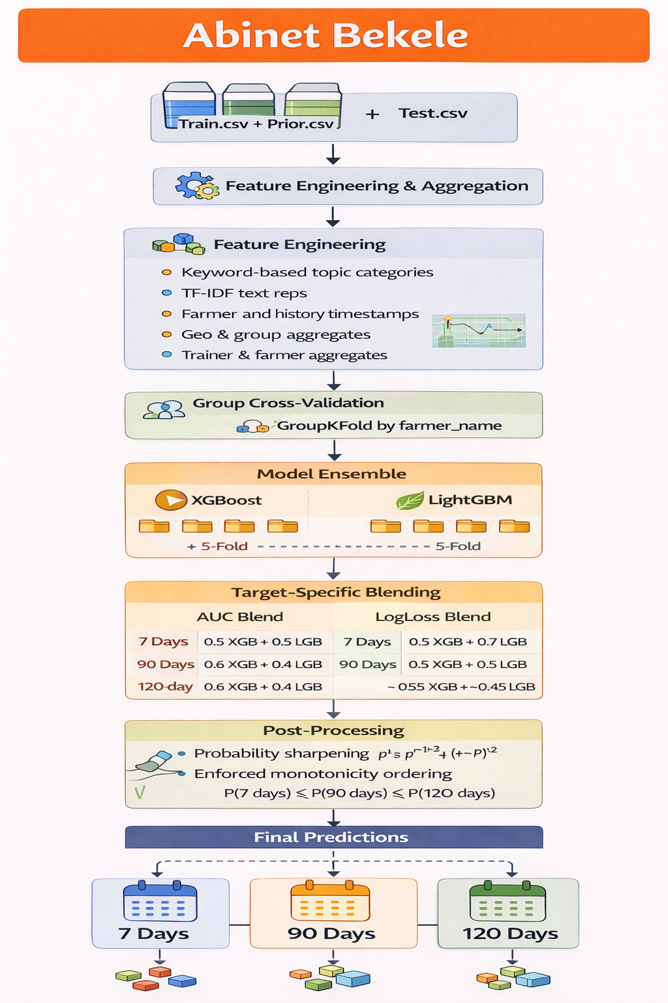
A key strength is the use of Prior.csv as historical context only (not direct label expansion), enabling realistic feature construction while avoiding overly aggressive data leakage.
The modelling strategy trains separate models per prediction horizon (7, 90, 120 days) and combines XGBoost and LightGBM using target-specific weighted ensembling, optimised differently for LogLoss and AUC.
The pipeline includes important post-processing steps:
- Probability sharpening to improve confidence calibration
- Monotonicity enforcement (7 ≤ 90 ≤ 120) to ensure logical consistency across time horizons

Strengths
- Strong validation design (grouped CV) – one of the most robust among reviewed solutions
- Deep feature engineering, especially farmer history and topic modelling
- Clean separation of feature construction vs modelling pipeline
- Thoughtful post-processing and probability calibration

Limitations
- No explicit feature selection, leading to a very large feature space
- Computationally heavy due to TF-IDF + SVD + multiple models
- Monotonicity handled only in post-processing rather than model design

This is a top-tier, production-aligned solution with excellent validation rigour and strong feature engineering. Its careful handling of temporal structure and farmer-level grouping makes it significantly more reliable than most submissions, placing it among the most methodologically sound approaches in the competition.

3rd Solution (Top Team with a Kenyan member) Overview

Public Leaderboard Score (0.75 LogLoss + 0.25 AUC): 0.961351188
Private Leaderboard Score(0.75 LogLoss +0.25 AUC): 0.953710687

This solution implements a reproducible, notebook-based ensemble pipeline designed to predict farmer adoption probabilities across 7-, 90-, and 120-day horizons..
The modelling approach uses a 10-fold StratifiedKFold cross-validation framework, where models are trained per fold and predictions are averaged to produce final outputs. The pipeline evaluates performance using both Log Loss and ROC-AUC, aligning with the competition metric.
The solution leverages a strong ensemble of gradient boosting models, including:
- XGBoost
- LightGBM
- CatBoost
Feature processing is handled within the notebook and includes:
- Categorical encoding
- Duplicate removal and feature alignment
- Integration of text-based representations via sentence-transformers
The following diagram shows the architecture of the proposed solution:
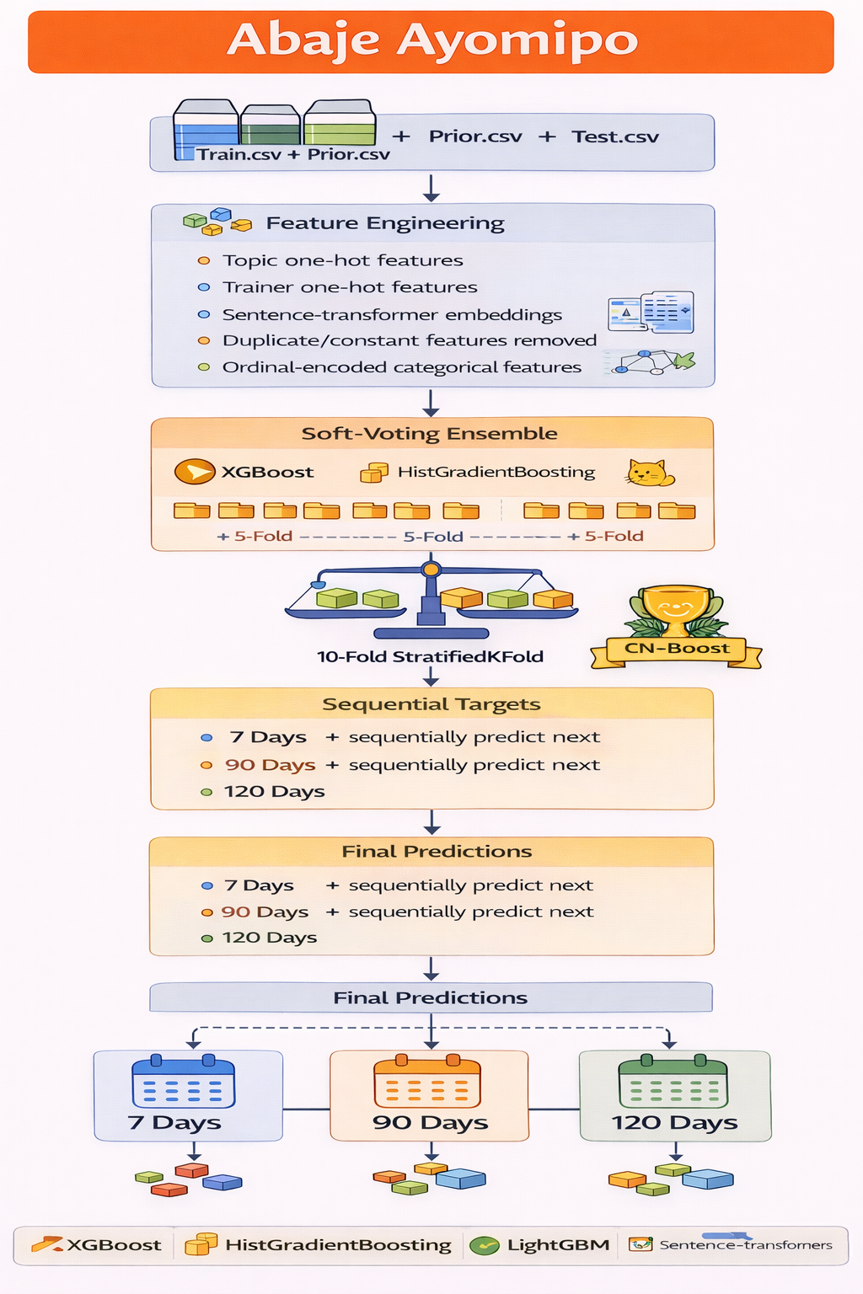
An additional EDA notebook supports the pipeline by providing insights into target distribution, feature relationships, and modelling considerations.

Strengths
- Fully reproducible and well-documented pipeline with clear setup instructions
- Use of robust cross-validation and fold averaging
- Strong ensemble of competitive models
- Clean separation of EDA and modelling workflows

Limitations
- Uses StratifiedKFold without farmer grouping, introducing potential leakage
- Limited explicit detail on feature engineering depth in the documentation
- No advanced post-processing (e.g. monotonicity or calibration)
This is a solid and well-executed mid-tier solution, combining strong ensemble modelling with good reproducibility practices.

