# **3-D Graphs**

## **LAB 01: Blender**

**Gaganjot SHAN**

**Zineb SENANE**

**Question N°1: First experiments, objects, materials, shading :**

The goal of this question is to have a first experience with the blender interface, create an object, modify some parameters (size, smoothness) and experiment with the materials (diffuse and specular coefficients). Please do some experiments and answer the question in the last row (value of In specular intensity and hardness for the four image examples).

**Modify the specular intensity and the hardness values to obtain images that look like the previous ones and give the values in your answer.**

1. Specular intensity=0 and hardness=300

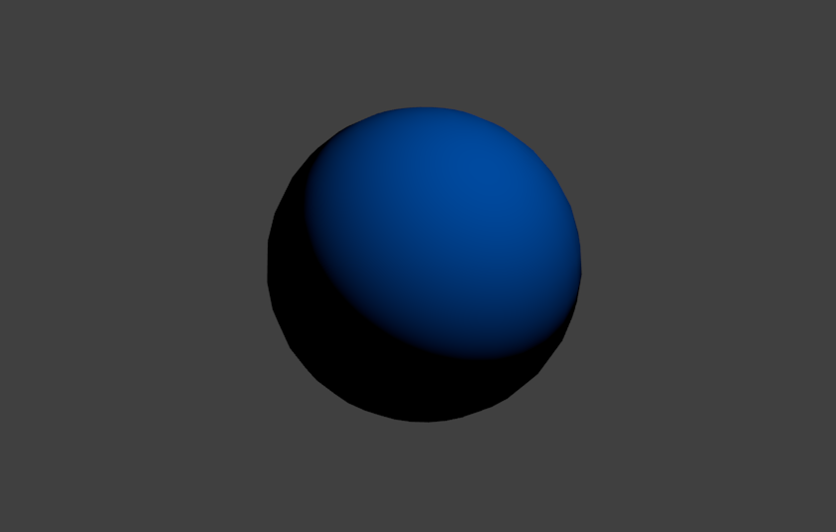

1. Specular intensity=0.8 and hardness=95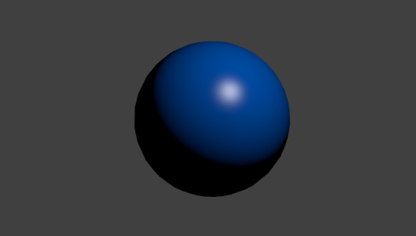
2. Specular intensity=0.6 and hardness=10

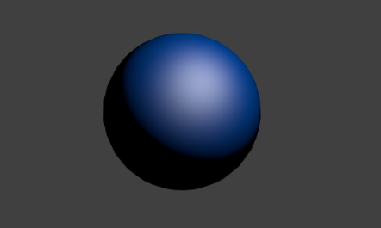

1. Specular intensity=0.6 and hardness=300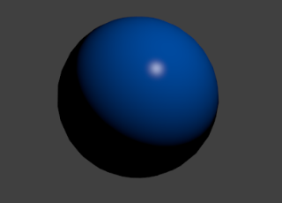

Conclusion: The size of the white highlight in the item is affected by its hardness. As we raise hardness, the shining spot shrinks. Whereas by increasing the specular intensity, the white spot becomes more intense and sharp.

**Question N°2: Create a scene, reflection, refraction, cast shadows :**

In this second question, starting from the previous question, we are going to add new objects to define a very simple scene made of a plane and 3 spheres. In this question you are going to manipulate the camera, add new objects and lights and experiment with refraction and reflection of the whitted algorithm.

**Explain what you see and relate what you see with the value of the coefficients we have chosen. Please focus on the colours of the cast shadows on the plane, why the black shadow does not look realistic? What do you think can be done to make that shadows more realistic?**

**Alpha Blend:** Controls how the channel **alpha** is used to create a transparent texture in the rendered image.

We have a fair amount of transparency across the surface since we set the transparency sphere's coefficient alpha to 0.3, says (0 means fully transparent). Instead of passing through, light simply reflects on the clear surface. The light beams do not converge as expected with a lense-like item like that transparent ball.

Ray-traced shadows provide incredibly exact shadows while using very little memory, although at the expense of processing time. When two shadows overlap, they turn grey or black. The plane's cast shadows do not appear realistic because they form perfect mathematical point light sources, which is not the case in real life.

Light is supposed to be created across an area, resulting in the formation of umbra and penumbra. We need to mimic an Area of Light to make that shadow more realistic. One technique is to create a plane, then partition it twice and make it the parent of our spotlight source, leading to a square array of spotlights that all shine in unison.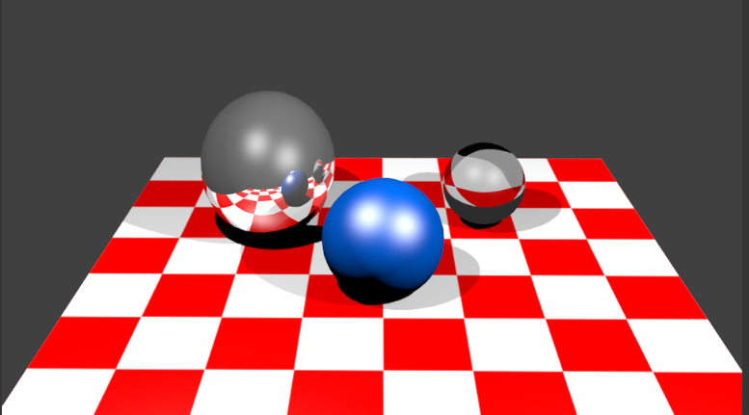

**Question N°3: Playing with textures, bumping, transparencies :**

In this third question, the goal is to go a bit further in the manipulation of concepts presented in the course. For that purpose, we are going to model the earth with four textures applied to it :

* A bump map to sculpt the earth according to the mountain relief (modification to N).
* A Colourmap to render the diffuse aspect of the earth (applied to Kd)
* A specular map to make the ocean specular (Ks=1) and the ground diffuse only (Ks=0)
* A transparency map to model the clouds.

**Explain the concepts behind each of the four steps, and relate those steps to the concepts we have seen in the course.**

Step 1: After we've generated the sphere, we apply the bump texture to disrupt the surface geometry and give the mountain relief.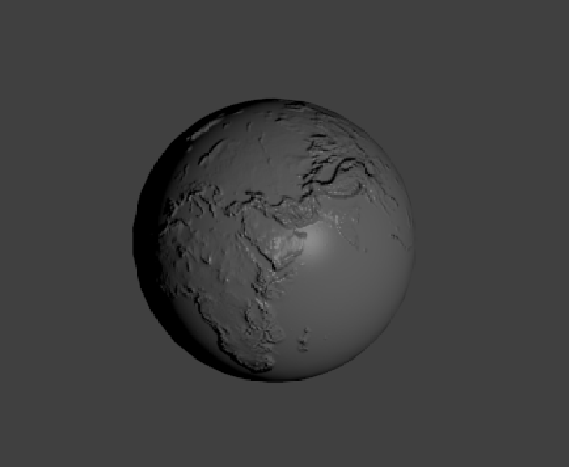

Step 2: We added the environment texture, as further texturing, which is responsible for the earth's hues (continents, ocean, etc.). We would prefer to eliminate the specular reflection, though, because dirt does not reflect light in the same manner as water does.

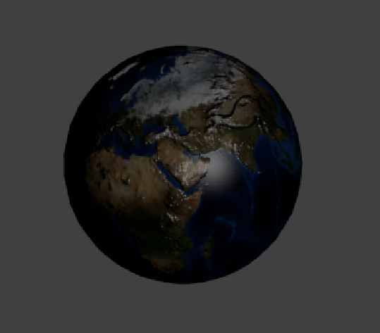

Step 3: We apply the alpha mask, which allows us to have the specular reflection over water only. It's the light-map texture we're looking for.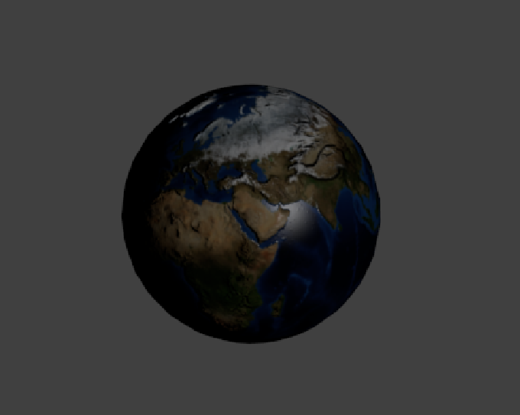

Step 4: We apply the transparency texture to the earth and strap the cloud texture to it. We must ensure that the white component of the texture shows through on the material, ie clouds.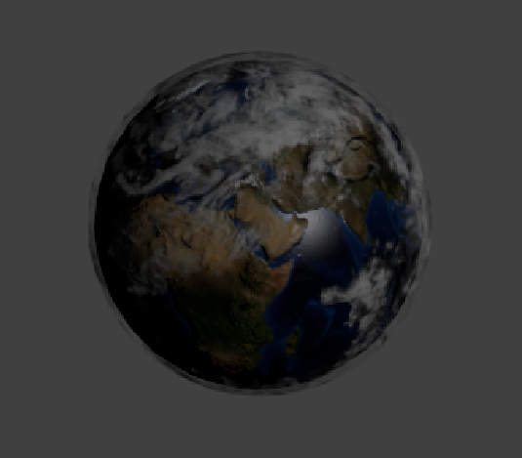

**Question N°4: More texture, environment mapping and chrome :**

In this fourth question, we are going to play a little more with textures and illustrate the environment mapping effect that you will see in more detail in the course. The idea is to play with two types of environment maps :

* The chrome effect (the idea being to use a reflection map to simulate a complex lightning process)

*Mirrored reflection colour (or mirror object), almost perfectly reflecting substance, such as chrome by default Other, similarly reflecting materials, on the other hand, tint the reflections with their hue. This is true, for example, of well-polished copper and gold. To duplicate this in Blender, change the Mirror Color to a suitable colour. To change the colour of the mirror, just click the colour button in the mirror panel and choose a colour.*

* The environment map (reflection of the environment) effect is described in the course.

*Environment maps take a 3D scene render and apply it to a texture to simulate reflections. Ray-traced reflections are an excellent option if you want to produce a realistic appearance. Environment Maps are another method for creating reflecting surfaces, although they are more difficult to implement.*

**Please comment on the resulting images and the parameters that were set to achieve the effect. Analyze the difference between the two last steps, what is according to your understanding of the theoretical difference. How do you think is it possible to validate the reflection effect?**

Regardless of the view angle, a reflection map trails the render camera. In models q4-1 through q4-3, we just updated the reflection technique. With q4-4, we generate the same environment, but this time on the sphere. The produced texture is applied to the sphere. The textures are mapped on the sphere, with the axes organized in the order X, Y, and Z, depending on the viewing angle.

Because there is no blurring area between q4-3 and q4-4, the viewer might prefer the generated q4-4. We can centre the camera view to check the reflection effect, adjusting the point of view that interacts with the reflected surroundings.

**Q4-1**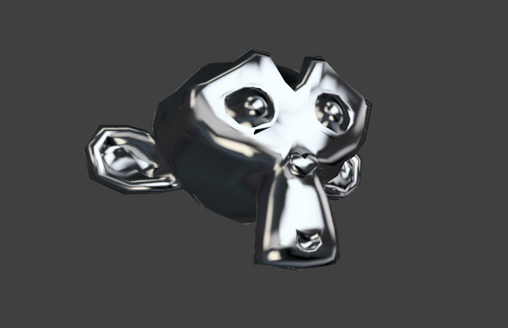

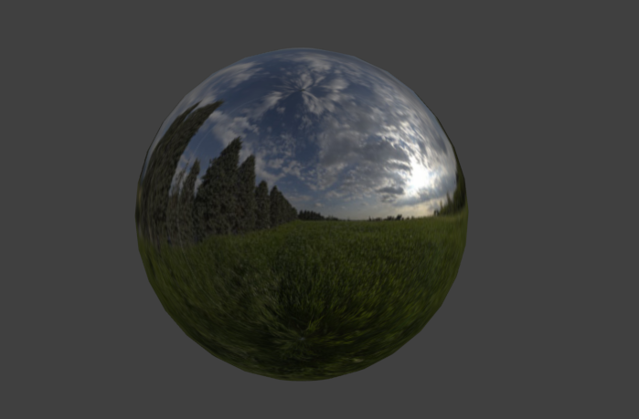

**Q4-2**

**Q4-3**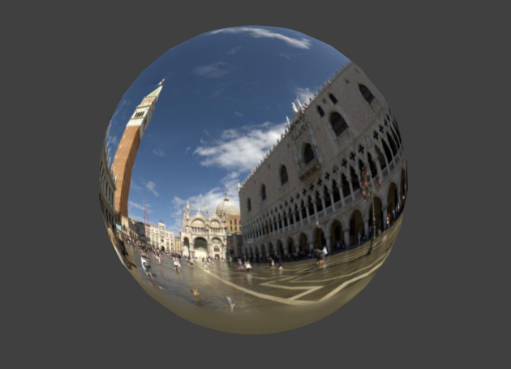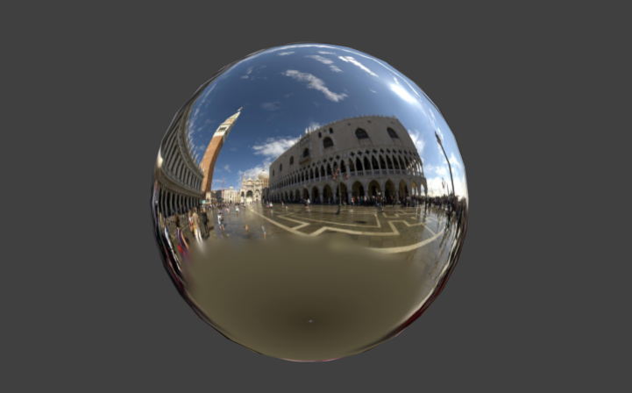

**Q4-4**

**Question N°5: Animation, path, focus, chrome effect:**

In this fourth question, we are going to animate the position of the camera to make the chrome effect more evident.

**Please comment on the resulting animation according to the chrome texture appearance when you turn around, why do you think a point on the object changes colour with the viewer position? Relate that effect to the previous question?**

The mapping of an environment map texture must be set to Reflection (reflection coordinates) in the Map Input panel of the Material tab for proper results.

Because the texture appearance is a reflection system of the surroundings, the reflections appear more realistic than when projected. Reflection mapping on the object makes the light in this animation follow the movement of the camera. As a result, as the viewer's location changes, a point on the object's colour changes naturally.

**Reference(s):**

* <https://docs.blender.org/manual/fr/2.79/render/blender_render/materials/properties/specular_shaders.html>
* Class notes