# **3-D Graphs**

## **VRML - Lab 02**

**Zineb SENANE**

**Gaganjot SHAN**

**Subject**

The goal of this TP is to experiment with the concepts presented in the course. During this TP we are going to use an interactive 3D rendering program that will allow us to describe 3D scenes using an XML tool that generates VRML scenes. We will experiment with how to interact and navigate interactively in the scene.

VRML (Virtual reality modelling language) is a normalized ASCII file format that allows us to describe 3D words on the web. The current version of VRML is 2.0 and we can install a plugin on your favourite web browser to automatically show in 3D the content of the file. VRML is based on the B-Rep modelling and generally, the VRML viewers are based on the Z-Buffer algorithm.

The objective is to define a solar system and navigate in it. Most of the time, the questions will make use of figures to show the structure of the hierarchy to be obtained. The following symbols are used in the figures:

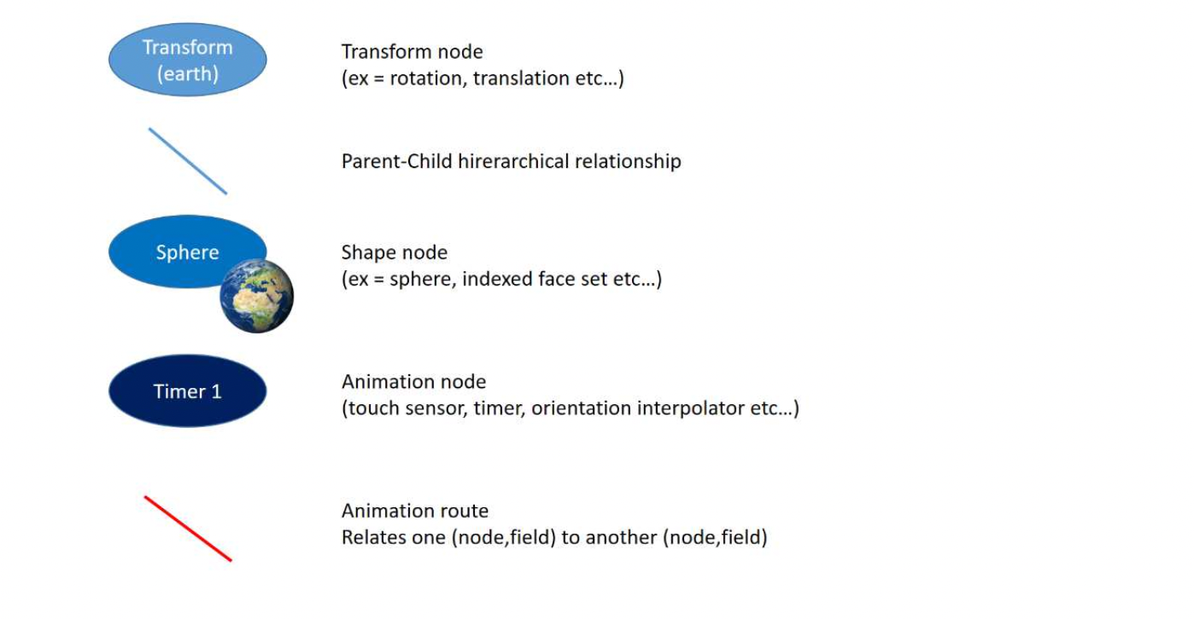

**Step N1:**

Using X3Dedit create a “step1.x3d” file that includes a sphere of radius 5 at the centre of the coordinate system (OC = WC).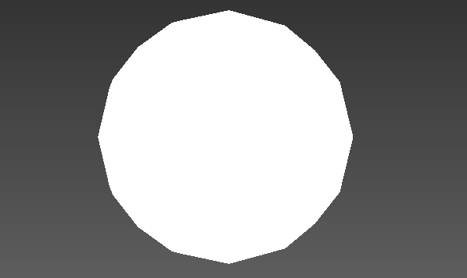

**Step N2:**

Map a texture image called “terre.gif” on the previous sphere. 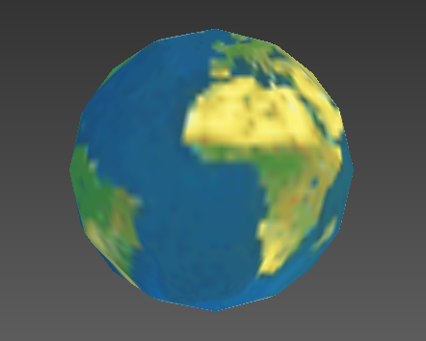

**Step N3&N4:**

We added the transforms to control the earth's movement.

**Step N5:**

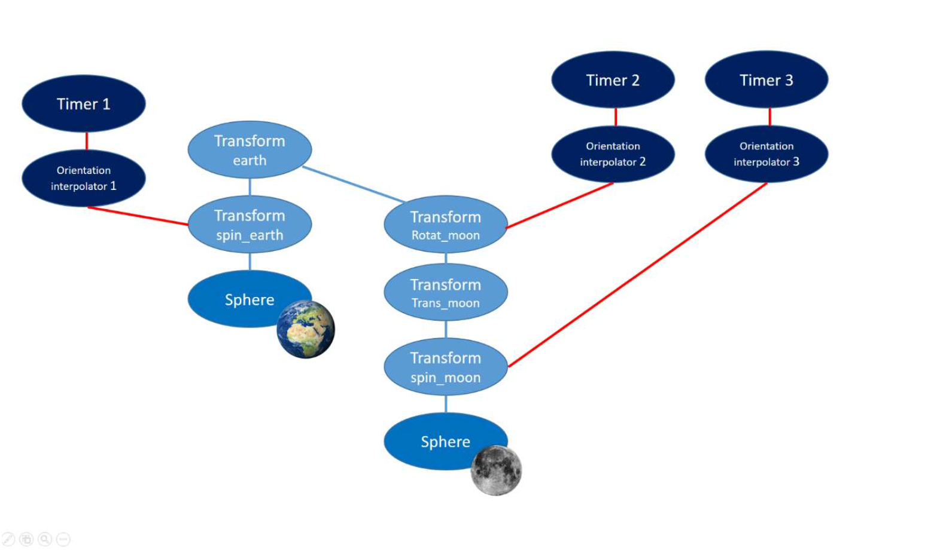

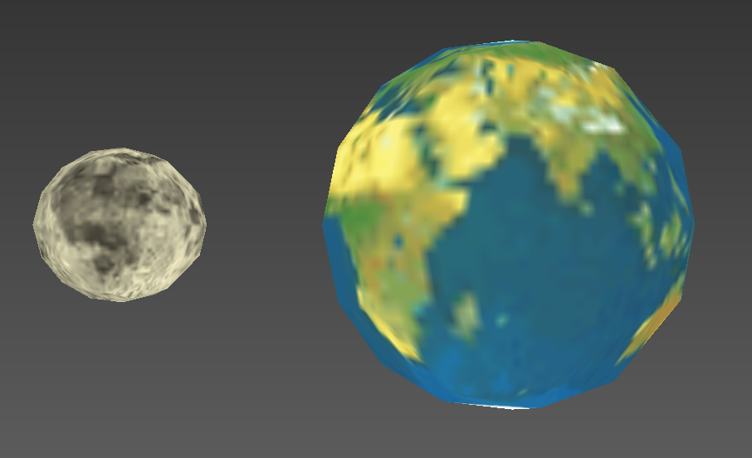

**Step N6:**

When we reverse the "orbit translation" and "orbit rotation," the moon begins with a rotation movement and then is translated from the earth, which means that in the end, we will not have the rotation around the earth as it is supposed to be; instead, the moon will only rotate around itself and fix its position far from the earth by doing the translation.

As the translation and rotation are not commutative.

**Step N7:**

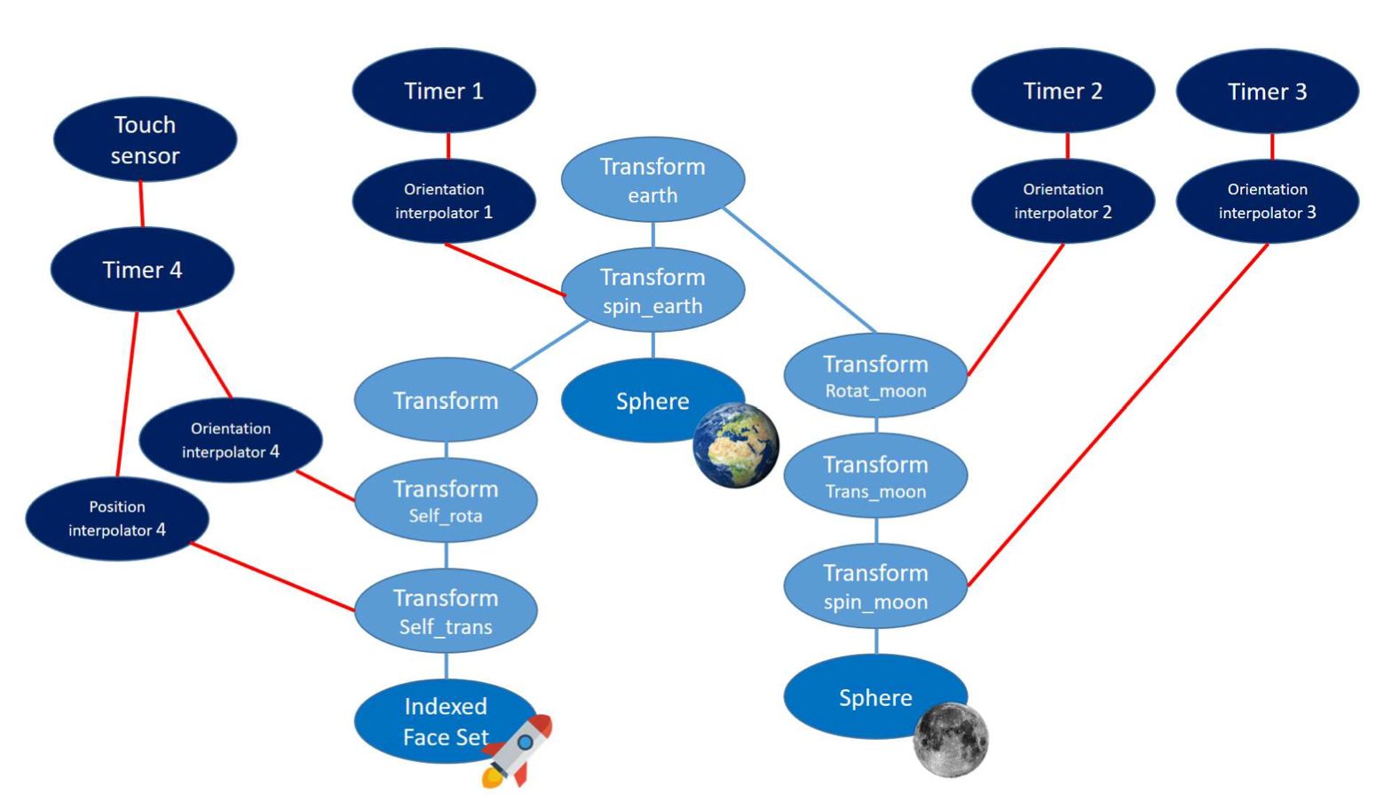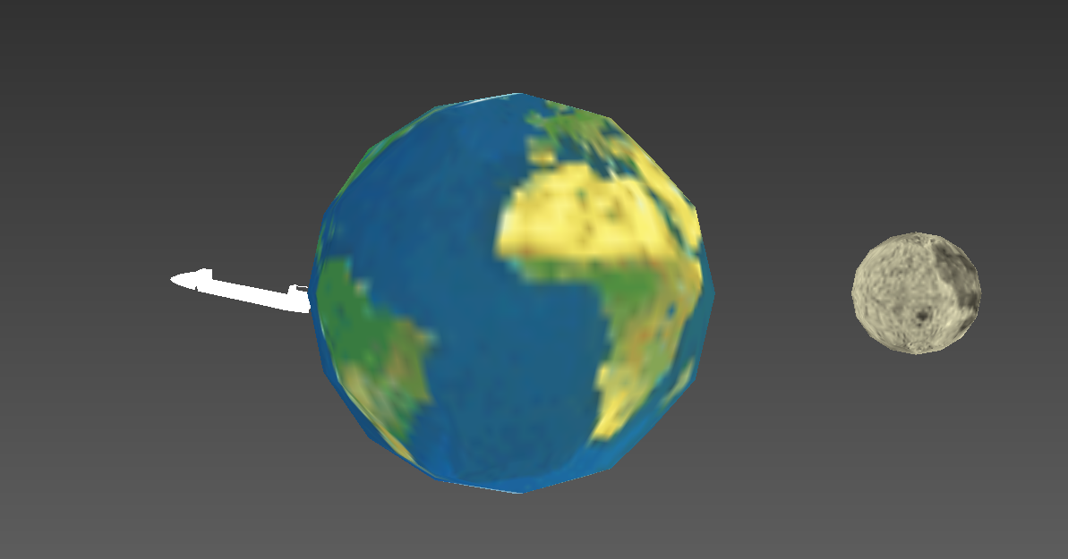

**Step N8:**

When we clicked on the earth in the first experiment, the shuttle took off and its trajectory was a translation plus the same rotation of the earth around itself. To fix this problem and keep only the shuttle translation, we add a rotation movement to the shuttle in the negative direction of the earth's rotation.

**Step N9:**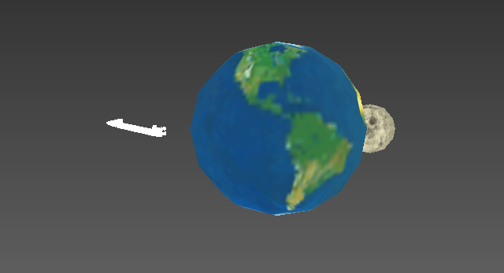

Navigation is the set of methods provided by the system to allow the user to move into the virtual world. Cortona provides some navigation metaphors that the user may control using its mouse.

Navigation tools :

**To reorient the camera :**

* Fit: zooms in or out to make the whole scene viewable
* Restore: brings us back to our original viewpoint
* Align: positions the camera's horizontal and longitudinal axes parallel to the scene's horizontal plane.

**To move around** :

(We took what was in the documentation for these tools as we were not sure of how they had to be used) Combine Walk, Fly, or Study + Plan/Pan/Turn/Roll

**Walk** :

Use WALK+PLAN to move in a horizontal plane.

Use WALK+PAN to move left or right in a horizontal plane.

Use WALK+TURN to change the angle of the camera in a world.

**Fly** :

Use FLY+PLAN to move left or right.

Use FLY+PAN to move up, down, left, or right within a single vertical plane. Use FLY+TURN to turn the camera.

Use FLY+ROLL to incline the camera.

**Study** :

Use STUDY+PLAN to examine an object from various angles.

Use STUDY+TURN to examine an object from various angles.

Use STUDY+ROLL to incline the camera around the central point which is defined by the center of the bounding box of the geometry in the 3D scene.

Go to + click on an object: goes to the object, so that we are in its local coordinate and the position is centered on it.

(more info on [http://www.cortona3d.com/en](http://www.cortona3d.com/sites/default/files/downloads/cortona3d-viewer-user-guide.pdf)[/cortona3d-viewer](http://www.cortona3d.com/en/cortona3d-viewer))

**Step N10:**

We constructed perspectives attached to the moon and the earth and discovered that modifying settings rendered the views unusable. We changed the location and orientation, therefore we had to figure out how to modify the orientation so that the translation from the position we provided still allowed us to see the earth. We were able to capture views of the earth and moon from the side and from above.

**Step N11:**

* The sun turns around itself at the centre of the world.
* Add Mercury, Earth, Mars, Jupiter and Saturn that turn around the Sun.
* The moon turns around the earth.

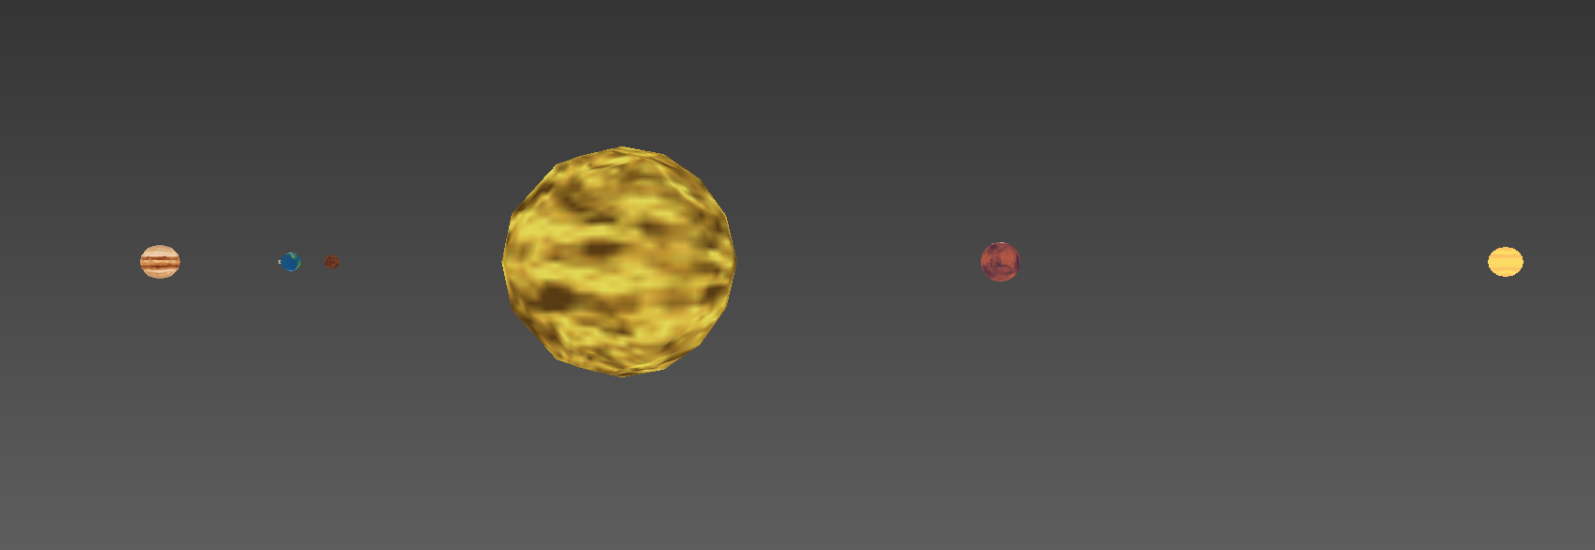

**References:**

* <http://www.cortona3d.com/en/cortona3d-viewer>
* <https://web.archive.org/web/20140210074407/http://www.web3d.org/x3d/specifications/vrml/ISO-IEC-14772-VRML97/>
* <http://www.web3d.org/>