**Deggendorf Institute of Technology**

**Department of Electrical Engineering and IT**

**Project as Elective Course:**

**Teaching Artificial Neural Networks**

**To Automate the Design of Phase-lead Compensator,**

**Based on Root-Locus approach**

**Student:** Zineddine Bettouche, MET 00809173

**Supervisor:** Prof. Nikolaus Müller

Deggendorf, 2021

**Abstract**

Automation has many advantages: higher production rates and increased productivity, more efficient use of materials, better product quality, improved safety, shorter workweeks for labor, and reduced factory lead times. Higher output and increased productivity have been two of the biggest reasons in justifying the use of automation. Despite the claims of high quality from good workmanship by humans, automated systems typically perform the manufacturing process with less variability than human workers do, resulting in greater control and consistency of product quality. In addition, increased process control makes use of materials more efficiently, resulting in less scrap. Furthermore, with the introduction of Machine Learning and Deep Learning, it is even more convenient to not only automate tasks, but also to teach artificial intelligence models to solve certain tasks and make predictions and classifications for new data.

**Content**

1. Introduction
   1. Aim of this work

1.2 Structure of Work

2. Related Work

3. Background

3.1 Control Theory

3.2 Root Locus

3.3 The Design of Feedback Control Systems

3.3.1 Compensators

3.3.2 Design: General Guidelines

3.4 Artificial Neural Networks

3.4.1 The Dense layer use in ANNs for Regression

3.4.2 Activation Functions

3.4.3 Epochs and Loss Metrics

3.5 Python Programming Language

3.5.1 Keras Deep Learning Framework

4. Methodology

4.1 Dataset

4.1.1 Data-Generating Program

4.1.2 Data Info

4.1.3 Data Standardization and Normalization

4.2 Project Directory Structure

4.3 Neural Network Structure

4.3.1 Functional Structure

4.3.2 RootLocusNN – Python Class

4.4 Python Scripts

4.4.1 Control Theory: *control_theory.py* and *control_theory_main.py*

4.4.2 Experiments: *experiment.py*

4.4.3 Main Script: *main.py*

5. Experiments

5.1 Distribution Experiment

5.2 Epochs-Loss Experiment

6. Evaluation

7. Conclusion & Outlooks

8. References

**1. Introduction**

People learn from experience. The richer our experiences, the more we can learn. In the artificial intelligence (AI) discipline known as deep learning, the same can be said for machines powered by AI software. The experiences through which machines can learn are defined by the data they acquire, and the quantity and quality of data determine how much they can learn.

Deep learning is a branch of machine learning. Unlike traditional machine learning algorithms, many of which have a finite capacity to learn no matter how much data they acquire, deep learning systems can improve their performance with access to more data: the machine version of more experience. After machines have gained enough experience through deep learning, they can be put to work for specific tasks such as driving a car, detecting weeds in a field of crops, detecting diseases, inspecting machinery to identify faults, and so on.

**1.1. Aim and Motivation**

As it is established earlier, artificial neural network can learn to modulate relations between the input data and the desired outcome from the training data and their labels.

Although engineering is known to belong to exact sciences, few engineering topics do not bind to a specific set of statements to solve their beheld issues. In such cases, intuition and experience are what engineers rely on to come up with acceptable designs and solutions. One of these topics, is the design of compensators based on Root-Locus, that would be further discussed in details in upcoming chapters. The speed, in which an engineer can design an acceptable compensator, is directly proportional to his experience. Therefore, this procedure of solving such a task gives rise to the following question: if experience is what it takes for an engineer to become faster at designing compensators, can an artificial neural network be trained to solve the task at hand?

As it is clear by now, this work is about a trial of teaching a neural network how to design a phase-lead compensator, which is again a task that is not bound by defined rules and can result in different solutions that might be equally acceptable.

**1.2. Structure of Work**

In this paper, the fundamental definitions and ideas of Control Theory and specifically designing a phase-lead compensator based on Root-Locus approach are to be introduced first. Due to lack of data at the beginning of this work, a Python program was built to generate a significant amount of data to later train the designed neural network. The program is going to be explained and its functionality is going to be documented accordingly. Afterwards, the process of building and training an artificial neural network is going to be introduced, which would be the initiation of the experimental part, in which different experiments and their outcomes are going to be discussed. A conclusion at the end is drawn, based on the previously acquired results, and further needed work is going to be suggestively stated.

All of the scripts used in this project belong to the following repository: Rootlocus Based Compensator (<https://mygit.th-deg.de/zb14173/rootlocus-based-compensator>)

**2. Related Work**

Work related to artificial neural network (ANN) design could be placed here, as it is going to be a tool that helps the development of this work’s experimental part. However, when it comes to specifically using ANN to design compensators, no work was perceived nor found, so far at least.

**3. Background**

In this chapter of the thesis, some processes, structures and programs that are relevant for the work are dealt with. This important information is presented to facilitate an overview of these topics.

**3.1. Control Theory**

In engineering and mathematics, control theory deals with the behavior of dynamical systems. The desired output of a system is called the reference. When one or more output variables of a system need to follow a certain reference over time, a controller manipulates the inputs to a system to obtain the desired effect on the output of the system. Rapid advances in digital system technology have radically altered the control design options. It has become routinely practicable to design very complicated digital controllers and to carry out the extensive calculations required for their design. These advances in implementation and design capability can be obtained at low cost because of the widespread availability of inexpensive and powerful digital processing platforms and high-speed analog IO devices.

**3.2. Root Locus**

The root locus [1] is the path of the roots of the characteristic equation traced out in the s-plane as a system parameter varies from zero to infinity. The relative stability and the transient performance of a closed-loop control system are directly related to the location of the closed-loop roots of the characteristic equation in the s-plane. It is frequently necessary to adjust one or more system parameters in order to obtain suitable root locations.

Therefore, it is worthwhile to determine how the roots of the characteristic equation of a given system migrate about the s-plane as the parameters are varied; that is, it is useful to determine the locus of roots in the s-plane as a parameter is varied. The root locus method was introduced by Evans in 1948 and has been developed and utilized extensively in control engineering practice. The root locus technique is a graphical method for sketching the locus of roots in the s-plane as a parameter is varied. In fact, the root locus method provides the engineer with a measure of the sensitivity of the roots of the system to a variation in the parameter being considered. The root locus technique may be used to great advantage in conjunction with the Routh-Hurwitz criterion. The root locus method provides graphical information, and therefore an approximate sketch can be used to obtain qualitative information concerning the stability and performance of the system. Furthermore, the locus of roots of the characteristic equation of a multi-loop system may be investigated as readily as for a single-loop system. If the root locations are not satisfactory, the necessary parameter adjustments often can be readily ascertained from the root locus.

**3.3. The Design of Feedback Control Systems**

In control theory [1], stable control systems resulting in an acceptable response to input commands, are less sensitive to system parameter changes, result in a minimum steady-state error for input commands, and, finally, are able to reduce the effect of undesirable disturbances. However, a feedback control system that provides an optimum performance without any necessary adjustments is rare indeed. Usually, it is necessary to compromise among the many conflicting and demanding specifications and to adjust the system parameters to provide a suitable and acceptable performance when it is not possible to obtain all the desired optimum specifications. For instance, if a set of performance measures are desired to be less than some specified values, a conflicting set of requirements are often encountered. Hence, if it is wished to have a system with a percent overshoot less than 20% and a settling time of 3.3 seconds, a conflicting requirement on the system damping-ratio is obtained. If it is impossible to relax these two performance requirements, the system must be altered in some way. The alteration or adjustment of a control system in order to provide a suitable performance is called compensation; that is, compensation is the adjustment of a system in order to make up for deficiencies or inadequacies.

**3.3.1 Compensators**

A compensator [1] is an additional component or circuit that is inserted into a control system to compensate for a deficient performance. The compensation network function Gc(s) is cascaded with the specified process G(s) in order to provide a suitable loop transfer function

L(s) = Gc(s) * G(s)

The compensator Gc(s) can be chosen to alter either the shape of the root locus or the frequency response. Consider the first-order compensator with the transfer function Gc(s) = k * (s+z)/(s+p) the design problem then becomes the selection of z, p, and k in order to provide a suitable performance. When |z| < |p|, the network is called a phase-lead network and has a pole-zero s plane configuration, which is the type of compensator that this work is going to train ANNs to design.

**3.3.2. Design: General Guidelines**

1. Analyze (simulate) the uncompensated system, if it meets the specification: stop here.
2. Select the compensator type (the simpler, the better)
3. Tune the compensator parameters (here, by help of the root-locus)
4. Simulate the compensated system, if not satisfactory go back to (3, or 2)

**3.4. Artificial Neural Networks**

Artificial neural networks (ANN) give machines the ability to process data similar to the human brain and make decisions or take actions based on the data. While there’s still more to develop before machines have similar imaginations and reasoning power as humans, ANNs help machines complete and learn from the tasks they perform. Ultimately, ANNs try to replicate how our human brains process information and make decisions. While ANNs are based on mathematical theory created in the 1940s, it was not until the last couple of decades that it became a focus for artificial intelligence.

When backpropagation was developed to help these networks learn and adjust actions based on outcomes its development and adoption really began to accelerate. When a human brain receives an input, it processes it through a series of neurons. Different neurons of the human brain are responsible for processing different aspects of input in a hierarchical fashion. ANNs try to replicate this through artificial neurons called units that are arranged in layers and connected to each other to create a web-like structure. ANNs have an input layer and output layer. Between these two layers, there are other hidden layers that perform the mathematical computations that help determine the decision or action the machine should take. Ultimately, these hidden layers are in place to transform the input data into something the output unit can use. The data is processed by each hidden layer and then moves on to the next based on connections that are weighted. Think of this process as an assembly line in a factory—raw materials as the input and different stops on the conveyor belt to add an element to the product equate to the hidden layers of an ANN that processes the data until you get to the output. Based on what the machine learns about the data when processed by one layer, it determines how to move it through to the next, more senior layer based on the value it receives when evaluated. Based on the complexity of the issue at hand, it can continue to process through more senior units until delivered to the output layer. Before an ANN can be fully deployed, it must be trained. This training involves comparing an outcome a machine gets with the human-provided description of what outcome is expected. If these do not match, the machine uses this feedback and goes back to adjust the weights of the layers (called backpropagation). These new learning rules are applied and help guide the neural networks in future processing. To illustrate how this works for the human brain, consider how humans might learn how to shoot a basketball so they score more baskets. Over time and with experience, different techniques are tried to improve the odds the shot will make it in the basket—bending legs less or more, adjusting the hand position, shooting force, the angle of the shot, use of backboard, etc. When a shot does not make it in, the brain adjusts based on this feedback and tries something else. Over time, there is enough learning to improve the outcome so that more balls make it through the net than miss it.

**3.4.1. The Dense layer use in ANNs for Regression**

Layers [2] in the deep learning model can be considered as the architecture of the model. There can be various types of layers that can be used in the models. All of these different layers have their own importance based on their features. For example, LSTM layers are mostly used in the time series analysis or in the Natural Language Processing problems, convolutional layers in image processing, etc. A dense layer, also referred to as a fully connected layer, is a layer that is used usually in the final stages of the neural network. This layer helps in changing the dimensionality of the output from the preceding layer so that the model can easily define the relationship between the values of the data in which the model is working. This relationship can come in handy when the task at hand is under the class of regression.

In any neural network, a dense layer is a layer that is deeply connected with its preceding layer, which means the neurons of the layer are connected to every neuron of its preceding layer. The dense layer’s neuron in a model receives output from every neuron of its preceding layer, where neurons of the dense layer perform matrix-vector multiplication.

Matrix vector multiplication is a procedure where the row vector of the output from the preceding layers is equal to the column vector of the dense layer. The general rule of matrix-vector multiplication is that the row vector must have as many columns as the column vector.

The general formula for a matrix-vector product is:

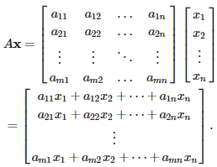

Values under the matrix are the trained parameters of the preceding layers and also can be updated by the backpropagation. Backpropagation is the most commonly used algorithm for training the feedforward neural networks. Generally, backpropagation in a neural network computes the gradient of the loss function with respect to the weights of the network for single input or output. From the above intuition, we can say that the output coming from the dense layer will be an N-dimensional vector. We can see that it is reducing the dimension of the vectors. Finally, one of the most important parameters in ANN layers is the activation functions.

**3.4.2. Activation Functions**

In neural networks, the activation function [3] is a function that is used for the transformation of the input values of neurons. It introduces the non-linearity into the networks of neural networks so that the networks can learn the relationship between the input and output values. An activation function decides whether a neuron should be fired or not. Whether the information that the neuron is receiving is relevant for prediction or should be ignored.

The types of activation functions fall under one of the following:

* **Binary Step:** This activation function is useful when the input pattern can only belong to one or two groups, that is, binary classification. However, the step function would not be able to classify more than one class classifier.

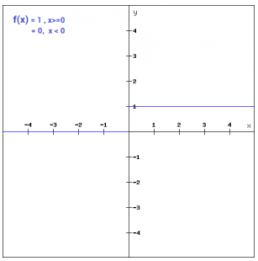

Figure 1: binary step

* **Sigmoid:** Usually used in output layer of a binary classification, where result is either 0 or 1 as value for the sigmoid function lies between 0 and 1. Therefore, the result can be mapped to be 1 if value is greater than 0.5 or 0 otherwise. However, sigmoid saturates and kills gradients and performs badly in hidden Layers.

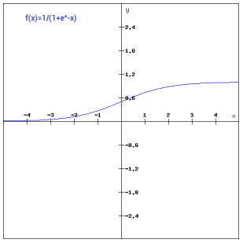

Figure 2: Sigmoid

* **Tanh:** Usually used in hidden layers of a neural network as its values lies between -1 and 1 hence the mean for the hidden layer comes out be 0 or very close to it, which means, it helps in centering the data by bringing the mean close to 0. This makes learning for the next layer much easier. However, similar to sigmoid, it also has a vanishing gradient problem.

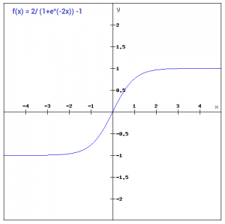

Figure 3: Tanh

* **ReLU:** less computationally expensive than Tanh and sigmoid because it involves simpler mathematical operations. At a time, only a few neurons are activated making the network sparse efficient and easy for computation. ReLU neurons have the tendency to become inactive for all inputs, i.e., they tend to die out. This can be caused by high learning rates, and can thus reduce the model’s learning capacity.

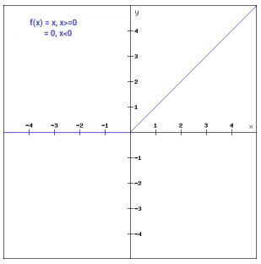

Figure 4: RelU

* **Softmax:** It is useful when classifying more than two classes. Unlike sigmoid, it can handle multiple classification problem. However, it can only be used in Output Layer.



After the quick summary of each of the activation function types, it becomes clear that the most suitable activation functions for a regression task are ReLU for the hidden layers and the linear function for the output layer.

**3.4.2. Epochs and Loss Metrics**

In deep learning, the loss is the value that a neural network is trying to minimize: the distance between the ground truth and the predictions. In order to minimize this distance, the neural network learns by adjusting weights and biases in a manner that reduces the loss. For instance, in regression tasks, you have a continuous target, e.g., height. What you want to minimize is the difference between the predictions, and the actual height. *mean_absolute_error* can be used for example as loss so the neural network knows this is what it needs to minimize.

In classification, it's a little more complicated, but very similar. Predicted classes are based on probability. The loss is therefore also based on probability. The neural network minimizes the likelihood to assign a low probability to the actual class. The loss is typically *categorical_crossentropy*.

Loss and *val_loss* (validation-loss) differ because the former is applied to the train set, and the latter to the test set. As such, the latter is a good indication of how the model performs on unseen data. It is best to rely on the *val_loss* to prevent overfitting. Overfitting is when the model fits the training data too closely, and the loss keeps decreasing while the *val_loss* is stale, or increasing.

The Mean Squared Error (MSE) loss is the default loss to use for regression problems. Mathematically, it is the preferred loss function under the inference framework of maximum likelihood if the distribution of the target variable is Gaussian. It is the loss function to be evaluated first and only changed if there is a good reason. Mean squared error is calculated as the average of the squared differences between the predicted and actual values. The result is always positive regardless of the sign of the predicted and actual values and a perfect value is zero. The squaring means that larger mistakes result in more error than smaller mistakes, meaning that the model is punished for making larger mistakes.

There may be regression problems in which the target value has a spread of values and when predicting a large value, you may not want to punish a model as heavily as mean squared error. Instead, the natural logarithm of each of the predicted values can be calculated first, then the mean squared error. This is called the Mean Squared Logarithmic Error loss, or MSLE for short. It has the effect of relaxing the punishing effect of large differences in large predicted values. As a loss measure, it may be more appropriate when the model is predicting unscaled quantities directly.

On some regression problems, the distribution of the target variable may be mostly Gaussian, but may have outliers, e.g. large or small values far from the mean value. The Mean Absolute Error, or MAE, loss is an appropriate loss function in this case as it is more robust to outliers. It is calculated as the average of the absolute difference between the actual and predicted values.

There are other loss functions for classification ANNs, however that is not in the scope of this work.

Finally, it worth stating that an experiment is done in this project to determine the most fitting loss function and epochs number for the ANN.

**3.5. Python Programming Language**

Python is an interpreted, general-purpose programming language, which is one of the most popular choices for modern software development. Python is modular – i.e. it can be easily integrated with other technologies and solutions. Secondly, it is open-source. There is a vibrant community of developers, who contribute to the development of the technology, and the Python Software Foundation oversees the quality and the direction in which the language is going. Thirdly, Python is interpreted, which means it is translated to machine code right before the program is launched. This facilitates writing portable and universal programs, which are easier to use on different operating systems.

AI projects differ from traditional software projects. The differences lie in the technology stack, the skills required for an AI-based project, and the necessity of deep research. To implement certain AI aspirations, the programming language that should be used, must be stable, flexible, and includes practical tools. Python offers all of this, which is why there are many Python AI projects today. From development to deployment and maintenance, Python helps developers be productive and confident about the software they are building. Benefits that make Python the best fit for machine learning and AI-based projects include simplicity and consistency, access to great libraries and frameworks for AI and machine learning (ML), flexibility, platform independence, and a wide community. These add to the overall popularity of the language.

**3.5.1. Keras Deep Learning Framework**

Keras [2] is a widely used and a very popular deep learning framework. It represents an interface to the TensorFlow backend. The Keras API was developed with the focus on enabling rapid experimentation. “Getting from the idea to the result as quickly as possible is the key to good research” is a principle of the Keras community. TensorFlow is an end-to-end, open-source machine learning platform. You can think of it as an infrastructure layer for differentiable programming. It has now developed into a quasi-standard in the area of programming neural networks and deep learning. TensorFlow is characterized by its high performance and good scalability Keras is TensorFlow's high-level API: an understandable, highly productive interface for solving machine-learning problems with a focus on modern deep learning.

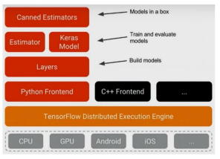

Figure 5: Keras layout over Tensorflow

It offers essential abstractions and building blocks for the development and integration of machine learning solutions. Keras enables the cross-platform capabilities of TensorFlow to be exploited: Keras can run on TPU or on large clusters of GPUs. Keras models can be exported in order to run them in the browser or on a mobile device.

**4. Methodology**

This section describes the structures and pipelines of development. The description includes how the program generates data with which the neural network is trained and tested.

**4.1. Dataset**

When the idea for this project was crafted, acquiring enough dataset to train a neural network was the biggest obstacle. Therefore a python program was written to generate data.

**4.1.1. Data-Generating Program**

As already mentioned, a Python program was written to come up with compensator parameters that satisfy the transient-time conditions. The script executes the following flowchart:

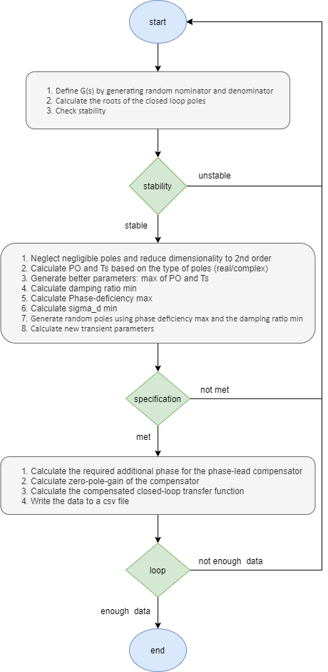

Figure 6: Execution flow of data-generating program

**4.1.2. Data Info**

After letting the program run for a few minutes, it gathered over 7000 rows. There is a total of 41 columns of all the data stored. At first, many of the columns were stored as complex numbers. This can cause issues in the learning process of a neural network. It is more suitable to divide the complex number into its real and imaginary parts and store separately. The data stored was as follows:

* Uncompensated open-loop: nominator (uoln), denominator (uold 0…3)
* Uncompensated closed-loop: denominator(ucld 0…3), poles (uclp 0…2 –r or -i)
* PO max (percentage overshoot), Ts max (settling time), c min (damping factor), phase deficiency max, sigma_d min.
* Compensation pole (pd -r, pd -i, pd phase)
* New c, new PO, new Ts, required additional phase
* Compensation transfer function (Gc-z, Gc-p, Gc-k)
* Compensated closed-loop: nominator (ccln), denominator (ccld 0…3),

poles (cclp 0…2 –r or -i)

It is important to note that no column is going to be used, but the input and output columns:

* **Inputs:** (PO max, Ts max); (uoln, uolds), (uoln, uclds).
* **Outputs:** (pd –r, pd –i), (Gc-z, Gc-p, Gc-k)

This leads to having many combinations for our network. In the evaluation part, our network is going to be trained and evaluated for all the combinations for optimal results.

Note that the specifications are always included (both columns of: PO max and Ts max), along with one of the two inputs: the uncompensated open-loop transfer function or its closed-loop version.

**4.1.3. Data Standardization and Normalization**

Deep learning neural networks learn how to map inputs to outputs from examples in a training dataset. The weights of the model are initialized to small random values and updated via an optimization algorithm in response to estimates of error on the training dataset. Given the use of small weights in the model and the use of error between predictions and expected values, the scale of inputs and outputs used to train the model are an important factor. Unscaled input variables can result in a slow or unstable learning process, whereas unscaled target variables on regression problems can result in exploding gradients causing the learning process to fail. Data preparation involves using techniques [4] such as the normalization and standardization to rescale input and output variables prior to training a neural network model.

**Normalization:** rescaling of the data from the original range so that all values are within the range of 0 and 1. Normalization requires that we know or are able to accurately estimate the minimum and maximum observable values. We may be able to estimate these values from the available data. Here y is the normalized value of x:

**Standardization:** Standardizing a dataset involves rescaling the distribution of values so that the mean of observed values is 0 and the standard deviation is 1. It is sometimes referred to as “whitening.” This can be thought of as subtracting the mean value or centering the data. Like normalization, standardization can be useful, and even required in some machine learning algorithms when the data has input values with differing scales. Standardization assumes that the observations fit a Gaussian distribution (bell curve) with a well behaved mean and standard deviation. We can still standardize the data if this expectation is not met, but we may not get reliable results. Standardization requires that we know or are able to accurately estimate the mean and standard deviation of observable values. We may be able to estimate these values from your training data. Here y is the standardized value of x:

In the following sections, an experiment will be conducted to calculate the distribution of the inputs and outputs of our dataset, in order to decide whether it should be standardized or normalized.

**4.2. Project Directory Structure**

The directory of the project is structured as follows:

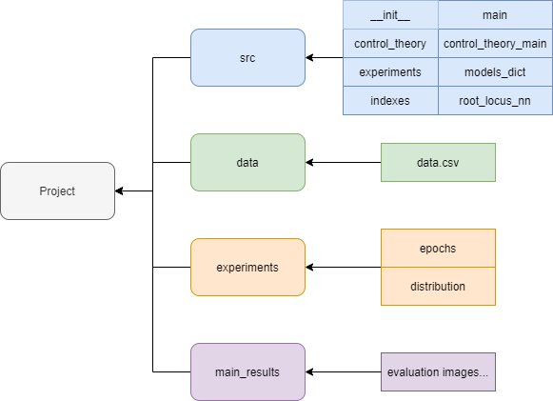

Figure: Project structure

The most important directory is the *src* folder, as it contains all the scripts. These scripts are going to be discussed in a bit of details in the upcoming subsections. The data directory is the directory containing the excel file generated from running the control theory scripts. It acts in this project as the main dataset to train and evaluate the neural networks constructed. The experiments folder contains all of the results of the experiments in its subdirectories. Finally, the *main_results* folder is the directory in which the main script stores its results.

**4.3. Neural Network Structure**

With the help of Keras framework, a Python script was defined to train and use the ANN. The functional structure of the neural network will be first discussed with its possible variations. Following this, the developed Python module within the scope of this work will be examined in more details.

**4.3.1. Functional Structure**

As discussed earlier, there exist many combinations between the input and output columns. This has led to create a Python class that is reusable enough to define an ANN model for every case of inputs-outputs combination.

Having a regression task, the dense layer was used to create the network. The input/output layers depend on how many inputs/outputs there are, whereas the number of hidden layers is three, and it can be calculated with the following formula:

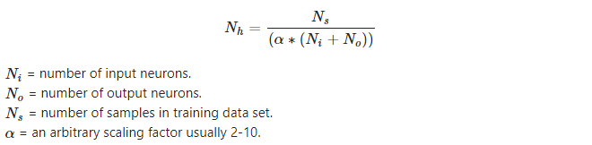

Therefore, our neural network would be of the shape of:

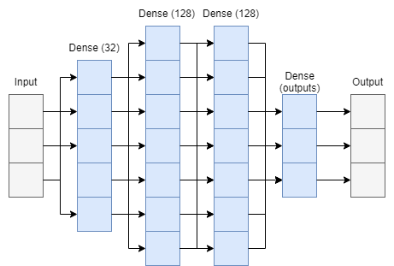

Figure 7: ANN layers connection

What is between brackets, represents the number of units in each layer. It was taken conventionally.

**4.3.2. RootLocusNN – Python Class**

This Python script, which was created as part of this work, is responsible for training the autoencoder. It was developed into a Python class to be used more efficiently in an object-oriented programming manner. A module essentially refers to a Python script that provides functionality, which in return can be imported into another script in order to provide more functions in a more robust way that can be beneficial to the speed of development and credited to increase the reusability of the code. Furthermore, to ensure that the package conflicts do not occur when a user tries to run the code, a requirements file was built through pip-tools to contain all of dependencies, so that the user’s Python environment operates on the same versions of libraries that the original code was developed on.

It is far more efficient to use a graphics processing unit GPU for training, rather than using a common central processing unit CPU. This is a product of the nature of neural networks, as they rely on passing tensors or more simply matrices, when GPUs are designed to operate on similar tasks. Therefore, it makes more sense to use a GPU as a hardware component, dedicated to training the ANN. In order to accomplish such a task, certain libraries are required depending on the hardware manufacturer.

One of the most widely used and supported libraries is NVidia’s CUDA, which ensures the optimization of the interaction between Keras, TensorFlow, and the graphics card, resulting in a faster training process.

The following figure displays the class structure:

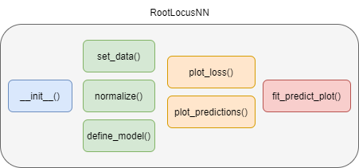

Figure 8: RootLocusNN class structure

* normalize(self, df): normalize the data.
* set_data(self, data, scale): splits the data into training and testing depending on the input and output columns. If the scale argument is true, it calls the normalize method on the splits.
* __init__(self, model_name, data, input_keys, output_keys, scale): this is the object initializing method. It sets the model name, the input and output keys, and finally calls the *set_data()* method.
* define_model(self): defines the model depending on the input and output keys.
* plot_loss(self, folder_path): plotting loss experienced in training and evaluating phases.
* plot_predictions(self, folder_path, titles): plotting the predicted values next to the testing values for comparison.
* fit_predict_plot(self, batch_size, epochs): this method is the most important method in the class. It calls *define_model()* to define the model, it trains the defined model with the passed epochs and batch size. The method then creates a directory and stores the trained model for future use, and calls the two plotting methods which both store their plots in the created directory.

**4.4. Python Scripts**

**4.4.1. Control Theory: *control_theory.py* and *control_theory_main.py***

The two scripts modulate the solution created to generate the dataset used in this project. c*ontrol_theory()* is the script holding all the functions used in *main_theory_main.py* script, whereas the “main” script in this scope contains the algorithm followed to generate transfer functions, and to try to solve for a compensating transfer function and store all of the obtained data.

**4.4.2. Experiments: *experiment.py***

All of the experiments undergone in this work are written in this script, which has the following functions:

* plot(title, column, bins, outputName, outputFolder): plotting a histogram of the passed columns to visualize the occurrence of every value.
* get_best_distribution(data): calling plot to get the histogram of occurrence, and then calculating the probability of falling that histogram into one of the most common distributions.
* distribution_experiment(data): performing the distribution experiment on the passed data by calling the two previously mentioned functions.
* epochs_experiment(data): performs the epoch experiment that can determine the fitting of an epoch in training the model.

**4.4.3. Main Script: *main.py***

For the main script, the evaluation was written in simple lines of code, thanks to the modulation of a python class for the neural network. The script goes through the following functional structure:

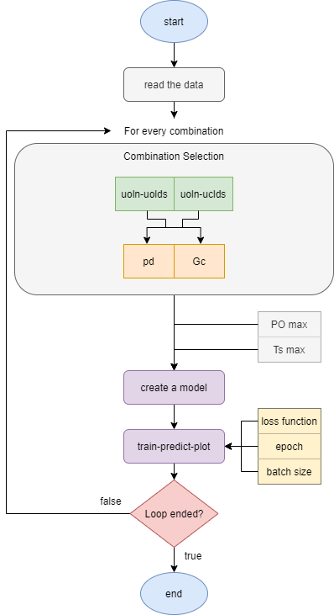

Figure 9: Main script execution flow

The program starts by reading the data. A loop starts, which goes through all the combination possible between the input columns and the output columns. A model is then created for the neural network depending on the inputs and outputs chosen. The model gets trained, evaluated, and the results get plotted and stored. This summarizes the flow of the main function in the main script.

**5. Experiments**

In this section, the experiments done in this work are discussed. The thought behind them more importantly is rationalized and explained in details. As mentioned in the previous sections, the experiments are all implemented in the *experiments.py* script.

**5.1. Distribution Experiment**

As it was explained in the section “4.1.3. Data Standardization and Normalization” it is important to determine the distributions of the inputs and outputs to decide which of the two preprocessing algorithms is more suitable for the date as a step to enhance the quality of the training of the neural network.

In this experiment, the distribution of every column of the inputs/outputs is plotted. A probability of the distribution falling into one of the most common data distribution is then calculated.

The most common data distributions are as following:

|  |  |  |
| --- | --- | --- |
| Normal | Weibull | Pareto |
|  |  |  |
| Exponential | Generalize extreme value |
|  |  |

Table 1: Common data distribution functions

The resulted distribution graphs and their probabilities are as following:

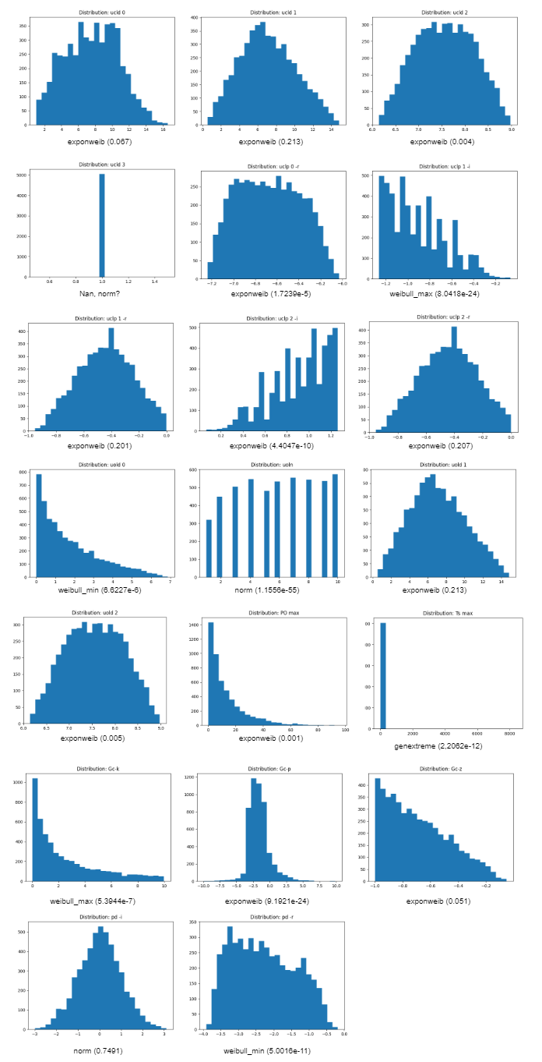

Figure 10: data distribution of input and output columns

As apparent, the columns do not fall under one specific distribution, and more importantly rarely are normally distributed. The only two columns that have a normal distribution are the uncompensated open-loop nominator (uoln), and the imaginary part of the compensation pole. Even then, uoln has a probability that is close to zero and therefore is neglected.

A result of the experiment would be: the standardization of the data is not suitable in this case due to not meeting the condition for it, which is, as stated earlier, the data need to be in a normal distribution. Therefore, the program normalizes the data before proceeding to training and testing phases.

**5.2. Epochs-Loss Experiment**

The second experiment done in this project aims to determine the number epochs and the loss function that lead to the best results in terms of training and testing losses.

The function created for this experiment takes the input set (uoln-uclds) which is essentially the uncompensated closed-loop transfer function and as always the specifications of the max percentage overshoot and the max settling time wanted (PO max, Ts max).

There are two sets of outputs: the first one is the compensation pole with its two columns (real, imaginary), and the second set is the zero-pole-constant for the compensating transfer function Gc. For the sake of simplicity, the input-output combination with the highest number of columns is chosen, that is the uncompensated closed-loop transfer function along with the specifications as input, and the compensation transfer function as output.

The program has a list of possible epochs: [10, 20, 50, 100, 200, 500]. A model of the ANN is created, and trained for every epoch number. On the other hand, the list of potential loss metrics are: [mean squared error, mean absolute error, mean logarithmic error] (refer to section 3.4.2). Finally, Each loss of every training/testing is recorded and plotted.

The results of loss and accuracy are as follows:

|  |  |  |
| --- | --- | --- |
| Mean Squared Error | Mean Absolute Error | Mean Squared Logarithmic Error |
|  |  |  |
|  |  |  |
|  |  |  |
|  |  |  |
|  |  |  |

Table 2: Losses of different loss functions depending on the epochs number

The first remark that can be made is that for all of the three loss functions, once the ANN is trained with more than 50 epochs, the validation error starts rising. This is known as overfitting. Although the ANN gets better at dealing with the training set, when it comes to predicting the output of new data (testing), it fails due to its exaggerated specificity with the training data, i.e. failing to generalize the input-output relationship. Therefore epochs over 100 are eliminated for all.

Concerning the range 10-50, the results can be acceptable. Note that the graphs may not do the fluctuations justice, as the y-scale is on a small range, making them appear larger at first glance. However, in fact, the fluctuations in both loss and validation-loss are in the scale of 0.001. finally, it can be clearly seen that the MSLE scored the best (lowest losses) out of the three, making it worth changing the default loss function from the common MSE to MSLE.

A general rule would be to take the highest number of epochs that does not result in overfitting, therefore the best epochs number is between 20 and 50.

For the lower end, the validation loss does not go over 0.186, which is not the case for 50 epochs, in which it goes up to 0.192. However, in the latter, the loss goes down to 0.180 while for 20 it does not go below 0.182.

A better decision would be to take an average value of the range of 20-50, rather than sticking to one end. This results in having a better training loss than the lower end, and also a better testing loss (validation) than the higher end.

Therefore, this experiments resulted in taking the loss function to be the mean squared logarithmic error, and 35 as the epochs number for ANN training.

**6. Evaluation**

In this section the final evaluation is going to presented. The main script *main.py* holds the code for the presented values as explained in the previous sections.

The aim of the evaluation is to attempt making the neural network learn how to predict a compensation transfer function or a compensation pole from the presented inputs. As stated throughout this work, there exist different sets of inputs and outputs, and one of the main goals of this evaluation is to determine the combination that lets the neural network operate in the highest accuracy.

The initial results of the evaluation are presented in the following table:

|  |  |  |
| --- | --- | --- |
|  | pd (real, imaginary) | Gc (z-p-k) |
| uoln-uolds |  |  |
| uoln-uclds |  |  |

Table 3: Predicted vs expected values in different input-output combinations (loss: msle, epochs: 35)

This table shows the predicted and the expected values in different input-output combinations while using 35 as epochs number and the MSLE as a loss function (refer to 5.2).

At first glance, the predicted values (orange) seem different than the expected values. The results are not very pleasant, as the mean-squared-logarithmic-error scored very well in the experiments part, and during this evaluation, those results of MSLE loss completely match. However, when it comes to having a coherence between what the ANN generates and the testing (expected) values, there seems to be a distortion.

The unpleasant results has lead to the idea that, although it states that the loss function is scoring well and not overfitting, when it comes to predicting new values, the MSLE function did not punish the training process correctly. As confusing as these results might be, it is worth it to go over the same evaluation while using the other two functions: MSE and MAE.

The results are in the two following tables respectively:

|  |  |  |
| --- | --- | --- |
|  | pd (real, imaginary) | Gc (z-p-k) |
| uoln-uolds |  |  |
| uoln-uclds |  |  |

Table 4: Predicted vs expected values in different input-output combinations (loss: mse, epochs: 35)

|  |  |  |
| --- | --- | --- |
|  | pd (real, imaginary) | Gc (z-p-k) |
| uoln-uolds |  |  |
| uoln-uclds |  |  |

Table 5: Predicted vs expected values in different input-output combinations (loss: mae, epochs: 35)

The results now overall seem more acceptable than when using MSLE. In all of the three cases, it was easier for the ANN to predict the compensating transfer function, where predicting the zero was the most accurate, followed by the pole, and in the lowest relative-accuracy comes the function coefficient “k”.

Due to the multi-dimensionality in the data, it can be harder to observe the differences and compare the results. One way to make a direct comparison, is to calculate the total absolute difference between the expected and the predicted values. The following table shows the results:

|  |  |  |  |  |  |
| --- | --- | --- | --- | --- | --- |
|  | pd (real, imaginary) | | Gc (z-p-k) | | |
| real | imaginary | z | p | k |
| uoln-uolds | mse: 1.4296  **msle: 1.3645**  mae: 1.4310 | **mse: 2.3930**  msle: 2.4623  mae: 2.4226 | **mse: 0.2174**  msle: 0.3179  mae: 0.5643 | **mse: 2.2990**  msle: 2.3699  mae: 2.4754 | **mse: 5.3040**  msle: 5.4412  mae: 5.4164 |
| uoln-uclds | mse: 1.5390  **msle: 1.3637**  mae: 1.4219 | **mse: 2.3914**  msle: 2.4178  mae: 2.4155 | **mse: 0.2836**  msle: 0.3433  mae: 0.4298 | **mse: 2.2939**  msle: 2.4011  mae: 2.3365 | **mse: 5.2086**  msle: 5.4786  mae: 5.6151 |

Table 6: the total absolute predicted-expected difference across different input-output combinations while using different loss functions

Finally, it seems that although the MSE did not score as good (as low) as the other functions, when it comes to predicting values, it is more efficient at resulting in accurate results, especially with the zero-pole-coefficient predictions.

**7. Conclusion & Outlooks**

At the beginning of this work, there was the question “can an artificial neural network learn to predict values that engineers learn to suggest based on their experience and intuition?”. The aim was to design an ANN and train it to compensate a transfer function based on Root-Locus method. The theoretical background of the relevant topics in control theory were discussed, then the artificial neural network subject was introduced. The framework Keras was presented as it is used mainly in ANN design.

First was the problem of data gathering. A python program was created to tackle the issue by mimicking the procedure of designing a compensator, in a way that the program keeps semi-randomly looping until falling into a satisfactory result.

After gathering enough data, the following procedure was to design an appropriate ANN and optimize it for the training phase. The dense layers were chosen to build the neural network, and their parameters such as activation functions, units, and number of hidden layers were chosen according to best practices while taking into consideration the nature of this work, i.e. regression task.

The experiments were done as an elimination or decision-making stage, in which it was decided whether it is more appropriate to standardize the dataset or to normalize it. A function was written to execute the experiment by calculating the distribution of every column, plot it, and calculate finally the probability of that distribution falling into one of the most common data distributions. This experiment concluded in the decision of normalizing the dataset due to the fact that the most columns have a distribution different than the normal (Gaussian) distribution. The second and final experiment was about deciding the number of epochs that the ANN goes through in the training process, along with the most efficient loss function. This was modulated also in a programming function that trains the ANN with different epochs number and different loss functions. The initial results stated that the MSLE function scored the lowest in terms of training and testing losses. In addition, it was decided that 35 epochs is appropriate for the ANN to train in, having the fact that it causes the least overfitting and an acceptable loss rate (0.182) in compared to higher or lower epoch numbers.

The last section was about evaluating the ANN by training it with the best results of the experiments and comparing its predictions to the expected values. It appeared that the loss functions experiment provided misleading results. The logical flow of thoughts would imply that lower loss rates would result in better predictions, especially when the validation loss is low and does not show signs of overfitting. However, this was not the case, as the ANN that was built with MSLE, resulted in distorted values, that did not overlap with the predicted values, and not even closely. This has lead to lengthen the evaluation section into including two other versions of the same evaluation process but with the two other loss functions: MSE and MAE. Thanks to this step, it was clear that although the MSE did not score as low as the other two loss functions, it resulted in predicted values that were much closer to the expected values than the MAE and MSLE. Finally the total absolute difference between the expected values and their predicted versions was calculated for every input-output combination, and across the different loss functions. The evaluation section was concluded that the compensating transfer function was more accurately predicted than the compensating complex pole, in both cases of having the input as: the uncompensated open-loop transfer function or its closed-loop version. And this concludes the work done in this project.

A future outlook for this work would be experimenting with other types of compensators other than the phase-lead. In addition, the data of different orders of transfer functions. The data gathering part can be more selective to observe the effects on the accuracy of the ANN. The neural network design can be subjected to further development for more optimization. Finally, as new research is being published on having a neural network that learns from complex numbers, it is only intuitive to attempt the integration of such research in this topic as the raw data contains originally complex numbers that had to be split into different columns.

In conclusion, depending on the threshold of accuracy acceptance, the results of this work can be labeled as successful, although it can be regarded only as the beginning of the development of such field.

**8. References**

[1] Dorf & Bishop, Modern Control Systems, 13th Edition

[2] Keras (https://keras.io/)

[3] Keras Layers (https://keras.io/api/layers/)

[4] Keras Activation Functions (https://keras.io/api/layers/activations/)

[5] Normalization VS Standardization

(https://medium.com/swlh/difference-between-standardization-normalization-99be0320c1b1)