**Name:** Zinga Banda Firmino René **Neptun:** GAA4QU

**Project work II: NoSQL**

**Export Data from Oracle Database to CSV file:**

1. I select the table that want to import.

1. By clicking on the right of mouse it appears this window with option and I selected to import:

1. It allows to open the window bellow for that I can choose my destination where I can save exported object:

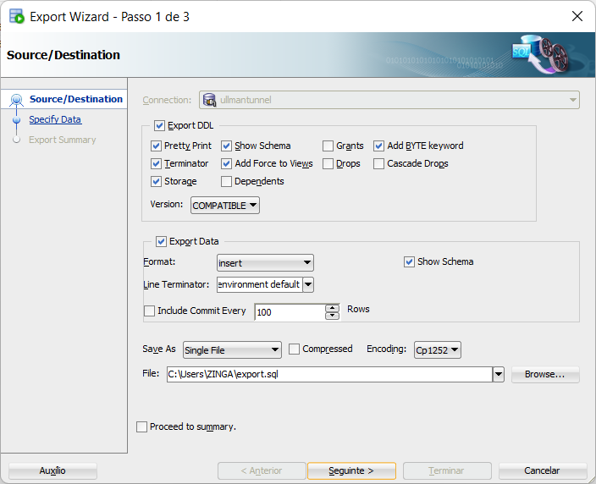

1. Uncheck export DDL, choose format csv, pick folder to save data in browse menu, write file name with extension .csv and click next.

1. It appears the option to choose specific data or column but by default it choose all (*) columns of my table Student like bellow:

1. It appears the summarization of exporting data and I clicked on finish:

1. It appears the processing of exporting my table student:

1. Finally, the table student is exported and I opened it with the Excel application:

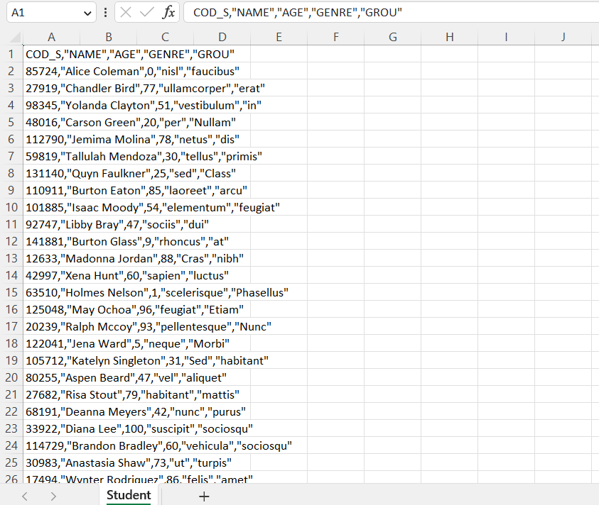

1. The student table exported opened on the Excel application:

**Note:** I did the same process with the table *Student_Subject* and *Subject*.

1. **MongoDB**
2. **MongoDB Community Edition**

From the official website, MongoDB Community edition is the most popular database. It is a free and open-source edition that works for powering modern applications (small and medium-sized). It is a document-based and distributed database that supports ad-hoc queries, secondary indexing, and real-time aggregations to access and analyze your data. And also it is easly deploy and running on computer.

1. **Why MongoDB?**

I’ve choose MongoDB because it is the most popular database in the NoSQL database category. And from the official website I know that MongoDB is flexible and adaptable to real business world situations and requirements since it uses documents that can contain sub-documents in complex hierarchies.

It allows the applications to interpret different properties found in a collection's documents. MongoDB is built on a scale-out architecture developing scalable applications with evolving data schemas. As a document database, MongoDB makes it easy for developers to store structured or unstructured data.

It is very simple for the users of NoSQL databases.

1. **Import Data**

My database contains three collections in CSV format file which is Student.csv, Student_Subject.csv and Subject.csv.

1. First I create Data Base with Name *University*.

1. After I create three Collections with Name *Student*, *Student_Subject* and *Subject*.

1. I imported my three tables into my collections:
   1. Uma imagem com texto, captura de ecrã, software, Página web

      Descrição gerada automaticamente I click on import data.
   2. I selected the Student file with csv extension.

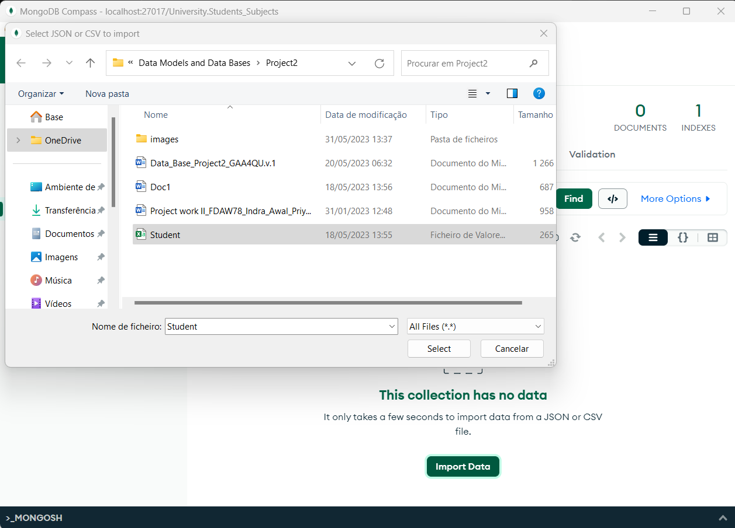

* 1. And it was imported.

* 1. I did the same with my three collections left wich is *Student_Subject* and *Subject*.

I also imported the csv files using command line:

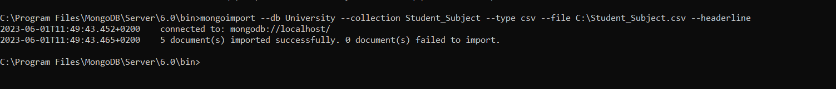

After import the three tables csv I made simple query to verify it.

1. **Queries**

**Query 1:** ProjectName, Age, Genre and Group of students with age 20 only 5 lines.

**Query 2:** Sort *Student* by the *Age* from the *min* to the *max* and select only 5 *Students* (aggregation)

**Query 3**: Find the Cod_S, total Age, and calculate how much Students can have Age return if he has 100 for total Age using subtract

**DDL Statement**: create a new collection with name “Professor” which will have id, name, and department.

**DML Statement**: insert Professor in Professor collection with id “1”, name “Szabo”, and department “Inf”.

1. **Neo4j**
2. **Neo4j Community Edition**

Neo4j Community Edition is a free and open-source edition. It is a graph database that supports nodes, edges, paths, and foreign keys to access and analyze your data. It is a great source of adaptation, assistance, feedback, innovation, and integration.

1. **Why Neo4j?**

I chose Neo4j because it is the most popular graph database in the NoSQL category. It helps visualize personal data and allows for data analysis and pattern detection. It is flexible to any changing business requirements since data teams can add to the existing graph structure without endangering current functionality so the performance stays constant even as your data grows year over year. It is very simple for the users of NoSQL graphs databases and developing with graph databases aligns perfectly with today’s agile, test-driven development practices.

1. **Import Data:** I using my dataset *Student*, *Subject* and *Student_Subject* in csv format and import them to neo4j with this command

bin\neo4j-admin import --database *University* --nodes:*Student*=import*Student*.csv --nodes:Subject=import\Subject.csv --relationships:Student_Subject=import\Student_Student_Subject.csv --id-type=INTEGER

1. **Queries**

**Query 1:** return the Student name which buy acted by “1000”

MATCH (st:Student)-[ss:Student_Subject]-(sb:Subject) where st.Name = “Alice Coleman” RETURN st,ss,sb

**Query2:** return student whose name ends with ‘n’ and they have subject which their tagline starts with ‘p’ and finishes with ‘e’ and that students names in end with ‘e’.

MATCH (st:Student)-[ss:Student_Subject]-(sb:Subject)  
 where NOT [st.name](http://p.name/) ENDS WITH 'n' AND sb.name START WITH 'p' AND st.name ENDS WITH 'e'  
 RETURN st,ss,sb

**Query3:** return 5 students who are “Masculine” and order them by their age

MATCH (st:Student)-[ss:Student_Subject]-(sb:Suubject) where st.Genre = “Masculine” RETURN st,ss,sb ORDER BY st.age LIMIT 5

**DDL:** create code professor with id 1, name ”Szabo”, department “Inf”

Create (pr: Professor {id: 1 , name:”Horror”, department: “Inf”})

**DML:** delete subject which name is “philosophy”

MATCH (sb:Subject {Name: “Phylosophy”}) RETURN

DELETE sb

1. **Comparison between MongoDB, Neo4j, and Oracle:**

**Oracle**

Oracle is a relational database management system (RDBMS). It was developed by Oracle Corporation in 1980. It is the first database designed for grid computing that provides the most flexible and cost-effective way to manage information and application. It runs on major platforms like Windows, Unix, Linux, and macOS. It is a relational database in which data is accessed by user through application or query language called SQL.

**Neo4j**

It is most famous graph database management system and it is also NoSQL database system which is developed by Neo4j, Inc. It is different from Mysql or MongoDB as it has its features that makes it special compared to other Database Management System. Neo4j also stores and present data in form of graph not in tabular format or not in a Jason format. In this whole data is represented by nodes and there you can create a relationship between nodes which means whole database collection will look like a graph, which makes Neo4j unique from other database management system.

**MongoDB**

MongoDB is a cross-platform document-oriented and a non relational (i.e., NoSQL) database program. It is an open-source document database, that stores the data in the form of key-value pairs. MongoDB was developed by MongoDB Inc. and initially released on 11 February 2009. It is written in C++, Go, JavaScript, Python languages. MongoDB offers high speed, high availability, and high scalability. Once MongoDB is installed, users can make use of Mongo shell as well. Mongo shell provides a JavaScript interface through which the users can interact and carry out CRUD operations.

And most different between them are they used in different field and different task like for graph database using Neo4j, for document oriented and non-relational database using MongoDB and for the basic knowledge using Oracle SQL Developer for better understanding about database. And I think MongoDB is the easiest one and more usefule this day especially when it comes to big data.

**References:**

<https://www.datavail.com/blog/exploring-mongodb-community-edition/>

<https://www.guru99.com/what-is-mongodb.html>

<https://www.educba.com/mongodb-vs-oracle/>

<https://www.geeksforgeeks.org/difference-between-oracle-and-mongodb/>

<https://www.geeksforgeeks.org/difference-between-neo4j-and-mongodb/>

<https://medium.com/@gp_pulipaka/the-differences-between-mongodb-and-neo4j-babd234ac1f7>

<https://db-engines.com/en/system/Neo4j%3BOracle>

https://www.oracle.com/database/technologies/appdev/sqldeveloper-landing.html