**CSC 433 Mini-Project (E-Market)**

**Group Members:** Chidinma Chukwu 202003295

Zinha Dos-Santos 202003176

Khethukuthula Simelane 202004401

Temakhosi Dlamini 202002729

**E-Market Website Documentation**

1. **Introduction**

There has been an enormous growth of small businesses among students at the University of Eswatini, Kwaluseni Campus for a variety of reasons, which may include the necessity to acquire basics while on campus, purchase learning materials, pay tuition fees, and so on. We discovered that this growth, as much as it has helped most students in a tremendous way, has come up with a lot of negative impacts for the students involved in the businesses which include an increase in the number of reported fraud cases or scams, theft of students’ merchandise, worsened academic performance due to the imbalance between school and business for some students, and, many more. So, with this E-Market project, we believe that all these problems will be eliminated since the website will only allow authenticated individuals to do business through it and it will help them save more time for their academics.

* 1. **Problem Statement**

Theproject “E-Market” is a platform which serves to encourage the circulation of money within the university students instead of spending money only on other businesses that are not owned by students. In as much as some students run proper businesses within the campus, some engage in illegal businesses which does not only put the school’s reputation on the edge but also the health of our youth and the future of this country at large are compromised. This is largely because a majority of the students do not have enough money to cater for all their day to day monetary needs, thus prone to accepting dangerous and illegal activities which promise to offer reasonable amounts of money to survive. Through this platform the students will be able to see what goods and services are available for sale from other students and also post what they sell. We believe that this will encourage them to start their own legal businesses.

As an example say student 01 braids hair but cannot do her nails and student 02 can do nails perfectly but cannot do her own hair then instead of supporting non-students who probably have jobs besides the side hustle, student 01 can search on the site for students who do nails and choose student 02 if she likes after viewing her profile and poster. Like this the student’s funds circulate more within them that spending outside thus helping each other to survive.

Another example could be when student A have notes, books or gadgets he would like to sell the student B can buy the items at reasonable prices within less time compared to having Student B search for the items on his own only to those closer to him.

**1.2 Objectives of the E-Market project**

- Launch a peer-to-peer buy-and-sell platform (the E-Market website) that will help students trade fairly between themselves.

- Create a website that will help reduce the manual work needed to be done by students selling or offering services when searching for a market; and those students who are customers when they

need certain products or services.

- Help to reduce the management costs of products

- Try and help reduce the increasing number of fraud cases reported frequently since most students buy from untraceable people.

**2. Functional requirements**

Our website allows people to find traders that they can buy products and services from. Before buying the potential client is able to see visuals of what is being sold, so the trader must upload a clear picture of what he or she is selling and add cell numbers which there must be functional and under MTN or Swazi Mobile network. The website must contain dimensions that support both phones and laptops to cater for all users. The website will also notify users of the time an item was uploaded and for as long as it appears it means that item is still available to be sold. When a trader posts first the admin will check if the item or service is online with our business policy and then authorize it to be publicised to the site.

**Non-functional requirements**

In terms of usability, searching for products and services is easy because customers can easily search on the search bar for the item they want and boom they appear right below so there’s no need to scroll down and waste time. A person’s password must be 8 characters long including both upper and lower case and special characters or a number.

**2.1 High-level view of users’ functional requirements using UML diagrams**

The following Structure Chart shows the users’ functional requirements from a high-level view:

SIGNUP

LOGIN

LOGOUT

PROFILE PAGE

SERVICES

PRODUCTS

HOMEPAGE

PRODUCTS

PRODUCTS

ADD-ITEM FORM

MAKE-UP

TUTORING

OTHER SERVICES

EVENTS

NAILS

HAIR-DRESSING

**2.2**

**Database Schema**

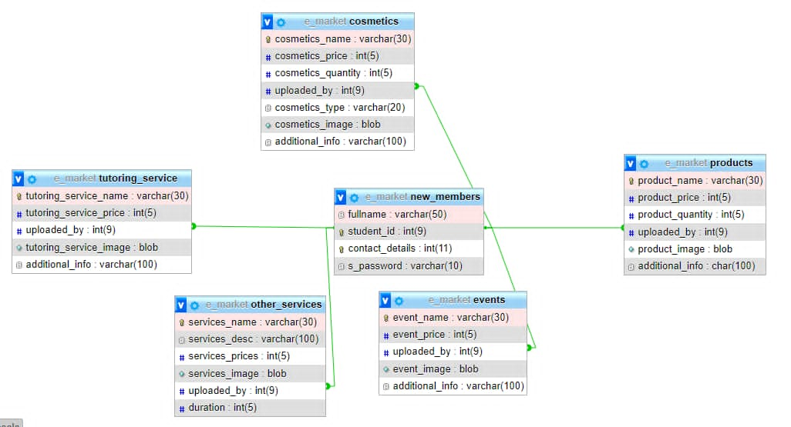

The primary key is the “student_id” and the Foreign key is the “uploaded_by” attribute.

**2.3 Home Wireframe Design**

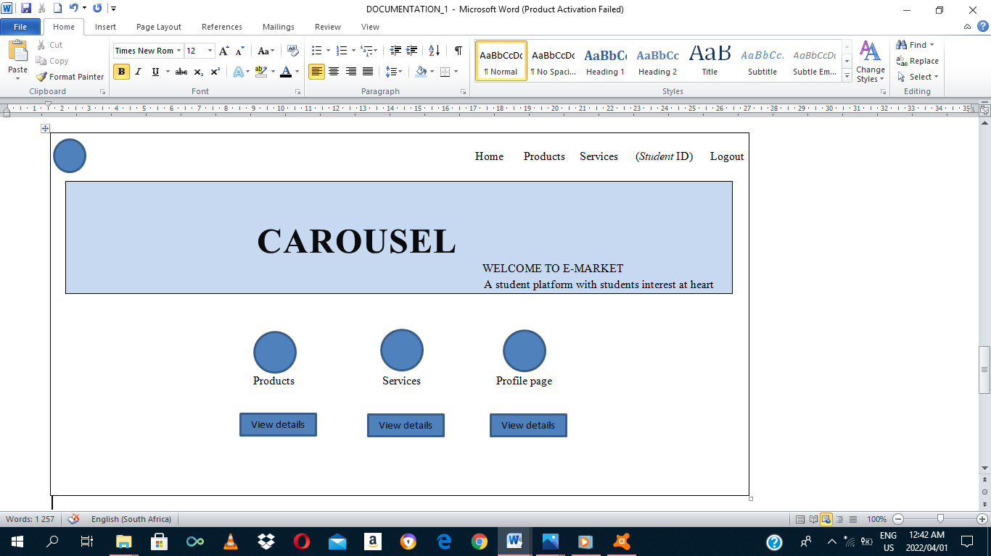

**3.** **Web-app & Development**

The site has the following pages with their functionalities:

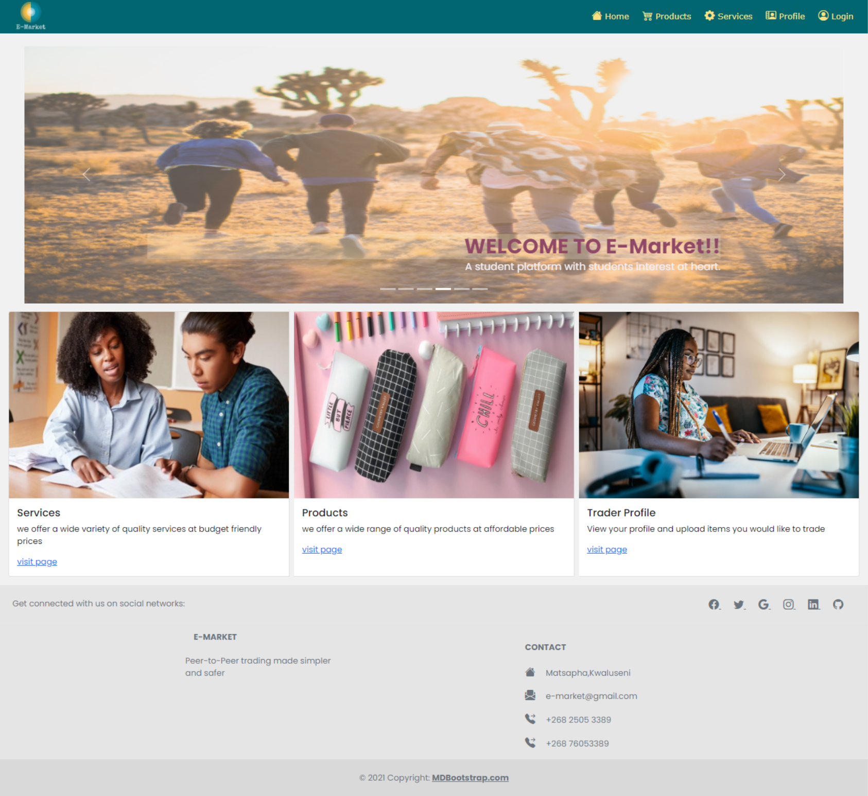

a) Homepage: this page contains the company logo and links to the other main pages of the website. This page enables users to gain access to the products , services , logout page as well as information about the organization and how individuals can be contacted.

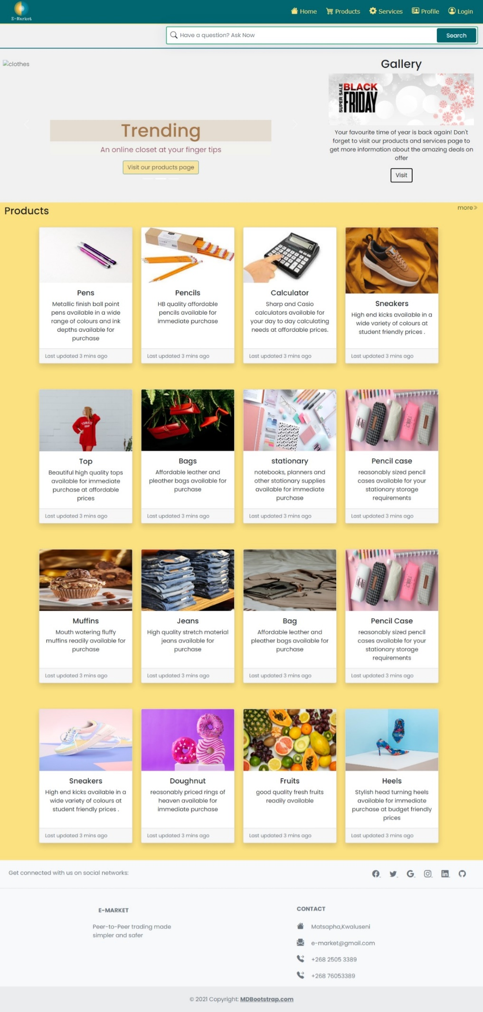

b) Products page: in this page the customer is able to navigate or use the search bar to search for a particular product that have been uploaded on the site. The products include books, beauty products, clothes and the like.

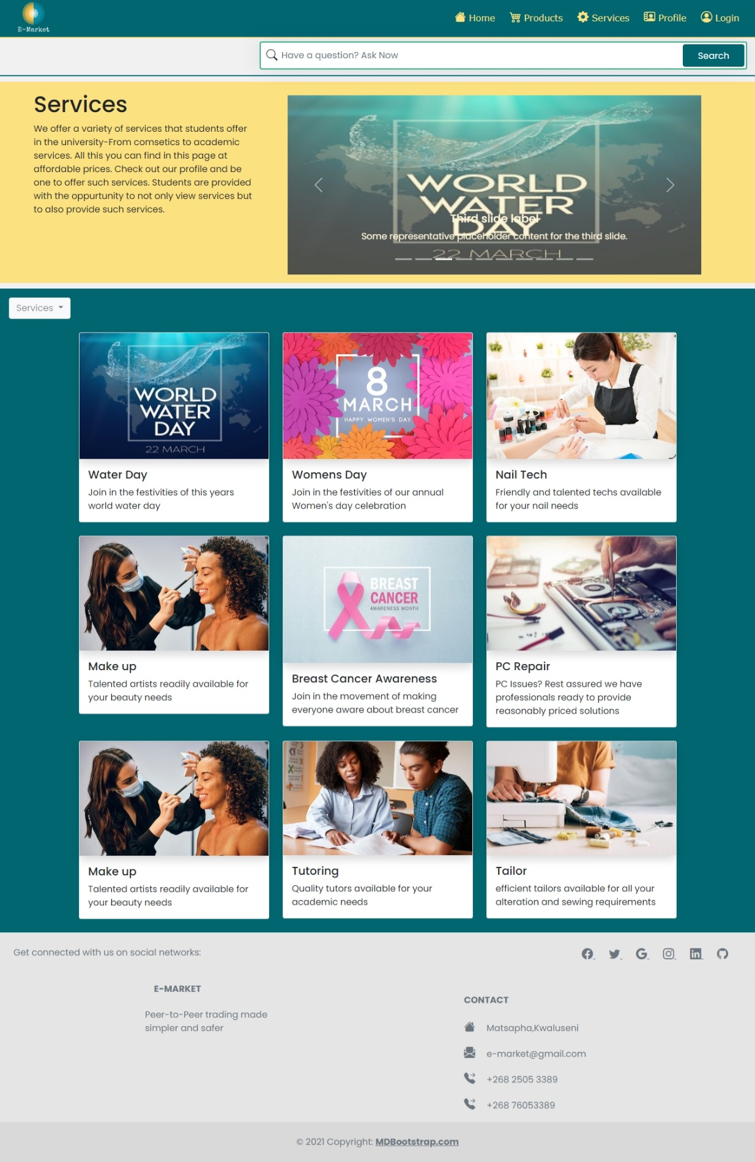

c) Services page: this page is where customers are able to see what services are available. These services include; tutoring, hair dressing, make up and the like.

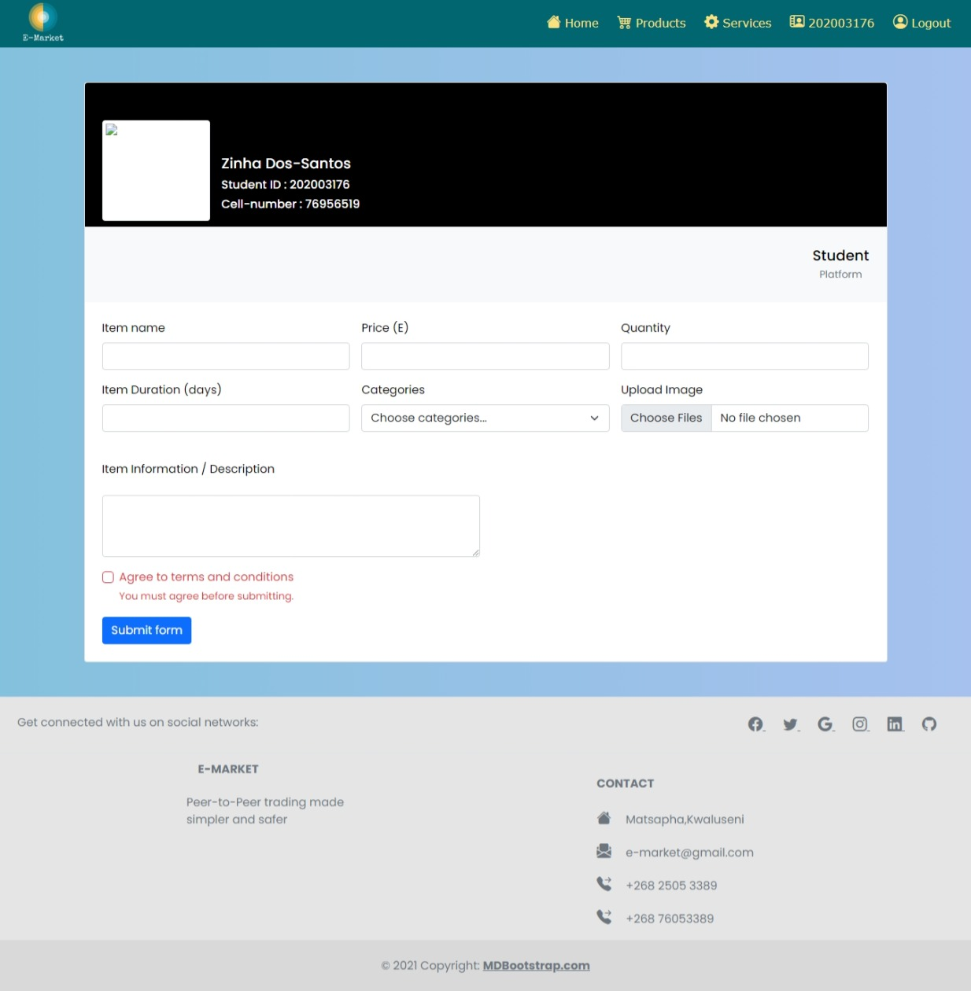

d) Profile page: this page is for every user of the site to register and for the sellers to use when uploading their products or services. It contains the user’s unique name, student id and password and allows them to add products or services they would like to sell. For example the one indicated above is for a user present in the site’s database.

e) Logout page: this page allows the user to log out of his or her account and be redirected to the login page.

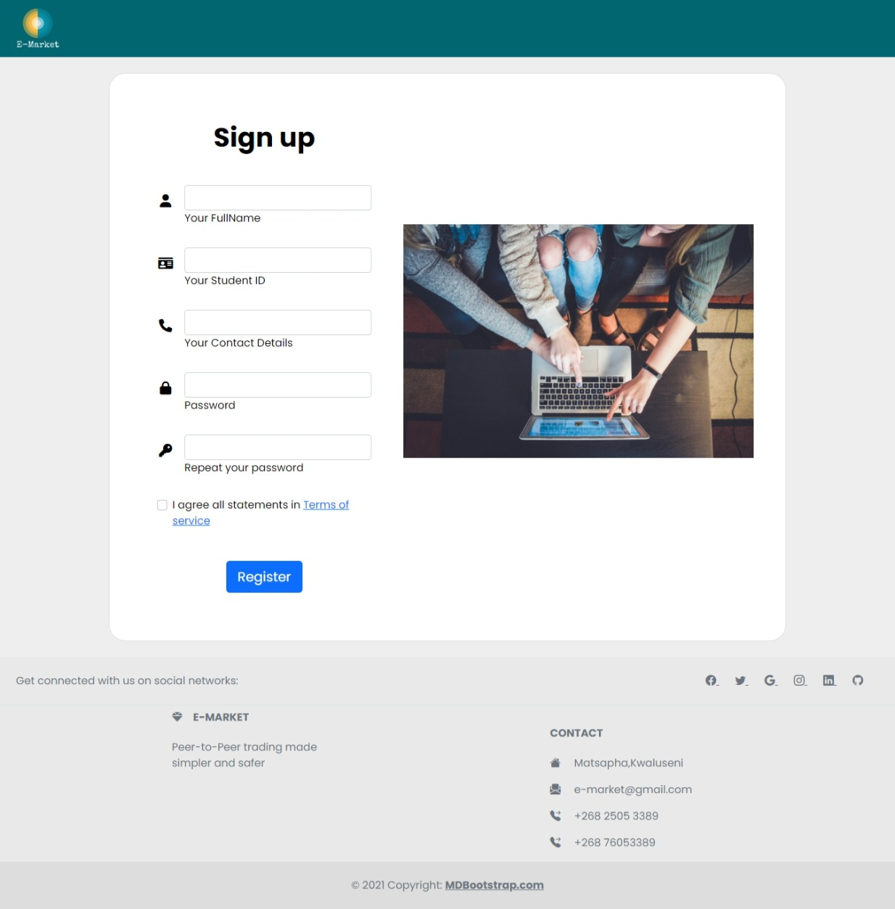

f) Sign-up page: this page allows the student to register an account and become a user. All the fields in the registration form are mandatory to fill before submitting it.

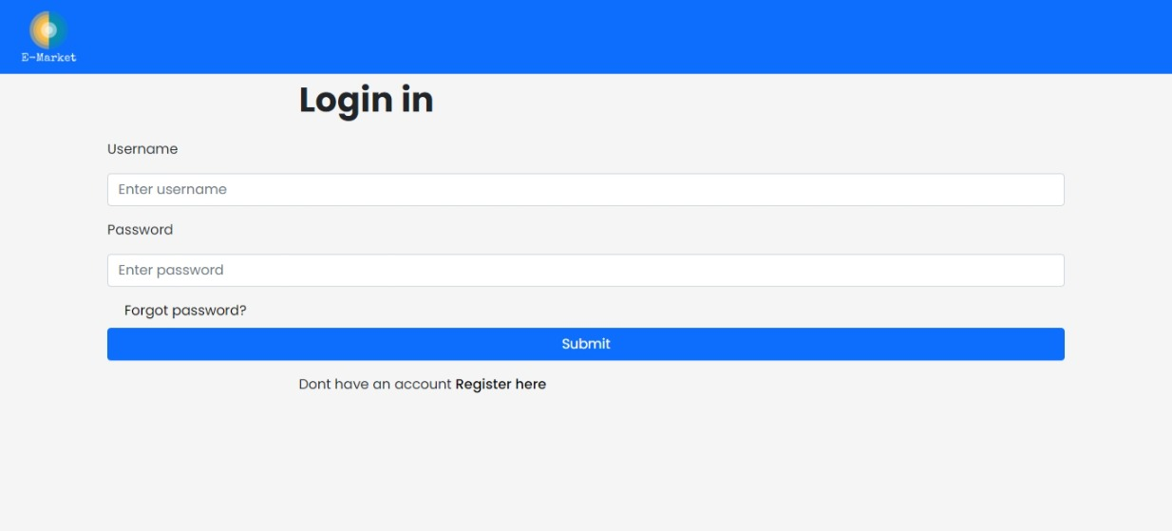

g) Sign-in page: this page allows the user to gain access to the website. Only users with the correct student_id are allowed access to the site.

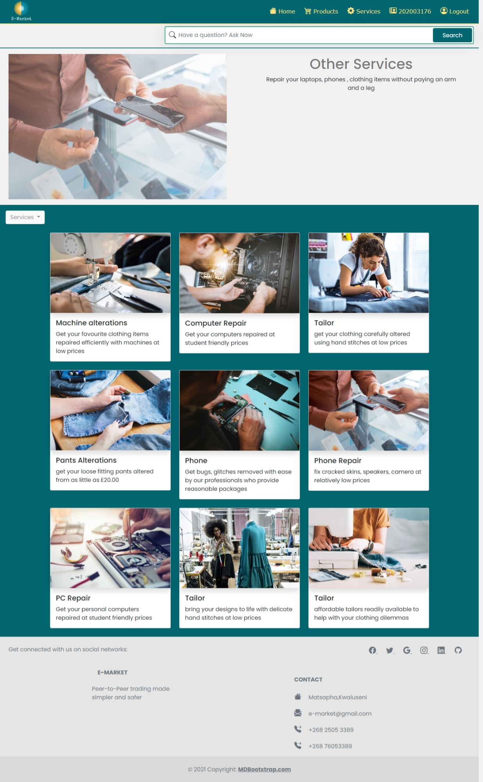

h) Footer: this is the bottom area of the site pages where information about us and how to contact us is found.

**4. Testing**

* We tested our sign up page by putting in wrong information, re-registering with information for an already existing or registered user and also tried putting in passwords shorter than 8 and it gave fatal errors but when following the instructions, it registered well.
* We also tested our navigation links to see how fast it is to load another page. It takes a few seconds. Then uploading a picture takes a little while on the profile page.
* We opened the site on different devices as well and it appeared perfectly fine.

**5. Conclusion**

We believe that this website will curb a lot of student’s problems with regard to their businesses. They will have a free platform to advertise on and reach a significant number of clients in a short time. Their profits shall increase thus improving their standard of living within the campus. They will now afford their essentials and need not to engage in illegal activities.