

**American International University-Bangladesh (AIUB)  
Department of Computer Science  
Faculty of Science &Technology (FST)  
Summer 21-22**

**Assignment**

**Selenium Installation Guide & Testing**

Software Quality & Testing

Section: A

Submitted To

Abhijit Bhowmik

Submitted By

Zaman, Sadia (18-38653-3)

Arefin, Md. Salman (18-38698-3)

Nissa, Zinnatun (18-38838-3)

Contents

**1.** **Flowchart of Selenium Installation & Testing** 3

**2.** **Python Download** 4

**3.** **Install Python** 5

**4.** **Upgrade pip** 6

**5.** **Install WebDriver Manager** 6

**6.** **Install Visual Studio Code** 7

**7.** **Install Selenium** 8

**8.** **Automation Testing by Selenium** 8

# **Flowchart of Selenium Installation & Testing**

Start

Download Python

Install Python

Install WebDriver

Install VS Code

Install Selenium

Write Test Code

Test Project

Done

# **Python Download**

First search for ‘Download python’, then click on the first link appear.

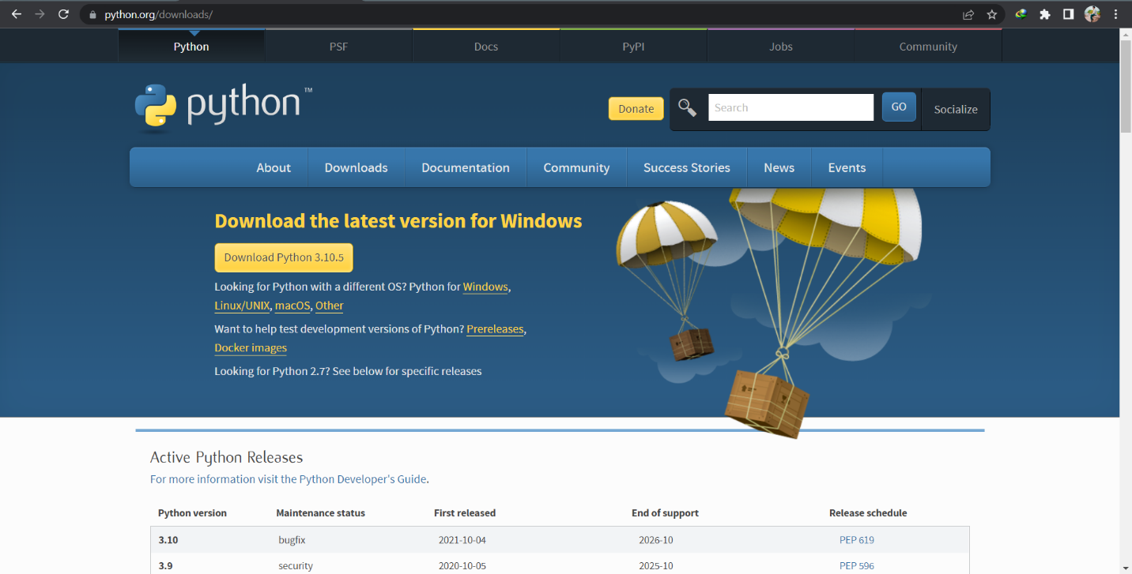

Next, Click on the download button simply.

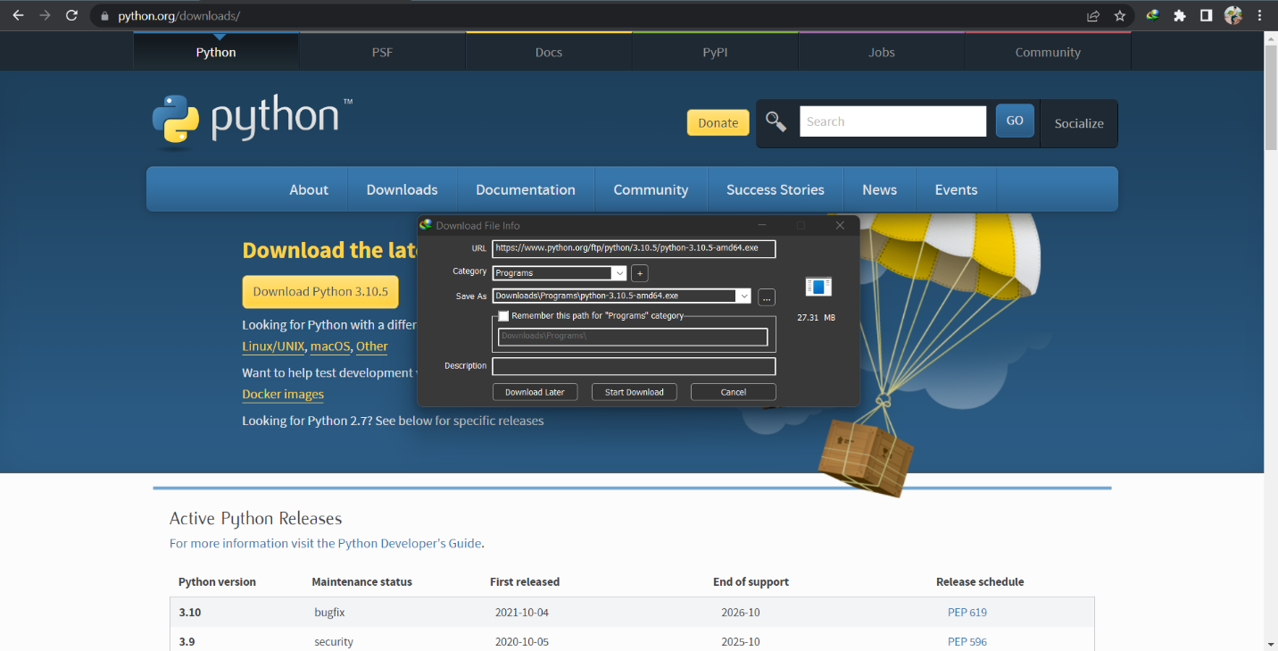

# **Install Python**

Next go to the download folder and click right button and select run as administrator. Then click on install launcher for all users (recommended) and as well as the Add Python 3.10 to PATH. Then click on Install Now.

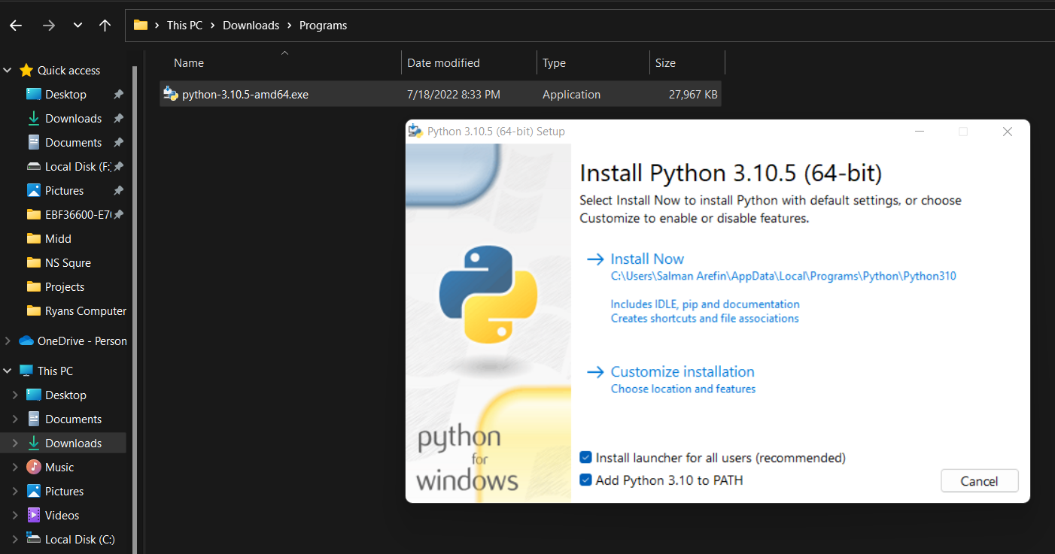

Next close the window.

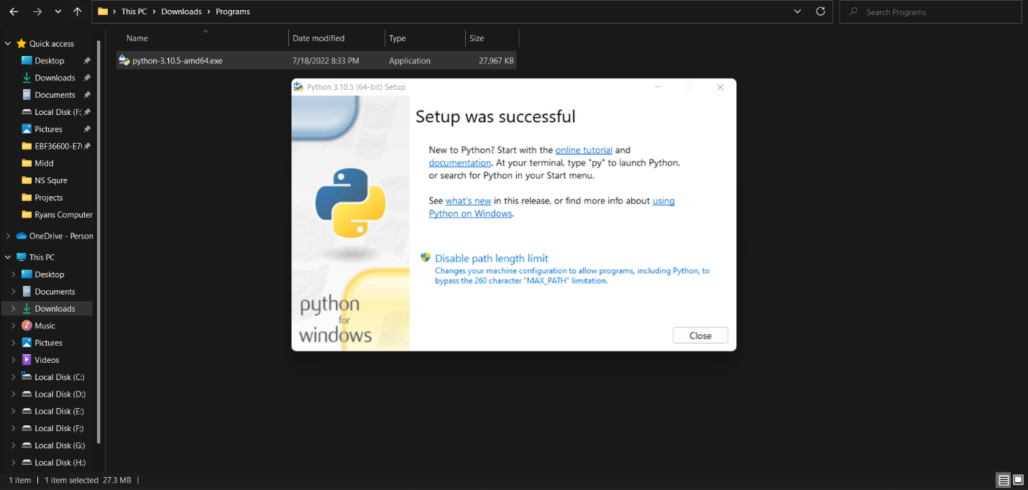

# **Upgrade pip**

Opening cmd write pip install –upgrade pip.

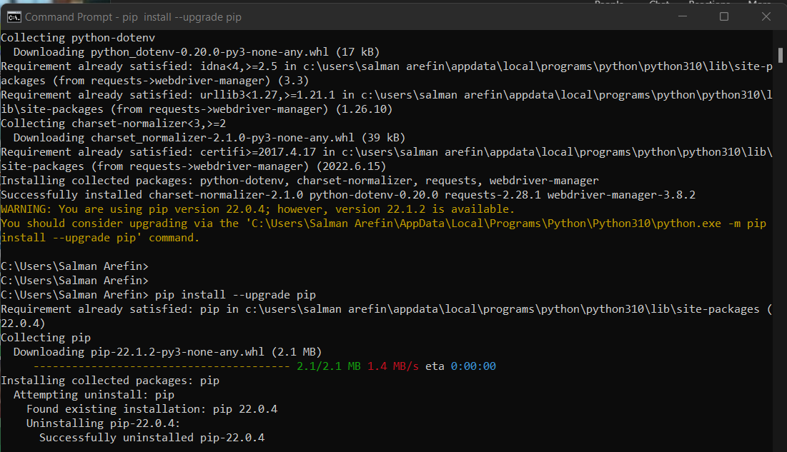

# **Install WebDriver Manager**

Opening cmd write pip install webdriver-manager.

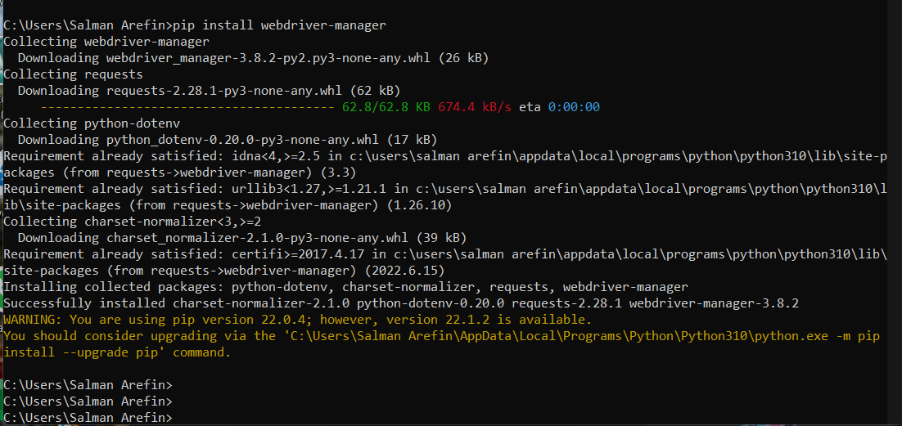

# **Install Visual Studio Code**

First search for ‘Visual Studio Code’, then click on the first link appear

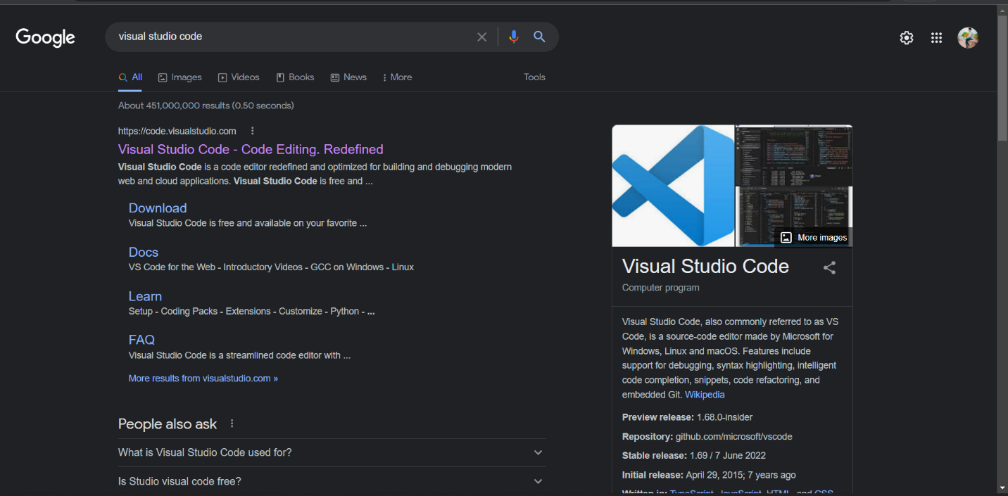

Next, Click on the download for windows stable build version.

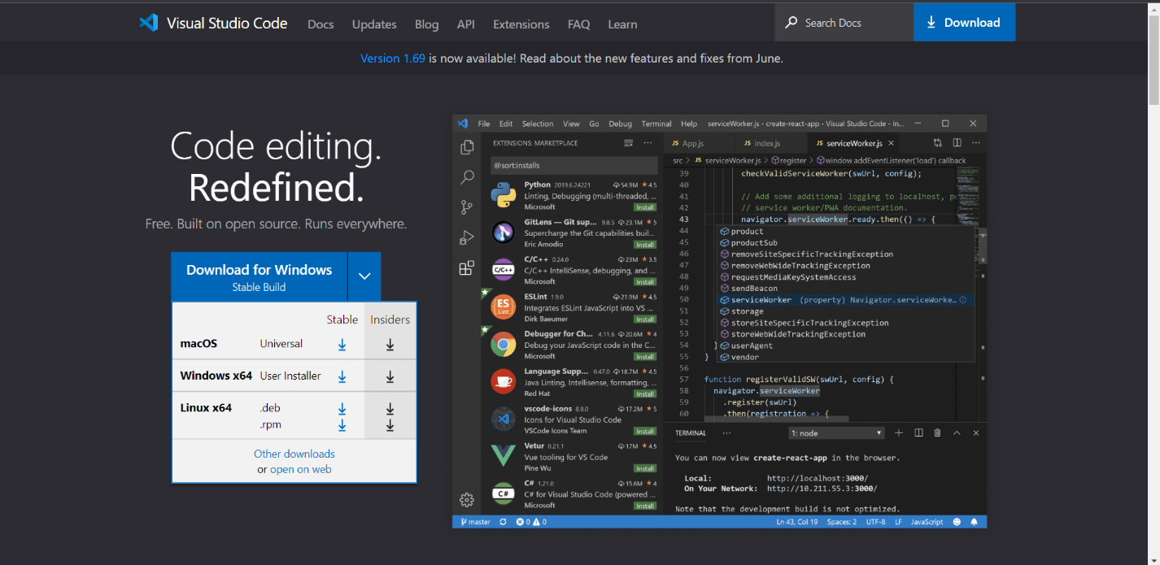

# **Install Selenium**

Opening cmd write pip install selenium.

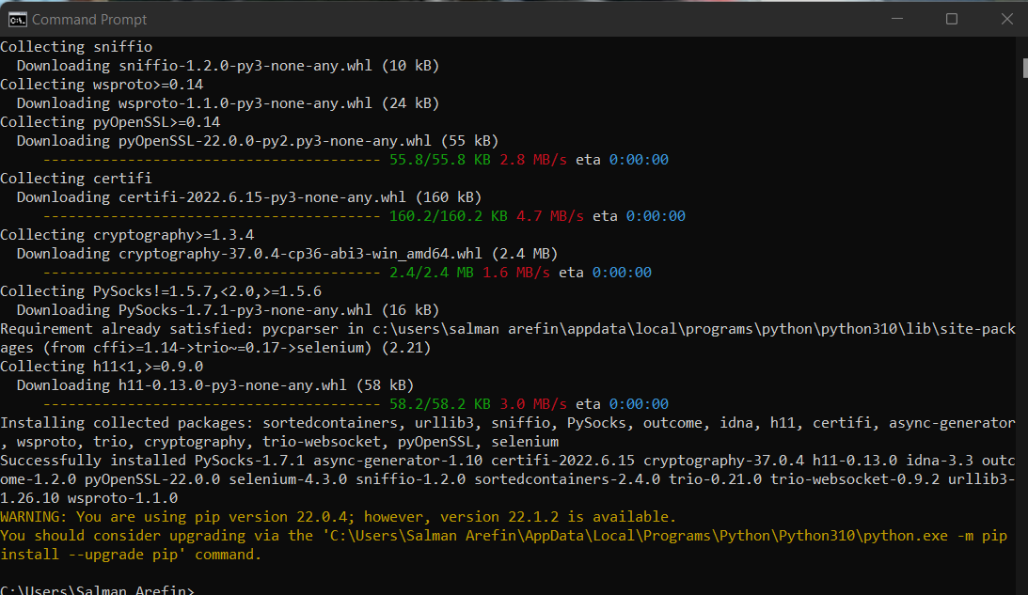

# **Automation Testing by Selenium**

First opening Vs code click ‘File’>’New Text File’.

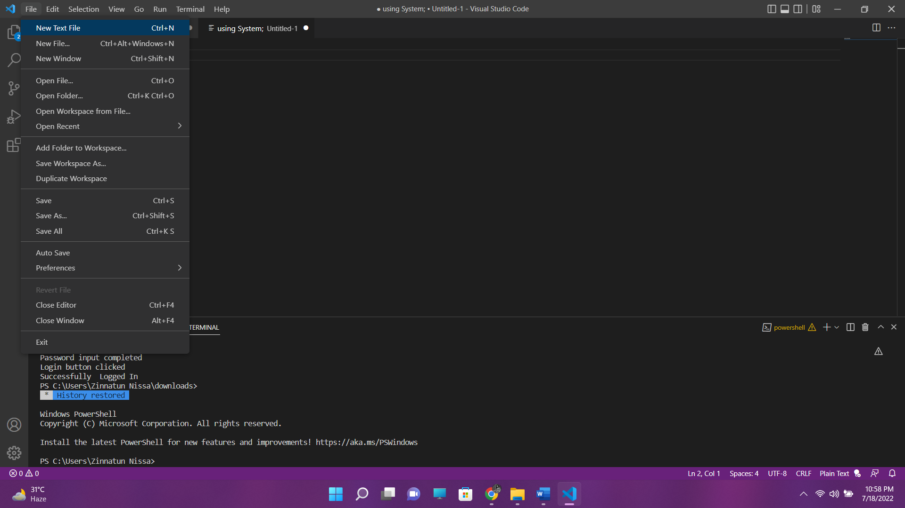

Then written a testing code in order to test an existing project login page. Then by running testing is successfully accomplished.

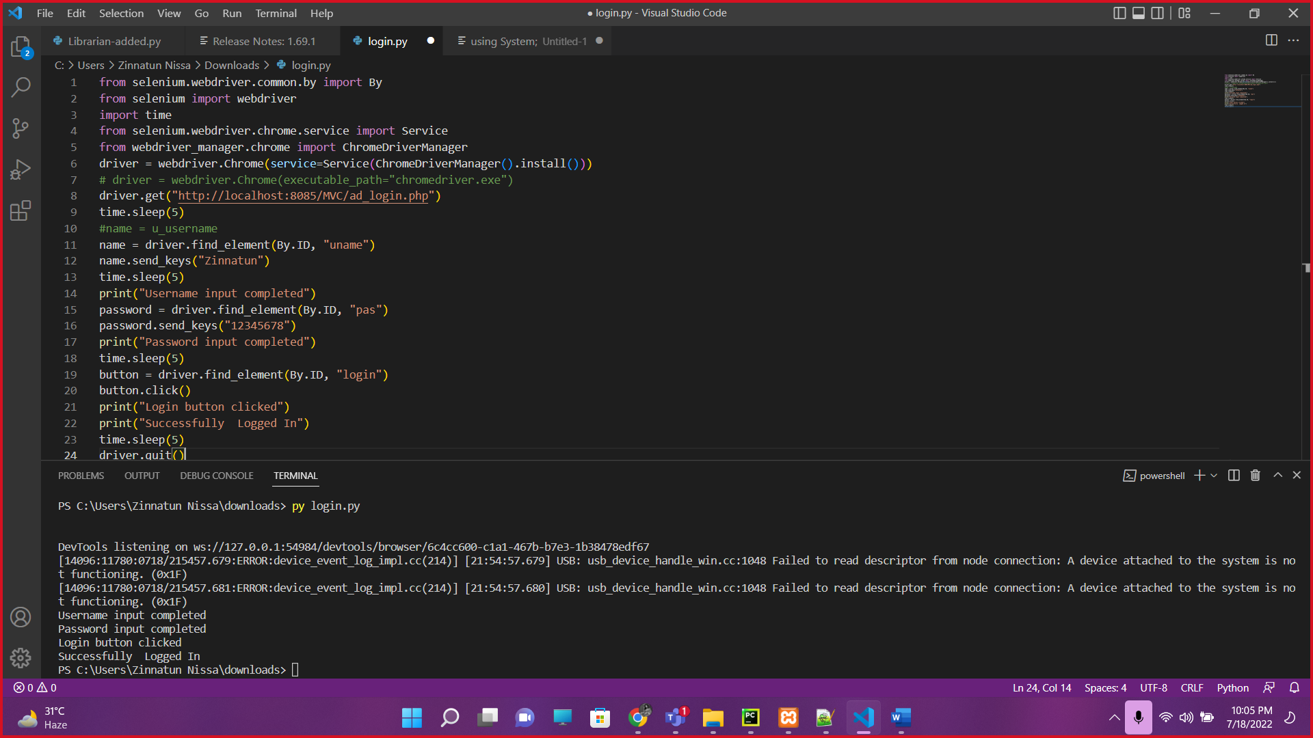

This page is automated tested by selenium.

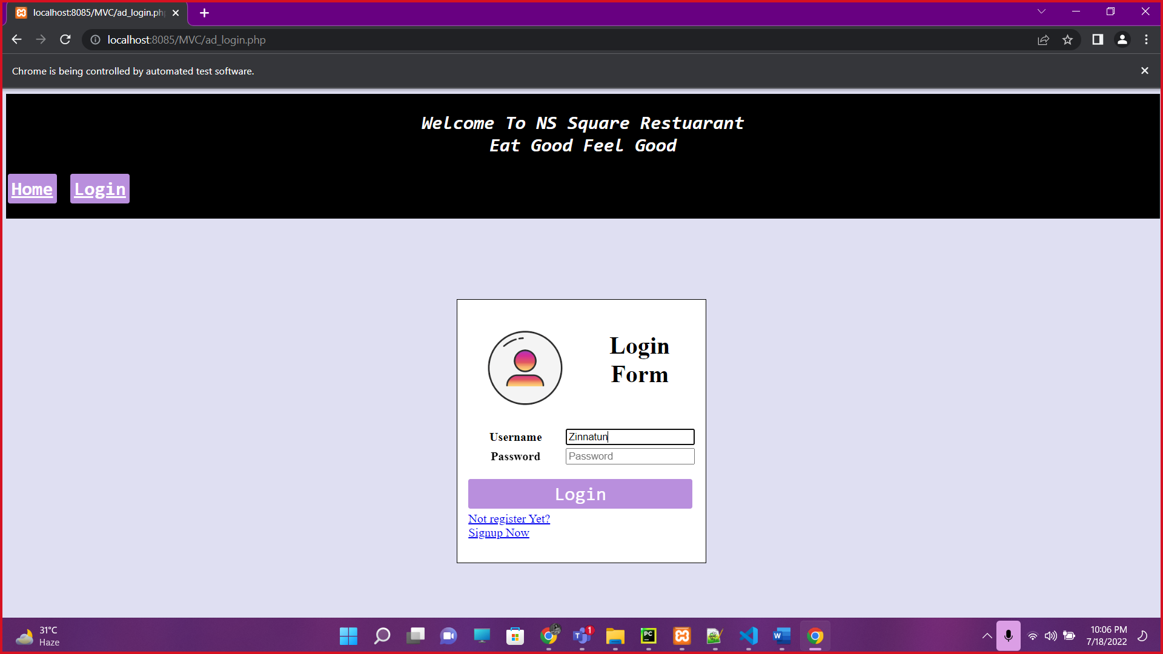

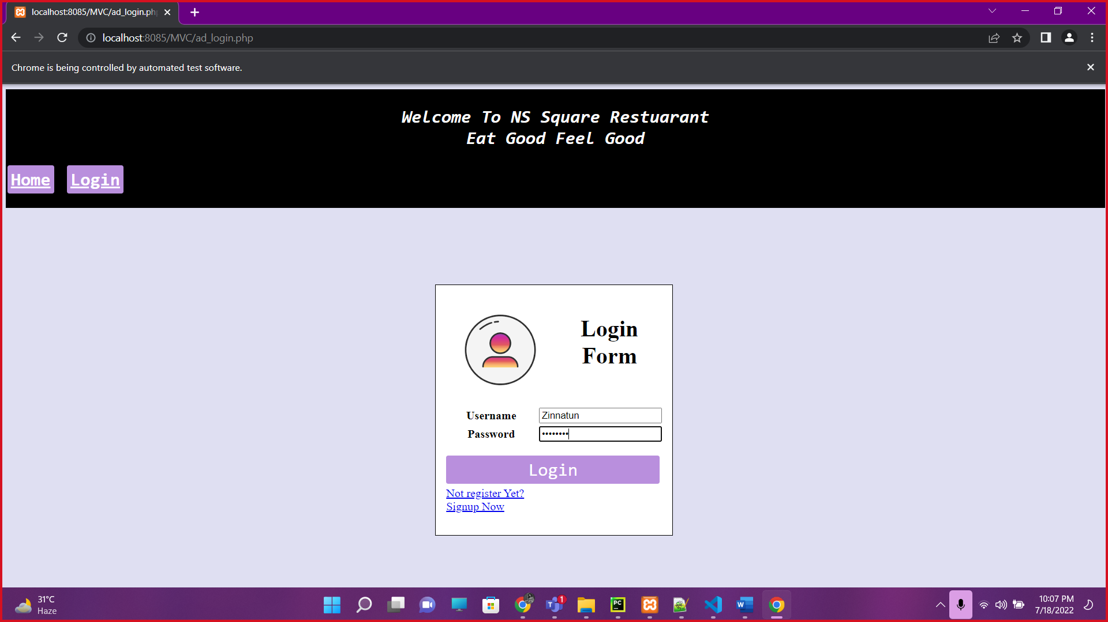

Finally, Home page is shown after a successful login.

