Step1-2

In docker-compose.yml

Step 3

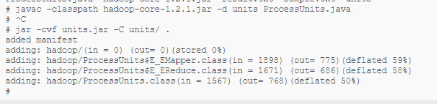

Step 4



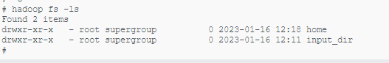

Step 5-6

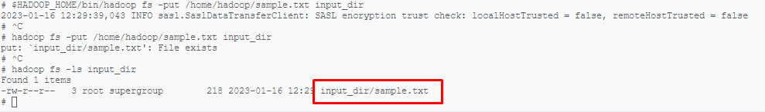

Step 7

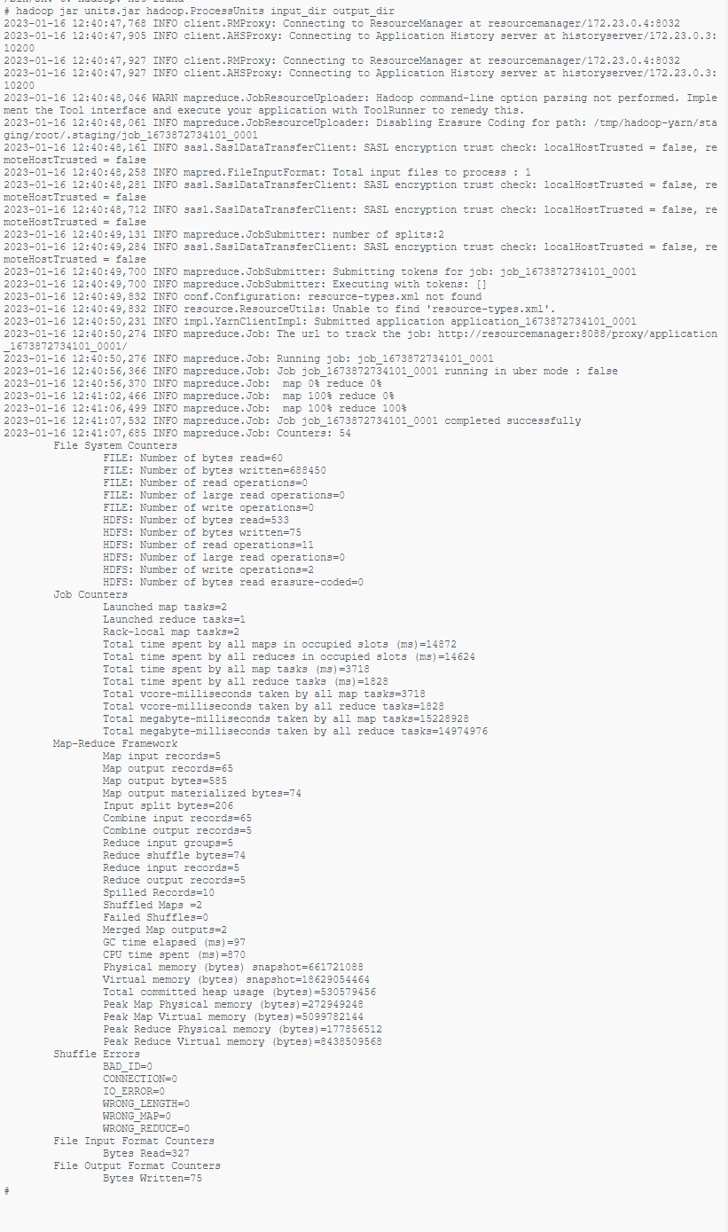

Step 8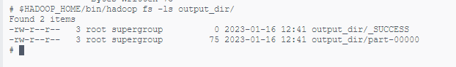

Step 9

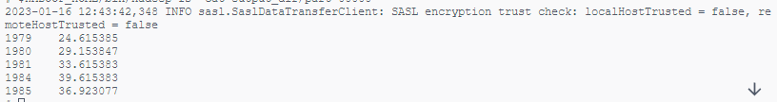

All is ok, in java code I dropped filter over 30 for avg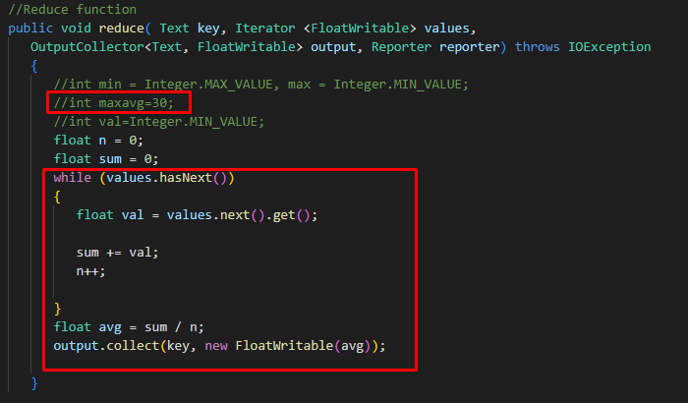

Step 10

