Purple Group
CST-135
January 14, 2018
Charles Lively

Milestone 3 Activity Vending Machine Project
GitHub Repository: https://github.com/Zinth/CST-135-Final_Project-Vending_Machine
Credits
Milestone 1
- Storyboard – James Ray
- Product Class UML – Jesus Leon
- Dispenser Class UML -Robert Wade
- Read Me – Christopher Hyde
Milestone 2
- UML design of product subclasses – Robert Wade
- Programming of Product Class & Subclasses – James Ray
- Programming of Dispenser Class – Jesus Leon / Christopher Hyde
- Programming of Main/Test Class – Christopher Hyde
- Read Me – Christopher Hyde
Milestone 3
- Comparable interface – Christopher Hyde / Robert Wade
- Test Class – Christopher Hyde / James Ray
- Read Me – James Ray

Milestone 4
- Steps 1-2 – Robert Wade
- Steps 3-5 – Christopher Hyde
- Minor debug – James Ray
Milestone 5
- Inventory Class – Robert Wade
- Animation – Christopher Hyde
- Implementation of Classes – James Ray
- Debugging – Robert Wade, Christopher Hyde, and James Ray

Project Objectives
Customers will be able to insert money into the machine and select a product from a predetermine list of products by button pushes. A boss will be able to restock, edit products, and collect money from a separate interaction window that will be available from in the customer window.
Customer Instructions:
- Selecting a product* - Select a product pushing the selection keys of the product number and pushing enter. The keys you have pressed will display above the selection keypad. Please double check selection entered before pressing enter.

- Paying for you product* – To pay just select a monetary button representing the amount equal to or above the cost of the product.

- Collecting Product – Once selected and purchased your product will appear in the lower Dispenser Slot. Click the product in the Dispenser Slot to collect.

- Don’t forget your change – Any left-over funds from your purchases can be collected by pressing the change button.
* The product numbers and prices are located above the products displayed icon.
How to Run the Program
- Run javac main.java
- Run java main
- Click category of interest.
- Click add to add items to your cart..
- To remove items click Remove from cart button.
- Total and list of products will be displayed.

Manager Instructions
- Click on lock image to open manager window.
- Modify product quantities as needed.
- Click refresh image to reset all quantities to default of 10.

Customer GUI Overview
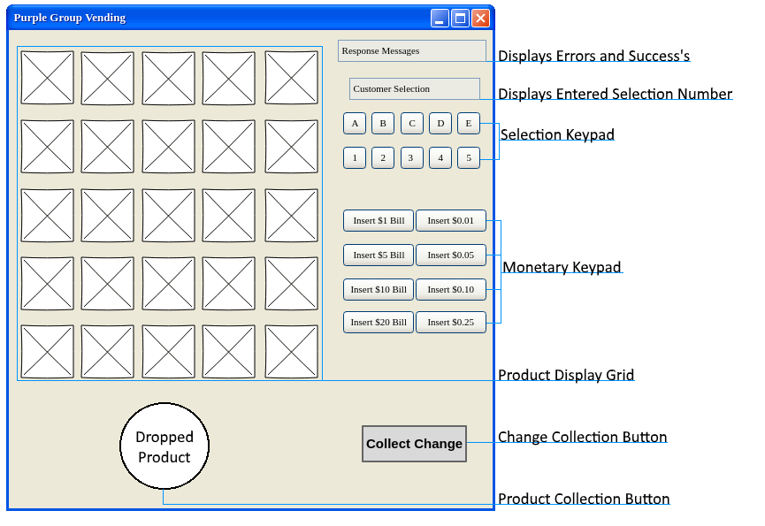

Customer Interactions:
- Selection Keypad - Button to enter the letter and number of the product to purchase.
- Monetary Keypad - Buttons that allow the user to input a selected amount of currency.
- Change Collection Button – Button that returns the change after product purchase to customer.
- Product Collection Button – Button that allows the user to collect their product.
Boss Instructions:
- Restock Products - Press the restock button to replenish all products stocks

- Collect Money– Press To collect funds button to collect the funds you earned.

- Edit Product – Use the selection keypad to choose a product then press the edit button. Edit any text property and click submit to finalize edits.

- Replace Product – Use the selection keypad to choose a product to replace then press the replace button. Fill in the new products details and click submit.
Boss GUI Overview
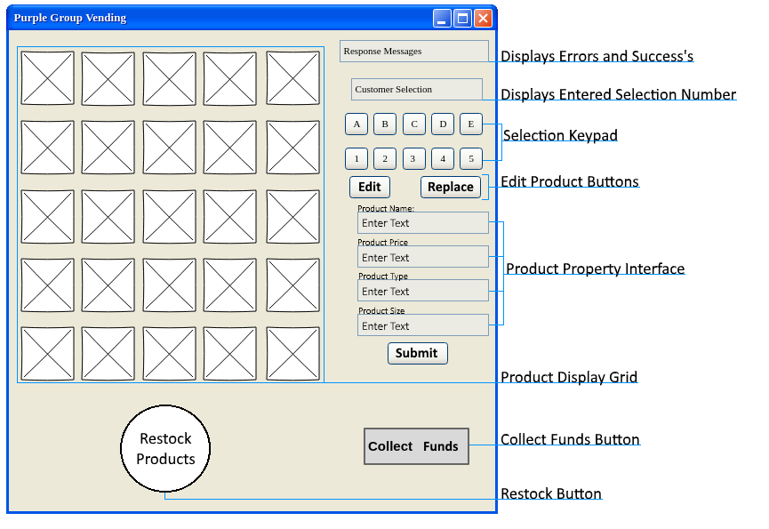
Boss Interaction:
- Selection Keypad - Button to enter the letter and number of the product to edited or replaced.
- Restock Button – Button that runs a method that restocks all products.
- Collect Money Button – Button that allows the boss to add the earned money to their account.
- Edit Product Button – Button that will run the edit product property interface.
- Replace Product Button – Button will run the replace product property interface.
- Submit Button – Submits changes made in the product property interface.

Customer Flowchart
Provided by James Ray

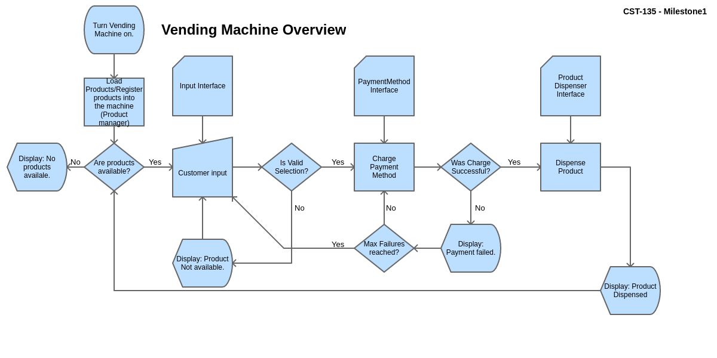

Class UML’s
Provided by Robert Wade & Jesus Leon
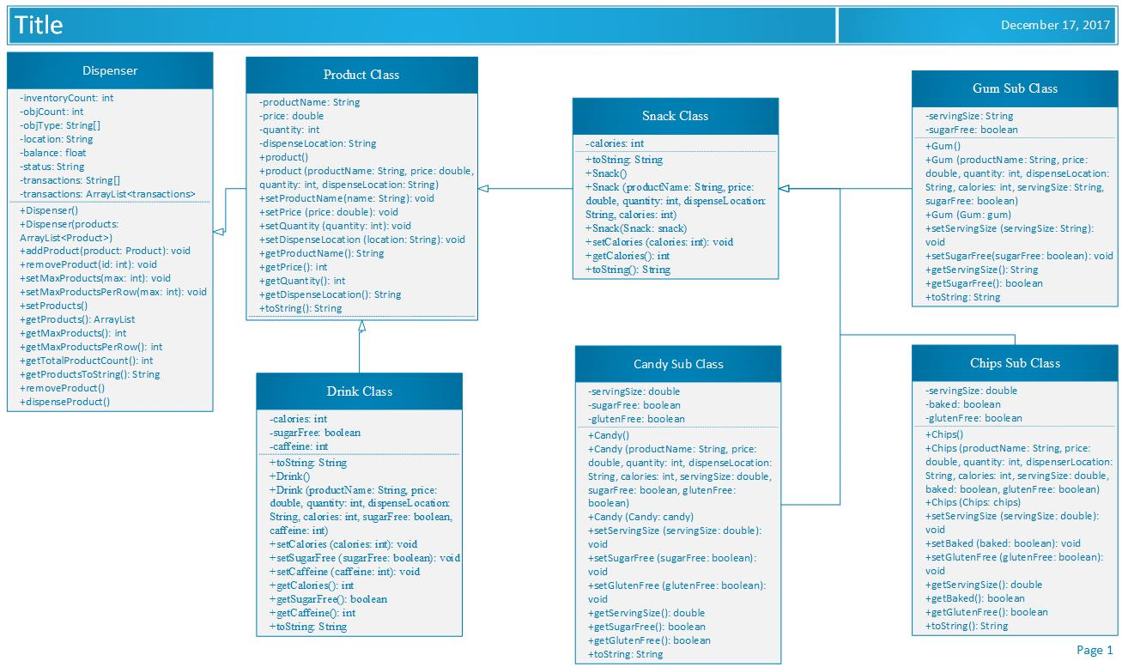
References

