Digital Signal Processing Project Report
Template Matching of Environmental Sounds using Normalised Cross-Correlation
Finding where a known sound occurs in a longer recording, scored against known ground truth (ESC-50)

Student name: [Student name]
Roll no: [Roll no]
Guide name: [Guide name]
Department: [Department]
Institute: [Institute]
Academic year: [Academic year]

Index
1 Introduction 3
2 Comparative Study of Literature 4
3 Objective 5
4 Methodology 6
5 Work Done 7
6 Results 9
7 References 12

1 Introduction

1.1 Background
Many sounds worth detecting, a door knock, a siren, a dog bark, have a characteristic waveform. If one example of the sound is known, a simple way to find it in a longer recording is template matching: slide the template along the recording and measure at every position how similar the two are. The similarity measure used here is normalised cross-correlation (NCC). Plain cross-correlation grows with loudness; dividing by the energy of the template and of the current window of the recording makes the score independent of volume and bounded by 1, so a single threshold can be used [4], [7].
To score such a detector honestly the true positions must be known. This project builds test recordings by joining clips from the ESC-50 dataset [1], [2] with silences between them, so the exact start and end of every clip is known and each detection can be marked correct or false.

1.2 Dataset and key figures
Table 1: Dataset facts (counted from the metadata file) and the setup of this project. No external usage statistics are claimed.
Quantity | Value | Source
Clips in ESC-50 | 2000 | Counted from meta/esc50.csv [2]
Classes | 50 | Counted from meta/esc50.csv [2]
Clips per class (chosen classes) | dog: 40, rooster: 40, rain: 40, siren: 40, door_wood_knock: 40 | Counted from meta/esc50.csv [2]
Cross-validation folds | 5 (folds 1-5) | meta/esc50.csv [2]
Clip length / original sample rate | 5 s / 44.1 kHz WAV | Dataset description [1], [2]
Rate used in this project | 16000 Hz (resampled) | Chosen to keep correlation fast
Classes used | dog, rooster, rain, siren, door_wood_knock | Chosen from the 50 class names in the CSV [2]
Test recordings per class and condition | 30 | This project (Section 6)
Licence of the data | CC BY-NC 3.0 (non-commercial, attribution) | [3]; clips originate from Freesound [16]

The data are used under the CC BY-NC 3.0 licence [3] for this non-commercial college project, with attribution to Piczak [1], [2].

2 Comparative Study of Literature
The base paper (a recent open-access paper on template matching or correlation-based sound event detection) could not be verified within the time limit: this session had no access to publisher or index websites to check authors, year, venue and DOI, and no unverified paper is cited. It is left as a highlighted placeholder for the student to fill in. The other entries are listed from latest to oldest; their summaries describe what each source is known for, not a full-text review.
Table 2: Comparative study (base paper first; then latest to oldest).
Title | Year | Source | Benefits | Future scope
[Base paper to be verified by the student] | [Year] | [Venue / DOI] | [Benefits] | [Future scope]
ESC: Dataset for Environmental Sound Classification [1], with the ESC-50 data [2] | 2015 | ACM Multimedia; GitHub | Supplies 2,000 labelled 5 s clips in 50 classes with a metadata file and fold assignment; the common benchmark for environmental sounds and the data used here. | Built for classification, not detection in long recordings; this project adds recordings with known clip positions.
Fundamentals of Radar Signal Processing, 2nd ed. [4] | 2014 | McGraw-Hill (book) | Derives the matched filter and its implementation by correlation; basis for the correlation and normalisation used here. | Written for radar; sounds are not known-shape signals in white noise, so the optimality argument only partly carries over.
Principles of Modern Radar: Basic Principles [5] | 2010 | SciTech (book) | Reference for correlation-based detection and detection thresholds. | General reference.
Radar Handbook, 3rd ed. [6] | 2008 | McGraw-Hill (handbook) | Broad reference on matched filtering and threshold detection. | General reference.
Matched Filter and Pulse Compression (Scientific Python course) [7] | undated | TU Berlin course material | Python explanation of correlation by FFT, used to cross-check the implementation approach. | No normalisation or detection scoring.

3 Objective
- Load ESC-50 clips, convert to mono, resample to 16 kHz, normalise the amplitude.
- Build test recordings by joining clips with 1 s silences, recording the exact start and end of every clip as ground truth.
- Implement template matching with FFT-based normalised cross-correlation in NumPy, and peak picking with non-maximum suppression.
- Match detections to ground truth by the centre-in-span rule and compute precision, recall and F1.
- Provide a Streamlit app: template class, test recording, threshold slider, plot with true spans and detections, table, metrics.
- Measure precision, recall and F1 against threshold for five classes over at least 20 recordings each, and report the best threshold per class honestly.

4 Methodology
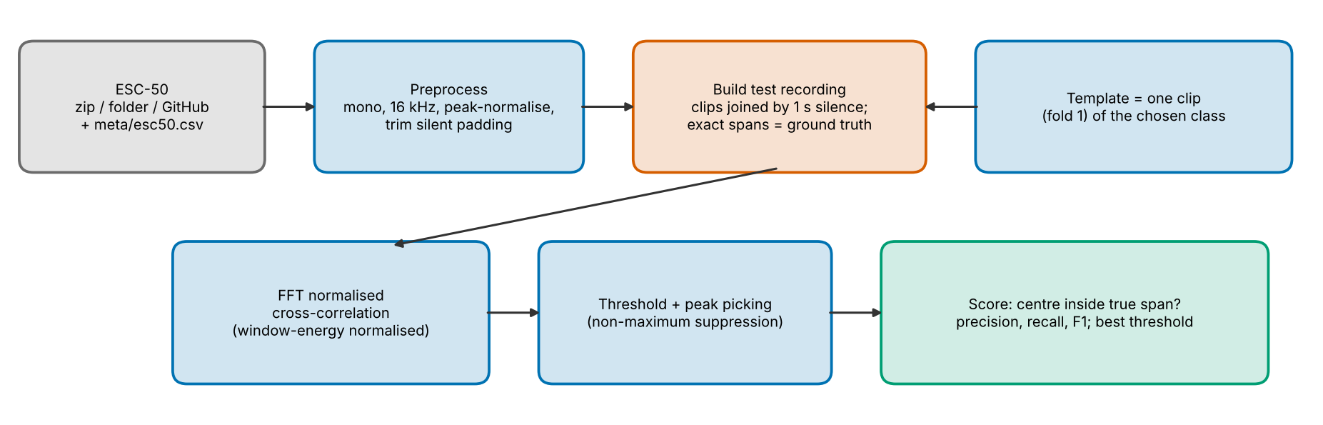
Figure 1: Flow chart of the system.

4.1 Preprocessing
Each clip is converted to mono, resampled from 44.1 kHz to 16 kHz with a polyphase filter [9], scaled so that its peak is 1, and stripped of the digital-silence padding ESC-50 adds to short events (samples below 0.1 % of the peak at the start and end are removed).

4.2 Test recordings and ground truth
A recording joins five clips separated by 1 s of silence in a random order: two occurrences of the template sound and three clips of the other classes. The start and end sample of every clip is stored. Two conditions are used. In the class condition the occurrences are other clips of the template's class (folds 2-5; the template itself, from fold 1, is never in the recording). In the repeat condition the occurrences are the template clip itself with a random gain of 0.5-1.5 and white noise at 20 dB SNR, which tests the method when the sound recurs exactly.

4.3 Normalised cross-correlation
For template t of length m and recording x, the score at lag k is c[k] = sum_n x[k+n] t[n] / ( sqrt(sum_n x[k+n]^2) x sqrt(sum_n t[n]^2) ). The numerator for all lags is one FFT-based correlation (zero-padded, so linear), IFFT( FFT(x) x conj(FFT(t)) ) [8]. The window energy in the denominator is a difference of a running sum of x^2. The score lies in [-1, 1]; 1 means the window is a scaled copy of the template. Windows with almost no energy (silence) are given score 0 so that quiet gaps cannot score highly.

4.4 Detection and scoring
Local maxima of the score above the threshold are candidates. Non-maximum suppression keeps the strongest and discards any peak closer than one template length to a kept one. The detection time is the centre of the window (start + half the template length). A detection is correct if its centre lies inside a true occurrence not already matched; any other detection (in another class's clip, in silence, or a second one in an already matched clip) is false. TP, FP and FN are summed over the recordings, then precision = TP/(TP+FP), recall = TP/(TP+FN), F1 = 2PR/(P+R) (0 when a denominator is 0). A chance baseline repeats the detection on the score curve circularly shifted by a random amount, which keeps the peak heights but destroys their positions.

5 Work Done

5.1 Tools
Table 3: Tools used.
Tool | Used for | Ref.
Python 3 (csv, zipfile, urllib) | Metadata, reading clips from the zip or folder, downloading single files | [15]
NumPy | FFT correlation, running energy, peak picking, all core DSP | [8]
SciPy | WAV reading and polyphase resampling only (no matched-filter or correlation routines) | [9]
Matplotlib | Figures | [10]
Streamlit | Interactive app | [11]
pytest | Tests | [12]
python-docx / python-pptx | This report and the slides | [13], [14]

5.2 Implementation steps
- src/dataset.py: reads clips from a local zip, an extracted folder, or (fallback) downloads only the needed files from GitHub; preprocessing as in Section 4.1.
- src/matching.py: ncc() and pick_peaks().
- src/recording.py: joins clips and stores the ground-truth spans, for the class and repeat conditions.
- src/metrics.py: detection, centre-in-span labelling, TP/FP/FN, precision/recall/F1.
- app.py: the Streamlit app (Figure 2).
- tests/: 6 pytest tests (self-correlation, embedded template, silence, metrics on a toy case, data loading from zip and folder).
- experiments/exp_threshold.py: the experiment of Section 6; writes docs/figures and docs/tables.
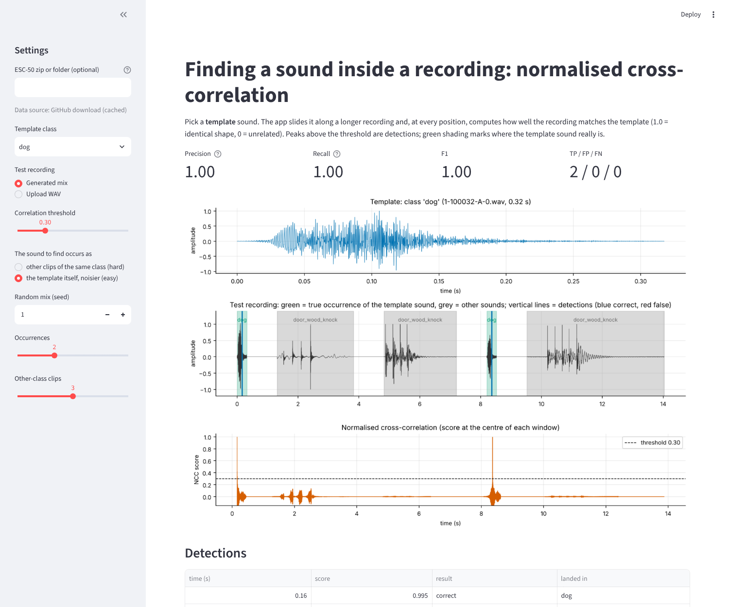
Figure 2: The Streamlit app: template 'dog', two true occurrences found, precision, recall and F1 all 1.00 in the repeat condition.

6 Results
Five classes (dog, rooster, rain, siren, door_wood_knock), 30 recordings per class and condition (each with 2 occurrences, so 60 true occurrences per class), thresholds 0.02 to 0.90 in steps of 0.02. The template for each class is the first fold-1 clip. All numbers come from experiments/exp_threshold.py.

6.1 Repeat condition: the same sound recurs
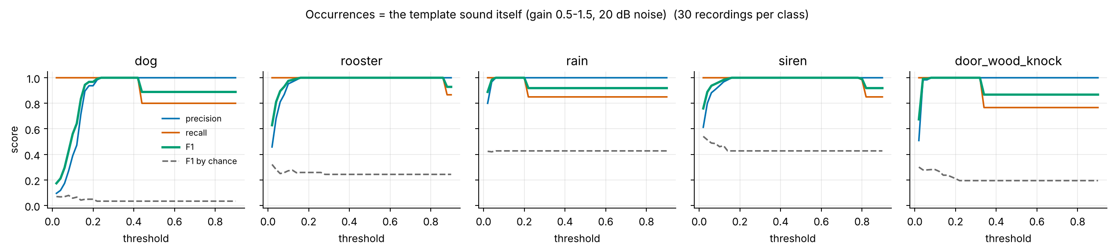
Figure 3: Precision, recall and F1 against threshold when the occurrence is the template itself (gain 0.5-1.5, 20 dB noise).

6.2 Class condition: other clips of the same class
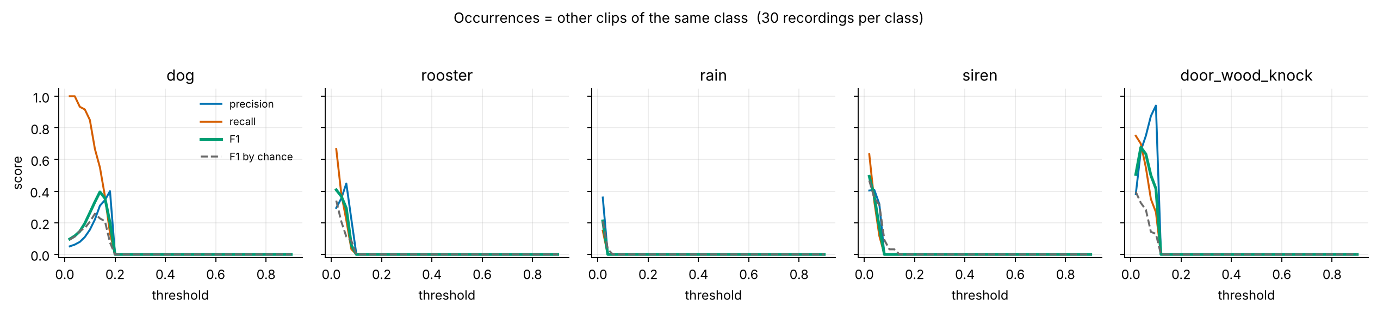
Figure 4: The same curves when the occurrences are other clips of the template's class. The dashed line is the chance baseline.
Table 4: Best threshold per class (the lowest threshold that maximises F1) and the results there.
Condition | Class | Template (s) | Best thr. | Precision | Recall | F1 | TP/FP/FN | Chance F1
class | dog | 0.32 | 0.14 | 0.308 | 0.550 | 0.395 | 33/74/27 | 0.228
class | rooster | 2.48 | 0.02 | 0.294 | 0.667 | 0.408 | 40/96/20 | 0.340
class | rain | 5.00 | 0.02 | 0.360 | 0.150 | 0.212 | 9/16/51 | 0.209
class | siren | 5.00 | 0.02 | 0.404 | 0.633 | 0.494 | 38/56/22 | 0.467
class | door_wood_knock | 2.92 | 0.04 | 0.656 | 0.700 | 0.677 | 42/22/18 | 0.326
repeat | dog | 0.32 | 0.24 | 1.000 | 1.000 | 1.000 | 60/0/0 | 0.034
repeat | rooster | 2.48 | 0.16 | 1.000 | 1.000 | 1.000 | 60/0/0 | 0.259
repeat | rain | 5.00 | 0.06 | 1.000 | 1.000 | 1.000 | 60/0/0 | 0.427
repeat | siren | 5.00 | 0.16 | 1.000 | 1.000 | 1.000 | 60/0/0 | 0.427
repeat | door_wood_knock | 2.92 | 0.08 | 1.000 | 1.000 | 1.000 | 60/0/0 | 0.281

6.3 Why: scores of true and other clips
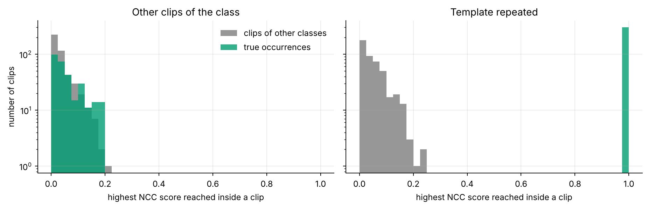
Figure 5: Highest NCC score reached inside each clip, for true occurrences and other-class clips (all five classes together).
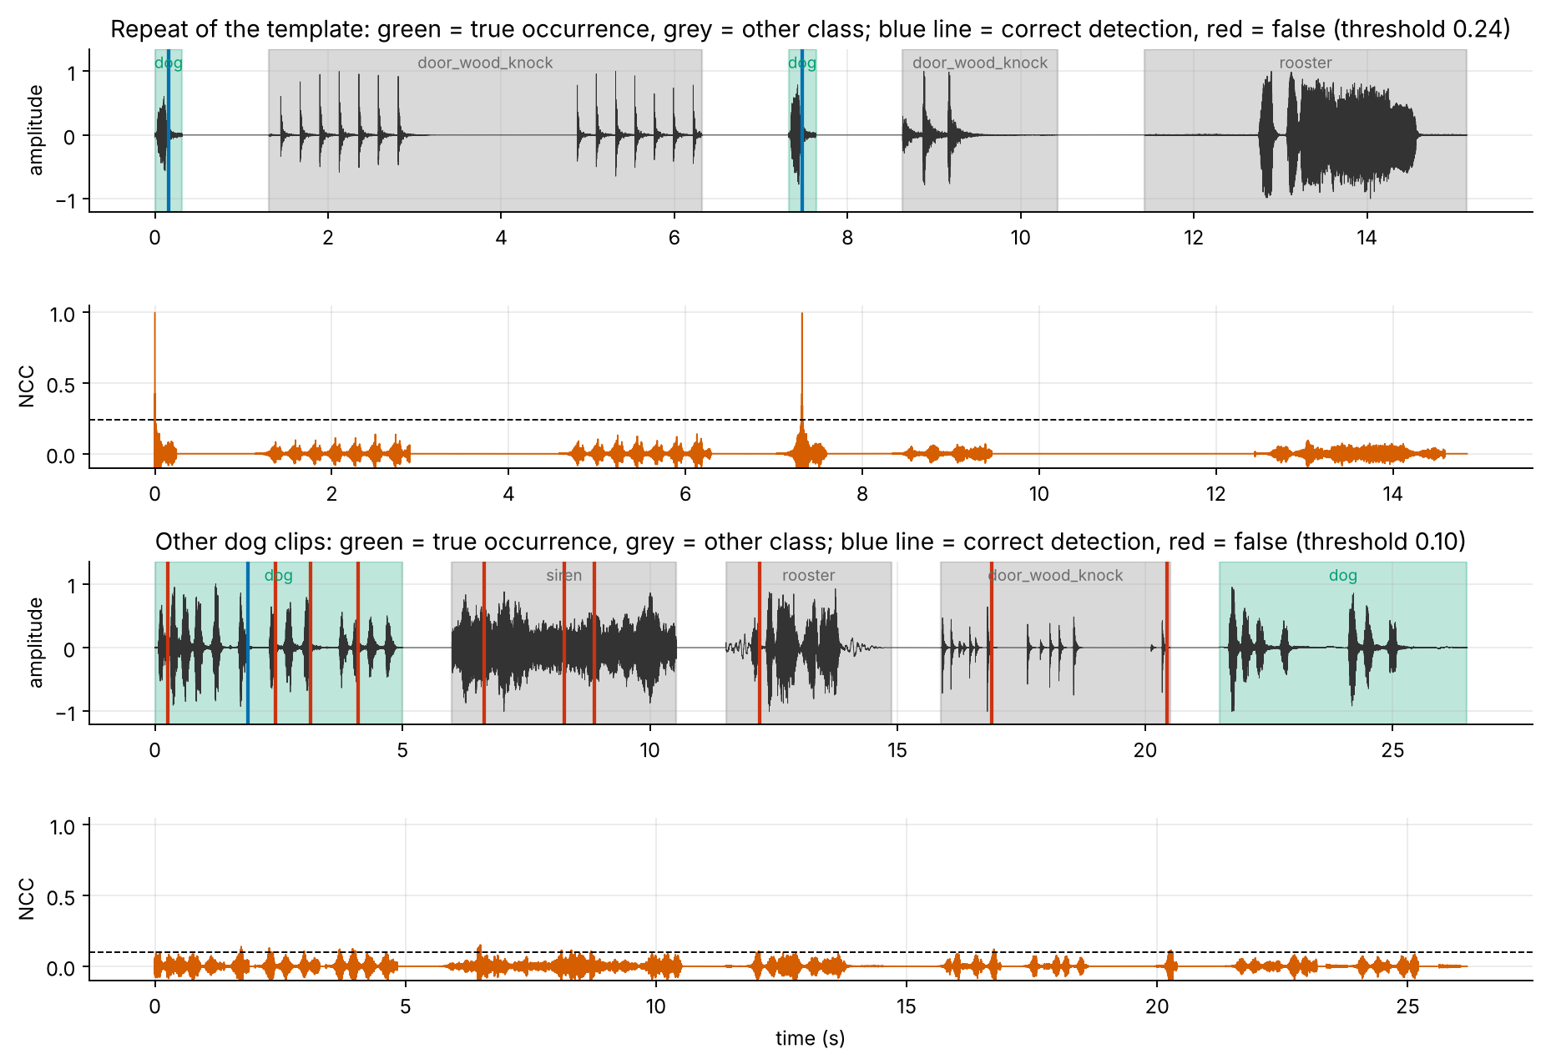
Figure 6: Examples. Top two panels: a repeat of the 'dog' template; the true occurrences score near 1. Bottom two: other 'dog' clips; every score stays below about 0.15.

6.4 Points to note
- Exact repeats are found perfectly. In the repeat condition every class reaches F1 = 1.000 (all 60 occurrences found, no false detections) at its best threshold; the range of thresholds that gives this best F1 is: dog 0.24-0.42, rooster 0.16-0.86, rain 0.06-0.20, siren 0.16-0.78, door_wood_knock 0.08-0.32. True occurrences reach a mean highest score of 0.995, other-class clips 0.079 (dog).
- Different clips of the same class are mostly not found. Raw-waveform NCC compares sample-by-sample shape, so two different dog barks, or two rain clips, correlate weakly (the mean highest score inside true clips is only 0.016-0.139). The best F1 values are dog 0.40 (chance 0.23), rooster 0.41 (chance 0.34), rain 0.21 (chance 0.21), siren 0.49 (chance 0.47), door_wood_knock 0.68 (chance 0.33).
- Only some of these are above chance. Dog and door_wood_knock clearly beat the chance baseline; rooster is slightly above; rain and siren are at chance level, so no skill is claimed for them. Part of the apparent F1 comes from the fact that true clips cover a large share of the recording, so even random detections often land in one.
- The best thresholds are very low (0.02-0.14 in the class condition), partly below the 0.1-0.9 range of the app's slider; at such thresholds the detector is close to picking arbitrary peaks. A large threshold gives zero recall for different instances.
- Scores of true and other-class clips overlap strongly (Section 6.3), so a better representation (for example spectrogram features) would be needed to recognise a class from one example; that is outside this project's scope.
- The template choice is fixed (first fold-1 clip per class) and there are 30 recordings per class (60 true occurrences), so the numbers carry sampling uncertainty; a different template could give different class-condition results.
- The centre-in-span rule matters: a template longer than the true clip can place the window centre outside the clip.
- The pytest suite has 6 tests and all pass. The app was run without errors.

7 References
[1] K. J. Piczak, "ESC: Dataset for Environmental Sound Classification", Proc. 23rd ACM International Conference on Multimedia (ACM Multimedia), 2015.
[2] K. J. Piczak, ESC-50: Dataset for Environmental Sound Classification (2,000 clips, 50 classes), github.com/karolpiczak/ESC-50.
[3] Creative Commons Attribution-NonCommercial 3.0 licence (CC BY-NC 3.0), creativecommons.org/licenses/by-nc/3.0/.
[4] M. A. Richards, Fundamentals of Radar Signal Processing, 2nd ed., McGraw-Hill, 2014.
[5] M. A. Richards, J. A. Scheer and W. A. Holm (eds.), Principles of Modern Radar: Basic Principles, SciTech Publishing, 2010.
[6] M. I. Skolnik, Radar Handbook, 3rd ed., McGraw-Hill, 2008.
[7] TU Berlin, "Matched Filter and Pulse Compression", chapter of the Scientific Python course, platform.commit.tu-berlin.de/en/book/sci-python/chapter/ch25/section/s01.
[8] NumPy documentation, numpy.org/doc/.
[9] SciPy documentation (scipy.io.wavfile, scipy.signal.resample_poly), docs.scipy.org/doc/scipy/.
[10] Matplotlib documentation, matplotlib.org/stable/.
[11] Streamlit documentation, docs.streamlit.io.
[12] pytest documentation, docs.pytest.org.
[13] python-docx documentation, python-docx.readthedocs.io.
[14] python-pptx documentation, python-pptx.readthedocs.io.
[15] Python standard library documentation (csv, zipfile, urllib), docs.python.org/3/library/.
[16] Freesound, the online sound database from which ESC-50 clips were extracted, freesound.org.
Base paper: [Base paper to be verified by the student]

